1. 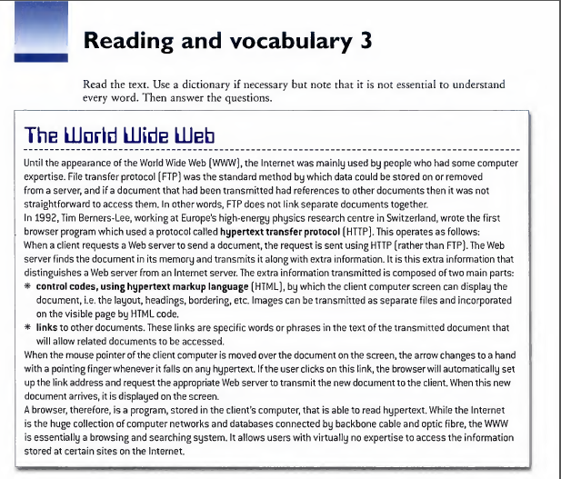**From memories if you can, fill in the missing prepositions**. **(5)**

* until the appearance … the World Wide Web
* the method … which data could be stored
* the data could be stored on or removed … a server
* references … other documents
* the server transmits the document … … extra information
* the information is composed … two parts
* the extra information provides links… other documents

1. **Use words and phrases from the text to rewrite the words in bold. (5)**

**(Bold words:** *1. easy and simple, almost. 2. right. 3. in its basic character. 4. makes, different. 5. mostly***)**

1. 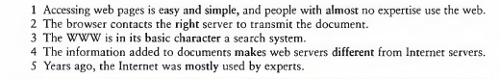**…**
2. **…**
3. **…**
4. **…**
5. **…**

**Reminder:**

* **Change this filename to [Name]_T01.docx (No Test01, please).**
* **Your [Name] should be written in English, without spaces, like this: BuiLeTuanAnh_T01.docx.**
* **Submit on time. A maximum of 45 minutes is allowed.**
* **Late submission or wrong filename will result in 0.**