**ACKNOWLEDGEMENT**

We would like to express my gratitude to all those who gave us the possibility to complete this eProject. We are deeply indebted to our supervisor Mr. Lai Duc Chung, whose help, stimulating suggestions and encouragement helped us in all the time of research for and doing of this eproject.

Our former schoolmates from Bachkhoa-Aptech IT System supported us in our eproject process. We want to thank them for all their help, supports, interest and valuable hints. Especially, we are obliged to our families and other friends who encouraged us whenever we had any trouble.

Last but not least, we would like to give my special thanks to all those who help us complete this eproject.

***Best regards,***

Group 1 – Bachkhoa-Aptech

# Problem Definition

## Introduction

“MyImage” is a group of people who wants to develop an online site were the user can upload his or her photographs and can order them for printing.

A customer can have a set of digital photographs in his desktop which he/she wants to print.

He/she can provide the application the path to the folder where the photographs are stored and can choose the photos that he/she wants to print and choose the size of the prints. The application will calculate the price after downloading the price information from the database for the different print sizes and show it to the user.

The user will enter his/her credit card/other payment option (or choose any other mode of payment) and shipping information if he/she wants to go ahead with the order.

If the credit card information is found correct, the photos are uploaded to the server and a purchase order is created in the database.

## Existing Scenario

Our client, MyImage wants the following actions to be implemented.

1. The users have to register themself with the site before using the functionality. After registrations user id and password will be provided to the user. Through which they can login.
2. The price information for the different print sizes will be stored in the database.
3. The user will upload JPEG files from their desktop, which they wants to print.
4. The application will show all the jpeg files in the folder to the user. The user can then choose the size(s) and the number of prints that they wants to print for each size for each photograph.
5. The application will calculate the total price for the order.
6. If the user decides to buy the prints, they will be asked to enter the mode of payment (credit card/direct payment in the nearest branch office) and the shipping address. If credit card option is chosen, the credit card information will be encrypted and sent to the server for verification.
7. The server will decrypt the credit card information and verify it. If found correct, payment will be completed.
8. A purchase request will be created in the database. The purchase order number will be provided to the user
9. An administrator user then can see the purchase request and can execute the same.
10. Once the photos are printed and shipped, the directory containing these photographs will be deleted from the server.
11. The admin will decide the price and other things. Proper validation should be applied.

## Project Objective

* There are registered people in the system. Some are approvers. An approver can also be a requestor. In the organization, the hierarchy is Users/Managers

## Requirements Specification

* The system should be able to display the contents of desktop folder
* An user should be able mark the photographs he wants to order and specify the size of the print and the number of copies
* If the user provides his credit card information, this should be encrypted before sending it to the server

## Hardware And Software Requirements

* Minimum Requirements
* Hardware Requirements:
  + Pentium III 2.6Ghz or over.
  + Ram 512MB
  + Hard disk require over 1GB free
* Software Requirements:
  + Visual Studio .Net / ASP
  + IIS server.
  + .Net Framework
  + Notepad/Java editor
* Recommended Requirements:
* Hardware Requirements:
  + Pentium IV 2.6Ghz or over.
  + Ram over 512MB
  + Hard disk require over 1GB free
* Software Requirements:
  + Microsoft Windows 2000/ XP/ Vista/ Windows 7.
  + MS SQL 2012.

# Customer Requirements Specification

## Users of the system are admin and customer.

- Creating the account of the employees

- There should be verification / check for all request.

- Change the password after logging into the system.

## User

- User can login and check list items.

- Change the password after logging into the system.

- User can view the detail of request.

# Architecture And Design Of The Project

**Presentation Layer**

**User Services**

**Business Logic Layer**

**Data Acess Layer**

User Interface – GUI components

C#(code-behind)

fles containing

business logic

Database Access

Web-based distributed Three- Layer Architecture of the Project

## Data Flow Diagrams (DFDs)

**Define**: Data Flows Diagram (DFD) describes the information flow in the system. The next step of system analysis is to consider in detail the information necessary for the implementation for functions discussed above and the one necessary for the improvement of the functions. Modeling tool frequently used for this purpose is DFD. DFD will support 4 main activities:

**Analysis**: DFD is used to determine requirement of users.

**Design**: DFD is used to map out plan and illustrate solution to analysis and users while designing a new system.

**Communication**: one of the strength of DFD is its simplicity and ease to understand to analysts and users;

**Document**: DFD is used to provide special description of requirement and system design. DFD provide an overview of key functional components of the system but it does not provide any detail on these components. We have to use other tools like database dictionary, process specification to get an idea of which information will be exchanged and how.

**The main components of Context Diagram:**

Data store

Data flow

External

Process

**The process**: Shows the common function of system

**The external factors**: External factors can be a person, a group of persons or an organization that are sources of information for the systems and are where system products are transferred to.

**The data flow**: Describe the movement of information from one part of the system to another.

**The data store**: The Data Store is used to model a collection of data packets at rest. A store is represented graphically by two parallel lines. The name of a Data Store that identifies the store is the plural of the name of the packets that are carried by flows into and out of the Data Store.

**User**

**ADMINISTRATOR**

**ITEMS**

**User  
Details**

**Authentcation Details**

**REQUEST**

**Items Details**

**Request  
Details**

### DFD LEVEL 0 - CONTEXT DIAGRAM

**Account  
& Password**

**User**

**Message**

**DATABASE**

**Feedback**

**Account  
& Password**

### DFD LEVEL 1 – LOGIN PROCESS

**Request**

**User**

**Message**

**Requesst**

**DATABASE**

**Message**

**SUPERIOR**

**Message**

### DFD LEVEL 1 – REQUEST PROCESS

**Requesst**

**User**

**Message**

**Old password  
& new Password**

**DATABASE**

**Feedback**

### DFD LEVEL 1 – CHANGE PASSWORD PROCESS

**Old password  
& new Password**

**Update  
Details**

**ADMINISTRATOR**

**Message**

**Update  
Details**

**DATABASE**

**Feedback**

### DFD LEVEL 1 – UPDATE PROCESS

**Insert  
Details**

**ADMINISTRATOR**

**Message**

**Insert  
Details**

**DATABASE**

**Feedback**

### DFD LEVEL 1 – INSERT PROCESS

## II. Data Flowchart

### Log in

**START**

**Input Account &Password**

**Check if it exist in database**

**Exist**

## *False*

## *True*

**Display error message**

**Display manager form**

**END**

### Change password

**START**

**Input old password, new password and confirm new pasword**

**Check if Old password is valid for database**

**Valid**

## *False*

## *True*

**Display error message**

**Update new password into database**

**END**

**Display successful message**

### Log out

**START**

**Confirm Log out**

**Valid**

## *False*

## *True*

**Back to**

**form log out**

**END**

### Create New Account (Admin - Employees)

**START**

**Fill Employees information in a form available**

**Check if Employees information is valid**

**Vaild**

## *False*

## *True*

**Display error message**

**Insert Employees information into database**

**END**

**Display successful message**

### Request ( Employees)

**START**

**Input Request**

**Send message to Superior**

**Approve  
or Reject**

**Send a message to Employees**

**END**

### Seach

**START**

**Input detail  
 to seach**

**Check if detail exist in database**

**exist**

## *False*

## *True*

**Display not found**

**END**

**Display information**

### Admin – insert (Images, customers)

**START**

**Fill information in a form available**

**Check if information is valid**

**Vaild**

## *False*

## *True*

**Display error message**

**Insert information into database**

**END**

**Display successful message**

### Admin – update (images, customers,user,admin)

**START**

**Change information in a form available**

**Check if information is valid**

**Vaild**

## *False*

## *True*

**Display error message**

**Update information in database**

**END**

**Display successful message**

### Admin – Delete (items, category, role,user)

**START**

**selected information should be deleted**

**Check if information is valid**

**Vaild**

## *False*

## *True*

**Display error message**

**Delete information in database**

**END**

**Display successful message**

# Entity Relationship Diagram

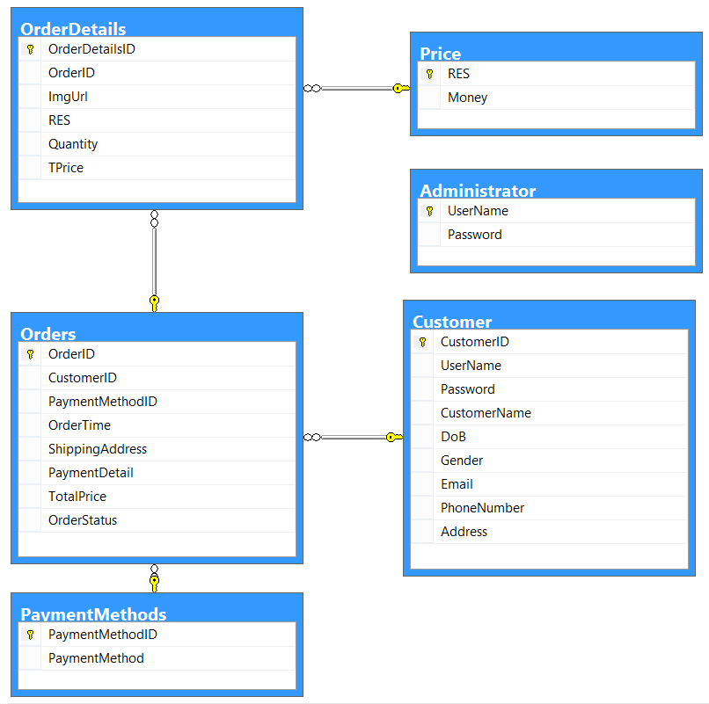

# Database Design/Structure

## Customer

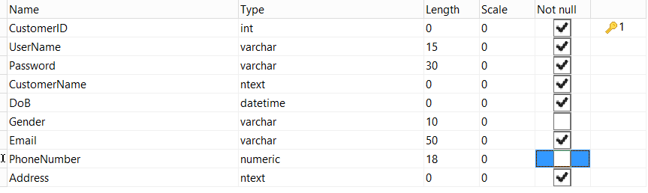

## Administrator



## Price

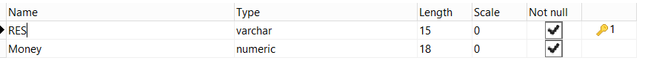

## PaymentMethod

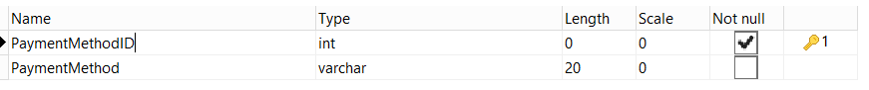

## Orders

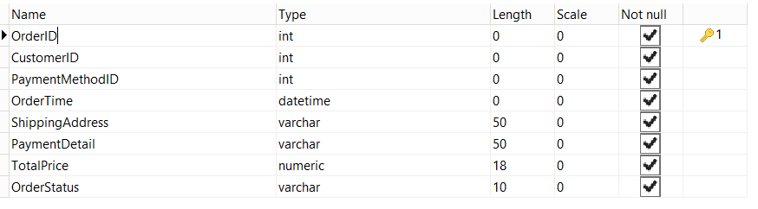

## OrderDetails

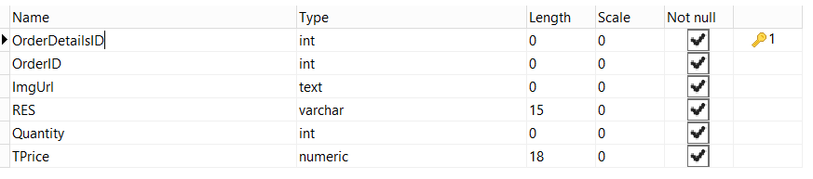

# Screen Shot

## Homepage

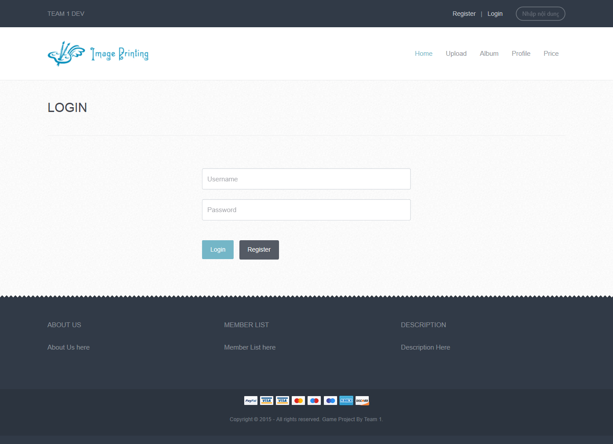

## Register page

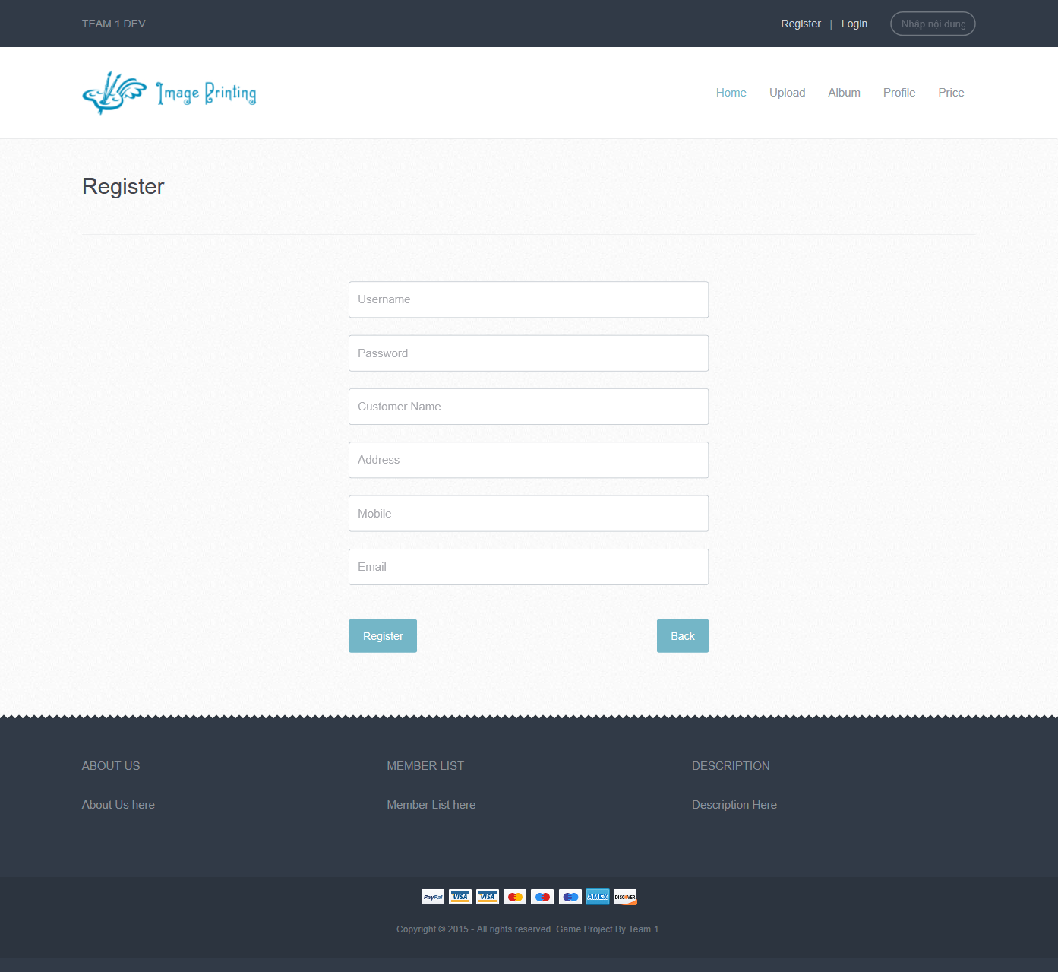

## Upload Page

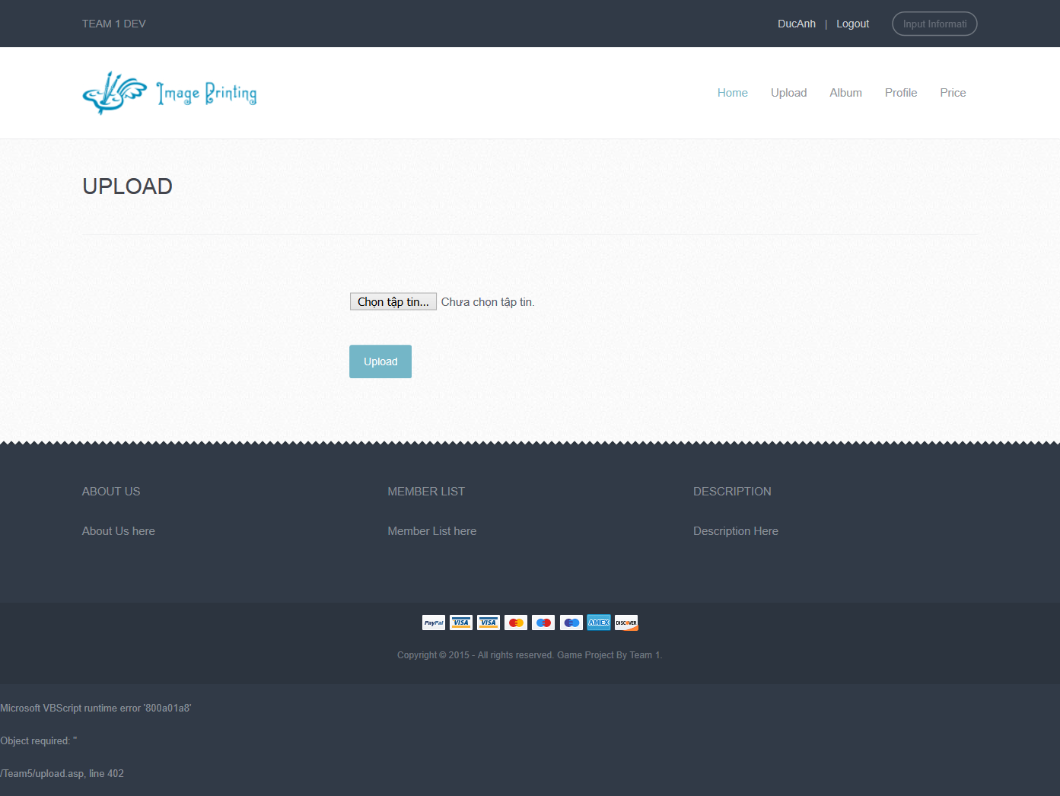

## Album

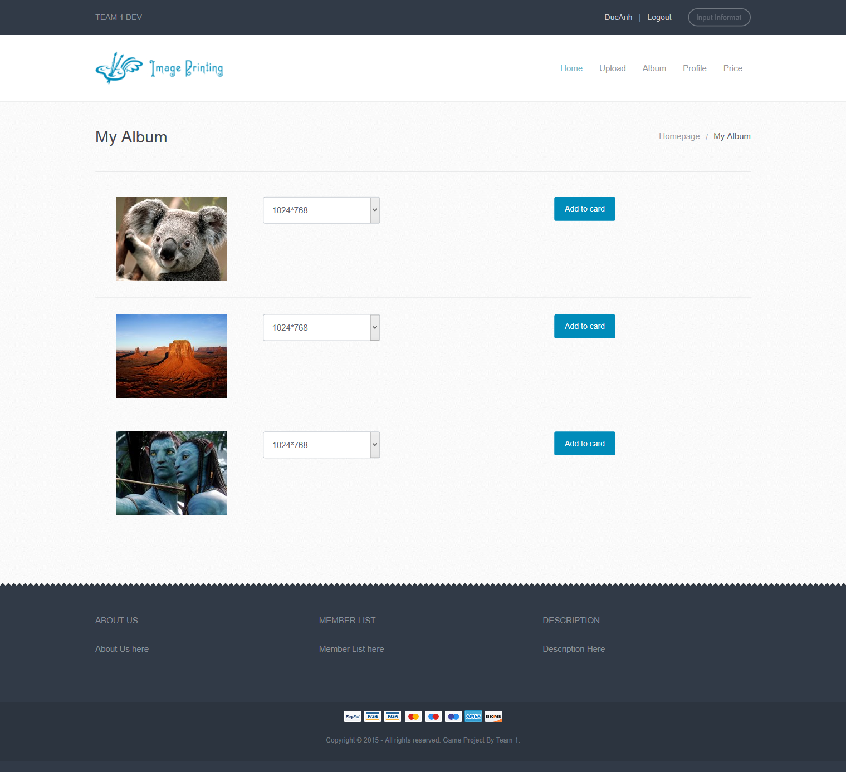

## Cart

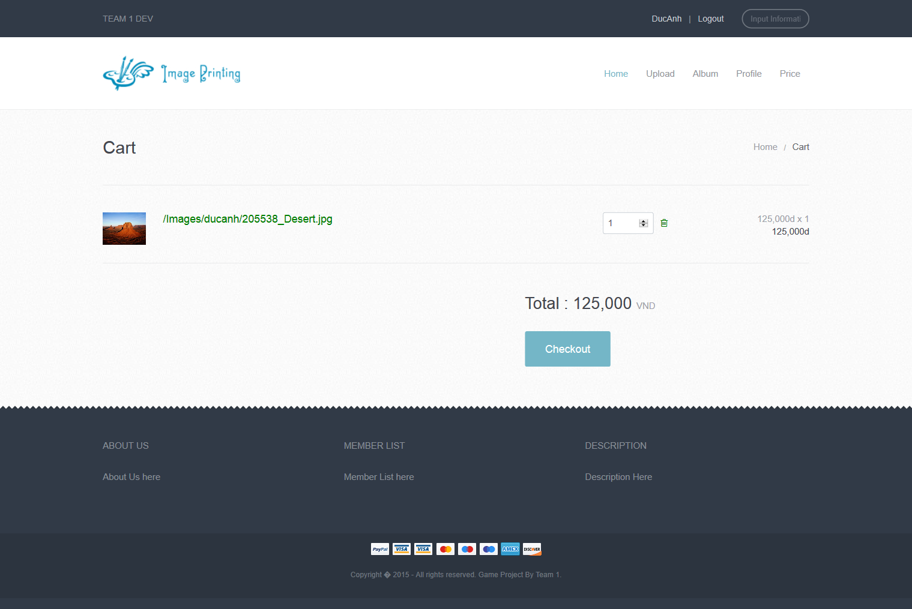

## Checkout

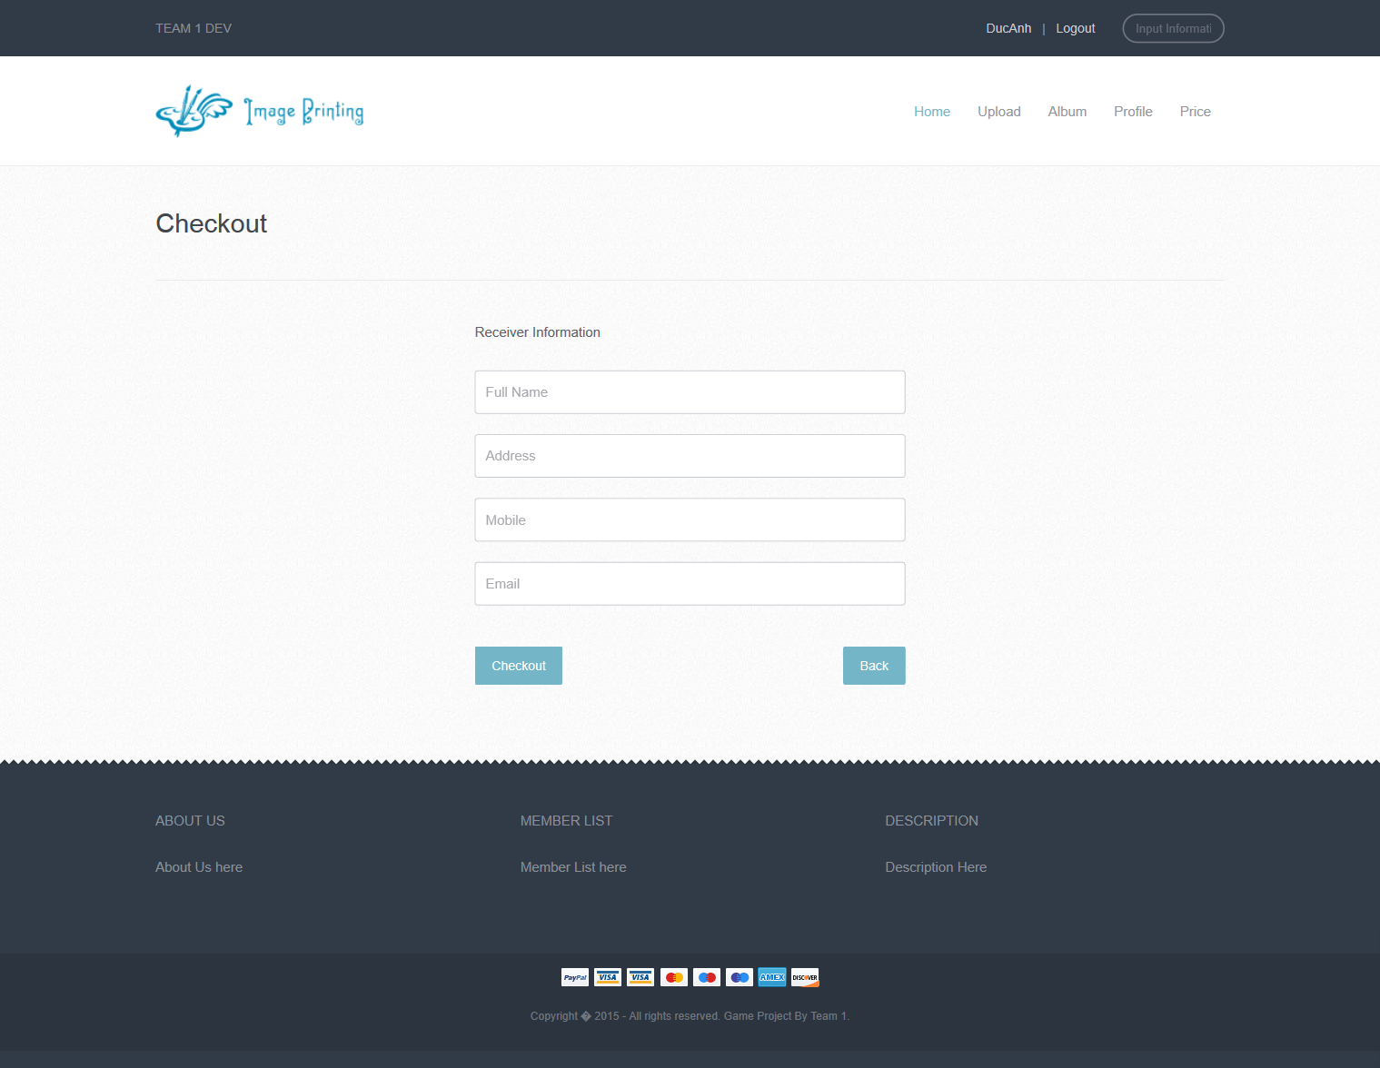

## Edit Profile

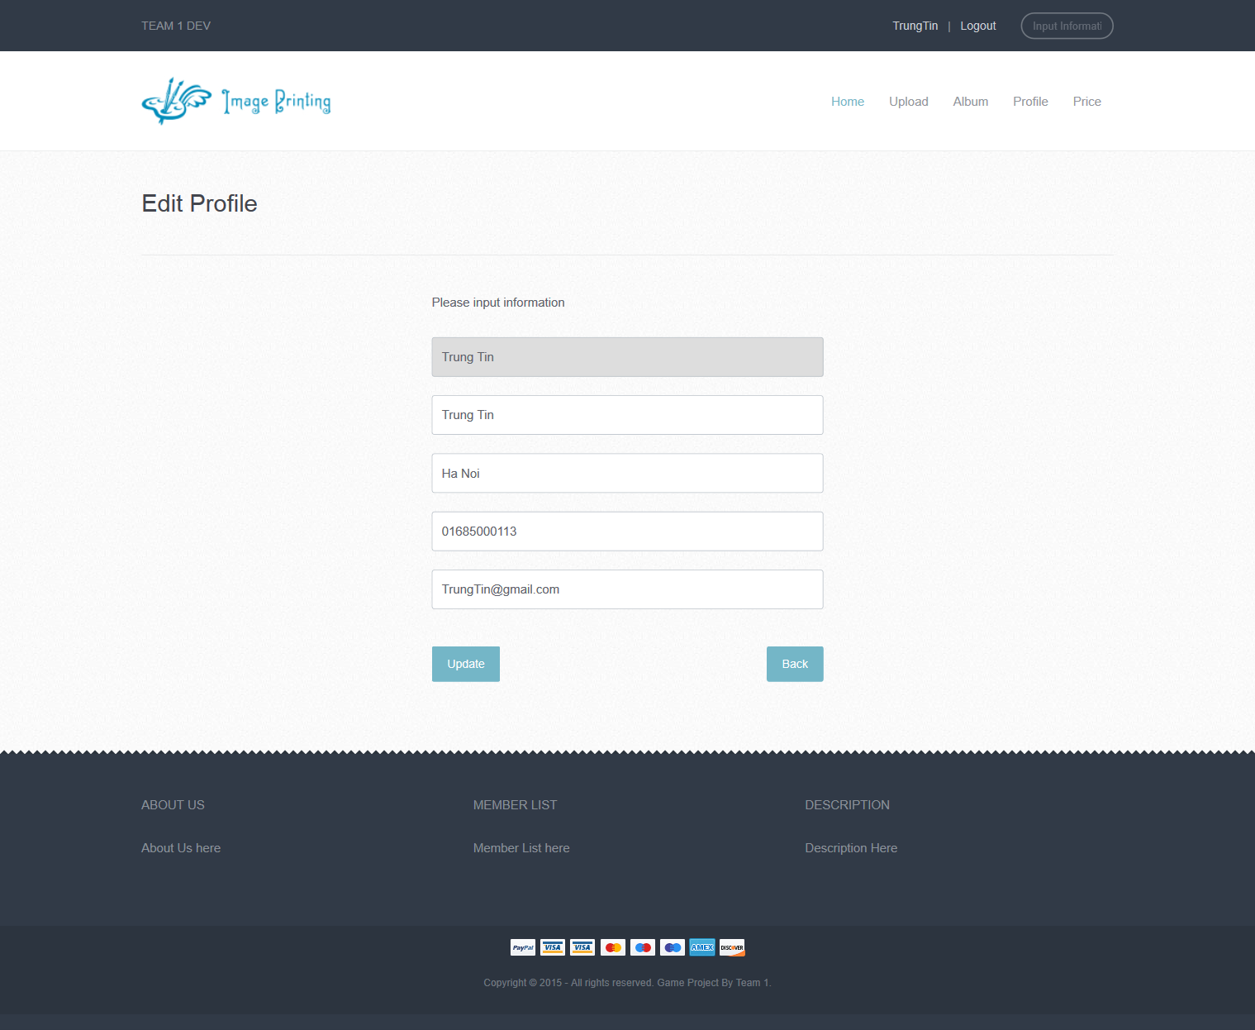

## Change Password

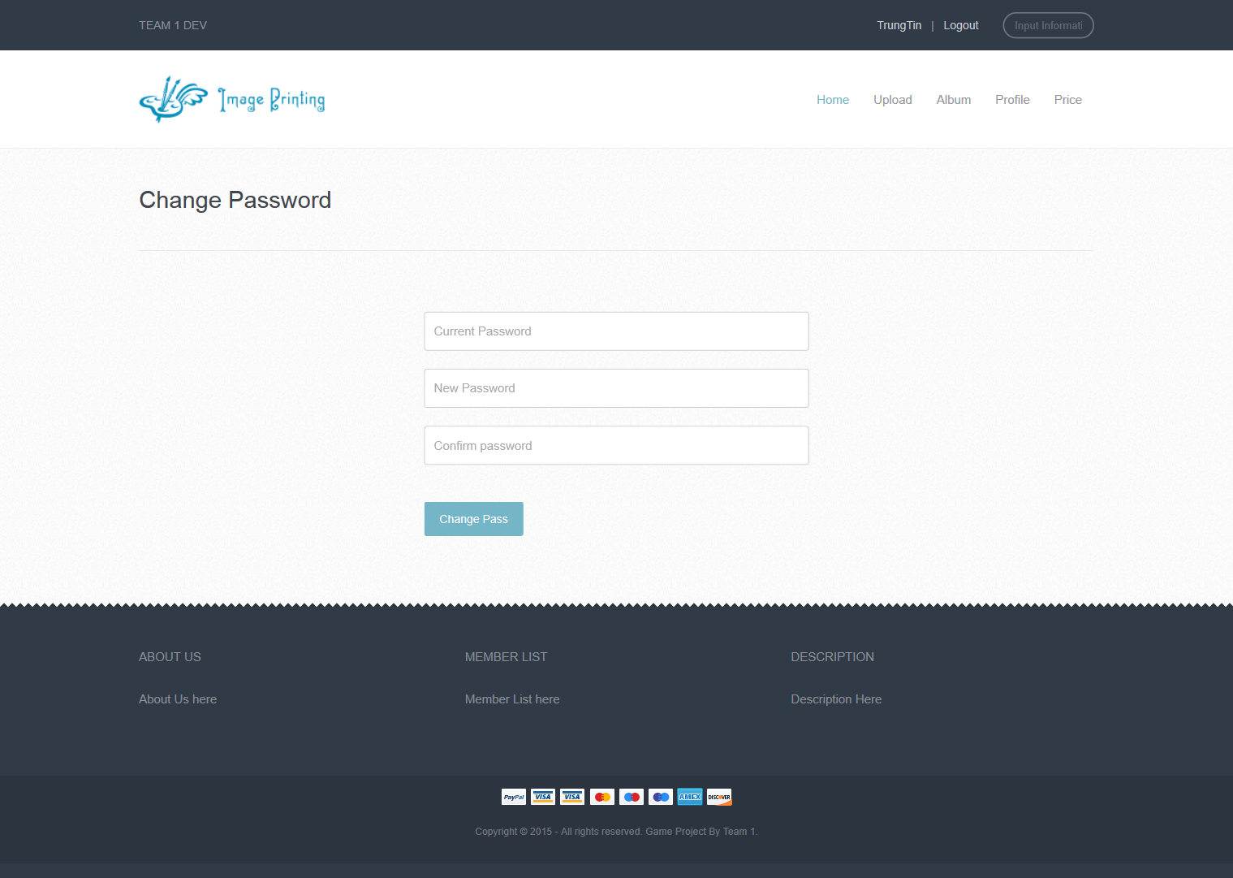

## Admin Login

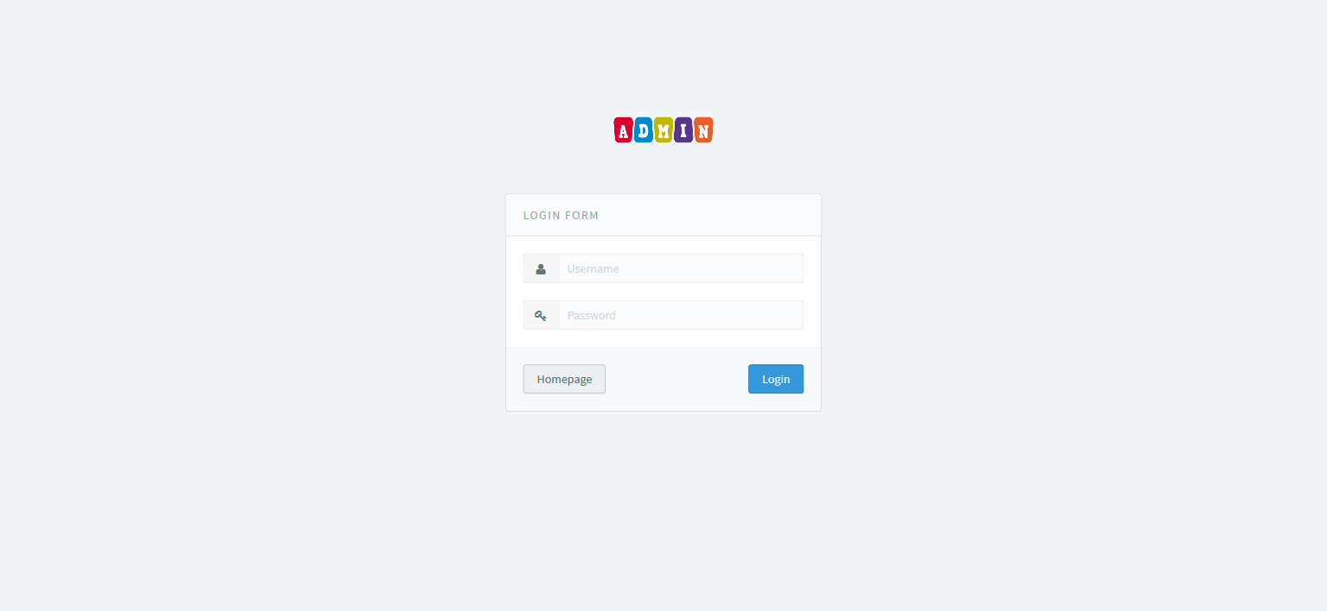

## Customer Manager

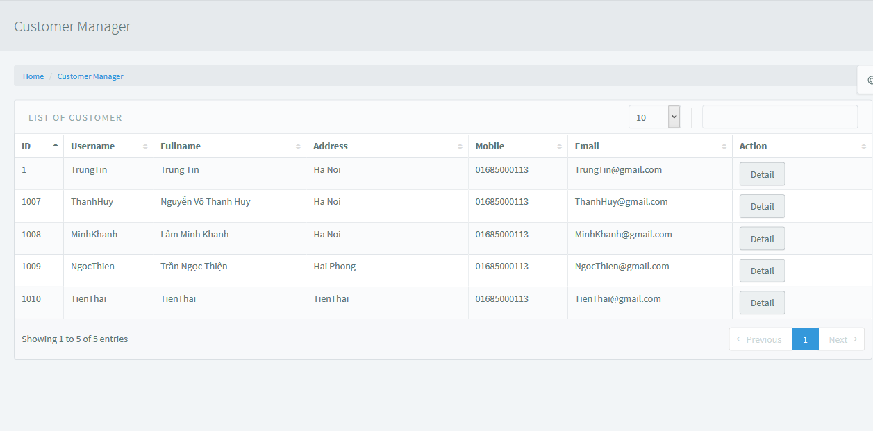

## Price Manager

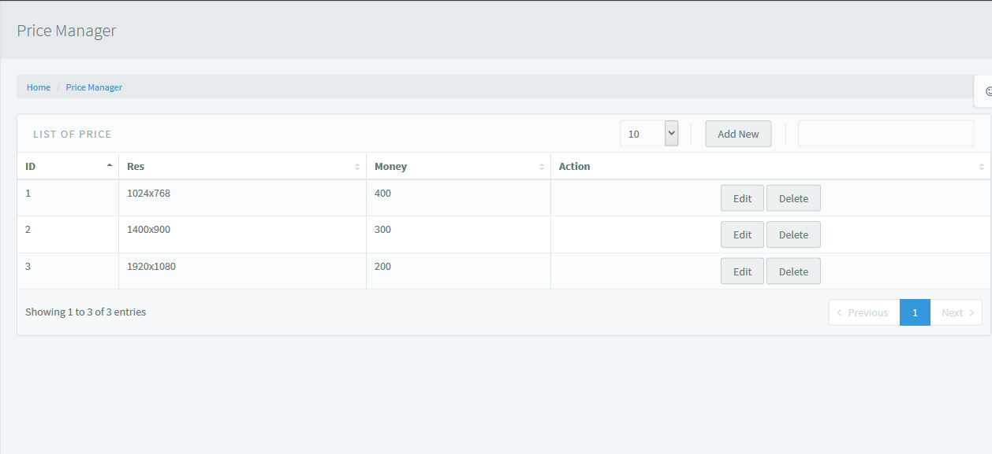

## Add New Price

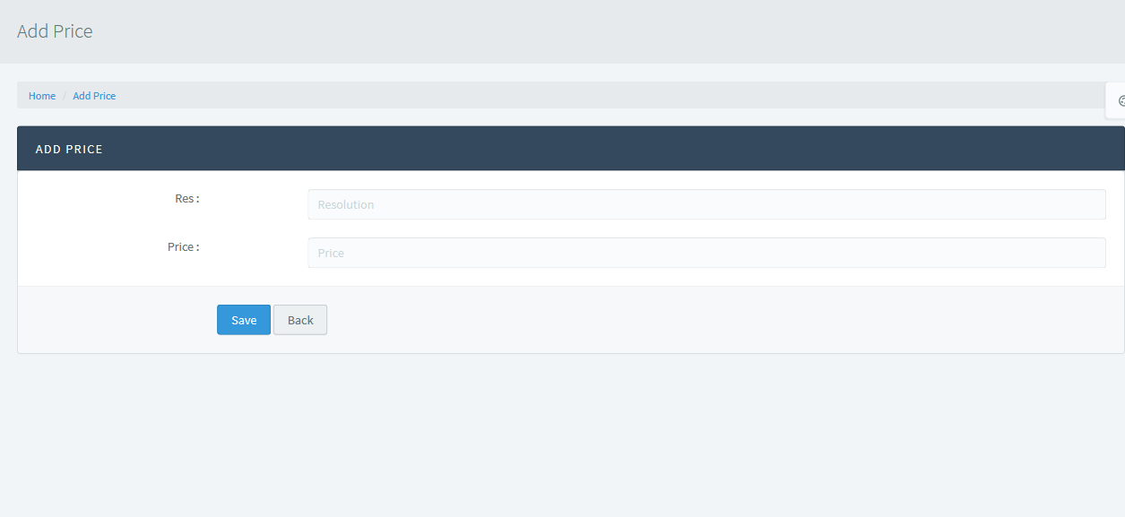

## Update Price

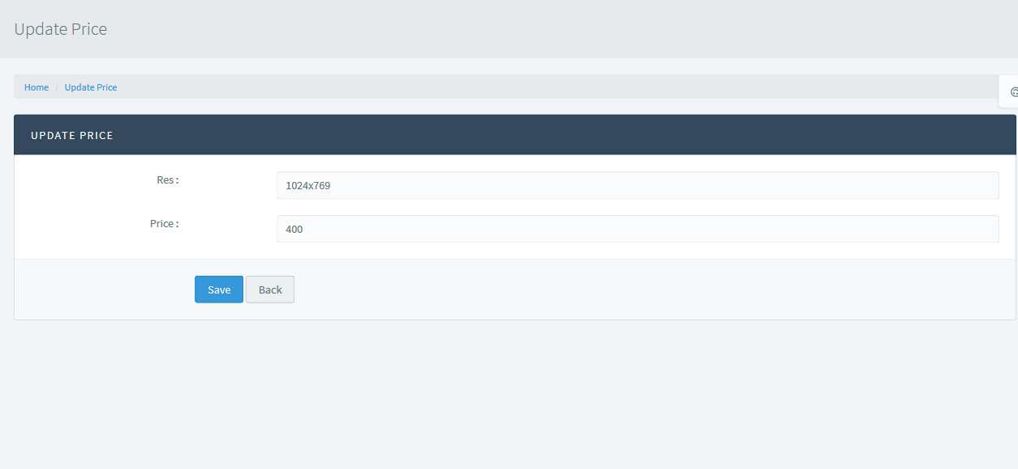

## Order Manager

