ClearCord - Tai lieu kien truc va dac ta chuc nang
  - Tong hop tu source code hien tai cua he thong web chat ClearCord
Du an | ClearCord
Pham vi | Frontend React/Vite, backend ASP.NET Core, realtime SignalR, voice/video WebRTC, Clear AI
Nguon doi chieu | Controllers, services, repositories, SignalR hub, frontend pages/components va cau hinh hien co trong workspace
Ngay tong hop | 13/06/2026
Tai lieu nay gom hai phan: so do kien truc tong the cua he thong web ClearCord va dac ta day du cac chuc nang dang co, kem giai thich cach Clear AI hoat dong va cong nghe tao nen lop AI do.

I. So do kien truc tong the
Kien truc cua ClearCord duoc to chuc theo kieu client-server co them hai lop giao tiep thoi gian thuc va media peer-to-peer. Frontend React chay trong trinh duyet, backend ASP.NET Core cung cap REST API va SignalR Hub, SQL Server luu du lieu nghiep vu, con WebRTC dam nhiem truyen audio/video giua cac client.
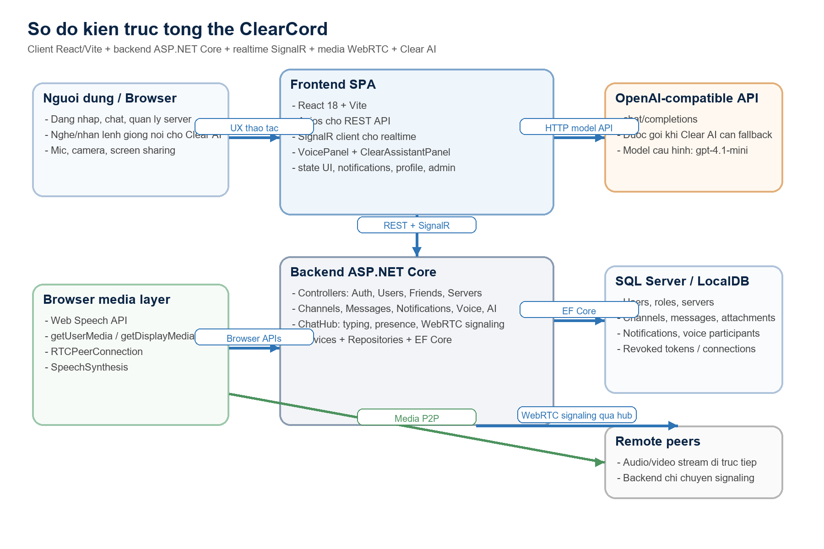
Hinh 1. So do kien truc tong the cua ClearCord
Thanh phan | Cong nghe | Vai tro trong he thong
Trinh duyet / client | React 18, Vite, JavaScript, CSS | Render giao dien SPA, xu ly state giao dien, goi API va nhan su kien realtime.
Lop giao tiep API | Axios + REST API | Xu ly CRUD cho auth, user, friends, servers, channels, messages, notifications va AI.
Lop realtime | @microsoft/signalr + ASP.NET SignalR Hub | Phat su kien messageCreated, typingChanged, presenceChanged, notificationCreated, voiceParticipantsUpdated va webrtcSignal.
Lop nghiep vu backend | ASP.NET Core Services | Ap dung logic dang nhap, phan quyen, tao server, xu ly tin nhan, thong bao, voice va Clear AI.
Lop du lieu | Repositories + EF Core DbContext | Truy cap SQL Server theo mo hinh entities, DTOs va repository pattern.
Co so du lieu | SQL Server / LocalDB | Luu users, friendships, servers, roles, channels, messages, attachments, notifications, voice participants va revoked tokens.
Lop AI | ClearAiService + OpenAI-compatible API | Phan tich lenh noi bo, suy dien ngu canh chat va goi model ngoai khi duoc cau hinh.
Voice / video media | WebRTC + Browser Media APIs | Truyen media peer-to-peer, lay microphone/camera/screen stream va dong bo state qua SignalR.

II. Luong tuong tac chinh
1. Truy cap va khoi tao: Nguoi dung mo ung dung tu ASP.NET Core hoac Vite dev server, sau do frontend React khoi tao giao dien va phien dang nhap.
2. CRUD va business flows: Moi thao tac CRUD nhu dang nhap, cap nhat profile, tao server, tao channel, gui message kem file deu di qua REST API.
3. Realtime: Khi can tinh thoi gian thuc, frontend ket noi SignalR Hub de nhan messageCreated, typingChanged, presenceChanged, notificationCreated va voiceParticipantsUpdated.
4. Voice/video: Voice/video media khong di qua backend; backend chi chuyen tin signaling Offer, Answer, ICE Candidate va Hangup de hai browser thiet lap ket noi WebRTC truc tiep.
5. AI flow: Khi nguoi dung goi Clear AI, backend uu tien parser lenh noi bo; neu lenh vuot pham vi parser va provider duoc cau hinh, he thong goi them model ngoai de sinh cau tra loi.

III. Dac ta chuc nang theo module
Bang dac ta duoi day tong hop cac chuc nang hien dang duoc the hien trong controllers, services, hub SignalR va giao dien frontend.

1. Xac thuc va phien dang nhap
Chuc nang | Mo ta nghiep vu | Cong nghe thuc hien
Dang ky | Tao tai khoan moi va tra ve access token cung thong tin user. | ASP.NET Identity, JWT, Axios
Dang nhap | Xac thuc email/ten dang nhap va mat khau, luu token vao localStorage. | JWT Bearer, Axios, localStorage
Dang xuat | Thu hoi token bang co che revoked token va xoa session tren client. | RevokedToken repository, JWT events
Quen / dat lai mat khau | Sinh reset token va doi mat khau thong qua endpoint reset. | Identity token providers

2. Ho so nguoi dung
Chuc nang | Mo ta nghiep vu | Cong nghe thuc hien
Xem thong tin ca nhan | Lay profile hien tai va profile theo user id. | UsersController, React modals
Cap nhat profile | Sua display name, thong tin ho so va dong bo lai client session. | UserService, Axios
Tai avatar | Upload anh dai dien bang multipart form data. | IFormFile, FileStorageService
Tim kiem user | Tim nguoi dung de ket ban, nhan tin hoac xem profile. | EF Core query + search endpoint

3. Ban be va direct conversation
Chuc nang | Mo ta nghiep vu | Cong nghe thuc hien
Gui loi moi ket ban | Tao friend request den user muc tieu. | FriendsController, SQL Server
Chap nhan / tu choi loi moi | Cap nhat trang thai request va dua user vao danh sach ban be. | FriendService
Danh sach ban be | Hien thi online/offline, avatar va hanh dong chat/call. | React state, presence update
DM 1-1 | Tao hoac mo direct conversation giua hai user. | DirectConversationService, SignalR

4. Server, invite va workspace
Chuc nang | Mo ta nghiep vu | Cong nghe thuc hien
Tao server | Tao workspace moi theo kieu Discord-style. | ServersController, EF Core
Tham gia bang invite | Join server thong qua invite code. | JoinServer endpoint
Roi / xoa server | Thanh vien co the roi; owner/admin du quyen xoa server. | ServerService + permissions
Xem chi tiet server | Lay categories, channels, roles, members va metadata cua server. | ServerDetailsDto
Lay invite | Sinh hoac lay invite link hien tai de chia se. | Server invite endpoint

5. Channel va cau truc noi dung
Chuc nang | Mo ta nghiep vu | Cong nghe thuc hien
Category | Tao, sua, xoa category de nhom channel. | ChannelsController, ChannelCategory entity
Text channel | Tao, sua, xoa kenh chat text. | ChannelService, ChannelType.Text
Voice channel | Tao, sua, xoa kenh voice/video. | ChannelService, ChannelType.Voice
Thu tu va topic | Quan ly position, topic, categoryId de sap xep workspace. | DTOs + admin UI

6. Tin nhan va noi dung chat
Chuc nang | Mo ta nghiep vu | Cong nghe thuc hien
Gui tin nhan kenh | Gui message vao text channel, co the kem file va reply. | MessagesController, multipart upload
Gui direct message | Gui tin nhan vao direct conversation. | DirectConversationsController, SignalR
Sua / xoa tin nhan | Cap nhat noi dung hoac danh dau deleted. | MessageService, realtime update
Reply | Gan quan he replyTo de hien ngu canh tra loi. | MessageDto, UI rendering
Reaction | Them / go emoji reaction. | MessageReaction entity
Pin | Ghim va bo ghim tin nhan quan trong. | TogglePin endpoint
Dinh kem tep | Gui tep va preview anh trong khung chat. | FileStorageService, MessageAttachment

7. Realtime, presence va notifications
Chuc nang | Mo ta nghiep vu | Cong nghe thuc hien
Realtime message | Tin nhan moi duoc day qua hub ngay sau khi tao. | SignalR messageCreated
Typing indicator | Thong bao dang go trong channel hoac DM. | typingChanged event
Online / offline | Theo doi ket noi va phat su kien presenceChanged. | UserConnection, SignalR
Thong bao he thong | Thong bao tin nhan moi, friend request va su kien server. | NotificationService
Danh dau da doc | Danh dau tung thong bao hoac tat ca la da doc. | NotificationsController

8. Voice, video va chia se man hinh
Chuc nang | Mo ta nghiep vu | Cong nghe thuc hien
Tham gia voice channel | User vao phong voice tren server va nhan danh sach participant. | VoiceService, SignalR
Direct call | Voice/video call trong direct conversation. | DirectVoiceService, SignalR
Mic / camera / screen state | Dong bo mute, camera va screen sharing giua cac participant. | UpdateVoiceState
WebRTC signaling | Trao doi Offer, Answer, ICE Candidate va Hangup qua hub. | ChatHub + RTCPeerConnection
Media peer-to-peer | Audio/video stream chay truc tiep giua cac client, backend chi mang signaling. | WebRTC, getUserMedia, getDisplayMedia

9. Quan tri server va phan quyen
Chuc nang | Mo ta nghiep vu | Cong nghe thuc hien
Role va permission | Tao role, to mau, cap quyen theo tap PermissionType. | ServerRole, ServerRolePermission
Gan / go role | Gan role cho thanh vien va thu hoi khi can. | AssignRole / RemoveRole
Quan ly channel/server | Bat buoc quyen ManageChannels hoac ManageServer. | PermissionService
Kick / ban member | Moderate member bang ly do tuy chon. | KickMembers, BanMembers permissions

10. Clear AI va tro ly giong noi
Chuc nang | Mo ta nghiep vu | Cong nghe thuc hien
Wake phrase va voice shortcut | Lang nghe wake phrase va hotkey Ctrl+Space de kich hoat. | SpeechRecognition, browser events
Doc tin nhan | AI co the doc recent messages, latest message va xac dinh nguoi gui. | Regex parser + MessageService
Gui tin nhan bang lenh | AI co the soan/gui DM hoac gui vao channel hien tai/channel dat ten. | ClearAiService
Mo voice/video call | AI co the khoi dong intent goi voice/video voi ban be. | ClearAiActionDto + UI action
Fallback chat model | Neu bat OpenAI provider, request se duoc day den chat/completions. | HttpClient, OpenAI-compatible API
Noi va phan hoi am thanh | Tra loi bang text va speech synthesis ngay tren client. | SpeechSynthesis

IV. Cach thuc AI hoat dong trong ClearCord

1. Dau vao tu text va giong noi
Clear AI nhan prompt tu o chat hoac tu giong noi. Tren frontend, component ClearAssistantPanel su dung Web Speech API de nghe wake phrase, nhan SpeechRecognition transcript va phat lai cau tra loi qua SpeechSynthesis.

2. Phan tich lenh noi bo
Backend ClearAiService chuan hoa cau lenh, loai bo wake phrase, xu ly dau tieng Viet va so khop bang nhieu bieu thuc chinh quy. Dich vu nay co the nhan biet cac nhom lenh nhu doc tin nhan, doc tin nhan moi nhat, gui DM, gui vao current channel, gui vao named channel, mo compose draft va bat dau voice/video call.
De tim dung ban be hoac kenh, service con dung chuan hoa chuoi, compact lookup va Levenshtein distance de cho phep nguoi dung noi/go ten gan dung van tim duoc doi tuong.

3. Giai doan thuc thi hanh dong
Khi parser da hieu yeu cau, Clear AI khong dung lai o muc tra loi van ban. No goi truc tiep cac service nghiep vu nhu MessageService, DirectConversationService, VoiceService va NotificationService de tao hanh dong that, sau do tra ve ClearAiActionDto de frontend mo dung man hinh hoac che do soan tin.

4. Fallback sang model ngoai
Neu provider duoc dat la openai va co API key, service se goi endpoint chat/completions voi model cau hinh trong appsettings. Luc nay he thong gui kem prompt, language va current scope de model tra loi tu nhien hon cho nhung cau hoi khong khop parser.

5. Gioi han hien tai
Phien ban hien tai la mot AI task-oriented trong app chat. No lam rat tot voi nhan/gui tin, doc thong tin gan day va mo call, nhung chua phai agent tong quat co kha nang suy luan ngoai pham vi nghiep vu cua ClearCord.

V. Cong nghe tao nen lop AI
Lop cong nghe | Thanh phan cu the | Vai tro
AI giao tiep giong noi | SpeechRecognition, SpeechSynthesis | Thu am lenh, nhan dang van ban va doc phan hoi tren trinh duyet.
Bo parser lenh | Regex, Unicode normalization, string matching | Nhan dien y dinh va tham so nghiep vu tu prompt tieng Viet/Anh.
Bo tim doi tuong gan dung | Levenshtein distance, compact lookup | Tim ban be, kenh va context ngay ca khi nguoi dung nhap/noi chua chinh xac tuyet doi.
Dieu phoi hanh dong | ClearAiService, DTO actions, ASP.NET services | Anh xa y dinh AI thanh thao tac thuc su trong he thong.
Model hoi thoai ngoai | OpenAI-compatible chat/completions, model gpt-4.1-mini theo cau hinh | Sinh cau tra loi tu nhien khi parser noi bo khong phu hop.

VI. Ket luan ky thuat
ClearCord la he thong web chat kieu Discord duoc xay theo mo hinh tach lop ro rang: React/Vite cho giao dien, ASP.NET Core cho API va nghiep vu, EF Core + SQL Server cho du lieu, SignalR cho realtime, WebRTC cho media va Clear AI cho dieu phoi lenh. Kien truc nay de mo rong them moderation, media server, search va AI agents o cac giai doan sau.

