KIỂM TRA GIỮA KỲ MÔN: THỰC HÀNH CƠ SỞ DỮ LIỆU 20232

Họ tên sinh viên: Lương Văn Khanh MSSV: 20225728

**Câu 1.**

*SQL:*

CREATE TABLE Book (  
    book_id CHAR(10) PRIMARY KEY,  
    title CHAR(50) NOT NULL,  
    publisher CHAR(20) NOT NULL,  
    published_year INTEGER CHECK (published_year > 1900),  
    total_number_of_copies INTEGER CHECK (total_number_of_copies >= 0),  
    current_number_of_copies INTEGER CHECK (current_number_of_copies >= 0),  
    CHECK (total_number_of_copies >= current_number_of_copies)  
);  
CREATE TABLE Borrower (  
    borrower_id CHAR(10) PRIMARY KEY,  
    name CHAR(50) NOT NULL,  
    address TEXT,  
    telephone_number CHAR(12)  
);  
CREATE TABLE BorrowCard (  
    card_id SERIAL PRIMARY KEY,  
    borrower_id CHAR(10),  
    borrow_date DATE NOT NULL,  
    expected_return_date DATE NOT NULL,  
    actual_return_date DATE,  
    FOREIGN KEY (borrower_id) REFERENCES Borrower(borrower_id)  
);  
CREATE TABLE BorrowCardItem (  
    card_id INT,  
    book_id CHAR(10),  
    PRIMARY KEY (card_id, book_id),  
    FOREIGN KEY (card_id) REFERENCES BorrowCard(card_id),  
    FOREIGN KEY (book_id) REFERENCES Book(book_id)  
);

**Câu 2.**

*SQL:*

CREATE VIEW BookShortInfo AS

(

SELECT book_id, title, publisher, published_year

FROM book

);

INSERT INTO BookShortInfo VALUES('B0011', 'Introduction to HPC', 'Addison-Wesley', 2021);

SELECT * FROM book;

*Kết quả:*

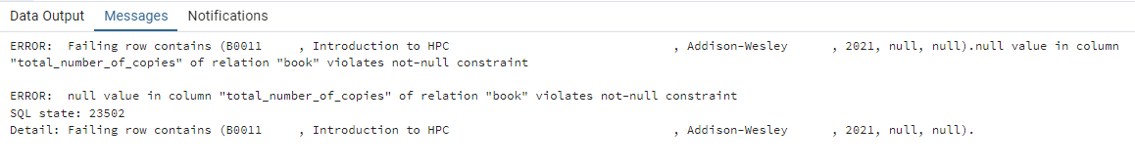

**Câu 3.**

*SQL:*

*CREATE OR REPLACE VIEW BorrowerStat AS*

*SELECT be.borrower_id, be.name, COUNT(bi.book_id) AS number_of_borrows*

*FROM borrower be*

*LEFT JOIN borrowcard bc ON bc.borrower_id=be.borrower_id*

*LEFT JOIN borrowcarditem bi ON bc.card_id=bi.card_id*

*GROUP BY be.borrower_id;*

*SELECT * FROM BorrowerStat;*

*Kết quả:*

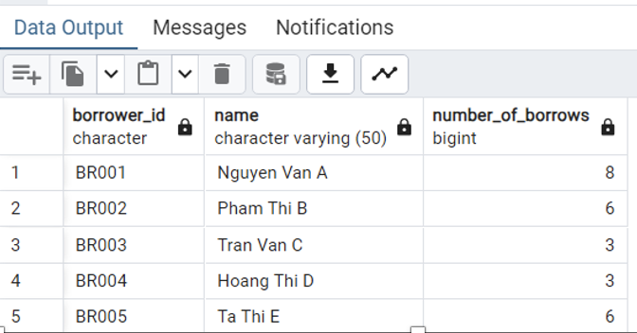

**Câu 4.**

*SQL:*

CREATE OR REPLACE FUNCTION number_of_borrowed_copies(id char(5)) RETURNS integer AS

$$

DECLARE cnt integer;

        new_table record;

BEGIN

   SELECT INTO new_table book_id, COUNT(card_id) AS num

   FROM borrowcarditem

   WHERE book_id = id

   GROUP BY book_id;

   IF new_table.num > 0 THEN cnt = new_table.num; RETURN cnt;

   ELSE cnt = 0; RETURN cnt;

   END IF;

END;

$$

LANGUAGE plpgsql;

SELECT number_of_borrowed_copies('B0001');

*Kết quả:*

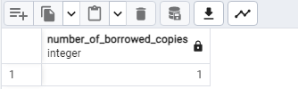

**Câu 5.**

*SQL:*

CREATE OR REPLACE FUNCTION number_of_borrowed_books_by_publisher(publisher CHAR(20), year INT)

RETURNS INT AS $$

DECLARE

   countr INT;

BEGIN

   SELECT COUNT(*)

   INTO countr

   FROM BorrowCard BC

   JOIN BorrowCardItem BCI ON BC.card_id = BCI.card_id

   JOIN Book B ON BCI.book_id = B.book_id

   WHERE B.publisher = number_of_borrowed_books_by_publisher.publisher

     AND EXTRACT(YEAR FROM BC.borrow_date) = number_of_borrowed_books_by_publisher.year;

   RETURN countr;

END;

$$ LANGUAGE plpgsql;

SELECT number_of_borrowed_books_by_publisher('Wiley', 2012);

*Kết quả:*

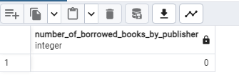

**Câu 6.**

*SQL:*

CREATE OR REPLACE FUNCTION books_by_publisher( publisher CHARACTER)

RETURNS TABLE ( title CHAR) AS $$

BEGIN

  RETURN QUERY

  SELECT title

  FROM library.Book

  WHERE book.publisher = books_by_publisher.publisher;

END;

$$ LANGUAGE plpgsql;

*Kết quả:*

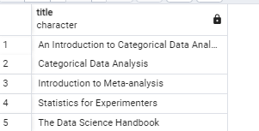

**Câu 7.**

*SQL:*

CREATE OR REPLACE FUNCTION set_default_values()

RETURNS TRIGGER AS $$

BEGIN

    IF NEW.total_number_of_copies IS NULL THEN

        NEW.total_number_of_copies := 0;

    END IF;

    IF NEW.current_number_of_copies IS NULL THEN

        NEW.current_number_of_copies := 0;

    END IF;

    IF NEW.total_number_of_copies < NEW.current_number_of_copies THEN

        RAISE EXCEPTION 'total_number_of_copies must be greater than or equal to current_number_of_copies';

    END IF;

    RETURN NEW;

END;

$$ LANGUAGE plpgsql;

CREATE TRIGGER set_default_values_trigger

BEFORE INSERT OR UPDATE ON book

FOR EACH ROW

EXECUTE FUNCTION set_default_values();

*Kết quả:*

**Câu 8.**

*SQL:*

CREATE OR REPLACE FUNCTION update_current_copies_trigger() RETURNS TRIGGER AS

$$

BEGIN

   UPDATE book

   SET current_number_of_copies = current_number_of_copies - 1

   WHERE book_id = NEW.book_id;

   RETURN NEW;

END;

$$

LANGUAGE plpgsql;

CREATE TRIGGER after_insert AFTER INSERT ON borrowcarditem

FOR EACH ROW

EXECUTE FUNCTION update_current_copies_trigger();

SELECT * FROM book;

INSERT INTO borrowcarditem VALUES('6', 'B0004');

*Kết quả:*

Trước khi INSERT thì current_number_of_copies của sách có mã ‘B0004’ là 3

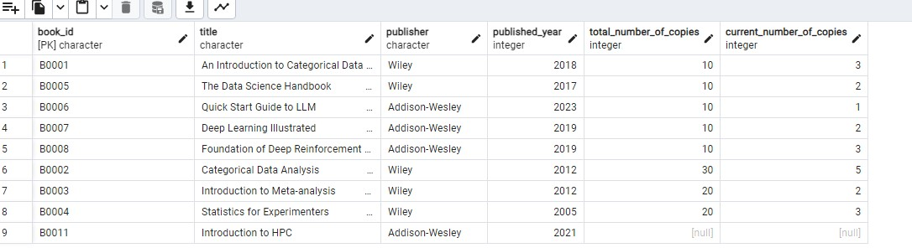

Sau khi INSERT thì current_number_of_copies của sách có mã ’B0004’ giảm xuống còn 2

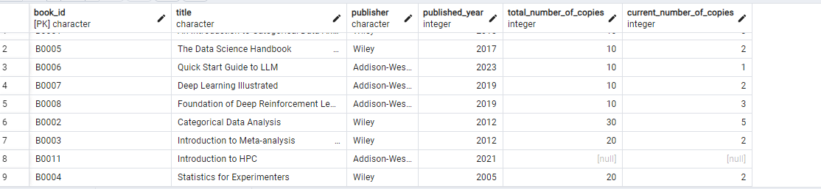

**Câu 9.**

*SQL:*

SELECT b1.card_id, book_id, actual_return INTO query91

FROM borrowcard b1, borrowcarditem b2

WHERE b1.card_id = b2.card_id;

CREATE OR REPLACE FUNCTION update_return_date_trigger() RETURNS TRIGGER AS

$$

BEGIN

   UPDATE book

   SET current_number_of_copies = current_number_of_copies + 1

   WHERE book_id = NEW.book_id;

   RETURN NEW;

END;

$$

LANGUAGE plpgsql;

CREATE TRIGGER after_return_v1 AFTER UPDATE ON query91

FOR EACH ROW

EXECUTE FUNCTION update_return_date_trigger();

SELECT * FROM query91;

SELECT * FROM borrowcard;

SELECT * FROM book ORDER BY book_id;

UPDATE query91

SET actual_return = '2024-05-05'

WHERE card_id = '8';

*Kết quả:*

Trước khi khách hàng có card_id là 8 trả sách: (khách này mượn các quyển B0002, B0003, B0008)

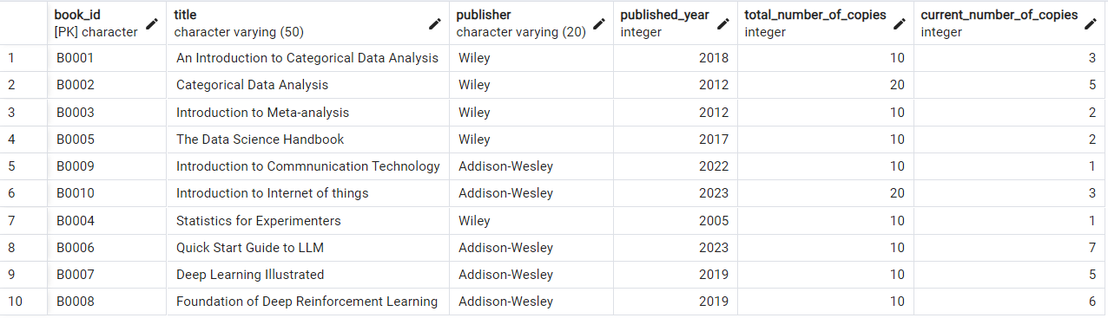Sau khi khách hàng có card_id là 8 trả sách:

