LAB1 – ANDROID CƠ BẢN
Họ tên: 1150080021 – Nguyễn Hưng Văn Khánh
AndroidManifest.xml

<?xml version="1.0" encoding="utf-8"?>
<manifest xmlns:android="http://schemas.android.com/apk/res/android"
xmlns:tools="http://schemas.android.com/tools">
<uses-permission android:name="android.permission.RECEIVE_SMS" />
<uses-permission android:name="android.permission.SEND_SMS" />
<uses-permission android:name="android.permission.READ_SMS" />
<uses-permission android:name="android.permission.INTERNET" />
<uses-permission android:name="android.permission.ACCESS_FINE_LOCATION" />
<uses-permission android:name="android.permission.ACCESS_COARSE_LOCATION" />
<uses-permission android:name="android.permission.POST_NOTIFICATIONS" />
<uses-permission android:name="android.permission.CAMERA" />
<uses-feature android:name="android.hardware.camera" android:required="false" />
<uses-feature android:name="android.hardware.telephony" android:required="false" />
<application
android:allowBackup="true"
android:dataExtractionRules="@xml/data_extraction_rules"
android:fullBackupContent="@xml/backup_rules"
android:icon="@mipmap/ic_launcher"
android:label="@string/app_name"
android:roundIcon="@mipmap/ic_launcher_round"
android:supportsRtl="true"
android:theme="@style/Theme.Androidcoban">
<activity android:name=".CameraActivity" />
<activity android:name=".LienLacActivity" />
<activity android:name=".XucXacActivity" />
<activity android:name=".MayTinhActivity" />
<activity
android:name=".MainActivity"
android:exported="true">
<intent-filter>
<action android:name="android.intent.action.MAIN" />
<category android:name="android.intent.category.LAUNCHER" />
</intent-filter>
</activity>
<receiver
android:name=".SmsReceiver"
android:exported="true"
tools:ignore="ExportedReceiver">
<intent-filter android:priority="1000">
<action android:name="android.provider.Telephony.SMS_RECEIVED" />
</intent-filter>
</receiver>
<receiver
android:name=".PowerStateChangeReceiver"
android:exported="false">
<intent-filter>
<action android:name="android.intent.action.ACTION_POWER_CONNECTED" />
<action android:name="android.intent.action.ACTION_POWER_DISCONNECTED" />
</intent-filter>
</receiver>
</application>
</manifest>

CameraActivity
package com.example.androidcoban;
import androidx.activity.result.ActivityResultLauncher;
import androidx.activity.result.contract.ActivityResultContracts;
import androidx.annotation.NonNull;
import androidx.appcompat.app.AppCompatActivity;
import androidx.camera.core.CameraSelector;
import androidx.camera.core.ImageCapture;
import androidx.camera.core.ImageCaptureException;
import androidx.camera.core.Preview;
import androidx.camera.lifecycle.ProcessCameraProvider;
import androidx.camera.view.PreviewView;
import androidx.core.content.ContextCompat;
import android.Manifest;
import android.content.pm.PackageManager;
import android.graphics.Bitmap;
import android.graphics.BitmapFactory;
import android.os.Bundle;
import android.util.Log;
import android.widget.Button;
import android.widget.ImageView;
import android.widget.Toast;
import com.google.common.util.concurrent.ListenableFuture;
import java.io.File;
import java.io.IOException;
import java.util.concurrent.ExecutionException;
import java.util.concurrent.ExecutorService;
import java.util.concurrent.Executors;
public class CameraActivity extends AppCompatActivity {
private PreviewView previewView;
private Button btnCapture;
private ImageView imgResult;
private ImageCapture imageCapture;
private ExecutorService cameraExecutor;
private final ActivityResultLauncher<String> requestPermissionLauncher =
registerForActivityResult(new ActivityResultContracts.RequestPermission(), isGranted -> {
if (isGranted) {
startCamera();
} else {
Toast.makeText(this, "Cần cấp quyền camera để sử dụng!", Toast.LENGTH_SHORT).show();
}
});
@Override
protected void onCreate(Bundle savedInstanceState) {
super.onCreate(savedInstanceState);
setContentView(R.layout.activity_camera);
previewView = findViewById(R.id.previewView);
btnCapture = findViewById(R.id.btnCapture);
imgResult = findViewById(R.id.imgResult);
cameraExecutor = Executors.newSingleThreadExecutor();
// Kiểm tra quyền camera
if (ContextCompat.checkSelfPermission(this, Manifest.permission.CAMERA)
== PackageManager.PERMISSION_GRANTED) {
startCamera();
} else {
requestPermissionLauncher.launch(Manifest.permission.CAMERA);
}
btnCapture.setOnClickListener(v -> takePhoto());
}
@Override
protected void onResume() {
super.onResume();
if (previewView != null &&
ContextCompat.checkSelfPermission(this, Manifest.permission.CAMERA)
== PackageManager.PERMISSION_GRANTED) {
startCamera();
}
}
private void startCamera() {
ListenableFuture<ProcessCameraProvider> cameraProviderFuture =
ProcessCameraProvider.getInstance(this);
cameraProviderFuture.addListener(() -> {
try {
ProcessCameraProvider cameraProvider = cameraProviderFuture.get();
Preview preview = new Preview.Builder().build();
imageCapture = new ImageCapture.Builder()
.setCaptureMode(ImageCapture.CAPTURE_MODE_MINIMIZE_LATENCY)
.build();
CameraSelector cameraSelector = CameraSelector.DEFAULT_BACK_CAMERA;
if (previewView != null) {
preview.setSurfaceProvider(previewView.getSurfaceProvider());
} else {
Log.e("CameraX", "⚠️ previewView = null!");
return;
}
cameraProvider.unbindAll();
cameraProvider.bindToLifecycle(this, cameraSelector, preview, imageCapture);
} catch (ExecutionException | InterruptedException e) {
Log.e("CameraX", "Lỗi khởi tạo CameraX", e);
}
}, ContextCompat.getMainExecutor(this));
}
private void takePhoto() {
if (imageCapture == null) return;
try {
File photoFile = File.createTempFile("photo_", ".jpg", getCacheDir());
ImageCapture.OutputFileOptions options =
new ImageCapture.OutputFileOptions.Builder(photoFile).build();
imageCapture.takePicture(options, ContextCompat.getMainExecutor(this),
new ImageCapture.OnImageSavedCallback() {
@Override
public void onImageSaved(@NonNull ImageCapture.OutputFileResults outputFileResults) {
Bitmap bitmap = BitmapFactory.decodeFile(photoFile.getAbsolutePath());
imgResult.setImageBitmap(bitmap);
Toast.makeText(CameraActivity.this, "📸 Đã chụp ảnh!", Toast.LENGTH_SHORT).show();
}
@Override
public void onError(@NonNull ImageCaptureException exception) {
Toast.makeText(CameraActivity.this, "Lỗi khi chụp ảnh!", Toast.LENGTH_SHORT).show();
}
});
} catch (IOException e) {
e.printStackTrace();
}
}
@Override
protected void onDestroy() {
super.onDestroy();
if (cameraExecutor != null) cameraExecutor.shutdown();
}
}
actvity_camera.xml
<?xml version="1.0" encoding="utf-8"?>
<LinearLayout xmlns:android="http://schemas.android.com/apk/res/android"
xmlns:app="http://schemas.android.com/apk/res-auto"
xmlns:tools="http://schemas.android.com/tools"
android:layout_width="match_parent"
android:layout_height="match_parent"
android:background="#FFF5FA"
android:orientation="vertical"
android:gravity="center_horizontal"
android:padding="20dp"
tools:context=".CameraActivity">
<!-- Tiêu đề -->
<TextView
android:id="@+id/tvTitle"
android:layout_width="wrap_content"
android:layout_height="wrap_content"
android:text="📷 Mở Camera"
android:textSize="20sp"
android:textStyle="bold"
android:textColor="#333333"
android:layout_marginBottom="15dp" />
<!-- Camera Preview -->
<androidx.camera.view.PreviewView
android:id="@+id/previewView"
android:layout_width="300dp"
android:layout_height="300dp"
android:layout_marginBottom="20dp"
android:background="#EDEDED"
app:implementationMode="performance"
android:elevation="4dp"
android:scaleType="centerCrop"
android:clipToOutline="true"
tools:background="@drawable/ic_launcher_foreground"
android:outlineProvider="background" />
<!-- Nút chụp ảnh -->
<Button
android:id="@+id/btnCapture"
android:layout_width="wrap_content"
android:layout_height="wrap_content"
android:text="CHỤP ẢNH"
android:textSize="16sp"
android:textStyle="bold"
android:textColor="#222"
android:paddingHorizontal="30dp"
android:paddingVertical="12dp"
android:layout_marginBottom="25dp"
android:background="@drawable/btn_bg_yellow"
android:backgroundTint="@null" />
<!-- Kết quả -->
<ImageView
android:id="@+id/imgResult"
android:layout_width="250dp"
android:layout_height="250dp"
android:layout_gravity="center"
android:background="#F8F8F8"
android:scaleType="centerCrop"
tools:src="@drawable/ic_launcher_foreground"
android:contentDescription="Ảnh chụp kết quả" />
</LinearLayout>
Kết quả:
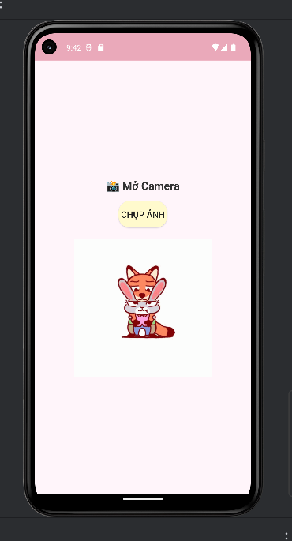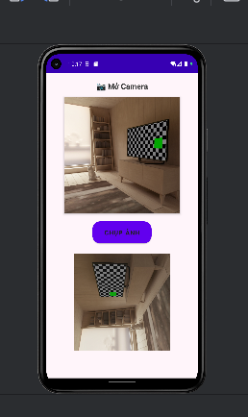
LienLacActivity
package com.example.androidcoban;
import androidx.appcompat.app.AppCompatActivity;
import android.os.Bundle;
import android.content.Intent;
import android.net.Uri;
import android.widget.*;
public class LienLacActivity extends AppCompatActivity {
EditText edtPhone;
Button btnCall, btnSms;
@Override
protected void onCreate(Bundle savedInstanceState) {
super.onCreate(savedInstanceState);
setContentView(R.layout.activity_lien_lac);
edtPhone = findViewById(R.id.edtPhone);
btnCall = findViewById(R.id.btnCall);
btnSms = findViewById(R.id.btnSms);
btnCall.setOnClickListener(v -> {
String sdt = edtPhone.getText().toString();
if (sdt.isEmpty()) {
Toast.makeText(this, "Nhập số điện thoại!", Toast.LENGTH_SHORT).show();
return;
}
Intent i = new Intent(Intent.ACTION_DIAL, Uri.parse("tel:" + sdt));
startActivity(i);
});
btnSms.setOnClickListener(v -> {
String sdt = edtPhone.getText().toString();
if (sdt.isEmpty()) {
Toast.makeText(this, "Nhập số điện thoại!", Toast.LENGTH_SHORT).show();
return;
}
Intent i = new Intent(Intent.ACTION_VIEW, Uri.parse("sms:" + sdt));
i.putExtra("sms_body", "Xin chào!");
startActivity(i);
});
}
}
actvity_lien_lac.xml
<?xml version="1.0" encoding="utf-8"?>
<LinearLayout xmlns:android="http://schemas.android.com/apk/res/android"
android:layout_width="match_parent"
android:layout_height="match_parent"
android:background="#FFF5FA"
android:orientation="vertical"
android:gravity="center_horizontal"
android:padding="20dp">
<TextView
android:text="Liên lạc"
android:textSize="20sp"
android:textStyle="bold"
android:textColor="#333333"
android:layout_width="wrap_content"
android:layout_height="wrap_content"
android:layout_marginBottom="20dp"/>
<EditText
android:id="@+id/edtPhone"
android:layout_width="match_parent"
android:layout_height="wrap_content"
android:hint="Nhập số điện thoại"
android:inputType="phone"
android:background="@drawable/edittext_bg"
android:padding="10dp"
android:textColor="#333333"
android:textSize="16sp"
android:layout_marginBottom="20dp"/>
<Button
android:id="@+id/btnCall"
android:layout_width="match_parent"
android:layout_height="30dp"
android:text="GỌI ĐIỆN"
android:textColor="#200"
android:textSize="18sp"
android:background="@drawable/btn_bg_blue"
android:layout_marginBottom="10dp"
android:layout_marginTop="10dp"/>
<Button
android:id="@+id/btnSms"
android:layout_width="match_parent"
android:layout_height="30dp"
android:text="NHẮN TIN"
android:textColor="#200"
android:textSize="18sp"
android:background="@drawable/btn_bg_mint"
android:layout_marginBottom="10dp"
android:layout_marginTop="10dp"/>
</LinearLayout>
Kết quả:
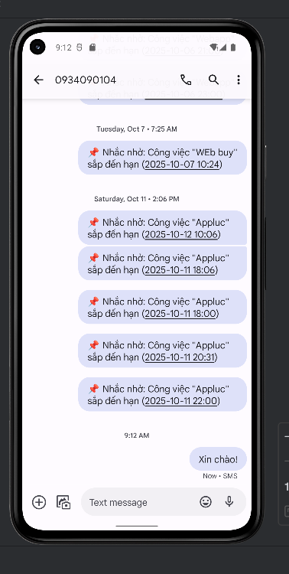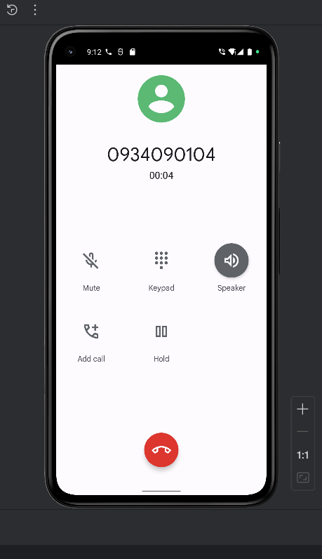
MainActivity

package com.example.androidcoban;
import android.app.role.RoleManager;
import android.content.Intent;
import android.content.SharedPreferences;
import android.content.pm.PackageManager;
import android.os.Build;
import android.os.Bundle;
import android.provider.Telephony;
import androidx.appcompat.app.AppCompatActivity;
import android.widget.Button;
public class MainActivity extends AppCompatActivity {
Button btnMayTinh, btnXucXac, btnLienLac, btnCamera;
private boolean isRunning = false;
@Override
protected void onCreate(Bundle savedInstanceState) {
super.onCreate(savedInstanceState);
setContentView(R.layout.activity_main);
// Gán view
btnMayTinh = findViewById(R.id.btnMayTinh);
btnXucXac = findViewById(R.id.btnXucXac);
btnLienLac = findViewById(R.id.btnLienLac);
btnCamera = findViewById(R.id.btnCamera);
// Lưu user (demo)
SharedPreferences prefs = getSharedPreferences("user_session", MODE_PRIVATE);
String username = prefs.getString("username", "Người dùng");
// Điều hướng
btnMayTinh.setOnClickListener(v -> startActivity(new Intent(this, MayTinhActivity.class)));
btnXucXac.setOnClickListener(v -> startActivity(new Intent(this, XucXacActivity.class)));
btnLienLac.setOnClickListener(v -> startActivity(new Intent(this, LienLacActivity.class)));
btnCamera.setOnClickListener(v -> startActivity(new Intent(this, CameraActivity.class)));
}
@Override
protected void onResume() {
super.onResume();
isRunning = true;
}
@Override
protected void onPause() {
super.onPause();
isRunning = false;
}
}
activity_main.xml
<?xml version="1.0" encoding="utf-8"?>
<RelativeLayout xmlns:android="http://schemas.android.com/apk/res/android"
android:layout_width="match_parent"
android:layout_height="match_parent">
<ImageView
android:id="@+id/imgBackground"
android:layout_width="match_parent"
android:layout_height="match_parent"
android:src="@drawable/nickjudy_bg"
android:scaleType="centerCrop"
android:alpha="0.25"
android:contentDescription="@string/app_name" />
<View
android:layout_width="match_parent"
android:layout_height="match_parent"
android:background="#FFF5FA"
android:alpha="0.6" />
<LinearLayout
android:orientation="vertical"
android:gravity="center_horizontal"
android:layout_width="match_parent"
android:layout_height="match_parent"
android:padding="20dp">
<TextView
android:text="TH1 - Nguyễn Hưng Văn Khánh"
android:textSize="22sp"
android:layout_width="match_parent"
android:layout_height="wrap_content"
android:textStyle="bold"
android:textColor="#333333"
android:layout_marginTop="60dp"
android:layout_marginBottom="30dp"
android:gravity="center"/>
<ImageView
android:layout_width="180dp"
android:layout_height="180dp"
android:layout_marginBottom="40dp"
android:alpha="0.8"
android:background="@drawable/edittext_bg"
android:scaleType="centerCrop"
android:src="@drawable/nickjudy_bg" />
<LinearLayout
android:orientation="horizontal"
android:gravity="center"
android:layout_width="match_parent"
android:layout_height="wrap_content"
android:weightSum="4">
<Button
android:id="@+id/btnMayTinh"
android:layout_width="0dp"
android:layout_height="65dp"
android:layout_weight="1"
android:text="Máy tính"
android:textSize="16sp"
android:textColor="#222"
android:background="@drawable/btn_bg_rounded"
android:backgroundTint="@null"
android:gravity="center"
android:layout_margin="6dp"/>
<Button
android:id="@+id/btnXucXac"
android:layout_width="0dp"
android:layout_height="65dp"
android:layout_weight="1"
android:text="Xúc xắc"
android:textSize="16sp"
android:textColor="#222"
android:background="@drawable/btn_bg_yellow"
android:backgroundTint="@null"
android:gravity="center"
android:layout_margin="6dp"/>
<Button
android:id="@+id/btnLienLac"
android:layout_width="0dp"
android:layout_height="65dp"
android:layout_weight="1"
android:text="Liên lạc"
android:textSize="16sp"
android:textColor="#222"
android:background="@drawable/btn_bg_mint"
android:backgroundTint="@null"
android:gravity="center"
android:layout_margin="6dp"/>
<Button
android:id="@+id/btnCamera"
android:layout_width="0dp"
android:layout_height="65dp"
android:layout_weight="1"
android:text="Camera"
android:textSize="16sp"
android:textColor="#222"
android:background="@drawable/btn_bg_blue"
android:backgroundTint="@null"
android:gravity="center"
android:layout_margin="6dp"/>
</LinearLayout>
</LinearLayout>
</RelativeLayout>
Kết quả:
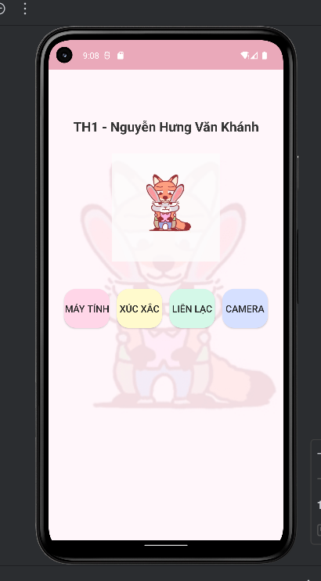

MayTinhActivity
package com.example.androidcoban;
import androidx.appcompat.app.AppCompatActivity;
import android.os.Bundle;
import android.view.View;
import android.widget.*;
public class MayTinhActivity extends AppCompatActivity {
EditText edtSoA, edtSoB;
TextView tvKetQua;
Button btnCong, btnTru, btnNhan, btnChia;
@Override
protected void onCreate(Bundle savedInstanceState) {
super.onCreate(savedInstanceState);
setContentView(R.layout.activity_may_tinh);
initControl();
}
private void initControl() {
edtSoA = findViewById(R.id.edtSoA);
edtSoB = findViewById(R.id.edtSoB);
tvKetQua = findViewById(R.id.tvKetQua);
btnCong = findViewById(R.id.btnCong);
btnTru = findViewById(R.id.btnTru);
btnNhan = findViewById(R.id.btnNhan);
btnChia = findViewById(R.id.btnChia);
View.OnClickListener listener = v -> {
try {
double a = Double.parseDouble(edtSoA.getText().toString());
double b = Double.parseDouble(edtSoB.getText().toString());
double kq = 0;
if (v.getId() == R.id.btnCong) {
kq = a + b;
} else if (v.getId() == R.id.btnTru) {
kq = a - b;
} else if (v.getId() == R.id.btnNhan) {
kq = a * b;
} else if (v.getId() == R.id.btnChia) {
if (b == 0) {
tvKetQua.setText("Không thể chia cho 0!");
return;
}
kq = a / b;
}
tvKetQua.setText("Kết quả: " + kq);
} catch (Exception e) {
tvKetQua.setText("⚠️ Vui lòng nhập số hợp lệ!");
}
};
btnCong.setOnClickListener(listener);
btnTru.setOnClickListener(listener);
btnNhan.setOnClickListener(listener);
btnChia.setOnClickListener(listener);
}
}
activity_may_tinh.xml
<?xml version="1.0" encoding="utf-8"?>
<LinearLayout xmlns:android="http://schemas.android.com/apk/res/android"
android:layout_width="match_parent"
android:layout_height="match_parent"
android:background="#FFF5FA"
android:orientation="vertical"
android:gravity="center"
android:padding="20dp">
<!-- Tiêu đề -->
<TextView
android:layout_width="wrap_content"
android:layout_height="wrap_content"
android:text="Máy tính cơ bản"
android:textSize="20sp"
android:textStyle="bold"
android:textColor="#333333"
android:layout_marginBottom="20dp"/>
<EditText
android:id="@+id/edtSoA"
android:layout_width="match_parent"
android:layout_height="wrap_content"
android:hint="Nhập số A"
android:inputType="numberDecimal"
android:background="@drawable/edittext_bg"
android:padding="10dp"
android:textColor="#333"
android:textSize="16sp"
android:layout_marginBottom="10dp" />
<EditText
android:id="@+id/edtSoB"
android:layout_width="match_parent"
android:layout_height="wrap_content"
android:hint="Nhập số B"
android:inputType="numberDecimal"
android:background="@drawable/edittext_bg"
android:padding="10dp"
android:textColor="#333"
android:textSize="16sp"
android:layout_marginBottom="10dp" />
<!-- Kết quả -->
<TextView
android:id="@+id/tvKetQua"
android:layout_width="match_parent"
android:layout_height="wrap_content"
android:text="Kết quả:"
android:textColor="#333333"
android:textSize="18sp"
android:layout_marginTop="20dp"/>
<!-- Các nút phép tính -->
<LinearLayout
android:layout_width="match_parent"
android:layout_height="wrap_content"
android:orientation="horizontal"
android:gravity="center"
android:layout_marginTop="25dp"
android:weightSum="4">
<Button
android:id="@+id/btnCong"
android:layout_width="0dp"
android:layout_height="60dp"
android:layout_weight="1"
android:text="+"
android:textSize="20sp"
android:textColor="#222"
android:textAlignment="center"
android:gravity="center"
android:background="@drawable/btn_bg_rounded"
android:backgroundTint="@null"
android:layout_margin="6dp"/>
<Button
android:id="@+id/btnTru"
android:layout_width="0dp"
android:layout_height="60dp"
android:layout_weight="1"
android:text="-"
android:textSize="20sp"
android:textColor="#222"
android:textAlignment="center"
android:gravity="center"
android:background="@drawable/btn_bg_yellow"
android:backgroundTint="@null"
android:layout_margin="6dp"/>
<Button
android:id="@+id/btnNhan"
android:layout_width="0dp"
android:layout_height="60dp"
android:layout_weight="1"
android:text="×"
android:textSize="20sp"
android:textColor="#222"
android:textAlignment="center"
android:gravity="center"
android:background="@drawable/btn_bg_mint"
android:backgroundTint="@null"
android:layout_margin="6dp"/>
<Button
android:id="@+id/btnChia"
android:layout_width="0dp"
android:layout_height="60dp"
android:layout_weight="1"
android:text="÷"
android:textSize="20sp"
android:textColor="#222"
android:textAlignment="center"
android:gravity="center"
android:background="@drawable/btn_bg_blue"
android:backgroundTint="@null"
android:layout_margin="6dp"/>
</LinearLayout>
</LinearLayout>
Kết quả:
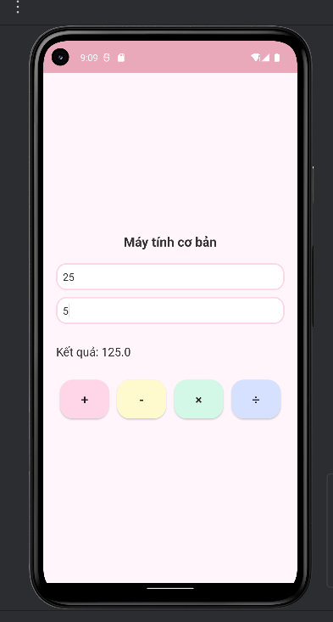 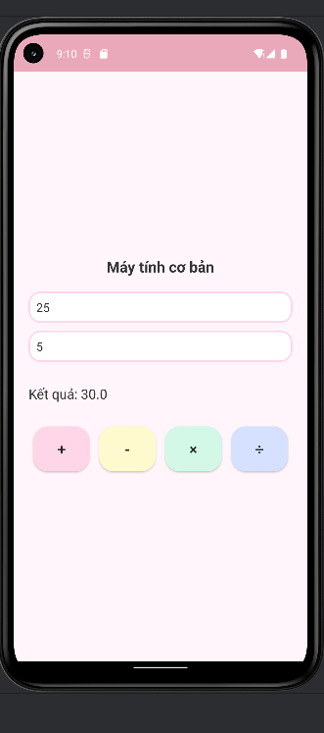 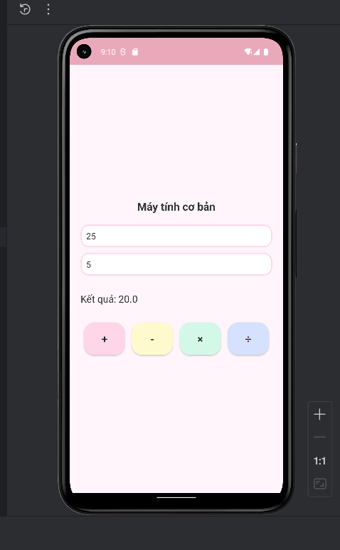 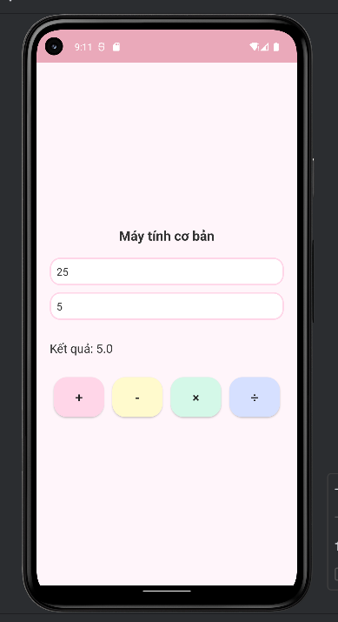b
XucXacActivity
package com.example.androidcoban;
import androidx.appcompat.app.AppCompatActivity;
import android.os.Bundle;
import android.widget.*;
import java.util.Random;
public class XucXacActivity extends AppCompatActivity {
private Button btnRoll;
private ImageView imgDice;
private TextView tvResult;
private final Random random = new Random();
@Override
protected void onCreate(Bundle savedInstanceState) {
super.onCreate(savedInstanceState);
setContentView(R.layout.activity_xuc_xac);
// Ánh xạ view
btnRoll = findViewById(R.id.btnRoll);
imgDice = findViewById(R.id.imgDice);
tvResult = findViewById(R.id.tvResult);
// Xử lý sự kiện bấm nút
btnRoll.setOnClickListener(v -> {
int so = random.nextInt(6) + 1; // random 1–6
// Hiển thị kết quả
tvResult.setText("🎲 Kết quả: " + so);
// Gán hình xúc xắc tương ứng
switch (so) {
case 1:
imgDice.setImageResource(R.drawable.dice1);
break;
case 2:
imgDice.setImageResource(R.drawable.dice2);
break;
case 3:
imgDice.setImageResource(R.drawable.dice3);
break;
case 4:
imgDice.setImageResource(R.drawable.dice4);
break;
case 5:
imgDice.setImageResource(R.drawable.dice5);
break;
case 6:
imgDice.setImageResource(R.drawable.dice6);
break;
}
});
}
}
activity_xuc_xac.xml
<?xml version="1.0" encoding="utf-8"?>
<LinearLayout xmlns:android="http://schemas.android.com/apk/res/android"
android:layout_width="match_parent"
android:layout_height="match_parent"
android:background="#FFF5FA"
android:orientation="vertical"
android:gravity="center"
android:padding="20dp">
<TextView
android:text=" Tung xúc xắc"
android:textSize="20sp"
android:textStyle="bold"
android:textColor="#333"
android:layout_width="wrap_content"
android:layout_height="wrap_content"
android:layout_marginBottom="20dp" />
<ImageView
android:id="@+id/imgDice"
android:layout_width="150dp"
android:layout_height="150dp"
android:src="@drawable/dice1"
android:layout_marginBottom="20dp" />
<TextView
android:id="@+id/tvResult"
android:layout_width="wrap_content"
android:layout_height="wrap_content"
android:text="Kết quả: Chưa tung "
android:textSize="18sp"
android:textColor="#333"
android:layout_marginBottom="20dp" />
<Button
android:id="@+id/btnRoll"
android:text="TUNG XÚC XẮC"
android:textSize="16sp"
android:textColor="#222"
android:background="@drawable/btn_bg_mint"
android:backgroundTint="@null"
android:layout_width="wrap_content"
android:layout_height="wrap_content"
android:padding="10dp" />
</LinearLayout>
Kết quả:

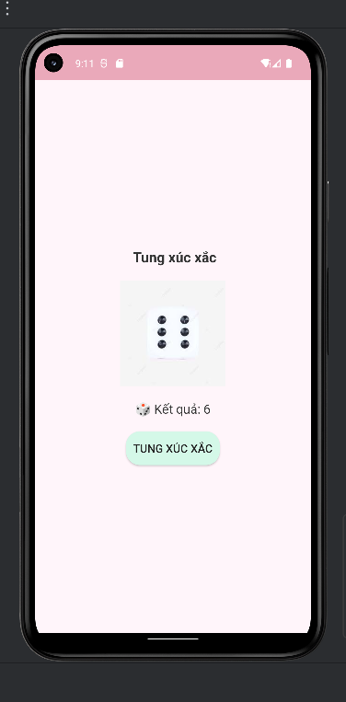

LAB2 – GIAO DIỆN
ProfileActivity
package com.example.btap8;
import androidx.appcompat.app.AppCompatActivity;
import android.os.Bundle;
public class ProfileActivity extends AppCompatActivity {
@Override
protected void onCreate(Bundle savedInstanceState) {
super.onCreate(savedInstanceState);
setContentView(R.layout.activity_profile);
}
}
activity_profile.xml
<?xml version="1.0" encoding="utf-8"?>
<ScrollView xmlns:android="http://schemas.android.com/apk/res/android"
android:layout_width="match_parent"
android:layout_height="match_parent"
android:background="@color/gray_light">
<LinearLayout
android:layout_width="match_parent"
android:layout_height="wrap_content"
android:orientation="vertical"
android:padding="16dp"
android:gravity="center_horizontal">
<ImageView
android:id="@+id/img_avatar"
android:layout_width="160dp"
android:layout_height="160dp"
android:src="@drawable/avatar_me"
android:layout_marginTop="24dp"
android:layout_marginBottom="16dp"
android:scaleType="centerCrop"
android:background="@drawable/bg_oval"
android:clipToOutline="true" />
<TextView
android:id="@+id/tv_name"
android:layout_width="match_parent"
android:layout_height="wrap_content"
android:text="Văn Khánh"
android:textColor="@color/indigo"
android:textSize="24sp"
android:textStyle="bold"
android:layout_marginBottom="6dp" />
<TextView
android:text="Nhà bảo tồn động vật "
android:textColor="@color/gray_mid"
android:layout_width="match_parent"
android:layout_height="wrap_content"
android:textSize="16sp"
android:layout_marginBottom="12dp" />
<LinearLayout
android:layout_width="match_parent"
android:layout_height="wrap_content"
android:orientation="horizontal"
android:gravity="center"
android:layout_marginTop="24dp">
<ImageButton
android:layout_width="60dp"
android:layout_height="60dp"
android:src="@drawable/ic_back"
android:background="@drawable/bg_oval"
android:padding="14dp"
android:contentDescription="Quay lại" />
</LinearLayout>
</LinearLayout>
</ScrollView>
Kết quả:

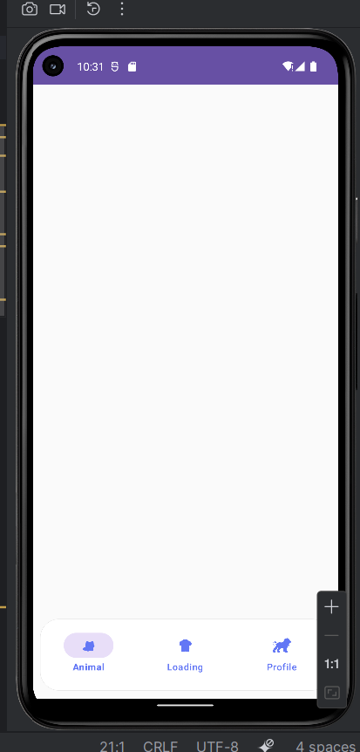

AndroidManifest.xml
<?xml version="1.0" encoding="utf-8"?>
<manifest xmlns:android="http://schemas.android.com/apk/res/android"
xmlns:tools="http://schemas.android.com/tools">
<application
android:allowBackup="true"
android:dataExtractionRules="@xml/data_extraction_rules"
android:fullBackupContent="@xml/backup_rules"
android:icon="@mipmap/ic_launcher"
android:label="@string/app_name"
android:roundIcon="@mipmap/ic_launcher_round"
android:supportsRtl="true"
android:theme="@style/Theme.Btap8">
<activity android:name=".Bai1Activity" />
<activity android:name=".Bai2Activity" />
<activity
android:name=".MainActivity"
android:exported="true">
<intent-filter>
<action android:name="android.intent.action.MAIN" />
<category android:name="android.intent.category.LAUNCHER" />
</intent-filter>
</activity>
</application>
</manifest>

MainActivity.java
package com.example.btap8;
import androidx.appcompat.app.AppCompatActivity;
import android.content.Intent;
import android.os.Bundle;
import android.widget.Button;
public class MainActivity extends AppCompatActivity {
@Override
protected void onCreate(Bundle savedInstanceState) {
super.onCreate(savedInstanceState);
setContentView(R.layout.activity_main);
Button btnBai1 = findViewById(R.id.btnBai1);
Button btnBai2 = findViewById(R.id.btnBai2);
btnBai1.setOnClickListener(v ->
startActivity(new Intent(MainActivity.this, Bai1Activity.class)));
btnBai2.setOnClickListener(v ->
startActivity(new Intent(MainActivity.this, Bai2Activity.class)));
}
}

Bai1Activity.java
package com.example.btap8;
import androidx.appcompat.app.AppCompatActivity;
import android.content.Intent;
import android.os.Bundle;
import android.os.Handler;
import android.view.View;
import android.widget.ImageView;
import android.widget.LinearLayout;
import android.widget.TextView;
import java.util.Random;
public class Bai1Activity extends AppCompatActivity {
private View loadingView;
private LinearLayout contentLayout;
private ImageView imgAnimal;
private TextView txtTitle, btnBack;
private int[] colors = { 0xFFE57373, 0xFF64B5F6, 0xFF81C784, 0xFFFFD54F, 0xFFBA68C8 };
private int[] icons = { R.drawable.ic_cat, R.drawable.ic_dog, R.drawable.ic_lion };
private String[] names = { "Cat", "Dog", "Lion" };
@Override
protected void onCreate(Bundle savedInstanceState) {
super.onCreate(savedInstanceState);
setContentView(R.layout.activity_bai1);
// Ánh xạ View
loadingView = findViewById(R.id.loadingView);
contentLayout = findViewById(R.id.contentLayout);
imgAnimal = findViewById(R.id.imgAnimal);
txtTitle = findViewById(R.id.txtTitle);
btnBack = findViewById(R.id.btnBack);
// QUAY LẠI MENU
btnBack.setOnClickListener(v -> {
startActivity(new Intent(Bai1Activity.this, MainActivity.class));
finish();
});
// Loading 2 giây trước khi hiện Animal
new Handler().postDelayed(() -> {
loadingView.setVisibility(View.GONE);
contentLayout.setVisibility(View.VISIBLE);
randomSplash();
}, 2000);
}
private void randomSplash() {
Random random = new Random();
contentLayout.setBackgroundColor(colors[random.nextInt(colors.length)]);
int index = random.nextInt(icons.length);
imgAnimal.setImageResource(icons[index]);
txtTitle.setText("Animal Sound - " + names[index]);
}
}
activity_main.xml
<?xml version="1.0" encoding="utf-8"?>
<LinearLayout xmlns:android="http://schemas.android.com/apk/res/android"
android:layout_width="match_parent"
android:layout_height="match_parent"
android:gravity="center"
android:orientation="vertical"
android:padding="24dp"
android:background="#FAFAFA">
<Button
android:id="@+id/btnBai1"
android:layout_width="match_parent"
android:layout_height="wrap_content"
android:text="Bài 1: Random Animal"
android:layout_marginBottom="16dp" />
<Button
android:id="@+id/btnBai2"
android:layout_width="match_parent"
android:layout_height="wrap_content"
android:text="Bài 2: Loading Overlay" />
</LinearLayout>

activity_bai1.xml
<?xml version="1.0" encoding="utf-8"?>
<FrameLayout xmlns:android="http://schemas.android.com/apk/res/android"
android:layout_width="match_parent"
android:layout_height="match_parent">
<TextView
android:id="@+id/btnBack"
android:layout_width="match_parent"
android:layout_height="wrap_content"
android:gravity="center"
android:padding="16dp"
android:text="Quay lại"
android:textSize="18sp"
android:textStyle="bold" />
<!-- Giao diện Animal, đặt dưới nút quay lại -->
<LinearLayout
android:id="@+id/contentLayout"
android:layout_width="match_parent"
android:layout_height="match_parent"
android:gravity="center"
android:orientation="vertical"
android:paddingTop="60dp">
<ImageView
android:id="@+id/imgAnimal"
android:layout_width="200dp"
android:layout_height="200dp"
android:scaleType="centerCrop" />
<TextView
android:id="@+id/txtTitle"
android:layout_width="wrap_content"
android:layout_height="wrap_content"
android:layout_marginTop="20dp"
android:textSize="24sp"
android:textColor="#000000" />
</LinearLayout>
<include
android:id="@+id/loadingView"
layout="@layout/item_loading"
android:visibility="visible" />
</FrameLayout>

Kết quả:
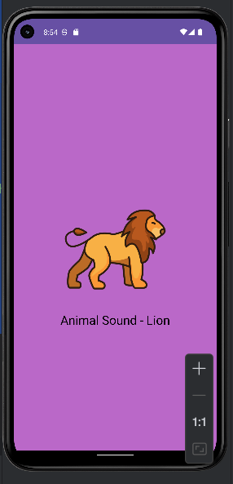
Bai2Activity.java
package com.example.btap8;
import androidx.appcompat.app.AppCompatActivity;
import android.content.Intent;
import android.net.Uri;
import android.os.Bundle;
import android.os.Handler;
import android.view.View;
import android.widget.Button;
import android.widget.EditText;
import android.widget.TextView;
public class Bai2Activity extends AppCompatActivity {
private View loadingView;
private Button btnShowLoading, btnCall;
private EditText edtPhone;
private TextView btnBack;
@Override
protected void onCreate(Bundle savedInstanceState) {
super.onCreate(savedInstanceState);
setContentView(R.layout.activity_bai2);
loadingView = findViewById(R.id.loadingView);
btnShowLoading = findViewById(R.id.btnShowLoading);
btnCall = findViewById(R.id.btnCall);
edtPhone = findViewById(R.id.edtPhone);
btnBack = findViewById(R.id.btnBack);
btnBack.setOnClickListener(v -> {
startActivity(new Intent(Bai2Activity.this, MainActivity.class));
finish();
});
btnShowLoading.setOnClickListener(v -> {
loadingView.setVisibility(View.VISIBLE);
new Handler().postDelayed(() ->
loadingView.setVisibility(View.GONE), 2000);
});
btnCall.setOnClickListener(v -> {
String phone = edtPhone.getText().toString().trim();
if (!phone.isEmpty()) {
Intent intent = new Intent(Intent.ACTION_DIAL, Uri.parse("tel:" + phone));
startActivity(intent);
} else {
edtPhone.setError("Vui lòng nhập số điện thoại");
}
});
}
}

activity_bai2.xml
<?xml version="1.0" encoding="utf-8"?>
<FrameLayout xmlns:android="http://schemas.android.com/apk/res/android"
android:layout_width="match_parent"
android:layout_height="match_parent">
<!-- Nút QUAY LẠI ở trên đầu, căn giữa -->
<TextView
android:id="@+id/btnBack"
android:layout_width="match_parent"
android:layout_height="wrap_content"
android:gravity="center"
android:padding="16dp"
android:text="Quay lại"
android:textSize="18sp"
android:textStyle="bold" />
<LinearLayout
android:layout_width="match_parent"
android:layout_height="match_parent"
android:gravity="center"
android:orientation="vertical"
android:paddingTop="70dp">
<Button
android:id="@+id/btnShowLoading"
android:layout_width="wrap_content"
android:layout_height="wrap_content"
android:text="Show Loading"
android:layout_marginBottom="30dp" />
<EditText
android:id="@+id/edtPhone"
android:layout_width="match_parent"
android:layout_height="wrap_content"
android:hint="Nhập số điện thoại"
android:inputType="phone"
android:padding="12dp"
android:layout_marginBottom="16dp" />
<Button
android:id="@+id/btnCall"
android:layout_width="match_parent"
android:layout_height="wrap_content"
android:text="Gọi điện" />
</LinearLayout>
<include
android:id="@+id/loadingView"
layout="@layout/item_loading"
android:visibility="gone" />
</FrameLayout>
Kết quả:
