Inventions of different languages:
1: Machine Language eg: 01001010 like this people were writing code.
2: Assembly Language eg: People used to interact direct with hardware eg: MOV A, 61H means move value of register A to 61H
3: Then procedural language comes which is used to write code but OOPS were not supported. EG: C language where oops is not supported.
4: OOPS supported language: Like Java, C++, Python, etc: help in solving Real World Problem, Data security, Scalable, Reusable, etc.
5: Abstraction is used for data hiding but Encapsulation is used for data security.
6: There are two types of UML diagram: Structural(Static) or Behaviroul(Dynamic) also the diagram name is UML Diagram and Sequence Diagram respectively.
7: There are two types of association that is Class Association and Object Association.. Inheritance is a Class association. Object association is of three types Simple, Aggregation, and Composition.
8: Robert C Martin published paper in 2000 regarding Design Principles.
9: Immutable Class cannot be inherited and immutable method cannot be override.
10: Principle of least knowledge should also be followed by our class: which means class should always talks to their immediate class only.
11: Strategy Design Pattern: Define a family of algorithm, put them into separate class so that they can be changes at run time.
Eg:
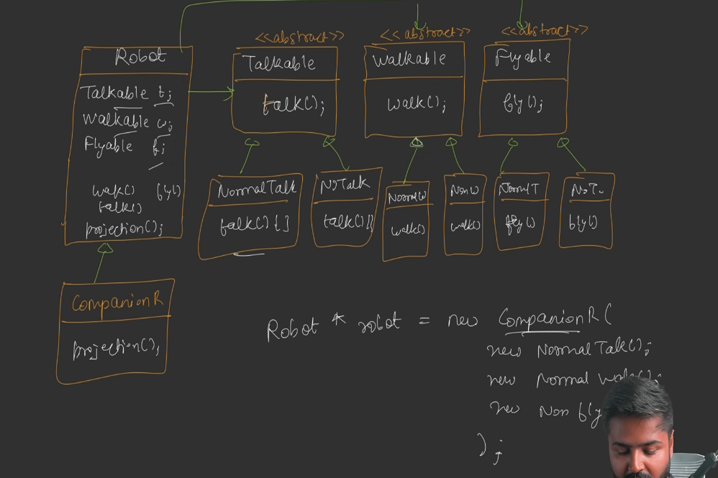

Here we have created separate interface for Talkable, Walkable and Flyable behaviour. From there we can create separate class and implement interface funtionality. Robot will have a "Has-A" relationship with all these interfaces.
Note: Without Strategy Desing Pattern it was going like:
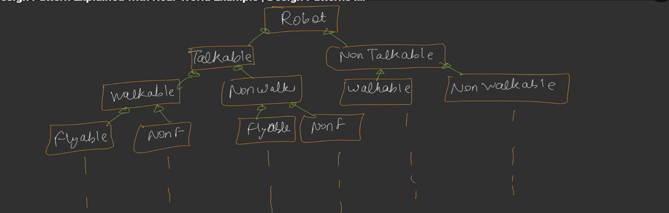

12: We should make a design like same code can be used every where so it will follow the concept of DRY : Do Not Repeat Yourself.
13: Model class are those class which does not have any logic. It just has getter or setter function.
14: We should design the class in a way that it should follow first principle of least knowledge. Means Class should not depend on other object so much that it has to take most of the value from particular object. Means Class should be loosely coupled with object.
15: Command Design Pattern: Encapsulate the request as an object, thereby letting you parameterize clients with different request, queue or log request and support undoable operations.
16: Command Design Pattern helps client to give command and execute the command. Let's take example we usually switch on and switch off the lights or fan. Here we are giving command to switch to on and off the light or fan. So like this command design pattern also work. When we want to undo our work there also we can use command design pattern like we use ctrl+z in computer.
17: Adapter design pattern we use if client is not able to interact with some other class or process. Here we have a middle class or interface, which work as adapter. Eg: Translator we use to translate different language because hindi person cannot understand chinese and chinese person cannot understand hindi. Eg: Java compiler can only compile java code but if we get C++ code then java compiler will not be able to execute so we can use some code conversion software as adapter. Eg: Compiler itself is a adapter because it helps working between High level language and low level language. Converts our code to machine level code and converts machine level error in human readable text.
18: Façade Design Pattern we use when we don't want client to interact with complex system so here client will interact with one class and that class will interact with other complex systems. Eg: Whenever we want to use our computer we just interact with CPU or Laptop opening button now laptop and CPU will interact with other component and start the systems in such a way that we can use that.
19: Composite Design Pattern which is also known as File design system: we use this design pattern whenever we want to use a system which have a tree like structure. Like file system where we can have file under folder and folder under folder as well.
Or we can say when we want to interact with a system where system has a structure inside structure and we want to interact with them in sequential way .
20: Template Design Pattern we use when we want our system to follow as specific path every time. Like If we are working on Image Processing and Neural Network then we have some specific order of calling the methods for these two work and for that we will define one template where order of calling the methods will be define.

21: Proxy Design Pattern: Here we have one object which is a replication of reciever to which client wants to interact, so instead of interacting directly reciever here client will be interacting with Proxy object but client is unaware of this. Because client is has a reference of interface or abstract class, and Proxy class and reciever class both have "IS-A" relationship with that interface or abstract class.

There are three types of Proxy design Pattern:
a: Virtual Proxy: This Proxy object protect the expensive resources of reciever. Eg Reciever is a class which load the image from cloud and display it to client, but here loading of cloud image is very expensive task so if client just make object of this class and doesn't call display method then this is a very expensive resource for reciever and doesn't gets used by client. So object of reciever gets created only when client wants to display image.

b: Protection Proxy: This Proxy object protect the critical resources of reciever. So here proxy will first authenticate the client then only give access to reciever resources. As we did in File access method.

c: Remote Proxy: This proxy object is usefull if client wants to connect through internet then proxy object will create a connection between client and reciever which is on internet.

22: Chain Of Responsibility: This design pattern we use when we task needs to be done by one class object but if that object is not able to complete the task it will assign that task to different class object and so on. Like this if one class object not able to fullfill that responsibility it will assign the task to different class object. Here all the classes will have "IS-A" relationship with one common abstract class or Interface.

23: Bridge Design Pattern: It is same as Strategy Design Pattern but the intent of using this is different. Here we divide the main logic in two parts HLP(High Level Part) & LLP(Low Level Part) also known as Abstraction and Implementation respectively. Here HLP will just have the overview of logic but unaware about the internal processing that is taken care by LLP which is responsible for internal processing. Here Abstraction has a object of Implementation so it will prevent our code from class explosion.

24: Builder Design Pattern: This design pattern we use when we have multiple instace varialbe so there we will required to create multiple constructor with multiple combinations of instance variables.
Also we cannot create setMethod of every variable because then user can change some critical information.
Also one problem is if we want to excute the method only after all the mandatory fields values are set but customer can call method anytime. So we can write validation logic as well but how many places we will write validation logic.
So for all the above problems we have Builder design pattern which will resolve this.

25: Iterator Design Pattern: This design pattern we use to define iterator for different type of data structures like tree, linked list, or any custom data structures or list of objects as well.

26: FlyWeight Design Pattern: This design pattern is usefull when we want to save a storage.
Let say we have to represent lakhs of asteroids in game so we have to create lakhs of asteroids object that will take allot of storage.
So using this design pattern we can save huge amount of storage.
Lets we say all the asteroid will have some common properties like size, color, hight, width, weight. Also some properties will be unique for each asteroids like position on x axis and position on y axis.
We we can create two different class on is for "Intrinsic" properties which are same, and "Extrinsic" properties which will be unique for each. And "Extrinsic" object will have a "Has-A" relationship with "Intrinsic" properties.
So let say we have 10 lakh unique postion for asteroid so we will have 10 lakh extrinsic object and we have 10 different combinations for "Intrinsic" objects so we will create only 10 "Intrinsic" object as compare to without flyweight design patten. This will save huge amout of storage.

