

**: WEB APP DEVELOPMENT:**

**Lab-5**

classwork

Khansa Noor-54039

Submitted to: Ma’am Nayab Khalid

console.log("WAD LAB CLASSWORK");

fullname="khansa Noor";

age=20;

price=100;

radius=20;

x=null;

y=undefined;

console.log(fullname);

console.log(age);

console.log(price);

console.log(radius);

console.log(x);

console.log(y);

//• var (Function-scoped, can be redeclared & reassigned)

var myname ="khansa"; //declaration

console.log(myname);

var myname = "Noor"; //redeclaration

console.log(myname);

 myname ="Khansa Noor"; //update

console.log(myname);

// variables are not limited to the block they can be accessed outside the block...

if(true){

    var test1="var can be inside and outside the block!";

    console.log(test1);

}

console.log(test1);

//• let (block-scoped,can be updated but cannot be redeclared)

let myage=20; // declaration

console.log(myage);

myage=21;     // updating

console.log(myage);

// let is limited to the block it cannot be accessed outside the block...

if(true){

    let test2="let inside the block!"

    console.log(test2);

}

// console.log(test2); error! test2 is not defined...

//• const (Block-scoped, cannot be reassigned or redeclared)

const pi=3.14;  // declaration

console.log(pi);

//CONDITIONAL SENTENCES

let marks=100;

if(marks>=80){

    console.log("excellent!")

}

else{

    console.log("good!");

}

// LOOP

for(let i=0 ; i<=5 ;i++){

    console.log("iterate:" +i);

}

// FOR-IN LOOP:

//Example with object:

const person={ Name:"khansa", age:20, city:"islamadad"};

for(let key in person){

   console.log(key , ":" , person[key]);

}

//Example with array:

const products=["laptop", "Phone", "charger"];

for(let index in products){

    console.log(index , ":" , products[index]);

}

//FOR-OF LOOP:

//Example with an array:

const fruits=["Apple","banana","Mango"];

for(let fruit of fruits ){

    console.log(fruit);

}

//Example with string:

const word = "one";

for (let char of word) {

    console.log(char);

}

//BOOLEAN

var yes=true;

var no=false;

if(yes){

    console.log("Executed!");

}

if(no){

    console.log(" Not Executed!");

}

//Accessing variable using object:

const detail={name:"Amna", age:30 , city:"lahore"};

console.log(detail.name);

console.log(detail.age);

console.log(detail.city);

//FUNCTION:

areyouokay();

function areyouokay(){

   var answer= "yes! i'm okay...";

   return answer;

}

console.log(areyouokay());

//arthematic operations:

let a = 10;

let b = 5;

console.log(a + b); // Addition

console.log(a - b); // Subtraction

console.log(a * b); // Multiplication

console.log(a / b); // Division

console.log(a % b); // Modulus

console.log(a++);   //post-increment

console.log(++a);   //pre-increment

console.log(b--);   //post-decrement

console.log(--b);   //pre-decrement

//USE OF PROMPT:

var num=prompt("Enter a number!");

if(num%2==0){

    console.log("Number is even!");

}

else{

    console.log("Number is odd!");

}

//SWITCH STATEMENT:

var grade=prompt("enter your grade:");

switch(grade){

         case"a":

         console.log("Excellent!");

         break;

         case"b":

         console.log("good!");

         break;

         case"c":

         console.log("Satisfactory!");

         break;

         default:

            console.log("invalid!");

}

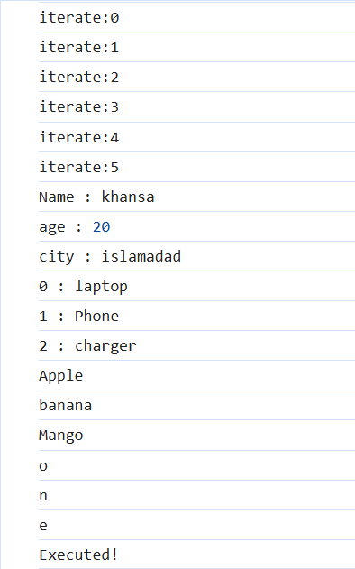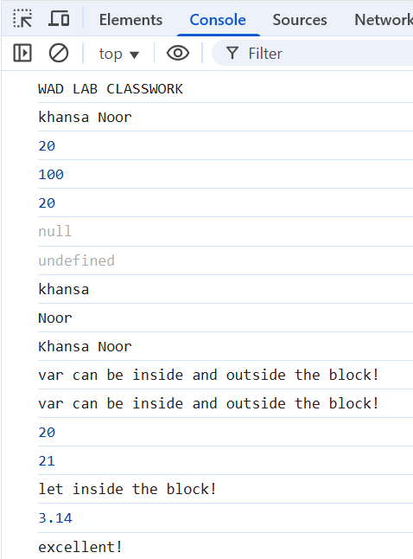

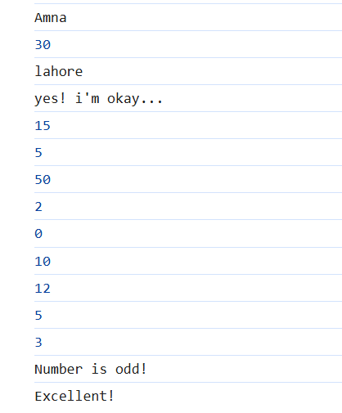

**----------------------------------------------------------------END------------------------------------------------------**