

**: WEB APP DEVELOPMENT:**

**Lab-5**

Khansa Noor-54039

Submitted to: Ma’am Nayab Khalid

//-----------------------------------------TASK-1-----------------------------------------

//1.Check the type of bigint and symbol.

console.log(typeof 1198n);

let bigNumber = BigInt(1198);

console.log(bigNumber);

//-----------------------------------------TASK-2-----------------------------------------

//2. Create a const object calld “Product” to store information shown in the given picture.

const product={

    productname:"PakWheels Waterless and Glass Cleaner",

    item1:"Glass Cleaner",

    item2:"aterless Car Wash",

    price_before:1198,

    price_after:958,

    discount:"20%",

};

for(let key in product){

    console.log(key , ":" , product[key]);

}

//-----------------------------------------TASK-3-----------------------------------------

//3.Create an object to create your Instagram profile. With screenshot of profile.

const profile={

    my_name:"noorkhansa",

    posts:30,

    followers:172,

    following:1448,

    bio:"demure..."

};

for(let key in profile){

    console.log(key , ":" , profile[key]);

}

//-----------------------------------------TASK-4-----------------------------------------

//4.Apply unary operators. ( a++ , ++a , a--, --a)

let a=10;

console.log(a++);   //post-increment

console.log(++a);   //pre-increment

console.log(a--);   //post-decrement

console.log(--a);   //pre-decrement

//-----------------------------------------TASK-5-----------------------------------------

//5.Get user to enter a number and check it its multiple of 3 or not?

let num=prompt("Enter a number to check if it is a multiple of 3 or not!");

if(num%3==0){

    console.log("The entered number is the multiple of 3!")

}

else{

    console.log("The entered number is not  the multiple of 3!")

}

//-----------------------------------------TASK-6-----------------------------------------

//6.Write a code which can give grades to students according to their scores:

let marks=prompt("enter your marks:");

if(marks>=80 && marks<=100){

    console.log("A");

}

else if(marks>=70 && marks<89){

    console.log("B");

}

else if(marks>=60 && marks<69){

    console.log("C");

}

else if(marks>=50 && marks<59){

    console.log("D");

}

else {

    console.log("F");

}

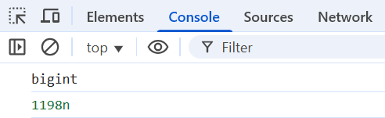**Outputs:**

**1:**

**2:**

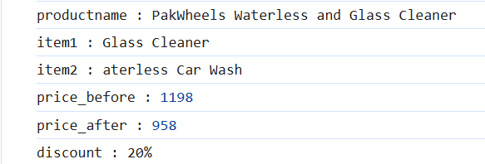

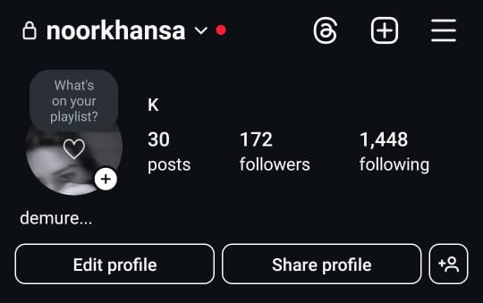**3:**

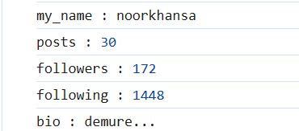

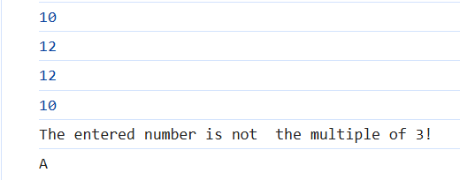**4,5,6:**