|  |  |  |  |
| --- | --- | --- | --- |
| **Document ID** | **Document Name** | **Version** | **Date** |
| **MOPT001** | **Test Plan** | **V 1** | **17-sep-22** |

***Table of Contents:***

1.1 Purpose 2

1.2 Definitions & Acronyms 2

2.0 Testing Approach/ Strategy 3

2.1 Scope of Testing 3

2.1.1 Features to be Tested 4

2.1.2 Features Not to be Tested 4

2.2 Test Entry and Exit Criteria 4

2.2.1 Entry Criteria 4

2.2.2 Suspension and Resumption Criteria 4

2.2.3 Exit Criteria 5

2.2.4 Testing Criteria 5

2.3 Test Result Classification 5

2.4 Tools or Apps used 6

3.0 Test Phases 7

4.0 Product Integration 7

5.0 Human Resources 8

6.0 Code Review ..…….....………...…………………………………………………….. 8

### *Purpose*

*Test Plan is a detailed document that describes the test strategy, objectives, schedule, estimation and deliverables, and resources required for testing identify the items being tested, the features to be tested, the testing tasks to be performed, the personnel responsible for each task, and the risks associated with the test plan. It helps us determine the effort needed to validate the quality of the application under test. The test plan serves as a blueprint to conduct software testing activities as a defined process which is minutely monitored and controlled by the test manager.*

### *Definitions & Acronyms*

|  |  |
| --- | --- |
| ***Term/ Abbreviation/ Acronym*** | ***Description*** |
| *UAT* | *User Acceptance Test* |
| *MR* | *Merge Request* |
| *UI* | *User Interface* |
| *API* | *Application Programming Interface* |
| *MOPT* | *MindOPTimizers-2.0* |
| *DB* | *Database* |

## Testing Approach/ Strategy

Work is allocated based on the JIRA tickets assigned to each resource. we follow Agile Scrum project execution and most of the Team is working on Scrum board. The estimation techniques are used in project execution is: **Fibonacci Series (User Story Level)**

**User Stories:**

Once EPIC into broken down into smaller Stories, teams will size the stories using story points by using plan it poker app in Jira Cloud average is taken as estimation and that is added as comment to story as shown in picture here pint represent the hours required to complete a story.

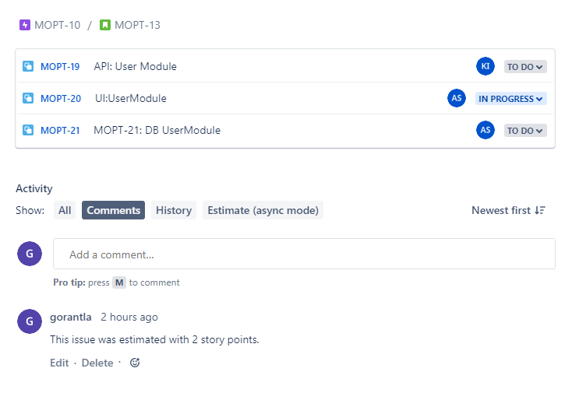

### 2.1 Scope of Testing

***Requirements:*** We collected all the requirement from the problem statement document and created as stories in a tracking tool (Jira Cloud)

Once the requirements ready, then through the backlog review team decides which stories need to be completed first and priority and dependencies if any.

All the stories picked in the sprint is planned and estimated in sprint planning and estimation meetings.

Once the sprint is Active then all the stories will be assigned to concern developer. All the stories will be tested by Test engineer

***Functional Testing****:* Here the functional requirements of an application is tested using different testing techniques of white and black box testing.

***Graphical User Interface******Testing:*** It**’**s to ensure the functionalities of software application work as per specifications by checking screens and controls like menus, buttons, icons, etc. is verified.

***Integration testing*:** Here individual units / components **tested** are integrated together to build a system. Here we will perform some regression suite to ensure everything is working as expected.

***Automation Testing:***Automation of the features will be done by using tools like selenium  
Postman used for Api Testing and Rest Assured for Api Automation.

#### 2.1.1 *Out Of Scope:*

Security Testing, Performance and penetration testing are not in the scope of testing due to time constraint.

#### 2.1.2 *Features to be Tested:*

Features to be covered and not covered will be mentioned as part of test cases which we are maintaining in JIRA with Xray app.

#### 2.1.3 *Features Not to be Tested*:

Features to be covered and not covered will be mentioned as part of test cases which we are maintaining in JIRA with Xray app.

### 2.2 *Test Entry and Exit Criteria:*

#### *2.2.1 Entry Criteria:*

* Availability of complete or partially testable code
* Appropriately defined and approved requirements
* Access to sufficient and desired test data
* The readiness of test cases
* Setting up of test environment with all the necessary resources like tools and devices

#### *2.2.2 Suspension and Resumption Criteria:*

If the functionality of an application is no more testable in test environment due to the issue in application or any requirement is got deviated, then we will be reopening (suspends the testing)

***Resumption Criteria:*** once the suspension criteria is resolved then we will be resuming the testing

#### *2.2.3 Exit Criteria:*

* Test case execution is 100% done
* No major defect exists/ approval from Product owner for the user story
* Effort should be made to automate the maximum test cases in the same sprint.
* Scripts should be executed without any code failure.
* Scripts should fail when there are legitimate failures.

#### 2.2.4 Testing Criteria:

***Testing Standards:***

* For each and every assigned ticket should be updated with the corresponding test cases links which is of Xray
* All the test cases will be executed and deviated requirement would be filed as bug-subtask and linked to the story in jira tool.
* On meeting acceptance criteria, it will be move to closed.

If ticket is moved to ‘Closed’ than it means that ticket is no longer worked upon or different ticket is created for the same.

### 2.3 Test Result Classification:

we will be assigning the priority to the newly raised tasks.it can be bug or improvement as subtask and nice to have as sub-story

|  |  |
| --- | --- |
| **Priority** | **Defect/ Test Result Description** |
| **Blocker** | Defect that would result in failure of the software element with no possible workaround. |
| **High** | Defect that would result in failure of the software element but has a possible workaround. |
| Medium | Defect that would affect only the non-functional aspects of the software elements. |
| low | Defect that would affect less which does not need immediate attention. |

### 

### 2.4 Tools/Apps used:

|  |  |  |  |  |
| --- | --- | --- | --- | --- |
| **S. No.** | **Tools/Apps** | **Location** | **Remarks** | |
| *1* | *JIRA Cloud* | [MOPT board - Agile board - Jira (atlassian.net)](https://minoptimezers.atlassian.net/jira/software/projects/MOPT/boards/1?issueParent=10009) | | *Used it To track stories* | |
| *2* | *Planit poker* | [Planning Poker - Jira (atlassian.net)](https://minoptimezers.atlassian.net/plugins/servlet/ac/agile.estimation.3.0_private/agile-estimation?project.key=MOPT&project.id=10000) | | *Used to Estimate stories* | |
| *3* | *SVN* | [Testing Board - Jira (atlassian.net)](https://minoptimezers.atlassian.net/projects/MOPT?selectedItem=com.atlassian.plugins.atlassian-connect-plugin%3Acom.xpandit.plugins.xray__testing-board#!page=test-repository&testPlanId=10000) | | *Used to track testcase* | |
| *4* | *VPN* | 115.110.108.202 | | *Pyramid’s VPN* | |
| *5* | *github* | https://github.com/KhansaCelsior/moptquizboard-backend | | *To host automation repo* | |
| *6* | *postman* | https://www.getpostman.com/collections/e4ed1566ad80db674b20 | | *Used to test api calls* | |
| *7.* | *Mysql* | Mysql-8.0 | | *For handling Database* | |
| *8* | *EasyAgileTeamRhythem* | [User Story Map - Jira (atlassian.net)](https://minoptimezers.atlassian.net/projects/MOPT?selectedItem=com.atlassian.plugins.atlassian-connect-plugin:com.kretar.jira.plugin.user-story-map__easy-agile-user-story-maps-web-panel#!/retros/board/1/retroId/9764) | | *For retrospective* | |

## 3.Test Phases

|  |  |  |
| --- | --- | --- |
| **Types of Testing** | **Prepared by** | **Remarks** |
| Unit Testing | Developer | Unit Testing done by Developer |
| Integration Testing | Tester | Integration Testing done Tester |
| Functional/System Testing | Tester | Testing done Tester |
| Regression Testing | Tester | Automation scripts will be taking care of regression |

### 4. Product Integration :

product integration approach such as Incremental approach is following to integrate all the completed features.

***5. Human Resources:***

|  |  |
| --- | --- |
| **Name Of the Resource** | ***Contribution*** |
| Arpi saxena | Development |
| Khansa Iqbal | Development |
| Praksa.R | Development |
| Vanaja Gorantla | Testing |

***6.CodeReviews:***Here we are following peer reviews by using teams as medium of communication

