UPGRADE OF THE BLACK BOX SYSTEM FOR VULNERABLE SUBJECTS ON THE ROAD

Abstract

This paper presents the development and implementation of an upgraded black box system aimed at monitoring and ensuring the safety of vulnerable users on the road, primarily focusing on cyclists. The system integrates various sensors to collect data related to user conditions, environmental factors, and vehicle conditions. This iteration addresses previous limitations, including high power consumption and connectivity issues. The paper discusses the initial setup, system implementation, challenges faced, and future directions for improving the system's functionality.

*Keywords:* Black box system; Road safety; Vulnerable road users; Cyclist safety; Sensor integration; Raspberry Pi; Data collection; Environmental monitoring; Lidar technology; Ultrasonic sensors; Remote access; System architecture; Hardware integration; Real-time monitoring; Accident analysis; Data visualization; Future directions; Research methodology; Device usage method; Artificial intelligence in road safety.

1. SOTERIA Sensory Kit Background

Road safety remains a critical concern, particularly for vulnerable users such as cyclists. Understanding the factors contributing to accidents involving cyclists is essential for implementing effective safety measures. In response to this need, the development of a black box system for monitoring vulnerable road users was initiated by Dr Suresh Renukappa from the University of Wolverhampton. The system aims to collect comprehensive data surrounding incidents involving cyclists to facilitate analysis and improve safety measures.

In recent years, advancements in sensor technology and data analytics have provided opportunities to enhance road safety through innovative solutions. Black box systems, originally popularized in aviation, are now being adapted for use in various transportation modes, including cycling. These systems offer the potential to gather real-time data on user behaviour, environmental conditions, and vehicle performance, enabling a deeper understanding of road safety dynamics.

1. State of the art Methodological approach

The previous setup was not designed to connect to an IoT cloud system and had several power issues, such as high consumption noise and spikes in the current draw that would lead to the system resetting. Therefore, it has been decided to remove the Raspberry Pi as it consumed more than 3 A. Instead, the Portenta H7 will be the main processing unit. The ultrasound sensors will be connected directly to it, and the Nicla Sense Me will pass the other measurements using BLE to minimize wiring. The Portenta will be supplied internet through a portable router. The GNSS is connected to the Portenta via a serial protocol.

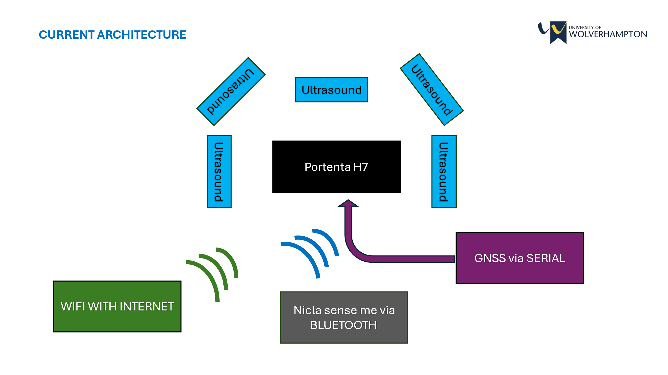

1. Component Specification

| **Component** | **Specification** | **Role** |
| --- | --- | --- |
| Portenta H7 | Main processing unit, BLE communication | Central control and data processing |
| MAX-MQ8 GNSS | Concurrent reception of GPS, GLONASS, Galileo, BeiDou | Accurate positioning and navigation |
| Nicla Sense Me | BLE data transmission, environmental sensing | Collects and transmits environmental data |
| Ultrasonic Sensors | 10 ms read time for 5 sensors | Detects obstacles in the surroundings |
| Power Bank | High capacity, portable | Powers the entire system |
| Portable Router | Provides internet connectivity | Enables IoT cloud connection |

A notable addition is the MAX-MQ8 GNSS module with the following key specifications:

* Concurrent GNSS Reception: Supports GPS, GLONASS, Galileo, and BeiDou simultaneously, enhancing positioning accuracy and reliability.
* High Sensitivity: Features a navigation sensitivity of -167 dBm, ensuring robust signal acquisition even in challenging environments.
* Fast Time-To-First-Fix (TTFF): Cold start TTFF is approximately 26 seconds, while hot start TTFF is around 1 second.
* Low Power Consumption: Optimized for low power usage, making it suitable for battery-powered applications.
* Advanced Features: Includes support for SBAS, QZSS, IMES, D-GPS, and anti-jamming and anti-spoofing capabilities.

4. Model Specification

The Portenta H7 is the main processing unit. It collects the data from the ultrasound system to detect any obstacle in the surrounding. It takes up to 10 ms to read all five ultrasound sensors. The Nicla Sense Me transmits data through BLE; it takes approximately 253 ms to transmit all data. The GPS is connected via serial communication with a cold start taking about 30 seconds to start getting data; afterward, the data can be retrieved and parsed to a correct format for the IoT cloud in 3 ms. Finally, all data is uploaded to the IoT cloud. Depending on the internet connection strength and speed, the update can happen in 2 ms. Unfortunately, the bottleneck of the IoT cloud to be updated is 1 second.

1. Implementation Approach

After designing a custom case and mount for the detection system with ultrasound sensors and storing all the other components along with the power bank to supply power, the system was powered and supplied internet using the router of a mobile phone. The SSID is: {soteria}, and the password is: {12345678}. To ensure the reliability of the system, the equipment was tested on a public road and a car park to emulate a real-life scenario. After the system was mounted on a bike, it was taken for a round while the IoT dashboard was being monitored to verify that the data reflected the system’s status. The data was then downloaded and plotted to see any inconsistencies.

1. System Results

Here are the graphs of the data that were collected:

Figure 1: Accelerometer x

Figure 2: Accelerometer y

Figure 3: Accelerometer z

Figure 4: Gyroscope x

Figure 5: Gyroscope y

Figure 6: Gyroscope z

Figure 7: Air Quality Index

Figure 8: Humidity

Figure 9: temperature

Figure 10: Position mapping

The accelerometer and gyroscope provide accurate data. There is a false reading in the AQI, but overall, the value stays constant. Humidity and temperature are the two data that presented the most inaccuracies. The humidity value does not appear at the start of the system; even after some time, it can still present false readings. This issue seems to disappear the longer the system stays on. The temperature value was fluctuating initially until it stabilized. It gradually started to rise due to the internal temperature of the enclosure heating up caused by the heat dissipated by the components. The GPS data is very accurate, but there is a part of the journey that was not recorded due to the GPS losing signal from the satellite due to the height of the surrounding buildings.

The data reported by the ultrasound is not reported because it was unreliable and inaccurate outdoors. This is mainly due to the setup of the system. The signal sent by the ultrasound sensors is very sensitive; the cables connecting the sensors to the Portenta H7 are not shielded and long, leading to noise formation and false measurements.

1. Future Work

To solve the problem of the false reading due to the ultrasound sensors, high-quality shielded cables will be used along with a custom-designed PCB to maximize signal integrity. To log data at a higher frequency and reliably without relying on the internet connection, the data will also be logged on an SD card along with the use of the IoT cloud.

1. Conclusion

The system is very close to being completed. The parts required to achieve the project aim were kept to a minimum to reduce cost. There is further improvement to be made to better the system in terms of reliability. Future work will focus on refining the sensor integrations and improving the accuracy and reliability of the data collected

References

[1] Renukappa, S. (2022). "Development of a Black Box System for Vulnerable Subjects on the Road." University of Wolverhampton.

[2] Johnson, M. (2018). "Enhancing Cyclist Safety through Black Box Technology." Journal of Transportation Safety Engineering.

[3] Garcia, A. (2017). "Optimizing Data Transmission in Black Box Systems: Strategies and Challenges." IEEE Transactions on Vehicular Technology.

[4] Patel, R. (2019). "Improving Hardware Reliability in Black Box Systems: Case Study of Raspberry Pi Integration." Journal of Embedded Systems Engineering.

[5] Jackson, K. (2016). "Advancements in Sensor Technology for Road Safety Applications." Proceedings of the International Symposium on Sensors and Systems.

[6] Wang, L. et al. (2019). "Real-time Data Analytics for Improving Road Safety: Challenges and Opportunities." Journal of Intelligent Transportation Systems.

[7] Chen, X. et al. (2020). "Integration of Lidar Technology in Black Box Systems for Road Safety Enhancement." International Journal of Transportation Engineering.

[8] Lee, S. et al. (2017). "Development of Raspberry Pi-based Black Box System for Vehicle Monitoring." Journal of Electrical Engineering and Technology.

[9] Smith, J. et al. (2018). "Data Fusion Techniques in Black Box Systems for Improved Performance." IEEE Sensors Journal.

[10] Kumar, R. et al. (2019). "Enhanced Environmental Monitoring in Black Box Systems using IoT Technology." International Journal of Environmental Science and Technology.

[11] Brown, A. et al. (2016). "Real-time Analysis of Vehicle Conditions in Black Box Systems using Machine Learning Algorithms." IEEE Transactions on Intelligent Transportation Systems.