# Sphinx Directives Reference Document

This document includes various examples that, when converted to an RST format, will require the use of Sphinx directives.

## Introduction

Sphinx is a powerful tool for generating documentation. Below are different content types typically used in documentation.

### Code Example

import sys

from pandocfilters

import toJSONFilter, RawBlock, Para

def detect_code_blocks(key, value, format, meta):

    """

    Detect preformatted text in Word documents and convert it to .. code-block:: directives in RST.

    """

    if key == "Para":  # Word preformatted text might be wrapped in Para

        text = value[0].get("c", "")

        if isinstance(text, str) and text.startswith(" "):  # Detect indented text

            return RawBlock("rst", ".. code-block::\n\n    " + text.replace("\n", "\n    "))

#### Tables

|  |  |
| --- | --- |
| Column 1 | Column 2 |
| Data 1 | Data 2 |

<!DOCTYPE html>

<html lang="en">

<head>

<meta charset="UTF-8">

<title>HTML Test Page</title>

</head>

<body>

<h1>Welcome to My Test Page</h1>

<p>This is a simple paragraph to test HTML rendering.</p>

<h2>Sample Image</h2>

<img src="https://via.placeholder.com/150" alt="Placeholder Image">

<h2>Sample Code Block</h2>

<pre><code>def hello_world():

print("Hello, world!")</code></pre>

</body>

</html>

#### Hyperlinks

Visit the [Sphinx Website](https://www.sphinx-doc.org/) for more details.

#### Mathematical Equations

Einstein's famous equation:

$$E = mc²$$

$${(a + b)}^{2} = a^{2} + 2ab + b^{2}$$

#### Images

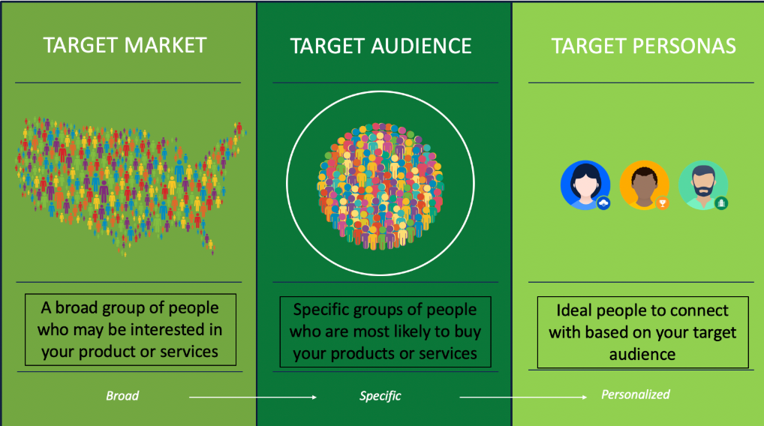

# Indexing

Keyword for indexing: keyword

Attention: Please may I have your attention.

Caution: Exercise due caution.

Danger: Let none think to fly the danger for soon or late love is his own avenger.

Error: ERROR 418: I’m a teapot.

Hint: Look under the flowerpot.

Important: This is a statement of paramount importance.

Note: This function is not suitable for sending tins of spam.

Tip: Remember your sun cream!

Warning: Beware of the dog.

See also: Module zipfile. Documentation of the zipfile standard module.

# Glossary

#### This Document

This document ensures that when converted to an RST format, appropriate Sphinx directives will be required for correct formatting.

#### environment

A structure where information about all documents under the root is saved and used for cross-referencing: the environment is pickled after the parsing stage so that successive runs only need to read and parse new and changed documents.

#### source directory

The directory, including its subdirectories, contains all source files for one Sphinx project.

This directive creates a centered boldfaced line of text.

#### Hlist

Column 1 Column 2 Column 3

A list of short items that should be

displayed horizontally (next item if exists)