AgriStream IoT
  - Sections A
Kukhanya Dlanjwa
Repository: https://github.com/KhanyaD/AgriStream
URL: https://agristreamweb20261106134042-d8ecauaybxc9a0hp.southafricanorth-01.azurewebsites.net/

System overview
AgriStream IoT supports commercial farms that receive large volumes of soil-sensor readings and drone imagery. The architecture separates the MVC management interface, relational user and device records, cloud media storage, telemetry storage and background processing. This allows web requests and farm operations to be handled independently during busy daylight periods.
Azure service | Role in the solution
App Service | Hosts the MVC dashboard, login, media upload and irrigation interface.
Azure SQL Database | Stores user accounts, roles and master device operational status.
Blob Storage | Stores drone images and other farm media.
Table Storage | Stores telemetry readings, irrigation events and upload audit records.
Storage Queue | Buffers irrigation commands for asynchronous processing.
Azure Functions | Provides exactly four functions: Blob, HTTP GET, HTTP POST and Queue triggers.
Azure Monitor / Application Insights | Captures request, dependency, failure and resource measurements.

Task (a): Web hosting
Azure App Service provides the managed hosting environment for the ASP.NET Core MVC application. Controllers handle requests, models represent farm data, and views present the dashboard, uploads and irrigation controls. Application settings supply connection details so that the same source can run locally and in Azure.
The runtime stack must match the published application. The App Service URL provides access to the hosted application; a successful publish must be supported by a page that actually opens and performs the relevant operation.

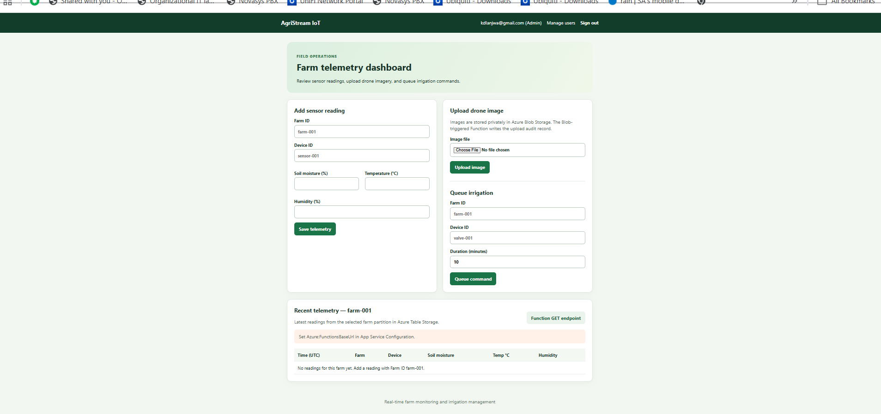
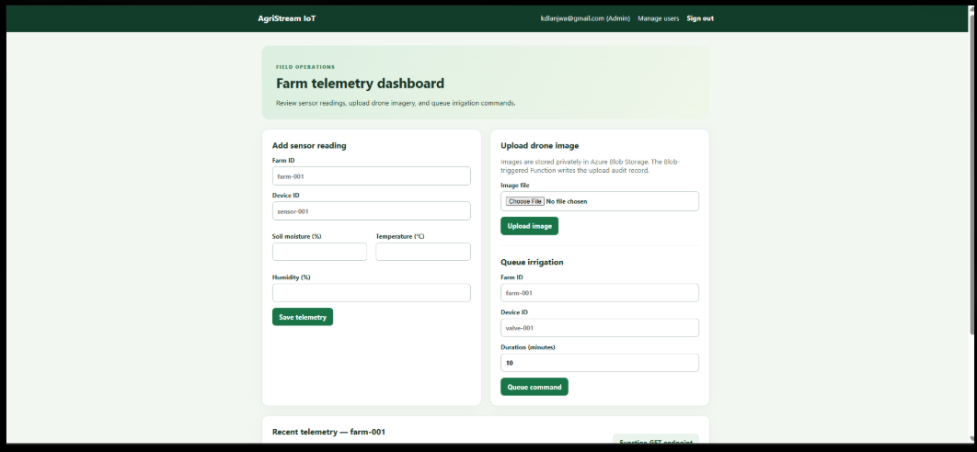
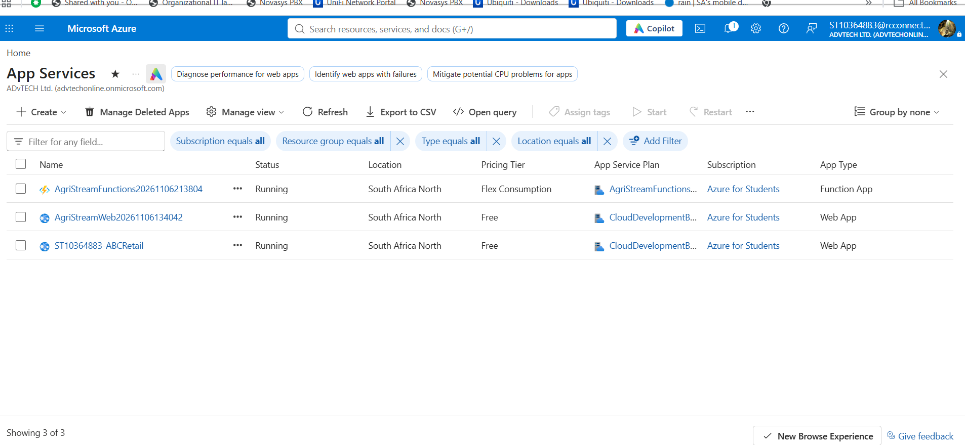

Task (b): Relational database and user management
Azure SQL Database provides durable relational storage for AgriStream user accounts and assigned roles. A user record identifies the account, stores a password hash and links the user to a role such as Farmer, Agronomist or Admin. Password verification compares the supplied password with its stored hash rather than storing a readable password.
The MVC application reads its SQL connection from configuration and uses a database context or parameterised SQL commands to query and update records. Authentication establishes the user identity; role checks determine which application actions the user may perform. Azure SQL also holds the master device registry so that background irrigation processing can update device operational status.
Database resource: practicumdb. Application integration evidence consists of a successful database operation from the MVC application, supported by the corresponding stored record or query result.
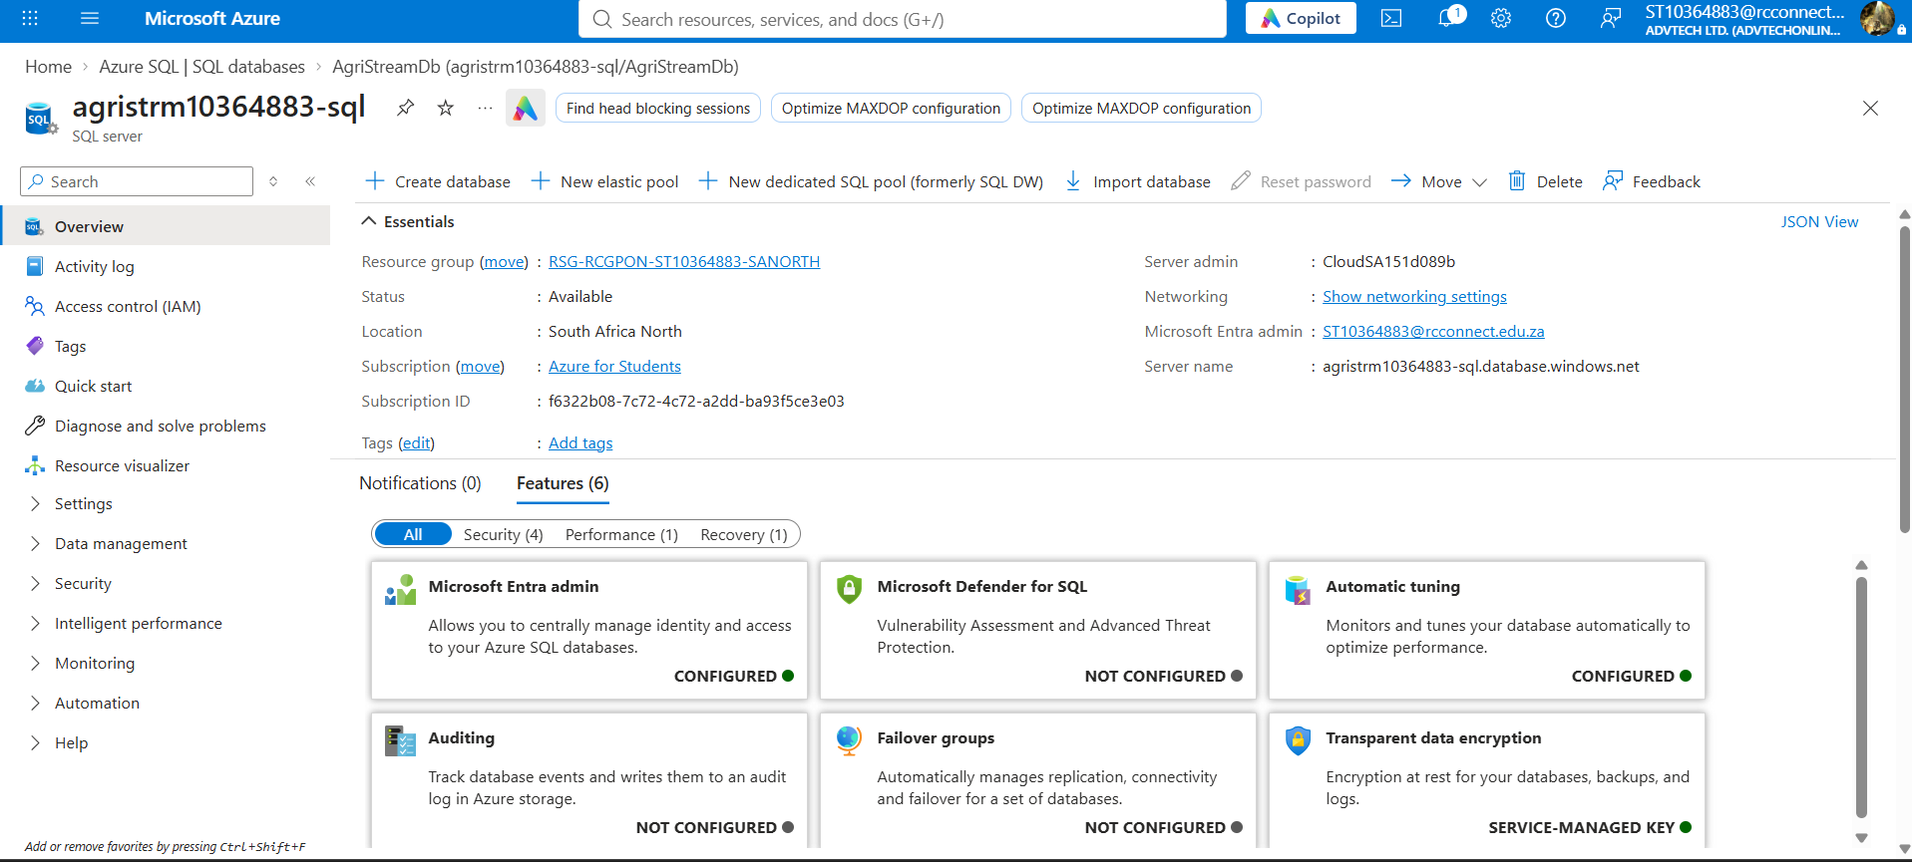

Task (c): Cloud storage for data and media
Blob Storage suits drone images because these files are unstructured binary media. The upload action validates the file and writes it to a blob container with a unique name. The blob identifier can then be used to retrieve the image and correlate its processing audit record.
Table Storage holds flexible telemetry entities without a relational schema. A farm or device identifier can group related entities through PartitionKey, while RowKey uniquely identifies each reading or event. Queries should filter using keys where possible. A timestamp records when a reading occurred; the dashboard must explicitly select the newest reading rather than assuming that the first returned entity is the latest.
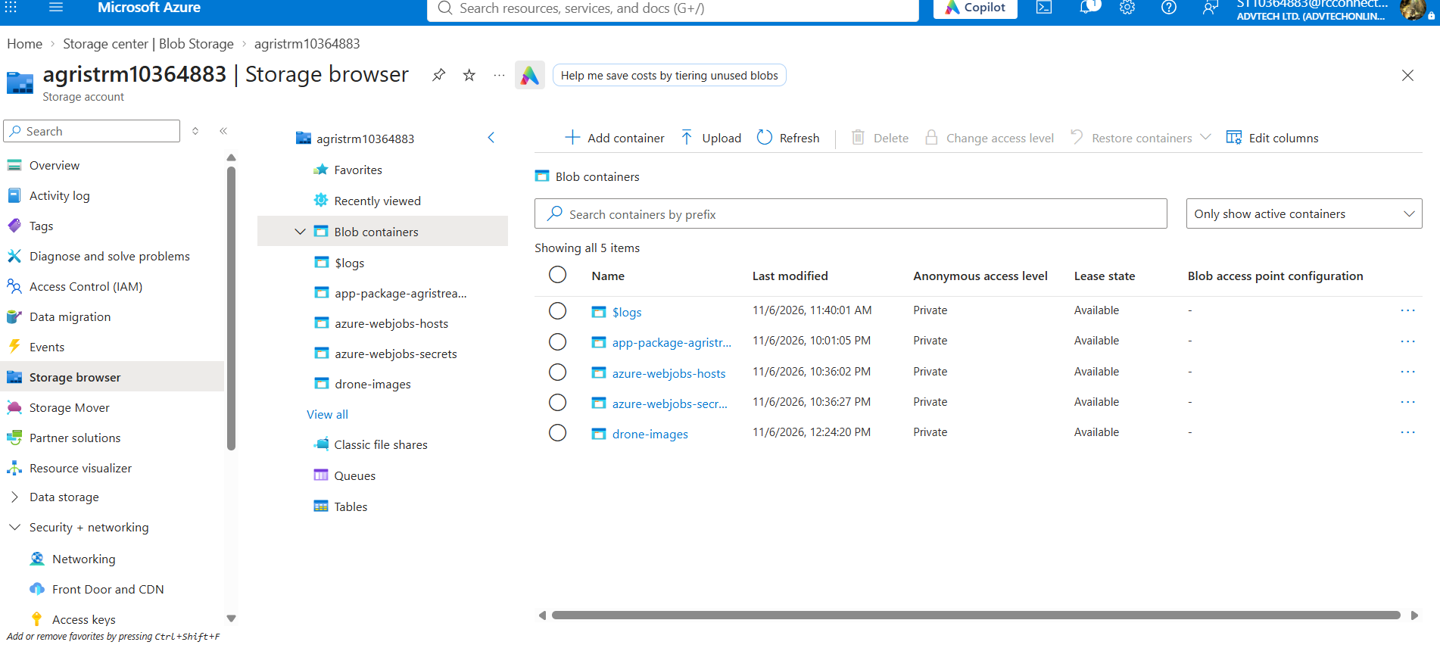

Task (d): Serverless data pipeline
The pipeline requires exactly four Azure Functions. Each has one trigger. Durable cloud storage connects the stages so that work does not depend on the memory of a particular web or function instance.

1. Blob-triggered function: drone upload audit
A new drone image in the monitored container starts the Blob-triggered function. The function captures the blob name, upload details and processing timestamp, then writes a processing-status audit entity to Table Storage. The audit record links the media file with its processing outcome.
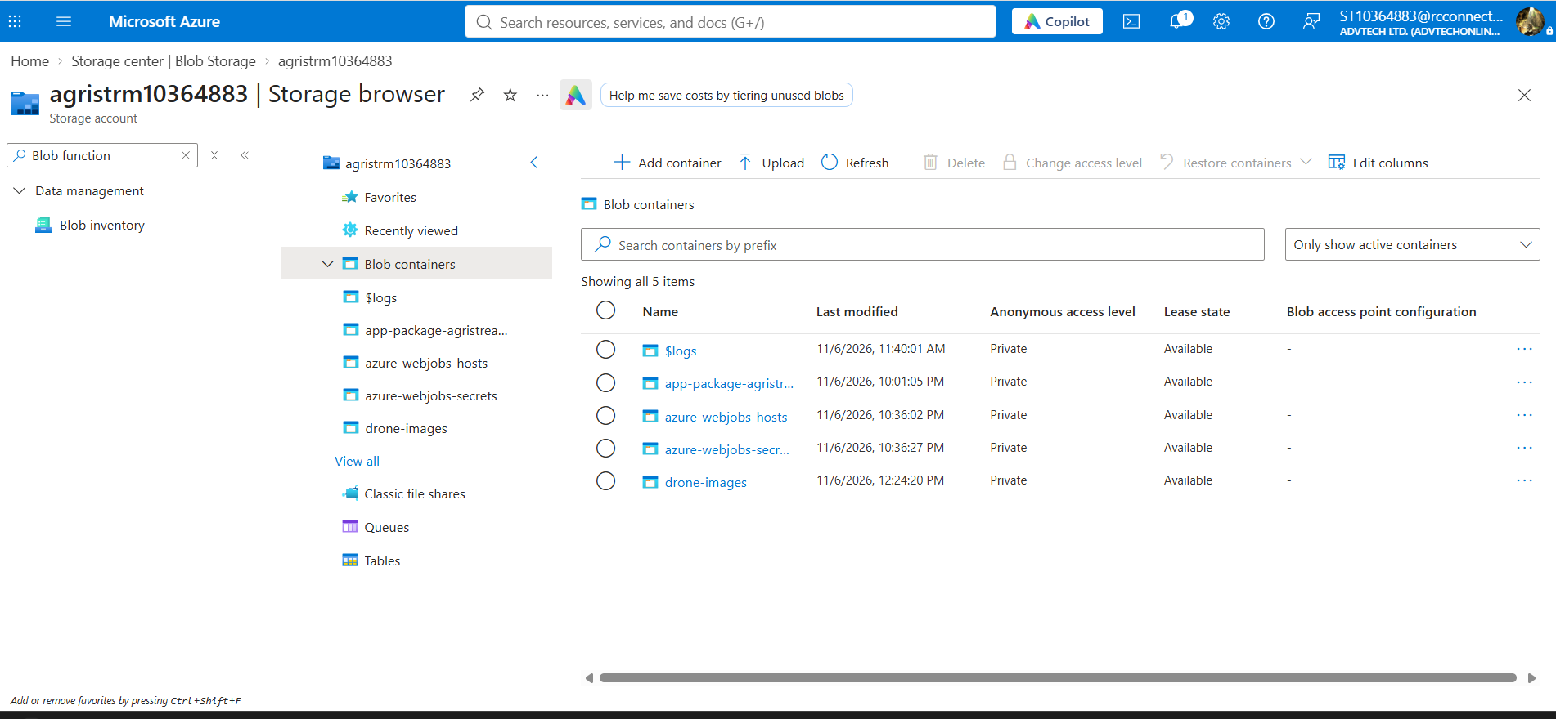

2. HTTP GET function: latest telemetry
The MVC dashboard calls the GET endpoint with the farm or device identifier. The function reads the relevant telemetry from Table Storage and returns the latest reading as JSON. Filtering and ordering by a reliable timestamp or suitable row-key design keeps the response relevant and efficient. The dashboard displays the returned values.
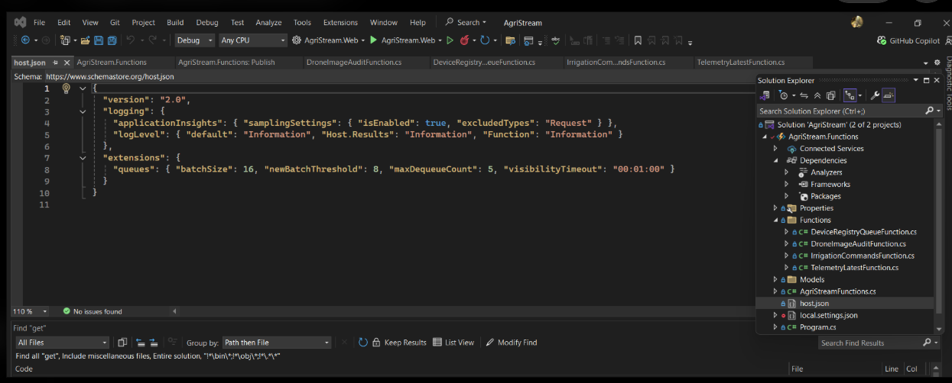

3. HTTP POST function: irrigation command
The irrigation action sends a POST request containing the target device and command details. The function validates the request, assigns a command identifier and places a message in Storage Queue. It can acknowledge that the request has been queued while the device update happens asynchronously.
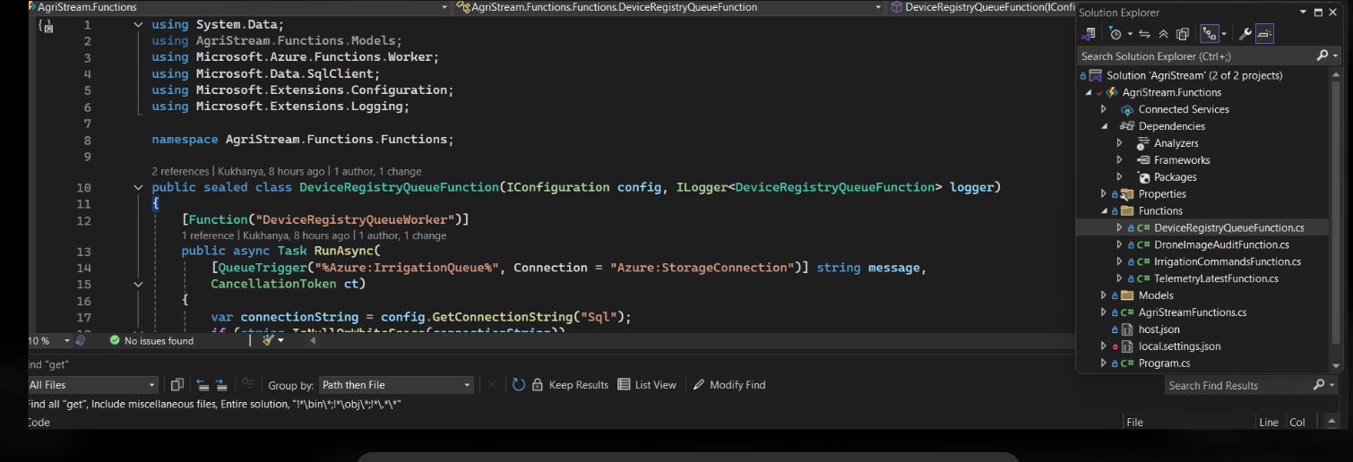

4. Queue-triggered function: device status update
A queued irrigation command starts the Queue-triggered function. The function validates and processes the command, then updates the matching device in the Azure SQL master registry. Using a command identifier for deduplication helps prevent repeated delivery from applying the same operation twice. Failed messages require logging and appropriate retry or poison-message handling.
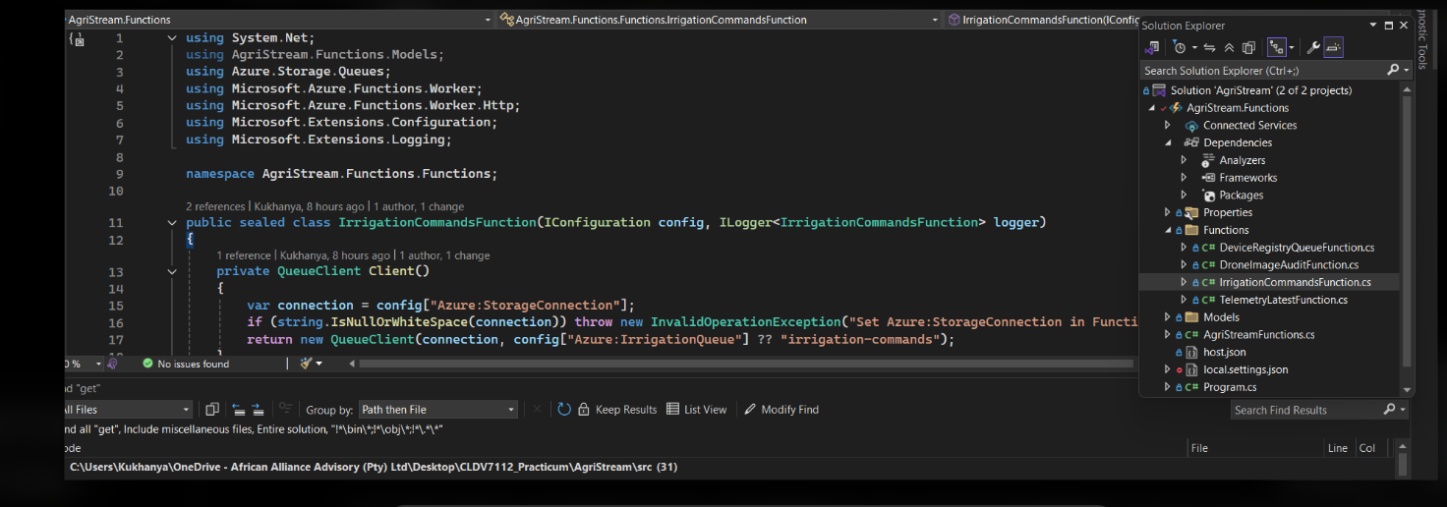

Task (e): Load testing
Load testing simulates multiple concurrent users accessing the App Service. A useful test runs against the deployed dashboard or a representative endpoint, increases concurrency in stages and maintains the higher load long enough to observe the system response. GET requests should test normal reads; irrigation POST requests should use controlled test devices.
The test script should record attempted requests, successful responses, failures and elapsed time. Throughput shows completed requests per second, while average and percentile response times expose latency. Failed HTTP responses and exceptions must be counted rather than reported as successful requests.

Measurement | Actual result
Target URL and endpoint
Concurrent users / requests
Test duration and timestamps
Successful / failed requests
Throughput and response-time statistics

Task (f): Monitoring and evaluation
Azure Monitor and Application Insights provide the measurements needed to evaluate the load test. App Service plan CPU and memory indicate resource pressure. Application request duration, failure counts and dependency timings help distinguish web-server saturation from slow SQL or storage operations. Function invocation failures and queue backlog show whether background processing is keeping up.
Use the same time range for the test output and Azure charts. Compare the baseline with the peak-load period and the period after scaling. A successful scale-out should be supported by an increased instance count and acceptable latency and failure measurements; a configured rule alone does not demonstrate that scaling occurred.

Performance evaluation: [Insert the actual baseline, peak and post-scale observations; explain whether the measured results met the expected scalability and reliability requirements.]

Task (g): App Service autoscaling
Horizontal scaling adds worker instances to share incoming requests. Metric-based autoscale is configured on the App Service plan using a supported pricing tier. Minimum, default and maximum instance counts bound the capacity. A scale-out rule increases the instance count when CPU or memory remains above its threshold, and a scale-in rule reduces capacity after sustained low utilisation.
Separate thresholds and suitable evaluation and cooldown periods reduce rapid repeated scaling. The MVC application must keep durable data in SQL and shared storage so that any instance can handle a request. SQL capacity and storage access patterns must also be considered because adding web instances does not remove a downstream bottleneck.
Example configuration for explanation: minimum 1, default 1 and maximum 3 instances; add 1 instance after average CPU exceeds 70% for 5 minutes; remove 1 after CPU remains below 30% for 10 minutes; allow a 5-minute cooldown. These are suggested values to replace with the actual configuration.

Autoscale evidence | Actual value / observation
App Service plan and pricing tier
Minimum / default / maximum instances
Metric, threshold and evaluation period
Scaling action and cooldown
Instances before / during / after load
Observed latency and failure-rate change

Implementation and result summary
[Insert the final deployment, integration, load-test and scaling outcomes supported by your snippets and screenshots. Record any task that remains incomplete.]

Technical reference
Microsoft Learn. Get started with autoscale in Azure. https://learn.microsoft.com/en-us/azure/azure-monitor/autoscale/autoscale-get-started (accessed 06 November 2026).

Section A: Complete Visual Studio source
This reference implementation covers Tasks (a)-(g). The complete file contents below are also supplied in the accompanying source ZIP. The code has not been compiled or executed in this environment; screenshots, measured results and deployment evidence must come from the actual application.
Open AgriStream.sln in Visual Studio 2022. This is a separate reference solution with Core, Web, Functions and LoadTest projects. It does not overwrite your existing solution. Follow README.md for SQL setup, private configuration, local startup and publishing.
Section A task | Included source
(a) Hosting | MVC project, Program.cs, controllers and views; publishing steps in README.
(b) SQL users and roles | database.sql, FarmDb, authentication and admin account creation.
(c) Blob and Table storage | FarmStorage upload/telemetry operations and pipeline audit handling.
(d) Four Functions | Blob, GET, POST and Queue triggers; Queue output binding; SQL update.
(e) Load testing | Practicum.LoadTest concurrent HTTP console application.
(f) Monitoring | Application Insights registration and monitoring.kql queries.
(g) Autoscaling | autoscale.ps1 with bounded CPU scale-out and scale-in rules.

How to use the source
Create or open the projects shown by each relative path. Keep namespaces and project references consistent. Enter connection strings privately through User Secrets, local.settings.json and Azure application settings. The web app and Functions must target the same farm Storage account and SQL database.
The code uses a Queue output binding, while Table reads/writes use the SDK. Latest telemetry currently scans a farm partition; for production-scale sensor traffic, replace this with a maintained latest-reading entity or another indexed query. Irrigation updates the SQL registry and records the requested duration; physical device control is outside this reference.

Practicum.Core/Practicum.Core.csproj
Shared .NET 8 project used by the MVC app and Functions.
<Project Sdk="Microsoft.NET.Sdk">
<PropertyGroup>
<TargetFramework>net8.0</TargetFramework>
<ImplicitUsings>enable</ImplicitUsings><Nullable>enable</Nullable>
</PropertyGroup>
</Project>

Practicum.Core/Contracts.cs
Defines the telemetry response and irrigation command exchanged between components.
namespace Practicum.Core;
// Shared JSON contract for telemetry returned to the dashboard.
public sealed record TelemetryDto(string FarmId, string DeviceId,
double TemperatureC, double SoilMoisture, DateTimeOffset ObservedUtc);
// The same identifier travels from the HTTP endpoint to the queue consumer.
public sealed record IrrigationCommand(Guid CommandId, string FarmId,
string DeviceId, int DurationSeconds);
public sealed record CommandAccepted(Guid CommandId, string Status);

Practicum.Web/Practicum.Web.csproj
Adds MVC hosting, SQL persistence, Blob/Table SDKs and shared cookie-key storage.
<Project Sdk="Microsoft.NET.Sdk.Web">
<PropertyGroup>
<TargetFramework>net8.0</TargetFramework>
<ImplicitUsings>enable</ImplicitUsings><Nullable>enable</Nullable>
<UserSecretsId>agristream-web-st10364883</UserSecretsId>
</PropertyGroup>
<ItemGroup>
<ProjectReference Include="../Practicum.Core/Practicum.Core.csproj" />
<PackageReference Include="Microsoft.EntityFrameworkCore.SqlServer" Version="8.0.11" />
<PackageReference Include="Azure.Storage.Blobs" Version="12.22.2" />
<PackageReference Include="Azure.Data.Tables" Version="12.9.1" />
<PackageReference Include="Azure.Extensions.AspNetCore.DataProtection.Blobs" Version="1.3.3" />
</ItemGroup>
</Project>

Practicum.Web/Program.cs
Registers SQL, authentication, shared cookie keys, storage and the Functions HTTP client. Optional one-time bootstrap creates the first admin with a password hash.
using Microsoft.AspNetCore.Authentication.Cookies;
using Microsoft.AspNetCore.DataProtection;
using Microsoft.AspNetCore.Identity;
using Microsoft.EntityFrameworkCore;
using Practicum.Web;
var builder = WebApplication.CreateBuilder(args);
builder.Services.AddControllersWithViews();
builder.Services.AddDbContext<FarmDb>(o => o.UseSqlServer(
builder.Configuration.GetConnectionString("Sql")
?? throw new InvalidOperationException("Set ConnectionStrings:Sql.")));
builder.Services.AddScoped<IPasswordHasher<AppUser>, PasswordHasher<AppUser>>();
builder.Services.AddSingleton<FarmStorage>();
builder.Services.AddHttpClient<FunctionApi>(c =>
{
c.BaseAddress = new Uri(builder.Configuration["Functions:BaseUrl"]
?? "http://localhost:7071/");
c.Timeout = TimeSpan.FromSeconds(30);
var key = builder.Configuration["Functions:Key"];
if (!string.IsNullOrWhiteSpace(key))
c.DefaultRequestHeaders.Add("x-functions-key", key);
});
builder.Services.AddAuthentication(CookieAuthenticationDefaults.AuthenticationScheme)
.AddCookie(o =>
{
o.LoginPath = "/Account/Login";
o.AccessDeniedPath = "/Account/Denied";
o.Cookie.HttpOnly = true;
o.Cookie.SecurePolicy = CookieSecurePolicy.Always;
o.ExpireTimeSpan = TimeSpan.FromHours(2);
});
builder.Services.AddAuthorization();
// All scaled web workers use the same persisted authentication keys.
var storage = builder.Configuration["Storage:ConnectionString"];
if (!string.IsNullOrWhiteSpace(storage))
{
var blob = new Azure.Storage.Blobs.BlobServiceClient(storage);
var container = blob.GetBlobContainerClient("web-keys");
await container.CreateIfNotExistsAsync();
builder.Services.AddDataProtection().SetApplicationName("AgriStream")
.PersistKeysToAzureBlobStorage(container.GetBlobClient("keys.xml"));
}
var app = builder.Build();
if (!app.Environment.IsDevelopment())
{
app.UseExceptionHandler("/Home/Error");
app.UseHsts();
}
app.UseHttpsRedirection();
app.UseStaticFiles();
app.UseRouting();
app.UseAuthentication();
app.UseAuthorization();
app.MapControllerRoute("default", "{controller=Home}/{action=Index}/{id?}");
// Run database.sql first. Bootstrap only when explicitly configured.
if (app.Configuration.GetValue<bool>("Bootstrap:Enabled"))
{
using var scope = app.Services.CreateScope();
var db = scope.ServiceProvider.GetRequiredService<FarmDb>();
if (!await db.Users.AnyAsync())
{
var name = app.Configuration["Bootstrap:Username"]
?? throw new InvalidOperationException("Set Bootstrap:Username.");
var password = app.Configuration["Bootstrap:Password"]
?? throw new InvalidOperationException("Set Bootstrap:Password.");
if (password.Length < 12)
throw new InvalidOperationException("Bootstrap password: 12+ characters.");
var user = new AppUser { Username = name.Trim(), Role = "Admin" };
user.PasswordHash = scope.ServiceProvider
.GetRequiredService<IPasswordHasher<AppUser>>()
.HashPassword(user, password);
db.Users.Add(user);
await db.SaveChangesAsync();
}
}
app.Run();

Practicum.Web/Data.cs
Maps users and device registry entities, validates login/account input and supplies the dashboard model.
using System.ComponentModel.DataAnnotations;
using Microsoft.EntityFrameworkCore;
using Practicum.Core;
namespace Practicum.Web;
public sealed class AppUser
{
public int Id { get; set; }
[Required, MaxLength(100)] public string Username { get; set; } = "";
[Required, MaxLength(512)] public string PasswordHash { get; set; } = "";
[Required, MaxLength(20)] public string Role { get; set; } = "Farmer";
}
public sealed class Device
{
[MaxLength(100)] public string Id { get; set; } = "";
[Required, MaxLength(100)] public string FarmId { get; set; } = "";
[Required, MaxLength(30)] public string Status { get; set; } = "Idle";
public DateTimeOffset UpdatedUtc { get; set; } = DateTimeOffset.UtcNow;
}
public sealed class FarmDb(DbContextOptions<FarmDb> options) : DbContext(options)
{
public DbSet<AppUser> Users => Set<AppUser>();
public DbSet<Device> Devices => Set<Device>();
protected override void OnModelCreating(ModelBuilder b)
{
b.Entity<AppUser>().HasIndex(u => u.Username).IsUnique();
b.Entity<Device>().HasKey(d => d.Id);
}
}
public sealed class LoginForm
{
[Required] public string Username { get; set; } = "";
[Required, DataType(DataType.Password)] public string Password { get; set; } = "";
}
public sealed class UserForm
{
[Required, StringLength(100, MinimumLength=3)]
public string Username { get; set; } = "";
[Required, StringLength(128, MinimumLength=12), DataType(DataType.Password)]
public string Password { get; set; } = "";
[Required] public string Role { get; set; } = "Farmer";
}
public sealed class Dashboard
{
public string FarmId { get; set; } = "F-01";
public List<Device> Devices { get; set; } = [];
public TelemetryDto? Latest { get; set; }
public string? ServiceError { get; set; }
}

Practicum.Web/Services.cs
Uploads private media to Blob Storage, writes telemetry entities and calls the GET/POST Functions from the server.
using Azure;
using Azure.Data.Tables;
using Azure.Storage.Blobs;
using Azure.Storage.Blobs.Models;
using Practicum.Core;
namespace Practicum.Web;
public sealed class FarmStorage
{
private readonly BlobContainerClient _images;
private readonly TableClient _telemetry;
public FarmStorage(IConfiguration c)
{
var connection = c["Storage:ConnectionString"]
?? throw new InvalidOperationException("Set Storage:ConnectionString.");
_images = new BlobServiceClient(connection)
.GetBlobContainerClient("drone-images");
_telemetry = new TableServiceClient(connection)
.GetTableClient("Telemetry");
}
public async Task<string> UploadAsync(IFormFile file)
{
await _images.CreateIfNotExistsAsync(PublicAccessType.None);
var extension = Path.GetExtension(file.FileName).ToLowerInvariant();
var name = $"{Guid.NewGuid():N}{extension}";
using var stream = file.OpenReadStream();
await _images.GetBlobClient(name).UploadAsync(stream,
new BlobUploadOptions
{
HttpHeaders = new BlobHttpHeaders { ContentType = file.ContentType }
});
return name;
}
public async Task AddReadingAsync(TelemetryDto reading)
{
await _telemetry.CreateIfNotExistsAsync();
var key = $"{DateTimeOffset.UtcNow.UtcTicks:D19}-{Guid.NewGuid():N}";
var row = new TableEntity(reading.FarmId, key)
{
["DeviceId"] = reading.DeviceId,
["TemperatureC"] = reading.TemperatureC,
["SoilMoisture"] = reading.SoilMoisture,
["ObservedUtc"] = reading.ObservedUtc
};
await _telemetry.AddEntityAsync(row);
}
}
public sealed class FunctionApi(HttpClient client)
{
public async Task<TelemetryDto?> LatestAsync(string farm)
{
var url = "api/telemetry?farmId=" + Uri.EscapeDataString(farm);
using var response = await client.GetAsync(url);
if (response.StatusCode == System.Net.HttpStatusCode.NoContent) return null;
response.EnsureSuccessStatusCode();
return await response.Content.ReadFromJsonAsync<TelemetryDto>();
}
public async Task<CommandAccepted?> IrrigateAsync(IrrigationCommand command)
{
using var response = await client.PostAsJsonAsync("api/irrigation", command);
response.EnsureSuccessStatusCode();
return await response.Content.ReadFromJsonAsync<CommandAccepted>();
}
}

Practicum.Web/Controllers/AccountController.cs
Authenticates against SQL password hashes, issues role claims and protects logout against cross-site requests.
using System.Security.Claims;
using Microsoft.AspNetCore.Authentication;
using Microsoft.AspNetCore.Authentication.Cookies;
using Microsoft.AspNetCore.Authorization;
using Microsoft.AspNetCore.Identity;
using Microsoft.AspNetCore.Mvc;
using Microsoft.EntityFrameworkCore;
namespace Practicum.Web.Controllers;
public sealed class AccountController(FarmDb db,
IPasswordHasher<AppUser> hasher) : Controller
{
[AllowAnonymous, HttpGet]
public IActionResult Login() => View(new LoginForm());
[AllowAnonymous, HttpPost, ValidateAntiForgeryToken]
public async Task<IActionResult> Login(LoginForm form)
{
if (!ModelState.IsValid) return View(form);
var user = await db.Users.SingleOrDefaultAsync(
x => x.Username == form.Username.Trim());
var result = user is null ? PasswordVerificationResult.Failed
: hasher.VerifyHashedPassword(user, user.PasswordHash, form.Password);
if (user is null || result == PasswordVerificationResult.Failed)
{
ModelState.AddModelError("", "Invalid username or password.");
return View(form);
}
if (result == PasswordVerificationResult.SuccessRehashNeeded)
{
user.PasswordHash = hasher.HashPassword(user, form.Password);
await db.SaveChangesAsync();
}
var claims = new[]
{
new Claim(ClaimTypes.NameIdentifier, user.Id.ToString()),
new Claim(ClaimTypes.Name, user.Username),
new Claim(ClaimTypes.Role, user.Role)
};
var identity = new ClaimsIdentity(claims,
CookieAuthenticationDefaults.AuthenticationScheme);
await HttpContext.SignInAsync(
CookieAuthenticationDefaults.AuthenticationScheme,
new ClaimsPrincipal(identity));
return RedirectToAction("Index", "Home");
}
[Authorize, HttpPost, ValidateAntiForgeryToken]
public async Task<IActionResult> Logout()
{
await HttpContext.SignOutAsync();
return RedirectToAction(nameof(Login));
}
[AllowAnonymous]
public IActionResult Denied() => StatusCode(403, "Access denied.");
}

Practicum.Web/Controllers/HomeController.cs
Provides the dashboard, image upload, telemetry entry, irrigation command and admin-only account creation actions.
using Microsoft.AspNetCore.Authorization;
using Microsoft.AspNetCore.Identity;
using Microsoft.AspNetCore.Mvc;
using Microsoft.EntityFrameworkCore;
using Practicum.Core;
namespace Practicum.Web.Controllers;
[Authorize]
public sealed class HomeController(FarmDb db, FarmStorage storage,
FunctionApi functions, IPasswordHasher<AppUser> hasher,
ILogger<HomeController> logger) : Controller
{
[HttpGet]
public async Task<IActionResult> Index(string farmId = "F-01")
{
var model = new Dashboard
{
FarmId = farmId,
Devices = await db.Devices.AsNoTracking()
.Where(d => d.FarmId == farmId).ToListAsync()
};
try { model.Latest = await functions.LatestAsync(farmId); }
catch (Exception ex)
{
logger.LogError(ex, "Telemetry retrieval failed");
model.ServiceError = "Telemetry service unavailable. Check service logs.";
}
return View(model);
}
[HttpPost, ValidateAntiForgeryToken]
public async Task<IActionResult> Upload(IFormFile? image, string farmId)
{
var extensions = new[] { ".jpg", ".jpeg", ".png" };
if (image is null || image.Length == 0 || image.Length > 10*1024*1024
|| !extensions.Contains(Path.GetExtension(image.FileName).ToLowerInvariant()))
{
TempData["Message"] = "Select a JPG or PNG image up to 10 MB.";
return RedirectToAction(nameof(Index), new { farmId });
}
var blobName = await storage.UploadAsync(image);
TempData["Message"] = "Uploaded drone image: " + blobName;
return RedirectToAction(nameof(Index), new { farmId });
}
[Authorize(Roles="Admin,Agronomist"), HttpPost, ValidateAntiForgeryToken]
public async Task<IActionResult> Reading(string farmId, string deviceId,
double temperatureC, double soilMoisture)
{
if (soilMoisture < 0 || soilMoisture > 100
|| !await db.Devices.AnyAsync(d => d.Id == deviceId && d.FarmId == farmId))
return BadRequest("Invalid reading or device.");
await storage.AddReadingAsync(new TelemetryDto(farmId, deviceId,
temperatureC, soilMoisture, DateTimeOffset.UtcNow));
TempData["Message"] = "Telemetry reading stored.";
return RedirectToAction(nameof(Index), new { farmId });
}
[HttpPost, ValidateAntiForgeryToken]
public async Task<IActionResult> Irrigate(string farmId, string deviceId,
int durationSeconds)
{
if (durationSeconds < 1 || durationSeconds > 3600
|| !await db.Devices.AnyAsync(d => d.Id == deviceId && d.FarmId == farmId))
return BadRequest("Invalid device or irrigation duration.");
var command = new IrrigationCommand(Guid.NewGuid(), farmId,
deviceId, durationSeconds);
var accepted = await functions.IrrigateAsync(command);
TempData["Message"] = "Queued command: " + accepted?.CommandId;
return RedirectToAction(nameof(Index), new { farmId });
}
[Authorize(Roles="Admin"), HttpGet]
public IActionResult CreateUser() => View(new UserForm());
[Authorize(Roles="Admin"), HttpPost, ValidateAntiForgeryToken]
public async Task<IActionResult> CreateUser(UserForm form)
{
if (!new[] { "Farmer", "Agronomist", "Admin" }.Contains(form.Role))
ModelState.AddModelError(nameof(form.Role), "Invalid role.");
if (await db.Users.AnyAsync(u => u.Username == form.Username.Trim()))
ModelState.AddModelError(nameof(form.Username), "Username already exists.");
if (!ModelState.IsValid) return View(form);
var user = new AppUser { Username = form.Username.Trim(), Role = form.Role };
user.PasswordHash = hasher.HashPassword(user, form.Password);
db.Users.Add(user);
await db.SaveChangesAsync();
TempData["Message"] = "User account created.";
return RedirectToAction(nameof(Index));
}
[AllowAnonymous, HttpGet]
public IActionResult Health() => Ok(new { service = "AgriStream", status = "running" });
[AllowAnonymous]
public IActionResult Error() => StatusCode(500,
"Application error. Review Azure application logs for details.");
}

Practicum.Web/Views/_ViewImports.cshtml
Makes MVC tag helpers and app models available to all Razor views.
@using Practicum.Web
@addTagHelper *, Microsoft.AspNetCore.Mvc.TagHelpers

Practicum.Web/Views/_ViewStart.cshtml
Uses the shared application layout for all MVC pages.
@{ Layout = "_Layout"; }

Practicum.Web/Views/Shared/_Layout.cshtml
Adds navigation and an authenticated sign-out form to the application.
<!DOCTYPE html>
<html lang="en">
<head>
<meta charset="utf-8" />
<meta name="viewport" content="width=device-width, initial-scale=1" />
<title>AgriStream IoT</title>
<link rel="stylesheet" href="~/site.css" />
</head>
<body>
<header>
<h1>AgriStream IoT</h1>
<nav><a asp-controller="Home" asp-action="Index">Dashboard</a>
@if (User.IsInRole("Admin"))
{ <a asp-controller="Home" asp-action="CreateUser">Create user</a> }
@if (User.Identity?.IsAuthenticated == true)
{
<span>@User.Identity.Name</span>
<form asp-controller="Account" asp-action="Logout" method="post">
<button type="submit">Sign out</button>
</form>
}
</nav>
</header>
<main>
@if (TempData["Message"] is string message)
{ <p class="notice">@message</p> }
@RenderBody()
</main>
</body>
</html>

Practicum.Web/Views/Account/Login.cshtml
Renders the SQL-backed sign-in form and server-side validation messages.
@model LoginForm
<h2>Sign in</h2>
<form asp-action="Login" method="post">
<div asp-validation-summary="All" class="error"></div>
<label asp-for="Username"></label><input asp-for="Username" autocomplete="username" />
<label asp-for="Password"></label><input asp-for="Password" autocomplete="current-password" />
<button type="submit">Sign in</button>
</form>

Practicum.Web/Views/Home/CreateUser.cshtml
Allows an administrator to create users with one of the required system roles.
@model UserForm
<h2>Create user account</h2>
<form asp-action="CreateUser" method="post">
<div asp-validation-summary="All" class="error"></div>
<label asp-for="Username"></label><input asp-for="Username" />
<label asp-for="Password"></label><input asp-for="Password" autocomplete="new-password" />
<label asp-for="Role"></label>
<select asp-for="Role">
<option>Farmer</option><option>Agronomist</option><option>Admin</option>
</select>
<button type="submit">Create account</button>
</form>

Practicum.Web/Views/Home/Index.cshtml
Displays telemetry fetched through the GET Function, SQL devices and forms for uploads, irrigation and sample telemetry.
@model Dashboard
<h2>Farm dashboard</h2>
<form asp-action="Index" method="get">
<label>Farm identifier</label><input name="farmId" value="@Model.FarmId" required />
<button type="submit">Open farm</button>
</form>
@if (Model.ServiceError is not null)
{ <p class="error">@Model.ServiceError</p> }
<section>
<h3>Latest telemetry</h3>
@if (Model.Latest is { } reading)
{
<p>Device: @reading.DeviceId</p>
<p>Temperature: @reading.TemperatureC °C</p>
<p>Soil moisture: @reading.SoilMoisture %</p>
<p>Observed: @reading.ObservedUtc.ToString("u")</p>
}
else { <p>No reading is available for this farm.</p> }
</section>
<section>
<h3>Device registry</h3>
<table><thead><tr><th>Device</th><th>Status</th><th>Updated UTC</th></tr></thead>
<tbody>@foreach (var device in Model.Devices)
{ <tr><td>@device.Id</td><td>@device.Status</td><td>@device.UpdatedUtc.ToString("u")</td></tr> }
</tbody></table>
</section>
<section>
<h3>Upload drone image</h3>
<form asp-action="Upload" method="post" enctype="multipart/form-data">
<input type="hidden" name="farmId" value="@Model.FarmId" />
<input name="image" type="file" accept=".jpg,.jpeg,.png" required />
<button type="submit">Upload image</button>
</form>
</section>
<section>
<h3>Trigger irrigation</h3>
<form asp-action="Irrigate" method="post">
<input type="hidden" name="farmId" value="@Model.FarmId" />
<label>Device</label><select name="deviceId">
@foreach (var device in Model.Devices)
{ <option value="@device.Id">@device.Id</option> }
</select>
<label>Duration in seconds</label>
<input name="durationSeconds" type="number" min="1" max="3600" value="60" required />
<button type="submit">Trigger irrigation</button>
</form>
</section>
@if (User.IsInRole("Admin") || User.IsInRole("Agronomist"))
{
<section><h3>Record test telemetry</h3>
<form asp-action="Reading" method="post">
<input type="hidden" name="farmId" value="@Model.FarmId" />
<label>Device</label><select name="deviceId">
@foreach (var device in Model.Devices)
{ <option value="@device.Id">@device.Id</option> }
</select>
<label>Temperature (°C)</label>
<input name="temperatureC" type="number" step="0.1" value="25" required />
<label>Soil moisture (%)</label>
<input name="soilMoisture" type="number" step="0.1" min="0" max="100" value="40" required />
<button type="submit">Store reading</button>
</form></section>
}

Practicum.Web/wwwroot/site.css
Provides a simple responsive dashboard layout without external assets.
body { font:16px system-ui,sans-serif; margin:0; background:#f1f5f2; color:#19322a; }
header { background:#163e31; color:white; padding:20px 6%; }
nav { display:flex; gap:20px; align-items:center; flex-wrap:wrap; }
nav a { color:white; } nav form { margin:0; }
main { max-width:1050px; margin:30px auto; padding:0 20px; }
section { background:white; padding:20px; margin:20px 0; border-radius:8px; }
label { display:block; margin-top:12px; }
input,select,button { padding:10px; margin:6px 0; max-width:100%; box-sizing:border-box; }
button { background:#176846; color:white; border:0; border-radius:4px; cursor:pointer; }
table { border-collapse:collapse; width:100%; }
th,td { text-align:left; padding:10px; border-bottom:1px solid #ddd; }
.notice { padding:12px; background:#d9efdf; } .error { color:#a11919; }

Practicum.Web/appsettings.json
Lists configuration keys; supply real secrets through User Secrets or Azure settings.
{
"ConnectionStrings": { "Sql": "" },
"Storage": { "ConnectionString": "" },
"Functions": { "BaseUrl": "http://localhost:7071/", "Key": "" },
"Bootstrap": { "Enabled": false, "Username": "", "Password": "" },
"Logging": { "LogLevel": { "Default": "Information", "Microsoft.AspNetCore": "Warning" } },
"AllowedHosts": "*"
}

Practicum.Web/Properties/launchSettings.json
Sets the local Visual Studio HTTPS/HTTP URLs for the MVC project.
{
"profiles": {
"Practicum.Web": {
"commandName": "Project",
"launchBrowser": true,
"applicationUrl": "https://localhost:7200;http://localhost:5200",
"environmentVariables": { "ASPNETCORE_ENVIRONMENT": "Development" }
}
}
}

Practicum.Functions/Practicum.Functions.csproj
Uses the isolated .NET Functions worker and the required HTTP, Blob and Queue extensions.
<Project Sdk="Microsoft.NET.Sdk">
<PropertyGroup>
<TargetFramework>net8.0</TargetFramework><AzureFunctionsVersion>v4</AzureFunctionsVersion>
<OutputType>Exe</OutputType><ImplicitUsings>enable</ImplicitUsings><Nullable>enable</Nullable>
</PropertyGroup>
<ItemGroup>
<ProjectReference Include="../Practicum.Core/Practicum.Core.csproj" />
<PackageReference Include="Microsoft.Azure.Functions.Worker" Version="1.23.0" />
<PackageReference Include="Microsoft.Azure.Functions.Worker.Sdk" Version="1.18.1" OutputItemType="Analyzer" />
<PackageReference Include="Microsoft.Azure.Functions.Worker.Extensions.Http" Version="3.2.0" />
<PackageReference Include="Microsoft.Azure.Functions.Worker.Extensions.Storage.Blobs" Version="6.6.0" />
<PackageReference Include="Microsoft.Azure.Functions.Worker.Extensions.Storage.Queues" Version="5.5.0" />
<PackageReference Include="Azure.Data.Tables" Version="12.9.1" />
<PackageReference Include="Microsoft.Data.SqlClient" Version="5.2.2" />
<PackageReference Include="Microsoft.ApplicationInsights.WorkerService" Version="2.22.0" />
<PackageReference Include="Microsoft.Azure.Functions.Worker.ApplicationInsights" Version="1.4.0" />
</ItemGroup>
<ItemGroup>
<None Update="host.json"><CopyToOutputDirectory>PreserveNewest</CopyToOutputDirectory></None>
<None Update="local.settings.json">
<CopyToOutputDirectory>PreserveNewest</CopyToOutputDirectory>
<CopyToPublishDirectory>Never</CopyToPublishDirectory>
</None>
</ItemGroup>
</Project>

Practicum.Functions/Program.cs
Starts the isolated worker, registers pipeline services and enables Application Insights telemetry.
using Microsoft.Azure.Functions.Worker;
using Microsoft.Extensions.DependencyInjection;
using Microsoft.Extensions.Hosting;
using Practicum.Functions;
var host = new HostBuilder()
.ConfigureFunctionsWorkerDefaults()
.ConfigureServices(services =>
{
services.AddApplicationInsightsTelemetryWorkerService();
services.ConfigureFunctionsApplicationInsights();
services.AddSingleton<PipelineStore>();
}).Build();
host.Run();

Practicum.Functions/PipelineStore.cs
Handles image audit writes, latest telemetry queries, device validation and transactional/idempotent SQL command processing.
using Azure;
using Azure.Data.Tables;
using Microsoft.Data.SqlClient;
using Microsoft.Extensions.Configuration;
using Practicum.Core;
using System.Data;
namespace Practicum.Functions;
public sealed class PipelineStore
{
private readonly TableServiceClient _tables;
private readonly string _sql;
public PipelineStore(IConfiguration c)
{
_tables = new TableServiceClient(c["FarmStorage"]
?? throw new InvalidOperationException("Set FarmStorage."));
_sql = c["SqlConnection"]
?? throw new InvalidOperationException("Set SqlConnection.");
}
public async Task AuditImageAsync(string name, long bytes)
{
var table = _tables.GetTableClient("ImageAudit");
await table.CreateIfNotExistsAsync();
// Stable identity: a retry updates the same audit row.
var hash = Convert.ToHexString(System.Security.Cryptography.SHA256
.HashData(System.Text.Encoding.UTF8.GetBytes(name)));
var row = new TableEntity("DroneImages", hash)
{
["BlobName"] = name, ["SizeBytes"] = bytes,
["Status"] = "Recorded", ["ProcessedUtc"] = DateTimeOffset.UtcNow
};
await table.UpsertEntityAsync(row, TableUpdateMode.Replace);
}
public async Task<TelemetryDto?> LatestAsync(string farm)
{
var table = _tables.GetTableClient("Telemetry");
await table.CreateIfNotExistsAsync();
var filter = TableClient.CreateQueryFilter($"PartitionKey eq {farm}");
TelemetryDto? latest = null;
await foreach (var row in table.QueryAsync<TableEntity>(filter: filter))
{
var observed = row.GetDateTimeOffset("ObservedUtc");
if (observed is null) continue;
if (latest is null || observed.Value > latest.ObservedUtc)
latest = new TelemetryDto(farm, row.GetString("DeviceId") ?? "",
row.GetDouble("TemperatureC") ?? 0,
row.GetDouble("SoilMoisture") ?? 0, observed.Value);
}
// Demonstration query; for very large partitions maintain a latest-row index.
return latest;
}
public async Task<bool> DeviceExistsAsync(string farm, string device)
{
await using var cn = new SqlConnection(_sql);
await cn.OpenAsync();
await using var cmd = cn.CreateCommand();
cmd.CommandText = "SELECT COUNT(1) FROM dbo.Devices WHERE Id=@id AND FarmId=@farm";
cmd.Parameters.Add("@id", SqlDbType.NVarChar, 100).Value = device;
cmd.Parameters.Add("@farm", SqlDbType.NVarChar, 100).Value = farm;
return Convert.ToInt32(await cmd.ExecuteScalarAsync()) == 1;
}
public async Task ApplyCommandAsync(IrrigationCommand command)
{
await using var cn = new SqlConnection(_sql);
await cn.OpenAsync();
await using var tx = (SqlTransaction)await cn.BeginTransactionAsync(
IsolationLevel.Serializable);
await using var cmd = cn.CreateCommand();
cmd.Transaction = tx;
cmd.CommandText = """
IF NOT EXISTS (SELECT 1 FROM dbo.ProcessedCommands WITH (UPDLOCK,HOLDLOCK)
WHERE CommandId=@command)
BEGIN
UPDATE dbo.Devices SET Status=N'Irrigating',UpdatedUtc=SYSUTCDATETIME()
WHERE Id=@device AND FarmId=@farm;
IF @@ROWCOUNT<>1 THROW 50001,'Device not found.',1;
INSERT dbo.ProcessedCommands(CommandId,DeviceId,DurationSeconds,ProcessedUtc)
VALUES(@command,@device,@duration,SYSUTCDATETIME());
END
""";
cmd.Parameters.Add("@command", SqlDbType.UniqueIdentifier).Value = command.CommandId;
cmd.Parameters.Add("@device", SqlDbType.NVarChar,100).Value = command.DeviceId;
cmd.Parameters.Add("@farm", SqlDbType.NVarChar,100).Value = command.FarmId;
cmd.Parameters.Add("@duration", SqlDbType.Int).Value = command.DurationSeconds;
await cmd.ExecuteNonQueryAsync();
await tx.CommitAsync();
}
}

Practicum.Functions/FarmFunctions.cs
Implements exactly four functions with Blob, HTTP GET, HTTP POST and Queue triggers. The POST uses a declarative Queue output binding; Table reads use the SDK.
using System.Net;
using System.Text.Json;
using Microsoft.Azure.Functions.Worker;
using Microsoft.Azure.Functions.Worker.Http;
using Microsoft.Extensions.Logging;
using Practicum.Core;
namespace Practicum.Functions;
public sealed class FarmFunctions(PipelineStore store, ILogger<FarmFunctions> logger)
{
private static readonly JsonSerializerOptions Json = new(JsonSerializerDefaults.Web);
// Function 1: audit drone media without loading the whole image into memory.
[Function("DroneImageUploaded")]
public async Task DroneImageUploaded(
[BlobTrigger("drone-images/{name}", Connection="FarmStorage")]
Stream image, string name)
{
long bytes = 0;
var buffer = new byte[81920];
int read;
while ((read = await image.ReadAsync(buffer.AsMemory())) > 0) bytes += read;
await store.AuditImageAsync(name, bytes);
logger.LogInformation("Drone image audited: {Name}; {Bytes} bytes", name, bytes);
}
// Function 2: return the latest farm telemetry to MVC.
[Function("GetLatestTelemetry")]
public async Task<HttpResponseData> GetLatestTelemetry(
[HttpTrigger(AuthorizationLevel.Function, "get", Route="telemetry")]
HttpRequestData request)
{
var farm = Query(request.Url, "farmId");
if (string.IsNullOrWhiteSpace(farm) || farm.Length > 100)
return await Reply(request, HttpStatusCode.BadRequest,
new { error = "Provide farmId (1-100 characters)." });
var reading = await store.LatestAsync(farm);
if (reading is null) return request.CreateResponse(HttpStatusCode.NoContent);
return await Reply(request, HttpStatusCode.OK, reading);
}
// Function 3: validate and enqueue an irrigation command through an output binding.
[Function("QueueIrrigation")]
public async Task<IrrigationOutput> QueueIrrigation(
[HttpTrigger(AuthorizationLevel.Function, "post", Route="irrigation")]
HttpRequestData request)
{
IrrigationCommand? command;
try { command = await JsonSerializer.DeserializeAsync<IrrigationCommand>(
request.Body, Json); }
catch (JsonException)
{
return new IrrigationOutput { Response = await Reply(request,
HttpStatusCode.BadRequest, new { error = "Invalid JSON." }) };
}
if (command is null || string.IsNullOrWhiteSpace(command.FarmId)
|| string.IsNullOrWhiteSpace(command.DeviceId)
|| command.FarmId.Length > 100 || command.DeviceId.Length > 100
|| command.DurationSeconds is < 1 or > 3600)
return new IrrigationOutput { Response = await Reply(request,
HttpStatusCode.BadRequest, new { error = "Invalid command fields." }) };
if (!await store.DeviceExistsAsync(command.FarmId, command.DeviceId))
return new IrrigationOutput { Response = await Reply(request,
HttpStatusCode.NotFound, new { error = "Device not found." }) };
if (command.CommandId == Guid.Empty)
command = command with { CommandId = Guid.NewGuid() };
return new IrrigationOutput
{
Message = JsonSerializer.Serialize(command, Json),
Response = await Reply(request, HttpStatusCode.Accepted,
new CommandAccepted(command.CommandId, "Queued"))
};
}
// Function 4: queue retries are safe because SQL stores processed command IDs.
[Function("ProcessIrrigation")]
public async Task ProcessIrrigation(
[QueueTrigger("irrigation-commands", Connection="FarmStorage")] string message)
{
var command = JsonSerializer.Deserialize<IrrigationCommand>(message, Json)
?? throw new InvalidOperationException("Empty command.");
if (command.CommandId == Guid.Empty || command.DurationSeconds is < 1 or > 3600)
throw new InvalidOperationException("Invalid queued command.");
await store.ApplyCommandAsync(command);
logger.LogInformation("Processed irrigation command {Id}", command.CommandId);
}
private static string? Query(Uri uri, string name)
{
foreach (var part in uri.Query.TrimStart('?').Split('&',
StringSplitOptions.RemoveEmptyEntries))
{
var pair = part.Split('=', 2);
if (Uri.UnescapeDataString(pair[0]) == name)
return pair.Length == 2 ? Uri.UnescapeDataString(pair[1]) : "";
}
return null;
}
private static async Task<HttpResponseData> Reply(HttpRequestData request,
HttpStatusCode status, object body)
{
var response = request.CreateResponse(status);
response.Headers.Add("Content-Type", "application/json; charset=utf-8");
await response.WriteStringAsync(JsonSerializer.Serialize(body, Json));
return response;
}
}
public sealed class IrrigationOutput
{
[QueueOutput("irrigation-commands", Connection="FarmStorage")]
public string? Message { get; set; }
public HttpResponseData Response { get; set; } = null!;
}

Practicum.Functions/host.json
Configures queue encoding, retries and runtime logging without adding extra functions.
{
"version": "2.0",
"logging": {
"applicationInsights": { "samplingSettings": { "isEnabled": true } },
"logLevel": { "default": "Information" }
},
"extensions": {
"queues": {
"messageEncoding": "base64", "maxDequeueCount": 5,
"visibilityTimeout": "00:00:30", "batchSize": 8
}
}
}

Practicum.Functions/local.settings.example.json
Copy to local.settings.json locally and enter private SQL/storage values. Never publish that file.
{
"IsEncrypted": false,
"Values": {
"AzureWebJobsStorage": "UseDevelopmentStorage=true",
"FUNCTIONS_WORKER_RUNTIME": "dotnet-isolated",
"FarmStorage": "UseDevelopmentStorage=true",
"SqlConnection": "SET_PRIVATE_SQL_CONNECTION_STRING",
"APPLICATIONINSIGHTS_CONNECTION_STRING": ""
}
}

Practicum.Functions/Properties/launchSettings.json
Uses port 7071 for the local Functions host.
{
"profiles": {
"Practicum.Functions": { "commandName": "Project", "commandLineArgs": "--port 7071" }
}
}

database.sql
Creates the user/role, device and deduplication tables and inserts one controlled test device. Existing incompatible tables need schema alignment before running the app.
-- Run against the existing practicumdb database in Azure SQL Query Editor.
IF OBJECT_ID('dbo.Users','U') IS NULL
BEGIN
CREATE TABLE dbo.Users(
Id int IDENTITY(1,1) NOT NULL CONSTRAINT PK_Users PRIMARY KEY,
Username nvarchar(100) NOT NULL,
PasswordHash nvarchar(512) NOT NULL,
Role nvarchar(20) NOT NULL,
CONSTRAINT UQ_Users_Username UNIQUE(Username),
CONSTRAINT CK_Users_Role CHECK(Role IN ('Farmer','Agronomist','Admin'))
);
END;
IF OBJECT_ID('dbo.Devices','U') IS NULL
BEGIN
CREATE TABLE dbo.Devices(
Id nvarchar(100) NOT NULL CONSTRAINT PK_Devices PRIMARY KEY,
FarmId nvarchar(100) NOT NULL,
Status nvarchar(30) NOT NULL,
UpdatedUtc datetimeoffset NOT NULL
);
CREATE INDEX IX_Devices_FarmId ON dbo.Devices(FarmId);
END;
IF OBJECT_ID('dbo.ProcessedCommands','U') IS NULL
BEGIN
CREATE TABLE dbo.ProcessedCommands(
CommandId uniqueidentifier NOT NULL CONSTRAINT PK_ProcessedCommands PRIMARY KEY,
DeviceId nvarchar(100) NOT NULL,
DurationSeconds int NOT NULL,
ProcessedUtc datetimeoffset NOT NULL,
CONSTRAINT FK_Command_Device FOREIGN KEY(DeviceId) REFERENCES dbo.Devices(Id)
);
END;
IF NOT EXISTS(SELECT 1 FROM dbo.Devices WHERE Id=N'D-01')
INSERT dbo.Devices(Id,FarmId,Status,UpdatedUtc)
VALUES(N'D-01',N'F-01',N'Idle',SYSUTCDATETIME());
SELECT Id,FarmId,Status,UpdatedUtc FROM dbo.Devices;

Practicum.LoadTest/Practicum.LoadTest.csproj
Creates a Visual Studio console application for concurrent HTTP load testing.
<Project Sdk="Microsoft.NET.Sdk">
<PropertyGroup>
<OutputType>Exe</OutputType><TargetFramework>net8.0</TargetFramework>
<ImplicitUsings>enable</ImplicitUsings><Nullable>enable</Nullable>
</PropertyGroup>
</Project>

Practicum.LoadTest/Program.cs
Measures concurrent requests, status codes, failures, throughput and response-time percentiles without counting redirects as success.
using System.Collections.Concurrent;
using System.Diagnostics;
using System.Net;
// dotnet run --project Practicum.LoadTest -- https://APP.azurewebsites.net/Home/Health 20 120
if (args.Length < 1 || !Uri.TryCreate(args[0], UriKind.Absolute, out var url)
|| (url.Scheme != "https" && url.Scheme != "http"))
{
Console.WriteLine("Usage: <URL> [concurrent-users=10] [seconds=60]");
return;
}
int users = args.Length > 1 ? int.Parse(args[1]) : 10;
int seconds = args.Length > 2 ? int.Parse(args[2]) : 60;
if (users is < 1 or > 500 || seconds is < 1 or > 3600)
throw new ArgumentException("Users: 1-500. Seconds: 1-3600.");
using var handler = new HttpClientHandler { AllowAutoRedirect = false };
using var client = new HttpClient(handler) { Timeout = TimeSpan.FromSeconds(30) };
// For an authorised dashboard run, supply a private test-session cookie in this env var.
var cookie = Environment.GetEnvironmentVariable("AGRISTREAM_TEST_COOKIE");
if (!string.IsNullOrWhiteSpace(cookie)) client.DefaultRequestHeaders.Add("Cookie", cookie);
var times = new ConcurrentBag<double>();
var codes = new ConcurrentDictionary<string, int>();
long successful = 0, failed = 0;
var started = DateTimeOffset.UtcNow;
var watch = Stopwatch.StartNew();
var tasks = Enumerable.Range(0, users).Select(async workerIndex =>
{
while (watch.Elapsed.TotalSeconds < seconds)
{
var requestWatch = Stopwatch.StartNew();
try
{
using var response = await client.GetAsync(url);
await response.Content.ReadAsByteArrayAsync();
codes.AddOrUpdate(((int)response.StatusCode).ToString(),1,(_,n)=>n+1);
if (response.IsSuccessStatusCode) Interlocked.Increment(ref successful);
else Interlocked.Increment(ref failed);
}
catch (Exception ex) when (ex is HttpRequestException or TaskCanceledException)
{
codes.AddOrUpdate(ex.GetType().Name,1,(_,n)=>n+1);
Interlocked.Increment(ref failed);
}
finally { times.Add(requestWatch.Elapsed.TotalMilliseconds); }
}
}).ToArray();
await Task.WhenAll(tasks);
watch.Stop();
var sorted = times.Order().ToArray();
double Percentile(double p) => sorted.Length == 0 ? 0 :
sorted[Math.Clamp((int)Math.Ceiling(p * sorted.Length)-1,0,sorted.Length-1)];
Console.WriteLine($"Start UTC: {started:O}; End UTC: {DateTimeOffset.UtcNow:O}");
Console.WriteLine($"URL: {url}; Users: {users}; Duration: {watch.Elapsed.TotalSeconds:F2}s");
Console.WriteLine($"Total: {times.Count}; Success: {successful}; Failed: {failed}");
Console.WriteLine($"Requests/sec: {times.Count/watch.Elapsed.TotalSeconds:F2}");
Console.WriteLine($"Success/sec: {successful/watch.Elapsed.TotalSeconds:F2}");
Console.WriteLine($"Average ms: {(sorted.Length==0?0:sorted.Average()):F2}");
Console.WriteLine($"P95 ms: {Percentile(.95):F2}; P99 ms: {Percentile(.99):F2}");
foreach (var result in codes.OrderBy(x=>x.Key))
Console.WriteLine($"{result.Key}: {result.Value}");
// A health endpoint measures web-host capacity only. Use a test login cookie
// and a representative dashboard URL to include SQL and Functions dependencies.

monitoring.kql
Supplies monitoring queries for request latency, errors and dependency timings. Use application-scoped Logs; workspace tables may instead be AppRequests/AppDependencies/AppExceptions.
// Application Insights Logs: set the time picker to match the load test.
requests
| summarize Requests=count(), Failures=countif(success == false),
AverageMs=avg(duration / 1ms), P95Ms=percentile(duration / 1ms,95) by bin(timestamp,1m)
| order by timestamp asc
// Run separately to identify slow/failing dependencies.
dependencies
| summarize Calls=count(), Failures=countif(success == false),
AverageMs=avg(duration / 1ms), P95Ms=percentile(duration / 1ms,95)
by type, target, bin(timestamp,1m)
| order by timestamp asc
// Run separately to inspect exceptions.
exceptions
| project timestamp, type, outerMessage, operation_Name
| order by timestamp desc

autoscale.ps1
Creates CPU-based App Service plan scale-out and scale-in rules. Run once with your resource names and verify actual scaling during the test.
param(
[Parameter(Mandatory=$true)][string]$ResourceGroup,
[Parameter(Mandatory=$true)][string]$AppServicePlan
)
$ErrorActionPreference = 'Stop'
# Requires Azure CLI login and a plan tier supporting metric autoscale.
$planId = az appservice plan show --resource-group $ResourceGroup `
--name $AppServicePlan --query id -o tsv
if ($LASTEXITCODE -ne 0) { throw 'Could not read App Service plan.' }
$name = 'agristream-cpu-autoscale'
az monitor autoscale create --resource-group $ResourceGroup --name $name `
--resource $planId --min-count 1 --count 1 --max-count 3
if ($LASTEXITCODE -ne 0) { throw 'Could not create autoscale settings.' }
az monitor autoscale rule create --resource-group $ResourceGroup `
--autoscale-name $name --condition 'CpuPercentage > 70 avg 5m' `
--scale out 1 --cooldown 5
if ($LASTEXITCODE -ne 0) { throw 'Could not create scale-out rule.' }
az monitor autoscale rule create --resource-group $ResourceGroup `
--autoscale-name $name --condition 'CpuPercentage < 30 avg 10m' `
--scale in 1 --cooldown 5
if ($LASTEXITCODE -ne 0) { throw 'Could not create scale-in rule.' }
# Capture the actual Autoscale history and Instance count chart during load.

.gitignore
Excludes build files and local private configuration from source control.
**/bin/
**/obj/
.vs/
**/local.settings.json
**/appsettings.Development.json
**/*.user
**/*.pubxml.user

Setup, deployment and verification guide
Explains local setup, configuration, publishing, evidence capture and implementation limitations.
# AgriStream Section A reference solution
Complete reference source for tasks (a)-(g). This source is generated for the
submission appendix; it has not been compiled or executed in this environment.
It is separate from the existing Practicum solution. Review and test before use.
## Open in Visual Studio
1. Install Visual Studio 2022 with ASP.NET/web and Azure development workloads,
.NET 8 SDK, and Azure Functions Core Tools v4. Open AgriStream.sln.
2. Restore NuGet packages and build the solution. Run database.sql in the existing
Azure SQL practicumdb. The reference uses Users, Devices and ProcessedCommands;
compare existing schemas first. It does not migrate incompatible tables.
3. In Practicum.Web, Manage User Secrets. Supply these keys privately:
ConnectionStrings:Sql, Storage:ConnectionString, Functions:BaseUrl,
Functions:Key, Bootstrap:Enabled, Bootstrap:Username, Bootstrap:Password.
Set Bootstrap:Enabled=true only for the first admin creation; use a private
password of 12+ characters, then disable bootstrap and remove that password.
4. Copy Functions/local.settings.example.json to local.settings.json. Fill
SqlConnection. FarmStorage must point to the same account used by Web Storage.
AzureWebJobsStorage is the host storage account. Use Azurite locally, or real
connection strings. FUNCTIONS_WORKER_RUNTIME must be dotnet-isolated.
5. Create the private drone-images container, Telemetry and ImageAudit tables,
and irrigation-commands queue before starting the Functions host. The web and
audit code also create their required storage resources on first use.
6. Start Practicum.Functions and Practicum.Web as multiple startup projects.
Functions uses port 7071; MVC uses https://localhost:7200. Trust the local
development certificate if prompted. Sign in as the bootstrap admin.
7. Record telemetry for F-01/D-01. Refresh the dashboard, upload a JPG/PNG, trigger
irrigation and inspect Table audit, queue processing and SQL device status.
## Publish and configure Azure
- Publish Practicum.Web to an Azure App Service matching .NET 8. Publish
Practicum.Functions separately to a .NET 8 isolated Function App (runtime v4).
Use a Functions plan supporting the polling Blob trigger, such as a classic
Consumption or Premium plan. This reference is not the Event Grid Blob mode
required by a Flex Consumption deployment.
- App Service settings: ConnectionStrings__Sql, Storage__ConnectionString,
Functions__BaseUrl (Function App root URL with trailing slash), Functions__Key.
Double underscores map to configuration colons. Bootstrap settings work in
the same way, only when a first user must be created in an empty Users table.
- Function App settings: AzureWebJobsStorage, FUNCTIONS_WORKER_RUNTIME,
FarmStorage, SqlConnection, APPLICATIONINSIGHTS_CONNECTION_STRING.
Use the same farm storage and database as the web application.
- Permit the application to connect using the SQL server's appropriate network
path and database credentials. Use HTTPS; do not publish secret values in code.
- Connect App Service to Application Insights using Azure's supported .NET
App Service instrumentation. Functions telemetry is enabled in Program.cs.
- Use an App Service tier supporting metric autoscale, then run autoscale.ps1
with the actual resource group and plan name. Review cost/instance limits.
## Load test and capture evidence
From the solution folder:
dotnet run --project Practicum.LoadTest -- https://APP.azurewebsites.net/Home/Health 20 120
Increase concurrency in stages for the actual test; run long enough to cover the
5-minute scale-out evaluation window. The example above is a short smoke load,
not sufficient evidence that autoscale activated. Redirects count as failures.
For the authenticated dashboard, set AGRISTREAM_TEST_COOKIE privately to a test
session cookie and target /Home/Index?farmId=F-01. Never submit that cookie.
Capture CPU, memory, instance count, latency, failures, Functions invocations,
queue processing and SQL status in the same test time window. monitoring.kql
contains example application-scoped Application Insights queries.
## Implementation limits to evaluate
- This is a practicum reference, not a production IoT device-control service.
Irrigation updates a registry status and stores requested duration; it does
not connect to physical hardware or automatically switch irrigation off.
- Latest telemetry scans one farm partition and selects the newest ObservedUtc.
For millions of readings, maintain a per-farm latest entity or indexed store.
- User roles are enforced, but per-farm ownership isolation is not implemented.
- The POST Function uses a Queue output binding. Table access uses the SDK;
do not claim a Table input binding was implemented. SQL access is parameterised.
- Blob processing records upload audit status; it does not perform AI image analysis.
- No successful deployment, load-test result or scaling event is claimed.
## Sources
https://learn.microsoft.com/en-us/azure/azure-functions/dotnet-isolated-process-guide
https://learn.microsoft.com/en-us/azure/azure-functions/functions-triggers-bindings
https://learn.microsoft.com/en-us/aspnet/core/security/authentication/cookie
https://learn.microsoft.com/en-us/azure/azure-monitor/autoscale/autoscale-get-started

AgriStream IoT
  - Section B:

1. Disaster recovery and redundancy
Storage redundancy maintains extra copies of data so that hardware failures do not necessarily cause permanent loss. Azure offers local, zone and geographic redundancy options. The choice depends on the impact of losing records, acceptable downtime, cost and regional recovery requirements.
Criterion | Locally redundant storage (LRS) | Geo-redundant storage (GRS)
Replication | Three synchronous copies in one physical location in the primary region. | Local replication in the primary region plus asynchronous replication to a secondary region.
Failure protection | Protects against individual disk, server or rack failures; does not provide a separate regional copy. | Adds a remote copy for recovery from a major primary-region outage.
Trade-off | Lower cost; a location-wide disaster can affect every local copy. | Higher cost; recent writes may be lost if failover happens before replication completes.
AgriStream suitability | Temporary, reproducible sensor logs. | Critical historical crop harvest records.
For AgriStream, GRS is the more appropriate choice for critical historical harvest records because losing long-term production history would damage planning, reporting and auditability. LRS is reasonable for genuinely temporary sensor logs that can be recreated or discarded after processing. Readings that cannot be reproduced deserve stronger protection even if they are called logs.
Other options include ZRS for copies across availability zones and GZRS for zone resilience combined with geographic replication. Read-access variants allow secondary-region reads. Redundancy does not replace backups, retention controls or a tested recovery plan.
The recovery plan should define acceptable data loss (RPO) and restoration time (RTO), identify the failover steps and test recovery. Standard GRS generally requires failover before secondary data can be used for normal access. Azure SQL recovery is configured separately from Storage account redundancy.

2. Stateless versus stateful architecture
A stateless application does not rely on information held only in a particular running instance between requests. Each request carries enough context to be handled independently, while durable information is held in shared services. A stateful instance retains session or workflow information that subsequent requests need.
Stateless design is crucial for horizontal scaling because the load balancer can send requests to any available App Service instance. New instances can immediately serve requests, and instances can be restarted or removed without losing essential application data. Azure Functions likewise must not rely on one invocation reaching the same worker as an earlier invocation.
For example, if a farmer logs in on instance A and the session exists only in its memory, a later dashboard request routed to instance B may lose that session. Adding instances therefore creates inconsistent behaviour. Sticky sessions can keep a user on one worker, but they can create uneven load and do not protect the session when that worker fails.
Files written only to a worker-local temporary directory create a similar problem. Another instance may not see the drone image, and the file may disappear when the worker is recycled or scaled in. AgriStream therefore uses Blob Storage for durable media, Table Storage for telemetry and audit data, and SQL for users, roles and device records. If server-side session storage is needed, a shared distributed store allows all workers to access it.
The irrigation workflow keeps pending work in Storage Queue rather than an in-memory list. The POST function enqueues a command and a separate Queue-triggered function processes it. Unique command identifiers and idempotent updates help handle retries without duplicate effects. Shared authentication configuration must also allow all MVC instances to validate the same login cookie.
Stateless compute therefore supports scale-out, load balancing and recovery while shared services preserve the state needed for the farm workflow.

3. Serverless triggers and bindings
A trigger determines when a function runs. Each Azure Function has exactly one trigger. Input and output bindings connect an invocation to additional data sources or destinations, reducing repetitive integration code. A function can have multiple supported bindings.
Component | Definition | Purpose | AgriStream pipeline example
Trigger | An event or request source that starts execution. | Invokes the function and provides the initiating payload. | A Blob trigger receives an uploaded drone image; GET retrieves telemetry; POST accepts irrigation requests; a Queue trigger receives commands.
Input binding | A declarative connection that supplies additional data during execution. | Reads supporting data without manually creating all client calls. | The GET function reads Table Storage through TableClient in this reference. A declarative Table input binding is an alternative, rather than a claim about this code.
Output binding | A declarative connection that sends a result to an external service. | Writes output or forwards work to another pipeline stage. | A Queue output binding can place an irrigation command on Storage Queue after the HTTP POST request is validated.
In the drone workflow, the Blob trigger initiates execution and supplies the image context; writing the audit entity to Table Storage is a separate output operation. In the irrigation workflow, the HTTP POST request starts the function, while the declared Queue output binding sends work onward. The Queue-triggered function then starts from that message and updates the SQL device registry.
A trigger is therefore responsible for starting work, an input binding reads supporting data, and an output binding writes the outcome. Direct TableClient, QueueClient or SQL commands perform SDK/database operations; they should only be described as declarative bindings when the actual function code declares those bindings.

