Ndima Khanyisa

3D E-Commerce Platform Architecture on AWS

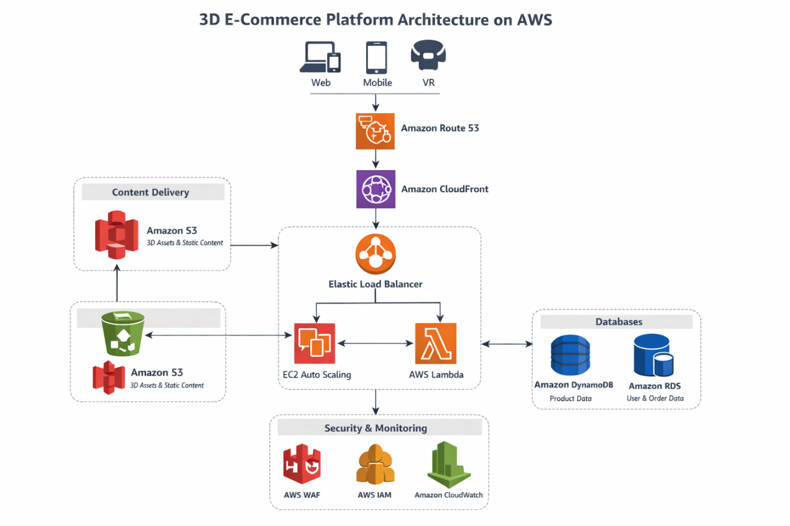
Overview
The 3D e-commerce platform allows users to interact with realistic 3D product models before purchasing. The architecture is designed to support millions of global users while ensuring:
- High availability
- Fast performance
- Security
- Cost efficiency
AWS managed services provide scalability, reliability, and minimal operational overhead.
AWS Services Used and Justification
- Amazon Route 53
  - Provides global DNS routing with health checks.
  - Ensures traffic is directed to healthy endpoints and nearest edge locations.
- Amazon CloudFront
  - Delivers 3D assets, images, and static content from edge locations.
  - Reduces latency and improves global user experience.
- Amazon S3
  - Stores static website files and 3D models.
  - Durable, scalable, and cost-efficient storage.
- Application Load Balancer (ALB)
  - Distributes incoming traffic across EC2 instances.
  - Supports SSL termination and fault tolerance.
- Amazon EC2 Auto Scaling
  - Hosts backend application services.
  - Automatically scales instances based on traffic demand.
- AWS Lambda
  - Serverless functions for lightweight tasks (e.g., authentication, cart updates).
  - Reduces server management and costs.
- Amazon DynamoDB
  - NoSQL database for product catalog, user sessions, and interactions.
  - Provides millisecond latency for high-traffic operations.
- Amazon RDS (Multi-AZ)
  - Relational database for orders, payments, and customer data.
  - Offers automated backups and failover support.
- Amazon CloudWatch
  - Monitors logs, metrics, and triggers alerts or auto-scaling actions.
  - Ensures platform health and performance.
- AWS WAF & IAM
  - Web Application Firewall protects against attacks.
  - IAM enforces least-privilege access for secure operations.
How Architecture Meets Requirements
- High Availability
  - Multi-AZ RDS deployment.
  - EC2 Auto Scaling across multiple Availability Zones.
  - CloudFront edge locations for global content delivery.
  - Route 53 health checks for traffic failover.
- Scalability
  - EC2 Auto Scaling adjusts compute resources automatically.
  - Lambda scales per request without provisioning.
  - DynamoDB auto-scales throughput to meet demand.
  - CloudFront efficiently handles traffic spikes worldwide.
- Performance
  - CloudFront caches 3D assets near users.
  - S3 ensures fast access to static content.
  - DynamoDB provides low-latency data reads.
  - ALB distributes requests efficiently.
- Security
  - AWS WAF protects against web attacks.
  - IAM enforces least-privilege access policies.
  - Security groups isolate EC2, RDS, and Lambda resources.
  - HTTPS enforced via ALB and CloudFront.
- Cost Optimization
  - Auto Scaling prevents idle EC2 instances.
  - Lambda pay-per-use reduces costs for lightweight functions.
  - S3 lifecycle policies optimize storage costs.
  - CloudWatch and Trusted Advisor monitor and recommend cost savings.
Design Trade-offs and Challenges
- Two databases (DynamoDB + RDS)
  - Adds complexity but optimizes performance for different workloads.
- CloudFront caching
  - Improves speed but requires cache invalidation for updated 3D assets.
- EC2 vs Lambda mix
  - EC2 provides control for complex backend logic.
  - Lambda reduces server management for lightweight tasks.
- Global traffic management
  - Using Route 53 and CloudFront ensures low latency but requires careful configuration for failover and health checks.

Conclusion
This AWS architecture provides a secure, scalable, and cost-efficient foundation for a 3D e-commerce platform.
By combining managed services, auto-scaling, and global content delivery, the platform delivers:
- Fast 3D interactions
- High availability
- Operational efficiency
- Global accessibility and resilience

