# ****Criminal Records Management System (CRMS)****

### ****Project Documentation****

## ****Table of Contents****

1. Introduction
2. System Overview
3. Software Requirements Specification (SRS)
   * Purpose
   * Product Scope
   * System Features
4. System Design
   * Data Flow Diagram (DFD)
   * Database Design
5. Implementation
6. Testing
7. AI Integration
8. Conclusion
9. References

## ****1. Introduction****

The Criminal Records Management System (CRMS) is designed to digitize and simplify the management of criminal records. It enables authorized users such as police officers, NCRB officials, and CBI agents to securely manage, update, and retrieve criminal data efficiently.

## ****2. System Overview****

The CRMS is a centralized system that helps law enforcement agencies manage and analyze criminal data. It allows for functionalities like:

* Adding, updating, and searching criminal records.
* Generating reports for specific crimes or criminals.

## ****3. Software Requirements Specification (SRS)****

### ****3.1 Purpose****

The CRMS aims to:

1. Provide a centralized database for criminal records.
2. Enhance data accessibility for law enforcement agencies.
3. Ensure data security and integrity.

### ****3.2 Product Scope****

The system will:

* Store comprehensive criminal details (e.g., name, age, aliases, crimes committed, arrest dates).
* Provide user-specific access based on roles (e.g., NCRB, CBI, Police).

### ****3.3 System Features****

1. **User Authentication**: Role-based login (NCRB, CBI, Police).
2. **Record Management**: Add, update, and delete criminal records.
3. **Advanced Reporting**: Generate detailed reports based on filters like crime type and location.
4. **Search**: Search records using various attributes (e.g., name, aliases, location).

## ****4. System Design****

### ****4.1 Data Flow Diagram (DFD)****

The DFD represents the data flow within the CRMS.

#### Level 0:

* Input: User login credentials, record data.
* Output: Search results, reports, analysis insights.

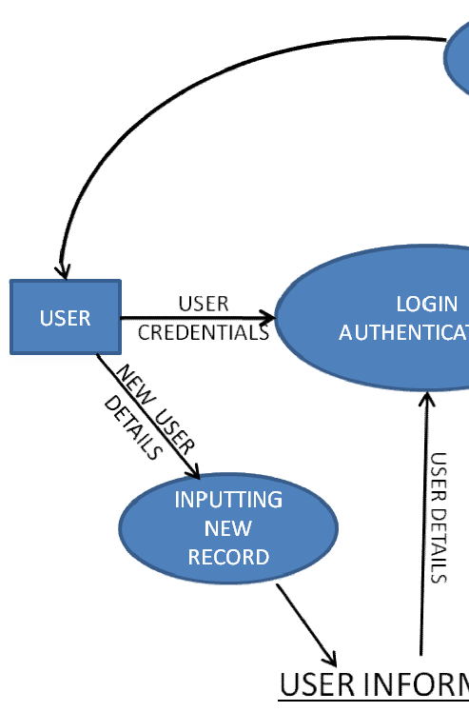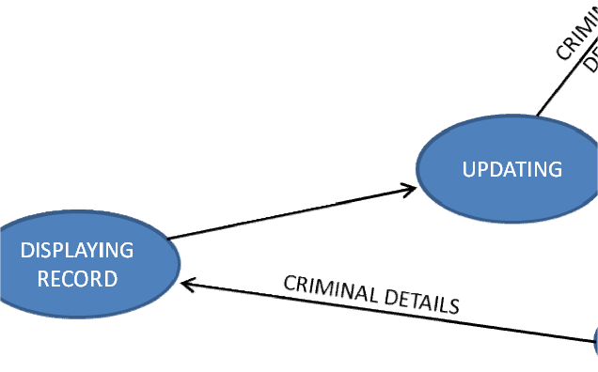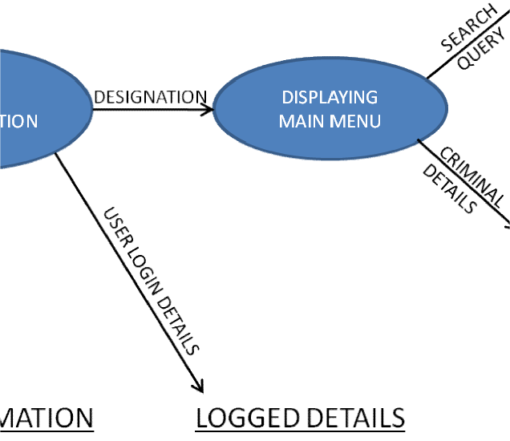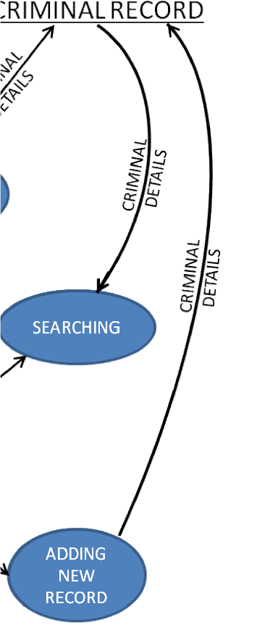

### ****4.3 Database Design****

The database consists of tables such as:

* **Users**: Manages login credentials and roles.
* **Criminals**: Stores criminal data.
* **Logs**: Tracks user actions.

## ****5. Implementation****

The CRMS implementation is divided into:

1. **Frontend**: Built using HTML, CSS for responsive design.
2. **Backend**: PHP for server-side logic and MySQL for database management.

## ****6. Testing****

### ****6.1 Testing Objectives****

1. Ensure data accuracy and security.
2. Validate user role-specific access.
3. Test performance under varying loads.

### ****6.2 Testing Strategies****

* **Unit Testing**: Verify each module (login, record management, reporting).
* **Integration Testing**: Ensure seamless interaction between frontend, backend, and database.
* **Stress Testing**: Test system under high user loads and data volumes.

## ****8. Conclusion****

The Criminal Records Management System (CRMS) addresses the need for an efficient and secure way to manage criminal data. By integrating advanced reporting the system enhances the decision-making capabilities of law enforcement agencies.

## ****9. References****

1. [GeeksforGeeks](https://www.geeksforgeeks.org/)
2. [Stack Overflow](https://stackoverflow.com/)
3. [W3Schools](https://www.w3schools.com/)
4. [Python Official Documentation](https://docs.python.org/)
5. [PHP Official Documentation](https://www.php.net/)