Khaoula Azdoud

08/11/2023

Module 1.3 Assignment: **Building a Web Page Exercise, Part 1**

1. **Link to your GitHub repository:**

[**https://github.com/Khaoulaab92/csd-340.git**](https://github.com/Khaoulaab92/csd-340.git)

1. **Take a screenshot of the validator results:**

1. **Take a screenshot of the updated results:**

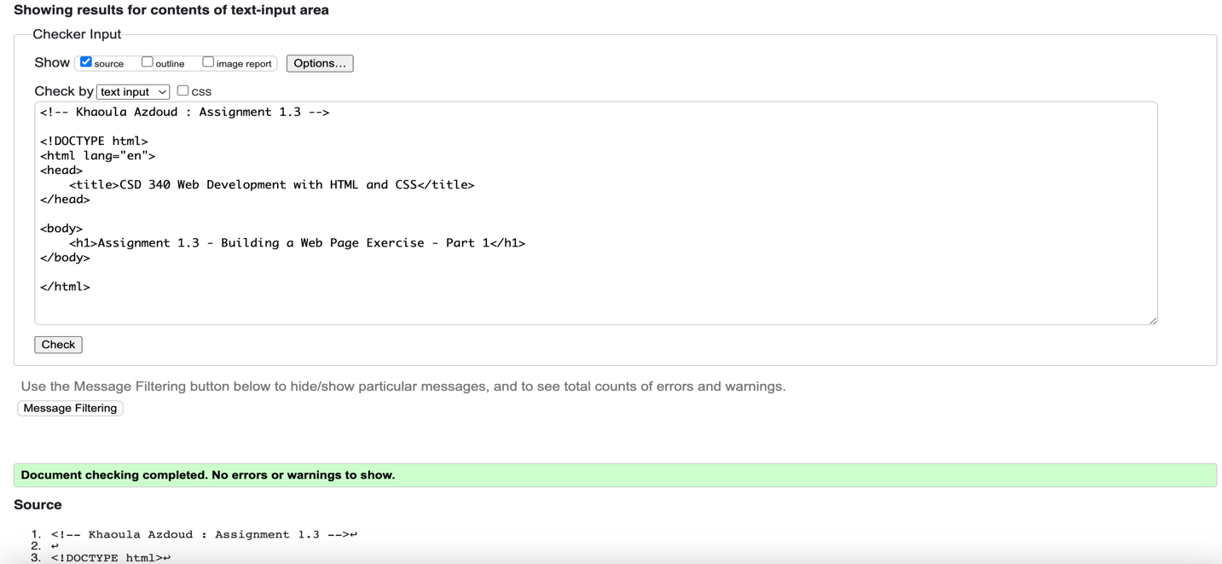

1. **Take a screenshot of the updated results:**

1. **Open the file in your computer's default browser and take a screenshot of the web page:**

