NON-INVASIVE CONTINUOUS HEALTH MONITOR
with Multimodal Sensing, Federated Learning, Privacy, and Edge Deployment

FINAL REVISED ML IMPLEMENTATION SPECIFICATION
B.Tech Academic Engineering / Research Project
Three-person ML team
Version 2.2
27 September 2026
Status: LOCKED CORE SPECIFICATION
Clinical status: research prototype only; not a diagnostic or clinical decision-support device.

DOCUMENT CONTROL
Field | Value
Document | Final Revised ML Implementation Specification
Version | 2.2
Date | 27 September 2026
Status | LOCKED core; extensions require version bump
Team | 3-person ML team
Scope | Data, signal processing, modeling, federation, privacy, deployment, validation, API/dashboard, testing, reproducibility
Clinical claim boundary | Research physiological-pattern monitoring only; no diagnosis, treatment recommendation, or clinical readiness claim

Change History
Version | Date | Status | Major change
1.x | Source documents | Baseline | Original development and work-division plans
2.0 | 27 September 2026 | Superseded | First adversarial correction of target, dataset roles, leakage controls, multimodal claims, FL, privacy and deployment.
2.1 | 27 September 2026 | Superseded | Lead policy, stateful causal resampling, alert-episode debouncing, quality-aware multimodal experiment, simulated-site claim boundary, seed policy and PTB-XL removal.
2.2 | 27 September 2026 | LOCKED | Final micro-fix freeze: training-only majority baseline; explicit causal short-gap policy; shared explicit AAMI_SVF_MAP_V1 for MIT-BIH/INCART; locked Integrated Gradients parameters; cluster-bootstrap metric computation; calibration/API wording tightened.

Source Documents Used
- NHM — ML Development Plan (uploaded source).
- NHM — Detailed ML Work Division & Execution Plan (uploaded source).
- Master Prompt — Adversarial Audit + Complete Implementation Specification (uploaded source).
- Final v2.1 audit / micro-fix review (uploaded source).
- Authoritative external documentation listed in Section 43 / References.

TABLE OF CONTENTS
Right-click and update field in Word to populate the table of contents.

1. EXECUTIVE SUMMARY
This specification replaces the baseline plan where necessary. The project remains a wearable physiological-monitoring and federated-learning research prototype, but its core ML target is narrowed to an implementable, label-consistent task: detection of 10-second single-lead ECG windows containing at least one mapped AAMI S/V/F beat (the project-defined AAMI_SVF_WINDOW_V1 target). PPG, SpO2, and HR remain first-class monitored modalities, but they are used for quality/context and deterministic decision-level fusion rather than being falsely presented as a jointly supervised arrhythmia classifier when the available synchronized multimodal dataset does not carry compatible arrhythmia labels.
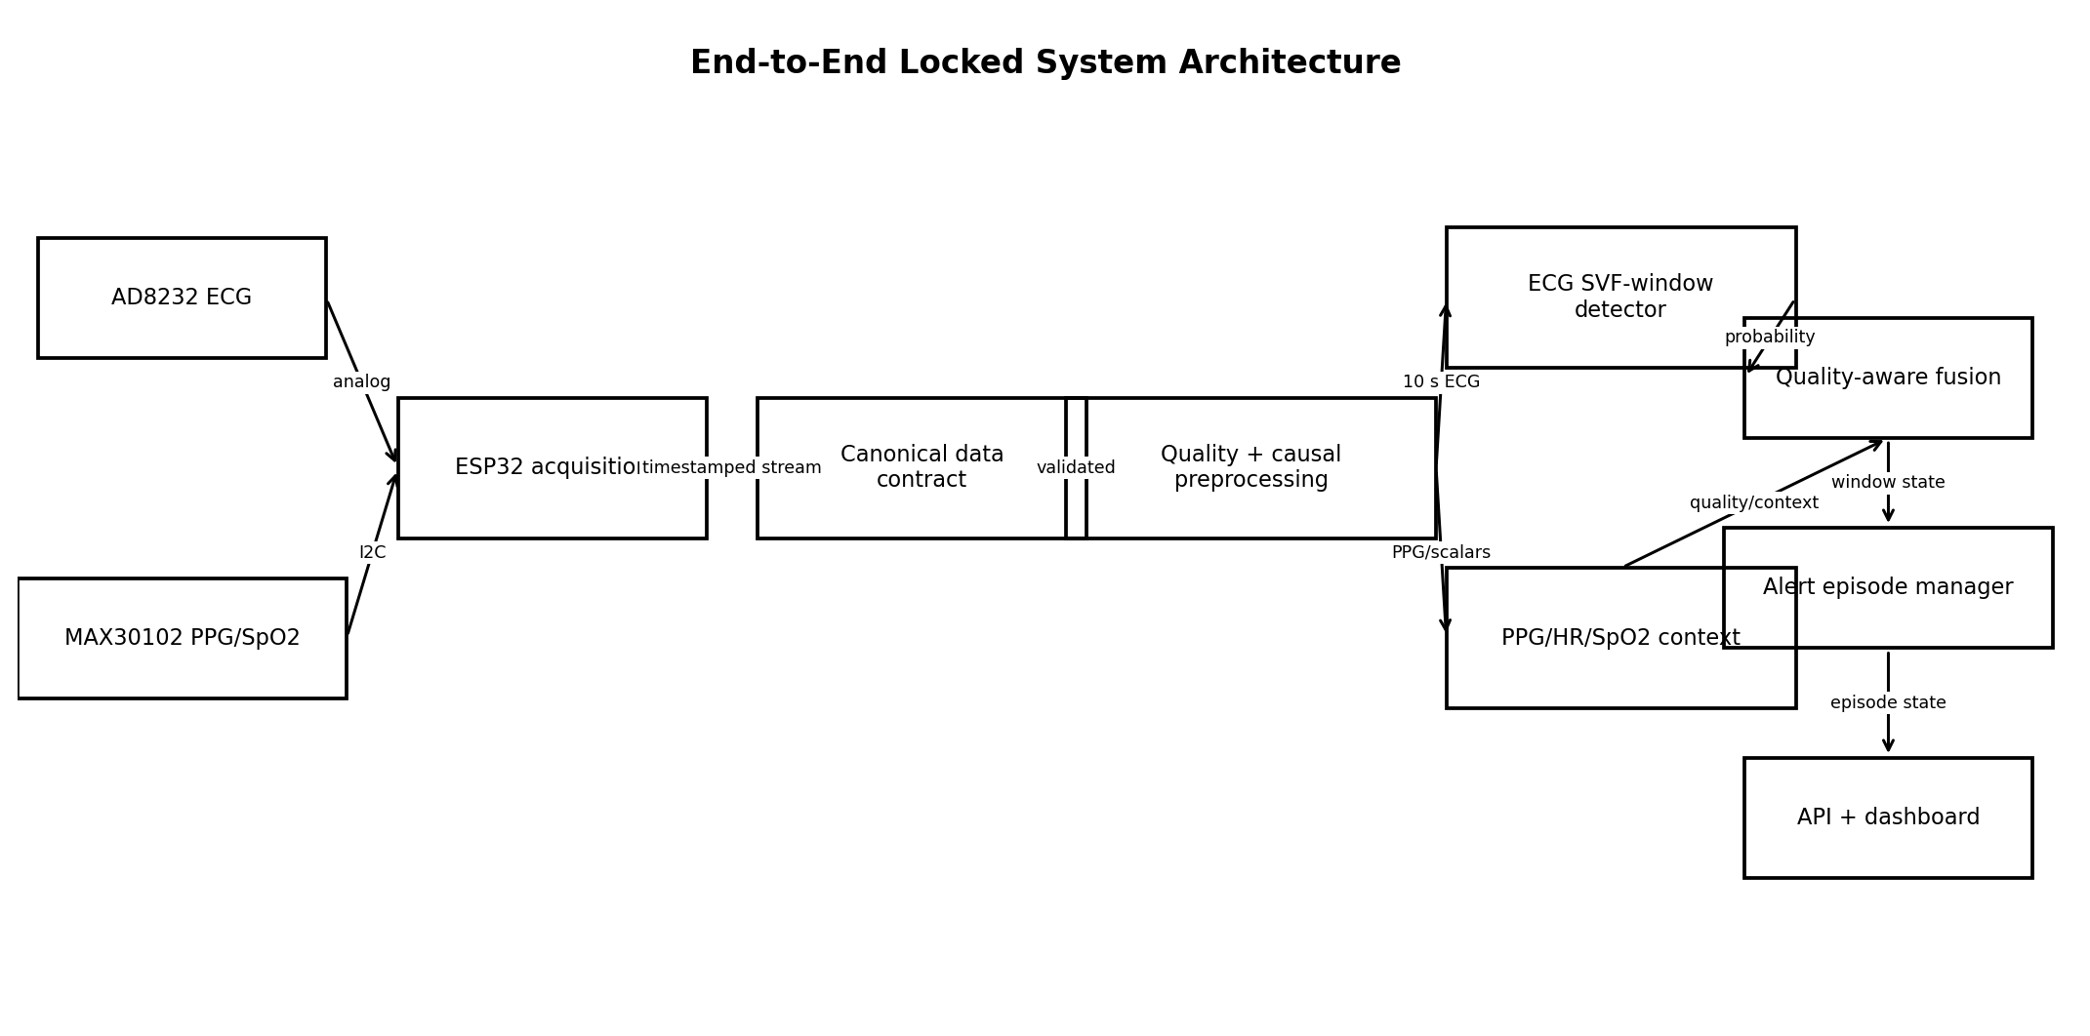
Figure 1. End-to-end locked architecture.

1.1 Adversarial Audit — Major Corrections
Severity | Baseline decision / weakness | Why it fails | Locked correction
CATASTROPHIC | PTB-XL as primary ECG development set for the core rhythm task | Its record-level diagnostic/rhythm statements do not match the beat-annotation-derived 10-second SVF-window target and add avoidable scope. | MIT-BIH is the sole core development dataset for the beat-annotation-derived AAMI_SVF_WINDOW_V1 target; PTB-XL is removed from v2.2 execution scope.
CATASTROPHIC | BIDMC used to prove ECG+PPG+SpO2 improves abnormality classification | BIDMC provides synchronized signals and physiologic numerics but no compatible beat-level arrhythmia target for the proposed classifier. | No learned multimodal arrhythmia claim. PPG/SpO2/HR are quality/context channels; BIDMC validates synchronization, signal processing, HR/pulse consistency, and failure handling.
CATASTROPHIC | MIT-BIH treated as external validation while also being the most appropriate labeled rhythm data | This wastes the only directly aligned beat-annotated source and makes target definition inconsistent. | MIT-BIH is development/internal test; St Petersburg INCART is external validation using compatible beat annotations.
MAJOR | Preprocessing not explicitly causal | Zero-phase filtering, centered/offline resampling, whole-record normalization, or interpolation across a boundary can leak future information into streaming predictions. | All deployment-relevant transforms, including resampling, are stateful and causal; fitting is train-only; no result at t may depend on samples after t.
MAJOR | Patient-level split principle without a complete example/statistics unit policy | Overlapping windows remain correlated; window-level confidence intervals would be anti-conservative. | Split patients before cached windows; patient-cluster bootstrap and patient-macro metrics are required.
MAJOR | Federated clients described as patient groups without a controlled construction algorithm | Arbitrary row splits can leak patients or confound label/quantity/feature skew. | Eight simulated sites are constructed only from whole training patients; client manifests are frozen and audited.
MAJOR | Edge target ambiguous between ESP32 and a workstation | Running on a laptop does not prove MCU feasibility; PyTorch checkpoints do not deploy directly to an ESP32. | Mandatory inference target is the local CPU gateway. ESP32 performs acquisition; MCU inference is an optional extension after a separate benchmark.
MAJOR | Secure aggregation and DP scope could exceed a three-person schedule | Adding several privacy mechanisms before the core experiment is stable makes failures uninterpretable. | SecAgg+ is the mandatory privacy mechanism. DP is extension-only, not required for project completion.
MAJOR | Single-lead input left without an exact public-dataset channel rule | Choosing a channel after observing performance creates an untracked model-selection degree of freedom and weakens external validation. | MIT-BIH core input is the channel explicitly named MLII; records without MLII are excluded before splitting. INCART external input is standard Lead II; no performance-driven fallback.
MAJOR | 5-second rolling windows had no alert-episode semantics | One event can trigger multiple overlapping positive windows, inflating false-alert counts and causing dashboard chatter. | A locked episode manager requires two consecutive VALID above-threshold windows to open an episode, two consecutive below-threshold windows to close it, and a 30-second cooldown.
MAJOR | Multimodal context had engineering tests but no direct research experiment | Person 2 could validate plumbing without demonstrating whether context changes monitoring behavior. | Add a controlled ECG-only versus quality-aware monitor experiment measuring degradation-induced excess alert episodes, prediction suppression, recheck rate and state chattering.
MAJOR | Majority baseline wording allowed test prevalence to determine the predicted class | A baseline defined from held-out labels leaks test-distribution information into model definition. | Determine the majority class from training labels only, freeze it, then evaluate unchanged on validation/calibration/test/external partitions.
MAJOR | Gap handling specified only what not to do for gaps >100 ms | Short-gap interpolation could still use a future sample and violate the time-t invariant. | For gaps <=100 ms use causal zero-order hold from the most recent valid sample, emit a gap mask and downgrade quality; gaps >100 ms make spanning windows UNUSABLE and reset streaming state.
MAJOR | INCART external labels were described as compatible without an explicit mapping contract | Different symbol handling across development and external datasets can silently change the target. | Use one explicit AAMI_SVF_MAP_V1 allowlist for both MIT-BIH and INCART; all unlisted beat symbols are excluded and a source-symbol census is mandatory before G4.
MINOR | Explainability allowed either saliency or Integrated Gradients | Choosing the method after inspecting plots is another hidden analysis degree of freedom. | Lock Integrated Gradients on the pre-sigmoid logit with zero baseline in normalized input space, 64 Gauss-Legendre steps, signed attribution export and normalized absolute-attribution overlay.

1.2 Research Contribution
- Leakage-safe single-lead AAMI-SVF-containing-window detection with patient-disjoint internal and external validation.
- Controlled federated learning under IID and whole-patient non-IID site partitions, comparing FedAvg and FedProx under matched budgets.
- Explicit signal-quality gating and a controlled ECG-only versus quality-aware multimodal monitoring experiment using ECG, PPG, SpO2 and HR without unsupported diagnostic fusion claims.
- Privacy demonstration with secure aggregation plus communication/resource accounting.
- Actual AD8232/MAX30102 domain validation through the same versioned preprocessing and API interfaces.

2. PROJECT DEFINITION

2.1 Problem Statement
Build a non-invasive research prototype that continuously acquires ECG and PPG-derived physiology, detects evidence that the recent single-lead ECG window contains mapped AAMI S/V/F beats, distinguishes poor acquisition from physiological alerts, demonstrates federated training under heterogeneous clients, protects individual client updates with secure aggregation, and exposes results through a reproducible local API/dashboard.

2.2 Research Questions
1. RQ1: On patient-disjoint MIT-BIH data, how well can a lightweight 1D CNN distinguish 10-second windows containing at least one mapped AAMI S/V/F beat from windows containing only mapped N-class beats?
2. RQ2: How much does performance degrade under controlled ambulatory ECG noise and on the independent INCART dataset?
3. RQ3: Under identical model, data pool, rounds, and local training budget, how do FedAvg and FedProx differ under IID, label-skew, quantity-skew, and feature/noise-skew site partitions?
4. RQ4: What are the global, mean-client, and worst-client performance/communication trade-offs of federated training?
5. RQ5: Under controlled sensor-degradation scenarios, does the locked quality-aware ECG+PPG+SpO2+HR monitor reduce degradation-induced excess alert episodes and state chattering relative to the same ECG detector operated without multimodal quality/context gating?
6. RQ6: What computation, memory, latency, communication, and secure-aggregation overhead is required by the deployable pipeline?

2.3 Scope and Non-Scope
In scope | Out of scope
Single-lead AAMI-SVF-containing-window detection; signal quality; PPG/SpO2/HR context; FL simulation; secure aggregation; gateway inference; real hardware domain validation. | Disease diagnosis; 12-lead interpretation; treatment advice; clinical-grade SpO2 validation; clinical certification; prospective clinical outcome prediction; claims of patient safety or clinical readiness.

2.4 Core Invariant
NO COMPUTATION USED FOR A RESULT AT TIME t MAY DEPEND ON INFORMATION UNAVAILABLE BY TIME t.

3. SYSTEM ARCHITECTURE
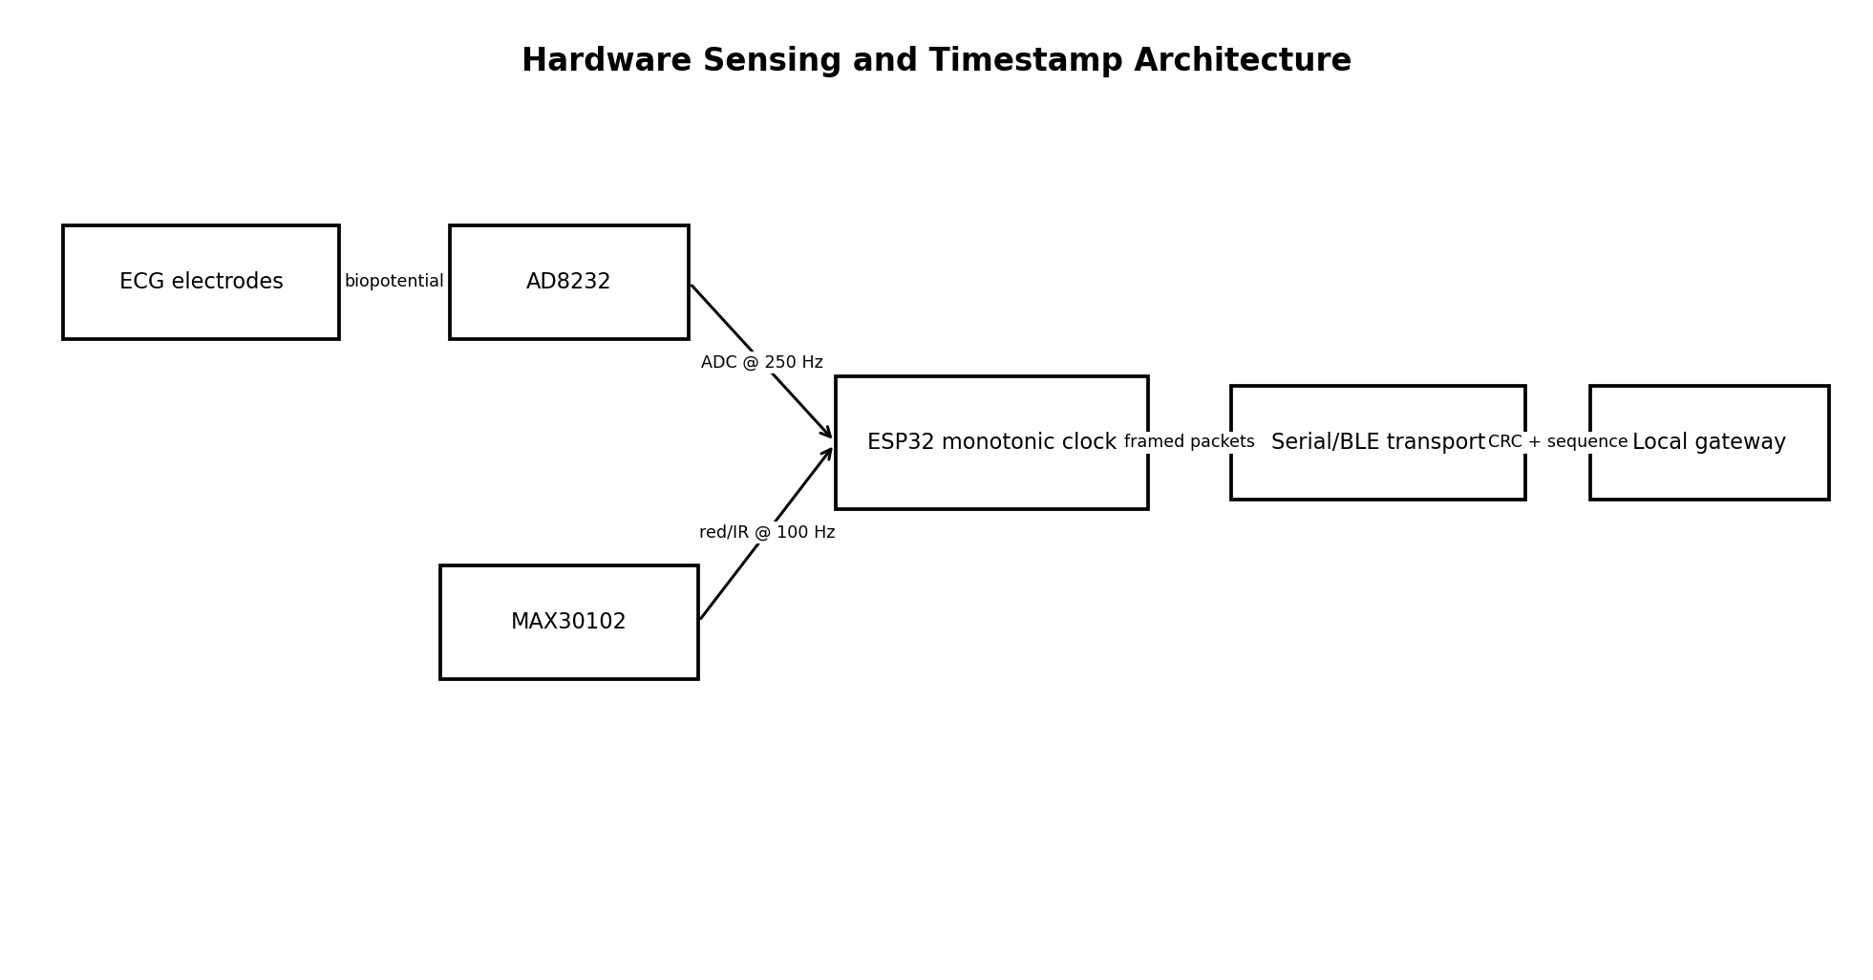
Figure 2. Hardware sensing and timestamp architecture.
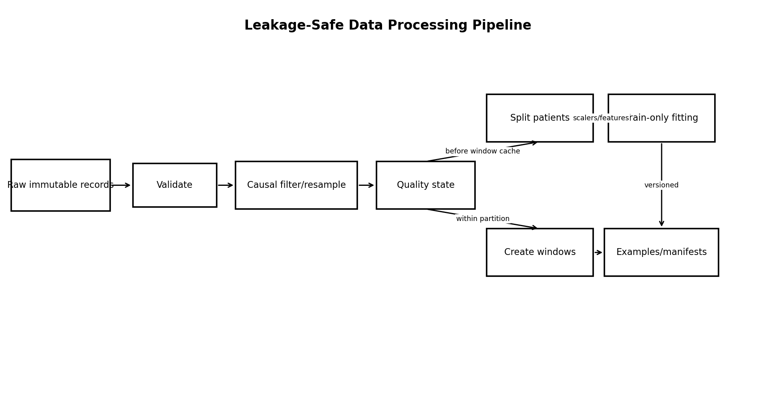
Figure 3. Leakage-safe data pipeline.
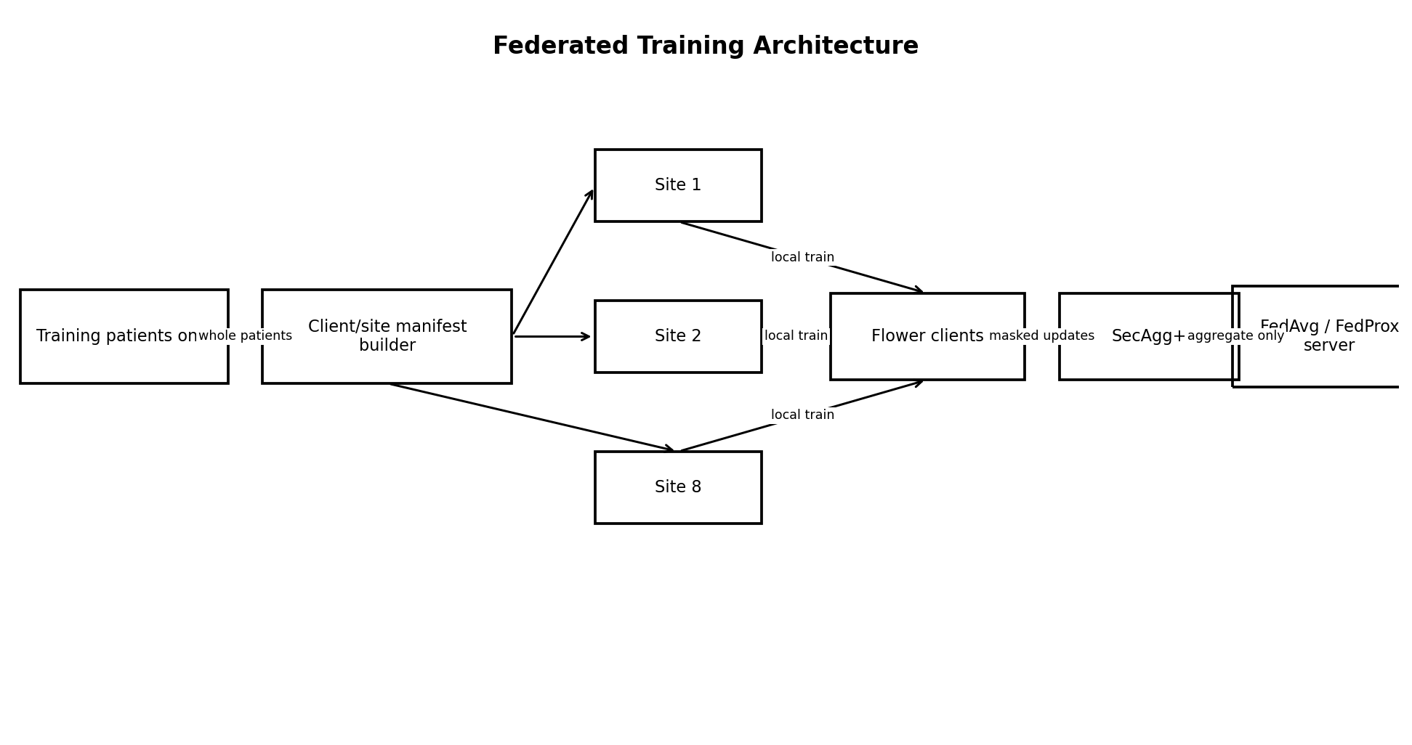
Figure 4. Federated training architecture.
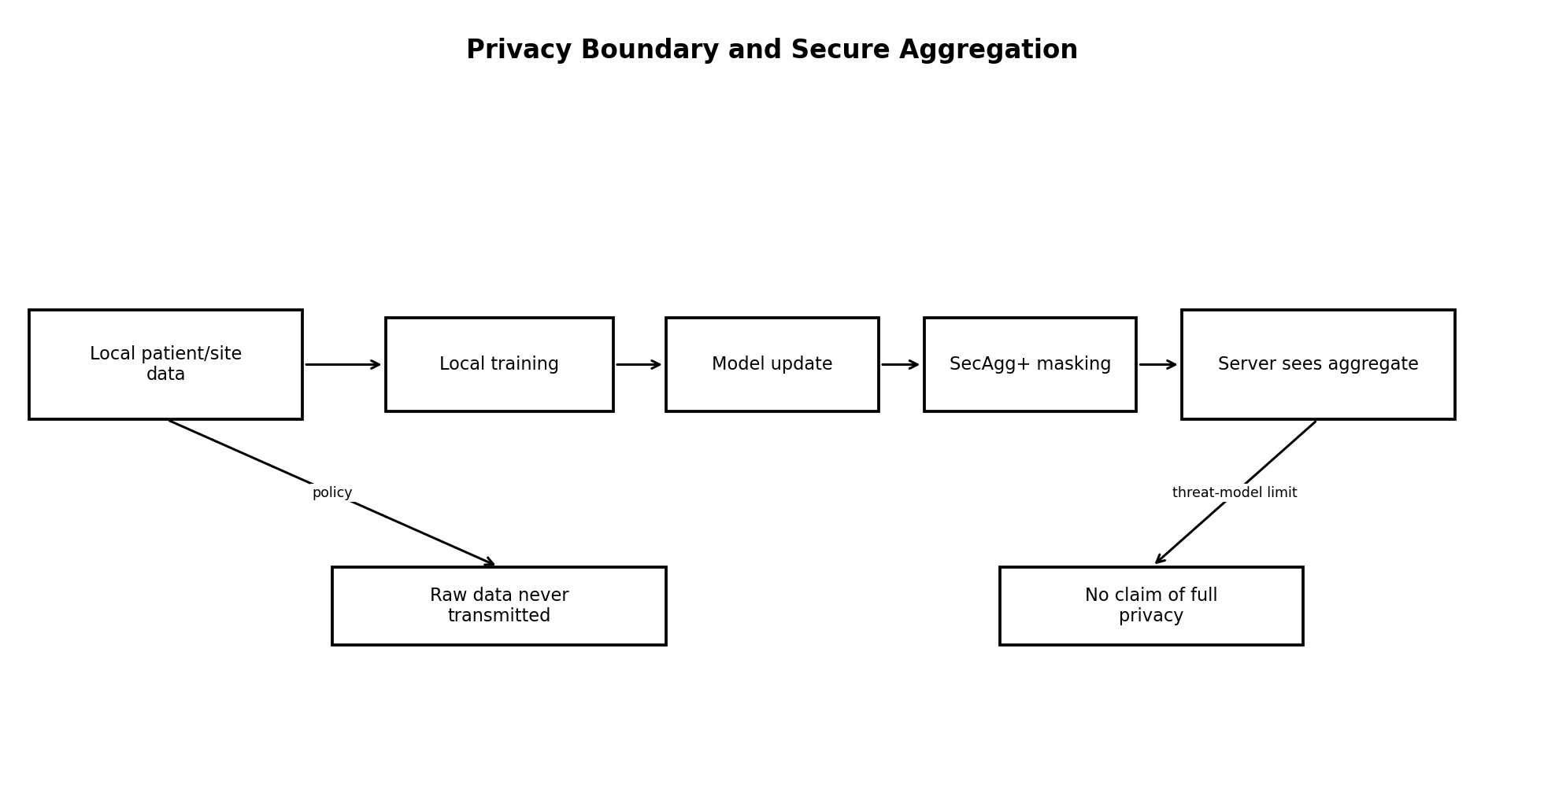
Figure 5. Privacy boundary.
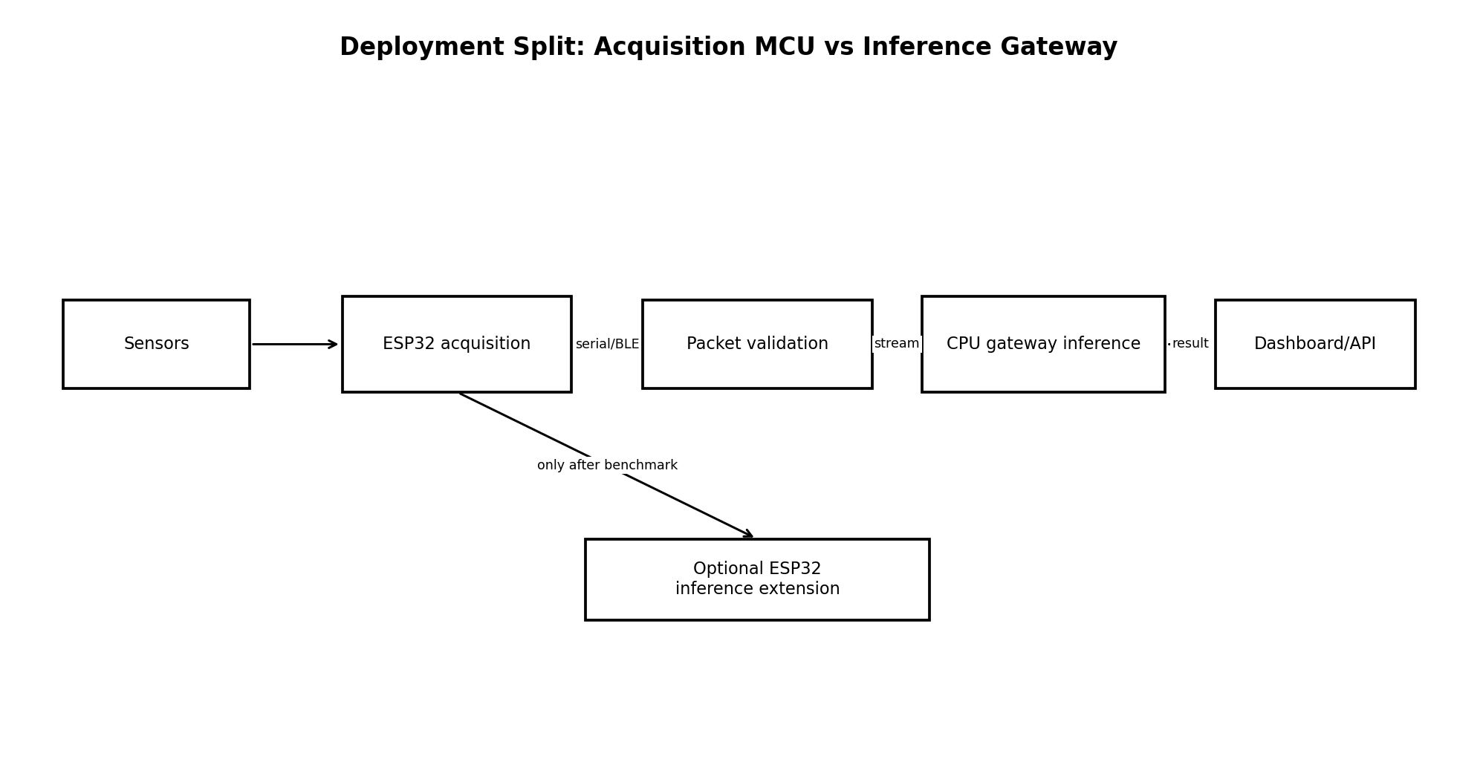
Figure 6. Deployment split.
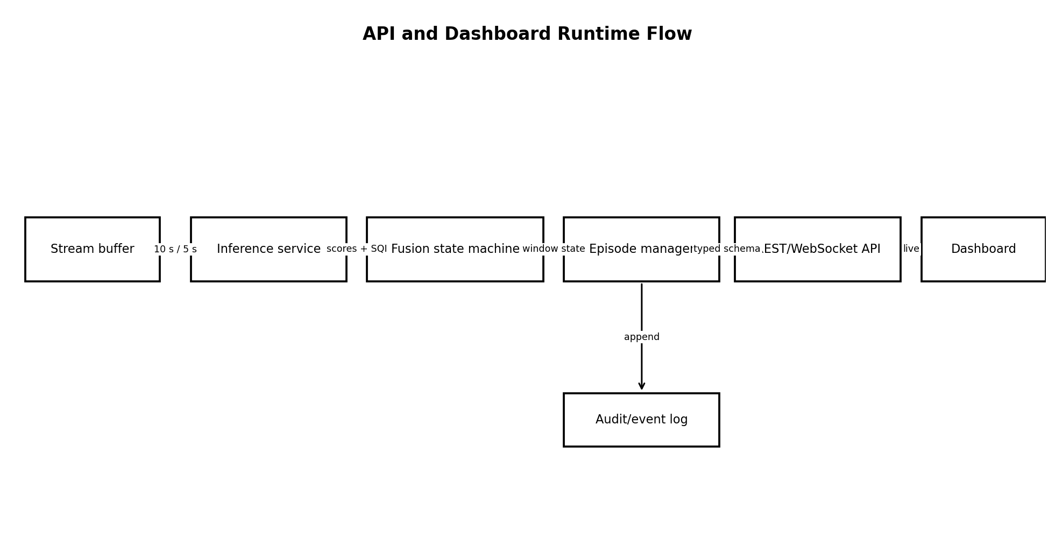
Figure 7. API/dashboard runtime flow.
Architecture dependency order: hardware → raw immutable data → contract validation → causal preprocessing → quality state → patient split → window creation → centralized baselines → locked ECG model → federated experiments → secure aggregation → gateway deployment → wearable domain validation → API/dashboard → final evidence package.

4. HARDWARE AND SENSOR SPECIFICATION
Component | Locked role | Project configuration | Output | Verification required
AD8232 | Analog ECG front end | Single acquisition channel; ECG sampled by ESP32 at 250 Hz | raw ADC count + sample_index + timestamp_us | Exact electrode placement, board gain/filter components, ADC attenuation/reference, usable dynamic range
MAX30102 | Red/IR PPG sensing | 100 Hz red + IR samples; fixed register configuration per firmware version | red_raw, ir_raw, sample_index, timestamp_us | LED current, pulse width, ADC range, sample averaging and actual achieved rate
SpO2 | Derived scalar | Updated at 1 Hz by the selected algorithm; never treated as laboratory ground truth | spo2_pct + valid flag + algorithm_version | Algorithm provenance and validation on the exact module
HR | Derived scalar | ECG HR and PPG pulse rate maintained separately at 1 Hz; disagreement is retained | hr_ecg_bpm, pr_ppg_bpm, validity flags | Derivation implementation and behavior during poor SQI
ESP32 | Acquisition/timestamp MCU | Monotonic microsecond clock; packet sequence numbers; sensor configuration in every session manifest | framed stream | Exact ESP32 variant, ADC behavior, timer jitter and transport throughput
Transport | ESP32 → gateway | Serial is reference implementation; BLE may be added behind same packet schema | framed packets + CRC/checksum | Chosen production demo transport

4.1 Timestamp Rules
- Every waveform sample has monotonically increasing sample_index and timestamp_us from the ESP32 clock.
- Wall-clock UTC is session metadata only and is not required for within-session alignment.
- Packet loss is detected by sequence/sample-index gaps. Gaps <=100 ms use only causal zero-order hold from the last valid sample, are marked in gap_mask, and force at least DEGRADED quality; gaps >100 ms are never filled, break the continuous segment, reset streaming preprocessing state, and make any spanning inference window UNUSABLE.
- Gateway timestamps are receive-time metadata only and never replace device acquisition timestamps.

5. DATA CONTRACT

5.1 Canonical Session Manifest
Field | Type | Rule
participant_id | string | Pseudonymous identifier; never infer demographics from it.
session_id | string | Unique per acquisition session.
device_id | string | Pseudonymous hardware identifier.
firmware_version | string | Required.
sensor_config_hash | string | Hash of frozen register/ADC configuration.
start_utc | ISO-8601|null | Optional wall clock; alignment uses monotonic time.
activity | enum | rest_seated / standing / walking / small_motion / unknown.
dataset_id | string | Public dataset or WEARABLE_V1.
contract_version | string | HARDWARE_DATA_CONTRACT_V1.

5.2 Canonical Waveform Record
Field | Type | Unit / meaning
participant_id | string | group key
session_id | string | session key
timestamp_us | int64 | microseconds since device session start
sample_index | int64 | monotonic source index
ecg_raw | int|null | ADC counts; mV only after calibration
ppg_red_raw | int|null | sensor counts
ppg_ir_raw | int|null | sensor counts
spo2_pct | float|null | derived % with validity flag
hr_ecg_bpm | float|null | derived
pr_ppg_bpm | float|null | derived
ecg_quality | enum | VALID/DEGRADED/UNUSABLE
ppg_quality | enum | VALID/DEGRADED/UNUSABLE
source | string | provenance
preprocess_version | string | pipeline version

5.3 Example Record
{"participant_id":"P007","session_id":"S20260927_01","timestamp_us":12500000,"sample_index":3125,"ecg_raw":1874,"ppg_red_raw":82311,"ppg_ir_raw":90211,"spo2_pct":97.0,"spo2_valid":true,"hr_ecg_bpm":72.4,"pr_ppg_bpm":71.8,"ecg_quality":"VALID","ppg_quality":"VALID","contract_version":"HARDWARE_DATA_CONTRACT_V1"}

6. DATASET STRATEGY
Dataset | Core role | Key source fact | Allowed conclusion | Not allowed
MIT-BIH Arrhythmia v1.0.0 | Development + internal test | 48 half-hour, 2-channel ambulatory ECG recordings from 47 subjects; 360 Hz; beat annotations | Train/evaluate AAMI_SVF_WINDOW_V1 on the locked MLII channel | Population-wide clinical performance or disease diagnosis
St Petersburg INCART v1.0.0 | External validation | 75 half-hour 12-lead recordings from 32 Holter records/patients; 257 Hz; >175k beat annotations | Cross-dataset robustness after a locked channel/resampling/mapping procedure | Claim equivalence to the wearable or to 12-lead diagnosis
MIT-BIH Noise Stress Test v1.0.0 | Noise robustness | Ambulatory baseline-wander, muscle, electrode-motion noise and noisy ECG records | Performance degradation under controlled noise | General robustness to every real-world artifact
BIDMC PPG & Respiration v1.0.0 | Multimodal engineering validation | 53 eight-minute critical-care records; ECG/PPG 125 Hz; HR/RR/SpO2 1 Hz | Synchronization, PPG processing, HR/pulse agreement, missingness/quality behavior | Supervised AAMI-SVF/arrhythmia improvement from multimodal fusion
WEARABLE_V1 | Domain validation | Team-collected synchronized AD8232 + MAX30102 sessions | Pipeline compatibility, signal quality, timing, latency, qualitative/domain-shift evidence | Disease sensitivity/specificity without clinical labels

6.1 Dataset Decision Rationale
The source plan attempted to make one multimodal supervised classification program from datasets with different modalities and label semantics. The locked design refuses that merge. Each dataset has a single declared role, and conclusions cannot cross that role. PTB-XL is intentionally removed from the executable v2.2 plan because it does not answer a mandatory research question.

6.2 Locked ECG Channel Policy
Dataset / source | Locked channel rule | Failure handling | Rationale
MIT-BIH Arrhythmia | Use the signal whose WFDB header channel name is exactly MLII. Channel index is not assumed. | If a record has no MLII channel, exclude that record before patient splitting and record the exclusion in the dataset manifest. No V1/V5 fallback in the core study. | Prevents performance-driven lead selection and approximates the intended single-channel wearable axis more closely than mixing leads.
St Petersburg INCART | Use the standard lead whose header name is exactly II for every external record. | If Lead II is missing/malformed, exclude the record before the first external evaluation and log it. Never select another lead based on external performance. | Creates one a-priori external channel and avoids 12-lead cherry-picking.
WEARABLE_V1 | Use one fixed Lead-II-like / MLII-inspired AD8232 placement for all sessions; exact electrode positions are frozen in HARDWARE_DATA_CONTRACT_V1 after bench/supervisor verification. | A changed placement creates a new hardware-contract version and cannot be silently mixed. | Maintains a stable single-channel domain while avoiding a claim that the low-cost setup is electrically identical to a clinical lead.

The record and patient counts used in all later tables/reports are the post-channel-policy counts, not the raw database counts. The exclusion list is generated before any split or model training.

7. DATA ACQUISITION AND STANDARDIZATION
1. Download/version the exact public dataset release; store source URL, version, hash, license, and download date in dataset_manifest.yaml.
2. Parse records with WFDB or the dataset-provided format.
3. Validate record count, channel count, sampling rate, annotations, finite values, duration, patient/record identifiers, and duplicate hashes; emit an annotation-symbol census before target mapping.
4. Map source patient identifiers to project participant_id without losing the original source ID in provenance.
5. Convert waveforms into canonical float arrays in physical units only when calibration metadata supports conversion; otherwise preserve raw units.
6. Store standardized data separately from raw; raw data is immutable.
7. Create split manifests by patient before exporting window caches.
8. Generate window caches independently within each partition so no overlapping or neighboring windows cross partitions.

7.1 Dataset Build Pseudocode
def build_dataset(spec):
raw = download_exact_version(spec.url, spec.version, expected_hashes=spec.hashes)
records = parse(raw)
validate_schema_and_annotations(records)
write_annotation_symbol_census(records)
records = select_locked_lead(records, LEAD_POLICY_V1) # MLII for MIT-BIH; II for INCART
patients = resolve_patient_groups(records)
split = make_group_split(patients, split_spec=LOCKED_SPLIT_SPEC)
for partition in ["train","val","calibration","test"]:
sessions = select_records(records, split[partition])
processed = [causal_preprocess(s) for s in sessions]
windows = make_windows(processed, label_rule=AAMI_SVF_WINDOW_V1)
write_partition_cache(partition, windows, manifest_hash=hash(split))
run_leakage_tests()

8. SIGNAL PROCESSING
Stage | ECG | PPG | Leakage rule
Validation | finite, monotonic samples, gap map | finite, saturation/gap map | uses current/past only
Resample | stateful causal rational/polyphase resampler to 250 Hz; FIR state retained across chunks | stateful causal resampler to 100 Hz where needed | each output sample may use only input samples at or before its output timestamp; deterministic group delay is accounted for; no centered whole-record resample_poly path
Filter | causal 4th-order Butterworth 0.5–40 Hz SOS | causal 4th-order Butterworth 0.5–8 Hz SOS | sosfilt/stateful; no filtfilt
Normalize CNN input | per-window z-score with epsilon; window ends at t | per-window robust scaling for quality/context only | window contains only ≤t samples
Features | RR/QRS/statistics; scaler fit on training only | pulse interval/amplitude/quality; scalers training-only | no patient-global or full-dataset fit
Segmentation | 10 s, 5 s stride | aligned 10 s context window | right edge defines prediction time

8.1 Quality States
State | Meaning | Runtime action
VALID | No hard failure and quality checks pass | Allow inference/fusion.
DEGRADED | Usable but artifact indicators elevated | Run model but lower trust; dashboard shows degraded quality.
UNUSABLE | Missing/gap/flatline/clipping or detector-consistency failure makes interpretation unreliable | Suppress physiological alert; return RECHECK_SENSOR.

Quality thresholds are engineering parameters validated on training/noise-development data and stored in QUALITY_V1.yaml. They are not clinical thresholds. The held-out test sets cannot be used to tune them.

8.2 Causal Resampler Contract
- Implement the production resampler as a stateful streaming rational/polyphase FIR (for example, a tested upfirdn/polyphase wrapper with explicit state); do not call a centered whole-record convenience resampler that can use future samples.
- For MIT-BIH 360→250 Hz and INCART 257→250 Hz, ratio, FIR coefficients, state initialization, group delay and timestamp mapping are versioned in PREPROC_V1.
- Chunking a session at arbitrary boundaries must reproduce the same samples as one continuous causal stream, within numerical tolerance.
- Causality test: append arbitrary future samples after cutoff t; every resampled output timestamped ≤t must remain unchanged.
- LOCKED GAP_POLICY_V1: if a source gap is >0 and <=100 ms, fill only the missing source-time positions by zero-order hold of the most recent valid pre-gap sample; set gap_mask=1 for all filled positions and downgrade any affected analysis window to at least DEGRADED. The first post-gap real sample is processed only when it actually arrives and never retroactively changes earlier outputs.
- If a gap is >100 ms, perform no fill, terminate the current continuous segment, reset filter/resampler state at the next valid sample, and mark every 10-second inference window spanning the discontinuity UNUSABLE. No interpolation may use a post-gap/future sample for any earlier timestamp.
- Gap causality test: for both short and long synthetic gaps, replacing or removing every post-gap sample must leave all outputs timestamped before those samples unchanged; verify the short-gap fill values equal the last pre-gap sample exactly.

9. LABEL AND TARGET SPECIFICATION

9.1 Primary Target: AAMI_SVF_WINDOW_V1
For a 10-second ECG window ending at prediction time t, map beat annotations that fall inside [t−10 s, t] into AAMI-style superclasses. N-class symbols are treated as the reference class; S, V, and F classes define the positive SVF-containing-window event; Q/unknown/paced or unmappable beats make the affected window ineligible for the binary core target unless all included beats are otherwise mappable and Q count is zero.
Condition | Target
≥1 mapped S/V/F beat and no Q/unknown beat | 1 = SVF_CONTAINING_WINDOW
All mappable beats are N-class and no Q/unknown beat | 0 = N_ONLY_WINDOW
Any Q/unknown/unmappable/paced beat | EXCLUDE from core supervised target
Fewer than 5 mappable beats | EXCLUDE
Window quality UNUSABLE | EXCLUDE from training; runtime returns RECHECK_SENSOR

9.2 Shared Beat Mapping: AAMI_SVF_MAP_V1
The exact same allowlist mapping is applied to MIT-BIH development data and INCART external data. INCART states that its annotations follow the standard PhysioBank beat-annotation definitions; nevertheless, the project does not infer a class for any symbol outside the frozen allowlist. This intentionally conservative mapping prevents external-target drift.
Source beat annotation symbol(s) | Mapped project class | Core-target handling
N, L, R, e, j | N | Eligible reference beat
A, a, J, S | S | Eligible positive-class beat
V, E | V | Eligible positive-class beat
F | F | Eligible positive-class beat
/, f, Q | Q | Window excluded from core binary target
? or any beat symbol not explicitly listed above | UNMAPPABLE | Window excluded; never silently coerce to N/S/V/F
Non-beat annotations such as rhythm/noise/comment markers | NOT_A_BEAT | Ignored for beat-class target mapping; may be consumed separately by quality/provenance logic

- Before G4, generate annotation_symbol_census.csv separately for MIT-BIH and INCART with raw symbol counts and mapped/excluded counts.
- The mapper is a pure versioned function. The external dataset may not introduce a new symbol-to-class rule after MODEL_V1 is frozen; any mapping change requires AAMI_SVF_MAP_V2 and invalidates the previous external-comparison claim.
- Unit tests must contain every allowlisted symbol plus unknown, paced and non-beat examples.

9.3 Output Semantics
The model output is P(SVF_CONTAINING_WINDOW | ECG samples in the most recent 10 seconds). This is a probability for the project-constructed window target, not a conventional beat-classifier output, not a probability that the user has an arrhythmia or heart disease.

9.4 Timestamp Logic
The prediction timestamp is the right edge of the window. The label is descriptive of the observed window, not a future forecast. There is no future prediction horizon in the core task.

10. TRAINING EXAMPLE CONSTRUCTION
One model example = one participant/session + one 10-second ECG window + prediction timestamp t + quality state + target label + provenance. A participant may generate many examples; this dependence is handled by patient-level splitting and patient-cluster statistics.
for session in partition_sessions:
y = causal_filter_and_resample(session.ecg)
for t in range(10s, session_end, 5s):
x = y[t-10s:t]
q = ecg_quality(x, history=session[:t])
label = label_from_annotations(session.annotations, t-10s, t)
if q != UNUSABLE and label in {0,1}:
emit(example_id, participant_id, session_id, t, x, q, label)

11. SPLITTING AND LEAKAGE PREVENTION

11.1 Locked Split
After the locked MLII channel rule and eligibility checks, remaining MIT-BIH patients are partitioned once into approximately 60% development-train, 15% model-selection validation, 10% calibration/threshold, and 15% internal test. Records 201 and 202 must be assigned to the same patient group. A deterministic patient-level stratification algorithm balances whether each patient contains mapped S/V/F events; the chosen manifest is frozen before model training and never regenerated based on model results.
Sample-size rule: the database contains only 47 source subjects before channel/eligibility exclusions, so the true statistical n is the number of eligible patients, not the number of overlapping windows. Every report must display patient counts per partition and per simulated site next to window counts. Window count must never be used to imply an independent sample size.
Partition | Use | Forbidden
Train | fit weights, feature/scaler parameters, augmentation | model selection from test outcomes
Validation | architecture/hyperparameter selection, early stopping | calibration/test reporting
Calibration | temperature scaling and operating threshold only | architecture changes
Internal test | one final locked evaluation | any tuning
INCART external | one locked cross-dataset evaluation | adaptation/tuning before primary report

11.2 Leakage Audit Matrix
Leakage Risk | Example | Prevention | Automated Test | Owner | Evidence
Patient overlap | same patient windows in train and test | group split before windows | assert disjoint participant_id sets | P1 | split_audit.json
201/202 duplicate subject | MITDB records from same subject separated | manual group override | assert group(record201)==group(record202) | P1 | mitdb_groups.csv
Overlapping windows | near duplicates split across partitions | windows built after patient split | hash neighborhood + group audit | P1 | window_audit.json
Whole-record normalization | test/future statistics influence a window | window normalization or train-fit scalers | fit-scope unit test | P1 | preprocess_tests.xml
Zero-phase filter | future samples affect output | causal SOS filter | impulse causality test | P1 | causality_test.json
Centered/offline resampling | future samples influence earlier resampled outputs | stateful causal rational/polyphase resampler with explicit group delay | future-append + chunk-equivalence resampler tests | P1 | resampler_causality.json
Gap filling | future/post-gap sample influences earlier filled values | GAP_POLICY_V1: <=100 ms causal zero-order hold + gap mask; >100 ms no fill, state reset and spanning windows UNUSABLE | short/long gap future-append + exact-fill test | P1/P2 | gap_tests.json
Feature selection | test used to choose features | train/val only | registry provenance check | P1 | experiment_registry.csv
Threshold/calibration | test used for threshold | calibration partition only | config source assertion | P1 | calibration.json
Client contamination | patient in multiple federated clients | whole-patient assignment | client-manifest disjointness test | P3 | client_audit.json
External adaptation | INCART results trigger retuning then re-reported as external | freeze model before first external run | checkpoint hash gate | All | release_manifest.json

12. BASELINE MODELS
Model | Input | Purpose | Locked evaluation
Majority baseline | single class chosen from TRAINING-partition label prevalence only; frozen before validation/test | sanity floor | evaluate the frozen predictor unchanged on every partition; never inspect held-out prevalence to choose the class
Logistic Regression | train-fit RR/QRS/statistical features | interpretable classical baseline | patient-macro F1 + pooled metrics
Random Forest | same feature set | nonlinear classical comparison | same split; no test tuning
1D CNN | raw normalized 10 s ECG | primary neural candidate | locked after validation

13. ECG MODEL

13.1 MODEL_V1 Architecture
Input: 1×2500 samples (10 s at 250 Hz). Architecture: Conv1d(1→16,k=7,stride=1) → BatchNorm → ReLU → MaxPool(2) → Conv1d(16→32,k=5) → BatchNorm → ReLU → MaxPool(2) → Conv1d(32→64,k=5) → ReLU → adaptive global average pooling → Dropout(0.2) → Linear(64→1). Sigmoid is applied only for inference; training uses BCEWithLogitsLoss with class weighting derived from the training partition.

13.2 Training Contract
Item | Locked decision
Optimizer | AdamW
Initial LR | 1e-3
Weight decay | 1e-4
Batch size | 64
Max epochs | 50
Early stopping | validation AUPRC, patience 7
LR scheduler | ReduceLROnPlateau on validation AUPRC
Seeds | Primary release seed = 20260927, predeclared before training. Seeds 20260928 and 20260929 are development robustness replicates; report validation mean ± SD and do not use them to choose the release checkpoint.
Checkpoint | best validation AUPRC; SHA-256 stored
Loss | BCEWithLogitsLoss with training-only positive weight
Augmentation | training-only amplitude scale ±10%, small baseline drift/noise from training resources; no time reversal

14. PPG / SpO2 MODELING
PPG/SpO2 is not trained to predict AAMI_SVF_WINDOW_V1 because the selected synchronized public dataset does not provide compatible beat-level S/V/F labels. Person 2 implements deterministic PPG filtering, pulse detection, pulse-rate estimation, signal-quality indicators, SpO2 validity/provenance tracking, ECG–PPG rate agreement, the alert-episode state machine, and the controlled quality-aware monitoring experiment in Section 15.2.

14.1 BIDMC Validation Tasks
- Verify 125 Hz ECG/PPG synchronization and 1 Hz physiologic parameter alignment.
- Compare derived PPG pulse rate to provided pulse-rate numerics and ECG-derived HR to provided HR numerics as engineering validation, not clinical certification.
- Test behavior under missing PPG, clipped PPG, dropouts, and intentionally degraded segments.
- Document critical-care domain mismatch and the absence of a compatible AAMI-SVF window target.

15. MULTIMODAL FUSION
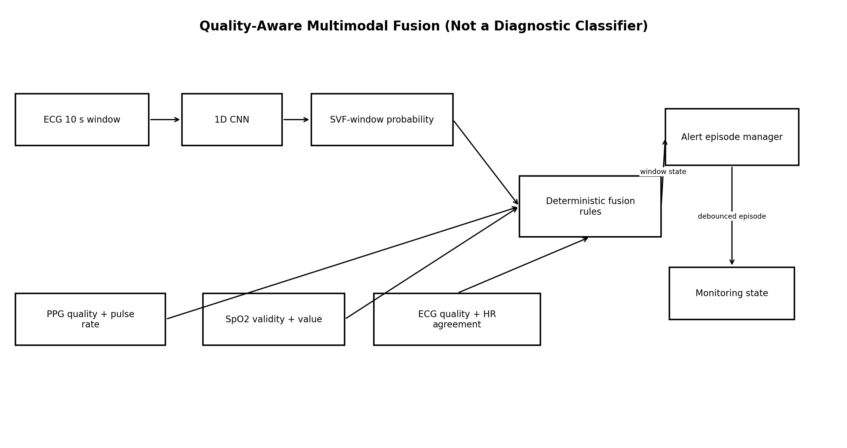
Figure 8. Quality-aware multimodal fusion.
The core fusion layer is a deterministic state machine rather than a learned clinical-risk MLP. This is the central correction that prevents label fabrication.
Condition | Monitoring state
ECG UNUSABLE | RECHECK_SENSOR; no SVF-pattern alert
ECG VALID/DEGRADED and SVF-window probability below locked threshold | NORMAL_MONITORED_PATTERN; quality shown
ECG VALID and probability ≥ threshold | ABOVE_THRESHOLD_VALID_WINDOW; eligible to advance alert episode counter
ECG DEGRADED and probability ≥ threshold | RECHECK_SENSOR + POSSIBLE_PATTERN; cannot open a confirmed alert episode
PPG/SpO2 unavailable but ECG valid | ECG-only result; mark context unavailable
ECG/PPG HR disagreement > configured tolerance for ≥10 s | QUALITY_WARNING; retain both values; do not overwrite

15.1 Alert Episode Aggregation / Debouncing
Window-level predictions are produced every 5 seconds from 10-second windows, but user-visible alerts are episode-level. The default ALERT_POLICY_V1 is an engineering policy, not a clinical threshold: two consecutive VALID above-threshold windows open one POTENTIAL_ECTOPY_ASSOCIATED_PATTERN episode; two consecutive VALID below-threshold windows close an active episode; after closure, a 30-second cooldown prevents a new episode from opening. DEGRADED windows may show POSSIBLE_PATTERN but do not advance the open counter. UNUSABLE ECG immediately produces RECHECK_SENSOR, clears the open-confirmation counter, and pauses alert counting until usable data resumes. Any K/M/cooldown change requires a policy version bump and may be tuned only on train/validation/calibration resources, never test or INCART outcomes.
Metric | Locked episode definition
Alert episodes/hour | Number of episode-open transitions divided by usable monitoring hours; overlapping positive windows inside one episode count once.
Degradation-induced excess alert episodes | Alert episodes on a deliberately degraded copy minus episodes on its time-aligned clean/reference copy.
State chattering | Number of user-facing state transitions/hour excluding expected session start/stop.
Recheck rate | RECHECK_SENSOR time or episode count per usable hour.
Prediction suppression rate | Fraction of candidate windows intentionally suppressed because ECG is UNUSABLE.

15.2 Controlled Quality-Aware Multimodal Experiment
Compare two monitors with the identical locked ECG model, probability threshold, window cadence and episode-debouncing parameters: A) ECG-only monitor, which uses only ECG quality hard failures; B) quality-aware multimodal monitor, which additionally uses PPG quality, SpO2 validity/provenance and ECG–PPG rate-consistency rules. Apply deterministic degradation scenarios to time-aligned copies of BIDMC and WEARABLE_V1 streams: clean reference, ECG clipping/dropout/noise, PPG clipping/dropout, missing PPG, cross-modal rate disagreement, and motion-tagged wearable segments. Because these datasets do not provide the AAMI-SVF target, this experiment does NOT estimate sensitivity/specificity for ectopy. Its primary outcome is operational robustness: degradation-induced excess alert episodes/hour. Secondary outcomes are state chattering, recheck rate, suppression of unusable predictions, and preservation of the reference monitor state when context is healthy. All perturbation seeds and rules are frozen before results are inspected.

16. CENTRALIZED TRAINING
1. Run G0–G6 gates.
2. Train trivial/classical baselines.
3. Train the predeclared primary seed and two robustness replicate seeds using the train partition; validation controls early stopping and architecture choice, but seed identity never becomes a selection hyperparameter.
4. Freeze architecture and preprocessing version.
5. Fit temperature scaling and decision threshold only on calibration partition.
6. Evaluate once on internal test; store complete predictions at window and patient level.
7. Run noise robustness and external INCART only after checkpoint hash is frozen.

17. FEDERATED LEARNING
Federated learning wraps the same MODEL_V1 architecture. It does not introduce a different network. Only training location/aggregation changes.

17.1 Client Definition
Primary federated clients are eight controlled simulated sites formed from whole training patients only. A patient may belong to exactly one site. Validation, calibration, and test patients are never clients. These are synthetic research partitions, not hospitals, clinics, or independent deployed populations. The eight-site choice is a protocol/heterogeneity simulation; every report must show patients per site so small-client sample size is visible.

17.2 FedAvg Locked Defaults
Parameter | Value
clients | 8 fixed training sites
clients per round | 8 for the primary experiment
rounds | 50
local epochs | 1
batch size | 64
optimizer | AdamW
client LR | 1e-3 initially; locked per experiment
aggregation | sample-count-weighted model delta average
evaluation | server evaluates frozen validation during development; test only after FL config freeze
checkpoint | best validation AUPRC round; full round log stored

for round in range(1, 51):
global_state = server.state_dict()
updates = []
for client in all_8_clients:
local = clone(global_state)
train_one_epoch(local, client.train_loader)
updates.append((n_samples(client), local - global_state))
aggregate = secure_aggregate(updates)
global_state = global_state + weighted_mean(aggregate)
log_round_metrics(global_state)

18. NON-IID EXPERIMENTS
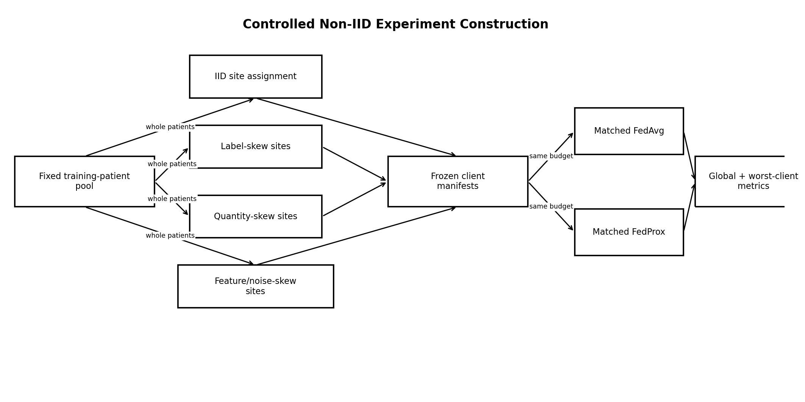
Figure 9. Non-IID construction while preserving patient integrity.
Condition | Construction | What changes | What stays fixed
IID control | deterministic balanced assignment of whole patients to 8 sites minimizing label/quantity divergence | site manifest | model, total patient pool, rounds, local epochs
Label skew | whole patients assigned to maximize between-site positive-rate variation subject to ≥2 patients/site | label distribution | same patient pool and budget
Quantity skew | site patient counts follow predefined 1:1:1:2:2:3:3:4 allocation normalized to available patients | sample quantity | patient integrity and model
Feature/noise skew | apply fixed NSTDB noise regimes to complete client-site training streams only; clean validation/test retained for primary metric | input distribution | labels and training budget
Combined | label + quantity + feature skew using frozen manifest | multiple heterogeneities | same model and total patient pool

19. FEDAVG VS FEDPROX
FedProx changes only the local objective by adding μ/2 ||w−w_global||². All client manifests, rounds, clients per round, local epochs, batch size, initialization, evaluation code, and seeds remain matched.
FedProx item | Locked plan
μ candidates | 0.001, 0.01, 0.1 tuned on federated validation under label-skew only
Selected μ | best validation mean-client AUPRC with no >5 percentage-point worst-client AUPRC degradation; then frozen
Primary comparison | FedAvg vs frozen FedProx across all heterogeneity conditions
Report | global AUPRC/F1, patient-macro F1, mean/median/worst-client AUPRC, rounds-to-best, bytes transmitted

20. PRIVACY
Figure 10. Privacy architecture and claim boundary.

20.1 Threat Model
The mandatory privacy objective is to prevent the central server from inspecting an individual participating client’s raw model update during aggregation. Raw physiological data stays local to simulated clients. Secure aggregation does not make the system anonymous, does not prevent all inference attacks against the final model, and does not replace access control or transport security.

20.2 Mandatory Mechanism
Use Flower SecAgg+ for the designated privacy experiment after FedAvg is stable. The demonstrated claim is narrow: in the instrumented Flower simulation and configured SecAgg+ workflow, the server-side aggregation component should not receive individual clear client updates while forming the aggregate. Record client count, threshold/dropout settings, round completion rate, runtime, bytes sent/received, and server-visible objects. With eight simulated clients this is a protocol correctness/overhead demonstration, not evidence of privacy or security at realistic institutional scale. Differential privacy is explicitly outside the Level-1 mandatory scope; it may be added as a separately versioned extension using Opacus only after all core gates pass.

21. EDGE DEPLOYMENT
Figure 11. Mandatory gateway deployment and optional MCU extension.
The mandatory deployment target is CPU inference on the local gateway connected to the ESP32. The ESP32 is the acquisition/timestamp device. A microcontroller inference claim is not required for project completion and may only be added after a separate conversion/memory/latency benchmark on the exact board.
Metric | Mandatory measurement
Model size | serialized checkpoint + deployable artifact bytes
Parameter count | exact trainable parameters
Peak RAM | gateway process peak during single-window inference
Latency | p50/p95 over ≥1000 windows after warm-up
Throughput | windows/s
Quantization | compare FP32 vs INT8/optimized CPU artifact if conversion is reliable
Accuracy delta | same internal test predictions before/after deployment conversion
ESP32 extension | optional: use Espressif TFLite Micro stack only if exact board RAM/flash and operator support pass

22. REAL-WEARABLE VALIDATION
WEARABLE_V1 is a domain-validation dataset, not a clinical efficacy dataset. Collect consenting adult volunteer sessions only under the institution’s applicable ethics/supervisor process. Do not intentionally induce pathology.
Protocol item | Locked requirement
States | rest seated, standing, walking, intentional small hand/body motion
Duration | ≥5 min per state per participant where practical
Signals | raw AD8232 ADC, MAX30102 red/IR, derived SpO2/HR with provenance
Clock | single ESP32 monotonic clock
Ground truth | activity state and sensor placement only; no arrhythmia/disease ground truth claimed
Evaluation | quality-state distribution, dropout rate, ECG/PPG timing, HR agreement, inference latency, model output distribution, qualitative false-alert review
Prohibition | no sensitivity/specificity claim for disease or AAMI-SVF-window detection from unlabeled wearable sessions

23. EVALUATION PROTOCOL

23.1 Primary Classification Metrics
Metric | Use
AUPRC | primary threshold-independent metric for imbalanced AAMI-SVF window target
AUROC | secondary discrimination metric
F1 | thresholded balance of precision/recall
Sensitivity/Recall | positive-window detection
Specificity | negative-window rejection
Precision | positive predictive proportion for the project target
Confusion matrix | error structure
Alert episodes/hour | episode-open transitions per usable hour; overlapping windows in one episode count once
Patient-macro F1 | equal patient weighting for the thresholded F1 summary; AUPRC is not averaged per patient

23.2 Statistical Unit
The patient is the unit for confidence intervals and between-model resampling. Report point estimates plus 95% patient-cluster bootstrap intervals (2,000 bootstrap resamples) on internal and external test sets. Window-level bootstrap intervals are prohibited.

23.3 Model Comparison
Statistical inference uses the patient as the resampling cluster, but not every metric is averaged patient-by-patient. For AUPRC, AUROC, sensitivity, specificity and pooled F1, each bootstrap replicate samples patients with replacement, includes all windows belonging to the sampled patients, and recomputes the metric on that pooled replicate. For the explicitly reported patient-macro F1, compute F1 per sampled patient using the frozen threshold with zero_division=0, then average those patient scores. Report the number of unique/effective patients contributing to every estimate. For paired model comparisons, use the same resampled patient IDs for both models and compute the replicate-level metric difference; do not average per-patient AUPRC and do not run a naive t-test over windows. A formal paired permutation p-value is optional only for a predeclared patient-level score with a defined value for every included patient; otherwise report the paired patient-cluster bootstrap difference and 95% CI without a p-value.

24. CALIBRATION AND UNCERTAINTY
Fit a single temperature parameter on the dedicated MIT-BIH calibration partition using logits from the locked centralized model. Report Brier score and reliability diagram before/after calibration. The decision threshold is selected on the same calibration partition to maximize F1 for AAMI_SVF_WINDOW_V1 and is frozen before internal/external test. Because the eligible-patient count is small, the calibration artifact must record the number of calibration patients and is described as source-domain calibration under small-patient-sample uncertainty, not as a stable clinical calibration curve. The resulting probability is source-domain calibrated to MIT-BIH only. It must not be described as calibrated for INCART or WEARABLE_V1 without a separate, prospectively declared calibration study. API/dashboard fields expose calibration_domain=MIT-BIH-v1.0.0, calibration_patient_count and calibration_id; wording is model probability for the project target, never disease risk.

25. EXPLAINABILITY
EXPLAINABILITY_V1 is locked to Integrated Gradients (IG) on the MODEL_V1 pre-sigmoid logit. Use a zero tensor in the per-window z-scored input space as the reference baseline, 64 integration steps, and Gauss-Legendre integration. Run the model in eval mode. Save both signed attribution values and an absolute-attribution overlay normalized within each window only for visualization; never renormalize across test patients. Apply the identical method to representative true-positive, true-negative, false-positive, and false-negative windows selected by a predeclared rule (for example, highest-confidence TP/TN and highest-confidence FP/FN within the locked test output), not by visual attractiveness. Record the IG completeness/convergence delta as diagnostic metadata. Explanations are engineering diagnostics, not causal clinical explanations, and raw ECG plus nearby public-dataset beat annotations must accompany the overlay.

26. ERROR ANALYSIS
Slice | Required analysis
Patient | best/worst patient; no identity disclosure
Class composition | S-dominant, V-dominant, F-containing positives
Signal quality | VALID vs DEGRADED
Noise type/SNR | baseline wander, muscle artifact, electrode motion
Heart rate range | training-defined bins; descriptive only
Dataset | MIT-BIH internal vs INCART external
Threshold region | errors near calibrated threshold
Wearable domain | output/quality distribution only, not labeled accuracy

27. API SPECIFICATION

27.1 POST /v1/infer-window
Request:
{"session_id":"...","timestamp_us":...,"ecg":[2500 floats],"ecg_quality":"VALID","ppg_context":{"quality":"VALID","pr_bpm":72.1,"spo2_pct":97.0,"spo2_valid":true},"model_id":"MODEL_V1"}
Response schema illustration (placeholders only — not experimental results and not a valid literal runtime response):
{"timestamp_us":"<int64>","model_id":"MODEL_V1","target":"AAMI_SVF_WINDOW_V1","raw_probability":"<float 0..1>","source_domain_calibrated_probability":"<float 0..1>","calibration_domain":"MIT-BIH-v1.0.0","calibration_patient_count":"<int>","calibration_id":"CAL_V1","threshold":"<frozen float>","ecg_quality":"VALID|DEGRADED|UNUSABLE","monitoring_state":"<enum>","context":{"ppg_quality":"<enum>","spo2_valid":"<bool>"},"latency_ms":"<measured float>"}

27.2 API Rules
- 400 for schema errors; 422 for unusable/incomplete signal window; 500 only for server failure.
- Model/preprocess/contract/alert-policy/calibration IDs returned with every inference; calibration_domain is explicit.
- No endpoint returns a disease diagnosis string.
- WebSocket streaming endpoint may wrap the same response schema; no alternate inference logic.

28. DASHBOARD SPECIFICATION
The dashboard has four persistent panels: live waveforms, signal quality, current episode-level monitoring state, and technical metadata. A fifth research panel exposes window probability/history and is clearly labeled research-only. It displays calibration_domain and alert_policy_id so a probability or episode state cannot be mistaken for wearable-domain clinical calibration.
State | UI behavior
NORMAL_MONITORED_PATTERN | neutral status; show latest confidence and signal quality
POTENTIAL_ECTOPY_ASSOCIATED_PATTERN | one debounced episode state; highlight potential SVF-associated ECG pattern and advise recording review rather than diagnosis
RECHECK_SENSOR | prominent quality warning; suppress disease-like wording
CONTEXT_UNAVAILABLE | continue ECG result if valid; show missing PPG/SpO2 context
SYSTEM_ERROR | show technical error and stop clinical-style status

29. TESTING STRATEGY
Component | Test | Input | Expected Result | Failure Meaning | Owner
Data | record-count/schema validation | known dataset manifest | exact expected files/records or explicit documented version exception | corrupt/mis-versioned dataset | P1
Timestamps | monotonicity + gap detection | synthetic gaps | all gaps flagged; no backward time | alignment invalid | P1/P2
Windows | 10 s/5 s boundaries | synthetic signal | exact samples; no future sample | temporal leakage | P1
Synchronization | ECG/PPG alignment | synthetic shared pulse events | offset within configured tolerance | multimodal mismatch | P2
Preprocessing | causality impulse + GAP_POLICY_V1 tests | impulse after cutoff; <=100 ms and >100 ms synthetic gaps with alternative futures | earlier output unchanged; short gap equals causal last-value hold with mask; long-gap spanning windows UNUSABLE | future leakage/gap-policy bug | P1/P2
Resampling | future-append + chunk-equivalence | same prefix with two different futures; multiple chunk boundaries | outputs timestamped before cutoff identical and chunked stream matches continuous causal stream | resampler look-ahead/state bug | P1
Quality | hard-failure rules | flatline/clipping/gaps | UNUSABLE | quality subsystem unsafe | P1/P2
Labels | AAMI_SVF_MAP_V1 mapping + source symbol census | every allowlisted symbol, paced/unknown/unlisted beat symbols and non-beat markers | expected N/S/V/F/Q-exclude/unmappable-exclude behavior; MIT-BIH and INCART mapper identical | target corruption/external target drift | P1
Splits | group disjointness | frozen manifests | zero participant overlap | catastrophic leakage | P1
Model | shape/checkpoint determinism | fixed batch | same output checksum within tolerance | reproducibility failure | P1
Federated | weighted aggregation toy case | 2 toy clients | matches analytical mean | FL implementation bug | P3
FedProx | μ=0 equivalence | toy clients | matches FedAvg local objective | FedProx bug | P3
Privacy | SecAgg server visibility | instrumented run | no individual clear update at server aggregation interface | privacy claim invalid | P3
API | schema contract | valid/invalid payloads | typed status codes and version fields | integration failure | P3
Alert episodes | debounce/cooldown state test | scripted above/below/degraded/unusable window sequence | exact one episode per configured sequence; K=2, M=2, cooldown=30 s | inflated false-alert counts/dashboard chatter | P2
Dashboard | state mapping | all API states | correct wording; no diagnosis label | unsafe presentation | P2/P3
Reproducibility | clean-environment smoke run | locked config | same artifact IDs and metric tolerance | release not reproducible | All
End-to-end | sensor replay → dashboard | recorded wearable stream | continuous results with logs | system integration failure | All

30. REPRODUCIBILITY
1. Freeze Python version and dependencies in lock file.
2. Every run writes run_manifest.json with git commit, dataset IDs/hashes, split ID, preprocess ID, model ID, config hash, seed, start/end times and hardware summary.
3. All public data builds are scriptable from source URLs and checksums; private wearable raw data is never committed.
4. No manual spreadsheet edits are allowed in split/client manifests.
5. Provide one command for unit tests, one for dataset build, one for centralized training, one for FL simulation, and one for evaluation.
6. Final release includes environment setup, expected directory tree and a smoke-test configuration that completes on a CPU.

31. EXPERIMENT REGISTRY
Experiment ID format: NHM-{YYYYMMDD}-{TRACK}-{NNN}. TRACK ∈ {BASE,ECG,NOISE,EXT,CTX,FL,PRIV,EDGE,WEAR}. Every row stores hypothesis, dataset/split, config hash, checkpoint hash, primary metric, status, owner, and allowed conclusion.

32. REPOSITORY STRUCTURE
nhm/
├── contracts/ # hardware/data/label/API schemas
├── configs/ # versioned YAML experiment configs
├── data/ # ignored raw/standardized local data
├── datasets/ # loaders + manifest builders
├── manifests/ # splits, clients, dataset hashes
├── preprocessing/ # ecg.py, ppg.py, quality.py, sync.py
├── features/ # deterministic classical features
├── models/ # baselines + ecg_cnn.py
├── fusion/ # deterministic multimodal state machine
├── training/ # centralized runner
├── federated/ # Flower clients/server/partitioning/FedProx
├── privacy/ # SecAgg+ config + audits
├── evaluation/ # metrics, calibration, CIs, plots
├── deployment/ # export, gateway benchmark, replay
├── api/ # typed service
├── dashboard/ # UI
├── tests/ # unit/integration/leakage/e2e
├── experiments/ # run manifests and summaries
├── reports/ # generated evidence
├── docs/ # design decisions, viva notes
└── scripts/ # one-command entry points

33. GIT AND TEAM WORKFLOW
- Protected main branch; pull requests required for shared interfaces.
- Feature branches: p1/*, p2/*, p3/* plus fix/* and release/*; no long-lived person-specific fork.
- Any change to contracts/, preprocessing shared interfaces, labels, split logic, model input shape, API schema, or federated state format requires review by at least one other member.
- Release tags: v2.1-spec, v0.1-data, v0.2-model, v0.3-fl, v1.0-final.
- Generated checkpoints and large datasets use release artifacts/object storage, not normal Git history.

34. THREE-PERSON WORK DIVISION
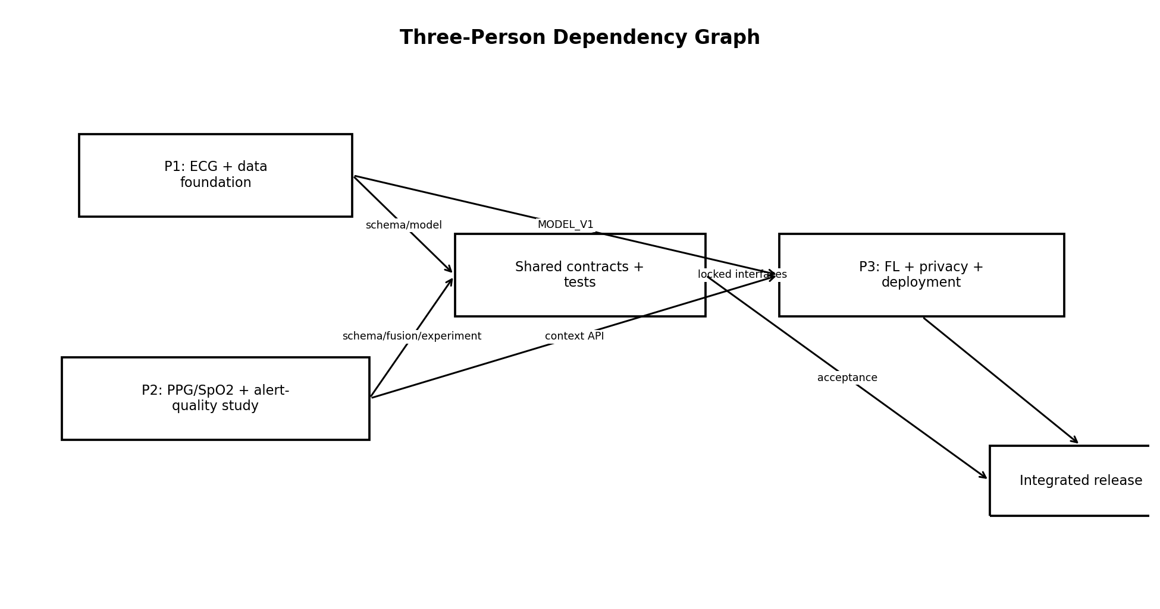
Figure 12. Three-person dependency graph.
Person | Primary ownership | Core modules | Core evidence
P1 | data engineering + ECG target/model | datasets/, preprocessing/ecg.py, features/, models/, splitting/labels | dataset manifests, leakage audit, baselines, MODEL_V1, internal/external/noise reports
P2 | PPG/SpO2/HR + signal quality + alert-robustness experiment + fusion/dashboard semantics | preprocessing/ppg.py, quality.py, sync.py, fusion/, evaluation/context_alerts.py, dashboard/ | BIDMC engineering report, controlled quality-aware alert report, wearable synchronization/quality report, fusion/episode tests, UI state evidence
P3 | experiment infrastructure + FL + privacy + deployment/API | training runner, federated/, privacy/, deployment/, api/ | FedAvg/FedProx reports, client manifests, SecAgg+ report, edge benchmark, API/e2e evidence

34.1 Individual Viva Ownership
- P1: target mathematics, patient splits, leakage, causal ECG processing, CNN/baselines, external/noise validation.
- P2: PPG/SpO2 provenance, synchronization, quality states, alert-episode mathematics, controlled ECG-only vs quality-aware experiment, why no learned multimodal arrhythmia classifier, dashboard safety semantics.
- P3: FL client construction, FedAvg/FedProx math, non-IID controls, secure aggregation threat model, deployment/runtime benchmark.

35. PARALLEL DEVELOPMENT PLAN
Interface | Artifact | Producer | Consumer | Acceptance
P1→P2 | contracts/sample_schema_v1.json + split ID + ECG window API | P1 | P2 | schema validation test passes; participant/timestamps consistent
P1→P3 | MODEL_V1.pt + model_config.yaml + preprocess ID + test vector | P1 | P3 | P3 reproduces logits on supplied test vector within tolerance
P2→P3 | fusion_state_machine.py + alert_policy_v1.yaml + API context schema | P2 | P3 | all state-table tests pass
Shared→All | experiment runner + registry schema | P3 with review | All | same run manifest fields for centralized/FL
All→Release | release_manifest.json | All | every artifact hash and gate status present

P2 does not wait for P1’s final model: P2 develops PPG/synchronization/quality plus the alert episode manager and perturbation experiment harness against BIDMC, wearable fixtures and synthetic contract fixtures. P3 does not wait for MODEL_V1: P3 builds the runner, aggregation tests, client-manifest logic, API and deployment harness against a toy model. Only final integration waits for frozen interfaces.

36. PHASE-BY-PHASE SCHEDULE
Week | P1 | P2 | P3 | Shared / gate | Primary risk
1 | contracts, MIT-BIH/INCART loaders | PPG/SpO2 contract + BIDMC loader | repo, config, run registry, toy model interface | G0–G2 scope/data review | dataset field mismatch
2 | label mapping, patient groups, split/leakage tests | PPG filter, sync, quality tests | aggregation unit tests, client manifest builder | G3–G5 | label/split defects
3 | classical baselines, causal ECG preprocessing | BIDMC HR/pulse validation | centralized runner + metrics harness | G6–G7 | quality thresholds unstable
4 | CNN candidates | quality/fusion state machine | Flower IID scaffold with toy model | model interface review | CNN instability
5 | MODEL_V1 selection/freeze | dashboard state logic + wearable ingest fixture | integrate MODEL_V1, FedAvg IID | G8–G11 | interface mismatch
6 | calibration + internal test package | wearable synchronization dry run | IID FL tuning on validation only | centralized evidence freeze | test contamination risk
7 | NSTDB noise study | PPG degradation/missing-modality tests + alert episode harness | non-IID manifests + experiments | G12 | non-IID confounding
8 | INCART external evaluation | ECG-only vs quality-aware alert experiment + BIDMC final report | FedProx tuning/comparison | G13 | external domain collapse
9 | wearable ECG domain sessions | wearable PPG/SpO2 sessions | SecAgg+ integration + audit | G14–G16 | hardware delays
10 | error analysis + figures | quality-aware experiment figures + fusion/dashboard integration | gateway export/API/latency benchmark | G17–G19 | deployment conversion
11 | re-run locked evidence if needed | dashboard/e2e regression | reproducibility + communication report | G20–G21 | failed regression
12 | report/viva evidence | report/viva evidence | report/viva evidence | buffer, final audit, release G22 | insufficient buffer

37. INTEGRATION GATES
Gate | Owner | Artifacts | Pass criterion | Fail criterion | Recovery
G0 Scope Freeze | All | task/RQs/non-scope signed | task and claim boundary explicit | ambiguity | stop all modeling
G1 Hardware/Data Contract | P1/P2 | contract + firmware schema | all required fields/types/timestamps defined | sensor semantics unknown | bench hardware, update version
G2 Dataset Acquisition | P1/P2 | download manifests/hashes | exact versions parse | missing/corrupt data | redownload/repair
G3 Dataset Validation | P1 | validation report | record/annotation checks pass | unexpected fields/counts | block downstream
G4 Label Freeze | P1 | AAMI_SVF_WINDOW_V1 spec/tests | symbol mapping unit tests pass | ambiguous target | revise before training
G5 Split/Leakage Audit | P1 | split manifests + audit | zero patient overlap; 201/202 grouped | any leakage | regenerate and invalidate runs
G6 Preprocessing Pass | P1/P2 | filter/resampler causality + QC tests | all future-append and chunk-equivalence tests pass | future dependence/state mismatch | replace transform
G7 Baseline Pass | P1 | baseline report | nontrivial pipeline produces metrics | pipeline failure | debug data/model
G8 ECG Model Lock | P1 | MODEL_V1 hash/config | validation acceptance + reproducibility | unstable model | simplify/tune on val
G9 Multimodal Context Pass | P2 | fusion rules + episode policy + BIDMC/quality-aware alert report | sync/quality/episode tests pass and controlled perturbation comparison is reproducible | false multimodal claim or undefined alert counting | fix context/episode experiment; never invent predictive labels
G10 Central Eval Freeze | All | calibration + internal report | checkpoint/threshold locked | post-test tuning | version bump/new test policy
G11 FedAvg Pass | P3 | IID FL report | toy equivalence + stable convergence | aggregation bug | block FL extensions
G12 Non-IID Pass | P3 | manifests/report | patient integrity + matched budgets | confounded clients | rebuild manifests
G13 FedProx Pass | P3 | matched comparison | only optimizer objective differs | unmatched settings | rerun
G14 Privacy Pass | P3 | SecAgg+ report | individual update hidden at server interface | privacy claim unsupported | remove privacy claim/fix
G15 Edge Benchmark | P3 | gateway benchmark | latency/memory/model-size measured | no deployable artifact | keep research model on gateway Python
G16 Wearable Validation | P1/P2 | domain report | same contract/pipeline accepts hardware data | separate hidden pipeline | fix integration
G17 Explainability | P1 | EXPLAINABILITY_V1 IG case report | fixed zero baseline, 64-step Gauss-Legendre IG, signed values + normalized absolute overlay, convergence delta and predeclared case selection saved | method/parameter drift or tool breaks model | fix implementation; omit from core UI if still unstable
G18 API Pass | P3 | OpenAPI/schema tests | versioned outputs and errors pass | schema drift | fix before dashboard
G19 Dashboard Pass | P2/P3 | UI tests | state wording exactly matches spec | diagnostic wording | block release
G20 Reproducibility | All | clean-run report | smoke run reproduces IDs/metrics tolerance | manual dependency | lock environment
G21 Final Integration | All | e2e replay | recorded stream→dashboard works | integration failure | use fallback level
G22 Final Release | All | release/evidence manifest | all mandatory artifacts present | missing evidence | do not submit as complete

38. FAILURE MODES AND RECOVERY
Failure | Detection | Owner | Recovery | Fallback
Too few positive patients in a split | split audit | P1 | re-run deterministic stratifier under predefined class-coverage constraints before training | binary target remains; reduce split granularity only with documented version bump
CNN overfits | train/val divergence | P1 | smaller CNN, stronger regularization, early stop | classical baseline may become primary
INCART external performance collapses | external report | P1 | report domain shift; do not retune and relabel as external | keep as limitation
PPG unusable during motion | quality state | P2 | RECHECK_SENSOR / ECG-only context | no multimodal context claim
FedAvg unstable | round metrics | P3 | lower local LR, confirm aggregation, run IID toy gate | centralized + FL toy proof
FedProx no benefit | matched report | P3 | report null/negative result | FedAvg remains system default
SecAgg+ integration fails | privacy gate | P3 | debug with Flower reference workflow | Level 3: no privacy performance claim; architecture/threat model only
ESP32 cannot run model | MCU benchmark | P3 | retain gateway inference | mandatory design already gateway
Hardware collection delayed | missing WEARABLE_V1 | P1/P2 | use replay fixtures while repairing | Level 3 minimal synchronized demo session
Alert episode chatter/inflated false-alert count | episode tests/stream replay | P2 | fix ALERT_POLICY_V1 implementation; do not change K/M/cooldown from test outcomes | report window scores without alert-rate claim until fixed
Dashboard misrepresents result | UI test | P2/P3 | lock strings/states from API enums | block final release

39. FALLBACK STRATEGY

39.1 LEVEL 1 — FULL SYSTEM
All mandatory gates G0–G22: centralized ECG model, internal/noise/external evidence, PPG/SpO2 quality/context, deterministic fusion, FedAvg + controlled non-IID + FedProx, SecAgg+, gateway deployment benchmark, wearable validation, API/dashboard, reproducibility and viva package.

39.2 LEVEL 2 — ROBUST REDUCED SYSTEM
Remove optional INT8 optimization, advanced explainability variants, combined non-IID condition, and any DP extension. Preserve data/label rigor, MODEL_V1, internal + noise + external test, one label-skew and one quantity/feature-skew FL condition, FedAvg/FedProx, SecAgg+, gateway deployment, wearable domain validation, API/dashboard, tests and reproducibility.

39.3 LEVEL 3 — EMERGENCY SUBMISSION SYSTEM
Preserve the scientifically defensible core: frozen target, patient-disjoint MIT-BIH split, causal pipeline, one classical baseline + lightweight CNN, internal test, one external INCART run, deterministic quality gating, working FedAvg IID and one patient-safe non-IID experiment, gateway replay demo, minimal synchronized wearable acquisition, reproducible scripts. Remove FedProx if unstable, remove SecAgg+ implementation if it cannot pass its correctness gate (and then make no implemented privacy claim), remove rich dashboard features, and document all omissions. Cut breadth before rigor.

40. FINAL LOCKED PROJECT SPECIFICATION
Item | Locked decision
1. Project problem statement | Research monitoring of AAMI-SVF-containing 10-second ECG windows with quality-aware multimodal context and federated training; not diagnosis.
2. Exact research questions | RQ1–RQ6 in Section 2.2.
3. Primary task | Binary classification: SVF_CONTAINING_WINDOW vs N_ONLY_WINDOW under AAMI_SVF_WINDOW_V1.
4. Secondary tasks | Signal quality; PPG pulse rate/SpO2 context; cross-modal consistency; FL/privacy/resource studies.
5. Prediction unit | One 10-second ECG window from one patient/session.
6. Input modalities | Primary model: ECG only. Runtime context: PPG red/IR, SpO2, ECG HR, PPG pulse rate, quality states.
7. Sensor configuration | AD8232→ESP32 ECG 250 Hz; MAX30102 red/IR 100 Hz; derived SpO2/HR 1 Hz; exact board/register details verified and versioned.
8. Data contract | HARDWARE_DATA_CONTRACT_V1 in Section 5.
9. Prediction timestamp | Right edge t of the 10-second ECG window.
10. Prediction frequency | Every 5 seconds after 10 seconds of valid history.
11. Historical lookback | 10 seconds for primary inference; quality functions may use only current/past session history.
12. Window length | 10 s.
13. Window stride | 5 s.
14. Synchronization rule | ESP32 monotonic acquisition timestamps; context aligned to window end; GAP_POLICY_V1 uses causal zero-order hold only for gaps <=100 ms and no fill for larger gaps.
15. Signal-quality policy | VALID/DEGRADED/UNUSABLE; UNUSABLE suppresses physiological alert.
16. Feature set | Classical RR/QRS/statistical features for baselines; raw ECG for CNN; PPG pulse/quality/context features outside primary classifier.
17. Missing-data representation | Explicit null + validity/quality/gap_mask flags; <=100 ms gaps may use only causal last-value hold; >100 ms gaps are not imputed and make spanning windows UNUSABLE.
18. Label definition | AAMI_SVF_WINDOW_V1: ≥1 mapped S/V/F beat = positive; all mapped beats N-class = negative; Q/unknown/paced/unmappable = exclude; ≥5 mappable beats required.
19. Training target | Binary BCE target for AAMI_SVF_WINDOW_V1.
20. Evaluation target | Same exact binary target; no disease diagnosis endpoint.
21. Development datasets | MIT-BIH core supervised development; BIDMC engineering/context validation only. PTB-XL removed from v2.2 execution scope.
22. External-validation dataset | St Petersburg INCART v1.0.0.
23. Noise-robustness dataset | MIT-BIH Noise Stress Test v1.0.0.
24. Wearable-validation dataset | WEARABLE_V1 team-collected AD8232/MAX30102 sessions.
25. Patient grouping rule | Patient is indivisible across partitions/clients; MITDB records 201/202 grouped together.
26. Train split | ~60% patients, frozen before modeling.
27. Validation split | ~15% patients for model selection.
28. Test split | ~15% patients, untouched until freeze.
29. External test | INCART standard Lead II + the identical frozen AAMI_SVF_MAP_V1 allowlist used for MIT-BIH; one locked evaluation before any adaptation, mapping change or alternate-lead exploration.
30. Leakage invariants | Section 11; no future samples including resampler look-ahead, patient overlap, test fitting, or cross-client patient sharing.
31. Classical baseline | Majority class fixed from training prevalence only; Logistic Regression on train-fit ECG features; Random Forest secondary.
32. Primary neural model | MODEL_V1 lightweight 1D CNN in Section 13.
33. Multimodal model | No learned SVF classifier fusion in core; deterministic quality-aware fusion plus controlled alert-robustness experiment.
34. FedAvg specification | 8 controlled simulated whole-patient sites, 50 rounds, 1 local epoch, all clients/round, weighted average; not a multi-hospital deployment claim.
35. FedProx specification | Same setting; μ tuned from {0.001,0.01,0.1} on federated validation then frozen.
36. Privacy mechanism | Flower SecAgg+ mandatory privacy experiment; DP extension-only.
37. Edge deployment target | Local CPU gateway; ESP32 acquisition. MCU inference optional extension only.
38. Primary metrics | AUPRC and patient-macro F1; 95% patient-cluster bootstrap CIs.
39. Secondary metrics | AUROC, sensitivity, specificity, precision, episode-level alerts/hour, degradation-induced excess alerts/hour, state chattering, client metrics, communication, latency/memory.
40. Calibration method | Temperature scaling on dedicated MIT-BIH calibration patients; source-domain calibration under small-patient-sample uncertainty only, with calibration_domain and calibration_patient_count exposed.
41. Uncertainty representation | MIT-BIH-source-domain calibrated model probability + quality state + patient-level CI on evaluation metrics; no clinical or wearable-domain calibration interpretation.
42. Explainability method | EXPLAINABILITY_V1: Integrated Gradients on pre-sigmoid logit; zero normalized-input baseline; 64 Gauss-Legendre steps; signed export + normalized absolute overlay; fixed case-selection rule.
43. API contract | Versioned /v1/infer-window schema in Section 27.
44. Dashboard behavior | Episode-driven UI in Section 28; ALERT_POLICY_V1 K=2/M=2/30-s cooldown; diagnostic wording prohibited.
45. Testing requirements | Matrix in Section 29; all leakage and e2e tests mandatory.
46. Reproducibility requirements | Locked environment, manifests, hashes, one-command builds/runs.
47. Experiment versioning | NHM-{date}-{track}-{NNN}; model/data/split/preprocess IDs and hashes.
48. Definition of done | Section 44.
49. Fallback level 1 | Full Level 1 system.
50. Fallback level 2 | Reduced breadth, all rigor preserved.
51. Emergency fallback | Level 3; no unsupported claim for omitted components.
52. Final demo procedure | Replay/live acquisition → quality → preprocessing → ECG inference → fusion → API → dashboard; show model/version; then replay a predefined federated experiment summary and evidence registry.

41. FULL-MARKS EVIDENCE CHECKLIST
Area | Evidence | Owner
Architecture | 10 figures/diagrams + final dependency chain | All
Contracts | hardware/data/label/API schemas | P1/P2/P3
Data | exact dataset manifests + hashes/licenses | P1/P2
Splits | patient split + client manifests + audits | P1/P3
Preprocessing | causal transforms + causality tests | P1/P2
Baselines | majority/logistic/RF report | P1
MODEL_V1 | checkpoint/config/hash/test vector | P1
Calibration | temperature + threshold artifact | P1
Robustness | NSTDB report | P1
External | INCART locked report | P1
Multimodal | BIDMC synchronization/quality report + controlled quality-aware alert experiment + fusion/episode tests | P2
FL | FedAvg IID/non-IID + FedProx matched reports | P3
Privacy | SecAgg+ threat-model/overhead/correctness report | P3
Deployment | gateway model-size/RAM/latency report | P3
Wearable | WEARABLE_V1 domain report | P1/P2
API/Dashboard | schema tests + e2e video/screenshots | P2/P3
Testing | unit/integration/leakage/e2e test report | All
Reproducibility | clean environment smoke-run report | All
Viva | decision map + limitations | All

42. VIVA DEFENSE MAP
Question | Why chosen | Rejected alternative | Validation | Limitation | Future work
Why ECG? | Beat annotations in MIT-BIH/INCART directly support AAMI_SVF_WINDOW_V1; the locked channels are MIT-BIH MLII and INCART Lead II, and the wearable has an AD8232 single ECG channel. | A PPG-only classifier was rejected because the core public PPG dataset lacks compatible AAMI-SVF window labels. | ECG baseline/CNN + external validation. | Single-lead/domain mismatch remains. | Collect clinically annotated wearable ECG in future work.
Why PPG and SpO2 if they do not enter the classifier? | They provide synchronized physiological context and quality cross-checks without fabricating labels, and their measurable research role is the controlled reduction of degradation-induced excess alert episodes/state chattering. | A learned multimodal arrhythmia MLP was rejected because BIDMC does not supply the same AAMI-SVF window target. | BIDMC engineering validation + controlled quality-aware alert experiment + wearable quality tests. | Context rules are not clinical evidence. | Acquire synchronized ECG+PPG data with compatible beat-level S/V/F annotations.
Why patient-level splitting? | Windows from one patient share morphology and temporal structure. | Random-window split would inflate generalization. | Leakage audit + patient-cluster test. | Small number of patients widens uncertainty. | Larger multi-site cohort.
Why causal preprocessing? | Runtime decisions at time t cannot use future samples. | filtfilt, centered resampling and whole-record transforms are convenient offline but inconsistent with streaming. | filter and resampler future-append/chunk-equivalence tests. | Causal filters may have phase delay. | Assess alternative causal filters.
Why FedAvg? | It is the reference aggregation baseline for FL. | Starting with personalization/complex methods would obscure whether federation itself works. | IID FedAvg gate. | May struggle with heterogeneity. | FedProx/personalization after baseline.
Why FedProx? | It explicitly modifies the local objective to address heterogeneous federated optimization. | Unmatched algorithm comparisons were rejected. | matched non-IID experiment. | May not outperform FedAvg. | Report negative result or test personalization later.
Does FL guarantee privacy? | No. Raw data stays local, but model updates can leak information. | “FL = privacy” wording is rejected. | SecAgg+ experiment. | Secure aggregation does not protect against all attacks/final-model leakage. | Add a scoped DP study in future.
Can it run on ESP32? | The core claim is gateway inference, not ESP32 inference. | Laptop success is not MCU evidence. | gateway benchmark; optional MCU benchmark. | Less impressive embedded claim but technically honest. | Optimize/convert to supported TFLite Micro operators on exact board.
How do you know multimodal sensing helps? | The project does not claim predictive gain for the S/V/F target under current labels. It tests whether multimodal quality/context reduces degradation-induced excess alert episodes and state chattering relative to the same ECG detector without those context rules. | Forcing supervised fusion would be invalid. | Predeclared paired clean-vs-degraded BIDMC/WEARABLE operational robustness experiment. | No labeled multimodal AAMI-SVF efficacy result. | Acquire compatible labeled multimodal dataset.
What happens on unseen patients? | Internal test and INCART are patient-disjoint; metrics and CIs are reported at patient level. | Window-level CV was rejected. | internal/external reports. | Datasets are small and historical. | Prospective diverse cohort.

43. FINAL SELF-AUDIT

43.1 Remaining Risks and Verification-Required Items
Item | Status / required action
Exact ESP32 variant and ADC configuration | VERIFICATION REQUIRED before G1; record board model, ADC resolution/attenuation, timer implementation and measured sampling jitter.
AD8232 electrode placement and analog filter/gain network | VERIFICATION REQUIRED on the actual circuit; document schematic and placement.
MAX30102 register configuration and SpO2 algorithm | VERIFICATION REQUIRED; freeze register values and algorithm/version; do not claim medical-grade SpO2.
Shared beat-symbol mapping | LOCKED AAMI_SVF_MAP_V1 allowlist is identical for MIT-BIH and INCART; generate raw source-symbol census before G4; any unlisted beat symbol is unmappable/excluded unless a new map version is declared before model freeze.
ECG lead/channel policy | LOCKED: MIT-BIH channel named MLII; INCART standard Lead II. Records missing the locked channel are excluded by manifest before splitting/evaluation; no performance-driven fallback.
Small patient counts | MIT-BIH has 47 source subjects before lead/eligibility exclusions; show post-policy patient counts per split/client and patient-cluster CIs. The calibration partition may contain only a few patients, so report calibration_patient_count and treat calibration as source-domain/small-sample only. Never market overlapping windows as independent n.
Historical/domain shift | MIT-BIH/INCART differ from modern wearable hardware and populations.
Secure aggregation simulation | Demonstrates protocol correctness/overhead with controlled simulated clients, not production privacy certification or realistic institutional-scale security.
Wearable data ethics/consent | Institution/supervisor requirements must be satisfied before collection.
No labeled multimodal AAMI-SVF dataset | Core document intentionally does not claim multimodal predictive improvement.

43.2 Authoritative External Sources
Source | URL | Used for
MIT-BIH Arrhythmia v1.0.0 | https://physionet.org/content/mitdb/1.0.0/ | 48 half-hour two-channel ECG recordings from 47 subjects; 360 Hz; beat annotations.
MIT-BIH Database Directory — ECG lead configuration | https://physionet.org/files/mitdb/1.0.0/mitdbdir/intro.htm | Most records use MLII as the upper signal; records 102 and 104 could not use MLII; record-level lead names are documented and must drive channel selection.
MIT-BIH Noise Stress Test v1.0.0 | https://physionet.org/content/nstdb/1.0.0/ | Ambulatory baseline-wander, muscle and electrode-motion noise stress material.
BIDMC PPG and Respiration v1.0.0 | https://physionet.org/content/bidmc/1.0.0/ | 53 eight-minute records; ECG/PPG 125 Hz; HR/RR/SpO2 1 Hz; critical-care context.
St Petersburg INCART v1.0.0 | https://physionet.org/content/incartdb/1.0.0/ | 75 half-hour 12-lead annotated recordings from 32 Holter records; 257 Hz; annotations follow standard PhysioBank beat annotation definitions.
PhysioBank standard annotation codes | https://physionet.org/static/lightwave/doc/annotations.html | Authoritative symbol meanings used to freeze AAMI_SVF_MAP_V1; project mapping remains an explicit allowlist and excludes unlisted beat symbols.
WFDB annotation mapping documentation | https://physionet.org/physiotools/wpg/wpg_37.htm | Documents WFDB map2 superclass mapping concepts and motivates versioned explicit mapping rather than dataset-specific ad-hoc coercion.
Flower Secure Aggregation | https://flower.ai/docs/framework/main/en/explanation-ref-secure-aggregation-protocols.html | SecAgg and SecAgg+ protocol support and privacy boundary.
Flower Differential Privacy explainer | https://flower.ai/docs/framework/explanation-differential-privacy.html | FL update leakage motivation and DP options.
FedProx (MLSys 2020) | https://proceedings.mlsys.org/paper/2020/hash/1f5fe83998a09396ebe6477d9475ba0c-Abstract.html | FedProx for heterogeneous federated optimization.
Opacus PrivacyEngine | https://opacus.ai/api/privacy_engine.html | Optional PyTorch DP extension; privacy accounting APIs.
Espressif esp-tflite-micro | https://github.com/espressif/esp-tflite-micro | Optional MCU inference extension and supported Espressif/TFLite Micro integration.

All web facts above were verified on 27 September 2026. Dataset counts are version-specific; future dataset versions require a manifest/version update rather than silent substitution.

44. DEFINITION OF DONE
1. G0–G22 mandatory gates are either PASS or explicitly downgraded through the documented fallback level; no gate is silently skipped.
2. Dataset, split, client, preprocessing, model, calibration, API and release artifacts have immutable IDs/hashes.
3. A clean environment can run tests and the smoke pipeline from documented commands.
4. MODEL_V1 has internal, noise and external evaluation with patient-level uncertainty reporting.
5. PPG/SpO2/HR pipelines, alert episode manager, and quality-aware fusion pass synchronization/quality/episode tests; the controlled ECG-only vs quality-aware experiment is complete; no learned multimodal AAMI-SVF classifier is implied.
6. FedAvg, non-IID and matched FedProx experiments are reproducible; all client manifests preserve patient integrity.
7. SecAgg+ passes the privacy correctness gate or the implemented-privacy claim is removed under the emergency fallback.
8. Gateway deployment has measured size, memory and latency; any ESP32 inference claim has a separate on-device benchmark.
9. At least one real synchronized wearable session passes the exact canonical data path and end-to-end replay/live demo.
10. API/dashboard wording matches the research-only output semantics and exposes quality/model versions.
11. Final repository contains the evidence checklist, experiment registry, limitations and viva defense map.
12. The team can state clearly what the system does, what it does not do, which results are source facts vs engineering decisions vs experiments, and which risks remain.

APPENDIX A. COMPLETE EXPERIMENT MATRIX
ID | Research Question | Dataset | Input | Model | Federation | Non-IID | Privacy | Metric | Owner | Artifact | Allowed conclusion
E01 | Pipeline sanity | MIT-BIH train | features | Majority/LR | none | none | none | AUPRC/F1 | P1 | baseline_report | Establish baseline only
E02 | Neural gain | MIT-BIH | ECG | 1D CNN | none | none | none | AUPRC | P1 | model_selection | Compare model families
E03 | Calibration | MIT-BIH calibration | ECG | MODEL_V1 | none | none | none | Brier/ECE | P1 | calibration.json | Calibrate target probability only
E04 | Internal generalization | MIT-BIH test | ECG | MODEL_V1 | none | none | none | AUPRC/F1+CI | P1 | internal_test | Patient-disjoint internal performance
E05 | Noise robustness | NSTDB/noise-mixed | ECG | MODEL_V1 | none | feature noise | none | AUPRC degradation | P1 | noise_report | Noise sensitivity only
E06 | External generalization | INCART | single ECG lead | MODEL_V1 | none | domain | none | AUPRC/F1+CI | P1 | external_report | Cross-dataset performance
E07 | Multimodal engineering | BIDMC | ECG+PPG+numerics | quality/consistency | none | none | none | alignment/rate error | P2 | bidmc_report | Engineering compatibility, not SVF predictive gain
E08 | Quality-aware alert robustness | BIDMC + WEARABLE_V1 controlled perturbations | ECG+PPG+SpO2+HR+SQI | same ECG MODEL_V1 + deterministic context/episode rules | none | sensor degradation scenarios | none | excess alert episodes/h + chattering + recheck/suppression | P2 | quality_aware_alert_report | Multimodal context changes operational alert robustness; no AAMI-SVF sensitivity claim
E09 | FedAvg IID | MIT-BIH train clients | ECG | MODEL_V1 | FedAvg | IID | none | global/worst AUPRC | P3 | fl_iid | Federated baseline
E10 | Label skew | same | ECG | MODEL_V1 | FedAvg | label | none | global/worst AUPRC | P3 | fl_label_skew | Sensitivity to label heterogeneity
E11 | Quantity skew | same | ECG | MODEL_V1 | FedAvg | quantity | none | global/worst AUPRC | P3 | fl_quantity | Sensitivity to client-size imbalance
E12 | Feature/noise skew | same | ECG | MODEL_V1 | FedAvg | noise | none | global/worst AUPRC | P3 | fl_feature | Sensitivity to domain/noise skew
E13 | FedProx comparison | same frozen clients | ECG | MODEL_V1 | FedProx | matched | none | paired differences | P3 | fedprox_report | Algorithm effect under matched conditions
E14 | Secure aggregation overhead | same | ECG | MODEL_V1 | FedAvg | chosen core condition | SecAgg+ | runtime/bytes | P3 | privacy_report | Protocol overhead/privacy boundary
E15 | Gateway deployment | MIT-BIH test replay | ECG | deploy artifact | none | none | none | latency/RAM/accuracy delta | P3 | edge_report | Gateway feasibility
E16 | Wearable domain | WEARABLE_V1 | all sensors | locked pipeline | none | real motion | none | quality/latency/distributions | P1/P2 | wearable_report | Domain compatibility only

APPENDIX B. FINAL EVIDENCE PACKAGE
Artifact path | Owner | Version | Acceptance criterion
contracts/HARDWARE_DATA_CONTRACT_V1.md | P1/P2 | v1 | G1 passed
contracts/LABEL_SCHEMA_V1.md | P1 | AAMI_SVF_MAP_V1 | explicit shared MIT-BIH/INCART mapping + symbol census + label tests pass
manifests/datasets/*.yaml | P1/P2 | versioned | hashes + licenses present
manifests/splits/MITDB_SPLIT_V1.csv | P1 | immutable | zero patient overlap
manifests/clients/CLIENTS_*.csv | P3 | immutable | whole-patient disjoint clients
preprocessing/ | P1/P2 | PREPROC_V1 + GAP_POLICY_V1 | filter/resampler causality, short/long gap, chunk-equivalence and unit tests pass
checkpoints/MODEL_V1.* | P1 | SHA-256 | test vector reproducible
reports/internal_test.* | P1 | final | locked test + CIs
reports/noise_robustness.* | P1 | final | noise curves complete
reports/external_incart.* | P1 | final | one locked external evaluation
reports/bidmc_multimodal_engineering.* | P2 | final | sync/quality evidence
reports/quality_aware_alert_robustness.* | P2 | final | paired degradation experiment + episode metrics
reports/fedavg_fedprox.* | P3 | final | matched configs
reports/privacy_secagg.* | P3 | final | privacy gate pass
reports/edge_benchmark.* | P3 | final | size/RAM/latency/accuracy delta
reports/wearable_validation.* | P1/P2 | final | same pipeline on hardware
api/openapi.* | P3 | v1 | schema tests pass
dashboard/ | P2/P3 | v1 | state tests pass
reports/test_report.* | All | final | all mandatory tests green
docs/REPRODUCE.md | All | final | clean smoke run passes
experiments/registry.csv | All | final | all core experiment IDs/artifacts
release/release_manifest.json | All | v1.0 | hashes + gate status + limitations

END OF LOCKED SPECIFICATION — v2.2 FINAL FREEZE

