LAB 1:
<!DOCTYPE html>
<html>
<body>

<form method="get" action="">
Name: <input type="text" name="name">
<input type="submit">
</form>

<?php
$age = 18;
if($age >= 18){
echo "You are eligible to vote";
}
?>

</body>
</html>



LAB 2:
<!DOCTYPE html>
<html>
<body>

<form method="POST">
Enter a number:
<input type="number" name="number">
<input type="submit" value="Check">
</form>

<?php

if(isset($_POST['number'])){

$number = $_POST['number'];

if($number >= 0){
echo "Positive number";
}
else{
echo "Negative number";
}

}

?>
</body>
</html>
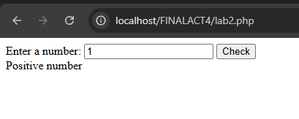

LAB 3:
<!DOCTYPE html>
<html>
<body>

<form method="POST">
Enter grade:
<input type="number" name="grade">
<input type="submit" value="Check">
</form>

<?php

if(isset($_POST['grade'])){

$grade = $_POST['grade'];

if($grade >= 90 && $grade <= 100){
echo "Excellent";
}
elseif($grade >= 80){
echo "Good";
}
elseif($grade >= 70){
echo "Average";
}
else{
echo "Failed";
}

}

?>

</body>
</html>

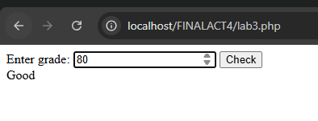

LAB 4:
<!DOCTYPE html>
<html>
<body>

<form method="POST">
Enter a number:
<input type="number" name="number">
<input type="submit" value="Check">
</form>

<?php

if ($_SERVER["REQUEST_METHOD"] == "POST") {

$number = $_POST['number'];

if ($number % 2 == 0) {
echo "The number is Even";
} else {
echo "The number is Odd";
}

}

?>

</body>
</html>
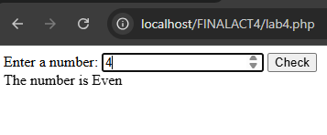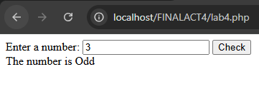

LAB 5:
<!DOCTYPE html>
<html>
<body>

<form method="POST">

Number 1:
<input type="number" name="num1"><br><br>

Number 2:
<input type="number" name="num2"><br><br>

Number 3:
<input type="number" name="num3"><br><br>

<input type="submit" value="Find Largest">

</form>

<?php

if(isset($_POST['num1']) && isset($_POST['num2']) && isset($_POST['num3'])){

$num1 = $_POST['num1'];
$num2 = $_POST['num2'];
$num3 = $_POST['num3'];

if($num1 >= $num2 && $num1 >= $num3){
echo "Largest number is: " . $num1;
}
elseif($num2 >= $num1 && $num2 >= $num3){
echo "Largest number is: " . $num2;
}
else{
echo "Largest number is: " . $num3;
}

}

?>x`
</body>
</html>

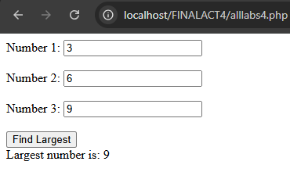

LAB 6:
<!DOCTYPE html>
<html>
<body>

<form method="POST">

Enter Password:
<input type="password" name="password">

<input type="submit" value="Login">

</form>

<?php

if(isset($_POST['password'])){

$correctPassword = "admin123";
$userPassword = $_POST['password'];

if($userPassword == $correctPassword){
echo "Access Granted";
}
else{
echo "Access Denied";
}

}

?>
</body>
</html>

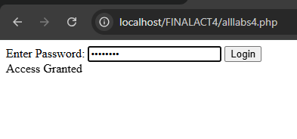
LAB 7:
<!DOCTYPE html>
<html>
<body>

<form method="POST">

Enter Year:
<input type="number" name="year">

<input type="submit" value="Check">

</form>

<?php

if(isset($_POST['year'])){

$year = $_POST['year'];

if(($year % 4 == 0 && $year % 100 != 0) || ($year % 400 == 0)){
echo "Leap Year";
}
else{
echo "Not a Leap Year";
}

}

?>
</body>
</html>
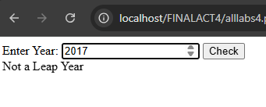
LAB 8:
<!DOCTYPE html>
<html>
<body>

<form method="POST">

Enter Age:
<input type="number" name="age"><br><br>

Enter Citizenship:
<input type="text" name="citizen"><br><br>

<input type="submit" value="Check">

</form>

<?php

if(isset($_POST['age']) && isset($_POST['citizen'])){

$age = $_POST['age'];
$citizen = $_POST['citizen'];

if($age >= 18){

if($citizen == "Filipino"){
echo "Eligible to vote";
}
else{
echo "Not eligible to vote";
}

}
else{
echo "Not eligible to vote";
}

}

?>
</body>
</html>

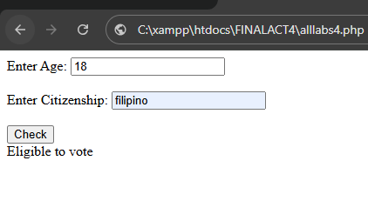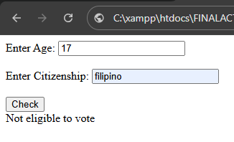

LAB 9:
<!DOCTYPE html>
<html>
<body>

<form method="POST">

Enter Purchase Amount:
<input type="number" name="amount">

<input type="submit" value="Calculate">

</form>

<?php

if(isset($_POST['amount'])){

$amount = $_POST['amount'];

if($amount >= 1000){

$discount = $amount * 0.20;
$total = $amount - $discount;

echo "20% Discount<br>";
echo "Total Amount: " . $total;

}
elseif($amount >= 500){

$discount = $amount * 0.10;
$total = $amount - $discount;

echo "10% Discount<br>";
echo "Total Amount: " . $total;

}
else{

echo "No Discount<br>";
echo "Total Amount: " . $amount;

}

}

?>
</body>
</html>

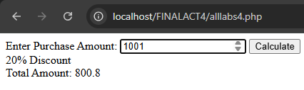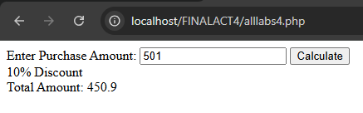
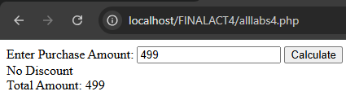

LAB 10:
<!DOCTYPE html>
<html>
<body>

<form method="POST">

Username:
<input type="text" name="username"><br><br>

Password:
<input type="password" name="password"><br><br>

<input type="submit" value="Login">

</form>

<?php

if(isset($_POST['username']) && isset($_POST['password'])){

$correctUsername = "admin";
$correctPassword = "1234";

$username = $_POST['username'];
$password = $_POST['password'];

if($username == $correctUsername && $password == $correctPassword){
echo "Login Successful";
}
else{
echo "Invalid Username or Password";
}

}

?>
</body>
</html>

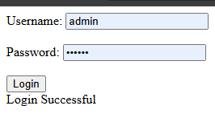

LAB 11:
<!DOCTYPE html>
<html>
<body>

<form method="POST">

Enter number (1–7):
<input type="number" name="day">

<input type="submit" value="Check">

</form>

<?php

if(isset($_POST['day'])){

$day = $_POST['day'];

switch($day){
case 1: echo "Monday"; break;
case 2: echo "Tuesday"; break;
case 3: echo "Wednesday"; break;
case 4: echo "Thursday"; break;
case 5: echo "Friday"; break;
case 6: echo "Saturday"; break;
case 7: echo "Sunday"; break;
default: echo "Invalid input";
}

}

?>
</body>
</html>

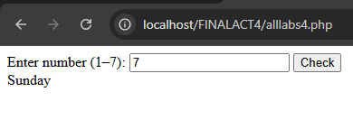

LAB 12:
<!DOCTYPE html>
<html>
<body>

<form method="POST">

Enter letter grade:
<input type="text" name="grade">

<input type="submit" value="Check">

</form>

<?php

if(isset($_POST['grade'])){

$grade = strtoupper($_POST['grade']);

switch($grade){
case "A": echo "Excellent"; break;
case "B": echo "Good"; break;
case "C": echo "Average"; break;
case "D": echo "Below Average"; break;
case "F": echo "Failed"; break;
default: echo "Invalid grade";
}

}

?>
</body>
</html>

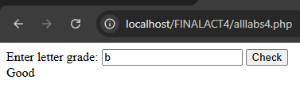

LAB 13:
<!DOCTYPE html>
<html>
<body>

<form method="POST">

Number 1:
<input type="number" name="num1"><br><br>

Number 2:
<input type="number" name="num2"><br><br>

Operator (+ - * /):
<input type="text" name="op"><br><br>

<input type="submit" value="Calculate">

</form>

<?php

if(isset($_POST['num1']) && isset($_POST['num2']) && isset($_POST['op'])){

$num1 = $_POST['num1'];
$num2 = $_POST['num2'];
$op = $_POST['op'];

switch($op){

case "+":
echo $num1 + $num2;
break;

case "-":
echo $num1 - $num2;
break;

case "*":
echo $num1 * $num2;
break;

case "/":
if($num2 != 0){
echo $num1 / $num2;
} else {
echo "Cannot divide by zero";
}
break;

default:
echo "Invalid operator";
}

}

?>
</body>
</html>

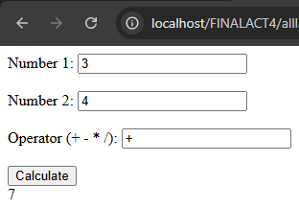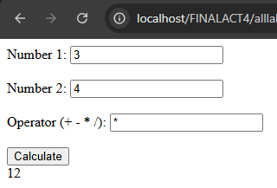
LAB 14:
<!DOCTYPE html>
<html>
<body>

<form method="POST">

Select option:
<select name="menu">
<option value="1">Add</option>
<option value="2">Edit</option>
<option value="3">Delete</option>
</select>

<input type="submit" value="Submit">

</form>

<?php

if(isset($_POST['menu'])){

$menu = $_POST['menu'];

switch($menu){
case 1: echo "Add selected"; break;
case 2: echo "Edit selected"; break;
case 3: echo "Delete selected"; break;
default: echo "Invalid option";
}

}

?>
</body>
</html>

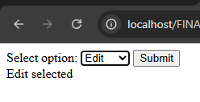

LAB 15:
<!DOCTYPE html>
<html>
<body>

<form method="POST">

Enter month number (1–12):
<input type="number" name="month">

<input type="submit" value="Check">

</form>

<?php

if(isset($_POST['month'])){

$month = $_POST['month'];

switch($month){
case 1: echo "January"; break;
case 2: echo "February"; break;
case 3: echo "March"; break;
case 4: echo "April"; break;
case 5: echo "May"; break;
case 6: echo "June"; break;
case 7: echo "July"; break;
case 8: echo "August"; break;
case 9: echo "September"; break;
case 10: echo "October"; break;
case 11: echo "November"; break;
case 12: echo "December"; break;
default: echo "Invalid month";
}

}

?>
</body>
</html>
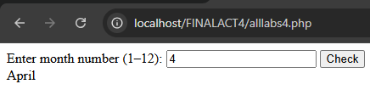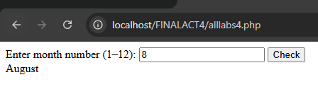

LAB 16:
<!DOCTYPE html>
<html>
<body>

<form method="POST">

Enter color:
<input type="text" name="color">

<input type="submit" value="Check">

</form>

<?php

if(isset($_POST['color'])){

$color = strtolower($_POST['color']);

switch($color){
case "red":
echo "Stop";
break;

case "yellow":
echo "Slow down";
break;

case "green":
echo "Go";
break;

default:
echo "Invalid color";
}

}

?>
</body>
</html>
