Supplementary Material
Beyond Embeddings: Language-Aware Sparse Representations and
Fine-Tuned Multilingual Transformers
Public reviewer package · aggregate evidence only · generated from the versioned artifacts

S1. Evidence runs and public-data boundary
This supplement documents two frozen runs. It contains aggregate statistics and figures only. Repository texts, handles, item-level predictions, split manifests, model weights, caches, credentials, and personal paths are excluded.
Run | Purpose | Source commit
20260802T165746Z_full_20k_v3_segmented_finetuned_2026 | Main 233-candidate experiment | 7181fcceb7a6
20260804T102544Z_convergence_audit_20k_2026 | Eight-fit LinearSVC convergence audit | 6e46e5c2af02

S2. Corpus, coverage, and frozen split
Property | Value
Documents | 19710
Labels / assignments | 37 / 24326
Abstract segments / full-text files | 24411 / 20750
Items with multiple abstracts / full texts | 4365 / 463
Represented full-text characters | 83.45%
Items reaching 400k cap | 510 (2.59%)
Train / calibration / validation / test | 12,836 / 1,927 / 1,988 / 2,959

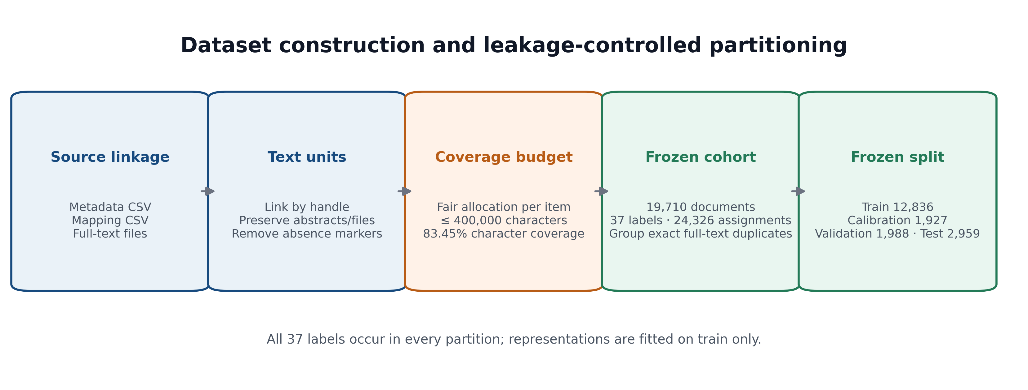
Figure S1. Dataset construction and leakage-controlled partitioning.

S3. Language audit
Evaluation | N | Agreement / accuracy
Declared vs. detected abstract | 15166 | 98.51%
Declared vs. detected full text | 19675 | 96.05%
Historical audited abstract reference | 23609 | 99.87%

The historical reference contains 23,055 human/historical-detector agreements and 554 manually audited disagreements; it is not an independently manual annotation set.

S4. Experimental protocol
The primary validation set contains 233 candidates: 189 sparse configurations, 42 frozen dense configurations, and two fine-tuned transformers. Macro-F1 is the prespecified primary selection criterion; thresholds are estimated on the dedicated calibration partition.
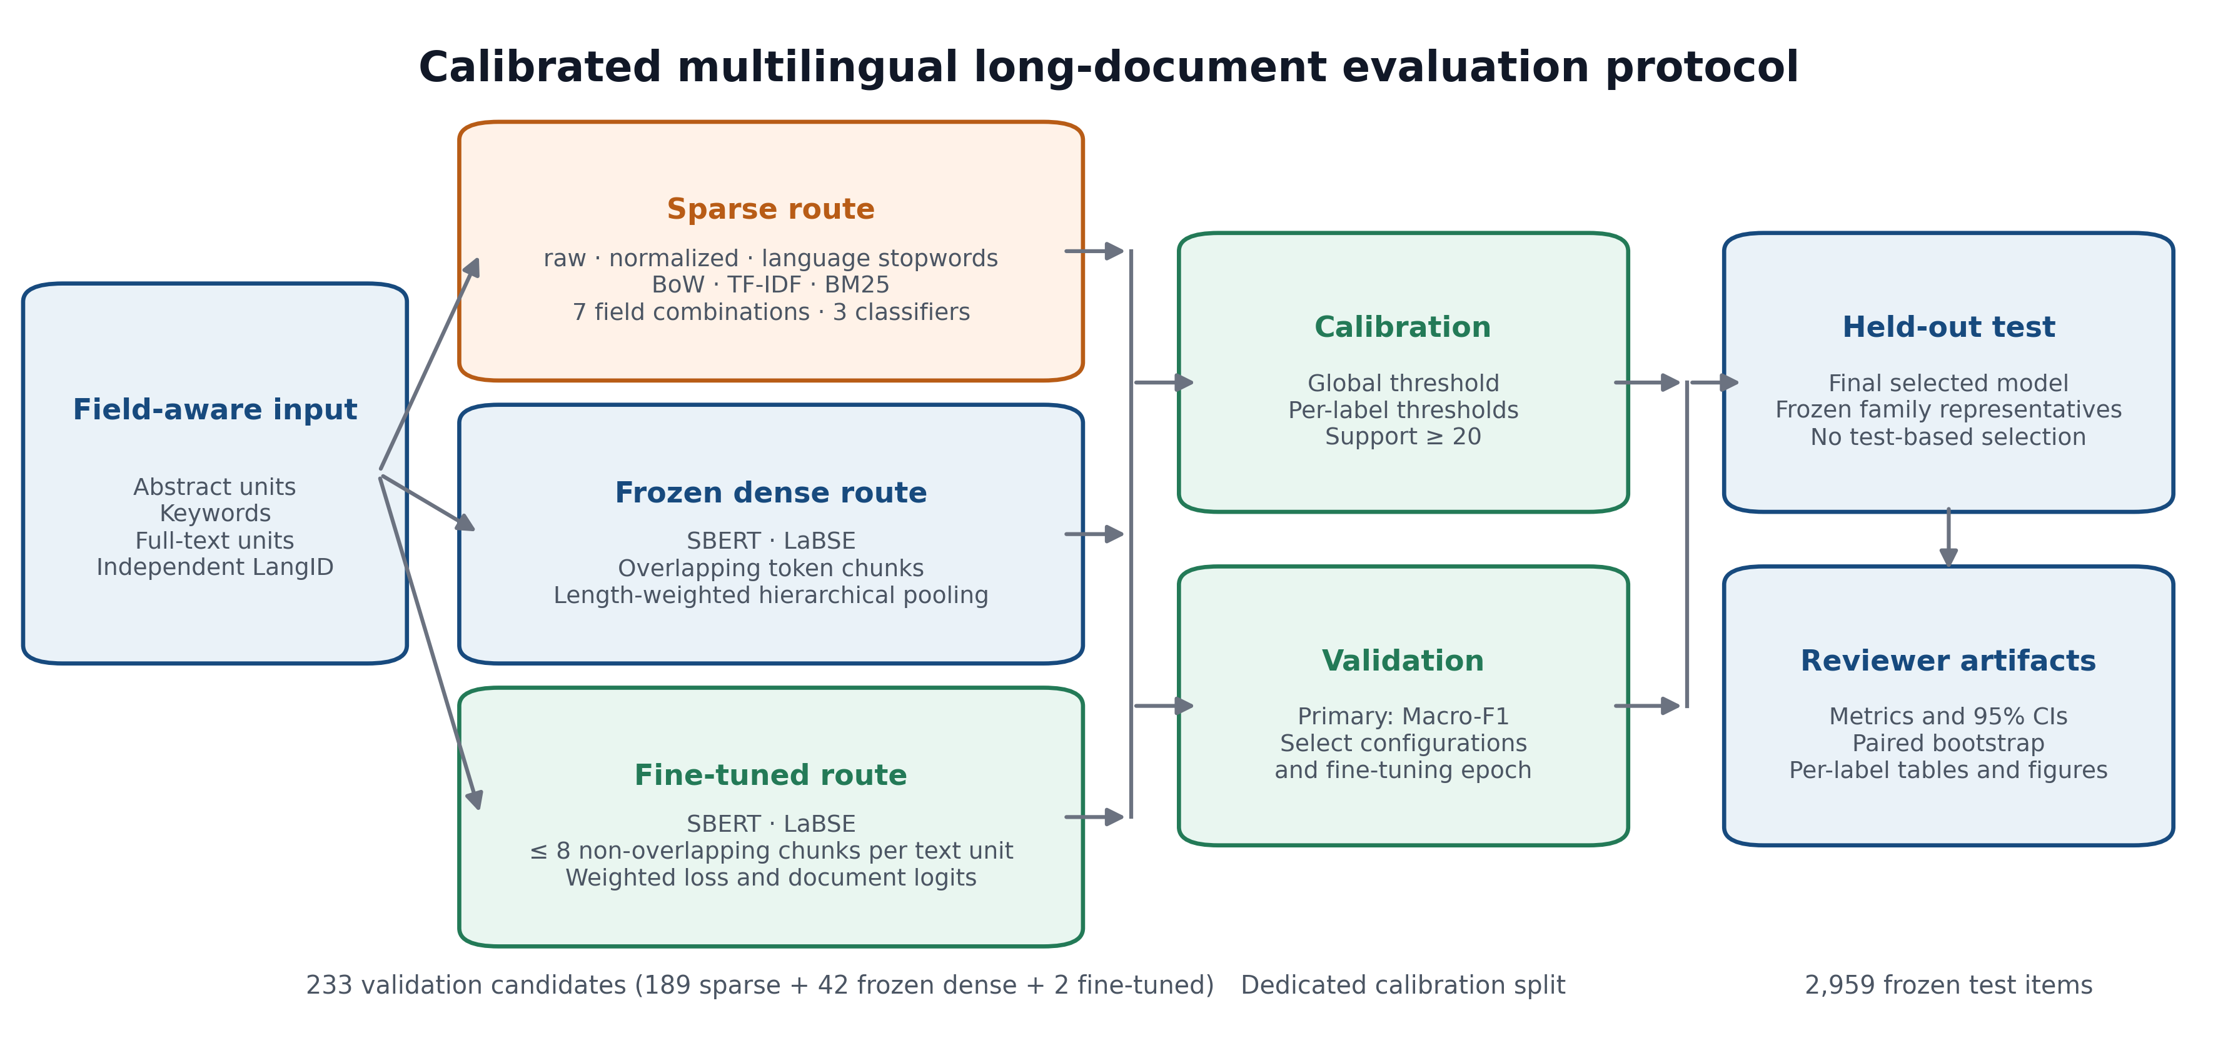
Figure S2. Calibrated multilingual long-document evaluation protocol.

S5. Validation and family-level test comparison
Selection basis | Configuration | Macro-F1 | Micro-F1
Macro-F1 | bm25 / fulltext / linear_svc | 0.7483 | 0.7705
Micro-F1 | bm25 / abstract+keywords+fulltext / logreg | 0.7388 | 0.7774

Rank | Validation configuration | Macro-F1 | Micro-F1
1 | bm25 / fulltext / language_stopwords / linear_svc | 0.7483 | 0.7705
2 | bm25 / abstract+keywords+fulltext / language_stopwords / logreg | 0.7388 | 0.7774
3 | tfidf / abstract+fulltext / language_stopwords / linear_svc | 0.7357 | 0.7571
4 | bm25 / fulltext / raw / linear_svc | 0.7338 | 0.7480
5 | bm25 / fulltext / normalized / linear_svc | 0.7335 | 0.7484
6 | tfidf / fulltext / language_stopwords / linear_svc | 0.7329 | 0.7550
7 | tfidf / keywords+fulltext / normalized / linear_svc | 0.7316 | 0.7533
8 | tfidf / abstract+keywords+fulltext / language_stopwords / linear_svc | 0.7315 | 0.7559
9 | bm25 / abstract+fulltext / language_stopwords / logreg | 0.7312 | 0.7752
10 | tfidf / abstract+keywords+fulltext / raw / linear_svc | 0.7296 | 0.7509
11 | bm25 / keywords+fulltext / language_stopwords / logreg | 0.7295 | 0.7704
12 | tfidf / abstract+keywords+fulltext / normalized / linear_svc | 0.7294 | 0.7512
13 | tfidf / keywords+fulltext / raw / linear_svc | 0.7294 | 0.7517
14 | bm25 / abstract+keywords+fulltext / language_stopwords / linear_svc | 0.7291 | 0.7612
15 | tfidf / keywords+fulltext / language_stopwords / linear_svc | 0.7291 | 0.7543

Table S6 reports the 15 highest Macro-F1 configurations. The complete 233-row validation grid is available at https://github.com/KharolusIII/institutional-repository-subject-classification/blob/main/paper_artifacts/runs/v3_main/results_validation_grid.csv.
Family | Selected source | Val. Macro-F1 | Test Macro-F1 | Test Micro-F1
bm25 | fulltext | 0.7483 | 0.7457 | 0.7641
tfidf | abstract+fulltext | 0.7357 | 0.7338 | 0.7529
labse_finetuned | abstract+keywords+fulltext | 0.7148 | 0.7069 | 0.7279
bow | abstract+keywords+fulltext | 0.6895 | 0.6782 | 0.7135
sbert_finetuned | abstract+keywords+fulltext | 0.6663 | 0.6595 | 0.6746
sbert_frozen | keywords+fulltext | 0.6278 | 0.6211 | 0.6397
labse_frozen | keywords+fulltext | 0.6254 | 0.6143 | 0.6334

S6. Convergence audit and final held-out metrics
Configuration | Macro-F1 | Micro-F1
bm25 / fulltext / language_stopwords / linear_svc_c05_tol5e4 | 0.7497 | 0.7732
bm25 / fulltext / language_stopwords / linear_svc_c05_tol1e4 | 0.7497 | 0.7732
bm25 / fulltext / language_stopwords / linear_svc_c1_tol5e4 | 0.7483 | 0.7705
bm25 / fulltext / language_stopwords / linear_svc_c1_tol1e4 | 0.7483 | 0.7705
tfidf / fulltext / language_stopwords / linear_svc_c1_tol1e4 | 0.7329 | 0.7550
tfidf / fulltext / language_stopwords / linear_svc_c1_tol5e4 | 0.7329 | 0.7550
tfidf / fulltext / language_stopwords / linear_svc_c05_tol1e4 | 0.7307 | 0.7554
tfidf / fulltext / language_stopwords / linear_svc_c05_tol5e4 | 0.7307 | 0.7554

Metric | Estimate | 95% CI where applicable
Subset accuracy | 0.5863 | —
Hamming loss | 0.0164 | —
Macro-F1 | 0.7522 | [0.7372, 0.7643]
Micro-F1 | 0.7685 | [0.7567, 0.7797]
Recall@3 | 0.9320 | —
Precision@3 | 0.3810 | —

Both C=0.5 tolerance settings converged for all 37 labels and tied on all stored validation metrics. The stored tol=0.0005 setting is not claimed to outperform tol=0.0001.
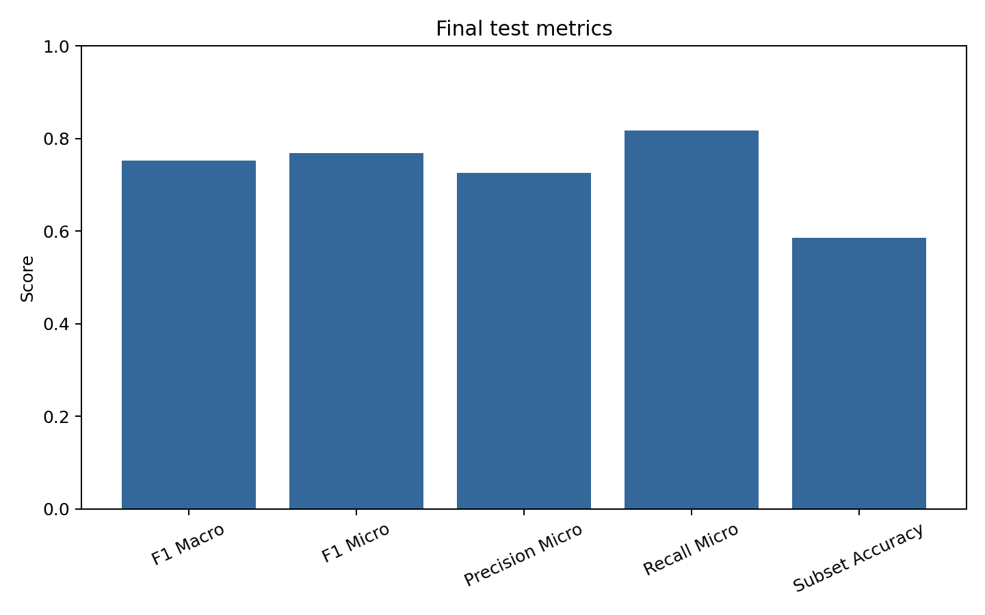
Figure S3. Final held-out metric overview.
Comparison | Metric | Difference | 95% CI | P(candidate > BM25)
tfidf minus final BM25 | f1_macro | -0.0184 | [-0.0299, -0.0068] | 0.0000
tfidf minus final BM25 | f1_micro | -0.0156 | [-0.0243, -0.0072] | 0.0010
labse_finetuned minus final BM25 | f1_macro | -0.0453 | [-0.0587, -0.0311] | 0.0000
labse_finetuned minus final BM25 | f1_micro | -0.0406 | [-0.0508, -0.0303] | 0.0000
bow minus final BM25 | f1_macro | -0.0741 | [-0.0896, -0.0590] | 0.0000
bow minus final BM25 | f1_micro | -0.0549 | [-0.0662, -0.0441] | 0.0000
sbert_finetuned minus final BM25 | f1_macro | -0.0928 | [-0.1070, -0.0779] | 0.0000
sbert_finetuned minus final BM25 | f1_micro | -0.0939 | [-0.1055, -0.0822] | 0.0000
sbert_frozen minus final BM25 | f1_macro | -0.1311 | [-0.1458, -0.1163] | 0.0000
sbert_frozen minus final BM25 | f1_micro | -0.1288 | [-0.1398, -0.1175] | 0.0000
labse_frozen minus final BM25 | f1_macro | -0.1379 | [-0.1528, -0.1233] | 0.0000
labse_frozen minus final BM25 | f1_micro | -0.1350 | [-0.1469, -0.1226] | 0.0000

S7. Fine-tuning trajectories
Model | Selected epoch | Val. Macro-F1 | Val. Micro-F1
labse_finetuned | 5 | 0.7148 | 0.7321
sbert_finetuned | 5 | 0.6663 | 0.6794

S8. Complete per-subject final results
Subject | Test support | Precision | Recall | F1 | AP
Odontología | 66 | 0.9275 | 0.9697 | 0.9481 | 0.9792
Ciencias Informáticas | 387 | 0.9623 | 0.9225 | 0.9420 | 0.9746
Educación Física | 73 | 0.9211 | 0.9589 | 0.9396 | 0.9882
Relaciones Internacionales | 115 | 0.8433 | 0.9826 | 0.9076 | 0.9674
Psicología | 100 | 0.8774 | 0.9300 | 0.9029 | 0.9597
Ciencias Veterinarias | 72 | 0.7753 | 0.9583 | 0.8571 | 0.9307
Letras | 182 | 0.7907 | 0.9341 | 0.8564 | 0.9442
Bibliotecología | 37 | 0.8611 | 0.8378 | 0.8493 | 0.9084
Ciencias Agrarias | 116 | 0.7754 | 0.9224 | 0.8425 | 0.8997
Bellas Artes | 106 | 0.7388 | 0.9340 | 0.8250 | 0.8927
Ciencias Jurídicas | 154 | 0.7245 | 0.9221 | 0.8114 | 0.9085
Ciencias Económicas | 85 | 0.9672 | 0.6941 | 0.8082 | 0.9138
Ciencias Médicas | 54 | 0.7385 | 0.8889 | 0.8067 | 0.8280
Sociología | 165 | 0.7622 | 0.8545 | 0.8057 | 0.8616
Ingeniería | 88 | 0.7207 | 0.9091 | 0.8040 | 0.8744
Arquitectura | 77 | 0.8852 | 0.7013 | 0.7826 | 0.8961
Química | 62 | 0.7105 | 0.8710 | 0.7826 | 0.8316
Filosofía | 53 | 0.9714 | 0.6415 | 0.7727 | 0.8262
Geografía | 35 | 1.0000 | 0.6286 | 0.7719 | 0.8621
Ciencias Naturales | 186 | 0.7022 | 0.8495 | 0.7689 | 0.8314
Física | 62 | 0.7143 | 0.8065 | 0.7576 | 0.8395
Ciencias Astronómicas | 37 | 0.6471 | 0.8919 | 0.7500 | 0.8160
Historia | 124 | 0.6522 | 0.8468 | 0.7368 | 0.8067
Antropología | 59 | 0.6970 | 0.7797 | 0.7360 | 0.8191
Astronomía | 35 | 1.0000 | 0.5714 | 0.7273 | 0.9160
Trabajo Social | 46 | 0.7619 | 0.6957 | 0.7273 | 0.8109
Ciencias de la Educación | 50 | 0.7447 | 0.7000 | 0.7216 | 0.7747
Zoología | 33 | 0.6486 | 0.7273 | 0.6857 | 0.6669
Periodismo | 88 | 0.6311 | 0.7386 | 0.6806 | 0.7561
Humanidades | 227 | 0.5545 | 0.8062 | 0.6571 | 0.7860
Comunicación Social | 93 | 0.6275 | 0.6882 | 0.6564 | 0.7186
Comunicación | 103 | 0.5769 | 0.7282 | 0.6438 | 0.6717
Educación | 185 | 0.5437 | 0.7405 | 0.6270 | 0.6475
Ciencias Exactas | 126 | 0.7765 | 0.5238 | 0.6256 | 0.7233
Urbanismo | 30 | 0.4340 | 0.7667 | 0.5542 | 0.6012
Ciencias Sociales | 104 | 0.5316 | 0.4038 | 0.4590 | 0.4887
Biología | 34 | 0.2152 | 0.5000 | 0.3009 | 0.2084

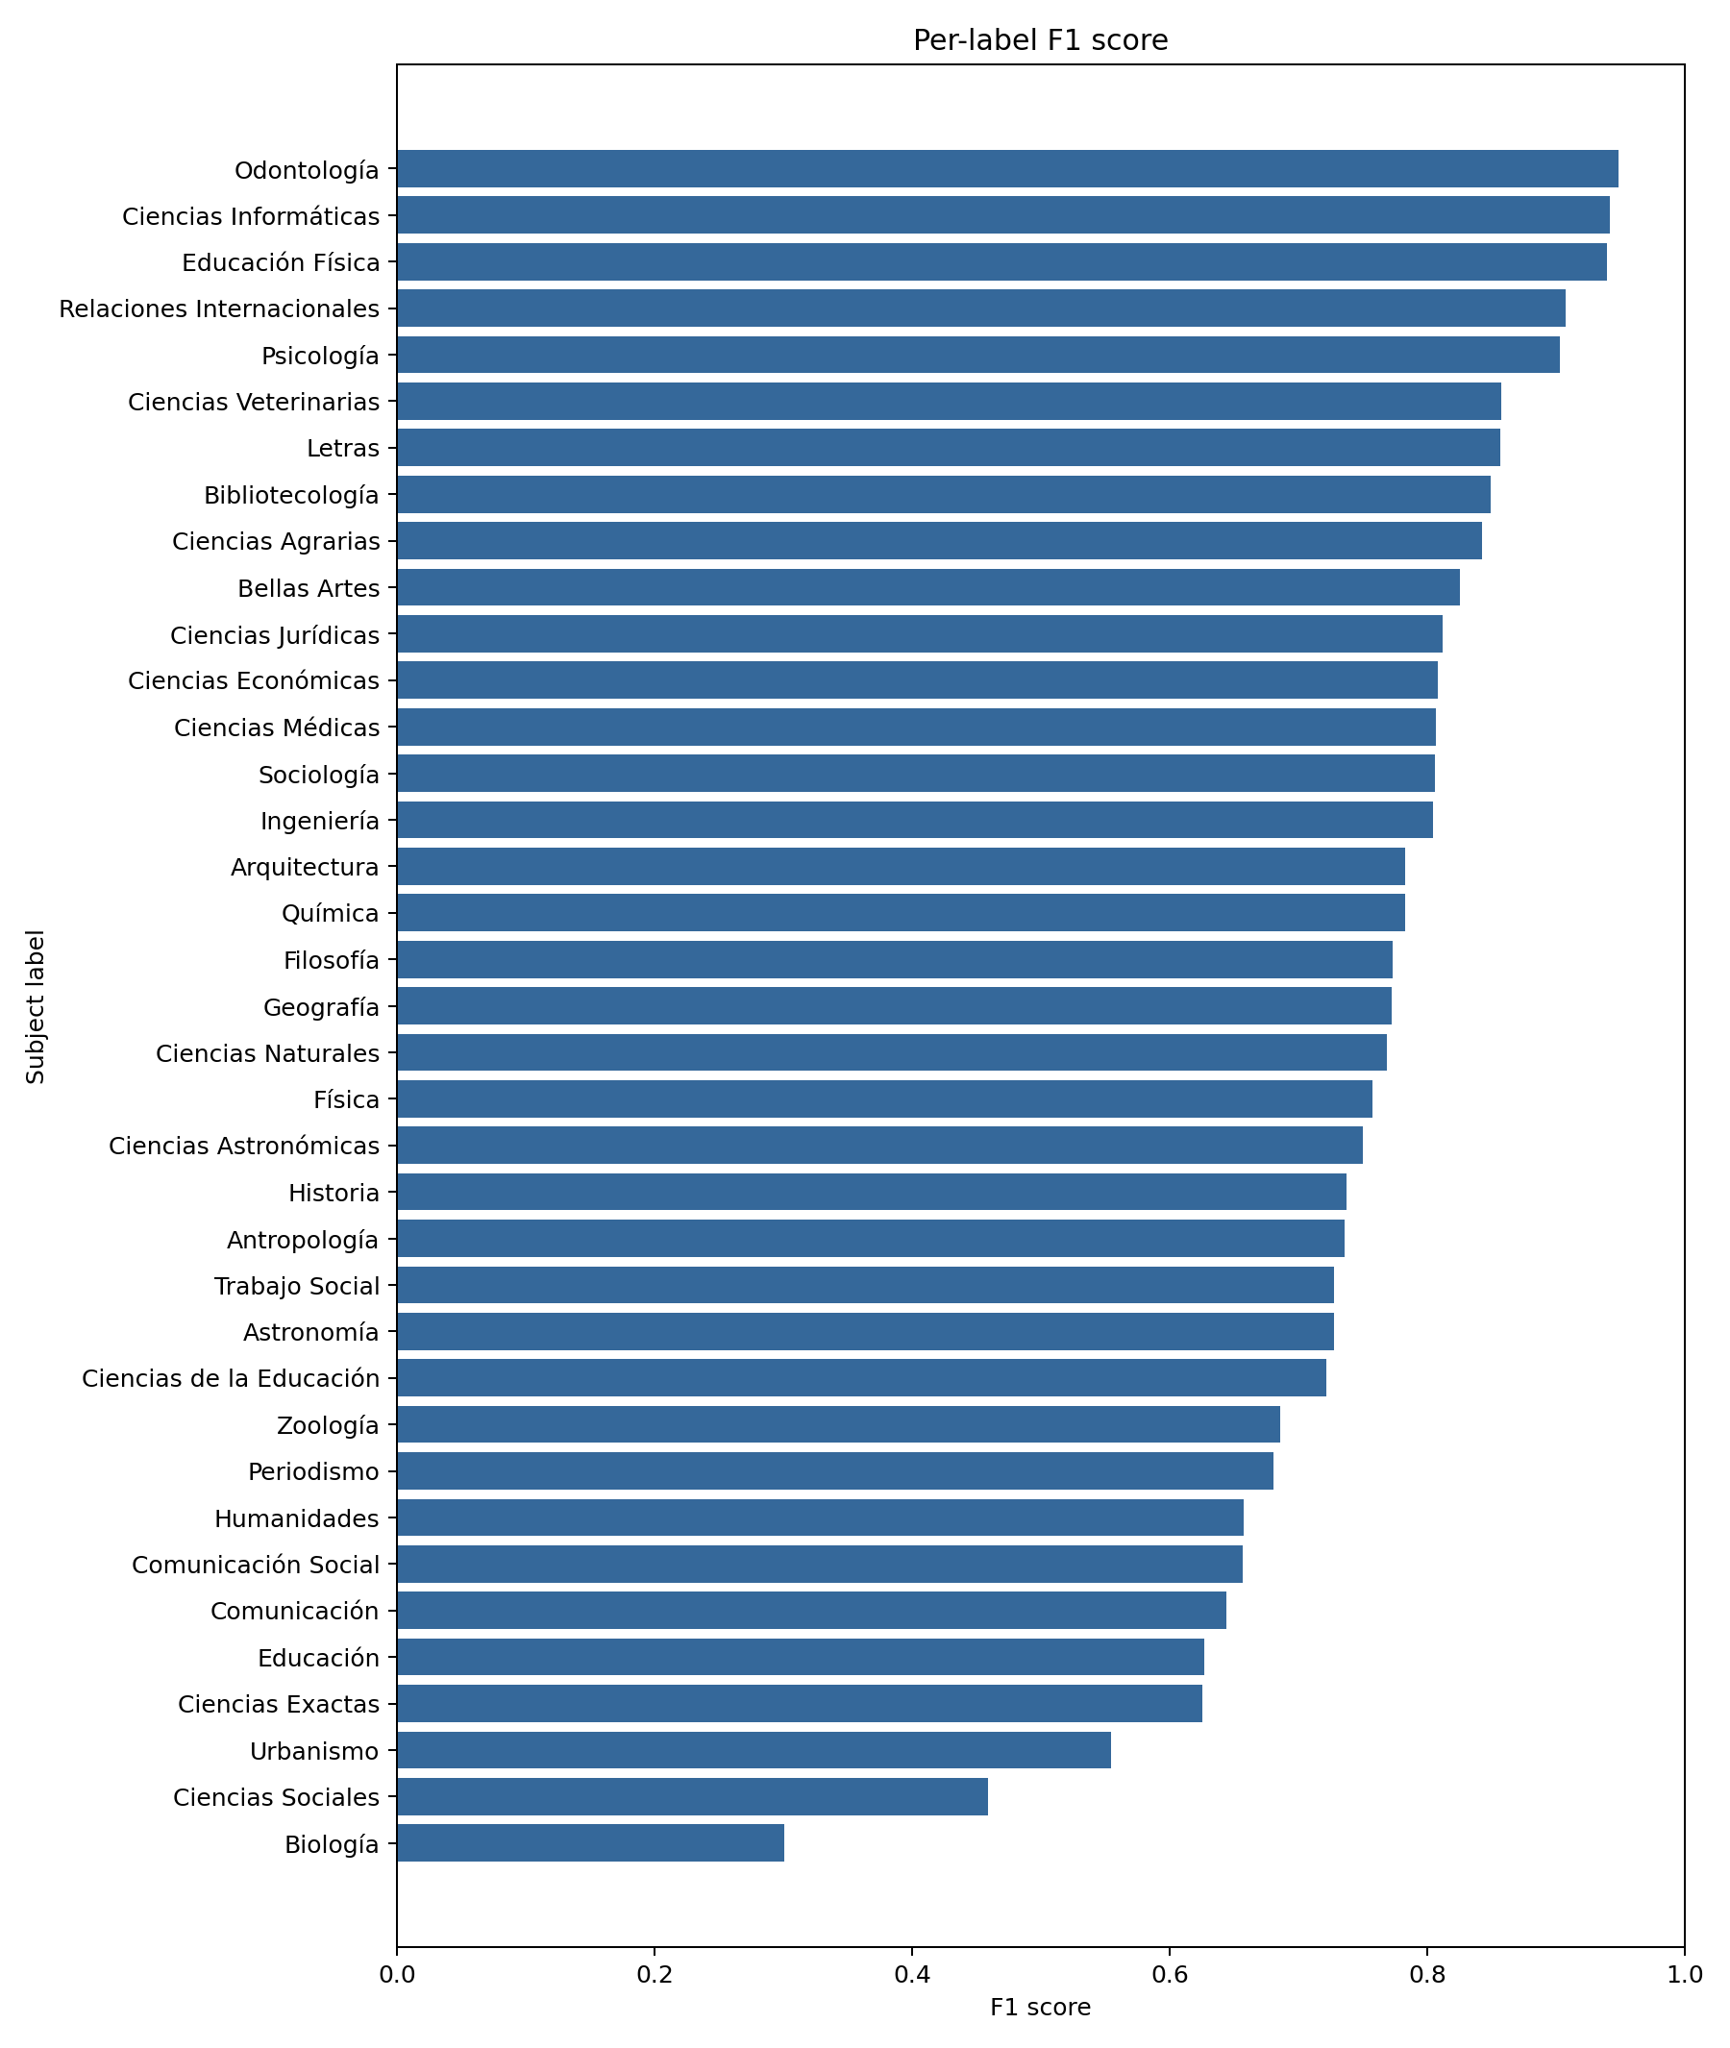
Figure S4. Final held-out F1 by subject.

S9. Diagnostic figures
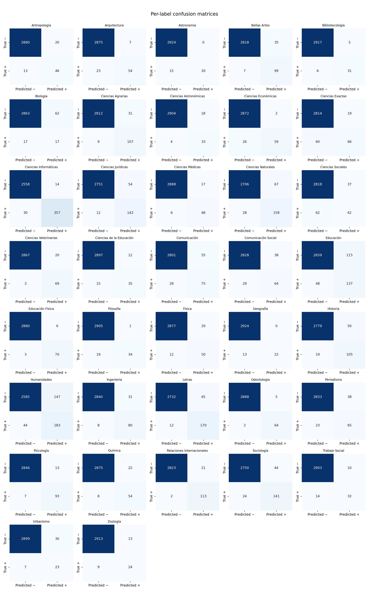
Figure S5. One-vs-rest confusion matrices for all 37 subjects.
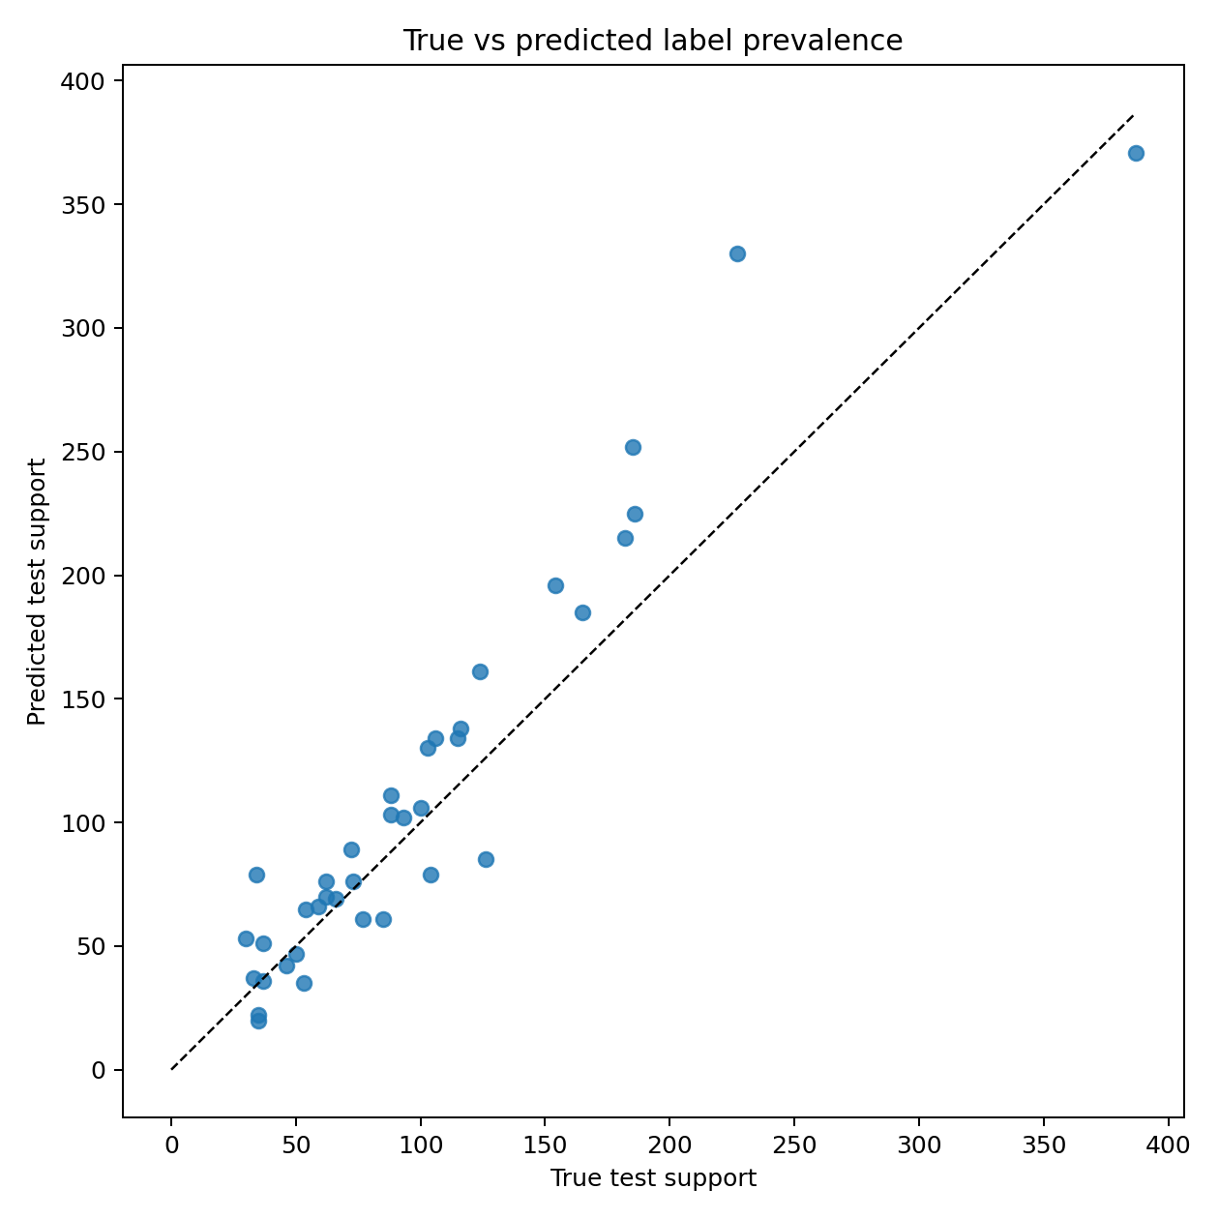
Figure S6. True versus predicted support by subject.
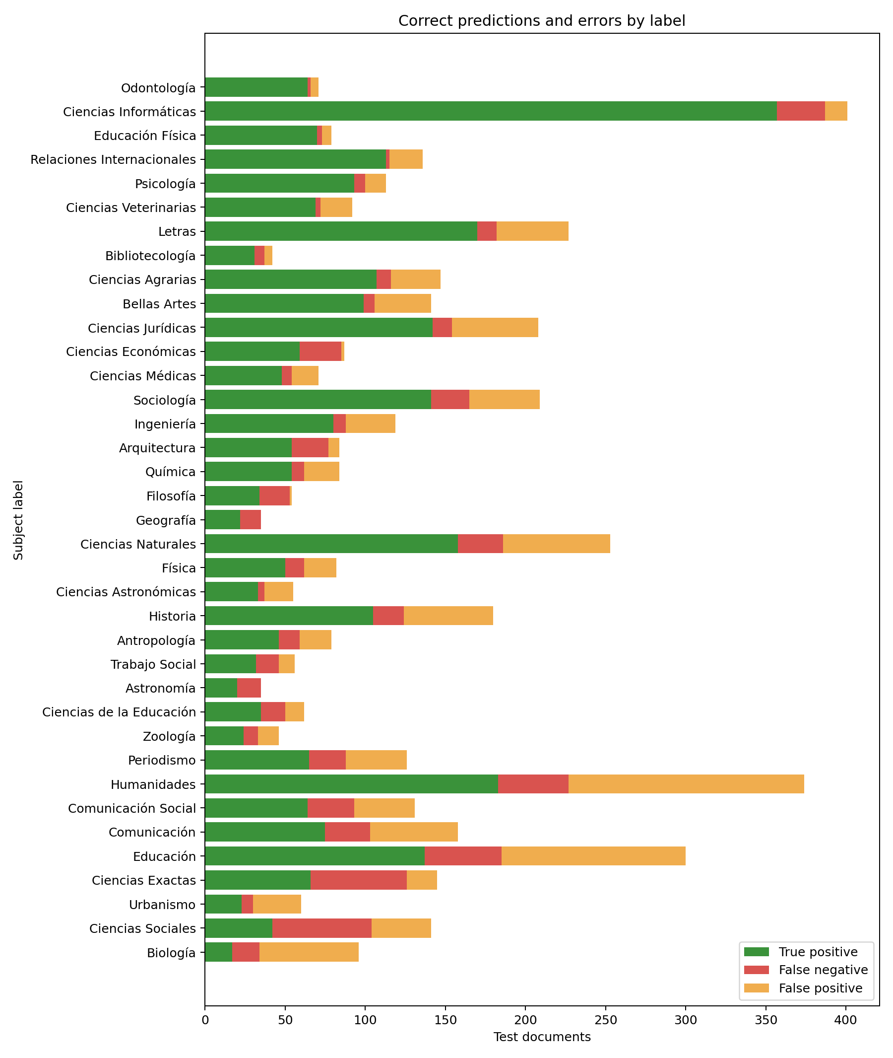
Figure S7. False-positive and false-negative counts by subject.
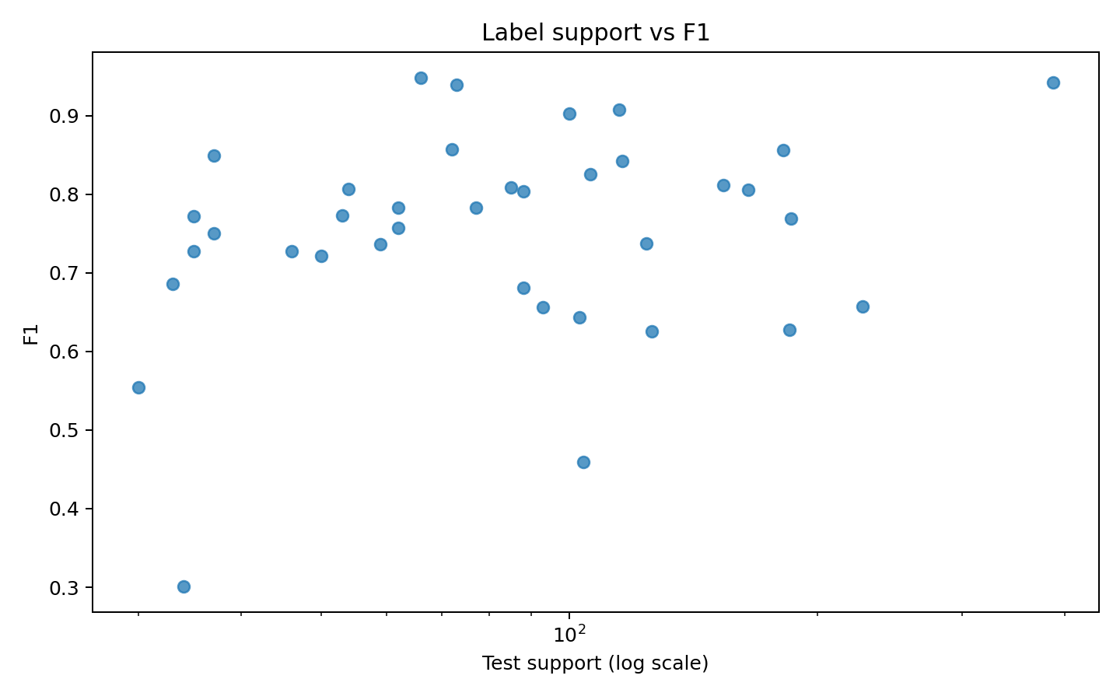
Figure S8. Relationship between test support and subject-level F1.
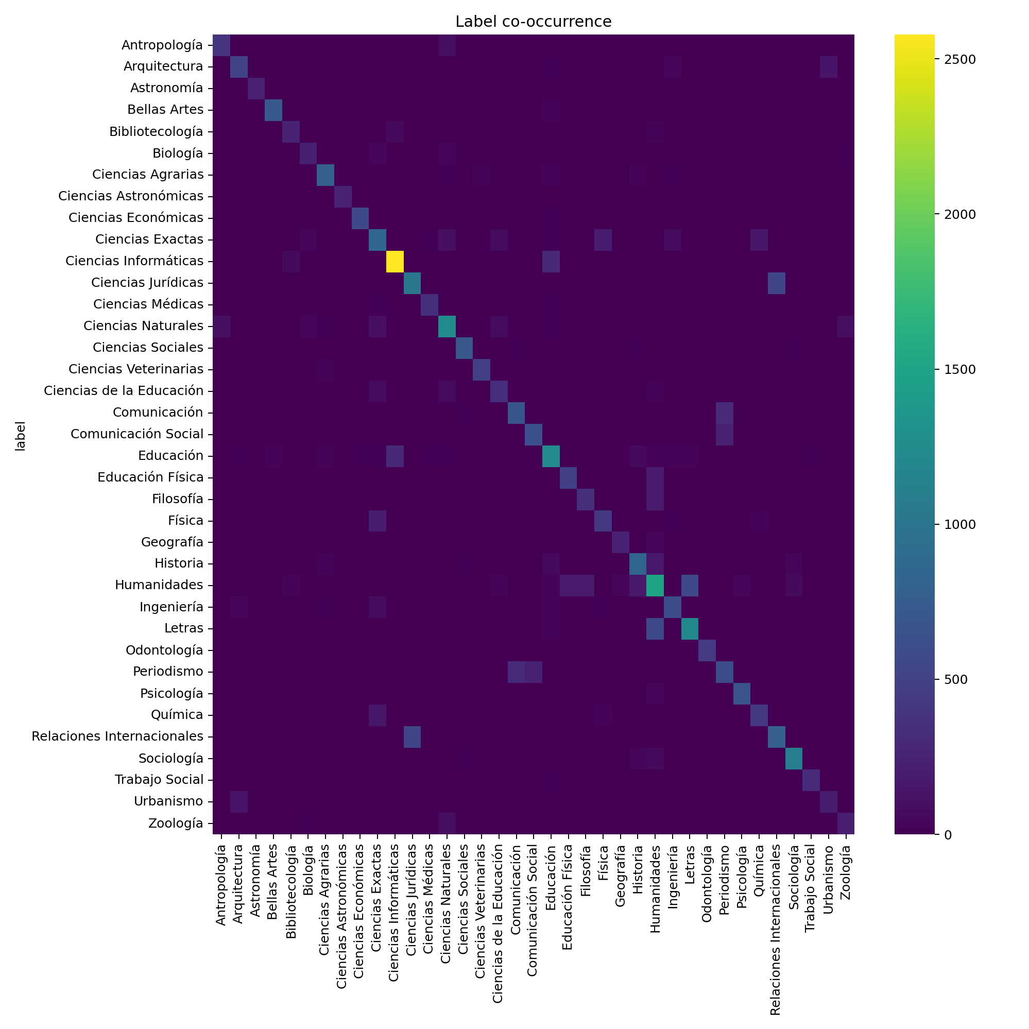
Figure S9. Label co-occurrence structure in the evaluation cohort.

S10. Artifact index and reproduction
The GitHub paper_artifacts directory includes the complete 233-row validation export, eight-row convergence audit, per-label convergence diagnostics, calibrated thresholds, paired-bootstrap differences, language distributions, label coverage, confusion matrices, error summaries, learning curves, and publication figures. The source configurations are configs/run_full_20k_v3_2026.yaml and configs/run_convergence_audit_20k_2026.yaml.
Code and aggregate evidence: https://github.com/KharolusIII/institutional-repository-subject-classification

