**School District Re-Analysis**

* **Overview**

The school board discovered the raw data file for the Thomas High School 9th grade reading and math test results were dishonestly altered. We we’re asked to void this part of the data and re-run the analysis.

* **Results**

Thomas High School ranking, 9th grade, and charter math & reading scores were increased with the editing of the data.

Fig.1 voided per school

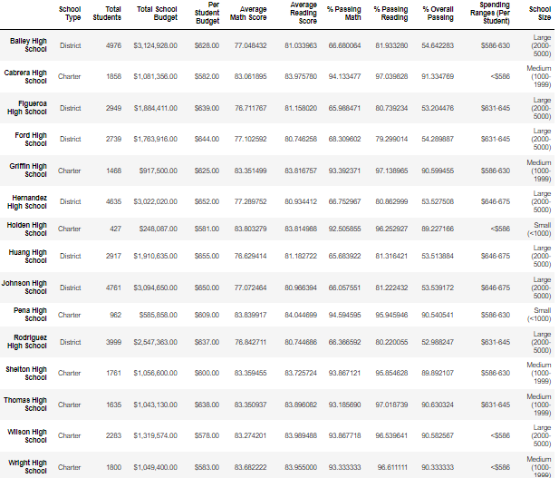

Fig.2 voided per school type

