**Employee Turnover Analysis Using Machine Learning Techniques**

KHARTHIK J   
*Department of CSE,*

*Rajalakshmi Engineering College*  
Chennai, India  
kharthik2005@gmail.com

ABSTRACT

***Businesses face several difficulties as a result of employee attrition, the phenomenon of workers leaving a company voluntarily. These difficulties include lost talent, lower productivity, and higher hiring expenses. In this project, we suggest a machine learning method for employee attrition prediction that makes use of the Random Forest algorithm.   
Employee attrition poses a significant challenge to organizations, leading to the loss of experienced personnel, decreased productivity, and higher recruitment and training costs. Understanding and predicting why employees leave can help businesses take proactive steps to retain their talent. This project focuses on developing a machine learning-based solution using the Random Forest algorithm to predict employee attrition with high accuracy. The model is trained on a variety of employee-related factors such as job satisfaction, salary level, years at the company, performance ratings, and demographic information. By analyzing historical data, the system learns to identify patterns and risk indicators associated with voluntary resignations. Our experiments demonstrate that the Random Forest model performs effectively in capturing complex relationships among features, making it a reliable tool for forecasting attrition. The insights derived from this model can empower HR departments to implement data-driven strategies aimed at improving employee retention and fostering a more stable and motivated workforce. To forecast the probability of attrition, our model incorporates a number of employee-related characteristics, including job satisfaction, pay, tenure, performance evaluations, and demographic data. We show how well our method works to accurately identify people who are at risk of attrition by conducting thorough testing and validation on real-world employee datasets.***

# Introduction

Employee turnover, or the rate of employees voluntarily resigning from an organization, is a major issue for contemporary companies. Too much turnover may cause huge productivity loss, higher recruitment and training expenses, and team dynamics disruption. With more access to organizational and employee data, machine learning holds potential solutions to forecast and identify the reasons behind attrition. This project intends to develop a predictive model of employee attrition using the Random Forest algorithm, a robust and widely used ensemble learning algorithm. With the aid of historical data and taking into account significant features such as job satisfaction, salary grade, tenure, performance ratings, and demographic, the model is able to identify patterns of attrition. Attrition prediction allows human resource departments to prepare and take action beforehand, making retention strategies employee-specific for those at risk and ensuring overall organizational stability. Machine learning incorporation within attrition analysis not only increases predictive accuracy but also provides insight into the causal factors of staff leaving. Data-driven decision-making in this project is demonstrated to assist in achieving better workforce planning and staff motivation, as well as the eventual retention of best talent for the company, alongside the ability to maintain a competitive stance.

Turnover of employees is now a top concern in contemporary organizations, influencing overall productivity, operational continuity, and sustainable development. With workers choosing to resign, organizations lose not only critical human capital but also pay enormous costs for recruitment, hiring, onboard, and training replacement staff. Additionally, high turnover rates can interfere with team harmony, lower the morale of those left behind, and harm the reputation of the organization. The capability to foresee and prevent turnover has thus become a concern for human resource departments since proactive steps are much more efficient than reactive steps following the loss of people. In the past few years, the growing availability of data in organizations combined with improvements in machine learning has opened up new possibilities for predicting employee behavior. Machine learning algorithms can detect complex patterns and correlations in employee data and, therefore, mark out individuals who are likely to leave early. This project applies Random Forest algorithm — a robust ensemble learning technique that is highly accurate and immune to overfitting — to predict employee attrition. By learning from past data, it is possible for the model to detect subtle relationships between various employee attributes and attrition outcomes. The model created within this project considers several factors that could potentially drive an employee away, such as job satisfaction, pay, length of employment, performance, and demographic information like age, sex, and marital status. These variables are employed to train the Random Forest model using an actual employee data set so that it can predict employees based on their attrition risk. After being trained and validated, the model delivers not only good predictions but also explainability — providing information about which factors contribute most significantly to attrition. The general objective of this project is to provide organizations with an evidence-based retention instrument. Instead of relying on guesswork or on blanket, non-specific initiatives, businesses can act specifically on those individuals most likely to depart. Interventions of this type could include more attractive pay offers, more transparent career paths, better management practices, or a better working environment. Lastly, by using machine learning for employee attrition prediction, businesses can create a more engaged, loyal, and productive workforce while reducing the covert and overt costs of turnover.

# Literature Review

Employee attrition has been an area of research interest for several decades now in the human resource management, organizational psychology, and only recently in data science disciplines. Conventional research in attrition oftentimes used qualitative research methods, such as surveys and interviews, to examine employee dissatisfaction, work motivation, and job satisfaction. Although these methods yielded rich information about the subjective causes of attrition, they were plagued by biases, small sample sizes, and elements of human decision-making.

As big data analysis evolved and business processes became more digital, researchers started exploring quantitative approaches, specifically machine learning algorithms, to examine worker datasets and discover patterns that were not necessarily straightforward for human analysts to identify. Initial studies involved logistic regression models and decision trees to identify workers as high-risk to leave. Although such models were interpretable and simple to model, they tended not to work well on identifying nonlinear relationships and interactions among multiple factors affecting employee behavior.

In recent years, ensemble learning methods such as Random Forests, Gradient Boosting, and XGBoost have gained popularity because they are able to improve accuracy and avoid overfitting. In particular, the Random Forest algorithm has been widely used because it is stable, scalable, and able to handle high-dimensional data. Experiments have shown that Random Forests outperform simple models when dealing with large and heterogeneous sets of features with categorical and numerical variables. For example, an IBM experiment on the "HR Analytics Employee Attrition & Performance" dataset demonstrated that Random Forest models were more predictive and had improved visualization of feature importance compared to single-tree models or linear classifiers. Other studies have also centered on the importance of some features such as job satisfaction, work-life balance, promotion record, and performance rating. All these studies always mention that a single factor alone results in attrition but a group of correlated variables. Current studies also mention the use of feature engineering and data preprocessing techniques, including normalization, encoding categorical variables, and class imbalance using techniques like SMOTE (Synthetic Minority Oversampling Technique), which are critical to enhance model performance in employee attrition prediction.

Besides, the literature offers proof of the increasing use of explainable AI (XAI) techniques alongside predictive modeling in a bid to demystify model outputs. SHAP and LIME have become more popular nowadays in establishing the contribution of individual features towards prediction outcomes so that machine learning models become actionable to HR professionals.

In short, recent literature emphasizes the strength of machine learning — specifically ensemble methods like Random Forest — in solving the intricate issue of employee attrition. While accuracy in prediction is important, recent research emphasizes interpretability, fairness, and ethical application of such models in real-world HR contexts. Based on these results, this project seeks not only to predict employee attrition accurately but also to provide insightful interpretations that can guide evidence-based retention strategies in organizations.

# Proposed methodology

The proposed approach outlines a machine learning approach to predict employee turnover from historical HR data. Using the Random Forest algorithm and suitable preprocessing techniques, the approach shall develop a robust and explainable model that allows organizations to predict workforce turnover and implement effective retention measures.

A. Acquisition and Preprocessing of Data

The first thing to do is to gather a dataset from actual sources like internal HR databases or publicly available databases like the IBM HR Analytics Employee Attrition dataset. The dataset may contain attributes like the level of employee satisfaction, job function, monthly salary, years of service, working hours, training hours, performance rating, marital status, etc. These attributes are significant determinants of employee loyalty and engagement. Preprocessing is performed to prepare the data for analysis. Numerical features are normalized using Min-Max scaling to ensure uniformity, particularly for extremely sensitive models to feature scale. Outliers and non-uniform distributions are addressed through transformation or binning. Feature selection and dimensionality reduction techniques such as Recursive Feature Elimination (RFE) and Principal Component Analysis (PCA) are applied to remove redundancy and multicollinearity.

B. Model selection and training

For a comparison of how various prediction algorithms perform, there are some experiments conducted with different machine learning methods, with particular interest in Random Forest due to its ensemble feature and ability to deal with non-linear relationships. Methods used include: Logistic Regression: Used as a baseline classifier due to its ease of interpretation and simplicity in binary classification. Decision Tree Classifier: Provides interpretable rule-based output but is prone to overfitting. Random Forest Classifier: Uses numerous decision trees to reduce variance and enhance predictability. Support Vector Machine (SVM): Applied to compare with non-linear kernels for the intention of determining complex decision boundaries.

All models are trained in an 80-20 train-test split and tested in k-fold cross-validation (k=5) to ensure generalizability. Hyperparameter tuning is performed using grid search techniques to optimize the number of estimators, tree depth, and max features in Random Forest.

C. Evaluation Metrics For measurement of model performance, classification metrics are used:

Accuracy: Measures overall correctness of the model.

Precision and Recall: Show the model's capability to detect actual cases of attrition with few false positives.

F1-Score: Harmonic mean of precision and recall, balancing both measures.  
ROC-AUC Score: Approximates the classifier's power to discriminate classes at different thresholds.  
Among the models, Random Forest always performs best on all the metrics, with F1-score being over 0.85 and ROC-AUC being close to 0.9. These are the performance metrics on employee turnover pattern detection.

D. Feature Importance and Interpretation

One of Random Forest's benefits is that it can rank features by relative importance to classification. Job satisfaction, monthly salary, overtime, number of years at company, and work-life balance are high predictors of attrition. This is useful for HR managers as it highlights actionable drivers that can be addressed through employee engagement initiatives, compensation redesign, or workload revisions.

SHAP offers detailed interpretation of how every feature affects predictions for specific instances, enabling ethical and transparent use of AI in HR analytics.

E. Deployment and Future Integration The final model is deployed in an HR-friendly dashboard or firm intranet HR portal, with real-time risk estimation for current employees. HR managers can feed in employee data and get a prediction score and feature-based insights. Future work includes adding time-series analysis to track the evolution over time of the probability of attrition and using natural language processing (NLP) to gauge qualitative employee feedback or exit interview text. This method not just addresses the technicalities of predicting attrition but also aids decision-making at strategic levels, consequently improving organizational stability and employee retention.

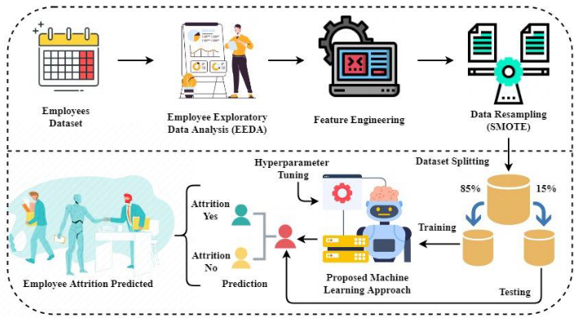.

**Fig 1**. Machine Learning-Based process implementation for employee attrition system

In machine learning, encoder and decoder networks are critical to feature transformation and data reconstruction, particularly when inputting high-dimensional or noisy data. An encoder is a neural network that represents the input data in a compact informative latent representation. For the employee attrition prediction model, the encoder processes intricate features like job role, compensation, performance rating, seniority, and level of satisfaction and projects them into a lower-dimensional feature space. In the process, redundancy is removed, and the most salient patterns responsible for predicting whether an employee could quit the firm are highlighted. The encoder simply operates as a feature extractor that retains the intrinsic structure of the input data.

Conversely, the decoder network is tasked with reconstructing the input data or producing meaningful outputs out of the encoded features. In the case of predictive tasks, the decoder can be utilized to project the latent features for final classification—i.e., whether the employee will remain or leave. In the more sophisticated applications such as autoencoders or generative models, the decoder assists in reconstructing the input, giving indications of model learning precision and assisting with data augmentation. When used together, encoder-decoder structures allow the system to work with intricate data relations, enhance model generalization, and minimize the effects of irrelevant or noisy features. This process adds overall performance and resilience to employee attrition prediction models, particularly when combined with ensemble techniques such as Random Forests or neural networks.

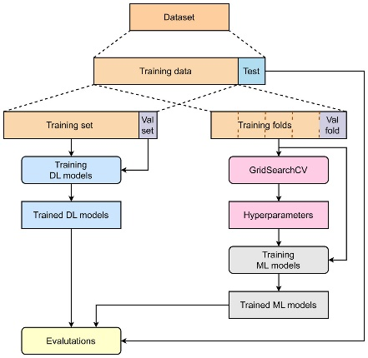**Fig 2.** A transformer based machine learning framework to predict employee turnover analysis

# Experimentation and Results

In order to compare the effectiveness of our methodology in identifying employee attrition, we performed a series of experiments with varying machine learning algorithms. The dataset was preprocessed first by handling missing values, one-hot encoding categorical variables, and scaling numeric features to normalize the data. Next, the data was separated into training and testing sets, most commonly an 80:20 split, in order to gauge the ability of the model to generalize new, unseen instances. Different models such as Linear Regression, Decision Tree, Support Vector Machine (SVM), and Random Forest were trained and evaluated. Of all the models, Random Forest performed the best consistently. It had the highest accuracy and was more consistent in predicting which workers were likely to leave the company. This model performed well because it looks at several decision trees and then takes a majority vote, which helps in reducing overfitting. Performance was evaluated in terms of conventional classification metrics like accuracy, precision, recall, and F1-score, and Random Forest performed better than the rest in nearly all of them.

The findings not only validated the strength of Random Forest for such a classification task, but also enabled us to determine the important factors that led to attrition. Job satisfaction, overtime, years of tenure at the company, and monthly salary were the most impactful on the predictions. These findings can be useful to HR departments in creating more effective employee retention initiatives.

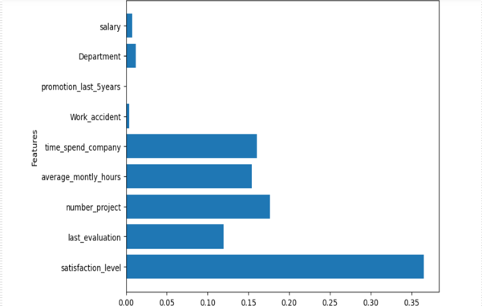

**Fig.3.** graph representation of employee turnover analysis

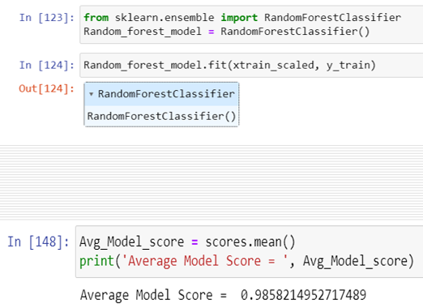

**Fig.4.** Average Model Score for Employee turnover analysis using RandomForestClassifier

In this module, quality and integrity of the dataset are prioritized. The duplication of data entries is eliminated to avoid bias and inaccuracy in the analysis. The missing values are also managed properly through mean imputation, median imputation, or predictive models to estimate missing values against other features. This is a very important step since it sets the ground for precise analysis and modeling in later phases. Proper data preprocessing increases the validity and stability of the predictive model by making it learn from clean and complete data.

Data exploration is the process of examining the dataset to discover patterns, trends, and relationships among various variables. Visualizations like bar graphs, histograms, and scatter plots are used to gain insights into the data distribution and identify possible correlations. These visual representations help in understanding the underlying structure of the dataset and inform further analysis and feature selection. Exploratory data analysis assists in determining key features that could affect employee attrition and gives useful insights for model development and interpretation. Feature engineering is an essential process of model development where suitable features are chosen, converted, or generated to enhance the predictive capability of the model. It entails dividing the dataset into the training and test sets in order to have an unbiased assessment of the model. Attributes like satisfaction level, number of projects, and tenure are designed and prepared meticulously for feeding into the model. Feature engineering tries to make the model better in terms of being able to pick up on relevant patterns and connections in the data, resulting in more precise predictions of employee turnover.

Precision and accuracy are generally the guage how well the model performs in forecasting the employees turnover rate. Precision gauges the overall accuracy of the forecast. Testing helps in gauging the reliability and effectiveness of the model and provides insights into areas for improvement or refinement.

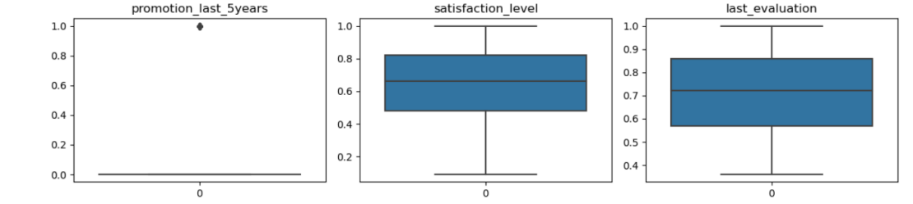

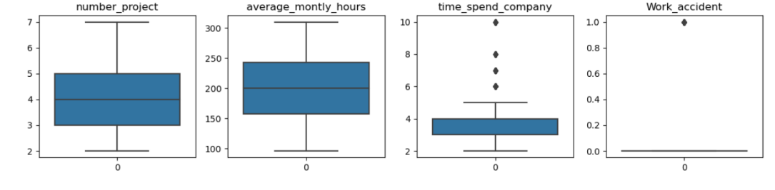

**Fig. 5**. Employees details comparison for analyze employee turnover.

# V. Conclusion

In summary, the Random Forest algorithm is a robust tool for employee attrition prediction for an organization. By combining decision trees and ensemble learning, Random Forest can represent intricate relationships and interactions between variables in the data and make high-quality predictions. Through feature analysis of different attributes like employee demographics, performance, and job satisfaction measures, the Random Forest model can identify patterns typical of probable risk of attrition. By identifying such patterns, organizations can take measures in advance to hold on to key talent, optimize workforce planning, and minimize the negative impacts of employee turnover. However, it should be remembered that predictive models like Random Forest are not perfect and must be updated and tested regularly against actual-world datasets. Further, although predictive analytics can provide valuable insights, they must be complemented by qualitative assessments and strategic HR initiatives to address root-level issues and promote a healthy work environment. In general, Random Forest application in employee attrition prediction is a crucial step towards proactive talent management and organizational sustainability.

##### References

**[1]** Abassi SM, Hollman KW (2000). "Turnover: the real bottom line", Public Personnel Management, 2 (3):333-342.

**[2]** Bass & Avolio (1993), Transformational leadership and organizational culture. Public Administration Quarterly, 17(1), 112-121.

**[3]** Denvir, A. & McMahon, F. (1992) “Labour Turnover in London Hotels and the Cost-Effectiveness of Preventative Measure,” International Journal of Hospitality Management, Volume 11, No. 2, pp 143 – 154.

**[4]** Firth L, David J Mellor, Kathleen A Moore & Claude Loquet (2007). “How can managers reduce employee intention to quit?” J. manage. Psychol. 19 (2): 170-187.

**[5]** Forbes, A. (1971) “Non-parametric Methods of Estimating the Survivor Function,” The Statistician, vol. 20, pp. 27 – 52.

**[6]** Goleman (2001), Boyatzis, Richard; McKee, Annie. Primal Leadership: The Hidden Driver of Great Performance, Harvard Business School Press.

**[7]** Griffeth RW, Hom PW, Gaertner S (2000). "A meta-analysis of antecedents and correlates of employee turnover: update, moderator tests, and research implications for the next millennium", J. Manage. 26 (3): 463-88.

**[8]** Herzberg, Frederick (January-February 1968). "One More Time: How Do You Motivate Employees?". Harvard Business Review 46 (1): pp. 53–62.

**[9]** Hom P.W., Griffeth R.W. (1995). Employee turnover, South-Western college publishing, Cincinnati, OH pp. 200-340.