# User Present in in-memory DB

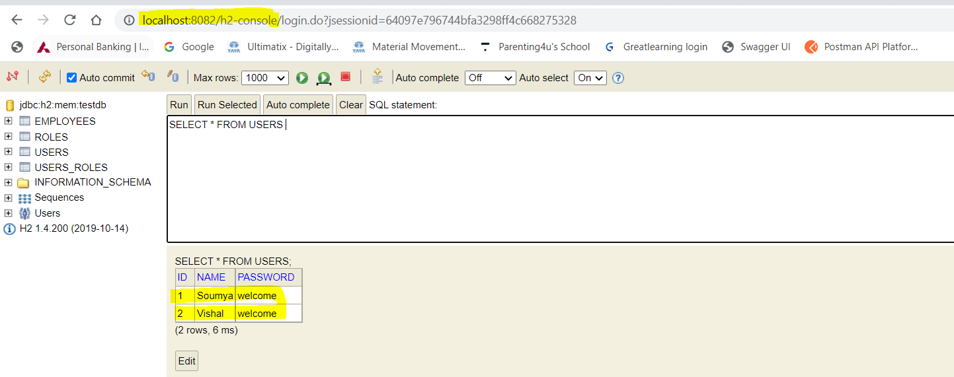

# Roles present in DB

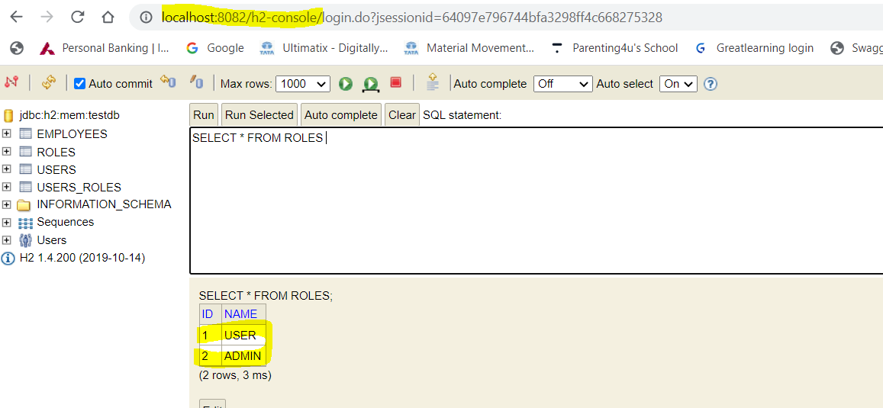

# User-Role Mapping in DB

* Soumya is ADMIN
* Vishal is USER

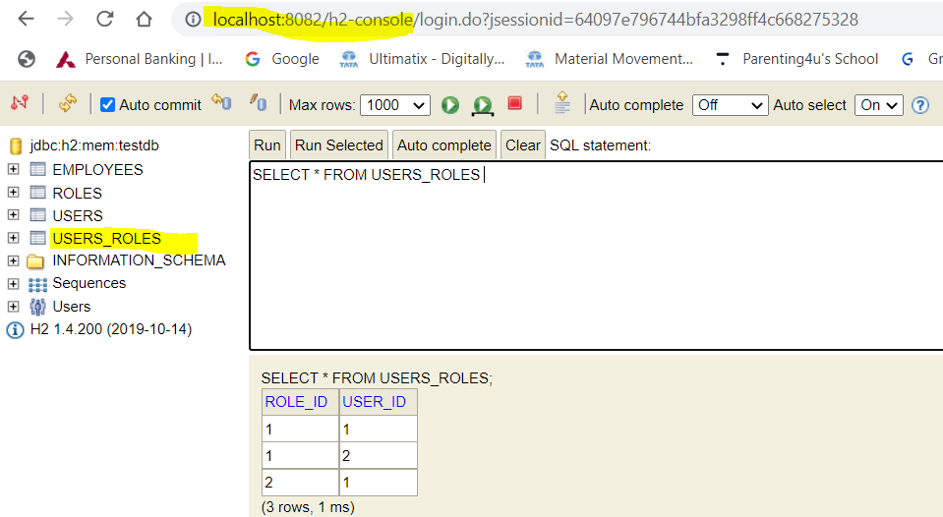

# ADMIN(Soumya) Activity Screen Shots-

## Get All Employee

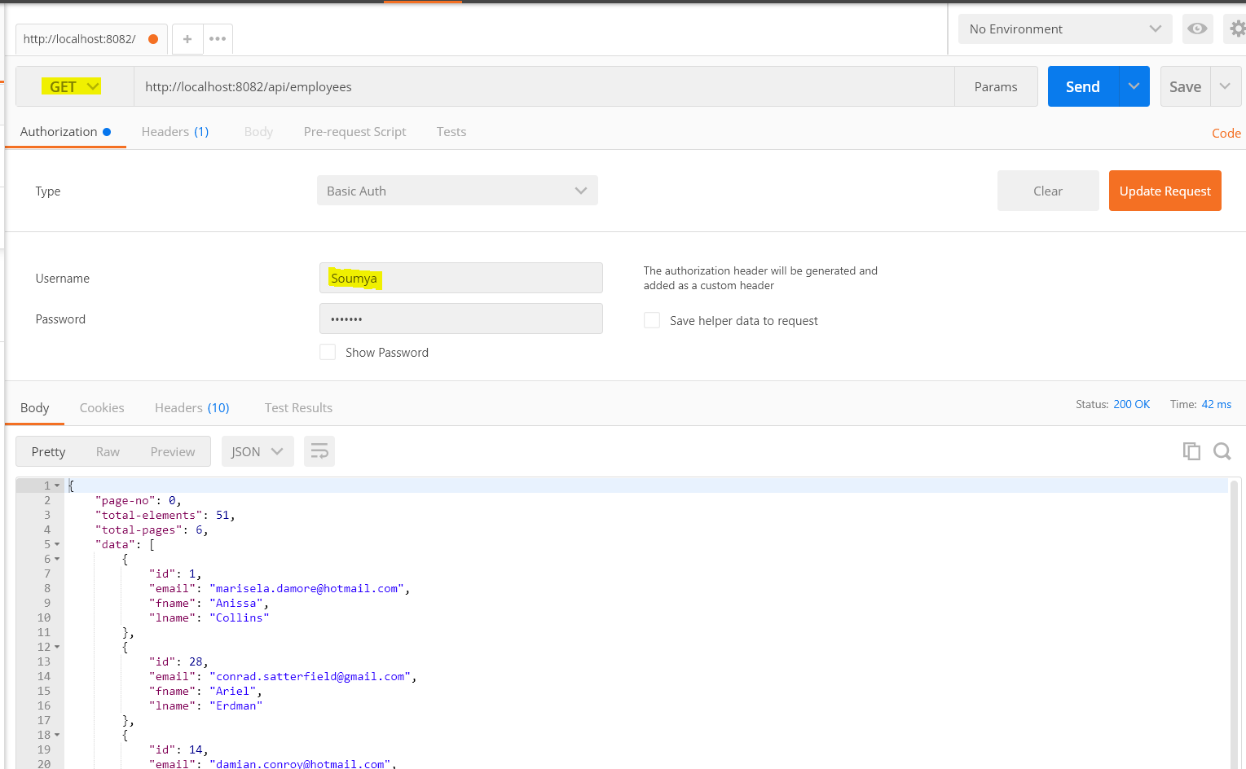

# Get Employee by Id (51)

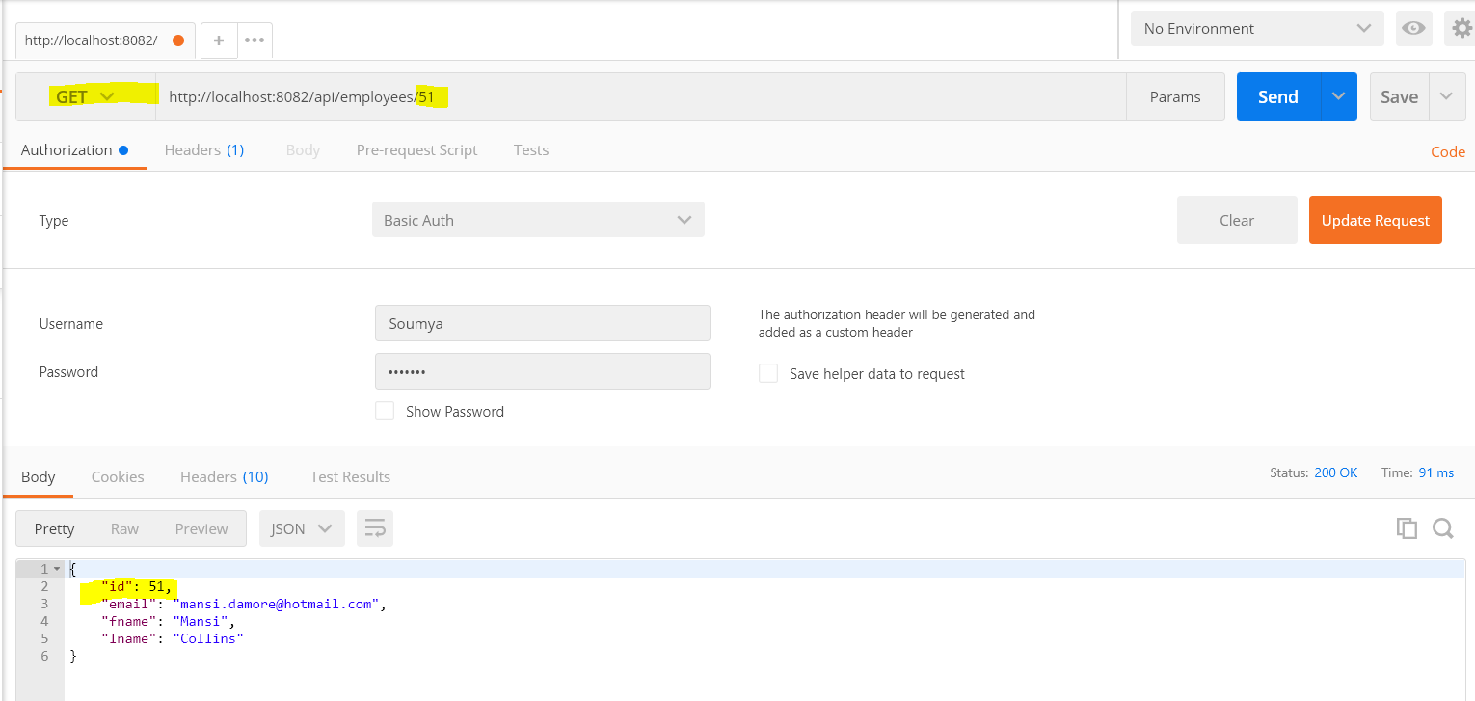

# Get Employee by Name(Mansi)

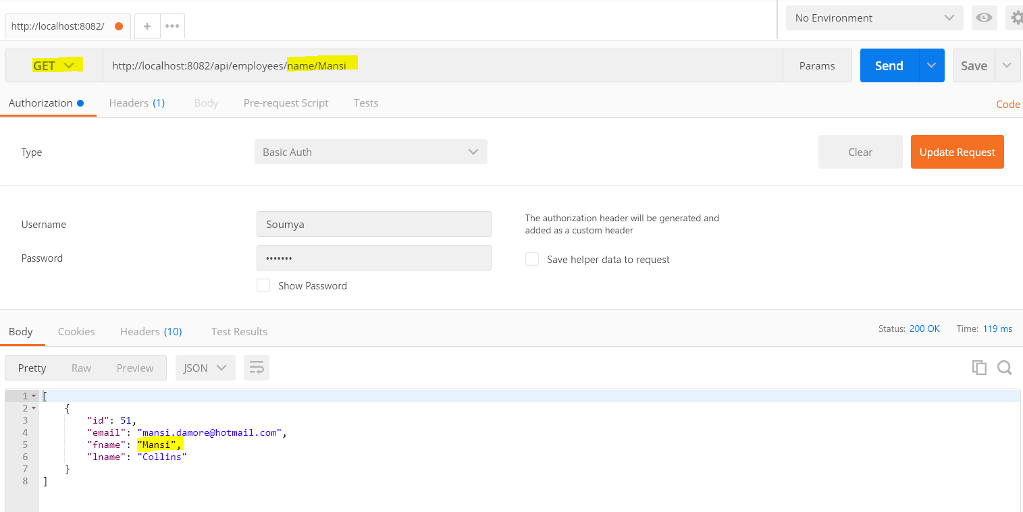

# Sorting by Desc order

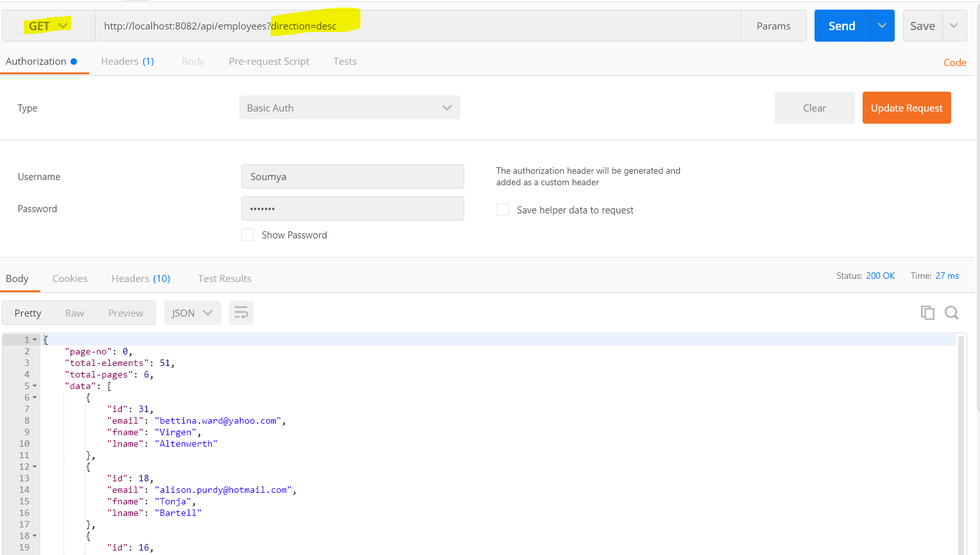

# Sorting by ASC order

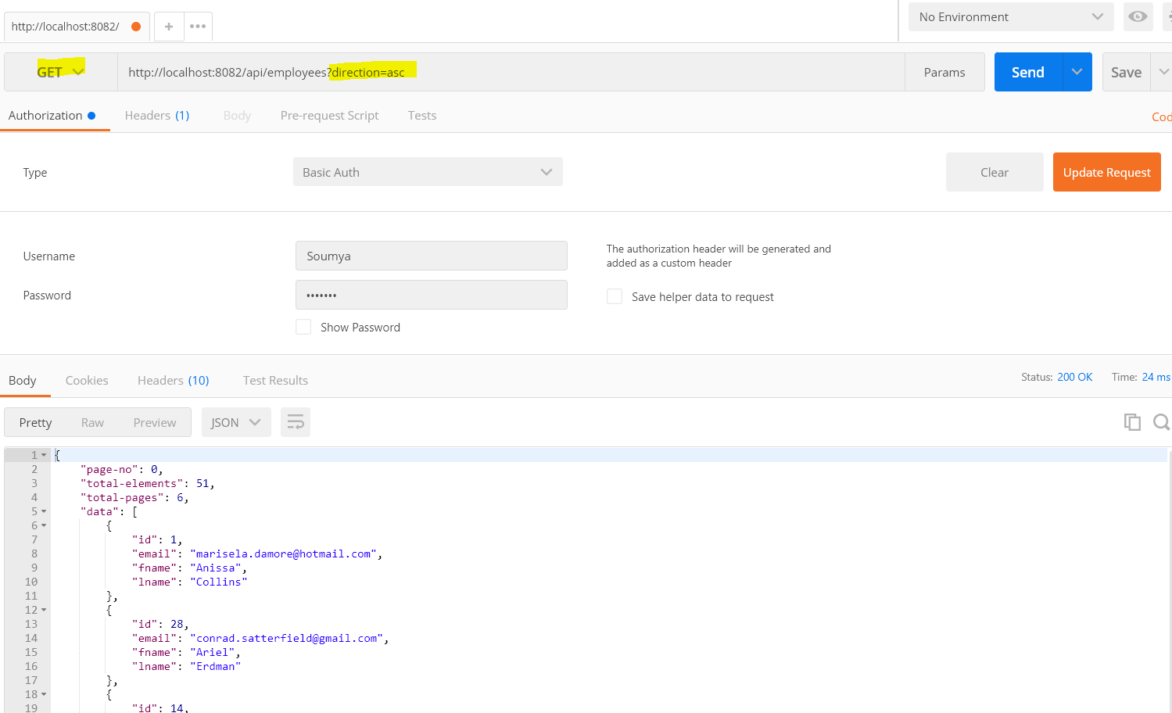

# Delete Employee by Id (28)

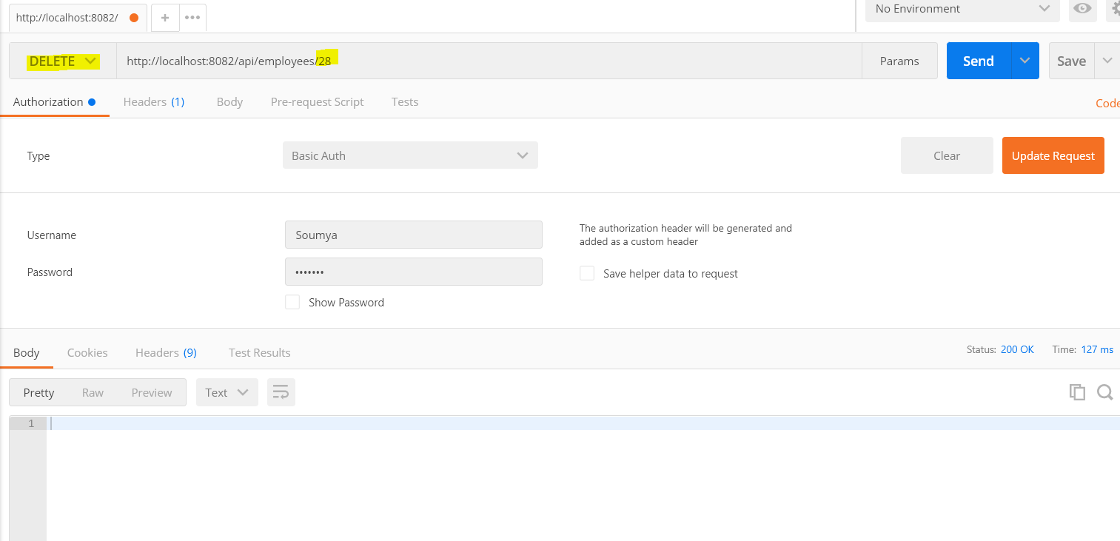

# After deleting searching employee by id 28(No employee found)

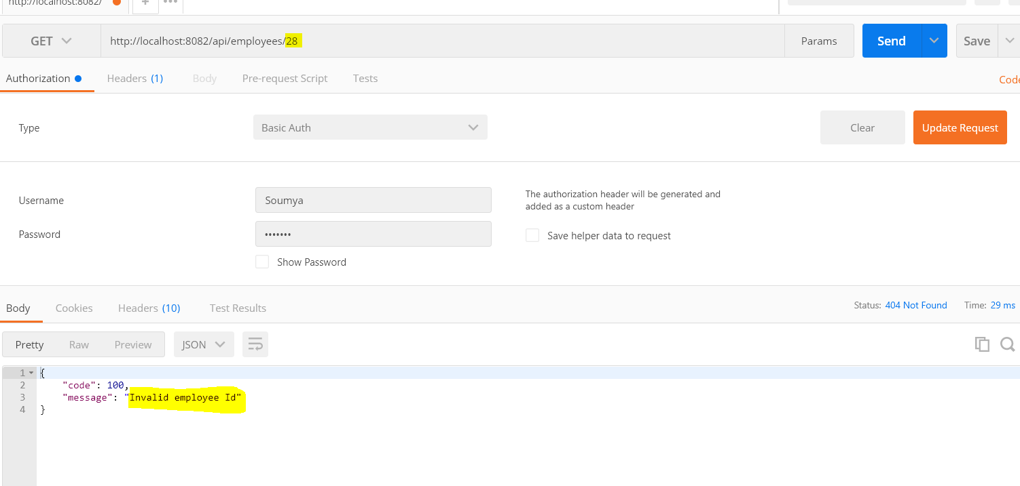

# Post Mapping(Inserting Employee Kavya)

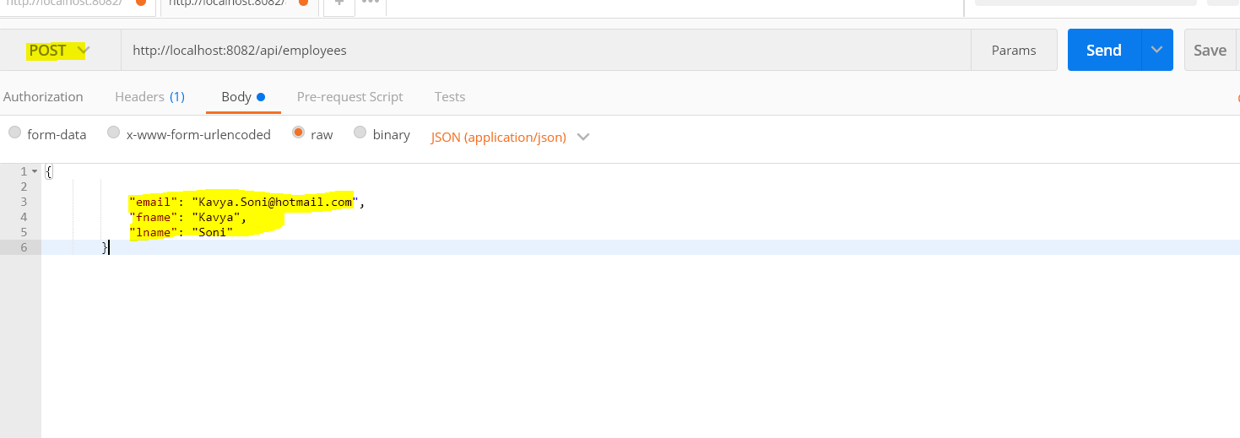

# Employee Inserted by Id 52

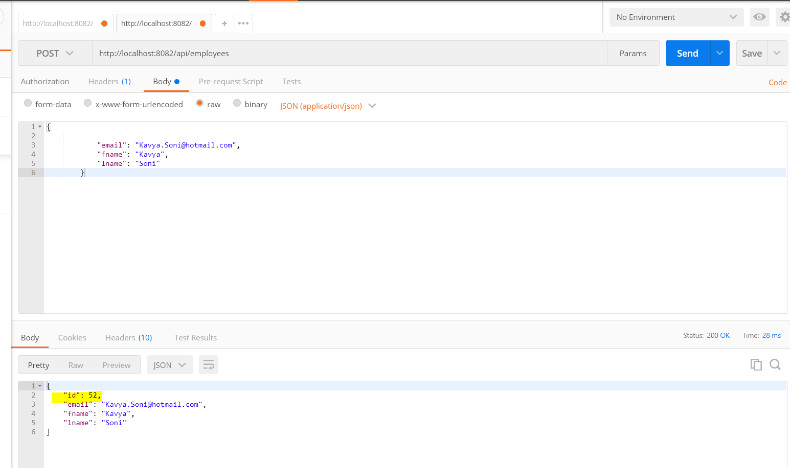

# USER (Vishal) Activity Screen shots-

## Get Employees( all employees)

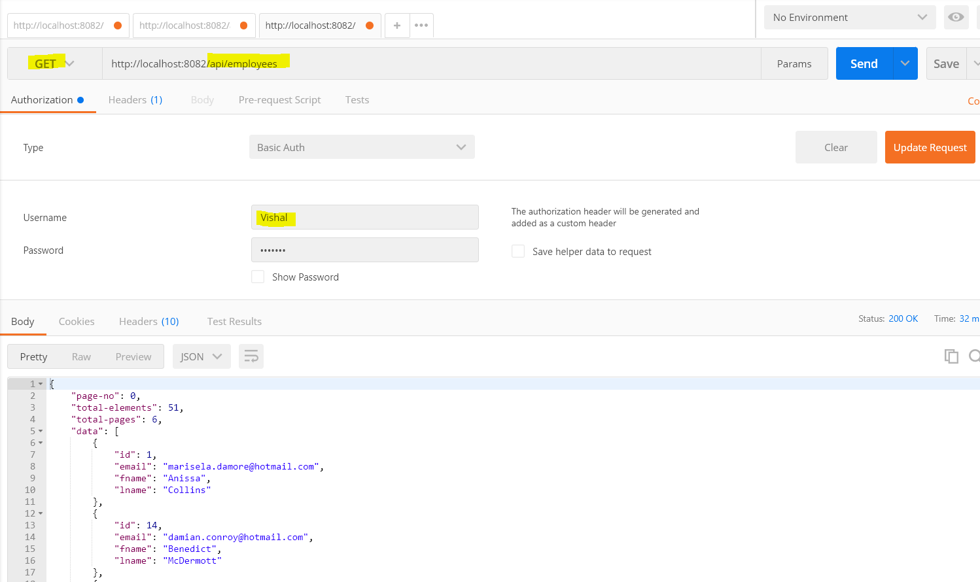

## Get employee by Id ( 51)

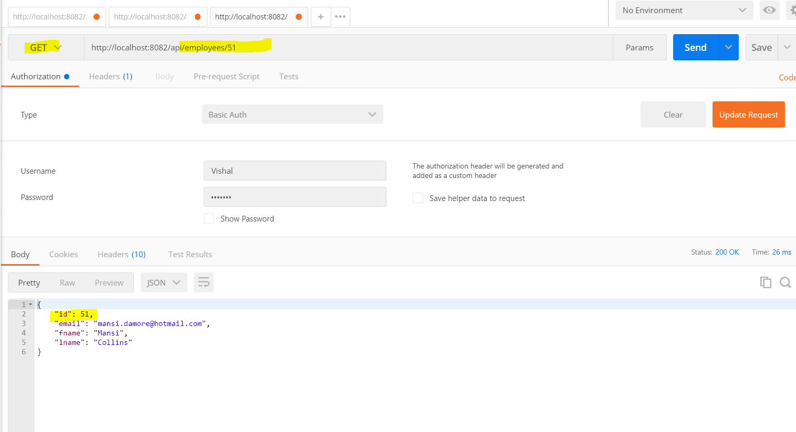

## Get employee by Name (Kavya)

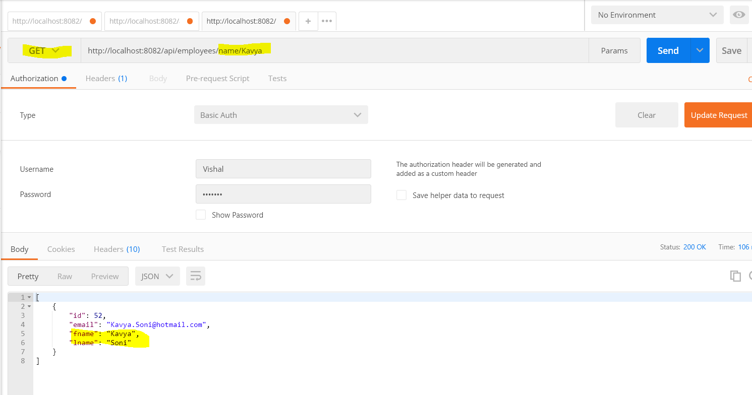

## Delete By Id ( 51) access Denied

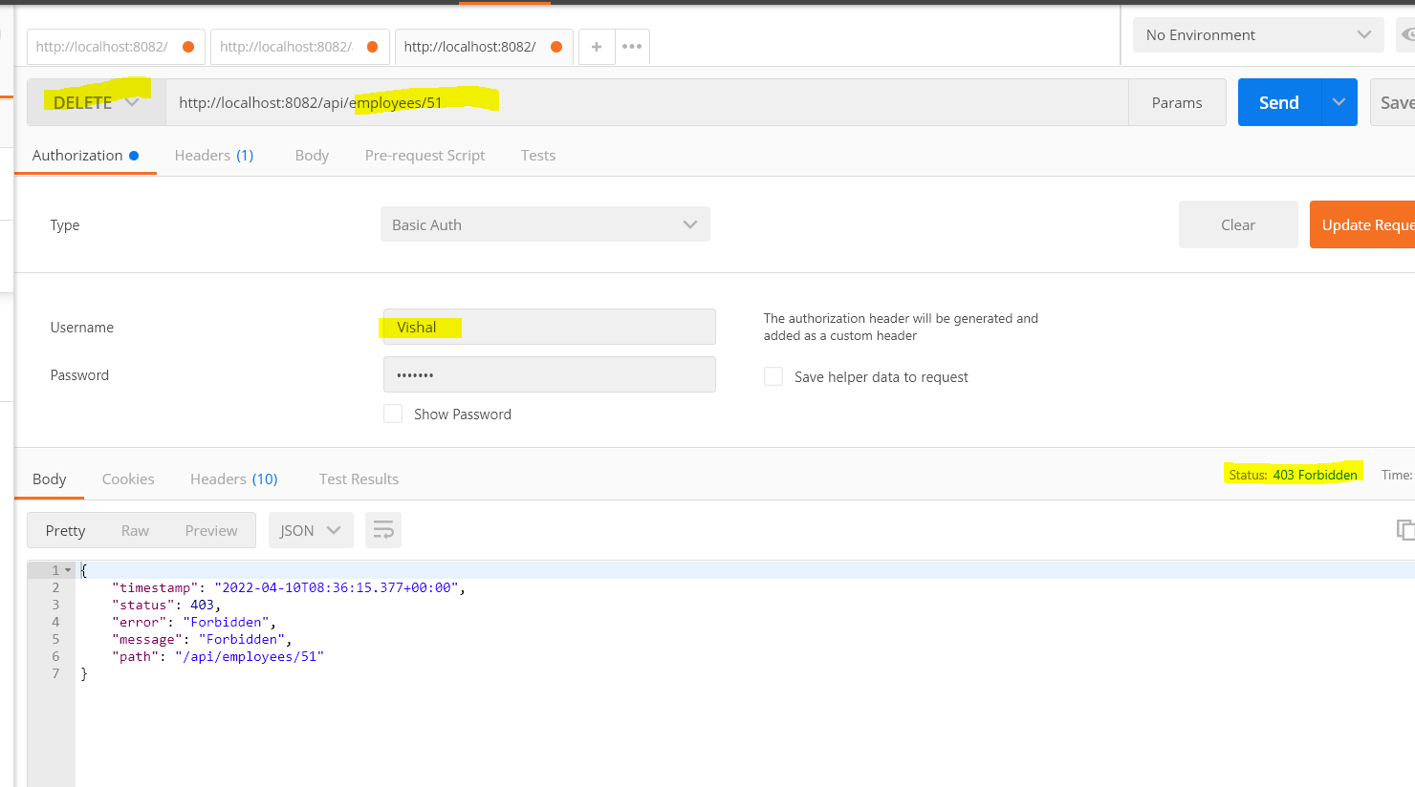

## Post employee (Access Denied)

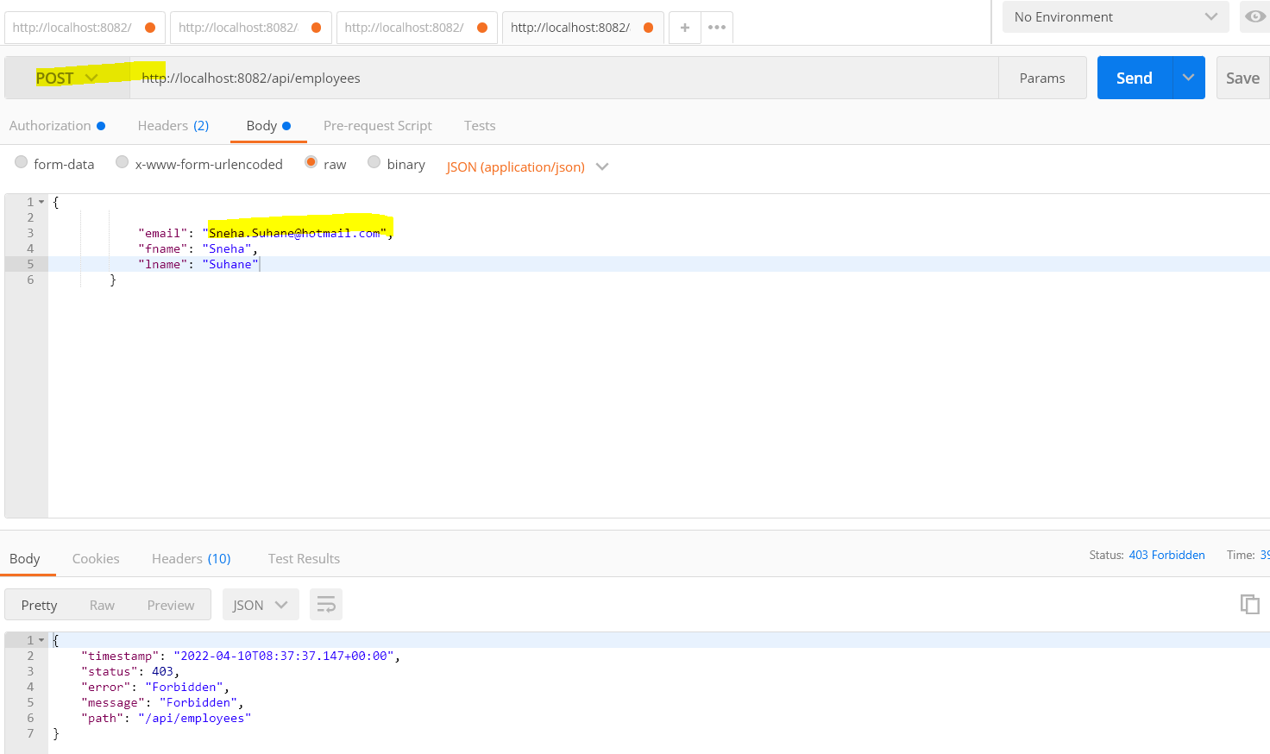

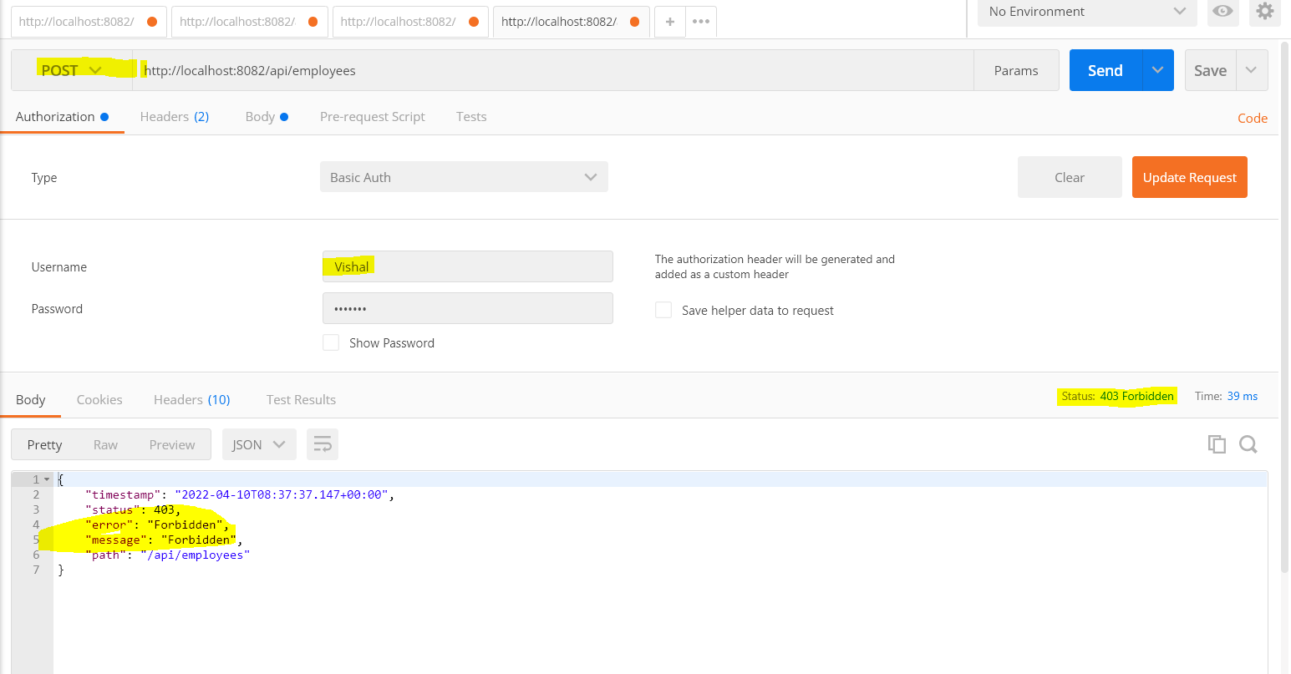

## Get Employee by Id

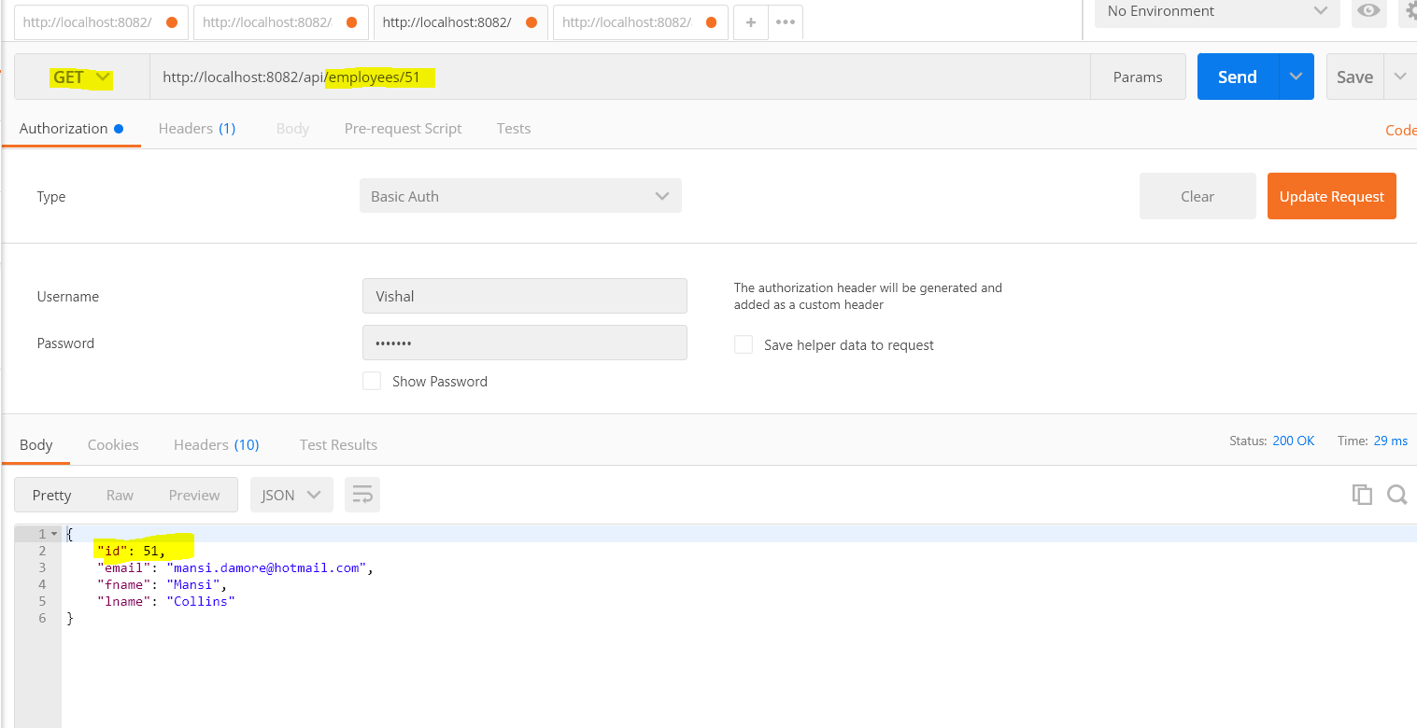

## Get employee By name (Kavya)

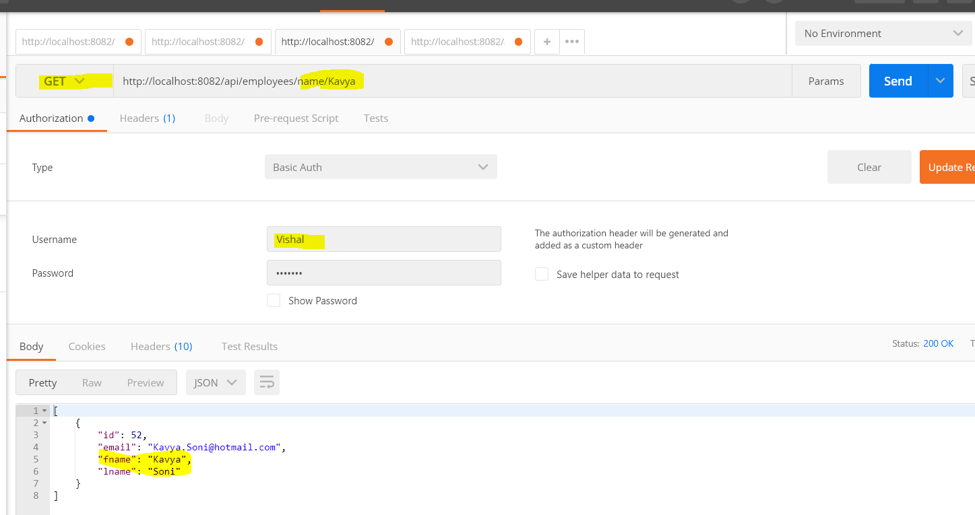

## Sorting data by ASC and DESC order

