

**Independent University, Bangladesh**

**Department of Computer Science & Engineering**

**Assignment 1**

**Student Name : Farsheed Rahman, S.M. Arif Mahmud, Md Tuhin Al Jobayer, Shahria Sultana, Md. Abrarul Karim, Md Abdullah**

**Student ID : 1830360, 1830398, 1831124, 1920280, 2022521, 1721558**

**Course ID : CSE307**

**Course section : 03**

1. Describe briefly three Information Gathering methods used for the project. (Include activities performed for each method) (3+3+3 Points)
2. Draw the Use Case Diagram of the Software. (6 Points)

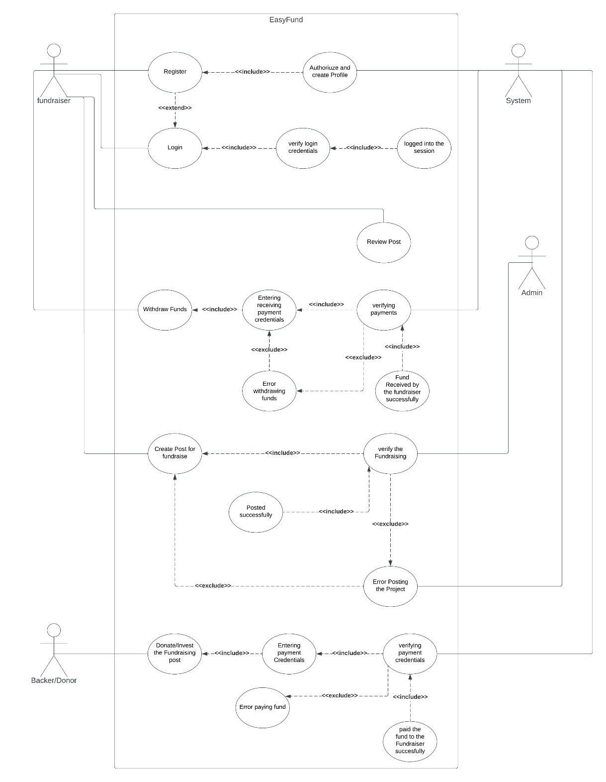

1. Draw Normal Scenario for 6 Use Cases. (6 Points)
2. Draw Alternative Scenarios for 6 Use Cases. (6 Points)
3. Identify Functional Requirements. (10 Points)
4. Identify at least five Non-Functional Requirements. (3 Points)