

**Independent University, Bangladesh**

Department of Computer Science & Engineering

**Assignment 1**

**Course ID : CSE307**

**Course section : 03**

**Instructor name : Sabrina Alam**

|  |  |
| --- | --- |
| **Student Name** | **Student ID** |
| **Farsheed Rahman** | **1830360** |
| **S.M. Arif Mahmud** | **1830398** |
| **Md Tuhin Al Jobayer** | **1831124** |
| **Shahria Sultana** | **1920280** |
| **Md. Abrarul Karim** | **2022521** |
| **Md Abdullah** | **1731558** |

**1. Easy Fund (Crowd Funding App)**

**2. Project objectives and Goal:**

* **Facilitate Funding:** The primary objective of the app is to provide a platform where project creators can create funds where can raise necessary funds for their ideas, products, or causes and from a wide audience of backers.
* **Empower Creativity and Innovation:** The app should encourage and support creative and innovative projects by giving aspiring entrepreneurs, artists, and individuals a chance to bring their ideas to life without traditional funding barriers. Users can create a room where they can talk about their problems to a counselor.
* **Accessibility and Inclusivity:** The app should democratize the funding process, making it accessible to people from all walks of life and geographical locations in Bangladesh.
* **Donating a social cause:** The Fundraiser can create a post for social and humanitarian cause where donors/backers can donate.
* **Trust and Transparency:** Establishing trust is crucial for the success of a crowdfunding app. It should implement measures to ensure transparency between project creators and backers, providing regular updates on project progress. The backers pay the fund through App so the system or App has the liability or responsibility to maintain the Trust.

**3. History Leading to Project Request:**

The history leading to the emergence of crowdfunding as a popular method for project financing is characterized by several key developments:

1. Early Forms of Crowdfunding: The concept of crowdfunding has roots in historical practices of collective financing, where communities would come together to fund projects or ventures of common interest. In the 17th and 18th centuries, crowdfunding was seen in the form of subscription models for publishing books or supporting artistic endeavors.
2. Emergence of Internet and E-Commerce: The advent of the internet and the rise of e-commerce platforms in the 1990s created new possibilities for fundraising. Websites like ArtistShare (2000) and Kiva (2005) offered some of the earliest forms of crowdfunding, primarily focused on supporting creative projects and micro-lending for social causes.
3. Growth of Reward-Based Crowdfunding: In 2008, platforms like Indiegogo and Kickstarter popularized the reward-based crowdfunding model. Creators could offer rewards or perks to backers based on their contribution levels. This approach democratized access to funding for creative projects, tech innovations, and small businesses.
4. JOBS Act: In 2012, the Jumpstart Our Business Startups (JOBS) Act was signed into law in the United States. It aimed to make it easier for startups and small businesses to raise capital by easing regulations on crowdfunding for equity (investment-based crowdfunding). This led to the emergence of platforms like SeedInvest and Crowdfunder, allowing ordinary investors to invest in early-stage companies.
5. Global Expansion: As crowdfunding gained popularity, it spread beyond the United States and reached a global scale. Numerous platforms were launched worldwide, tailored to local regulations and cultural preferences.
6. Rise of Donation-Based Crowdfunding: Donation-based crowdfunding platforms like GoFundMe gained traction, enabling individuals and non-profit organizations to raise funds for personal causes, medical expenses, disaster relief, and charitable initiatives.
7. Real Estate and Peer-to-Peer Lending: The success of crowdfunding models led to the emergence of real estate crowdfunding platforms and peer-to-peer lending platforms, providing opportunities for investors to diversify their portfolios.
8. Impact on Various Sectors: Crowdfunding has impacted diverse sectors, including arts and culture, technology, social causes, healthcare, and more. It has empowered creators and entrepreneurs to pursue projects that might have otherwise struggled to secure traditional financing.
9. Maturing Industry: Over time, crowdfunding platforms have improved their offerings, addressing challenges related to trust, transparency, and accountability. They have integrated social media and other marketing tools to enhance project visibility and engagement.
10. Continuous Innovation: The crowdfunding industry continues to evolve with the advancement of technology, such as blockchain-based crowdfunding, security token offerings (STOs), and decentralized finance (DeFi) platforms.

The history of crowdfunding showcases the power of collective support and the potential of technology to revolutionize fundraising methods, providing a diverse array of opportunities for project creators and backers alike. As a result, crowdfunding has become a significant force in shaping the future of financing projects and ventures.

**4. Problem, Solution & Opportunities:**

**4.1 Problem:**

The traditional methods of raising funds for various projects, causes, or ventures can be cumbersome and limited in reach. Many individuals and organizations face challenges in accessing capital due to a lack of awareness, limited networking opportunities, and the reliance on a few wealthy investors. Additionally, the trust factor can be an issue as potential backers may not be certain about the legitimacy and effectiveness of the projects they are supporting.

**4.2 Solution:**

A Crowd Funding App can provide an innovative and efficient solution to these problems. The app would act as a digital platform where individuals, startups, non-profit organizations, and other ventures can present their projects, causes, or ideas to a broad audience. Users who are interested in supporting these projects can contribute financially, becoming backers and receiving various rewards or incentives in return.

The app would facilitate the entire crowdfunding process, from project submission to payment processing. It would incorporate features like:

1. Project Presentation: Allow creators to showcase their projects with clear descriptions, images, and videos to attract potential backers.
2. Payment Processing: Secure and reliable payment methods to ensure smooth transactions between backers and project creators.
3. Social Integration: Integration with social media platforms to enable easy sharing of projects, thereby increasing their visibility and reach.
4. Transparency: Implement mechanisms to ensure transparency and accountability of the projects. This could include regular project updates, financial reporting, and progress tracking.
5. User Verification: Establish a verification process for project creators to enhance trust and credibility among potential backers.
6. Reward Management: Enable project creators to offer rewards or incentives to backers based on their contribution levels.

**4.3 Opportunities:**

1. Diverse Funding Opportunities: The Crowd Funding App can cater to various domains such as tech startups, social causes, art and creative projects, charitable initiatives, educational campaigns, and more.
2. Global Reach: The digital nature of the platform allows it to reach a vast and diverse audience worldwide, increasing the chances of projects getting funded.
3. Niche-specific Crowdfunding: The app can offer specialized categories or filters, enabling users to support causes and projects that align with their interests and values.
4. Data Insights: The platform can gather valuable data on user preferences, funding trends, and popular causes, which can be used for market research and targeted marketing.
5. Collaboration and Networking: The app can facilitate connections between creators, backers, and other stakeholders, fostering collaboration and potential partnerships.
6. Low Entry Barrier: The app can empower small-scale projects and individuals who might otherwise struggle to access funding through traditional channels.
7. Community Building: Building a community around the app can lead to increased engagement, user retention, and potential repeat backers.

**5. Product Description:**

1. Product Summary

**Overview:**

The Crowd Funding App is a cutting-edge digital platform that aims to revolutionize the way individuals, startups, non-profit organizations, and other ventures raise funds for their projects, causes, and initiatives. By leveraging the power of crowdfunding, this app provides an efficient, transparent, and inclusive solution for both project creators and backers.

**Key Features:**

* + 1. Project Showcase: The app allows project creators to present their ideas, ventures, or charitable causes with compelling descriptions, images, and videos to attract potential backers.
    2. Easy Contribution: Backers can securely and conveniently contribute funds to projects of their choice through a seamless and user-friendly payment processing system.
    3. Social Integration: To maximize project visibility, the app integrates with popular social media platforms, enabling easy sharing and engagement within the user's networks.
    4. Transparency and Accountability: Project creators are encouraged to provide regular updates, progress reports, and financial accountability, instilling trust and confidence among backers.
    5. Project Categories: The app supports diverse project categories, including technology, arts, social causes, environmental initiatives, healthcare, education, and more, catering to a wide range of interests.
    6. Verification System: To enhance credibility, the app incorporates a thorough verification process for project creators, reducing the risk of fraudulent or illegitimate projects.

**Benefits:**

1. Empowerment: The Crowd Funding App empowers individuals and organizations of all sizes to access capital, enabling them to bring their innovative ideas and impactful projects to life.

2. Global Reach: The app's digital nature facilitates access to a global audience, expanding the reach of projects beyond geographical boundaries.

3. Community Building: By fostering a community of project creators and backers, the app creates opportunities for collaboration, networking, and shared interests.

4. Personalized Engagement: Backers can choose projects aligned with their passions and values, allowing them to contribute to causes that matter most to them.

5. Democratizing Finance: The app breaks down traditional barriers to funding, democratizing the financial landscape by enabling micro-investments and donations.

**Use of Funds:**

1.The funds generated through the Crowd Funding

2. So the app is accountable for any kinds of transaction

3. The App will have ledger for all the Projects and Transactions

1. Product Stakeholders

Fundraiser, Backer.

1. Context Level Data Flow Diagram:

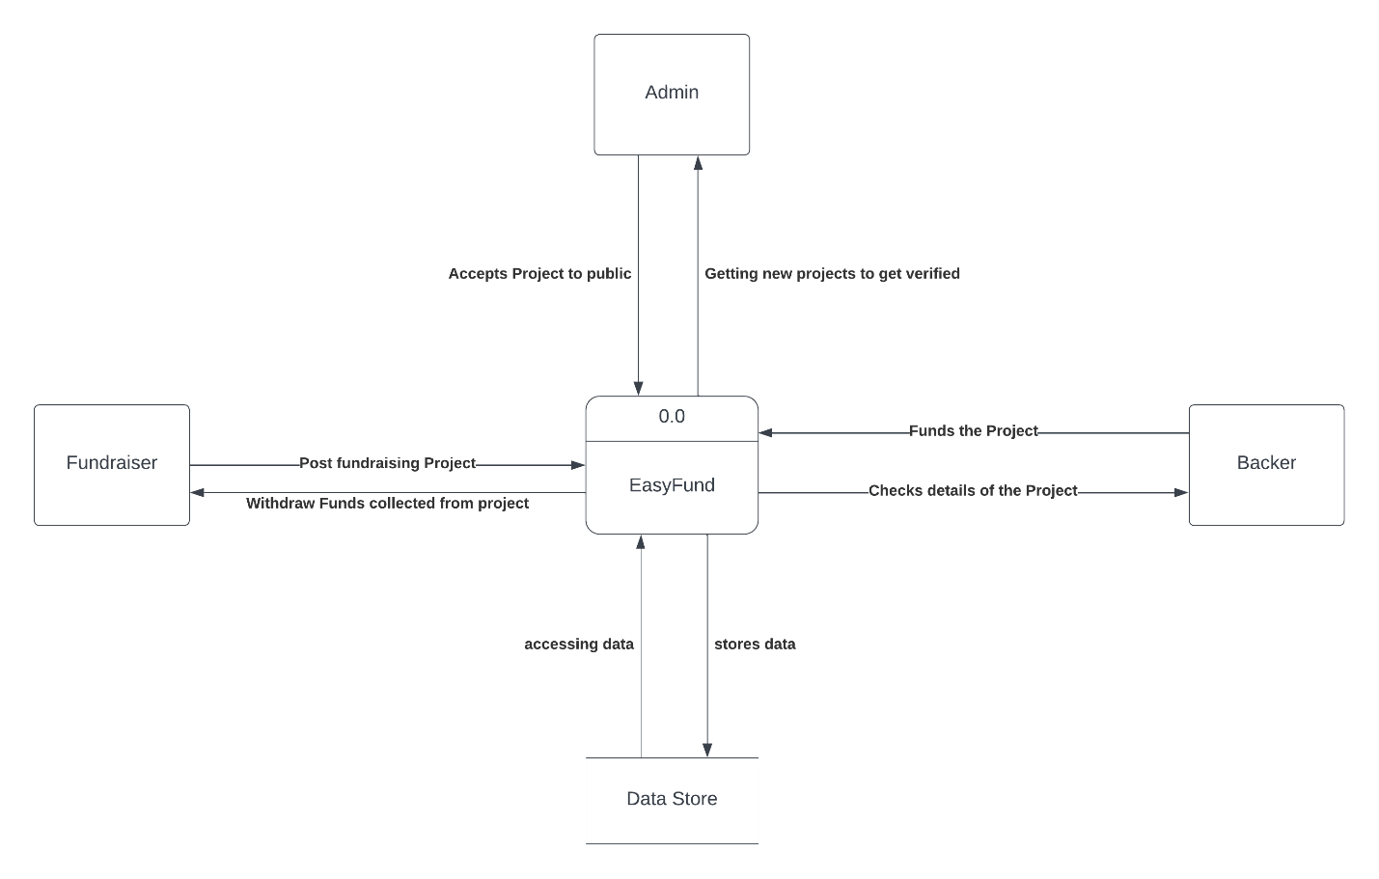

1. For now we are using this as a browser based Web-application.

| Operating System | Software | Hardware |
| --- | --- | --- |
| Windows OS, Mac OS, Android OS | Chrome, Firefox, Safari, Opera | 800 MHz Processors, 512 MB ram, Broadband connection. |

1. Software key technical features

**User Authentication and Security:**

Robust user authentication and authorization mechanisms to ensure secure access to the platform.

Encryption of sensitive user data to protect against unauthorized access and data breaches.

**Project Submission and Management:**

Intuitive project submission process, allowing creators to present their projects with detailed descriptions, images, and videos.

Project management dashboard for creators to track and update project progress, funding milestones, and communication with backers.

**Payment Gateway Integration:**

Seamless integration with secure and reliable payment gateways to facilitate easy financial transactions between backers and project creators.

Support for multiple payment methods, including BKash, Nagad, credit/debit cards, PayPal, cryptocurrencies, and other popular payment options.

**Social Media Integration:**

Integration with major social media platforms to enable easy sharing of projects, thereby increasing project visibility and attracting potential backers.

**Transparent Funding and Progress Tracking:**

Real-time tracking of funding progress, displaying the current amount raised, funding goal, and remaining days of the campaign.

Display of project updates, milestones, and financial reports to ensure transparency and accountability for backers.

**Backer Reward Management:**

Feature for project creators to define and manage reward tiers for backers based on their contribution levels.

Automated distribution of rewards to backers once the project is successfully funded and completed.

**User Feedback and Reviews:**

Rating and review system to collect feedback from backers about their experience with the crowdfunding process and the project they supported.

**Communication and Notifications:**

In-app messaging system to facilitate communication between backers and project creators.

Email notifications to keep backers informed about project updates, campaign milestones, and other relevant information.

**Mobile Responsiveness:**

Support for mobile devices and responsive design to ensure a seamless user experience across various screen sizes and devices.

**Analytics and Reporting:**

Data analytics and reporting tools to provide insights into campaign performance, user engagement, and funding trends.

Tracking and analysis of user behavior to improve the platform's usability and conversion rates.

**Scalability and Performance:**

Architecture designed for scalability to handle a growing number of users, projects, and transactions without compromising performance.

Load testing and optimization to ensure the platform can handle high traffic during peak periods.

**Compliance and Legal Considerations:**

Adherence to relevant crowdfunding regulations and compliance requirements in different regions and countries.

Implementation of data protection and privacy measures to comply with applicable laws.

These key technical features are essential for building a robust and successful crowdfunding software that can effectively connect project creators with backers, promote transparency, and facilitate seamless financial transactions while ensuring the security and privacy of users' data.