

**Independent University, Bangladesh**

**Department of Computer Science & Engineering**

**Assignment 2**

**Course ID : CSE307**

**Course section : 03**

**Instructor name : Sabrina Alam**

|  |  |
| --- | --- |
| **Student Name** | **Student ID** |
| **Farsheed Rahman** | **1830360** |
| **S.M. Arif Mahmud** | **1830398** |
| **Md Tuhin Al Jobayer** | **1831124** |
| **Shahria Sultana** | **1920280** |
| **Md. Abrarul Karim** | **2022521** |
| **Md Abdullah** | **1731558** |

1: Information Gathering

Gathering data is a key aspect of developing software that meets its goals. We will not be able to meet the needs of the software's users unless we consider their ideas and viewpoints. For my system, I have picked three relevant information collection methods: **stories, interviews, and questionnaires.**

1.1 Stories

Story 1

I was speaking to my friend Arif the other day and he mentioned needing money for his mother’s treatment. I asked how they were asking for donations, and he said that he had posted in Facebook and asked his friends to share. Also, this meant he was not getting enough money as the reach was not good. Also, people who were looking to donate were not finding a verifiable option to donate.

Findings from the story

* There is a need for a platform for where fundraisers can get donations.
* There is a need to make this platform according to the various demands of the fundraiser and the Backer.
* It is also necessary to make a trusting platform where people can donate with security and transparency.

Story 2

My friend Tuhin spoke to me about her recent experience where she was looking for capital for a startup. Even though she had been promised a capital and a sponsor. She was paid less than what was promised. They wanted to pay less because they did not think that the startup would be profitable. At the end she had to look for other ways of investment.

Findings from the story

* There is a need to ensure that the fundraiser gets the amount that is promised.
* Verify the data of the fundraiser and also the donor.
* There needs to be a fixed amount that should be collected by the fundraiser.

1.2 Interviewing

We have decided to meet with some of our stakeholders to have a better understanding of them. We began our interview after explaining our app and how it will function. There was a combination of open-ended and closed-ended questions asked. We learned about their perspectives and insights into the challenge they experienced when shopping for sweets by asking open-ended questions. When it came to arranging the questions, the Pyramid method was adopted.

It is very important to know who our users are and whether they are interested in using **EasyFund** or not. Having an in-depth conversation with some of the users will help to know what exactly they need from **EasyFund**.

**Selected interviewee**: Fundraiser

1. Are you happy with the current situation for people who are looking to raise funds?

2. Do you think the proposed system will help to serve your needs properly?

3. How long did it taking for you to collect funds?

4. Did you collect the money in time?

5. What challenges do you face with the current situation of collecting funds?

6. Did you encounter any misconduct during the process?

7. Do you think the right procedure was used while collecting funds?

8. If the proposed system were available today, would you use it?

9. Do they think the new system will be successful and accepted?

10. If you oversaw this system, what would you change?

11. How can we improve the new system?

**Selected interviewee**: Donors

1. Are you happy with how the current situation is for donating funds to people?

2. Do you think the proposed system will help to serve your need properly?

3. How were you donating to people before?

4. How did you find donating opportunities?

5. What challenges do you face while donating?

6. Did you encounter any security problems while donating?

7. Do you think the money that you are donating is used in the right cause?

8. If the proposed system were available today, would you use it?

9. Do they think the new system will be successful and accepted?

10. If you oversaw this system, what would you change?

11. How can we improve the new system?

**Selected Interviewee**: Admin /System Developer

1. What are the security issues that will cause problems?

2. How often do they need to check system?

3. How long will it take to update the system?

4. Can they work in case of emergency?

1.3 Questionnaire

We created an online survey form on Google Forms and invited the people and some of the stakeholders to respond to some questions regarding tuitions. The responses of each person will enable us to examine swiftly and simply what the people want. We were also able to gather specific information regarding their issues thanks to the survey.

**Selected stakeholder:** Fundraiser

(Personal Information)

Read the following questions and answer them appropriately:

1. Name

____________________________________________

2. Select your gender:

* Male
* Female
* Other

3. Age

* Under 18
* 18 to 24
* 25 to 34
* 35 to 44
* 45 to 54
* Over 55
* Prefer not to answer

4. Do you think you can get the required money by fundraising?

* Yes
* No
* Maybe

5. Are you happy with the current situation for fundraising?

* Yes
* No
* Unsure

6. How long does it take collect the required amount?

* Within the time limit
* Exceeds the time limit

8. Are you satisfied with the time needed?

* Yes
* No

9. Is the situation always safe for fundraisers?

Never Rare Sometimes Mostly Always

10. Do you feel the necessity of an automated system for raising funds?

Never Rarely Sometimes Often Always

11. How much help this automated system will do you?

Not at all little a little much helpful very helpful

11. How much help do you think this automated application will do to the general people?

Not at all little a little much helpful very helpful

12. Will you feel comfortable running a mobile application?

Not at all little a little much comfortable very comfortable

**Selected stakeholder:** Donor

(Personal Information)

Read the following questions and answer them appropriately:

1. Name

____________________________________________

2. Select your gender:

* Male
* Female
* Other

3. Age

* Under 18
* 18 to 24
* 25 to 34
* 35 to 44
* 45 to 54
* Over 55
* Prefer not to answer

4. Do you donate often to causes that need help?

* Yes
* No
* Maybe

5. Are you happy with the current situation through which you donate?

* Yes
* No
* Maybe

6. Do you get confirmation if your donation helps those who needs it?

* Yes
* No

7. Is the situation always safe for donations?

Never Rare Sometimes Mostly Always

8. Do you feel the necessity of an automated system for donatings?

Never Rarely Sometimes Often Always

9. How much help this automated system will do you?

Not at all little a little much helpful very helpful

10. How much help do you think this automated application will do to the general people?

Not at all little a little much helpful very helpful

11. Will you feel comfortable running a mobile application?

Not at all little a little much comfortable very comfortable

I conducted the above survey and received a mixed bag of positive and negative results:

The positive responses show that they are eager to embrace the new system, while the negative responses indicate that they believe the existing system is inefficient and time-consuming. Furthermore, both the fundraiser and the donors responded positively. People in general expect a hassle-free experience when raising funds and donating with a single click, and new opportunities will pop up as a result.

Users who gave a negative response were satisfied with the traditional/current system. They didn't want to learn a new system.

2: Use Case Diagram

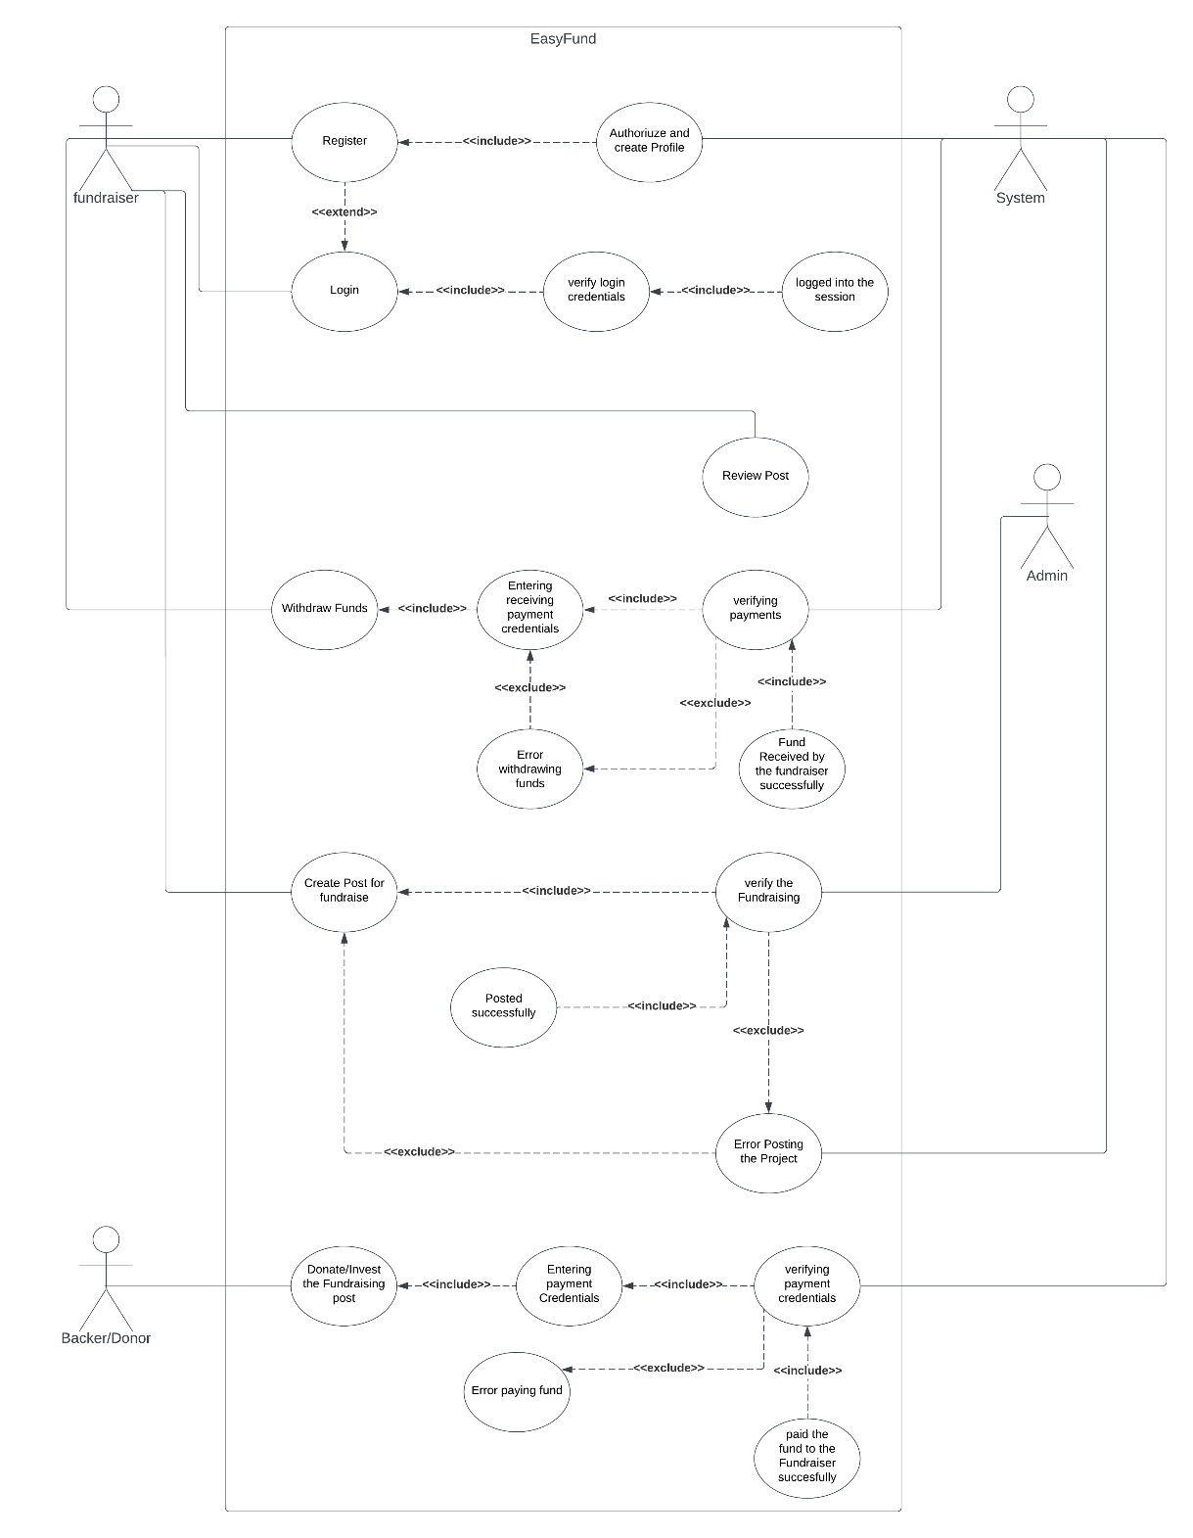

3: Normal Scenario

|  |  |
| --- | --- |
| Use Case Name: Register | Unique ID: SA-00001 |
| Actor(s): Fundraiser, Backer, System. | |
| Stakeholders: Fundraiser, Backer. | |
| Description: User registers in the app as Fundraiser, Backer. | |
| Triggering Event: User registers in the app and inputs information. | |
| Trigger type: External | |
| Steps Performed: | Information Required for Steps: |
| 1. The registration interface loads. |  |
| 2. User enters the following information:  Email, User type, username, mobile Number, address, password etc. | User wants to register as Fundraiser, Backer. |
| 3. Clicks the submit button. | Personal information of user like User type, username, Mobile Number, password, email, password. |
| 4. System verifies the user credentials | All required information must be filled up. |
| 5. If all information is correct then user will be registered to the system. |  |
| 6.A unique id will be given to the user and a confirmation message will be shown to the user interface. | Unique id and a confirmation message |
| Pre-condition: User needs to have idea about the features of the app. | |
| Post-condition: User must carefully input all required information while registering. | |
| Assumption: User wants to use the app to post fundraising post OR to donate fund. | |

|  |  |
| --- | --- |
| Use Case Name: Login | Unique ID: SA-00002 |
| Actor(s): Fundraiser, Backer, System. | |
| Stakeholders: Fundraiser, Backer. | |
| Description: User logs into the app as Fundraiser or Backer. | |
| Triggering Event: User logs into the app and inputs information. | |
| Trigger type: External | |
| Steps Performed: | Information Required for Steps: |
| 1. The login interface loads. |  |
| 2. User enters the following information:  username, password to log in. | User wants to logs into the app as Fundraiser, Backer. |
| 3. Clicks the login button. | Personal information username, password will be required to log into the system. |
| 4. System verifies the user credentials. | All required information must be filled up. |
| 5.then system will authenticate the user into the system. | Dashboard and confirmation message will pop up. |
| 6.User interface dashboard interface will load. |  |
| Pre-condition: User needs to logs into the app. | |
| Post-condition: User post fundraising post or funds a project. | |
| Assumption: User wants to use the app to post fundraising post OR to donate fund. | |

|  |  |
| --- | --- |
| Use Case Name: Create Post | Unique ID: SA-00003 |
| Actor(s): Fundraiser, Backer, Admin. | |
| Stakeholders: Fundraiser, Backer, Admin. | |
| Description: User posts a fundraising Project into the App. | |
| Triggering Event: After Entering all the necessary data in the form the post will go for verification to Admin and Moderators after the accept the post will go public. | |
| Trigger type: External | |
| Steps Performed: | Information Required for Steps: |
| 1. Dashboard interface loads. | User logs into the app as Fundraiser, Backer. |
| 2. User enters the information to post a Fundraising Project could be startup or donation based.  . | User enters the information to post a Fundraising Project could be startup or donation based |
| 3. Clicks the POST button. | Admin and moderators verifies the Post details. |
| 4. Admin and moderators verifies the Post details. | If the Admins and Moderators accepts the Post then it will be shown to public. |
| 5. If the Admins and Moderators accepts the Post then it will be shown to public. | Dashboard and confirmation message will pop up. |
| 6.User will be redirect to the dashboard interface. |  |
| Pre-condition: User needs to be registered user of the app. | |
| Post-condition: User posted the project successfully. | |
| Assumption: User wants to use the app to post fundraising post OR review post. | |

|  |  |
| --- | --- |
| Use Case Name: Withdraw Funds | Unique ID: SA-00004 |
| Actor(s): Fundraiser, System. | |
| Stakeholders: Fundraiser, System. | |
| Description: User withdraws project funds paid by the Backers. | |
| Triggering Event: After Entering all the necessary credentials to receive the project fund the form will go for verification to the Automated system and payment received by the Fundraiser. | |
| Trigger type: External, Internal | |
| Steps Performed: | Information Required for Steps: |
| 1. Dashboard interface loads. | Logged into the App to withdraw funds. |
| 2. Selects Withdraw Funds. | User inputs all the receiving method and credentials to withdraw the fund. |
| 3. Providing payment method and credentials to withdraw the fund. | Personal information username, password will be required to log into the system. |
| 4. System verifies the payment method and credentials. | All required information must be filled up. |
| 5. If payment credentials are accepted then payment will be received by the Fundraiser. | Dashboard and confirmation message will pop up. |
| 6.User will be redirect to the dashboard interface. |  |
| Pre-condition: User needs to withdraw funds from the app. | |
| Post-condition: User withdrawn funds successfully. | |
| Assumption: User wants withdraw funds from the app. | |

|  |  |
| --- | --- |
| Use Case Name: Donate or Invest in the Project | Unique ID: SA-00005 |
| Actor(s): Backer, System. | |
| Stakeholders: Backer, System. | |
| Description: User withdraws project funds paid by the Backers. | |
| Triggering Event: After Entering all the necessary credentials to receive the project fund the form will go for verification to the Automated system and payment received by the Fundraiser. | |
| Trigger type: External, Internal | |
| Steps Performed: | Information Required for Steps: |
| 1. Dashboard interface loads. | Must Logged into the App to back project. |
| 2. Selects the project which backer wants to fund. | Backer selects the project which backer wants to fund. |
| 3. Providing payment method and credentials to withdraw the fund. | Providing payment method and receiving credentials to withdraw the fund. |
| 4. The system will check and verifies the credentials. | System verifies the payment method and credentials. |
| 5. If payment credentials are accepted then payment will be received by the Fundraiser. | Dashboard and confirmation message will pop up. |
| 6.Backer will be redirect to the dashboard interface. |  |
| Pre-condition: User wants to fund or invest the project. | |
| Post-condition: User funded or invested the Project successfully. | |
| Assumption: User wants to fund the project. | |

|  |  |
| --- | --- |
| Use Case Name: Verifying the Project Post | Unique ID: SA-00006 |
| Actor(s): Admin, Fundraiser. | |
| Stakeholders: Admin, Fundraiser. | |
| Description: Admin User verifying and Accepts the Fundraising Post. | |
| Triggering Event: After The fundraiser submitted the Project it will go to Admin to get verified for Publicly visible. | |
| Trigger type: External | |
| Steps Performed: | Information Required for Steps: |
| 1. Dashboard interface loads. | Must Logged into the App to back the project. |
| 2. Fundraiser Selects new Post or Project. | Fundraiser entering all the necessary data to post. |
| 3. after submitting the post it will go to the admin for verifications. | Admin and Moderators will check authenticity of the Project. |
| 4. The post will be visible in the public. |  |
| 5 Redirect the user to their Dashboard. | Dashboard and confirmation message will pop up. |
| Pre-condition: Admin User wants to verify the project post. | |
| Post-condition: Admin User verified the Post authentic or non-authentic. | |
| Assumption: Admin User wants to verify the Post. | |

4: Alternate Scenario

|  |  |
| --- | --- |
| Use Case Name: Register | Unique ID: SA-00001 |
| Actor(s): Fundraiser, Backer, System. | |
| Stakeholders: Fundraiser, Backer. | |
| Description: User registers in the app as Fundraiser, Backer. | |
| Triggering Event: User registers in the app and inputs information. | |
| Trigger type: External | |
| Steps Performed: | Information Required for Steps: |
| 1. The registration interface loads. |  |
| 2. User enters the following information:  Email, User type, username, mobile Number, address, password etc. | User wants to register as Fundraiser, Backer using these information Email, User type, username, mobile Number, address, password etc. |
| 3. Clicks the submit button. | Personal information of user like User type, username, Mobile Number, password, email, password. |
| 4. System verifies the user credentials | All required information must be filled up. |
| 5. If all information is not correct or invalid then user will be instruct to enter correct information. |  |
| Pre-condition: User needs to have idea about the features of the app. | |
| Post-condition: User must carefully input all required information while registering. | |
| Assumption: User wants to use the app to post fundraising post OR to donate fund. | |

|  |  |
| --- | --- |
| Use Case Name: Login | Unique ID: SA-00002 |
| Actor(s): Fundraiser, Backer, System. | |
| Stakeholders: Fundraiser, Backer. | |
| Description: User logs into the app as Fundraiser or Backer. | |
| Triggering Event: User logs into the app and inputs information. | |
| Trigger type: External, internal | |
| Steps Performed: | Information Required for Steps: |
| 1. The login interface loads. |  |
| 2. User enters the following information:  username, password to log in. | Username and password. |
| 3. Clicks the login button. | Personal information username, password will be required to log into the system. |
| 4. System verifies the user credentials. | All required information must be filled up. |
| 5.If the system does not find any user, then system will pop up a window with error. | User can press OK button |
| 6. The login interface loads. |  |
| Pre-condition: User wants to log into the app. | |
| Post-condition: User unable to logged into the app. | |
| Assumption: User wants to use the app to post fundraising post OR to donate fund. | |

|  |  |
| --- | --- |
| Use Case Name: Create Post | Unique ID: SA-00003 |
| Actor(s): Fundraiser, Backer, Admin. | |
| Stakeholders: Fundraiser, Backer, Admin. | |
| Description: User posts a fundraising Project into the App. | |
| Triggering Event: After Entering all the necessary data in the form the post will go for verification to Admin and Moderators after the accept the post will go public. | |
| Trigger type: External | |
| Steps Performed: | Information Required for Steps: |
| 1. Dashboard interface loads. | User logs into the app as Fundraiser, Backer. |
| 2. User enters the information to post a Fundraising Project could be startup or donation based.  . | User enters the information to post a Fundraising Project could be startup or donation based |
| 3. Clicks the POST button. | Admin and moderators verify the Post details. |
| 4. Admin and moderators verifies the Post details. | If the Admins and Moderators accepts the Post, then it will be shown to public. |
| 5. If the Admins and Moderators does not accept the Post then it will not be shown to public. | Dashboard and confirmation message will pop up. |
| 6.User will be notified and redirect to the dashboard interface. |  |
| Pre-condition: User needs to be registered user of the app. | |
| Post-condition: User could not post the project successfully. | |
| Assumption: User wants to use the app to post fundraising post OR review post. | |

|  |  |
| --- | --- |
| Use Case Name: Withdraw Funds | Unique ID: SA-00004 |
| Actor(s): Fundraiser, System. | |
| Stakeholders: Fundraiser, System. | |
| Description: User withdraws project funds paid by the Backers. | |
| Triggering Event: After Entering all the necessary credentials to receive the project fund the form will go for verification to the Automated system and payment received by the Fundraiser. | |
| Trigger type: External, Internal | |
| Steps Performed: | Information Required for Steps: |
| 1. Dashboard interface loads. | Logged into the App to withdraw funds. |
| 2. Selects Withdraw Funds. | User inputs all the receiving method and credentials to withdraw the fund. |
| 3. Providing payment method and credentials to withdraw the fund. | Personal information username, password will be required to log into the system. |
| 4. System verifies the payment method and credentials. | All required information must be filled up. |
| 5. If payment credentials are not accepted then payment will not be received by the Fundraiser. | Dashboard and confirmation message will pop up. |
| 6. Error message will pop up and redirect to the . |  |
| Pre-condition: User needs to withdraw funds from the app. | |
| Post-condition: User withdrawn funds successfully. | |
| Assumption: User wants withdraw funds from the app. | |

|  |  |
| --- | --- |
| Use Case Name: Donate or Invest in the Project | Unique ID: SA-00005 |
| Actor(s): Backer, System. | |
| Stakeholders: Backer, System. | |
| Description: User withdraws project funds paid by the Backers. | |
| Triggering Event: After Entering all the necessary credentials to receive the project fund the form will go for verification to the Automated system and payment received by the Fundraiser. | |
| Trigger type: External, Internal | |
| Steps Performed: | Information Required for Steps: |
| 1. Dashboard interface loads. | Must Logged into the App to back project. |
| 2. Selects the project which backer wants to fund. | Backer selects the project which backer wants to fund. |
| 3. Providing payment method and credentials to withdraw the fund. | Providing payment method and receiving credentials to withdraw the fund. |
| 4. The system will check and verifies the credentials. | System verifies the payment method and credentials. |
| 5. If payment credentials are not accepted then payment will not be received by the Fundraiser. | Dashboard and confirmation message will pop up. |
| 6.Backer will be redirect to the dashboard interface. |  |
| Pre-condition: User wants to fund or invest the project. | |
| Post-condition: User funded or invested the Project successfully. | |
| Assumption: User wants to fund the project. | |

|  |  |
| --- | --- |
| Use Case Name: Verifying the Project Post | Unique ID: SA-00006 |
| Actor(s): Admin, Fundraiser. | |
| Stakeholders: Admin, Fundraiser. | |
| Description: Admin User verifying and Accepts the Fundraising Post. | |
| Triggering Event: After The fundraiser submitted the Project it will go to Admin to get verified for Publicly visible. | |
| Trigger type: External | |
| Steps Performed: | Information Required for Steps: |
| 1. Dashboard interface loads. | Must Logged into the App to back the project. |
| 2. Fundraiser Selects new Post or Project. | Fundraiser entering all the necessary data to post. |
| 3. after submitting the post it will go to the admin for verifications. | Admin and Moderators will check authenticity of the Project. |
| 4. If admin does not accept then the post will not be visible in the public. |  |
| 5 Redirect the user to their Dashboard. | Dashboard and confirmation message will pop up. |
| Pre-condition: Admin User wants to verify the project post. | |
| Post-condition: Admin User verified the Post authentic or non-authentic. | |
| Assumption: Admin User wants to verify the Post. | |

5. Functional Requirements

It's critical to under what the functional requirements of a system are for both the development team and the stakeholders. The functional requirements of the system are as follows:

1. Users will be able to use the app on a variety of mobile devices including Windows, Android, IOS and Linux.

2. Users will have the option of registering as a fundraiser or donor.

3. The user interfaces for fundraiser and donor will be distinct.

4. The user will be able to specify their preferences to achieve a better result.

5. The user will be able to both input and select the data that is required.

6. The app database will hold all the data.

7. All saved data will be safe and secure and will not be tampered with.

8. For each registered user, a user profile will be created.

9. Users will be allowed to edit their profile anytime.

10. The information that the user has altered will be automatically updated and saved.

11. Data on the available tutors will be updated frequently.

12. All user data will be encrypted for data security.

13. During registration, users' identities will be verified by email, phone number and NID verification.

14. The user will receive a verification code by email or phone call.

15. The user will be able to reset their password by submitting a request.

16. Any user criticism will be forwarded to the admin authority.

6. Non-Functional Requirements

The non-functional requirements of the system are as follows:

**Reliability:**

* The system must always be available and should not experience any downtime.
* All tasks must be completed without any software-related errors or with minimal errors.

**Performance:**

* It should return a search result in 2/3 seconds.
* The user interface must be visible in less than five seconds.

**Maintainability:**

* All this system's data must be maintained safe no matter what happens to it; hence the system will require data backup planning.
* If an error happens during any of the system's processes, the system will be able to trace each fault and correct it as quickly as possible before continuing the operation.

**Efficiency:**

* The system must be able to accommodate at least 1,000 individuals at the same time while also consuming minimal resources such as memory, CPU, and disk space.

**Security:**

* To utilize this system, users must first register, after which only registered users can access the system's features by logging in with their ID and password.
* Ascertain that the system, or any of its data, is never subjected to malware attacks or illegal access.
* Unless it is required, a user's personal information or other data should not be available to other users.

**Scalability:**

* This system must be scalable because it will be used by anyone living in the world to create fundraisers and donate 24 hours a day. That is, regardless of how much memory, servers, or disk space is required, the system should be able to accommodate an increase in the number of users and processes without affecting performance.