

**Independent University, Bangladesh**

**Department of Computer Science & Engineering**

**Assignment 2**

**Course ID : CSE307**

**Course section : 03**

**Instructor name : Sabrina Alam**

|  |  |
| --- | --- |
| **Student Name** | **Student ID** |
| **Farsheed Rahman** | **1830360** |
| **S.M. Arif Mahmud** | **1830398** |
| **Md Tuhin Al Jobayer** | **1831124** |
| **Shahria Sultana** | **1920280** |
| **Md. Abrarul Karim** | **2022521** |
| **Md Abdullah** | **1731558** |

1. **Draw Entity Relationship Diagram for the system. (5 Points)**

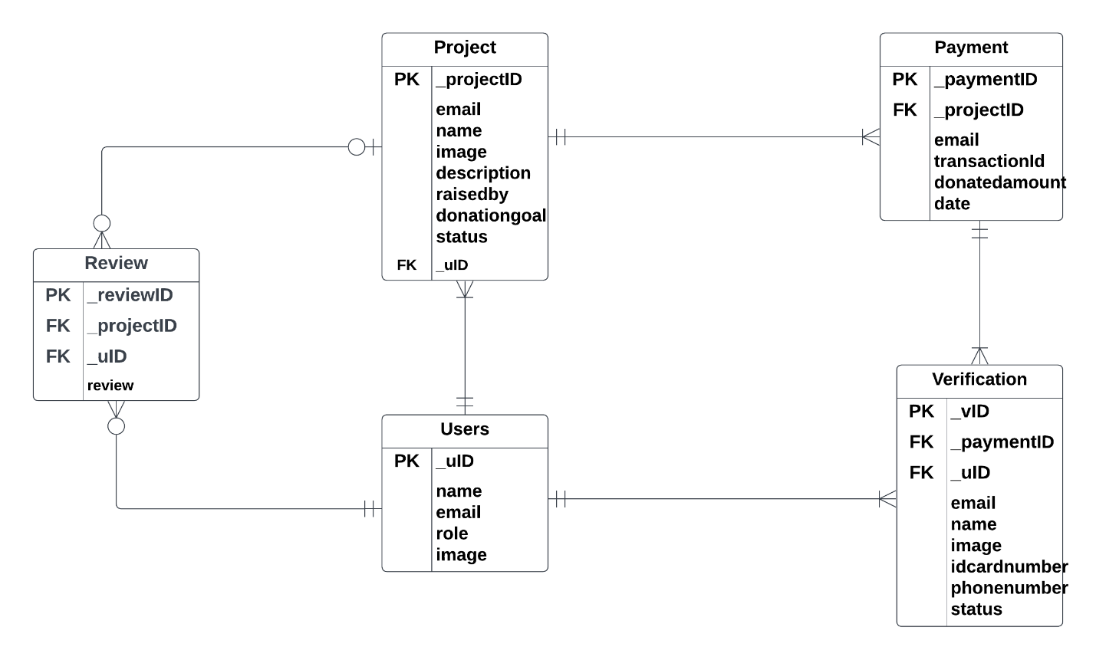

1. **Draw the Logical Data Flow diagrams. (5 Points)**

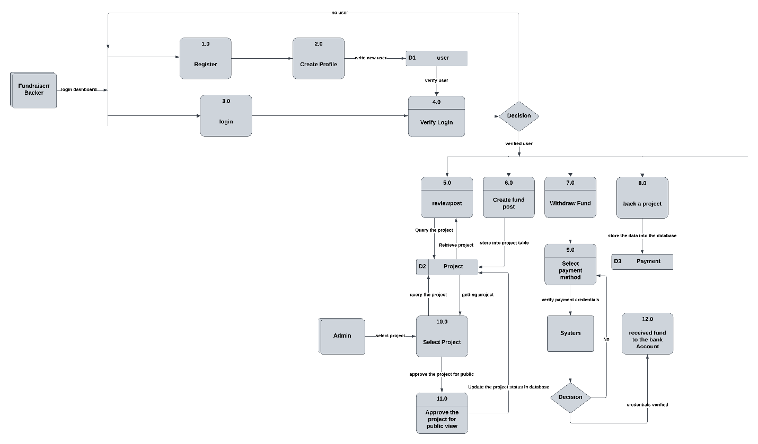

1. **Draw the Physical Data Flow diagrams. (5 Points)**

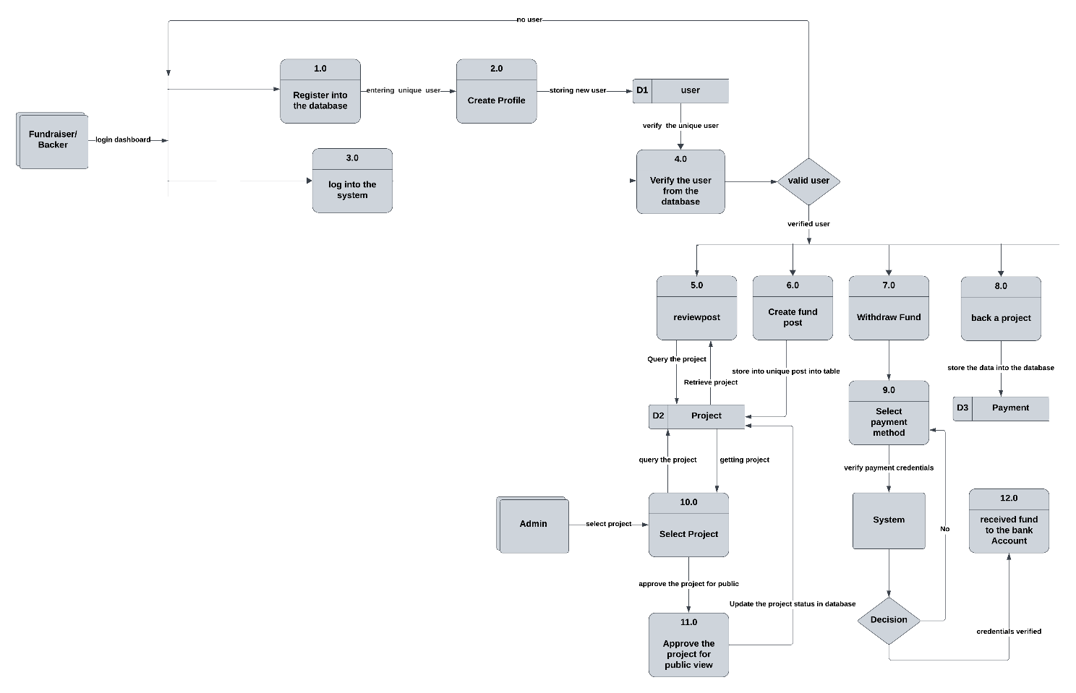

1. **Derive activity diagrams from use case diagrams and draw activitydiagrams. (5 Points)**

1. **Develop sequence and communication diagrams from use case scenarios. (5Points)**

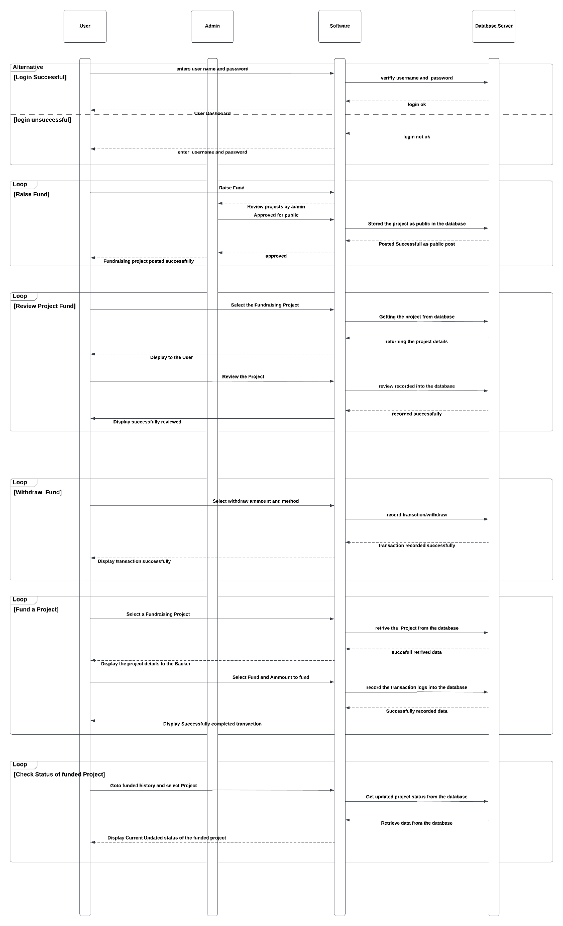

1. **Develop the Class diagrams. (5 Points)**

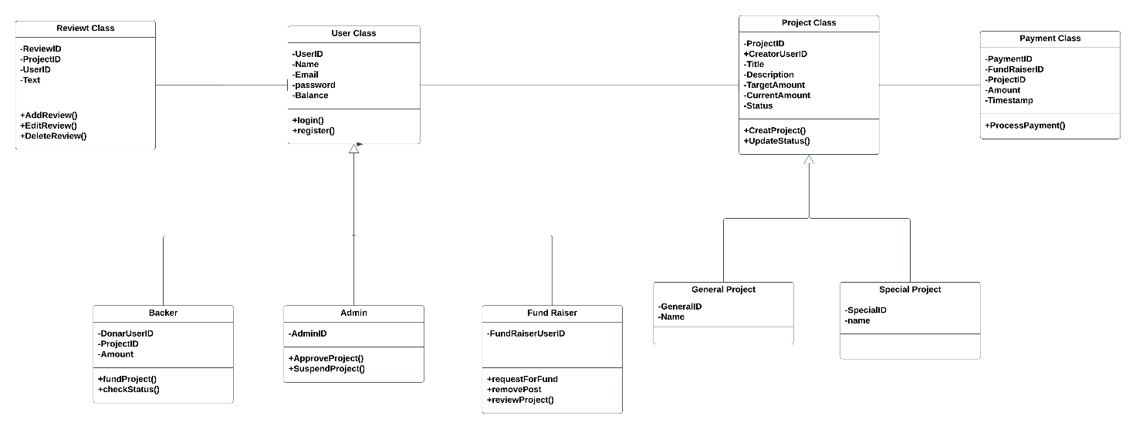

1. **Draw Statechart diagrams. (5 Points)**

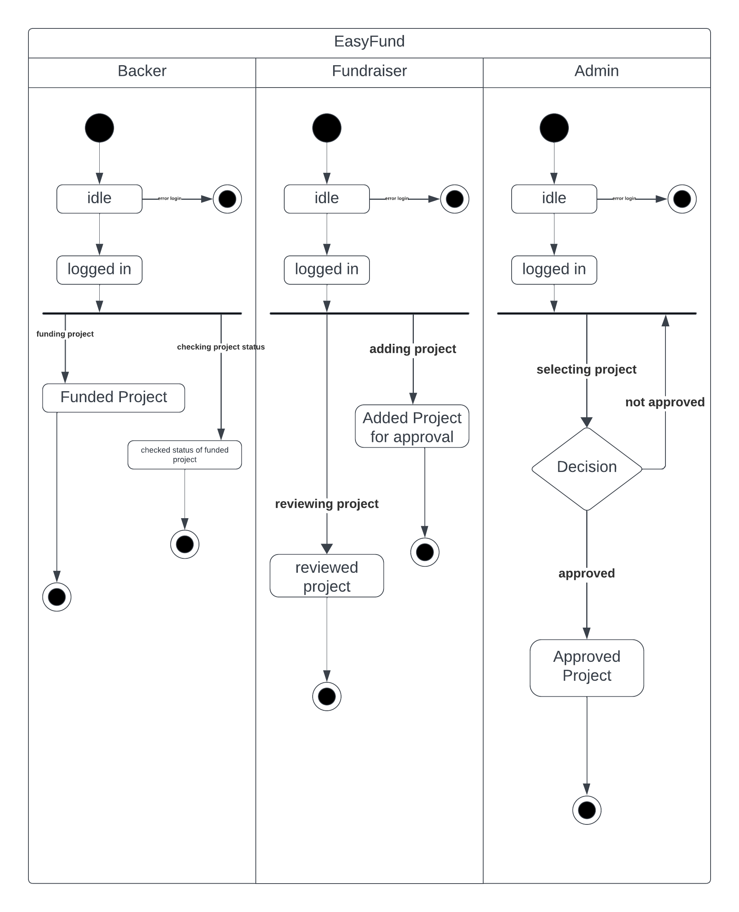

**8. Develop CRUD matrix. (5 Points)**

|  |  |  |  |  |  |  |
| --- | --- | --- | --- | --- | --- | --- |
| **PROGRAM** | | **TABLES** | | | | |
|  |  | Users | Project | Payment | Reviews | Verification |
| Users.register | Procedure | C |  |  |  |  |
| Users.login | Procedure | R |  |  |  |  |
| fundRaiser.CreateProject | Procedure | R | C |  |  |  |
| Users.addReview () | Procedure | R | R |  | C |  |
| Users.editReview() | Procedure | R | R |  | RU |  |
| Users.deleteReview() | Procedure | R | R |  | RD |  |
| fundRaiser.deleteproject() | Procedure | R | RD |  |  |  |
| Backer.fundProject() | Procedure | R | R | C |  | C |
| Backer.checkStatus() | View |  | R |  | R |  |
| Admin.approveProject() | Procedure | R | U |  |  |  |
| Admin.suspendproject() | Procedure | R | U |  |  |  |