EasyFund

We believe we can save more lives with you



# 

# Section-01:

1.**Abstract**

In a compassionate world, EasyFund revolutionizes crowdfunding, bridging creators and backers to drive positive change. We explore the history of crowdfunding, its maturation, and the challenges it addresses. EasyFund democratizes finance, providing a transparent, global platform. Key features include project presentation, secure payments, social integration, transparency, user verification, and rewards. Opportunities include diverse funding options, global reach, niche crowdfunding, data insights, networking, low barriers, and community building. Objectives involve facilitating funding, inspiring innovation, ensuring accessibility, supporting causes, and upholding trust. In essence, EasyFund empowers creators and backers worldwide, making crowdfunding secure, transparent, and accessible to all.

2. Introduction

In a world that thrives on connections and compassion, the power to make a positive impact is now more accessible than ever. People like to contribute to causes and sometimes people cannot find a trusted medium through which they can donate. Our app “EasyFund” redefines how we give, share and uplift those in need.

At EasyFund, we believe that the act of giving should be seamless, meaningful, and transparent. Our app is designed to bring together a community of individuals, nonprofits, and causes, all united by the common goal of making the world a better place. Whether you're passionate about supporting education, healthcare, disaster relief, or any other worthy cause, EasyFund empowers you to transform goodwill into tangible change.

3. History Leading to Project Request:

The history leading to the emergence of crowdfunding as a popular method for project financing is characterized by several key developments:

* **Early Forms of Crowdfunding**: The concept of crowdfunding has roots in historical practices of collective financing, where communities would come together to fund projects or ventures of common interest. In the 17th and 18th centuries, crowdfunding was seen in the form of subscription models for publishing books or supporting artistic endeavors.
* **Emergence of Internet and E-Commerce**: The advent of the internet and the rise of e-commerce platforms in the 1990s created new possibilities for fundraising. Websites like ArtistShare (2000) and Kiva (2005) offered some of the earliest forms of crowdfunding, primarily focused on supporting creative projects and micro-lending for social causes.
  + **Growth of Reward-Based Crowdfunding**: In 2008, platforms like Indiegogo and Kickstarter popularized the reward-based crowdfunding model. Creators could offer rewards or perks to backers based on their contribution levels. This approach democratized access to funding for creative projects, tech innovations, and small businesses.
  + **JOBS Act**: In 2012, the Jumpstart Our Business Startups (JOBS) Act was signed into law in the United States. It aimed to make it easier for startups and small businesses to raise capital by easing regulations on crowdfunding for equity (investment-based crowdfunding). This led to the emergence of platforms like SeedInvest and Crowdfunder, allowing ordinary investors to invest in early-stage companies.
  + **Global Expansion**: As crowdfunding gained popularity, it spread beyond the United States and reached a global scale. Numerous platforms were launched worldwide, tailored to local regulations and cultural preferences.
  + **Rise of Donation-Based Crowdfunding:** Donation-based crowdfunding platforms like GoFundMe gained traction, enabling individuals and non-profit organizations to raise funds for personal causes, medical expenses, disaster relief, and charitable initiatives.
  + **Real Estate and Peer-to-Peer Lending**: The success of crowdfunding models led to the emergence of real estate crowdfunding platforms and peer-to-peer lending platforms, providing opportunities for investors to diversify their portfolios.
  + **Impact on Various Sectors**: Crowdfunding has impacted diverse sectors, including arts and culture, technology, social causes, healthcare, and more. It has empowered creators and entrepreneurs to pursue projects that might have otherwise struggled to secure traditional financing.
  + **Maturing Industry**: Over time, crowdfunding platforms have improved their offerings, addressing challenges related to trust, transparency, and accountability. They have integrated social media and other marketing tools to enhance project visibility and engagement.
  + **Continuous Innovation**: The crowdfunding industry continues to evolve with the advancement of technology, such as blockchain-based crowdfunding, security token offerings (STOs), and decentralized finance (DeFi) platforms.

The history of crowdfunding showcases the power of collective support and the potential of technology to revolutionize fundraising methods, providing a diverse array of opportunities for project creators and backers alike. As a result, crowdfunding has become a significant force in shaping the future of financing projects and ventures.

4. Problem, Solution & Opportunities:

4.1 Problem:

The traditional methods of raising funds for various projects, causes, or ventures can be cumbersome and limited in reach. Many individuals and organizations face challenges in accessing capital due to a lack of awareness, limited networking opportunities, and the reliance on a few wealthy investors. Additionally, the trust factor can be an issue as potential backers may not be certain about the legitimacy and effectiveness of the projects they are supporting.

4.2 Solution:

A Crowd Funding App can provide an innovative and efficient solution to these problems. The app would act as a digital platform where individuals, startups, non-profit organizations, and other ventures can present their projects, causes, or ideas to a broad audience. Users who are interested in supporting these projects can contribute financially, becoming backers and receiving various rewards or incentives in return.

The app would facilitate the entire crowdfunding process, from project submission to payment processing. It would incorporate features like:

* **Project Presentation**: Allow creators to showcase their projects with clear descriptions, images, and videos to attract potential backers.
* **Payment Processing**: Secure and reliable payment methods to ensure smooth transactions between backers and project creators.
* **Social Integration:** Integration with social media platforms to enable easy sharing of projects, thereby increasing their visibility and reach.
* **Transparency**: Implement mechanisms to ensure transparency and accountability of the projects. This could include regular project updates, financial reporting, and progress tracking.
* **User Verification**: Establish a verification process for project creators to enhance trust and credibility among potential backers.
* **Reward Management**: Enable project creators to offer rewards or incentives to backers based on their contribution levels.

4.3 Opportunities:

* **Diverse Funding Opportunities**: The Crowd Funding App can cater to various domains such as tech startups, social causes, art and creative projects, charitable initiatives, educational campaigns, and more.
* **Global Reach**: The digital nature of the platform allows it to reach a vast and diverse audience worldwide, increasing the chances of projects getting funded.
* **Niche-specific Crowdfunding**: The app can offer specialized categories or filters, enabling users to support causes and projects that align with their interests and values.
* **Data Insights**: The platform can gather valuable data on user preferences, funding trends, and popular causes, which can be used for market research and targeted marketing.
* **Collaboration and Networking**: The app can facilitate connections between creators, backers, and other stakeholders, fostering collaboration and potential partnerships.
* **Low Entry Barrier**: The app can empower small-scale projects and individuals who might otherwise struggle to access funding through traditional channels.
* **Community Building**: Building a community around the app can lead to increased engagement, user retention, and potential repeat backers.

5. Project objectives and Goal:

* **Facilitate Funding:** The primary objective of the app is to provide a platform where project creators can create funds where can raise necessary funds for their ideas, products, or causes and from a wide audience of backers.
* **Empower Creativity and Innovation:** The app should encourage and support creative and innovative projects by giving aspiring entrepreneurs, artists, and individuals a chance to bring their ideas to life without traditional funding barriers. Users can create a room where they can talk about their problems to a counselor.
* **Accessibility and Inclusivity:** The app should democratize the funding process, making it accessible to people from all walks of life and geographical locations in Bangladesh.
* **Donating a social cause:** The Fundraiser can create a post for social and humanitarian cause where donors/backers can donate.
* **Trust and Transparency:** Establishing trust is crucial for the success of a crowdfunding app. It should implement measures to ensure transparency between project creators and backers, providing regular updates on project progress. The backers pay the fund through App so the system or App has the liability or responsibility to maintain the Trust.

# Section 02

6. Literature Review

The Evolution of Crowdfunding:

Crowdfunding's evolution has been extensively documented in the literature. Burtch, Ghose, and Wattal (2013) explored the emergence of crowdfunding in the digital age, emphasizing its roots in collective financing practices. They noted how technology, particularly the internet, facilitated the growth of crowdfunding platforms, making them accessible to a global audience.

Agrawal, Catalini, and Goldfarb (2014) conducted a comprehensive study on the historical development of crowdfunding platforms. They found that crowdfunding, in its various forms, has existed for centuries, but the internet revolutionized its scale and reach. This review highlights the pivotal role of technology in crowdfunding's evolution.

Crowdfunding Models and Their Impact:

The literature extensively covers different crowdfunding models and their impact on various sectors. Reward-based crowdfunding, popularized by platforms like Kickstarter, has enabled creators to fund creative projects. Belleflamme, Lambert, and Schwienbacher (2014) examined the success factors for crowdfunding campaigns on Kickstarter, shedding light on project characteristics that attract backers.

Equity-based crowdfunding, facilitated by the JOBS Act, has transformed early-stage financing for startups. Cumming, Leboeuf, and Schwienbacher (2017) explored the dynamics of equity crowdfunding and its implications for entrepreneurial finance. Their research illustrates how crowdfunding democratizes access to investment opportunities.

Crowdfunding and Social Causes:

Donation-based crowdfunding, as seen on platforms like GoFundMe, has become a powerful tool for raising funds for social causes and personal needs. Smith, Fischer, and Yongjian (2017) examined the motivations of donors on crowdfunding platforms, highlighting the role of empathy and social connectedness in driving contributions.

Challenges and Innovations:

The literature also delves into the challenges and innovations within the crowdfunding ecosystem. Mollick (2014) investigated the role of trust in crowdfunding campaigns, emphasizing the importance of social cues and prior success in building trust among backers.

Moreover, the emergence of blockchain technology has led to discussions on the potential of decentralized crowdfunding. Zhang, Ward, and Ekins-Daukes (2019) explored the use of blockchain in crowdfunding renewable energy projects, showcasing the innovative applications of technology in this space.

Crowdfunding's Impact on Entrepreneurship and Innovation:

Research by Block, Hornuf, and Moritz (2018) explored how crowdfunding impacts entrepreneurial success. They found that crowdfunding positively correlates with the survival and growth of entrepreneurial ventures, highlighting its role in fostering innovation.

In conclusion, the literature on crowdfunding encompasses its historical evolution, various models, impact on sectors, challenges, and innovations. Crowdfunding has not only democratized finance but has also become a powerful tool for creative projects, social causes, and entrepreneurship. It continues to evolve, with emerging technologies like blockchain promising new avenues for its growth.

References:

Here are the references:

* Burtch, G., Ghose, A., & Wattal, S. (2013). An empirical examination of the antecedents and consequences of contribution patterns in crowd-funded markets. Information Systems Research, 24(3), 499-519.
* Agrawal, A., Catalini, C., & Goldfarb, A. (2014). Some simple economics of crowdfunding. Innovation Policy and the Economy, 14(1), 63-97.
* Belleflamme, P., Lambert, T., & Schwienbacher, A. (2014). Crowdfunding: Tapping the right crowd. Journal of Business Venturing, 29(5), 585-609.
* Cumming, D., Leboeuf, G., & Schwienbacher, A. (2017). Crowdfunding models: Keep-it-all vs. all-or-nothing. European Financial Management, 23(3), 361-392.
* Mollick, E. (2014). The dynamics of crowdfunding: An exploratory study. Journal of Business Venturing, 29(1), 1-16.
* Smith, A. N., Fischer, E., & Yongjian, C. (2017). How does brand-related user-generated content differ across YouTube, Facebook, and Twitter? Journal of Interactive Marketing, 38, 99-113.
* Zhang, Y., Ward, J., & Ekins-Daukes, N. (2019). Peer-to-peer energy trading on blockchain: A review. Renewable and Sustainable Energy Reviews, 100, 143-152.
* Block, J., Hornuf, L., & Moritz, A. (2018). Which updates during an equity crowdfunding campaign increase crowd participation? Small Business Economics, 51(3), 657-673.

# Section 03

7. Product Description:

* 1. Product Summary

7.1.1 Overview:

* + The Crowd Funding App is a cutting-edge digital platform that aims to revolutionize the way individuals, startups, non-profit organizations, and other ventures raise funds for their projects, causes, and initiatives. By leveraging the power of crowdfunding, this app provides an efficient, transparent, and inclusive solution for both project creators and backers.

7.1.2 Key Features:

* + **Project Showcase**: The app allows project creators to present their ideas, ventures, or charitable causes with compelling descriptions, images, and videos to attract potential backers.
  + **Easy Contribution**: Backers can securely and conveniently contribute funds to projects of their choice through a seamless and user-friendly payment processing system.
  + **Social Integration**: To maximize project visibility, the app integrates with popular social media platforms, enabling easy sharing and engagement within the user's networks.
  + **Transparency and Accountability**: Project creators are encouraged to provide regular updates, progress reports, and financial accountability, instilling trust and confidence among backers.
  + **Project Categories**: The app supports diverse project categories, including technology, arts, social causes, environmental initiatives, healthcare, education, and more, catering to a wide range of interests.
  + **Verification System**: To enhance credibility, the app incorporates a thorough verification process for project creators, reducing the risk of fraudulent or illegitimate projects.

7.1.3 Benefits:

1. **Empowerment**: The Crowd Funding App empowers individuals and organizations of all sizes to access capital, enabling them to bring their innovative ideas and impactful projects to life.

2. **Global Reach**: The app's digital nature facilitates access to a global audience, expanding the reach of projects beyond geographical boundaries.

3. **Community Building**: By fostering a community of project creators and backers, the app creates opportunities for collaboration, networking, and shared interests.

4. **Personalized Engagement**: Backers can choose projects aligned with their passions and values, allowing them to contribute to causes that matter most to them.

5. **Democratizing Finance**: The app breaks down traditional barriers to funding, democratizing the financial landscape by enabling micro-investments and donations.

7.1.4 Use of Funds:

1.The funds generated through the Crowd Funding

2. So the app is accountable for any kinds of transaction

3. The App will have ledger for all the Projects and Transactions

* 1. Product Stakeholders

Fundraiser, Backer.

1. Context Level Data Flow Diagram:

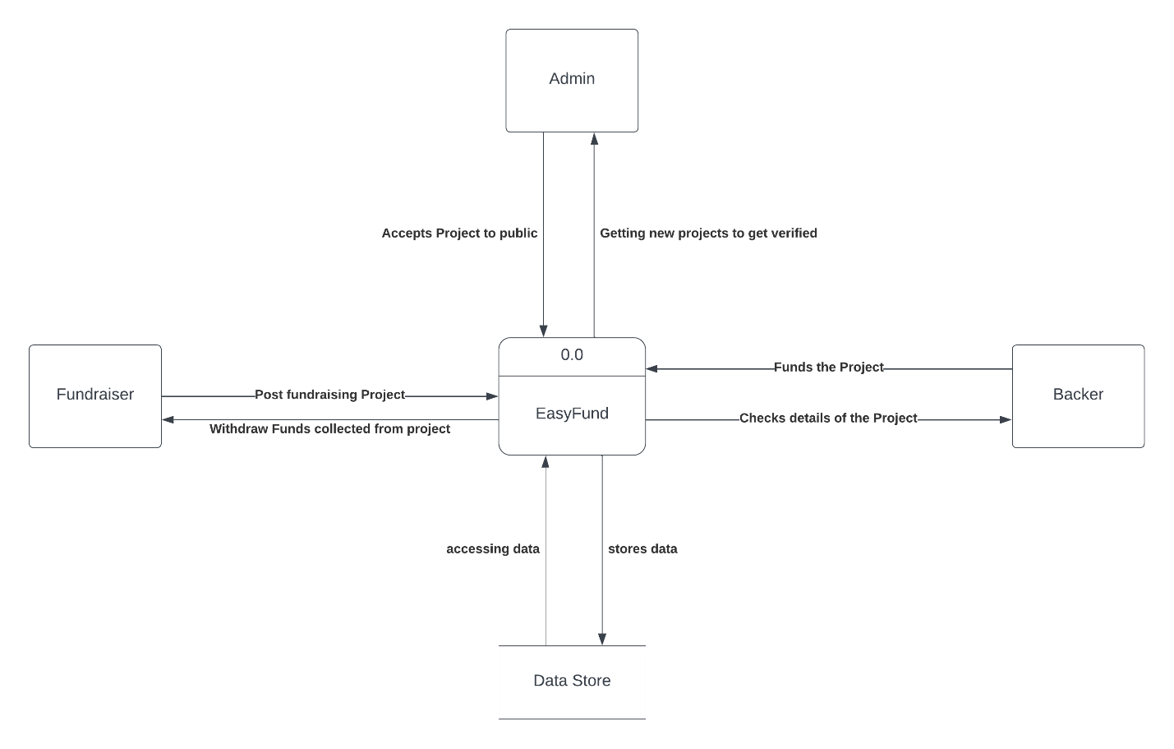

1. Hardware Details:

For now, we are using this as a browser-based Web-application.

| Operating System | Software | Hardware |
| --- | --- | --- |
| Windows OS, Mac OS, Android OS | Chrome, Firefox, Safari, Opera | 800 MHz Processors, 512 MB ram, Broadband connection. |

1. Key Technical Features:

User Authentication and Security:

Robust user authentication and authorization mechanisms to ensure secure access to the platform.

Encryption of sensitive user data to protect against unauthorized access and data breaches.

Project Submission and Management:

Intuitive project submission process, allowing creators to present their projects with detailed descriptions, images, and videos.

Project management dashboard for creators to track and update project progress, funding milestones, and communication with backers.

Payment Gateway Integration:

Seamless integration with secure and reliable payment gateways to facilitate easy financial transactions between backers and project creators.

Support for multiple payment methods, including BKash, Nagad, credit/debit cards, PayPal, cryptocurrencies, and other popular payment options.

Social Media Integration:

Integration with major social media platforms to enable easy sharing of projects, thereby increasing project visibility and attracting potential backers.

Transparent Funding and Progress Tracking:

Real-time tracking of funding progress, displaying the current amount raised, funding goal, and remaining days of the campaign.

Display of project updates, milestones, and financial reports to ensure transparency and accountability for backers.

Backer Reward Management:

Feature for project creators to define and manage reward tiers for backers based on their contribution levels.

Automated distribution of rewards to backers once the project is successfully funded and completed.

User Feedback and Reviews:

Rating and review system to collect feedback from backers about their experience with the crowdfunding process and the project they supported.

Communication and Notifications:

In-app messaging system to facilitate communication between backers and project creators.

Email notifications to keep backers informed about project updates, campaign milestones, and other relevant information.

Mobile Responsiveness:

Support for mobile devices and responsive design to ensure a seamless user experience across various screen sizes and devices.

Analytics and Reporting:

Data analytics and reporting tools to provide insights into campaign performance, user engagement, and funding trends.

Tracking and analysis of user behavior to improve the platform's usability and conversion rates.

Scalability and Performance:

Architecture designed for scalability to handle a growing number of users, projects, and transactions without compromising performance.

Load testing and optimization to ensure the platform can handle high traffic during peak periods.

Compliance and Legal Considerations:

Adherence to relevant crowdfunding regulations and compliance requirements in different regions and countries.

Implementation of data protection and privacy measures to comply with applicable laws.

These key technical features are essential for building a robust and successful crowdfunding software that can effectively connect project creators with backers, promote transparency, and facilitate seamless financial transactions while ensuring the security and privacy of users' data.

# Section 4.

11: Information Gathering

Gathering data is a key aspect of developing software that meets its goals. We will not be able to meet the needs of the software's users unless we consider their ideas and viewpoints. For my system, I have picked three relevant information collection methods: **stories, interviews, and questionnaires.**

11.1 Stories

Story 1

I was speaking to my friend Arif the other day and he mentioned needing money for his mother’s treatment. I asked how they were asking for donations, and he said that he had posted in Facebook and asked his friends to share. Also, this meant he was not getting enough money as the reach was not good. Also, people who were looking to donate were not finding a verifiable option to donate.

Findings from the story

* There is a need for a platform for where fundraisers can get donations.
* There is a need to make this platform according to the various demands of the fundraiser and the Backer.
* It is also necessary to make a trusting platform where people can donate with security and transparency.

Story 2

My friend Tuhin spoke to me about her recent experience where she was looking for capital for a startup. Even though she had been promised a capital and a sponsor. She was paid less than what was promised. They wanted to pay less because they did not think that the startup would be profitable. At the end she had to look for other ways of investment.

Findings from the story

* There is a need to ensure that the fundraiser gets the amount that is promised.
* Verify the data of the fundraiser and also the donor.
* There needs to be a fixed amount that should be collected by the fundraiser.

11.2 Interviewing

We have decided to meet with some of our stakeholders to have a better understanding of them. We began our interview after explaining our app and how it will function. There was a combination of open-ended and closed-ended questions asked. We learned about their perspectives and insights into the challenge they experienced when shopping for sweets by asking open-ended questions. When it came to arranging the questions, the Pyramid method was adopted.

It is very important to know who our users are and whether they are interested in using **EasyFund** or not. Having an in-depth conversation with some of the users will help to know what exactly they need from **EasyFund**.

Selected interviewee: Fundraiser

1. Are you happy with the current situation for people who are looking to raise funds?

2. Do you think the proposed system will help to serve your needs properly?

3. How long did it taking for you to collect funds?

4. Did you collect the money in time?

5. What challenges do you face with the current situation of collecting funds?

6. Did you encounter any misconduct during the process?

7. Do you think the right procedure was used while collecting funds?

8. If the proposed system were available today, would you use it?

9. Do they think the new system will be successful and accepted?

10. If you oversaw this system, what would you change?

11. How can we improve the new system?

Selected interviewee: Donors

1. Are you happy with how the current situation is for donating funds to people?

2. Do you think the proposed system will help to serve your need properly?

3. How were you donating to people before?

4. How did you find donating opportunities?

5. What challenges do you face while donating?

6. Did you encounter any security problems while donating?

7. Do you think the money that you are donating is used in the right cause?

8. If the proposed system were available today, would you use it?

9. Do they think the new system will be successful and accepted?

10. If you oversaw this system, what would you change?

11. How can we improve the new system?

**Selected Interviewee**: Admin /System Developer

1. What are the security issues that will cause problems?

2. How often do they need to check system?

3. How long will it take to update the system?

4. Can they work in case of emergency?

1.3 Questionnaire

We created an online survey form on Google Forms and invited the people and some of the stakeholders to respond to some questions regarding tuitions. The responses of each person will enable us to examine swiftly and simply what the people want. We were also able to gather specific information regarding their issues thanks to the survey.

Selected stakeholder: Fundraiser

(Personal Information)

Read the following questions and answer them appropriately:

1. Name

____________________________________________

2. Select your gender:

* Male
* Female
* Other

3. Age

* Under 18
* 18 to 24
* 25 to 34
* 35 to 44
* 45 to 54
* Over 55
* Prefer not to answer

4. Do you think you can get the required money by fundraising?

* Yes
* No
* Maybe

5. Are you happy with the current situation for fundraising?

* Yes
* No
* Unsure

6. How long does it take collect the required amount?

* Within the time limit
* Exceeds the time limit

8. Are you satisfied with the time needed?

* Yes
* No

9. Is the situation always safe for fundraisers?

Never Rare Sometimes Mostly Always

10. Do you feel the necessity of an automated system for raising funds?

Never Rarely Sometimes Often Always

11. How much help this automated system will do you?

Not at all little a little much helpful very helpful

11. How much help do you think this automated application will do to the general people?

Not at all little a little much helpful very helpful

12. Will you feel comfortable running a mobile application?

Not at all little a little much comfortable very comfortable

Selected stakeholder: Donor

(Personal Information)

Read the following questions and answer them appropriately:

1. Name

____________________________________________

2. Select your gender:

* Male
* Female
* Other

3. Age

* Under 18
* 18 to 24
* 25 to 34
* 35 to 44
* 45 to 54
* Over 55
* Prefer not to answer

4. Do you donate often to causes that need help?

* Yes
* No
* Maybe

5. Are you happy with the current situation through which you donate?

* Yes
* No
* Maybe

6. Do you get confirmation if your donation helps those who needs it?

* Yes
* No

7. Is the situation always safe for donations?

Never Rare Sometimes Mostly Always

8. Do you feel the necessity of an automated system for donatings?

Never Rarely Sometimes Often Always

9. How much help this automated system will do you?

Not at all little a little much helpful very helpful

10. How much help do you think this automated application will do to the general people?

Not at all little a little much helpful very helpful

11. Will you feel comfortable running a mobile application?

Not at all little a little much comfortable very comfortable

I conducted the above survey and received a mixed bag of positive and negative results:

The positive responses show that they are eager to embrace the new system, while the negative responses indicate that they believe the existing system is inefficient and time-consuming. Furthermore, both the fundraiser and the donors responded positively. People in general expect a hassle-free experience when raising funds and donating with a single click, and new opportunities will pop up as a result.

Users who gave a negative response were satisfied with the traditional/current system. They didn't want to learn a new system.

12. Use Case Diagram

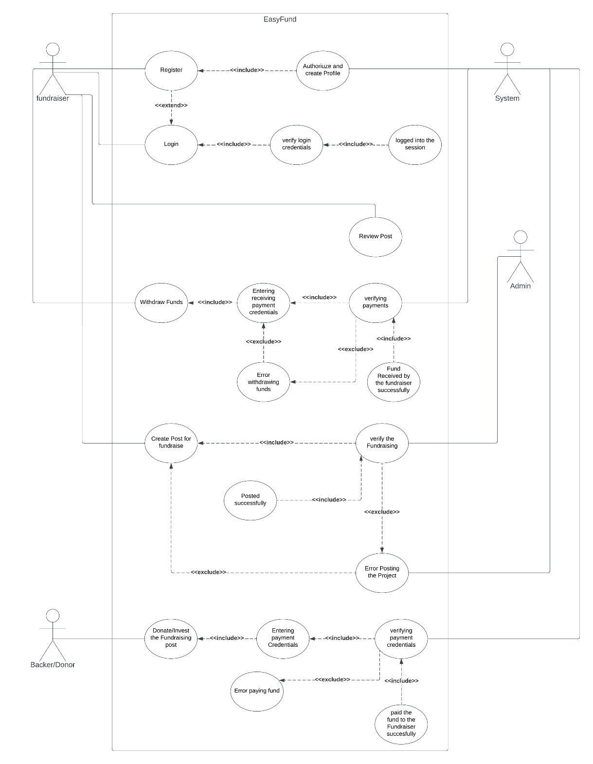

13.Normal Scenario

|  |  |
| --- | --- |
| Use Case Name: Register | Unique ID: SA-00001 |
| Actor(s): Fundraiser, Backer, System. | |
| Stakeholders: Fundraiser, Backer. | |
| Description: User registers in the app as Fundraiser, Backer. | |
| Triggering Event: User registers in the app and inputs information. | |
| Trigger type: External | |
| Steps Performed: | Information Required for Steps: |
| 1. The registration interface loads. |  |
| 2. User enters the following information:  Email, User type, username, mobile Number, address, password etc. | User wants to register as Fundraiser, Backer. |
| 3. Clicks the submit button. | Personal information of user like User type, username, Mobile Number, password, email, password. |
| 4. System verifies the user credentials | All required information must be filled up. |
| 5. If all information is correct then user will be registered to the system. |  |
| 6.A unique id will be given to the user and a confirmation message will be shown to the user interface. | Unique id and a confirmation message |
| Pre-condition: User needs to have idea about the features of the app. | |
| Post-condition: User must carefully input all required information while registering. | |
| Assumption: User wants to use the app to post fundraising post OR to donate fund. | |

|  |  |
| --- | --- |
| Use Case Name: Login | Unique ID: SA-00002 |
| Actor(s): Fundraiser, Backer, System. | |
| Stakeholders: Fundraiser, Backer. | |
| Description: User logs into the app as Fundraiser or Backer. | |
| Triggering Event: User logs into the app and inputs information. | |
| Trigger type: External | |
| Steps Performed: | Information Required for Steps: |
| 1. The login interface loads. |  |
| 2. User enters the following information:  username, password to log in. | User wants to logs into the app as Fundraiser, Backer. |
| 3. Clicks the login button. | Personal information username, password will be required to log into the system. |
| 4. System verifies the user credentials. | All required information must be filled up. |
| 5.then system will authenticate the user into the system. | Dashboard and confirmation message will pop up. |
| 6.User interface dashboard interface will load. |  |
| Pre-condition: User needs to logs into the app. | |
| Post-condition: User post fundraising post or funds a project. | |
| Assumption: User wants to use the app to post fundraising post OR to donate fund. | |

|  |  |
| --- | --- |
| Use Case Name: Create Post | Unique ID: SA-00003 |
| Actor(s): Fundraiser, Backer, Admin. | |
| Stakeholders: Fundraiser, Backer, Admin. | |
| Description: User posts a fundraising Project into the App. | |
| Triggering Event: After Entering all the necessary data in the form the post will go for verification to Admin and Moderators after the accept the post will go public. | |
| Trigger type: External | |
| Steps Performed: | Information Required for Steps: |
| 1. Dashboard interface loads. | User logs into the app as Fundraiser, Backer. |
| 2. User enters the information to post a Fundraising Project could be startup or donation based.  . | User enters the information to post a Fundraising Project could be startup or donation based |
| 3. Clicks the POST button. | Admin and moderators verifies the Post details. |
| 4. Admin and moderators verifies the Post details. | If the Admins and Moderators accepts the Post then it will be shown to public. |
| 5. If the Admins and Moderators accepts the Post then it will be shown to public. | Dashboard and confirmation message will pop up. |
| 6.User will be redirect to the dashboard interface. |  |
| Pre-condition: User needs to be registered user of the app. | |
| Post-condition: User posted the project successfully. | |
| Assumption: User wants to use the app to post fundraising post OR review post. | |

|  |  |
| --- | --- |
| Use Case Name: Withdraw Funds | Unique ID: SA-00004 |
| Actor(s): Fundraiser, System. | |
| Stakeholders: Fundraiser, System. | |
| Description: User withdraws project funds paid by the Backers. | |
| Triggering Event: After Entering all the necessary credentials to receive the project fund the form will go for verification to the Automated system and payment received by the Fundraiser. | |
| Trigger type: External, Internal | |
| Steps Performed: | Information Required for Steps: |
| 1. Dashboard interface loads. | Logged into the App to withdraw funds. |
| 2. Selects Withdraw Funds. | User inputs all the receiving method and credentials to withdraw the fund. |
| 3. Providing payment method and credentials to withdraw the fund. | Personal information username, password will be required to log into the system. |
| 4. System verifies the payment method and credentials. | All required information must be filled up. |
| 5. If payment credentials are accepted then payment will be received by the Fundraiser. | Dashboard and confirmation message will pop up. |
| 6.User will be redirect to the dashboard interface. |  |
| Pre-condition: User needs to withdraw funds from the app. | |
| Post-condition: User withdrawn funds successfully. | |
| Assumption: User wants withdraw funds from the app. | |

|  |  |
| --- | --- |
| Use Case Name: Donate or Invest in the Project | Unique ID: SA-00005 |
| Actor(s): Backer, System. | |
| Stakeholders: Backer, System. | |
| Description: User withdraws project funds paid by the Backers. | |
| Triggering Event: After Entering all the necessary credentials to receive the project fund the form will go for verification to the Automated system and payment received by the Fundraiser. | |
| Trigger type: External, Internal | |
| Steps Performed: | Information Required for Steps: |
| 1. Dashboard interface loads. | Must Logged into the App to back project. |
| 2. Selects the project which backer wants to fund. | Backer selects the project which backer wants to fund. |
| 3. Providing payment method and credentials to withdraw the fund. | Providing payment method and receiving credentials to withdraw the fund. |
| 4. The system will check and verifies the credentials. | System verifies the payment method and credentials. |
| 5. If payment credentials are accepted then payment will be received by the Fundraiser. | Dashboard and confirmation message will pop up. |
| 6.Backer will be redirect to the dashboard interface. |  |
| Pre-condition: User wants to fund or invest the project. | |
| Post-condition: User funded or invested the Project successfully. | |
| Assumption: User wants to fund the project. | |

|  |  |
| --- | --- |
| Use Case Name: Verifying the Project Post | Unique ID: SA-00006 |
| Actor(s): Admin, Fundraiser. | |
| Stakeholders: Admin, Fundraiser. | |
| Description: Admin User verifying and Accepts the Fundraising Post. | |
| Triggering Event: After The fundraiser submitted the Project it will go to Admin to get verified for Publicly visible. | |
| Trigger type: External | |
| Steps Performed: | Information Required for Steps: |
| 1. Dashboard interface loads. | Must Logged into the App to back the project. |
| 2. Fundraiser Selects new Post or Project. | Fundraiser entering all the necessary data to post. |
| 3. after submitting the post it will go to the admin for verifications. | Admin and Moderators will check authenticity of the Project. |
| 4. The post will be visible in the public. |  |
| 5 Redirect the user to their Dashboard. | Dashboard and confirmation message will pop up. |
| Pre-condition: Admin User wants to verify the project post. | |
| Post-condition: Admin User verified the Post authentic or non-authentic. | |
| Assumption: Admin User wants to verify the Post. | |

14. Alternate Scenario

|  |  |
| --- | --- |
| Use Case Name: Register | Unique ID: SA-00001 |
| Actor(s): Fundraiser, Backer, System. | |
| Stakeholders: Fundraiser, Backer. | |
| Description: User registers in the app as Fundraiser, Backer. | |
| Triggering Event: User registers in the app and inputs information. | |
| Trigger type: External | |
| Steps Performed: | Information Required for Steps: |
| 1. The registration interface loads. |  |
| 2. User enters the following information:  Email, User type, username, mobile Number, address, password etc. | User wants to register as Fundraiser, Backer using these information Email, User type, username, mobile Number, address, password etc. |
| 3. Clicks the submit button. | Personal information of user like User type, username, Mobile Number, password, email, password. |
| 4. System verifies the user credentials | All required information must be filled up. |
| 5. If all information is not correct or invalid then user will be instruct to enter correct information. |  |
| Pre-condition: User needs to have idea about the features of the app. | |
| Post-condition: User must carefully input all required information while registering. | |
| Assumption: User wants to use the app to post fundraising post OR to donate fund. | |

|  |  |
| --- | --- |
| Use Case Name: Login | Unique ID: SA-00002 |
| Actor(s): Fundraiser, Backer, System. | |
| Stakeholders: Fundraiser, Backer. | |
| Description: User logs into the app as Fundraiser or Backer. | |
| Triggering Event: User logs into the app and inputs information. | |
| Trigger type: External, internal | |
| Steps Performed: | Information Required for Steps: |
| 1. The login interface loads. |  |
| 2. User enters the following information:  username, password to log in. | Username and password. |
| 3. Clicks the login button. | Personal information username, password will be required to log into the system. |
| 4. System verifies the user credentials. | All required information must be filled up. |
| 5.If the system does not find any user, then system will pop up a window with error. | User can press OK button |
| 6. The login interface loads. |  |
| Pre-condition: User wants to log into the app. | |
| Post-condition: User unable to logged into the app. | |
| Assumption: User wants to use the app to post fundraising post OR to donate fund. | |

|  |  |
| --- | --- |
| Use Case Name: Create Post | Unique ID: SA-00003 |
| Actor(s): Fundraiser, Backer, Admin. | |
| Stakeholders: Fundraiser, Backer, Admin. | |
| Description: User posts a fundraising Project into the App. | |
| Triggering Event: After Entering all the necessary data in the form the post will go for verification to Admin and Moderators after the accept the post will go public. | |
| Trigger type: External | |
| Steps Performed: | Information Required for Steps: |
| 1. Dashboard interface loads. | User logs into the app as Fundraiser, Backer. |
| 2. User enters the information to post a Fundraising Project could be startup or donation based.  . | User enters the information to post a Fundraising Project could be startup or donation based |
| 3. Clicks the POST button. | Admin and moderators verify the Post details. |
| 4. Admin and moderators verifies the Post details. | If the Admins and Moderators accepts the Post, then it will be shown to public. |
| 5. If the Admins and Moderators does not accept the Post then it will not be shown to public. | Dashboard and confirmation message will pop up. |
| 6.User will be notified and redirect to the dashboard interface. |  |
| Pre-condition: User needs to be registered user of the app. | |
| Post-condition: User could not post the project successfully. | |
| Assumption: User wants to use the app to post fundraising post OR review post. | |

|  |  |
| --- | --- |
| Use Case Name: Withdraw Funds | Unique ID: SA-00004 |
| Actor(s): Fundraiser, System. | |
| Stakeholders: Fundraiser, System. | |
| Description: User withdraws project funds paid by the Backers. | |
| Triggering Event: After Entering all the necessary credentials to receive the project fund the form will go for verification to the Automated system and payment received by the Fundraiser. | |
| Trigger type: External, Internal | |
| Steps Performed: | Information Required for Steps: |
| 1. Dashboard interface loads. | Logged into the App to withdraw funds. |
| 2. Selects Withdraw Funds. | User inputs all the receiving method and credentials to withdraw the fund. |
| 3. Providing payment method and credentials to withdraw the fund. | Personal information username, password will be required to log into the system. |
| 4. System verifies the payment method and credentials. | All required information must be filled up. |
| 5. If payment credentials are not accepted then payment will not be received by the Fundraiser. | Dashboard and confirmation message will pop up. |
| 6. Error message will pop up and redirect to the . |  |
| Pre-condition: User needs to withdraw funds from the app. | |
| Post-condition: User withdrawn funds successfully. | |
| Assumption: User wants withdraw funds from the app. | |

|  |  |
| --- | --- |
| Use Case Name: Donate or Invest in the Project | Unique ID: SA-00005 |
| Actor(s): Backer, System. | |
| Stakeholders: Backer, System. | |
| Description: User withdraws project funds paid by the Backers. | |
| Triggering Event: After Entering all the necessary credentials to receive the project fund the form will go for verification to the Automated system and payment received by the Fundraiser. | |
| Trigger type: External, Internal | |
| Steps Performed: | Information Required for Steps: |
| 1. Dashboard interface loads. | Must Logged into the App to back project. |
| 2. Selects the project which backer wants to fund. | Backer selects the project which backer wants to fund. |
| 3. Providing payment method and credentials to withdraw the fund. | Providing payment method and receiving credentials to withdraw the fund. |
| 4. The system will check and verifies the credentials. | System verifies the payment method and credentials. |
| 5. If payment credentials are not accepted then payment will not be received by the Fundraiser. | Dashboard and confirmation message will pop up. |
| 6.Backer will be redirect to the dashboard interface. |  |
| Pre-condition: User wants to fund or invest the project. | |
| Post-condition: User funded or invested the Project successfully. | |
| Assumption: User wants to fund the project. | |

|  |  |
| --- | --- |
| Use Case Name: Verifying the Project Post | Unique ID: SA-00006 |
| Actor(s): Admin, Fundraiser. | |
| Stakeholders: Admin, Fundraiser. | |
| Description: Admin User verifying and Accepts the Fundraising Post. | |
| Triggering Event: After The fundraiser submitted the Project it will go to Admin to get verified for Publicly visible. | |
| Trigger type: External | |
| Steps Performed: | Information Required for Steps: |
| 1. Dashboard interface loads. | Must Logged into the App to back the project. |
| 2. Fundraiser Selects new Post or Project. | Fundraiser entering all the necessary data to post. |
| 3. after submitting the post it will go to the admin for verifications. | Admin and Moderators will check authenticity of the Project. |
| 4. If admin does not accept then the post will not be visible in the public. |  |
| 5 Redirect the user to their Dashboard. | Dashboard and confirmation message will pop up. |
| Pre-condition: Admin User wants to verify the project post. | |
| Post-condition: Admin User verified the Post authentic or non-authentic. | |
| Assumption: Admin User wants to verify the Post. | |

15. Functional Requirements

It's critical to under what the functional requirements of a system are for both the development team and the stakeholders. The functional requirements of the system are as follows:

* Users can register accounts with their email or social media profiles.
* Users can create and manage profiles with personal information.
* Fundraisers can provide additional details like project descriptions, goals, and campaign videos.
* Donors can view their donation history and manage their preferences.
* Fundraisers can create and submit campaigns with project details, images, and videos.
* Campaign creators can set funding goals, deadlines, and choose funding models.
* Fundraisers can edit and update campaign information during the fundraising period.
* Users can filter campaigns based on location, type, or funding progress.
* Campaign pages display compelling project descriptions, visuals, and funding progress.
* Users can contribute to campaigns using multiple payment methods (credit card, Bkash, etc.).
* Donation process should be user-friendly with options to enter custom donation amounts.
* Users can view a confirmation of their donation and receive email receipts.
* Admin panel for website administrators to manage campaigns, users, and content.
* Moderation tools to review and approve campaigns to ensure legitimacy and adherence to guidelines.
* Clear communication about how funds will be used and potential risks.
* Transparency in displaying the funding progress and where the money will go.
* The website should be responsive and usable on various devices including smartphones and tablets.

16. Non-Functional Requirements

The non-functional requirements of the system are as follows:

Reliability:

* The system must always be available and should not experience any downtime.
* All tasks must be completed without any software-related errors or with minimal errors.

Performance:

* It should return a search result in 2/3 seconds.
* The user interface must be visible in less than five seconds.

Maintainability:

* All this system's data must be maintained safe no matter what happens to it; hence the system will require data backup planning.
* If an error happens during any of the system's processes, the system will be able to trace each fault and correct it as quickly as possible before continuing the operation.

Efficiency:

* The system must be able to accommodate at least 1,000 individuals at the same time while also consuming minimal resources such as memory, CPU, and disk space.

Security:

* To utilize this system, users must first register, after which only registered users can access the system's features by logging in with their ID and password.
* Ascertain that the system, or any of its data, is never subjected to malware attacks or illegal access.
* Unless it is required, a user's personal information or other data should not be available to other users.

Scalability:

* This system must be scalable because it will be used by anyone living in the world to create fundraisers and donate 24 hours a day. That is, regardless of how much memory, servers, or disk space is required, the system should be able to accommodate an increase in the number of users and processes without affecting performance.

# Section 05

18.Entity Relationship Diagram

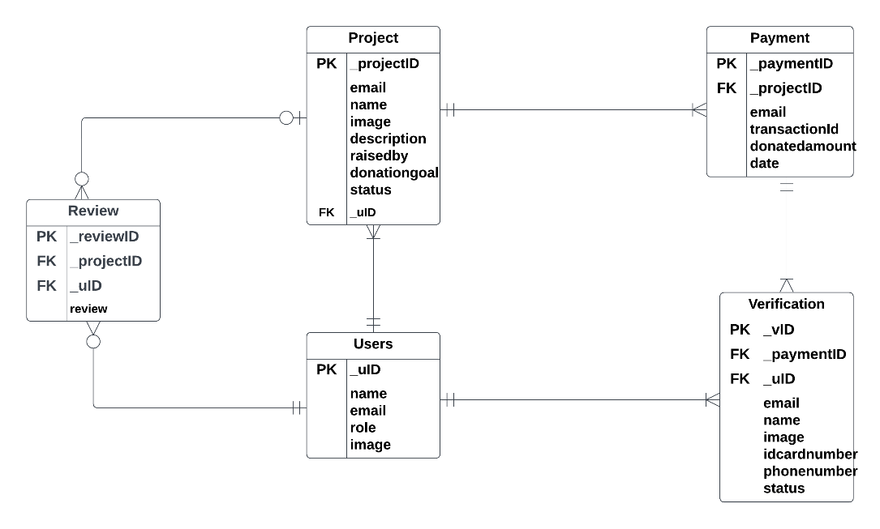

Fig 01: Entity Relationship Diagram

19. Physical Dataflow Diagram

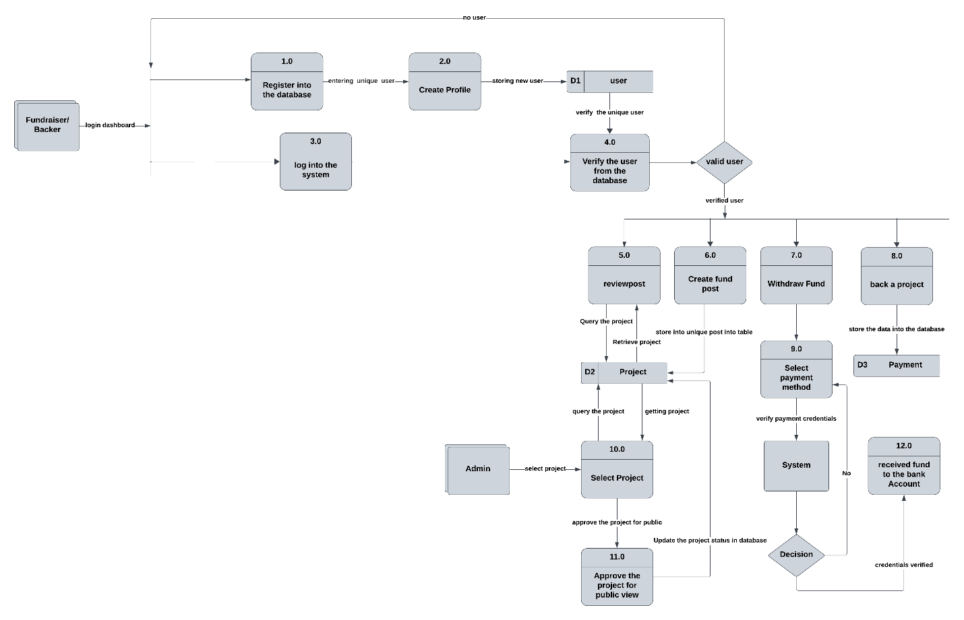

Fig 02: Physical Dataflow Diagram

20. Logical Dataflow Diagram

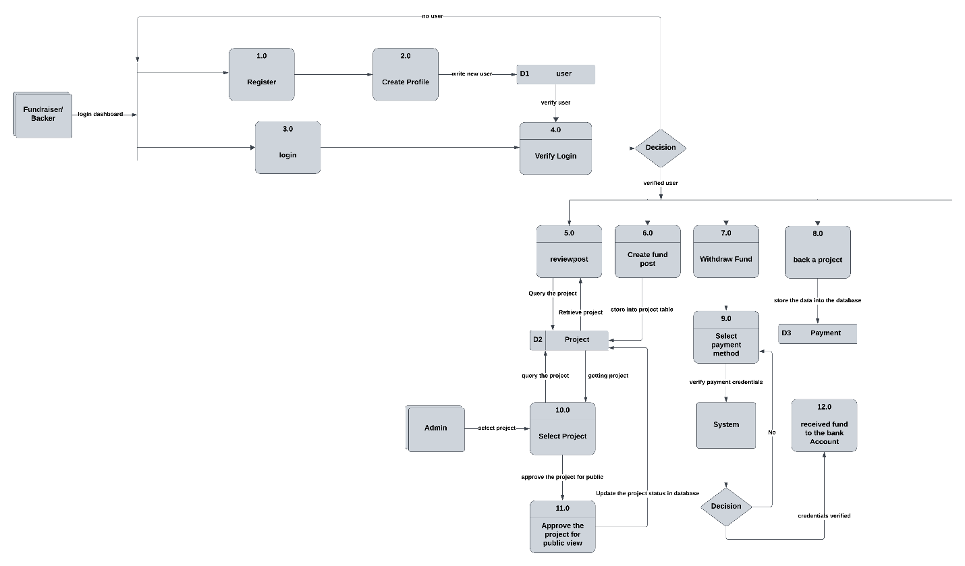

Fig 03: Logical Dataflow Diagram

21 Activity Diagram

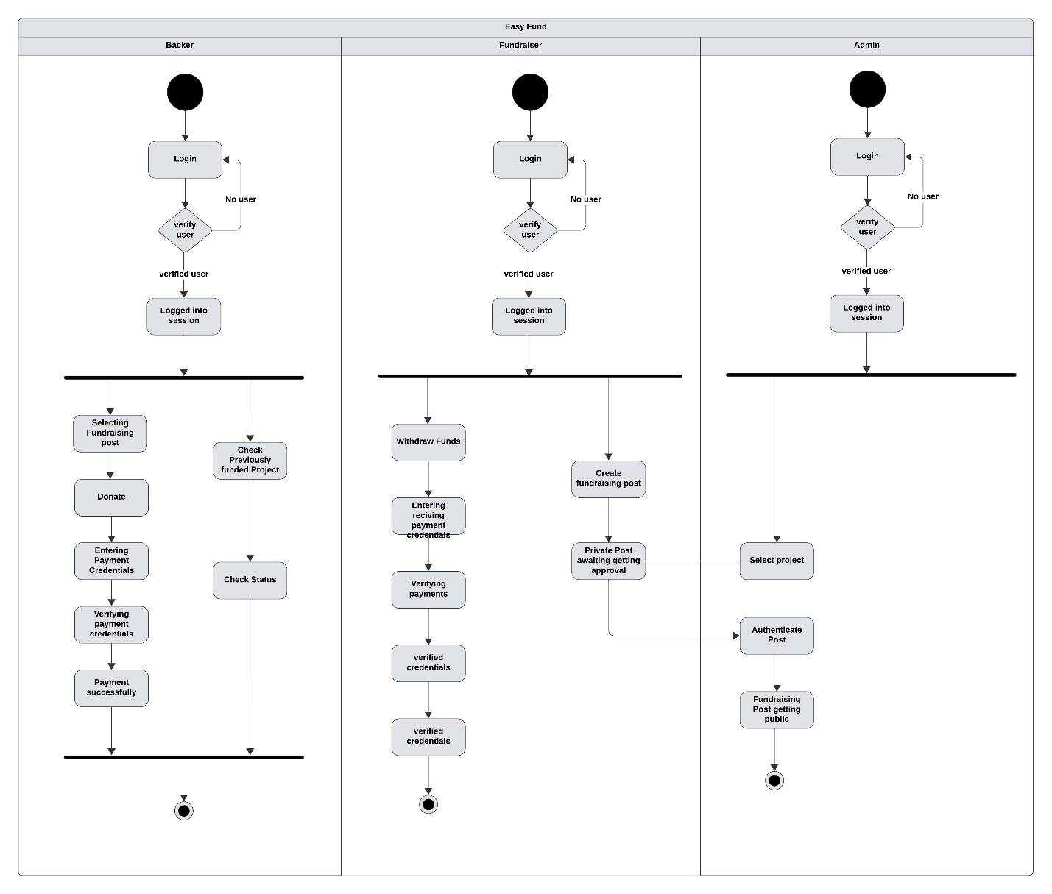

Fig 04: Activity Diagram

24. Class Diagrams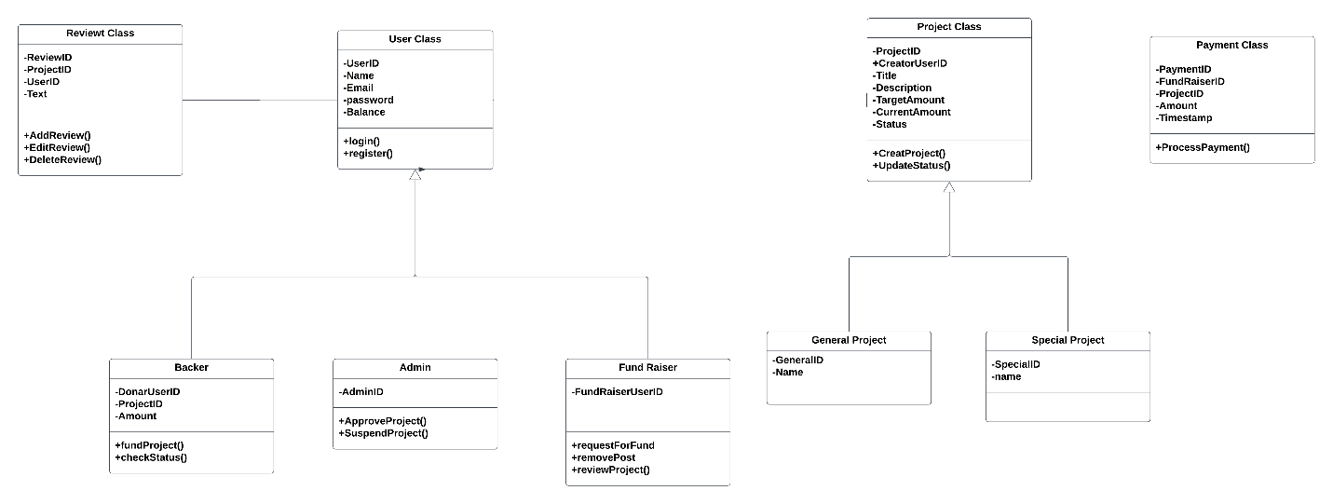

Fig 05 : Class Diagram

25. State chart Diagram

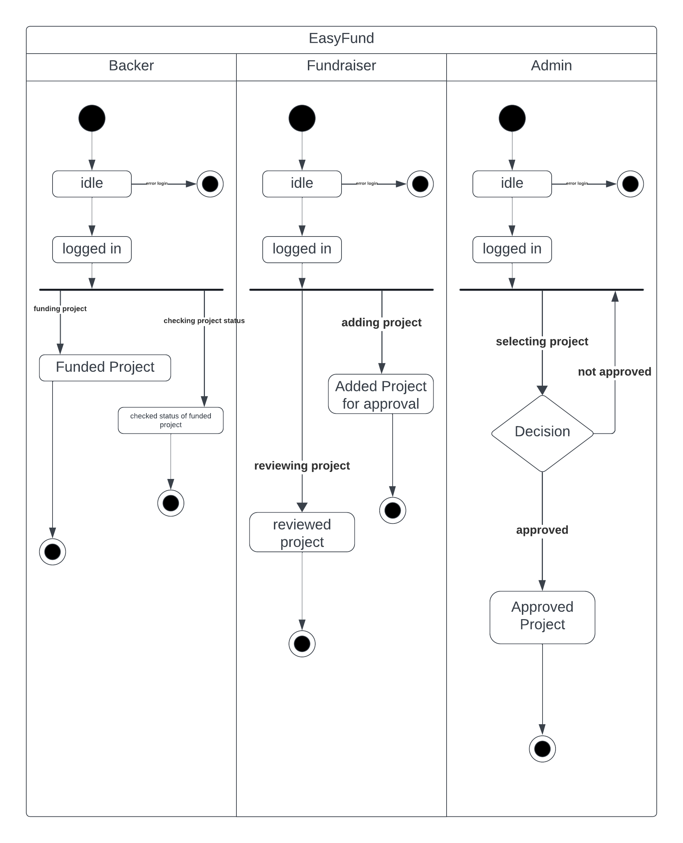

Fig 06: State chart Diagram

26. Sequence Diagrams

Fig 07: Sequence Diagram

27. CRUD MATRIX

|  |  |  |  |  |  |  |
| --- | --- | --- | --- | --- | --- | --- |
| **PROGRAM** | | **TABLES** | | | | |
|  |  | Users | Project | Payment | Reviews | Verification |
| Users.register | Procedure | C |  |  |  |  |
| Users.login | Procedure | R |  |  |  |  |
| fundRaiser.CreateProject | Procedure | R | C |  |  |  |
| Users.addReview () | Procedure | R | R |  | C |  |
| Users.editReview() | Procedure | R | R |  | RU |  |
| Users.deleteReview() | Procedure | R | R |  | RD |  |
| fundRaiser.deleteproject() | Procedure | R | RD |  |  |  |
| Backer.fundProject() | Procedure | R | R | C |  | C |
| Backer.checkStatus() | View |  | R |  | R |  |
| Admin.approveProject() | Procedure | R | U |  |  |  |
| Admin.suspendproject() | Procedure | R | U |  |  |  |

28. Conclusion

In conclusion, crowdfunding apps have emerged as a powerful tool for fundraising across various domains, but they also present challenges related to trust, regulation, and sustainability. Future research and developments in technology and regulation will likely continue to shape the crowdfunding landscape in the years ahead. Researchers and policymakers must remain vigilant in monitoring these developments to ensure the continued growth and integrity of crowdfunding ecosystems.