

PROJECT REPORT

DATABASE MANAGEMENT

CSE 303

GROUP 27

Section 03

|  |  |
| --- | --- |
| Name | ID |
| Md Tuhin Al Jobayer | 1831124 |
| Farsheed Rahman | 1830360 |
| S.M. Arif Mahmud | 1830398 |
| Safayet Khan | 1820080 |
| Sheikh Raiyan Hossain | 2021937 |
| Md Samiur Rahman | 1930661 |

Contents

Ch-1 Introduction: 3

Background of the organization: 3

Background of the project: 4

Objectives of the project: 4

Scope of the project 4

Ch-2: Requirement Analysis 5

Existing Business System (with rich picture) 5

Processes along with Six System Element Analysis 6

Existing Problems & Analysis of the problem 24

Proposed Business System (with rich picture) 26

Proposed Processes along with Six System Element Analysis 26

Ch-3 Logical System Design 26

Business Rules 39

Entity Relationship Diagram (ERD) 42

ERD to Relations 43

Normalization 43

Data Dictionary 46

Ch-4 Physical System Design 53

Input Forms 53

Output Query & Reports **Error! Bookmark not defined.**

Ch-5 Conclusion 56

Problem & Solution 56

Additional Feature & Future Development 56

Conclusion & Recommendations 56

# Ch-1 Introduction:

## Background of the organization:

Independent University, Bangladesh (IUB) established in 1993 is the leading private university in Bangladesh with an explicit focus on Research and Global partnerships.

The Independent University, Bangladesh (IUB) has robust and versatile schools – notably consisting of following:

● School of Business & Entrepreneurship

● School of Engineering, Technology & Sciences

● School of Environment and Life Sciences

● School of Liberal Arts & Social Sciences

● School of Pharmacy and Public Health.

The institution has actively contributed to the development of the education industry in Bangladesh and has produced competent and knowledgeable scholars who have made contributions both domestically and internationally. The University Grants Commission (UGC), the Ministry of Education, and other necessary institutions for each of the schools, along with regular curriculum updates, the implementation of a system to track student performance based on a quantified approach between course curriculum and standards set by UGC and the Bangladesh government, and ongoing student performance monitoring have all helped IUB achieve this.

The objectives of IUB are to produce graduates of international standards in the local environment who have the knowledge and necessary skills to provide leadership in business, public service, and welfare; to encourage and support useful research; to create knowledge; and to offer opportunities for adults to continue their education.

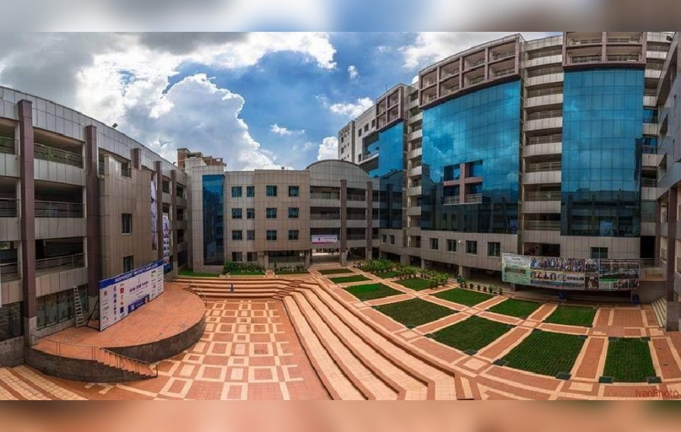

Figure : Independent University, Bangladesh

## Background of the project:

Our project's goal is to create, develop, and distribute software that, in our opinion, will assist universities worldwide in promoting a more fruitful and efficient method of student evaluation. As the central concept of our project, we've introduced the notion of Course Outcomes (COs) and Program Learning Outcomes (PLOs), where each CO is mapped to a PLO, and each PLO represents a particular valuable skill that students are expected to acquire or improve at the conclusion of that course, such as problem analysis, design, implementation of a skill and spider chart.

The details will all be present in the course outline for the students to have easy access and have all the necessary details regarding a course. The project will determine whether each student has successfully completed the PLOs that are linked to the COs requirements in order to evaluate them effectively through tools such as spider charts. IEB input is accepted by the system when establishing PLO criteria. For the system to map the COs to PLO appropriately, the faculties then input the COs for each of their students. It was discovered via the execution of this project that the efficiency not only reduced time but also increased quality. The PLOs are carefully and deliberately selected to guarantee that each student gets the most skills out of a course.

We also have the feature where faculties can input the questions in the question bank which can be accessed by the students which will help them gain knowledge on their desired topics and will provide them a vast field to practice.

Students can monitor their progress in each area and identify their areas for growth and improvement. Our program also aims to help the institutional bodies, including faculty, administrative, and departmental bodies, track student development, departmental performance, and better distribute and allocate resources.

## Objectives of the project:

Our project aims to develop an interactive, user-friendly program that will serve as a platform for university staff, faculty, and other participants to assist in enhancing the standard of instruction and revolutionizing how we incorporate technology into our education. We are confident that the information we have gathered, assessed, and organized will open doors for significant improvements in the educational sector as well as the field of computer science. In this situation, SMPS will broaden the project's scope in order to benefit all the departments

## Scope of the project

Our approach entails building a Web application called SPMS 2 that makes use of a Relational Database Management System (RDMS) to store, edit, add, and update the data required for tracking student performance as well as for producing and archiving related OBE data, reports, and documents. We created hypothetical users for the web based SPMS system and made assumptions about their usage patterns and the information and data they would require. Since issues can occur at many different points throughout all business processes, we will create unique user interfaces and login options for various stakeholders who will also be using this system. Since our data is stored using a (RDBMS), obtaining relevant files, tabular data, and page layouts is made possible and reports become exceedingly simple, enabling real-time interaction with the required data. Additionally, we develop user interfaces that allow all users to quickly access these data and use them to produce download reports, etc. We create a platform through which faculties may work together to create course outline, course reports, marksheets, assessments, map assessments to COs and PLOs for PLO successes, and keep track of student evaluations for all their courses throughout the semester and upload questions in the question bank for the students. The systems for reaching findings are also available to students, the IUB leadership team, and governmental organizations. Each stakeholder will only see the data that is specifically relevant to them, and data will also be protected.

# Ch-2: Requirement Analysis

## Existing Business System (with rich picture)

We are creating a platform through which faculties can work together to create course descriptions, course reports, make assessments, track assessments to COs and PLOs for the success of PLOs, and keep track of student evaluation for all of their courses throughout the semester. This platform is also available to students, the IUB admin and management, and UGC. Each stakeholder will see and monitor the data that specifically relevant to them and the data will also be protected. Students can give responses to their assessments via the platform to their faculties who then can grade the assessments and return. The system receives the assessment records, and it stores them. The system keeps a record of every report. The system offers bar graphs, pie charts and tables that display PLO achievement for all students.

The admin can use the system to update PLO requirements after managements sends them the updated PLO requirements through the system. The admin can also create new users for the system. The registrar’s office also plays a role in the system. Students can ask for grade change to the faculty who in turn can ask for grade change to the registrar’s office. The registrar’s office then sends the change grade. The registrar’s office can also use the system to get general reports and assessment reports about COs and PLOs.

The management are the body of power who updates and sends the PLO requirements. They also deal with governmental organizations like UGC to determine their curriculum and PLOs.

The system offers all users illuminating bar graphs, pie charts, and tables that display PLO achievement for all students, PLO achievement for a specific student, and PLO achievement regarding certain courses. Student responses to questions posed by the faculty are then given back to the faculty. The system receives the assessment records after it has been completed and stores them. The system keeps a record of every report.

The system offers all users illuminating bar graphs, pie charts, and tables that display PLO achievement for all students, PLO achievement for a specific student, and PLO achievement about certain courses.

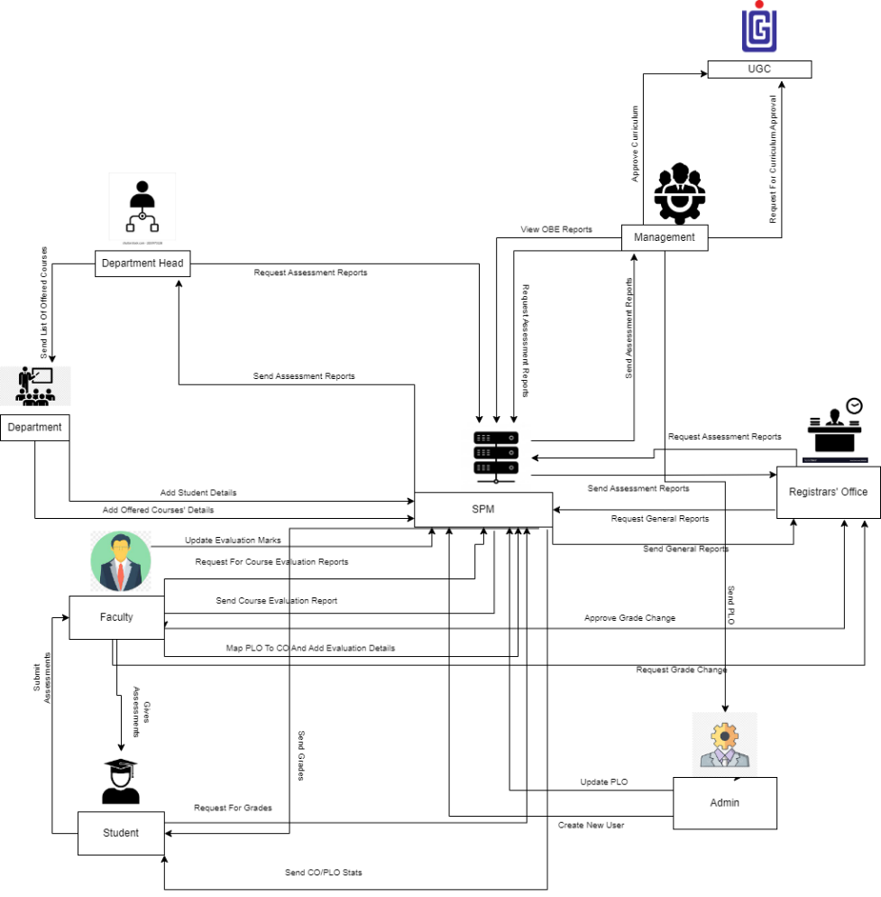

Figure : Rich Picture of Existing System

## Processes along with Six System Element Analysis

The Six Elements Analysis gives a thorough explanation of each element's function in each process. The table below makes it very evident that human entities predominate all important system operations, particularly the two most important ones—mapping course outcomes and examining documents associated with them. The existing approach, for instance, relies significantly on manually handled and processed hardcopy databases. As a result, there is a considerable amount of waiting involved in the interdependent processes before the Human components may perform their obligations.

|  |  |  |  |  |  |  |
| --- | --- | --- | --- | --- | --- | --- |
| **Process** | **System Roles** | | | | | |
| **Human** | **Non-Computing Hardware** | **Computing Hardware** | **Software** | **Database** | **Network and Communication** |
| **Student Registration** | **Student:**  **a) Search for the website**  **b) Goes to the website.**  **c) Clicks on the form option.**  **d) Fill up the form with required Information.**  **Registrar's Office:**  **a) Checks and verifies student enrollment information from the forms from**  **the website or hardcopy forms.**  **b) Registrar Office’s Admin**  **logs into the system using**  **Admin-ID and password.**  **c) Sends verified**  **student information as an**  **attachment to Admin/Team.**  **Admin:**  **a) Admin logs into**  **the system using**  **SPMS User-ID and**  **password.**  **b) Receives the student enrollment information in the**  **attached files.**  **c) Admin updates the student enrollment information in Database.**  **d) Notifies respected Stakeholders**  **Department Head:**  **a) Logs into the system using them**  **User-ID and password.**  **b) Inputs the desired time period for number of students enrolled.**  **Higher Authority (VC/ Dean):**  **a) Logs into the system using their**  **User-ID and password.**  **b) Inputs the desired time period and compare School/Department for the number of students enrolled accordingly.**  **Faculty:**  **a) logs into the system using**  **Faculty ID and**  **password**  **b) Inputs the ID of**  **the section the faculty is taking to view the students**  **enrolled.** | Paper and Stationery:  **a) Used to collect information about students through enrollment forms.** | **Computer/**  **Laptop**  **a) SPMS admin will use Computers to access and update data.**  **b) Users will use the**  **computer to view the data.**  **Database**  **Server**  **a) Used by**  **SPMS**  **Developers to collect data and maintain the software.**  **Networking Devices**  **(Router,**  **Switch,**  **Bridge, Hub):**  **a) Used to**  **access SPMS** | **Operating**  **Software**  **a) Utilized by**  **Registrar**  **Office and**  **SPMS.**  **Student**  **a) Uses to fill**  **up the form**  **from the**  **website.**  **SPMS**  **a) The software for which the administrator will set up user accounts.** | **Register**  **Office**  **Database**  **a) Used by the registrar's office to compile student data into an excel file for sending to SPMS.**  **SPMS**  **a) For any upgrades or new user accounts, information is kept in the database.**  **Excel**  **a) Data from student accounts may be kept in an excel file and used later in SPMS.** | **Internet**  **a) To access and store data to SPMS it is used.**  **b) It is used to collect the student form from the student to registrar office.**  **c)The Registrar office sends all the student information to SPM admin by using it.** |
| **Student Performance Based on CGPA** | **Student:**  **a) Logs into the System using Student-ID and**  **password.**  **b) Inputs the desired time period to view self CGPA**  **Progress.**  **Registrar's Office:**  **a) Logs into the System using User-ID and password.**  **b) Inputs the desired time**  **period and School, Department or program to view**  **Statistically and analyzed CGPA trend of students.**  **Department Head:**  **a) Logs into the System using User-ID and**  **password.**  **b) Inputs the desired time period and school, Department or program.**  **c) View statistically analyzed CGPA trend of students or any**  **individual student.**  **Faculty:**  **a) Logs into the system using**  **Faculty-ID and password.**  **b) Inputs the desired time period and program to view**  **statistically and**  **analyzed CGPA trend of students or any**  **individual student those**  **who attended**  **the faculty’s Section.**  **Higher Authority:**  **a) Logs into the system using their User-ID**  **and password.**  **b) Inputs the**  **desired time period, School and Department**  **c) View statistically analyzed CGPA trend of students.** |  | **Computer/**  **Laptop**  **a) User will need a computer to access SPMS**  **Printer**  **a) Used to print out the report if need be.**  **Networking Devices**  **(Router,**  **Switch,**  **Bridge, Hub):**  **a) Used to**  **access the**  **Internet.** | **Operating**  **Software**  **a) The user uses it to execute SPMS**  **SPMS**  **a) A performance trend will be generated by the software.** | **SPMS**  **Database**  **a) Obtain performance using the database.** | **Internet**  **a) To login into and access the SPMS it is used.** |
| **Course-wise student performance based on CGPA** | **Student:**  **a) Logs into the system using**  **Student-ID and**  **password.**  **b) Inputs the course**  **c) View self**  **GPA for the**  **course.**  **Department Head:**  **a) Logs into the System using User-ID and**  **password.**  **b) Inputs the desired time-**  **period Course-ID**  **c) View statistically analyzed GPA trend of Students.**  **Registrar’s office:**  **a) Logs into the System using**  **Admin-ID and**  **password.**  **b) Inputs the**  **desired time**  **-period and coursed**  **c) view**  **statistically analyzed**  **GPA trend of**  **students.**  **Faculty:**  **a) Logs into the System**  **using**  **Faculty-ID**  **and**  **password.**  **b) Inputs the**  **desired time period**  **Course-ID**  **under the**  **faculty**  **c)view**  **statistically analyzed**  **GPA trend of**  **students who faculty’s**  **section.**  **Higher Authority:**  **a) Logs into**  **the system**  **using their**  **User-ID**  **and**  **password.**  **b) Inputs the**  **desired time-**  **period and**  **Course-ID**  **c)View**  **statistically analyzed**  **GPA trend of**  **students for that specific**  **course.** |  | **Computer/**  **Laptop**  **a) User will need a computer to access SPMS**  **Printer**  **a) Used to print out the report if need be.**  **Networking Devices**  **(Router,**  **Switch,**  **Bridge, Hub):**  **a) Used to**  **access the**  **Internet.** | **SPMS**  **a) A performance trend based on GPA will be generated by the software.** | **SPMS**  **Database**  **a) Here, the performance will be stored and updated.** | **Internet**  **a) To login into and access the SPMS it is used.** |
| **Selective Number of Instructor-wise student performance based on the GPA** | **Department Head:**  **a) Logs into the system using User-ID and password.**  **b) Inputs the**  **desired time-**  **period Course-ID**  **c)View statistically**  **analyzed GPA trend of students for a**  **selective**  **number of**  **Instructors.**  **Registrar’s office:**  **a) Logs into the system using Admin-ID and**  **password.**  **b) Inputs the**  **desired time-**  **period Course-ID**  **c) View statistically**  **analyzed GPA trend of students for a**  **selective number of**  **Instructors**  **Faculty:**  **a) Logs into the system using**  **Faculty-ID and**  **password.**  **b) Inputs the**  **desired time -**  **period & Course-ID**  **c)View statistically**  **analyzed GPA trend of students for a**  **selective number of**  **Instructors.**  **Higher Authority:**  **a) Logs into**  **the System using User-ID and**  **password.**  **b) Inputs the desired time-**  **period Course-ID**  **c) View statistically**  **analyzed GPA trend of students for a**  **selective**  **number of**  **Instructors.** |  | **Computer/**  **Laptop**  **a) User will need a computer to access SPMS**  **Printer**  **a) Used to print out the report if need be.**  **Networking Devices**  **(Router,**  **Switch,**  **Bridge, Hub):**  **a) Used to**  **access the**  **Internet.** | SPMS  **a) The software will produce a performance trend for a specified instructor.** | **SPMS**  **Database**  **a) Here, the performance will be stored and updated.** | **Internet**  **a) To login into and access the SPMS it is used.** |
| **VC-wise, dean-wise, or department head-wise student performance** | **Department Head:**  **a) Logs into the system using User-ID and**  **password.**  **b) Select Input from VC/Dean/Department Head**  **c) View the**  **student**  **performance**  **trend as per choice.**  **Registrar’s office:**  **a) Logs into the system using User-ID and password.**  **b) Select Input from VC/Dean/Department Head**  **c) View the**  **student**  **performance**  **trend as per**  **choice.**  **Dean or VC**  **a) Logs into**  **the system using User-ID and password.**  **b) Select Input from**  **VC/Dean/Department Head**  **c) View the student performance trend as per choice.** |  | **Computer/**  **Laptop**  **a) User will need a computer to access SPMS**  **Printer**  **a) Used to print out the report if need be.**  **Networking Devices**  **(Router,**  **Switch,**  **Bridge, Hub):**  **a) Used to access the Internet.** | **SPMS**  **a) The software will produce a performance trend** | **SPMS**  **Database**  **a) Here, the performance will be stored.** | **Internet**  **a) To login into and access the SPMS it is used.** |
| **Instructor-wise student performance based on the GPA of the students** | **Department Head:**  **a) Logs into the system using**  **Department-I**  **D and Password.**  **b) Inputs a particular**  **instructor Name/ID**  **c)View the**  **student**  **performance**  **trend of**  **selected**  **Instructor.**  **Registrar’s office:**  **a) Logs into the system using User-ID and password.**  **b) Inputs a particular**  **instructor**  **c) View the student performance**  **trend of selected**  **Instructor.**  **Faculty:**  **a) Logs into the system using User-ID and**  **password.**  **b) Input their**  **Name/ID.**  **c) View the**  **student**  **performance**  **trend.**  **Dean:**  **a) Logs into**  **the system**  **using User-ID**  **and**  **password.**  **b) Inputs a**  **particular**  **instructor**  **c)View the**  **student**  **performance**  **trend of**  **selected**  **instructor**  **VC**  **a) Logs into**  **the system**  **using User-ID**  **and**  **password.**  **b) Inputs a**  **particular**  **instructor**  **c)View the**  **student**  **performance**  **trend of**  **selected**  **instructor.** |  | **Computer/**  **Laptop**  **a) User will need a computer to access SPMS**  **Printer**  **a) Used to print out the report if need be.**  **Networking Devices**  **(Router,**  **Switch,**  **Bridge, Hub):**  **a) Used to**  **access the**  **Internet.** | **SPMS**  **a) The software will produce a performance trend** | **SPMS**  **Database**  **a) The**  **performance**  **will be stored**  **and updated**  **in the**  **database.** | **Internet**  **a) To login into and access the SPMS it is used.** |
| **Total PLO percentage achieved and attempted by the student along with the departmental average** | **Student:**  **a) Logs into the system using Student-ID and Password**  **b) Inputs the**  **time- period**  **c)Views their**  **comparison**  **of attempted**  **vs achieved PLO**  **percentage**  **along with**  **the**  **departmental**  **Average.**  **Department Head:**  **a) Logs into the system**  **using User-ID and**  **Password**  **b) Inputs the time- period**  **c) Views the comparison of students**  **attempted**  **PLO vs**  **achieved**  **PLO**  **percentage**  **along with**  **the**  **departmental**  **average.**  **Registrar’s office:**  **a) Logs into the system using User-ID and**  **Password**  **b) Inputs the time- period**  **c) Views the**  **comparison**  **of students**  **Attempted PLO vs**  **Achieved PLO percentage along with the**  **departmental**  **average.**  **Faculty:**  **a) Logs into the system using User-ID and**  **Password.**  **b) Inputs the**  **time period.**  **c) Views the**  **comparison of students attempted PLO vs Achieved PLO**  **percentage**  **along with**  **the**  **departmental**  **Average.**  **Dean**  **a) Logs into**  **the system**  **using User**  **ID and**  **Password**  **b) Inputs the time period**  **c) Views the**  **comparison of students**  **Attempted PLO vs**  **achieved**  **PLO percentage**  **along with**  **the departmental**  **average.**  **VC**  **a) Logs into the system using User-ID and**  **Password.**  **b) Inputs the time- period.**  **c) Views the**  **comparison of students**  **attempted PLO vs Achieved PLO**  **percentage**  **along with**  **the**  **departmental**  **average.** |  | **Computer/**  **Laptop**  **a) User will need a computer to access SPMS**  **Printer**  **a) Used to print out the report if need be.**  **Networking Devices**  **(Router,**  **Switch,**  **Bridge, Hub):**  **a) Used to access the**  **Internet.** | **Operating**  **system**  **a) Used by**  **the**  **SPMS**  **SPMS**  **a) A comparison of the attempted vs. achieved PLO as well as the departmental average will be produced by the software.** | **SPMS**  **Database**  **a) Here, the performance will be stored.** | **Internet**  **a) To login into and access the SPM it is used.** |
| **PLO achievement** | **Student:**  **a) Logs into the system using**  **Student-ID**  **And password.**  **b) Selects PLO achievement**  **c) View PLO**  **Achievement.**  **Department Head:**  **a) Logs into the System using user-ID and**  **password.**  **b) Selects PLO**  **achievement**  **c) View PLO**  **Achievement.**  **Registrar’s office:**  **a) Logs into the system using user-ID and password.**  **b) Selects PLO achievement.**  **c) View PLO**  **Achievement.**  **Faculty:**  **a) Logs into the System using Faculty-ID and**  **password.**  **b) Selects PLO**  **Achievement.**  **c) View PLO**  **Achievement.**  **Dean**  **a) Logs into the System using user-ID and**  **password.**  **b) Selects PLO**  **achievement.**  **c) View PLO**  **Achievement.**  **VC**  **a) Logs into the system using user-ID and password.**  **b) Selects PLO**  **achievement.**  **c) View PLO**  **achievement** |  | **Computer/**  **Laptop**  **a) User will need a computer to access SPMS**  **Printer**  **a) Used to print out the report if need be.**  **Networking Devices**  **(Router,**  **Switch,**  **Bridge, Hub):**  **a) Used to access the Internet.** | **SPMS**  **a) A PLO achievement will be generated by the software.** | **SPMS**  **Database**  **a) Here, the performance will be stored and updated.** | **Internet**  **a) To login into and access the SPM it is used.** |
| **Expected PLO-achievement versus actual score (for course's, student’s,**  **Department’s, program’s or school’s)** | **Student:**  **a) Logs into the system using**  **Student-ID and**  **password.**  **b) Selects PLO**  **achievement**  **comparison**  **c) View PLO**  **achievement**  **Comparison.**  **Department Head:**  **a) Logs into the system using user-ID and**  **password.**  **b) Selects PLO**  **achievement**  **comparison**  **c) View PLO**  **achievement**  **Comparison.**  **Registrar’s office:**  **a) Logs into the system using user-ID and**  **password.**  **b) Selects PLO**  **achievement**  **comparison.**  **c) View PLO**  **achievement**  **comparison.**  **Faculty:**  **a) Logs into the System using**  **Faculty-ID and**  **password.**  **b) Selects PLO**  **achievement**  **comparison.**  **c) view PLO**  **Achievement comparison.**  **Dean**  **a) Logs into the system using user-ID and password.**  **b) Selects PLO**  **achievement**  **comparison.**  **c) View PLO**  **achievement**  **Comparison.**  **VC**  **a) Logs into the system using user-ID and**  **password.**  **b) Selects PLO**  **achievement**  **comparison**  **c) View PLO**  **achievement**  **Comparison.** |  | **Computer/**  **Laptop**  **a) User will need a computer to access SPMS**  **Printer**  **a) Used to print out the report if need be.**  **Networking Devices**  **(Router,**  **Switch,**  **Bridge, Hub):**  **a) Used to**  **access the**  **Internet.** | **SPMS**  **a) A) The software will calculate the expected vs. achieved PLO.** | **SPMS**  **Database**  **a) The**  **performance will be stored and updated in the database.** | **Internet**  **a) To login into and access the SPMS it is used.** |
| **CO-PLO achievement summary** | **Student:**  **a) Logs into the system using**  **Student-ID and**  **password.**  **b) Selects CO -PLO**  **achievement**  **summary.**  **c) View CO- PLO achievement summary.**  **Department Head:**  **a) Logs into the system**  **using user-ID**  **and**  **password.**  **b) Selects**  **CO -PLO**  **achievement**  **summary.**  **c) View CO**  **- PLO**  **achievement**  **Summary.**  **Registrar’s office:**  **a) Logs into the system**  **using user-ID**  **and**  **password.**  **b) Selects**  **CO -PLO**  **achievement**  **summary.**  **c) View CO**  **-PLO**  **achievement**  **Summary.**  **Faculty:**  **a) Logs into the system**  **using**  **Faculty-ID and**  **password.**  **b) Selects CO**  **-PLO**  **achievement**  **summary.**  **c) View CO**  **- PLO**  **achievement**  **Summary.**  **Dean**  **a) Logs into the system**  **using user-ID**  **and**  **password.**  **b) Selects**  **CO -PLO**  **achievement**  **summary.**  **c) View CO**  **- PLO**  **achievement**  **Summary.**  **VC**  **a) Logs into the system using user-ID and**  **password.**  **b) Selects CO**  **-PLO achievement**  **summary.**  **c) view CO**  **- PLO**  **achievement**  **summary.** |  | **Computer/**  **Laptop**  **a) User will need a computer to access SPMS**  **Printer**  **a) Used to print out the report if need be.**  **Networking Devices**  **(Router,**  **Switch,**  **Bridge, Hub):**  **a) Used to**  **access the**  **Internet.** | **SPMS**  **a) The software will produce a summary of CO-PLO accomplishments.** | **SPMS**  **Database**  **a) The**  **Summary**  **will be stored**  **and updated**  **in the**  **database.** | **Internet**  **a) To login into and access the SPMS it is used.** |

## Existing Problems & Analysis of the problem

|  |  |  |  |  |
| --- | --- | --- | --- | --- |
| **Process Name** | **Stakeholders** | **Concerns (Problems)** | **Analysis (Reason of the Problem)** | **Proposed Solution** |
| **Student Enrollment** | 1. Student 2. Department Head 3. Registrar’s Office 4. Faculty 5. Admin | Comparison of Student who have Enrolled in each Department with respect to a given Time Period/Semester | Student enrolled stat is recorded school-wise, department-wise, and program-wise but was not compared with respect to time period or semesters. | We want to keep the record in the count of students enrolled along with a visual comparison of the student stats as per school-wise, department-wise, program-wise and semester-wise. |
| **Assessments and Grading** | 1. Faculty 2. Students | 1) Condition of Question paper and Answer Script  2) Giving and Receiving Process  3) Unreliable Storage  4) Lack of Visibility of Learning and Question Difficulty | 1) The question papers and answer script which are being stored physically can get damaged or may get lost.  2) The Process of completing the assessment and giving it to the teacher in person is slow.  3) There may be a shortage of physical space due to increase number of papers.  4) Need to find the domain of learning and difficulty of the question manually and that also takes a lot of time. | The question papers and answer scripts can be stored into the database so there is no problem of storage. Once a question is placed inside the question bank, the question gets its difficulty level and domain of learning automatically assigned. Online submission of assessment saves time as it negates the necessity to submit a physical copy in person. |
| **Course Outline** | 1. Department 2. Faculty 3. Student | 1) Waiting Delay for receiving Necessary Resources  2) Creating a Course Outline | 1) The faculty needs to send requests to department and wait for them to send back the necessary materials.  2) It requires a lot of time to create a course outline manually. | A feature can be installed to generate the course outline automatically according to the things the faculty wants to add. It is stored in the database, and it can be downloaded by the stakeholders in a pdf file. |
| **Student Performance based on CGPA** | 1. Student 2. Department Head 3. Registrar’s Office 4. Faculty | Comparison of Student CGPA between Schools, Departments, Programs and Courses | The CGPA of students can only be observed individually but can be compared between different schools, departments, programs, and courses. | A system should be in place which will allow the stakeholders to analyze the CGPA not only individually but also based on different schools, departments, programs, and courses for a given time or semester. |
| **CO-PLO Achievement** | 1. Student 2. Department Head 3. Registrar’s Office 4. Faculty 5. Admin | 1) PLO Achievement of a Student for each Courses  2) Comparison of PLO Achievement within a Department  3) PLO Achievement Rate and Score  4) Reports based on CO-PLO | 1) Students are unable to monitor progress of their PLO achievement for respective courses as it is only available to higher authorities and is done manually  2) The PLO and corresponding CO of all courses a student does is never compared with cumulatively along with the departmental average performance.  3) PLO achieved versus attempted, and the actual score is done manually which can be extremely time consuming.  4) Reports based on PLO and CO may not be enough to give a clear picture. | A system should be implemented which will record the PLO’ and COs in the database which will give easier access to the stakeholders. Comparisons regarding PLO achievements can then be made automatically which will save time. Charts can then be generated for better analysis. |

## Proposed Business System (with rich picture)

The new system will allow the Faculty User to insert CO percentage of a student into the Database by manually or by importing a csv file. The user will be given a text box to type the question. After the Faculty User adds the question, the applications will create an option to view the question. In the question view interface, the user will be able to see the domain of learning along with its level.

The faculty user will be able to Submit Grade of a student of Enrolled Course. Faculty can also submit The Grades and COs of multiple students at a time by importing CSV file.

Faculty User can download course-wise OBE report. Faculty User can check PLO achievement Analysis in Spider Chart Graph of each student by searching Student ID. Faculty User can also get Their Own Departments PLO Achievement Analysis Graph as Spider-Chart graph.

The student users will be able to see Analysis of their own achieved CO’s of each graded Courses by searching Course ID and PLOs achievements off that students only in Spider Chart graph.

Bonus: Student User will be able to check their CGPA and Earned credits in their dashboard and can also download their Academic Transcript.

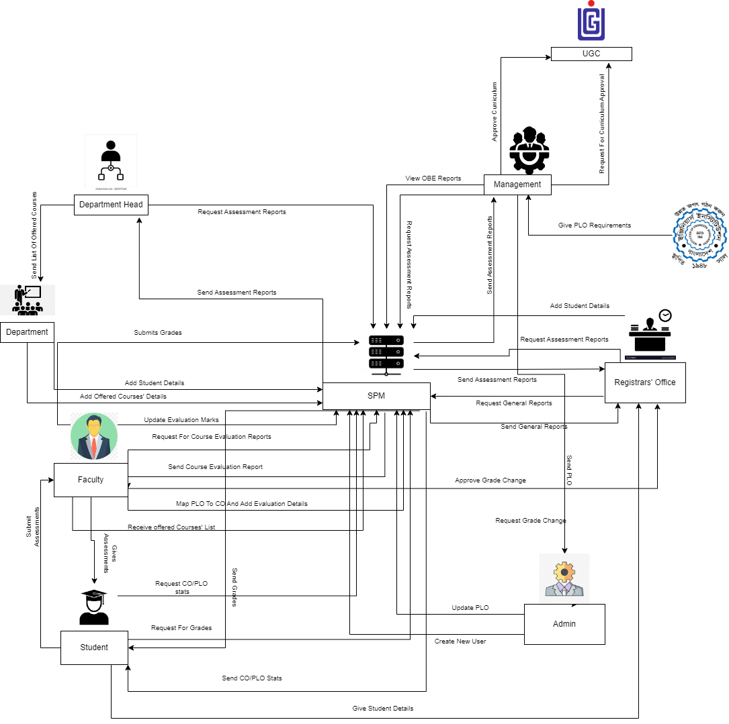

## Proposed Processes along with Six System Element Analysis

The six elements analysis of the proposed system is a continuation of an analysis process where each analysis is based on the one that comes before it. Based on the rich picture, the role of each element in the new system is further understood in the table below.

|  |  |  |  |  |  |  |
| --- | --- | --- | --- | --- | --- | --- |
| **Process** | **System Roles** | | | | | |
| **Human** | **Non-Computing Hardware** | **Computing Hardware** | **Software** | **Database** | **Network and Communication** |
| **Student Registration** | Student:  a) Search for the website  b) Goes to the website.  c) Clicks  on the  form  option.  c) Fill up the  form with  required  Information.  Admin:  a) Admin  logs into  the system  using  SPMS  User-ID and  password.  b)  Receives  the student  enrollment information in the  attached  files.  c) Admin  updates the  student  enrollment information in  Database.  d) Inputs  the desired  time  period for  number of  students  enrolled. | Paper and Stationery:  a) Used to collect information about students through enrollment forms. | Computer/  Laptop  a) SPMS admin will use Computers to access and update data.   b) Users will use the  computer to view the data.  Database  Server  a) Used by  SPMS  Developers to collect data and maintain the software.  Networking Devices  (Router,  Switch,  Bridge, Hub):  a) Used to  access SPMS | Operating  Software  a) Utilized by  Registrar  Office and  SPMS  Student  a) Uses to fill  up the form  from the  website.  SPMS  a) The software for which the administrator will set up user accounts. | Register  Office  Database  a) Used by the registrar's office to compile student data into an excel file for sending to SPMS.  SPMS  a) For any upgrades or new user accounts, information is kept in the database.  Excel  a) Data from student accounts may be kept in an excel file and used later in SPMS. | Internet  a) To access and store data to SPMS it is used.  b) It is used to collect the student form from the student to registrar office.  c)The Registrar office sends all the student information to SPMS admin by using it. |
| Student Performance Based on CGPA | Student:  a) Logs into  the System  using  Student-ID  and  password.  b) Inputs the desired time - period to  view self  CGPA  Progress.  Admin:  a) Logs into  the System  using User-ID  and  password.  b) Inputs the  desired time  period and  School,  Department or program to view.  Statistically and analyzed.  CGPA trend  of students.  Faculty:  a) Logs into the system  using  Faculty-ID  and  password.  b) Inputs the  desired time  -period and  program to view.  statistically and  analyzed  CGPA trend  of students or any  individual’s student those  who attended.  the faculty’s  Section. |  | Computer/  Laptop  a) User will need a computer to access SPMS  Printer  a) Used to print out the report if need be.  Networking Devices  (Router,  Switch,  Bridge, Hub):  a) Used to  access the  Internet. | Operating  Software  a) The user uses it to execute SPMS 2.0  SPMS  a) A performance trend will be generated by the software. | SPMS  Database  a) Obtain performance using the database. | Internet  a) To login into and access the SPMS it is used. |
| Course-wise student performance based on CGPA | Student:  a) Logs into the system  using  Student-ID  and  password.  b) Inputs the  course  c) View self  GPA for the  course. **Admin:**  a) Logs into the System  using User-ID and  password.  b) Inputs the desired time-  period  Course-ID  c) View statistically analyzed  GPA trend of  Students.  Faculty:  a) Logs into the System  using  Faculty-ID  and  password.  b) Inputs the  desired time  -  period  Course-ID  under the  faculty  c)view  statistically analyzed.  GPA trend of  students who faculty’s  section. |  | Computer/  Laptop  a) User will need a computer to access SPMS  Printer  a) Used to print out the report if need be.  Networking Devices  (Router,  Switch,  Bridge, Hub):  a) Used to  access the  Internet. | SPMS  a) A performance trend based on GPA will be generated by the software. | SPMS  Database  a) Here, the performance will be stored and updated. | Internet  a) To login into and access the SPMS it is used. |
| Selective Number of Instructor-wise student performance based on the GPA | Admin:  a) Logs into the system  using User-ID and  password.  b) Inputs the  desired time-  period  Course-ID  c)View  statistically  analyzed  GPA trend of  students for a  selective  number of  Instructors.  Faculty:  a) Logs into the system  using  Faculty-ID  and  password.  b) Inputs the  desired time -  period &  Course-ID  c)View  statistically  analyzed  GPA trend of  students for a  selective  number of  Instructors.  GPA trend of  students for a  selective  number of  Instructors. |  | Computer/  Laptop  a) User will need a computer to access SPMS  Printer  a) Used to print out the report if need be.  Networking Devices  (Router,  Switch,  Bridge, Hub):  a) Used to  access the  Internet. | SPMS  a) a) The software will produce a performance trend for a specified instructor. | SPMS  Database  a) Here, the performance will be stored and updated. | Internet  a) To login into and access the SPMS it is used. |
| Admin wise student performance | Admin:  a) Logs into the system  using User-ID  and  password.  b) Select  Input from  from  VC/Dean/Department  Head  c) View the  student  performance  trend as per  choice. |  | Computer/  Laptop  a) User will need a computer to access SPMS  Printer  a) Used to print out the report if need be.  Networking Devices  (Router,  Switch,  Bridge, Hub):  a) Used to  access the  Internet. | SPMS  a) The software will produce a performance trend | SPMS  Database  a) Here, the performance will be stored. | Internet  a) To login into and access the SPM it is used. |
| Instructor-wise student performance based on the GPA of the students | Admin:  a) Logs into the system  using  Department-I  D and  Password. b) Inputs a  particular  instructor  Name/ID  c)View the  student  performance  trend of  selected  Instructor.  Faculty:  a) Logs into the system  using User-ID and  password.  b) Input them  Name/ID.  c) View the  student  performance  trend. |  | Computer/  Laptop  a) User will need a computer to access SPMS  Printer  a) Used to print out the report if need be.  Networking Devices  (Router,  Switch,  Bridge, Hub):  a) Used to  access the  Internet. | SPMS  a) The software will produce a performance trend | SPMS  Database  a) The  performance  will be stored.  and updated.  in the  database. | Internet  a) To login into and access the SPM it is used. |
| Total PLO percentage achieved and attempted by the student along with the departmental average | Student:  a) Logs into the system  using Student-ID and  Password  b) Inputs the  time- period  c)Views their  comparison  of attempted.  vs achieved PLO.  percentage  along with  the  departmental  Average.  Admin:  a) Logs into the system  using User-ID and  Password  b) Inputs the time- period  c) Views the comparison of students  attempted  PLO vs  achieved  PLO  percentage  along with  the  departmental  average.  Faculty:  a) Logs into the system  using User-ID and  Password.  b) Inputs the  time period.  c) Views the  comparison of students  attempted  PLO vs  achieved  PLO  percentage  along with  the  departmental  Average. |  | Computer/  Laptop  a) User will need a computer to access SPMS  Printer  a) Used to print out the report if need be.  Networking Devices  (Router,  Switch,  Bridge, Hub):  a) Used to  access the  Internet. | Operating  system  a) Used by  the  SPMS  SPMS  a) A comparison of the attempted vs. achieved PLO as well as the departmental average will be produced by the software. | SPMS  Database  a) Here, the performance will be stored. | Internet  a) To login into and access the SPM it is used. |
| PLO achievement | Student:  a) Logs into the system  using  Student-ID  and  password. b) Selects  PLO  achievement  c) View PLO  Achievement.  Admin:  a) Logs into the System  using user-ID  and  password.  b) Selects  PLO  achievement  c) View PLO  Achievement.  Faculty:  a) Logs into  the System  using  Faculty-ID and  password.  b) Selects  PLO  Achievement.  c) View PLO  Achievement. |  | Computer/  Laptop  a) User will need a computer to access SPMS  Printer  a) Used to print out the report if need be.  Networking Devices  (Router,  Switch,  Bridge, Hub):  a) Used to  access the  Internet. | SPMS  a) A PLO achievement will be generated by the software. | SPMS  Database  a) Here, the performance will be stored and updated. | Internet  a) To login into and access the SPMS it is used. |
| Expected PLO-achievement versus actual score (for course's, student’s,  Department’s, program’s or school’s) | Student:  a) Logs into the system  using  Student-ID  and  password.  b) Selects  PLO  achievement  comparison  c) View PLO  achievement  Comparison.  Admin:  a) Logs into the system  using user-ID  and  password.  b) Selects  PLO  achievement  comparison  c) View PLO  achievement  Comparison.  Faculty:  a) Logs into the System  using  Faculty-ID and  password.  b) Selects  PLO  achievement  comparison.  c) view PLO  Achievement comparison. |  | Computer/  Laptop  a) User will need a computer to access SPMS  Printer  a) Used to print out the report if need be.  Networking Devices  (Router,  Switch,  Bridge, Hub):  a) Used to  access the  Internet. | SPMS  a) A) The software will calculate the expected vs. achieved PLO. | SPMS  Database  a) The  performance  will be stored  and updated  in the  database. | Internet  a) To login into and access the SPMS it is used. |
| CO-PLO achievement summary | Student:  a) Logs into the system  using  Student-ID  and  password.  b) Selects  CO -PLO  achievement  summary.  c) View CO- PLO achievement summary.  Admin:  a) Logs into the system  using user-ID  and  password.  b) Selects  CO -PLO  achievement  summary.  c) View CO  - PLO  achievement  Summary.  Faculty:  a) Logs into the system  using  Faculty-ID and  password.  b) Selects CO  -PLO  achievement  summary.  c) View CO  - PLO  achievement  Summary. |  | Computer/  Laptop  a) User will need a computer to access SPMS  Printer  a) Used to print out the report if need be**.**  Networking Devices  (Router,  Switch,  Bridge, Hub):  a) Used to  access the  Internet. | SPMS  a) The software will produce a summary of CO-PLO accomplishments. | SPMS  Database  a) The  Summary  will be stored  and updated  in the  database. | Internet  a) To login into and access the SPMS it is used. |
| CO percentage based on the obtained grades for each course summary | Student:  a) Logs into the system  using  Student-ID  and  password.  b) Selects  CO percentage based on the obtained grades for each course summary. c) View CO percentage based on the obtained grades for each course summary.  Admin:  a) Logs into the system  using user-ID and password.  b) Selects  CO percentage based on the obtained grades for each course summary.  c) View CO percentage based on the obtained grades for each course summary.  Faculty:  a) Logs into the system  using  Faculty-ID and  password.  b) Selects CO percentage based on the obtained grades for each course summary.  c) View CO percentage based on the obtained grades for each course summary.  d) Insert CO percentage for each student |  | Computer/  Laptop  a) User will need a computer to access SPMS  Printer  a) Used to print out the report if need be**.**  Networking Devices  (Router,  Switch,  Bridge, Hub):  a) Used to  access the  Internet. | SPMS  a) The software will produce a summary of CO percentage based on the obtained grades for each course accomplishments. | SPMS  Database  a) The  Summary  will be stored  and updated  in the  database. | Internet  a) To login into and access the SPMS it is used. |

# Ch-3 Logical System Design

## Business Rules

Business rules describe the operations, definitions and constraints that govern the data model. As opposed to the ERD, they are made using regular English sentences so that a non-technical stakeholder can decipher information about the data model without notation knowledge.

The business rules that govern our data model are as follows:

1. A student must have one department. A STUDENT has StudentID, FirstName, LastName, DateofBirth, Gender, Email, Phone, Address, EnrollmentDate. A department must have many students.

2. Student may perform many registrations. A REGISTRATION includes RegistrationID,

Semester, Year, Section Id, StutendID. A registration must be performed by at least one student.

3. A section mandatorily have many registrations. A registration has at least one section. A section includes SectionID, SectionNum, CourseId, FacultyID, Semester, Year.

4. A registration may belong to many EVALUATIONS. An evaluation mandatorily belongs to one registration. An evaluation contains EvaluationID, ObtainedMarks, AssessmentID,RegistrationID.

5. An evaluation must have one question. A question must have many evaluations.

Question contains QuestionID, AssessmentName, TotalMarks. An

question will have one section. A section contains one or many question.

6. Question must map with one CO’s. A CO maps with one or many question. A

CO’s includes COID, CourseID, PLOID. A CO must contain one Course. A Course contain one or many CO’s. A course may have many prerequisites. A course must affiliate one mark distribution. A mark distribution may affiliate many courses. A Mark Distribution includes DistID, A, A-, B+, B, B-, C+, C, C-, D+, D, ThresoldMarks.

7. A CO’s must map with one PLO’s. A PLO’s must map with one or many CO’s. PLO includes PLOID, PLONum, Details, ProgramID.

8. A PLO must contain one program. A program contains one or many PLO’s. A program has ProgramID, ProgramName, DepartmentID. A program must contain one or many courses. A Course must contain one course.

9. A program must belong to one department. A department must belong to one or many

programs. A department contain DepartmentID, DepartmentName, SchoolID.

10. A department must contain one school. A School must contain one or many departments. A school includes SchoolID, SchoolName.

11. An employee has two sub-type (Admin and Faculty). An employee

includes EmployeeID, FirstName, LastName, DateofBirth, Gender, Email, Phone, Address,

EmployeeType.An admin has EmployeeID,Rank,Join_Date , End_Date, Admin_Type.

12. A school must be run by one admin (Admin Type-Dean). A dean must run one school. A school has SchoolID,StartDate, EndDate.

13. A Department must manage one or many admin (Admin Type- Department head). A department head must manage one department.

14. A Faculty must have one Department. A department must have one or many Faculties. A

Faculty includes DepartmentID, Rank, JoinDate. A faculty may teach many sections. A section

must be taught by one faculty.

15.One or many sections must have a course outline.A course outline contains CouseOutlneID,Section_Num, Course_Description,multiple course objectives which includes Domain_and_level and PLOs.It has multiple PLOs which includes PLO_number,PLO_description.It also contains  Grade_Conversion_Scheme, Required_Textbook, Course_Policy, University_Regulation_And_Code_Of_Conduct and multiple values of Class_and_Schedule,Topics_and_Reading.

## Entity Relationship Diagram (ERD)

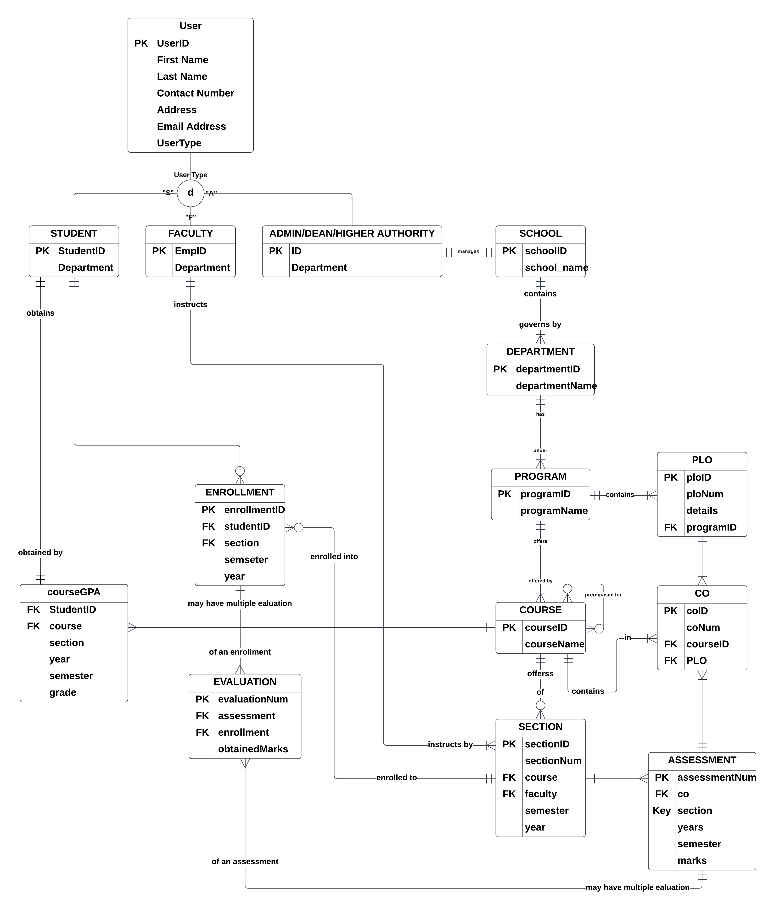

## ERD to Relations

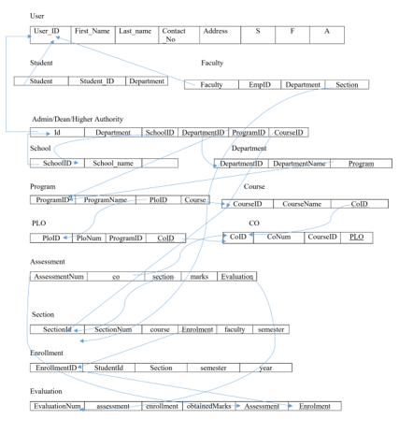

## Normalization

**NORMALZATION**

|  |  |  |  |  |  |  |
| --- | --- | --- | --- | --- | --- | --- |
| User | User_ID | | u1 | Program | Program_ID | p1 |
| First_Name | | u2 |
| Program_Name | p2 |
| Last_Name | | u3 |
| Contact_No | | u4 |
| Course_ID | c1 |
| Address | | u5 |
| Student_ID | | s1 |
| Plo_ID | o1 |
| Faculty_ID | | f1 |
| Admin_ID | | a1 |
| Student | Student_ID | | s1 | PLO | Plo_ID | o1 |
| Department_ID | | d1 | Plo_Num | o2 |
| Faculty | Faculty_ID | | f1 | Program_ID | p1 |
| Department | | d1 |
| Course_ID | c1 |
|  | |  |
| CO | Co_ID | i1 |
| Admin | Admin_ID | | a1 |
| Co_Num | i2 |
| Couse_ID | c1 |
| School_ID | | l1 |
| Plo_ID | o1 |
| Department_ID | | d1 |
| Assessment | Assessment_Num | m1 |
| Program_ID | | p1 |
| Course_ID | c1 |
| Course_ID | | c1 |
| Section_ID | w1 |
| School | School_ID | | l1 |
| Marks | m2 |
| School_Name | | l2 |
| Evaluation | n1 |
| Department | Department_ID | | d1 | Section | Section_ID | w1 |
| Department_Name | | d2 | Section_Num | w2 |
| Program | | p1 | Course_ID | c1 |
| Course | Course_ID | | c1 | Enrolment_ID | r1 |
| Course_Name | | c2 | Faculty_ID | f1 |
| CO_ID | | i1 | Semester | w3 |
| Enrollment | Enrollment_ID | | r1 | Evaluation | Evaluation_Num | n1 |
| Student_ID | | s1 | Assessment | m1 |
| Section_ID | | w1 |
| Enrollment_ID | r1 |
| Semester | | w3 |
| Obtain_Marks | n2 |
| Year | | r2 |
| CourseGPA | Student­_ID | s1 | |
| Course_ID | c1 | |
| Section_Num | w2 | |
| Year | r2 | |
| Semester | w3 | |
| Grade | g1 | |

|  |  |  |  |
| --- | --- | --- | --- |
| u1 | u2,u3,u4,u5,s1,a1,f1 | p1 | p2,o1,c1 |
| s1 | d1 | o1 | o2,p1,c1 |
| f1 | d1,w1 | i1 | i2,c1,o1 |
| a1 | l1,d1,p1,c1 | m1 | c1,m2,w1,n1 |
| l1 | l2 | w1 | w2,c1,r1,f1,w3 |
| d1 | d2,p1 | r1 | s1,w1,w2,r2 |
| c1 | c2,i1 | n1 | r1,n2 |
| s1,c1 | w2,r2,w3,g1 |

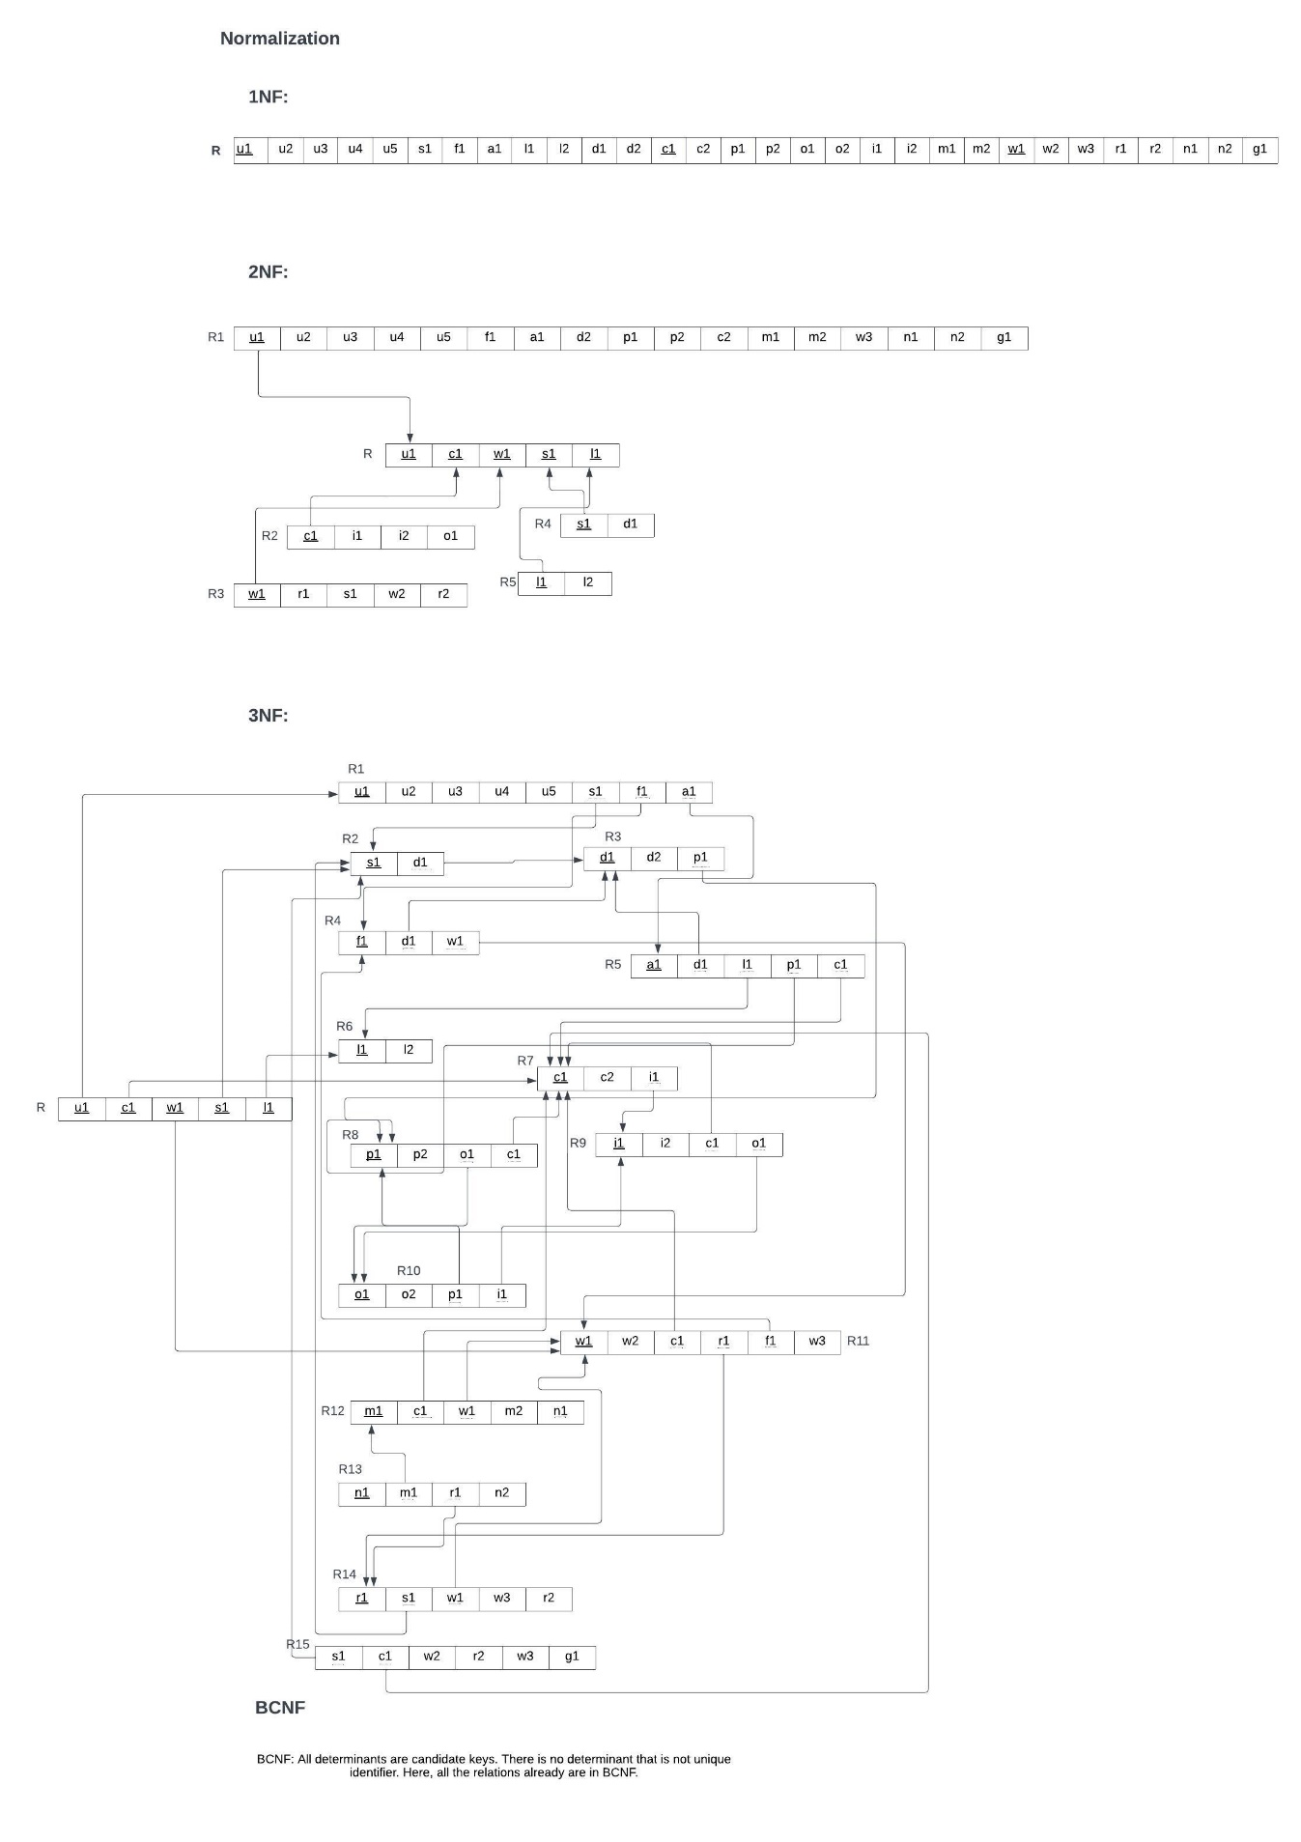

## Data Dictionary

School_T

|  |  |  |  |
| --- | --- | --- | --- |
| Name | Data Type | Size | Remarks |
| cSchoolID | VARCHAR | 10 | This is the primary key of School.  E.g.: “SETS” |
| cSchoolName | VARCHAR | 255 | This is the name of the school.  E.g.: “School of Engineering, Technology & Science”. |

Program_T

|  |  |  |  |
| --- | --- | --- | --- |
| Name | Data Type | Size | Remarks |
| cProgramID | VARCHAR | 5 | This is the primary key for a program. E.g.: “BSC1” |
| cProgramName | VARCHAR | 255 | This is the name of the program.  E.g.: “Bachelor of Science” |
| cDepartmentID | VARCHAR | 10 | This is the foreign key from the Department table.  E.g.: “CSE” |

Department_T

|  |  |  |  |
| --- | --- | --- | --- |
| Name | Data Type | Size | Remarks |
| cDepartmentID | VARCHAR | 10 | This is the primary key for the  Department table.  E.g.: “CSE” |
| cDepartmentName | VARCHAR | 255 | This is the name of the department.  E.g.: “Computer Science and Engineering”. |
| cSchoolID | VARCHAR | 10 | This is a foreign key from the school table.  E.g.: “SETS”. |

Course_T

|  |  |  |  |
| --- | --- | --- | --- |
| Name | Datatype | Size | Remarks |
| cCourseID | VARCHAR | 6 | This is the Primary Key for the Course.  E.g.: “CSE203” |
| cCourseName | VARCHAR | 255 | This is the name of the Course.  E.g.: “Discreet Mathematics” |
| nCreditNo | INTEGER |  | This is the number of credits for the Course.  E.g.: “3” |
| cProgramID | VARCHAR | 5 | This is the Program nme related to the Course. E.g.: “BSC1” |
| cPrerequisiteCourse | VARCHAR | 6 | This is the Primary Key for the Course.  E.g.: “CSE101” |

CLO_T

|  |  |  |  |
| --- | --- | --- | --- |
| Name | Data Type | Size | Remarks |
| nCLOID | INTEGER |  | This is the primary key for the CLO table.  E.g.: “1”. |
| cCLONum | TEXT |  | E.g.: “CLO1”. |
| cPLOID | INT |  | This is the foreign key from the Program Learning Outcome table.  E.g.: “PLO1” |
| cCourseID | VARCHAR | 6 | This is the Foreign Key from the Course_T.  E.g.: “CSE203” |

PLO_T

|  |  |  |  |
| --- | --- | --- | --- |
| Name | Datatype | Size | Remarks |
| nPLOID | INTEGER |  | This is the primary key for Program Learning Outcome.  E.g.: “1” |
| nPLONum | INTEGER |  | This is the PLO number. E.g.: “1” |
| cDetails | VARCHAR | 255 | This is the details for Program Learning Outcome. E.g.: “An ability to select and apply the knowledge, technique, skills and modern tools of the computer science and engineering discipline” |
| cProgramID | VARCHAR | 5 | This is the foreign key from the pPogram_T.  E.g.: “BSC1” |

Assessment_T

|  |  |  |  |
| --- | --- | --- | --- |
| NAME | DataType | Size | Remarks |
| nAssessmentNo | INTEGER |  | This is the Primary Key of an assessments  Eg:”124” |
| cMarks | NUMBER |  | This is the Marks of each assessments Eg:”65.6” |
| nCLOID | INTEGER |  | This is the Foreign Key From the CLO_T.  E.g.: “1”. |
| cSectionID | VARCHAR | 255 | This is the Foreign Key from Section_T.  E.g.: “summer23csc10101” |

Evaluation_T

|  |  |  |  |
| --- | --- | --- | --- |
| Name | Datatype | Size | Remarks |
| nEvaluationID | INTEGER |  | This is the Primary Key for Evaluation Table. |
| cObtainedMarks | NUMBER |  | This is the obtained marks of the student.  E.g.: “24.5” |
| nAssessmentNo | INTEGER |  | This is the Foreign Key from Assessment_T  Eg:”124” |
| nEnrollmentID | INTEGER |  | This is the Foreign Key from Enrollment_T. |

Student_T

|  |  |  |  |
| --- | --- | --- | --- |
| Name | Data Type | Size | Remarks |
| nStudentID | INTEGER |  | This is the primary key for the student table.  E.g.: “1921834”. |
| cFirstName | VARCHAR | 30 | This is the first name of the student.  E.g.: “Rakibul”. |
| cLastName | VARCHAR | 30 | This is the last name of the student.  E.g.: “Hasan”. |
| dDateOfBirth | DATE | DD  MM  YYYY | This is the birth date of the student.  E.g.: “21-12-1996”. |
| cEmail | VARCHAR | 30 | This is the email of the student.  E.g.: “1921834@iub.edu.bd” |
| nPhone | NUMERIC | 11 | This is the phone of the student.  E.g.: “01XXXXXXXXX”. |
| cAddress | VARCHAR | 50 | This is the address of the student.  E.g.: “House 1,  Road 4, Block D, Bashundhara RA”. |
| cProgramID | INTEGER |  | This is the foreign key from the program table.  E.g.: “BSc1” |
| cDepartmentID | VARCHAR | 3 | This is the foreign key from the Department table.  E.g.: “CSE” |

 Section_T

|  |  |  |  |
| --- | --- | --- | --- |
| Name | Datatype | Size | Remarks |
| cSectionID | VARCHAR | 255 | This is the Primary Key for Section.  E.g.: “summer23csc10101” |
| nSectionNum | INTEGER |  | This is the section number.  E.g.: “1” |
| cCourseID | VARCHAR | 6 | This is the foreign key from the Course table.  E.g.: “CSE101” |
| dYear | YEAR | yyyy | This is the year of registration.  E.g.: “2019” |
| cSemester | VARCHAR | 10 | This is the semester of the section.  E.g.: “Summer” |
| cFacultyID | NUMERIC | 4 | This is the foreign key from Faculty table.  E.g.: “1801” |

Enrollment_T

|  |  |  |  |
| --- | --- | --- | --- |
| Name | Datatype | Size | Remarks |
| nEnrollmentID | INTEGER |  | This is the Primary Key for Registration.  E.g.: “0101010101” |
| cStudentID | NUMERIC | 7 | This is the foreign key from Student Table extended from User_T.  E.g.: “1830398” |
| cSemester | VARCHAR | 10 | This is the semester of registration.  E.g.: “Spring” |
| dYear | YEAR | yyyy | This is the year of registration.  E.g.: “2019” |
| nSectionID | VARCHAR | 255 | This is the Foreign Key from Section_T.  E.g.: “summer23csc10101” |

Faculty_T

|  |  |  |  |
| --- | --- | --- | --- |
| Name | Datatype | Size | Remarks |
| nFacultyID | INTEGER |  | This is the primary key for the faculty table.  E.g.: “4250” |
| dJoinDate | DATE | dd-mm yyyy | This is starting date.  E.g.: “01-03-2020” |
| cRank | VARCHAR | 30 | This is the rank of the faculty.   E.g.: “Assistant Professor” |
| cDepartmentID | VARCHAR | 3 | This is the foreign key from the Department table.  E.g.: “CSE” |

Admin_T

|  |  |  |  |
| --- | --- | --- | --- |
| Name | Datatype | Size | Remarks |
| nAdminID | INTEGER |  | This is the primary key for the admin table.  E.g.: “4250” |
| cAdminType | VARCHAR | 30 | This is the type of user logging in  E.g.: “VC” |
| dJoinDate | DATE | dd-mm yyyy | This is starting date.  E.g.: “01-03-2020” |
| cRank | VARCHAR | 30 | This is the rank of the admin.  E.g.: “Assistant Professor” |
| dEndDate | DATE | dd-mm  yyyy | This is the date the admin retires from his post.  E.g.: “01-03-2024” |
| cDepartmentID | VARCHAR | 3 | This is the foreign key from the Department table.  E.g.: “CSE” |
| cSchoolID | VARCHAR | 5 | This is a foreign key from the school table.  E.g.: “SETS”. |

CourseGrade_T

|  |  |  |  |
| --- | --- | --- | --- |
| Name | Datatype | Size | Remarks |
| nID | INTEGER |  | This is the primary key for the CourseGrade_T table.  It increaments automatically  E.g.: “4250” |
| cStudentID | NUMERIC | 7 | This is the foreign key from Student Table extended from User_T.  E.g.: “1830398” |
| dEduYear | YEAR | yyyy | This is the year of registration or Enrollment.  E.g.: “2019” |
| cEduSemester | VARCHAR | 10 | This is the semester of registration or Enrollment.  E.g.: “Spring” |
| cCourseID | VARCHAR | 6 | This is the foreign key from the Course table.  E.g.: “CSE101” |
| nSectionNum | INTEGER |  | This is the section number.  E.g.: “1” |
| cGrade | VARCHAR | 2 | This is the Grade of a course example: “B” |

# Ch-4 Physical System Design

## Input Forms

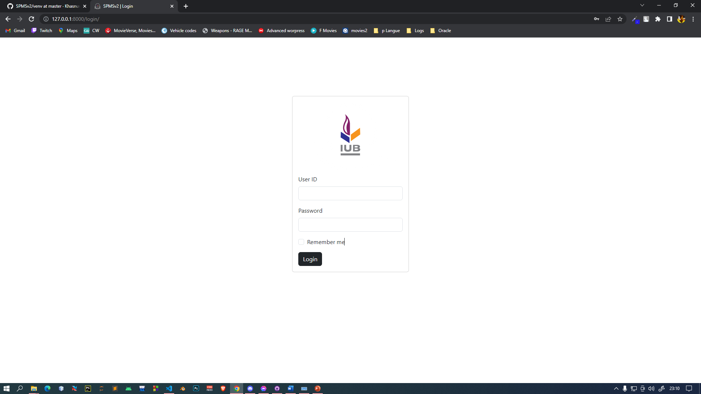

Figure: Sign in Form for all user

Figure: Student Dashboard and Navbar

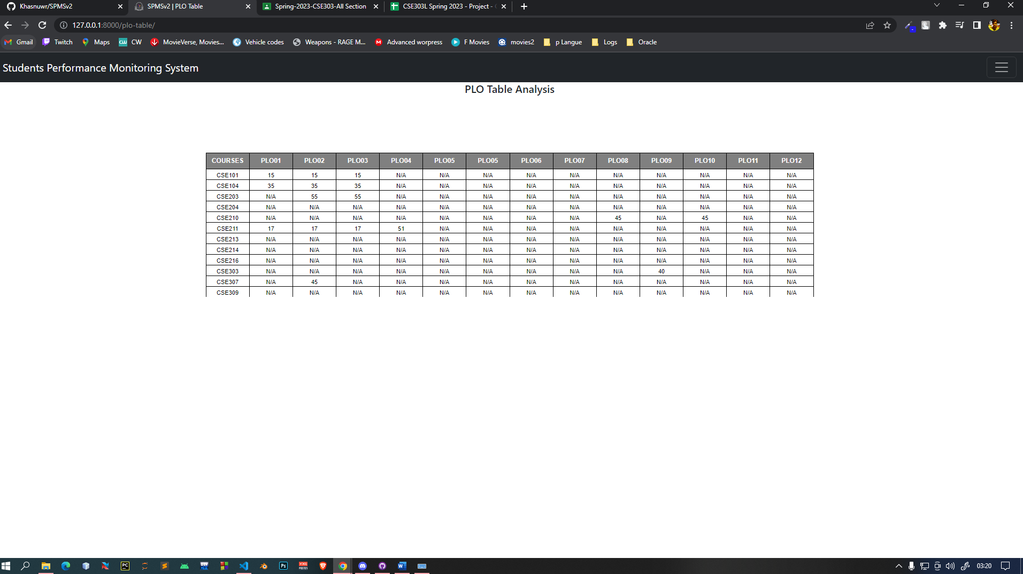

Figure: PLO table Analysis Student Wise

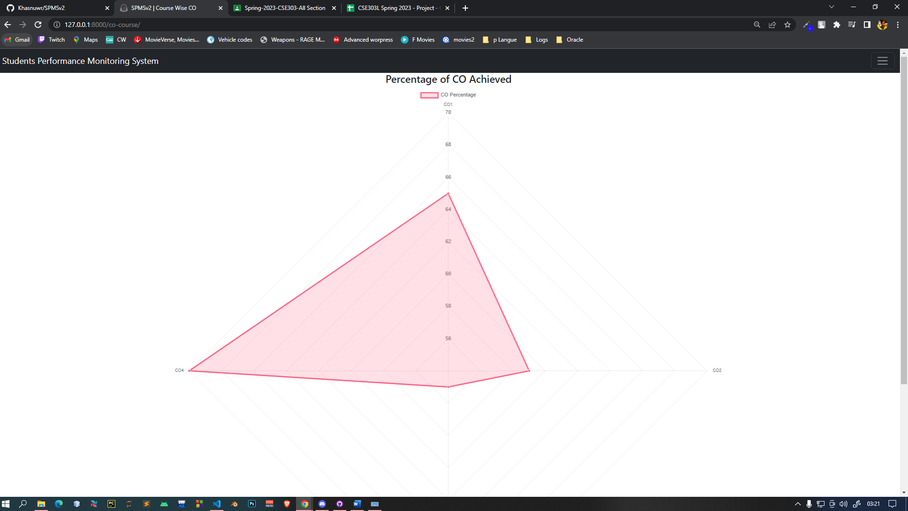

Figure: Achieved CO Analysis Student Wise

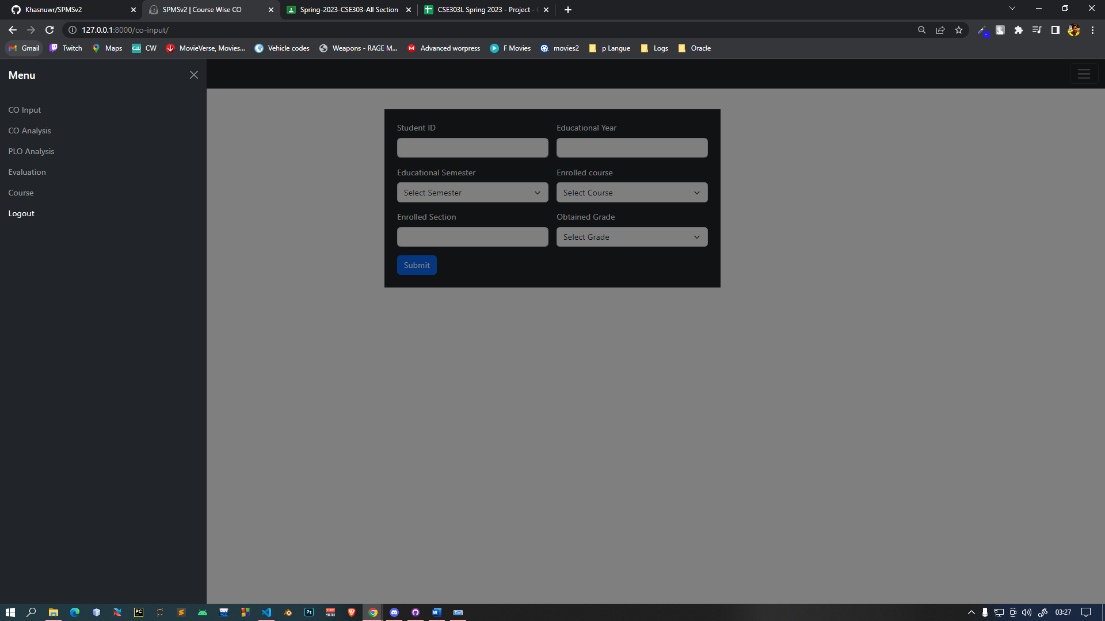

Figure: Faculty dashboard and Navbar

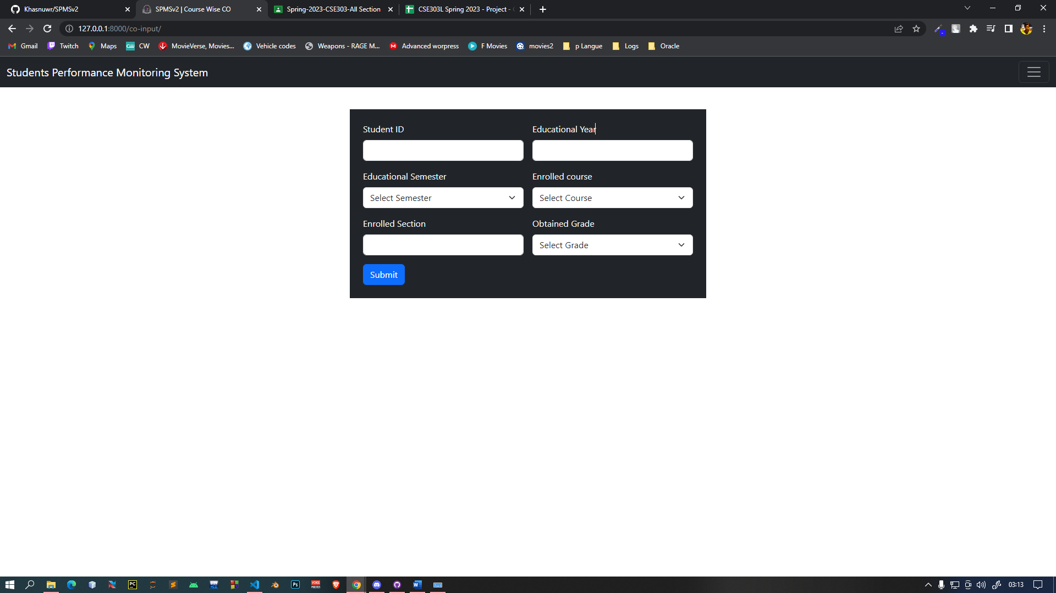

Figure: CO percentage insertion Form for Faculty User

# Ch-5 Conclusion

## Problem & Solution

1. Our ability to utilize this program to its full potential has been hampered by the limited period of the semester. We intend to make enhancements with greater analysis when given more time, but we believe we have produced the best program we could give the time and resources available.
2. We might think that we could have produced far more trustworthy and accurate outcomes, representations, and predictions if given more tools and information to work with.

## Additional Feature & Future Development

Future Development scope:

1. The number of users will be increased to include advisers, who will receive pertinent data on the students they are advising for better and more advantageous interactions between students and advisors.
2. Project goals include adding a component that predicts a candidate's grade based on prior grades and performances.

## Conclusion & Recommendations

We think the idea we had for our SPM software has been created, built, and implemented in the greatest way possible. With the appropriate application of this software, we intend to significantly raise the standard of education offered by institutions. This program can be used by students who want to become better and more capable scholars, by faculties to keep better track of their students and adjust their teaching strategies accordingly, and by institution members to more effectively manage their resources.