MOM & POP’S Pizzeria’s
Pizza System
Design Document
Stack UnderFlow

Written by: Arad Nasre Azadani, Jake Cashion,
Khason Murphys, Amaya Cruz

Table of Contents

Conceptual System Design Page 3
- Report Formats Page 3
- Screen Layouts Page #

Technical Design Page 7-14
- Class Diagrams Page #
- Supporting Text Specifications Page #
- Database Table Descriptions Page 24-32
- Technical Support Specification Page 33-35

Conceptual System Design
Report Format

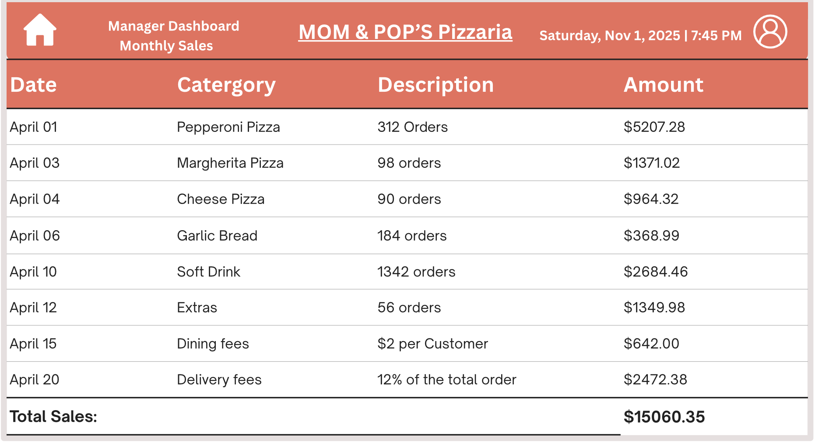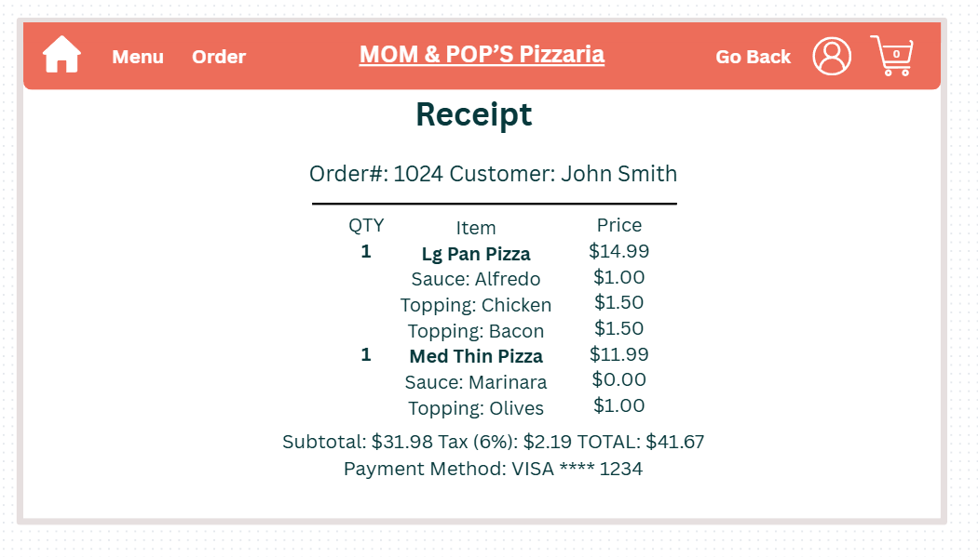
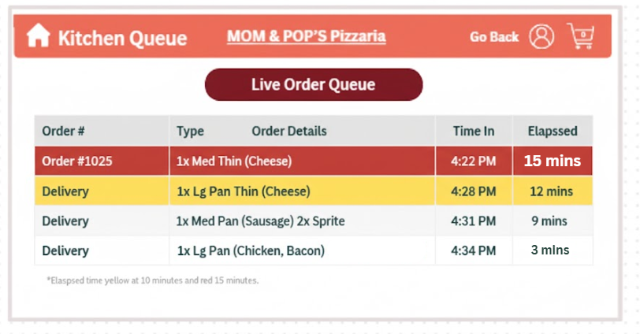
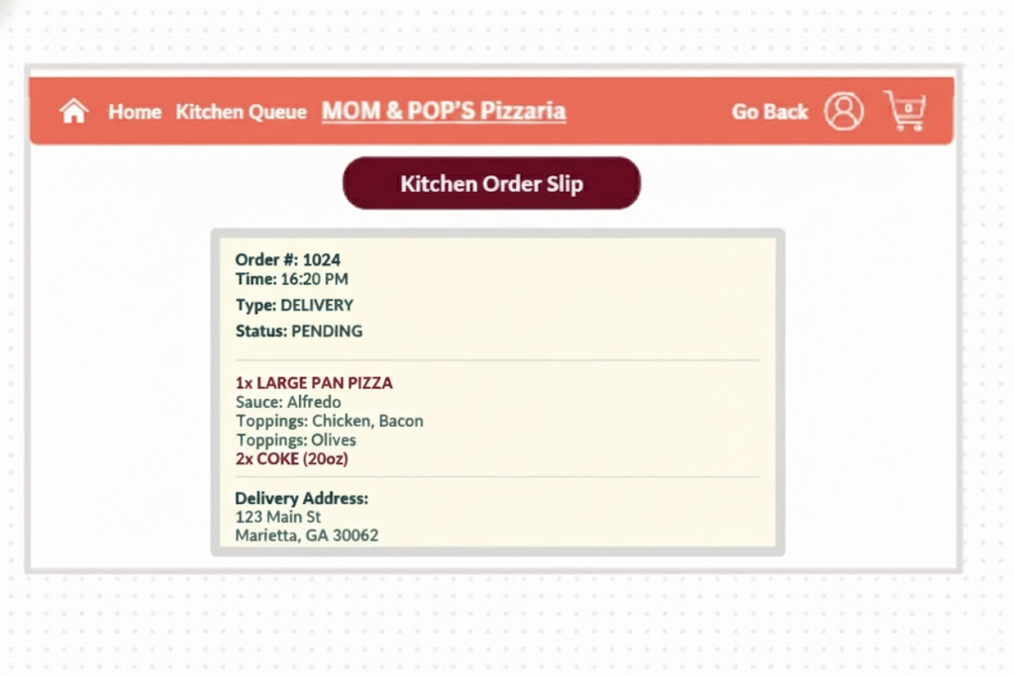

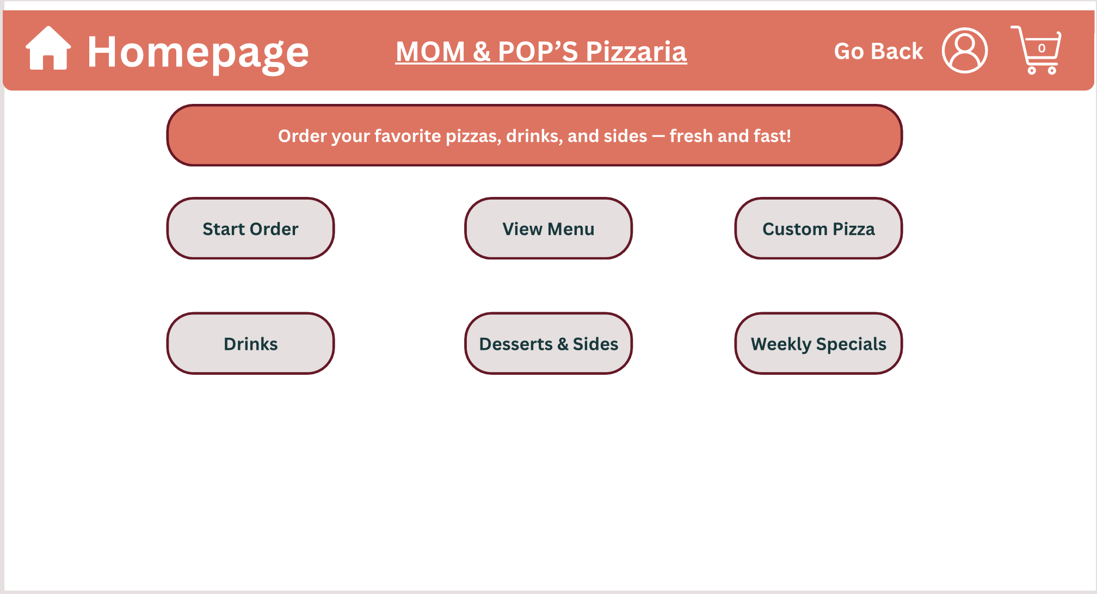
Screen Layout
Figure 1: Homepage overview

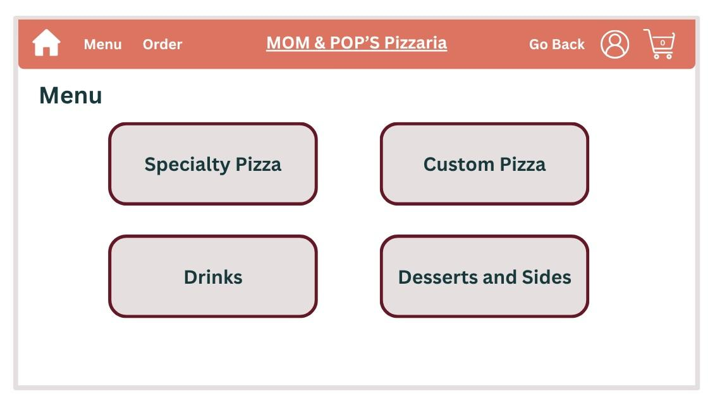
When the website is first opened, customers are greeted with the homepage. As seen in Figure 1, the customer will see six different icons that represent delivery, pick-up, menu, order history, and sign-in. At the top of the page, there will be an icon, represented by a house, that allows every user to return to the homepage. There are several options from which the user can proceed.
Figure 2: Overview of Menupage
When the user selects to view the menu, they will be greeted with a similar page containing four options: specialty pizzas, custom pizza, drinks, and desserts and sides. Figure 2 shows the screen of the overall menu page. The software will gather data from a separate table and categorize each item into one of the four options provided.
The customer is always provided with a “Go Back” option, serving as a way to undo any possible user error. Additionally, the user will always be able to see what is in their cart by clicking on the cart icon in the top right, as well as by seeing the number inside the icon.

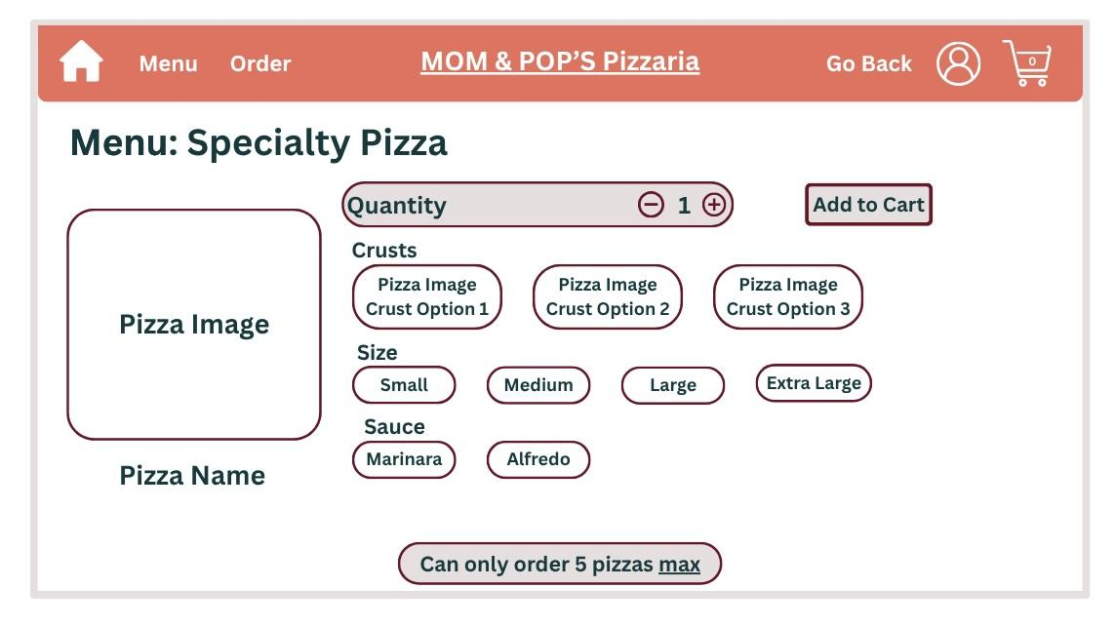
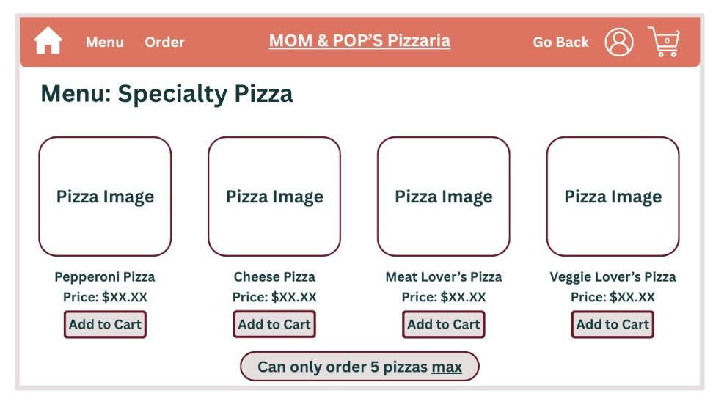
When the user selects the Specialty Pizza option, they will be taken to a new page. As seen in Figure 2.1, all the specialty pizzas will be displayed, as well as the price for each pizza. There is also a reminder telling the user the maximum amount of pizza that they can order. To simplify ordering, there is an “Add to Cart” button below every pizza. This allows the user to just add the pizza if they choose not to customize anything. The system makes sure that the item is in stock before any customer places an order; if the item is out of stock, then the system updates it and does not let anyone purchase the item.
Figure 2.3: Customizing specialty pizzas
Figure 2.1: Specialty Pizzas ordering page
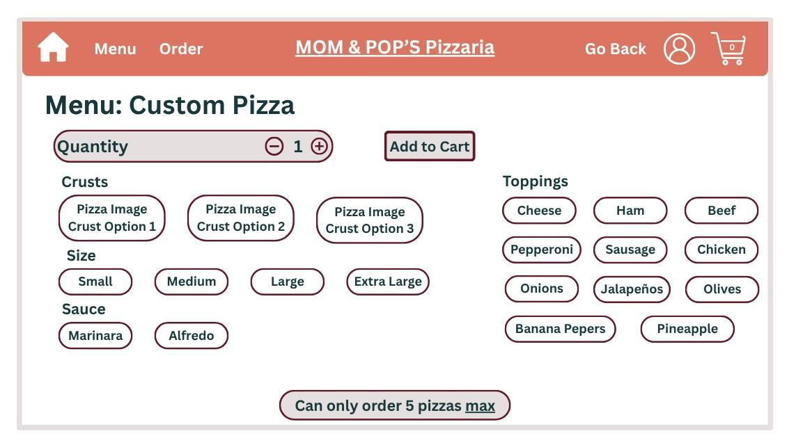
Figure 2.3 demonstrates all the options that a customer is given to customize a specialty pizza. Similarly, the system ensures that every item is in stock.
Figure 3: Custom Pizza screen
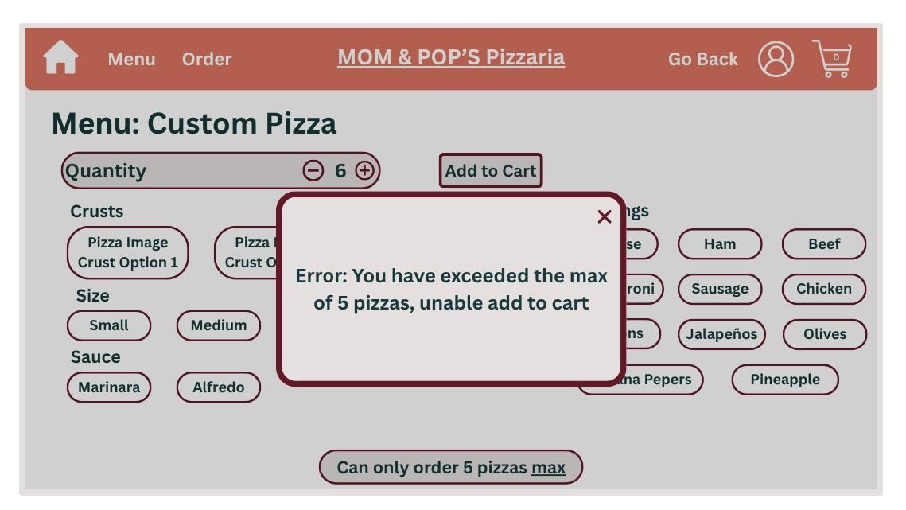
Custom pizzas are very different than personalizing a specialty pizza. Custom pizzas allow customers to make a combination of pizzas. As shown in Figure 3, the customer can select from different crusts, sizes, sauces, and topping options. If a user selects a quantity over 5 and clicks to add it to the cart, the system will throw an error in the form of a pop-up message. As demonstrated in Figure 3.1, the pop-up can be easily exited and clearly tells the user why the message appeared.
Figure 3.1: Error message for exceeding maximum
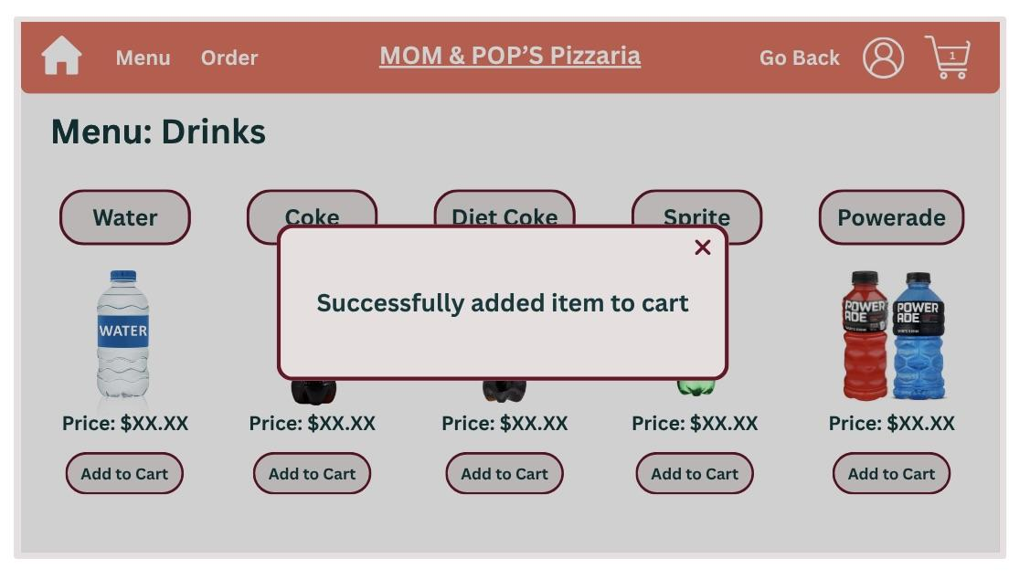
If an item is successfully ordered, then similarly, a different pop-up message will appear confirming to the customer that the item has been successfully added to the cart. The number inside the cart will also be updated. Figure 4 demonstrates the message that allows the user to still keep browsing the website.
Figure 4: Message for item being added to cart

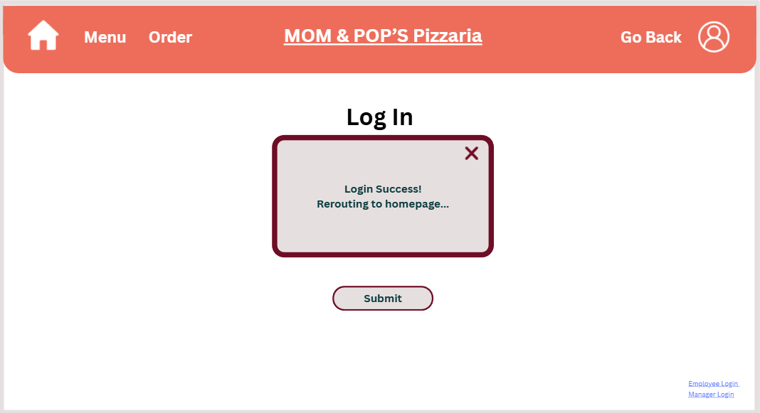
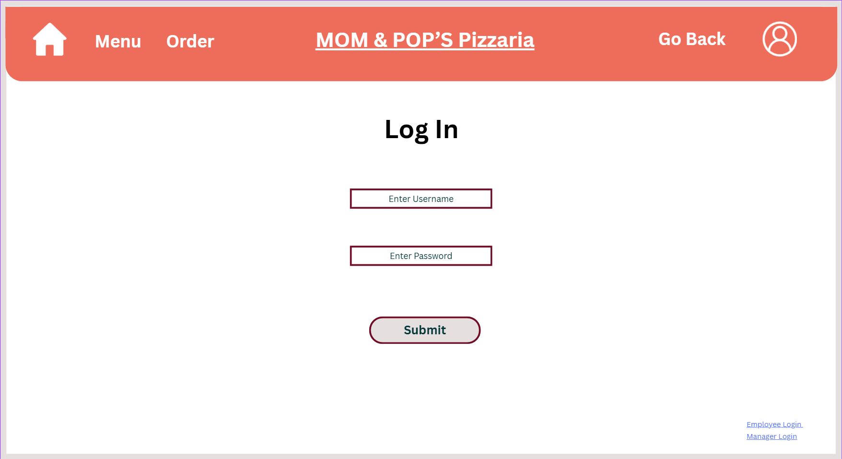
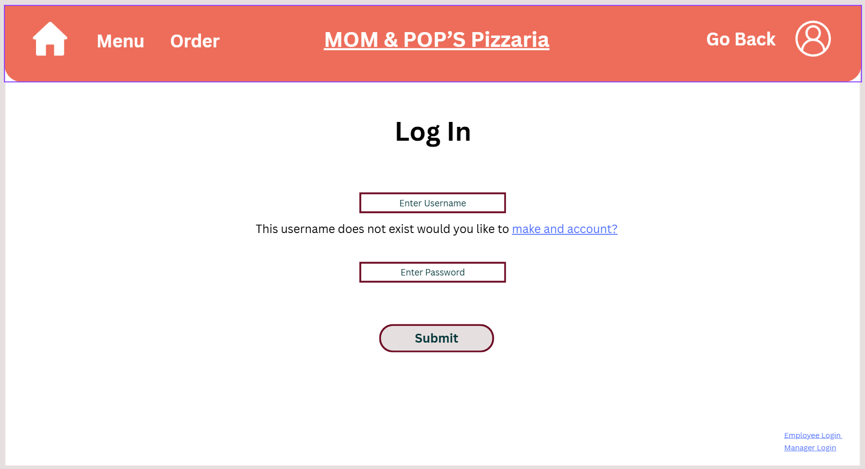
Before placing an order, customers will be prompted to log in. Figure 5 shows the screen on which the user will input their information. If a customer does not have an account, the system will prompt them to create an account allowing them to access the sign-up page where they can create a username and password (Figure 5.1). If the system verifies the input the user submits and matches it with the database, then the system will show a pop-up stating it was successful, this can be seen in Figure 5.2. If the wrong input is being added, the system will display an error message as seen in Figure 5.3, which also lets the user know the limit to how many attempts they can input before getting timed out.
Figure 5.2: Login success message
Figure 5: Log in screen to input information
Figure 5.1: Prompting user to sign up

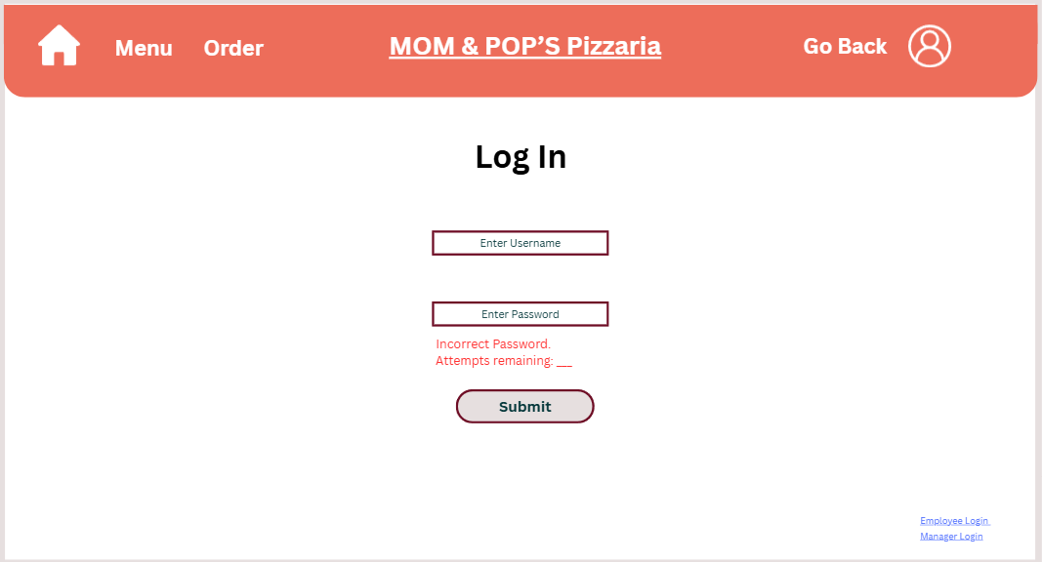
Figure 5.3: Incorrect input error message
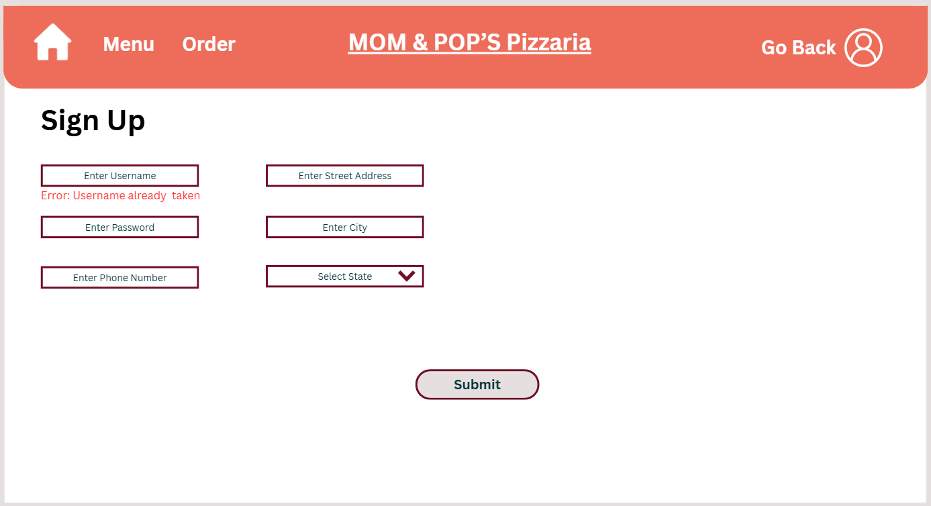
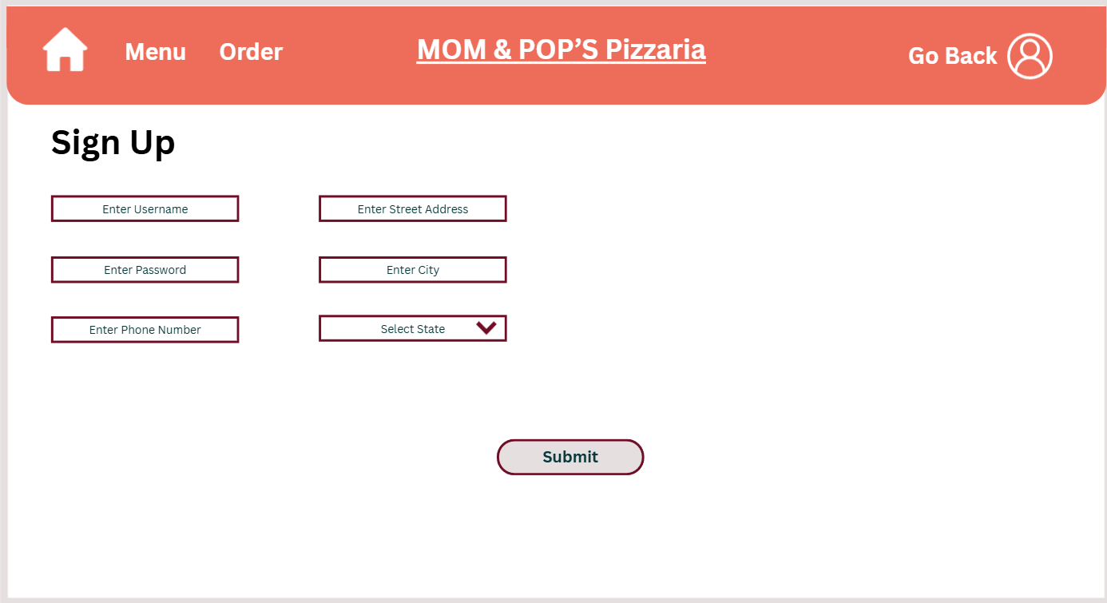
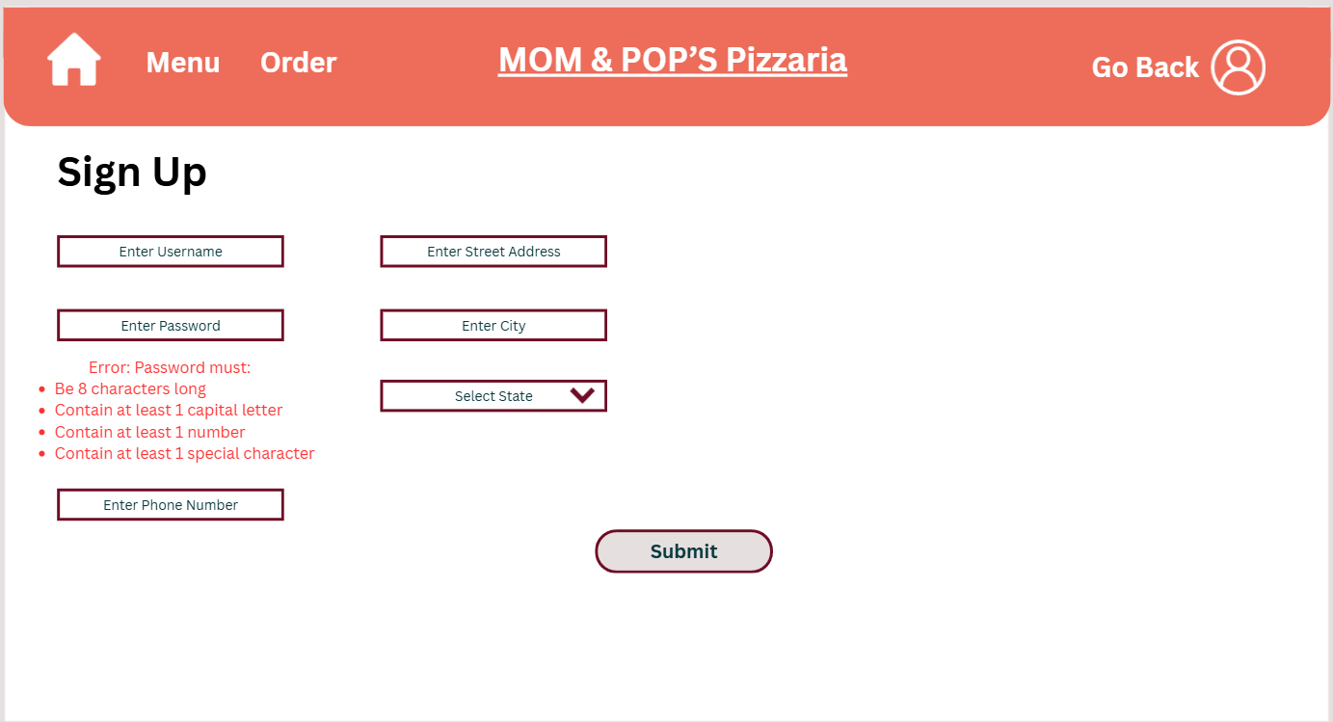
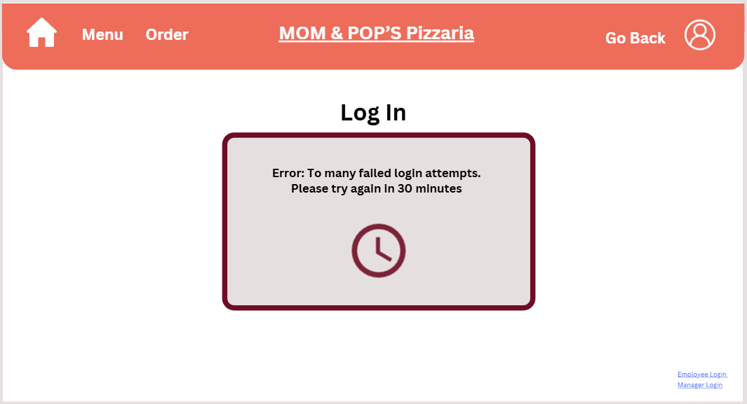
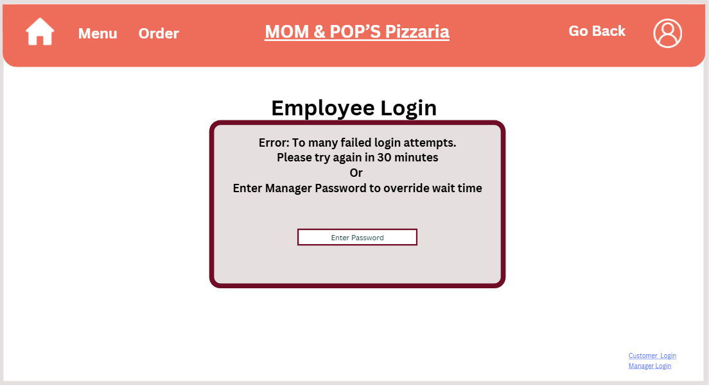
Once the user has exceeded the number of attempts allowed, the system will create a new pop-up letting them know how long they must wait until they can try again (Figure 5.4). The employees have a very similar log in process, the key difference is that once they have exceeded the number of incorrect attempts, they can have a manager enter a password to override and let the employees log in (Figure 6). The manager log in screen is the same as the employees, meaning they get the same error messages and confirmation pop-ups. The sign-up process requires for new users to create a username and password, as well as inputting their phone number, address, the city they are from, and their state, this is demonstrated in Figure 7. The system makes sure to check if a username is already taken, and if it is tells the user to create a different one for one already exists (Figure 7.1). Additionally, the system ensures that the password that is created is at least 8 characters long, contains at least 1 capital letter, contains at least 1 number, and contains at least 1 special character (Figure 7.2). The system also verifies everything that is inputted by the user, this can be shown in Figures 7.3, 7.4, 7.5, 7.6, and 7.7.
Figure 7.1: Error message for taken username
Figure 7: Sign Up page
Figure 7.2: Error message for invalid password
Figure 5.4: Timeout message
Figure 6: Employee Timeout Message
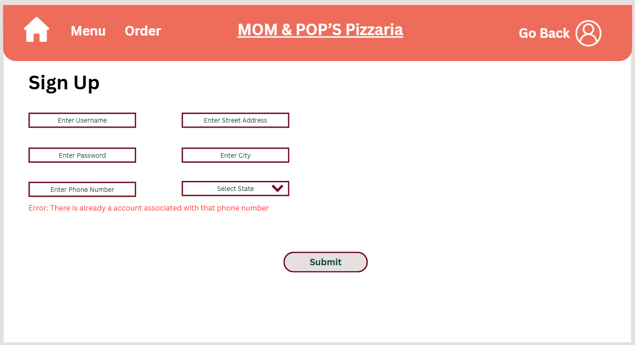
Figure 7.3: Invalid phone number

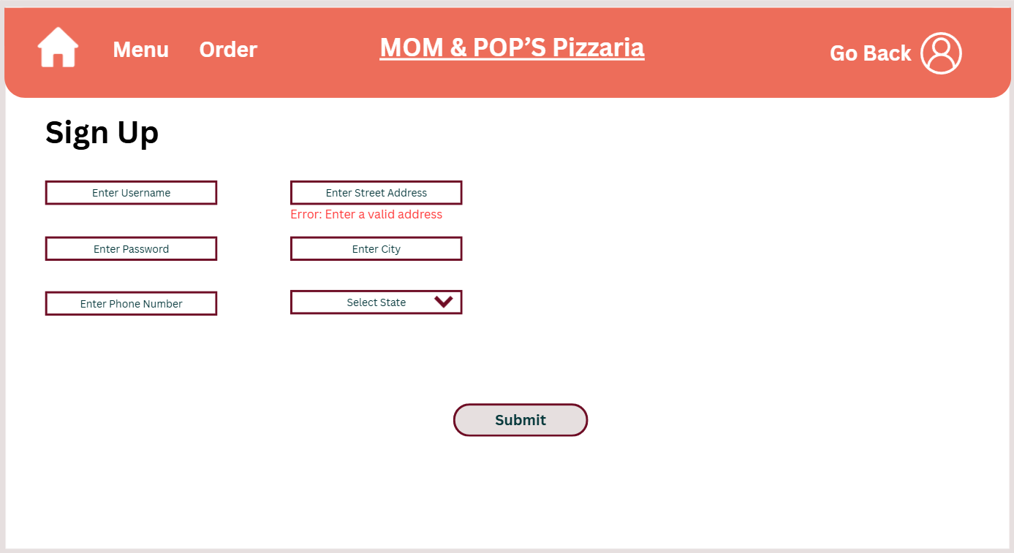
Figure 7.4: Invalid address error message

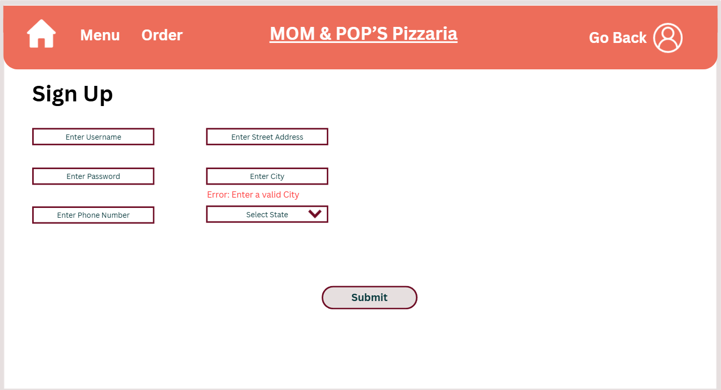
Figure 7.5: Invalid City

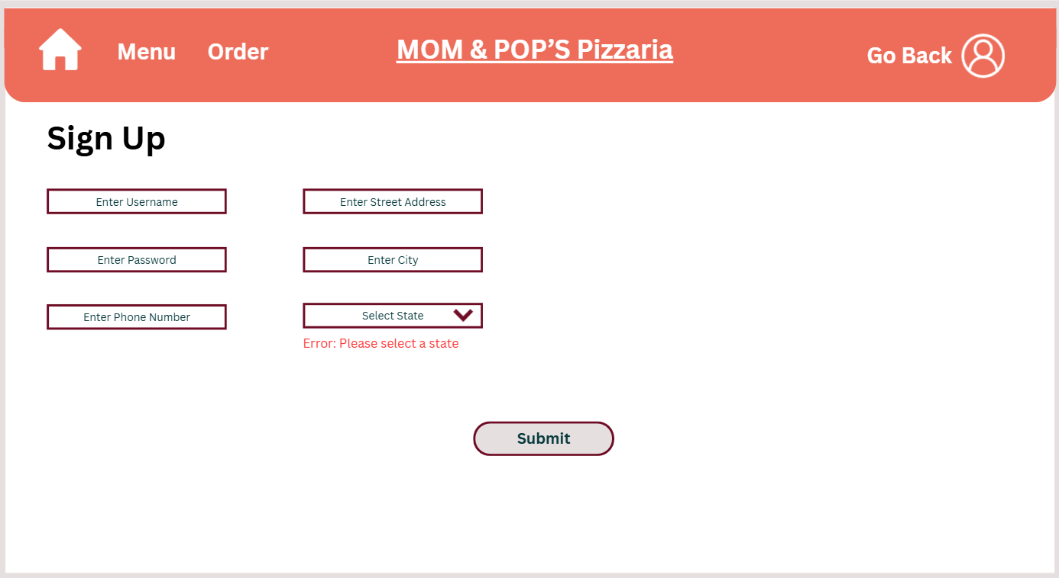
Figure 7.5: Error message for not inputting state

Once everything is verified and there are no errors, the user will get a pop-up message
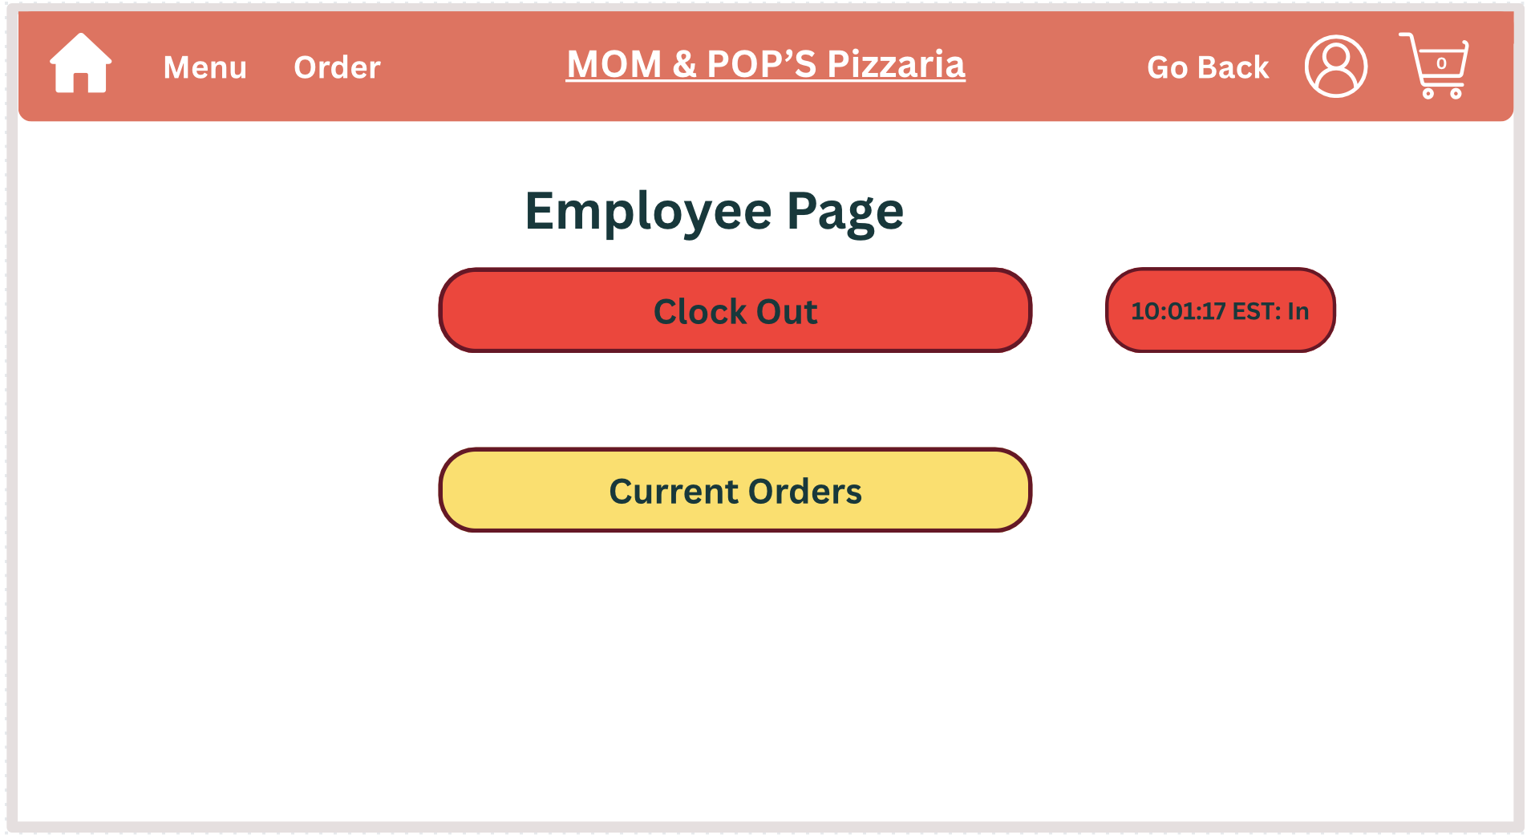
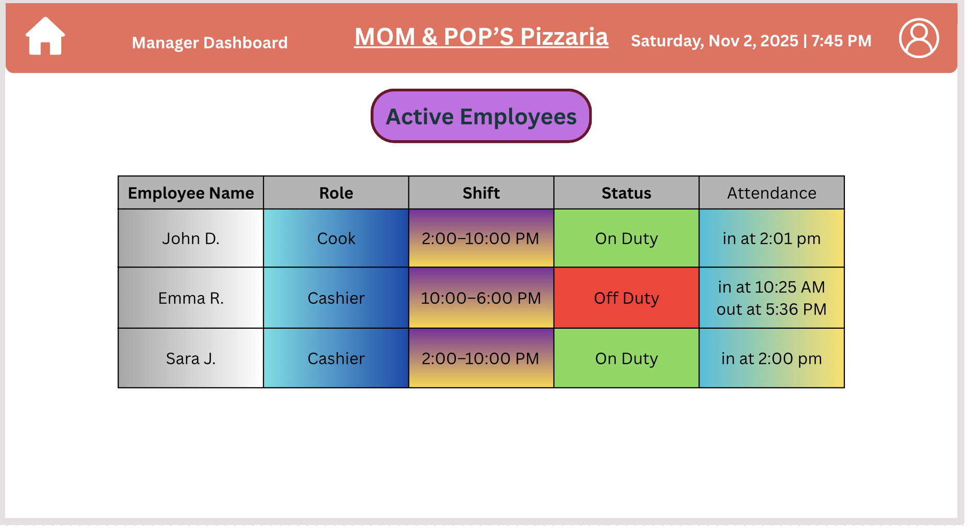
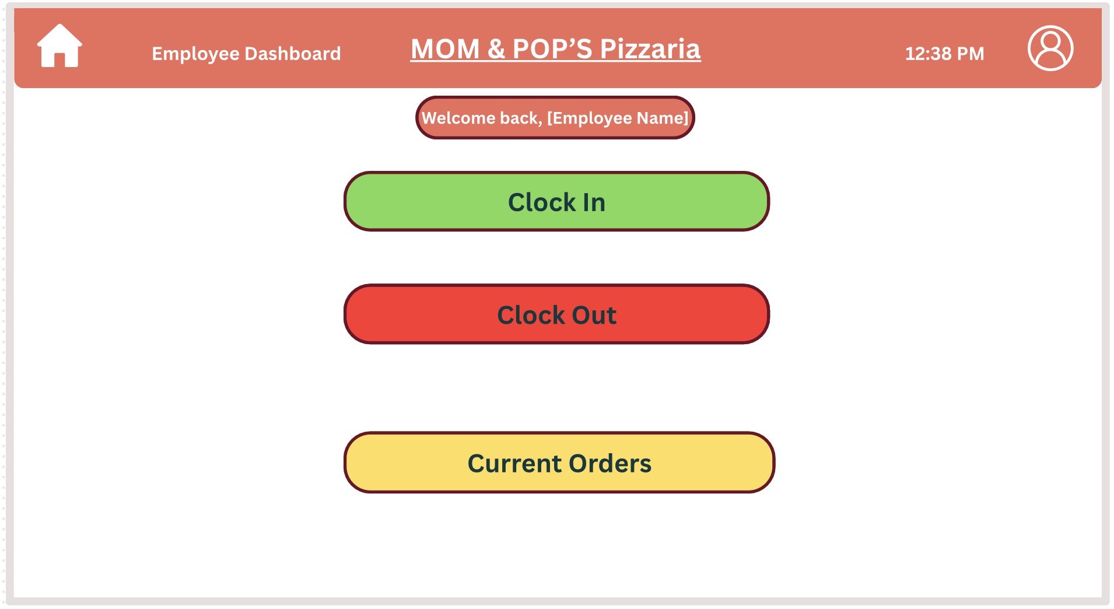
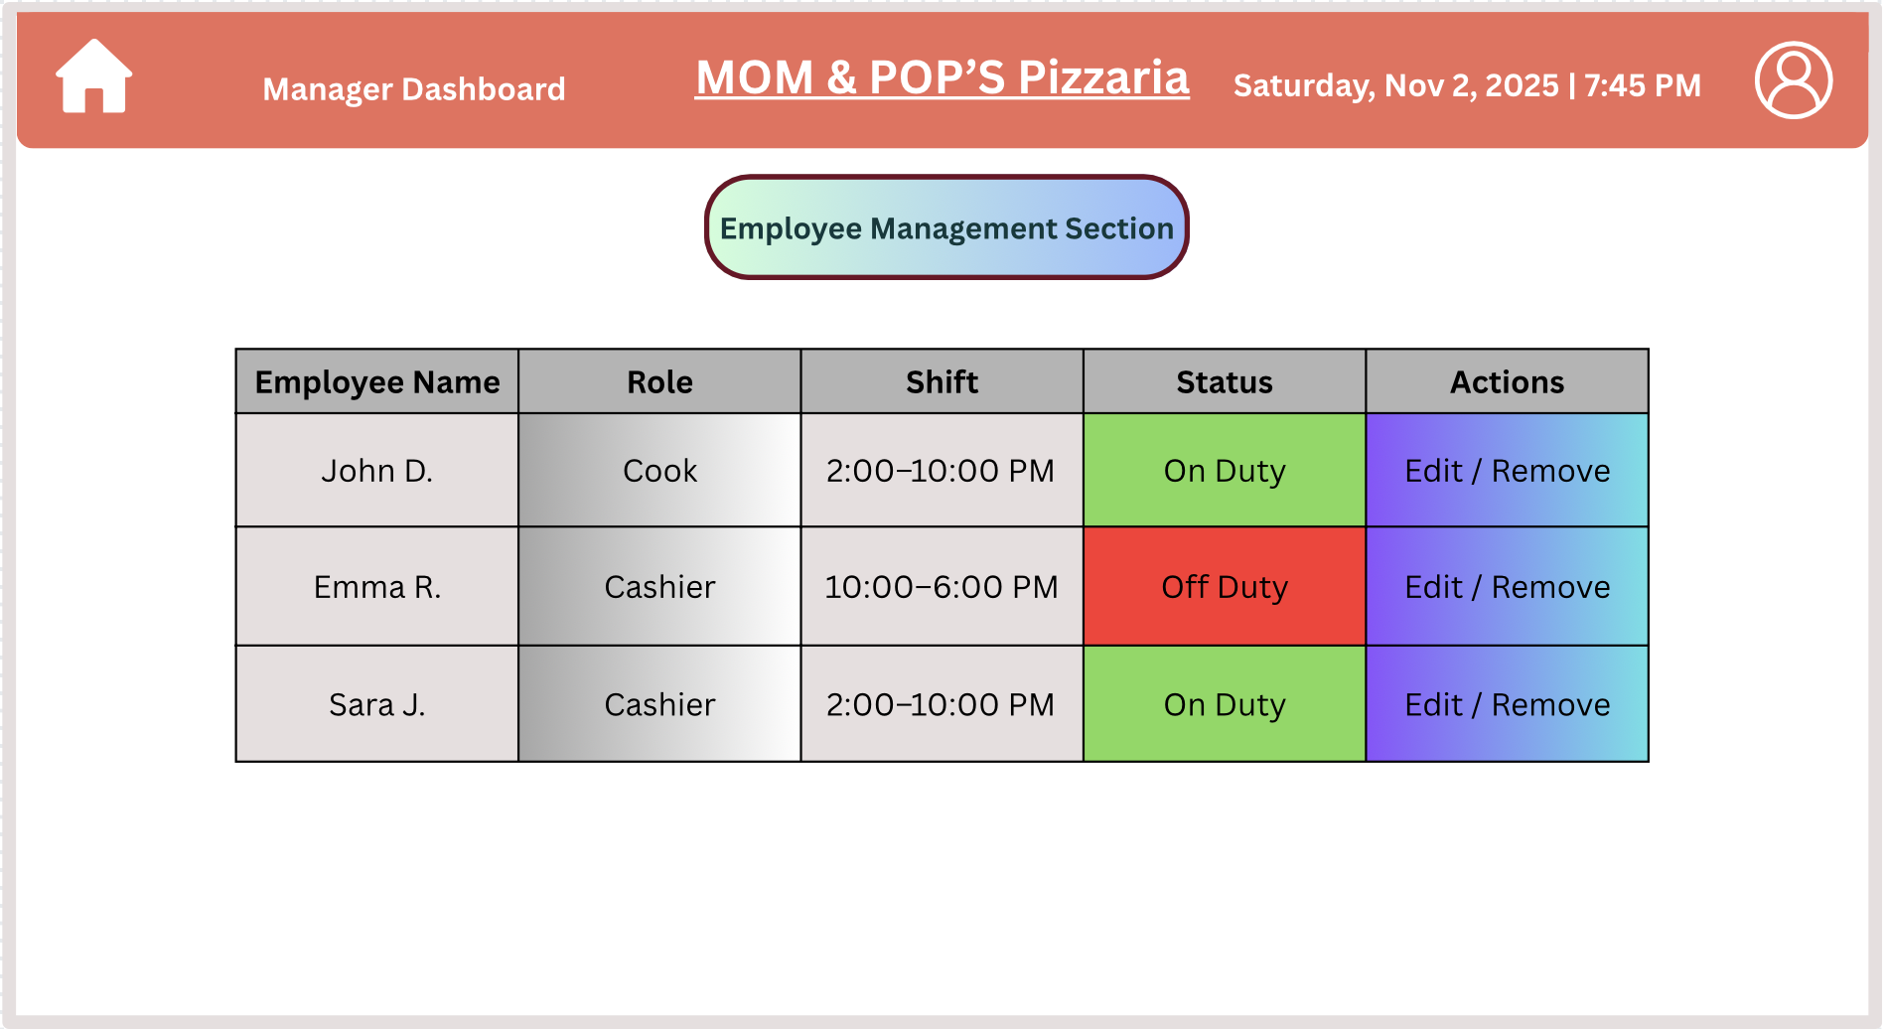
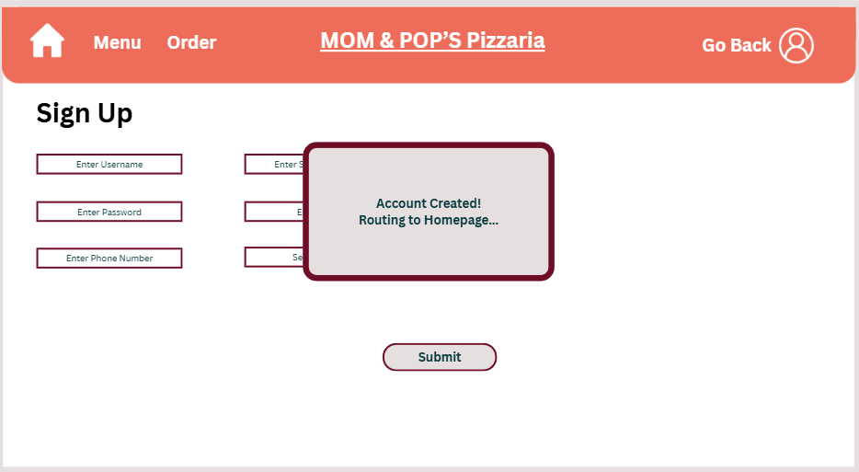
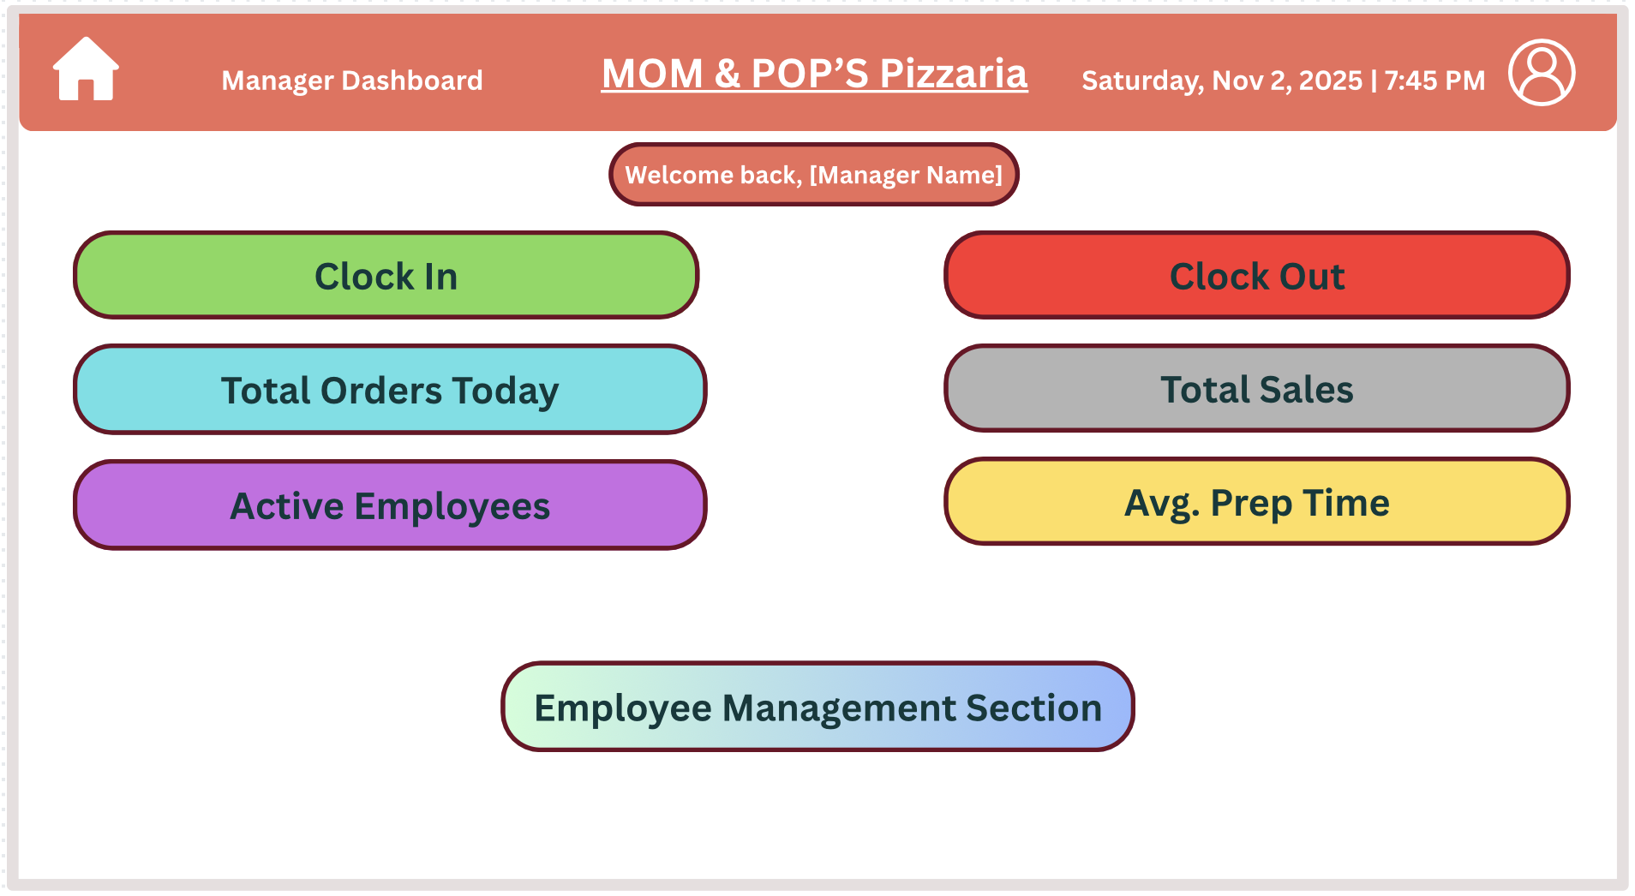
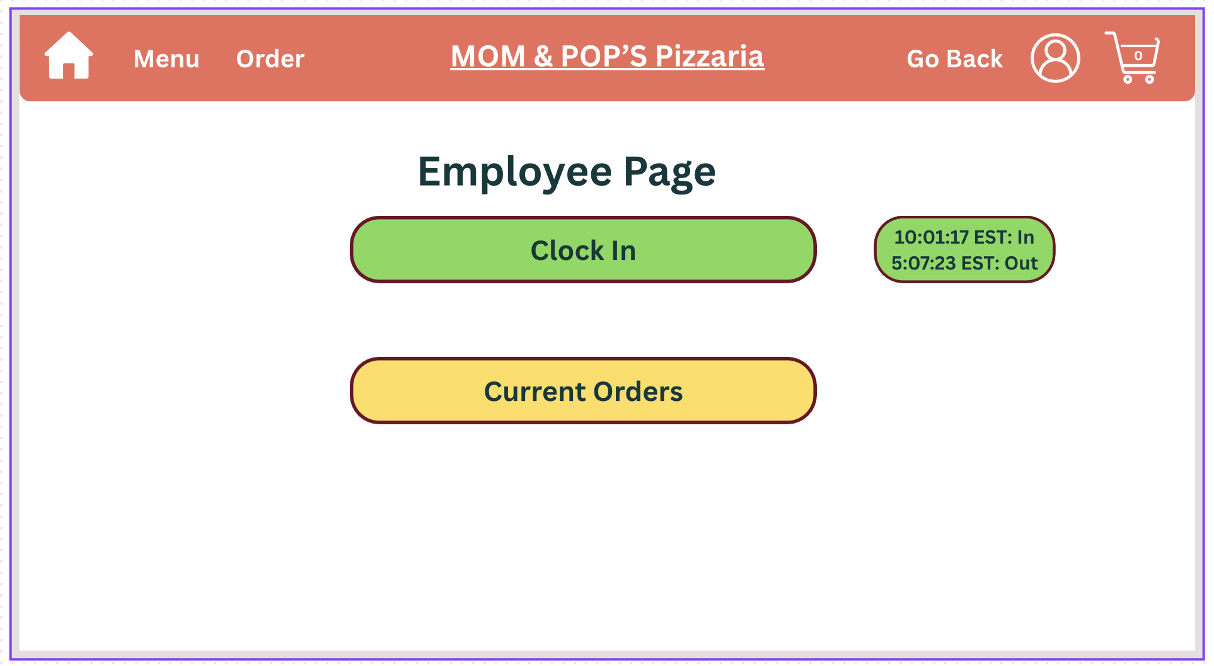
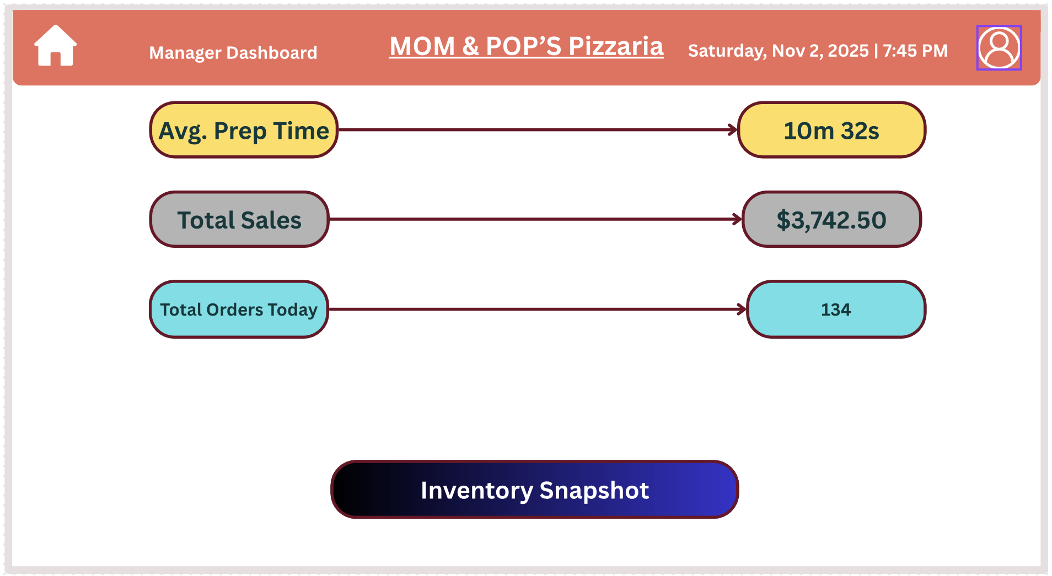
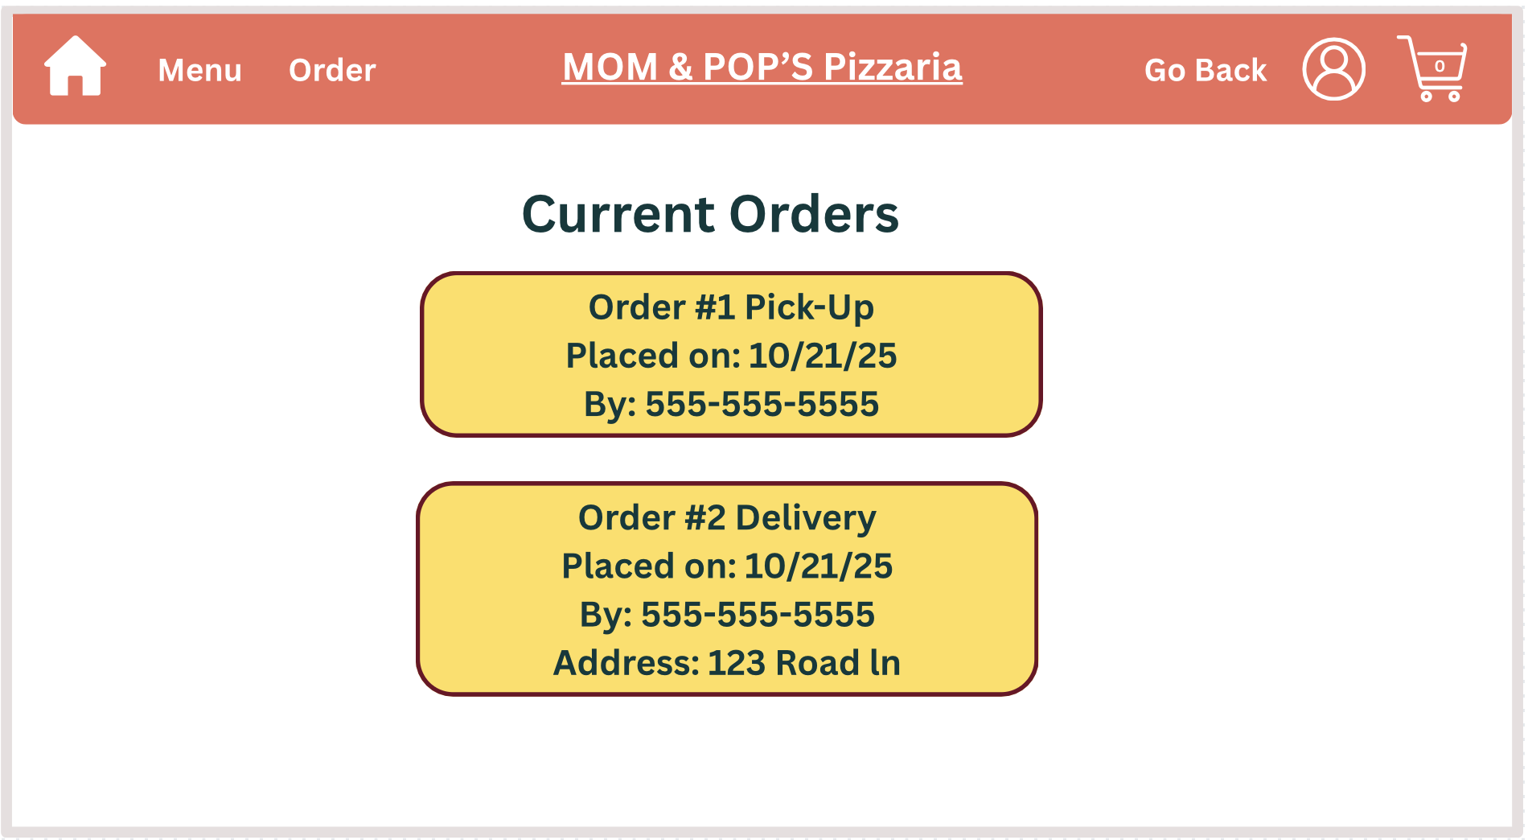
stating that their sign up was complete, then redirects them back to the homepage (Figure 8). Employees have additional features that customers cannot view, meaning they are able to do and view everything that a customer can. As seen in Figure 9, employees are able to clock in and clock out through the website after logging in, and they can view the current orders the restaurant is receiving. When an employee clocks in or out, they are able to see the exact time that they did so (Figures 9.1 and 9.2). Selecting the “Current Orders” option, they can see how the food is being picked up, when it was placed, and the phone number connected to the order. If the order is being delivered, employees will be allowed to see the address which the food must be delivered to as well as all the other information stated above (Figure 9.3). The manager page has the same features as the employees and customers. The additional feature for managers include the total orders placed, total sales, the average prep time, all active employees, and the employee management section (Figure 10). As shown in Figure 10.1, managers are given an exact time stamp for the average prep time, the amount of money made from all sales, as well as the exact number of orders placed. The active employees page provides the manager with the names, role, shift schedule, status, and the time of which employees clock in and out (Figure 10.2). The employee management section allows for the manager to edit an employees information, as well as remove them from the system (Figure 10.3). Managers are also able to view and edit the inventory of the restaurant, which allows the system to convey to the customers which items are out of stock automatically by checking what is in the inventory (Figure 10.4). 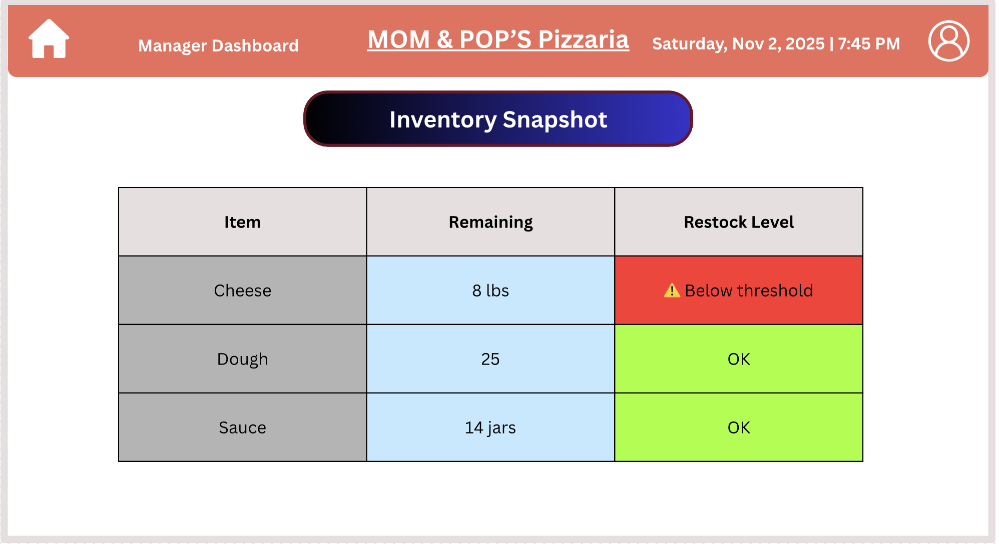
Figure 10.4: Inventory page
Figure 9.1: Employee clock out
Figure 10.2: Active employees page
Figure 9: Employee Page
Figure 10.3: Employee management page
Figure 8: Success message for sign up
Figure 10: Manager oage
Figure 9.2: Employee clock in
Figure 10.1: Manager view of sales, orders, and prep time
Figure 9.3: Employee view current orders page

Technical Design
Class Diagrams

3.a Detailed Class Diagram Overview
Our class diagram defines the core business logic of Mom and Pop’s Pizzeria System. It models customers, employees, managers, menu items, orders, and inventory management, reflecting how data and behavior flow through the system.
All attributes are marked with - (private) and operations with + (public) following UML conventions of encapsulation and controlled access UML-SWE-Project.
At a high level:
- Customer represents a user who can register, log in, and place orders.
- Employee represents a worker who can clock in/out and manage orders.
- Manager extends employee capabilities with inventory and sales management.
- MenuItem, Pizza, and Beverage model products offered on the menu.
- Order and OrderItem handle all ordering transactions.
- Inventory manages stock levels for ingredients.
- EmployeeLog tracks clock-in and clock-out times for payroll.
Relationships are represented as:
- A Customer places multiple Orders (1 → 0..*).
- An Employee handles multiple Orders (1 → 0..*).
- Each Employee logs multiple EmployeeLog records (1 → 1..*).
- Each Order contains multiple OrderItem objects (1 → 1..*).
- Each OrderItem uses multiple Inventory items (1 → 1..*).
- A Manager manages multiple Inventory items (1 → 1..*).

3.b Supporting Text Specification

Customer
Purpose:
Represents a registered user of the system who can log in, place new orders, and view past ones.
Attributes (private):
- customerID: int – unique ID for each customer.
- username: String – customer’s login username.
- passwordHash: String – hashed password for security.
Operations (public):
- login(user, pass): boolean – verifies credentials and returns true if valid.
- placeOrder(): Order – creates and submits a new order for the logged-in user.
- viewOrderHistory(): List<Order> – retrieves all previous orders placed by the customer.

Employee
Purpose:
Represents any restaurant employee (cashier, cook, driver) who interacts with orders and time tracking.
Attributes (private):
- employeeID: int – unique employee identifier.
- role: String – defines the employee’s position or duties.
Operations (public):
- clockIn(): void – logs the start of an employee’s shift.
- clockOut(): void – logs the end of an employee’s shift.
- viewCurrentOrders(): List<Order> – displays all current assigned orders.

Manager
Purpose:
Represents a manager with elevated permissions to oversee inventory and sales.
Operations (public):
- viewSalesReport(): Report – generates a report summarizing sales data.
- updateStock(item: Inventory, qty: int): void – updates or adjusts inventory quantities.

MenuItem
Purpose:
A generic representation of any menu item available for purchase.
Attributes (private):
- name: String – name of the menu item.
- basePrice: Money – item’s base cost before customization.
Operations (public):
- getPrice(): Money – returns the total cost of the menu item.

Pizza
Purpose:
Represents a pizza configuration selected by the customer.
Attributes (private):
- size: PizzaSize – enumerated pizza size (Small, Medium, Large).
- crust: CrustType – type of crust chosen.
- sauce: SauceType – sauce type (e.g., marinara, alfredo).

Beverage
Purpose:
Represents a drink item in the menu.
Attributes (private):
- volume: int – the beverage’s volume in milliliters or ounces.

Order
Purpose:
Represents an entire customer order including items, total, and order status.
Attributes (private):
- orderID: int – unique order identifier.
- status: String – order’s current status (Pending, Preparing, Delivered).
- totalPrice: Money – total order price.
Operations (public):
- addItem(item: OrderItem): void – adds an item to the order.
- calculateTotal(): Money – calculates total price of all order items.
- updateStatus(newStatus: String): void – changes the order’s workflow state.

OrderItem
Purpose:
Represents a single line item within an order, with quantity and subtotal.
Attributes (private):
- quantity: int – number of units ordered.
- subtotal: Money – cost for this item (quantity × price).
Operations (public):
- calculateSubtotal(): Money – computes subtotal for the item.
- addCustomization(item: Inventory): void – adds a customization like extra toppings.

Inventory
Purpose:
Tracks ingredient availability and associated costs for add-ons or toppings.
Attributes (private):
- ingredientID: int – unique ingredient identifier.
- ingredientName: String – name of the ingredient.
- currentStock: int – number of units currently available.
- extraCost: Money – additional cost when used as an extra topping.
Operations (public):
- isItemInStock(): boolean – returns true if item is in stock.
- reduceStock(amount: int): void – deducts a quantity after an order.

EmployeeLog
Purpose:
Stores records of employee work sessions for attendance and payroll tracking.
Attributes (private):
- logID: int – unique log entry ID.
- clockInTime: DateTime – time employee clocked in.
- clockOutTime: DateTime – time employee clocked out.

Associations and Multiplicities
- Customer → Order: One customer can place many orders (1 → 0..*).
- Employee → Order: One employee can handle many orders (1 → 0..*).
- Employee → EmployeeLog: Each employee has multiple log records (1 → 1..*).
- Order → OrderItem: Each order includes one or more items (1 → 1..*).
- OrderItem → Inventory: Each order item uses one or more ingredients (1 → 1..*).
- Manager → Inventory: Each manager oversees multiple inventory items (1 → 1..*).

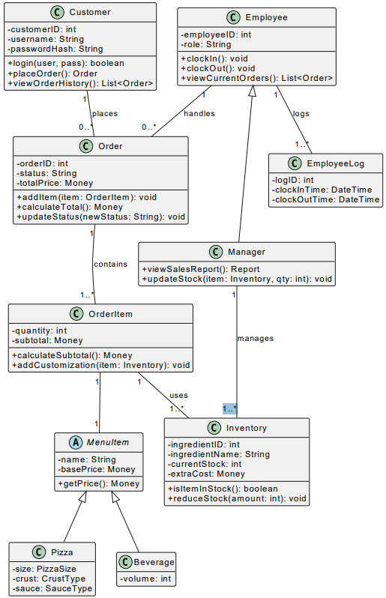

Supporting Text Specifications

Type here

Database Table Descriptions

Customers Table
Description for Customers Table 2
The Customers table stores all information for registered users who place orders. This table is functionally used during Login (FR-001) and Account Creation (FR-002). Its data is read to populate the delivery address during Order Placement (FR-008) and to identify the customer on Sales Reports and Receipts. The Customer_ID is the primary key and links to the Orders table.
Attributes | Data type | Attribute type | Dependency (PK/FK) | Description
Customer_ID | INT | Simple | Primary Key (PK) | Unique identifier for the customer.
Username | VARCHAR(50) | Simple | - | Customer's unique username for login³³.
Password_Hash | VARCHAR(255) | Simple | - | Hashed password for secure login⁴⁴⁴.
First_Name | VARCHAR(100) | Simple | - | Customer's first name⁵.
Last_Name | VARCHAR(100) | Simple | - | Customer's last name⁶.
Phone_Number | VARCHAR(15) | Simple | - | Customer's contact phone number.
Address | VARCHAR(255) | Simple | - | Full street address for delivery ⁷.
Email | VARCHAR(100) | Simple | - | Customer's email address⁸.

Employees Table
Description for Employees Table
The Employees table stores login and role information for all staff. This table is functionally used for Login (FR-001) and to differentiate between user types. The Role attribute is critical, as it controls UI access for the Employee Dashboard (FR-009) and Manager Dashboard (FR-010). Managers are simply employees with a 'Manager' role.
Attributes | Data type | Attribute type | Dependency (PK/FK) | Description
Employee_ID | INT | Simple | Primary Key (PK) | Unique identifier for the employee⁹.
Username | VARCHAR(50) | Simple | - | Employee's unique username for login.
Password_Hash | VARCHAR(255) | Simple | - | Hashed password for secure login¹⁰.
First_Name | VARCHAR(100) | Simple | - | Employee's first name¹¹.
Last_Name | VARCHAR(100) | Simple | - | Employee's last name.
Role | VARCHAR(20) | Simple | - | 'Employee' or 'Manager'. Controls permissions.

Orders Table
Description for Orders Table
The Orders table is the header record for every transaction. It is the primary source for the Food Queue Report, which displays Order_Type, Order_Date (as 'Time In'), and Status. It is also used to generate Sales Reports and Receipts. It links to Customers to know who placed the order and to OrderItems to get the list of items.
Attributes | Data type | Attribute type | Dependency (PK/FK) | Description
Order_ID | INT | Simple | Primary Key (PK) | Unique identifier for the order¹².
Customer_ID | INT | Simple | Foreign Key (FK) | Links to Customers.Customer_ID.
Employee_ID | INT | Simple | Foreign Key (FK) | Links to Employees.Employee_ID (who took the order).
Order_Date | DATETIME | Simple | - | Timestamp of when order was placed¹³. (Used for Food Queue).
Order_Type | VARCHAR(10) | Simple | - | 'Delivery' or 'Pickup' (Used for Food Queue).
Total_Price | DECIMAL(6,2) | Simple | - | Final calculated price (for Receipts/Sales Reports).
Status | VARCHAR(20) | Simple | - | 'Pending', 'Preparing', 'Ready', 'Completed' (Used for Food Queue).

MenuItems Table
Description for MenuItems Table
The MenuItems table stores the definition of all sellable products listed on the menu (FR-004), such as a "Specialty Pizza," "Coke," or "Lava Cake" 14. This table provides the Item_Name and Base_Price for the Customer Receipt. When an item is a "base" for customization (like a pizza), it's linked to OrderItems.
Attributes | Data type | Attribute type | Dependency (PK/FK) | Description
Item_ID | INT | Simple | Primary Key (PK) | Unique identifier for the menu item¹⁵.
Item_Name | VARCHAR(100) | Simple | - | Name of the item (e.g., 'Specialty Pizza', 'Coke')¹⁶.
Description | TEXT | Simple | - | Description shown on the menu.
Base_Price | DECIMAL(5,2) | Simple | - | Starting price of the item¹⁷.
Category | VARCHAR(20) | Simple | - | 'Pizza', 'Drink', 'Dessert', 'Side' ¹⁸.

Inventory Table
Description for Inventory Table
The Inventory table is the master list for all ingredients and sellable units (like beverages). It is the only source for the Inventory Report. It is functionally critical, as it's checked during Pizza Customization (FR-005) and Drink Selection (FR-006) to validate stock. The Manager can edit the Current_Stock field (FR-011).
Attributes | Data type | Attribute type | Dependency (PK/FK) | Description
Ingredient_ID | INT | Simple | Primary Key (PK) | Unique identifier for the ingredient/item.
Ingredient_Name | VARCHAR(100) | Simple | - | 'Pepperoni', 'Pan Crust', 'Coke (20oz bottle)'.
Current_Stock | INT | Simple | - | The quantity on hand (for Inventory Report).
Unit_Type | VARCHAR(20) | Simple | - | 'oz', 'slices', 'bottles', 'units' (for Inventory Report).
Extra_Cost | DECIMAL(4,2) | Simple | - | Added cost if this is an "extra" (e.g., topping).

OrderItems Table
Description for OrderItems Table
The OrderItems table is an associative entity that links an Order to a MenuItem. Each row represents one line item on the Customer Receipt (e.g., "1x Large Pizza", "2x Coke"). It stores the quantity and subtotal for that specific line. If the item is a pizza, this table's PK is used as a foreign key in OrderItemCustomizations.
Attributes | Data type | Attribute type | Dependency (PK/FK) | Description
OrderItem_ID | INT | Simple | Primary Key (PK) | Unique identifier for this line item.
Order_ID | INT | Simple | Foreign Key (FK) | Links to Orders.Order_ID¹⁹.
Item_ID | INT | Simple | Foreign Key (FK) | Links to MenuItems.Item_ID.
Quantity | INT | Simple | - | How many of this item were ordered²⁰.
Subtotal | DECIMAL(6,2) | Simple | - | The price for this line (Base Price * Qty)²¹.

OrderItemCustomizations Table
Description for OrderItemCustomizations Table
The OrderItemCustomizations table stores the specific ingredients selected for a customizable item. When a user adds toppings to a pizza, each topping is a new row in this table, linking the OrderItem (the pizza) to the Inventory item (the topping). This is how the Kitchen Order Slip knows the exact details for a custom pizza.
Attributes | Data type | Attribute type | Dependency (PK/FK) | Description
Custom_ID | INT | Simple | Primary Key (PK) | Unique identifier for this customization.
OrderItem_ID | INT | Simple | Foreign Key (FK) | Links to OrderItems.OrderItem_ID (the specific pizza).
Ingredient_ID | INT | Simple | Foreign Key (FK) | Links to Inventory.Ingredient_ID (the topping/crust) ²².
Type | VARCHAR(20) | Simple | - | 'Topping', 'Crust', 'Sauce'.

EmployeeLog Table
Description for EmployeeLog Table
The EmployeeLog table (named TimeCard in your ERD 23) stores a record of all employee clock-ins and clock-outs. This table is written to by the Employee Dashboard (FR-009) and read by the Manager Dashboard (FR-010) to view employee hours.
Attributes | Data type | Attribute type | Dependency (PK/FK) | Description
Log_ID | INT | Simple | Primary Key (PK) | Unique identifier for the log entry.
Employee_ID | INT | Simple | Foreign Key (FK) | Links to Employees.Employee_ID.
Clock_In_Time | DATETIME | Simple | - | Timestamp when employee clocked in.
Clock_Out_Time | DATETIME | Simple | - | Timestamp when employee clocked out (NULL if still clocked in).

Technical Support Specifications

Training Approach:
Our training approach will be hands-on and role-specific. We will conduct one 90-minute on-site training session for the staff.
- Managers (15 mins): We will train the manager on their specific dashboard, focusing on:
  - Viewing sales reports.
  - Updating the inventory.
  - Managing employee clock-in records.
- Employees (45 mins): We will train all employees (including the manager) on the operational flow:
  - How to clock in and clock out.
  - How to view the Food queue.
  - (If applicable) How to use the "Food Queue" screen.
  - How to create a new order in the system.
- Q&A (30 mins): In case employees or managers have any additional questions, the last 30 minutes will be dedicated to Q&A
Training Materials:
We will provide one concise "Quick Start Guide" (QSG) as a 2-page PDF. This digital document will be emailed to the manager and will include:
- Page 1 (Employees): A clear, visual guide on (1) Clocking In, (2) Viewing Orders, and (3) Updating Order Status.
- Page 2 (Manager): A simple guide on (1) Accessing Reports and (2) Updating Inventory.
- Employees will be emailed page one, while Managers will be emailed page one and two.
- This QSG will also include our support email for any questions.
Installation Support:
The final system is web-based, so no on-site installation is required. We will provide "Mom & Pop's" with the secure URL to access the system.

On-site or Remote Assistance and Troubleshooting:
Assistance will be provided remotely to ensure quick response times.
- Remote Assistance: We will provide email-based support with a 24-hour response time (Mon-Fri) for any questions or issues.
- Troubleshooting: The primary method for troubleshooting is via our support email. We will ask for screenshots of any errors to help us diagnose the problem faster.
- On-site Assistance: On-site assistance will be reserved for emergency, system-down issues.

Updates:

Our approach to long-term support is focused on reliability and clear communication.We provide a 2-week notice for all scheduled updates, which are performed after business hours. On update days, we offer 24-hour support to resolve any issues that may occur.

Support:
Given the nature of the restaurant/QSR industry, 9-to-5 help desk support might not be the most effective; we want to ensure the system stays online during dinner rush hours, when it’s most critical.

Standard Support (Non-Urgent)
This is for general questions, training, or minor bug reports.
- Channel: Email
- Hours: 9:00 AM – 5:00 PM, Monday – Friday
- Response Time: 24-hour response

Critical Support (System Down)
This is for emergencies only (e.g., "The order system is down," "No one can clock in").
- Channel: Dedicated Phone/Text Line
- Hours: 5:00 PM – 9:00 PM, Daily (Mon-Sun)
- Response Time: Immediate

