MOM & POP’S Pizzaria’s Pizza System by Stack UnderFlow
Project Plan
Scope pg 1
Schedule pg 4
Team Organization pg 4 Team Roles: pg 4
Resumes: pg 5
Technical Description pg 12
Data Management Plan pg 15
Test Plan pg 16

Scope
- Project Framework:
  - Creation of GitHub Repository
  - Creating Developer Branches
  - Project File Organization

- Login:
  - Username
  - Password
  - Error message
  - Success message

- Homepage
  - Delivery Icon
  - Pick-up Icon
  - Cart Icon
  - Menu Icon
  - Order Icon
  - Sign In Icon

- Menupage
  - Specialty Pizza Icon
    - Selection of Specialty Pizza
      - Specialty Pizza Page
      - Crust Customization
      - Topping Customization
      - Sizes
      - Sauces
      - Quantity
      - Error Messages for Out-of-Stock Item
      - Add to Cart
      - If Not Signed in, Prompt to sign in
  - Pizza Icon
    - Pizza Page
      - Crust Customization
      - Topping Customization
      - Sizes
      - Sauces
      - Quantity
      - Cheeses
      - Error Messages for Out-of-Stock Item
      - Add to Cart
      - If Not Signed in, Prompt to sign in
  - Drink Icon
    - Drink Page
      - Selection of Drinks
      - Quantity
      - Size
      - Error Messages for Out-of-Stock Item
      - Add to Cart
      - If Not Signed in, Prompt to sign in

- Ordering
  - Delivery or Carryout Prompt
  - If Delivery, Confirming Address
  - If Not Signed in, Prompt to sign in
  - Reroute to Menu

- Employee Page
  - Order Page (Employee to create an order)
    - Viewing Current customer orders
    - Order Input
    - Delivery Status
    - Receipt Page
  - Clockin/Clockout

- Manager Page
  - Inventory Page
    - Inventory Database
    - Edit Inventory
  - Receipt Page
  - Sales Page

- Database Creation
  - Creation of database
  - Creation of tables
  - Primary key and foreign key key relationships
  - API to front end

Schedule
Link to Schedule

Gantt Chart:

Link to Gantt Chart

Team Organization

Team Roles:
- Project Manager: Jake Cashion – oversees timeline, ensures tasks are completed on time.

- Front-End Development Team: Khason Murphys and Amaya Cruz – handle the user interface, including the login screen, homepage icons, menu navigation, and ensure the project is responsive and accessible

- Back-End Development Team: Arad Nasre Azadani – responsible for server logic, database design, and integration with the front-end

- Full Stack Developer: Jake Cashion – works across both front-end and back-end tasks, bridging both teams and ensuring smooth integration, resolving compatibility issues, and assisting where workload is highest.

Resumes
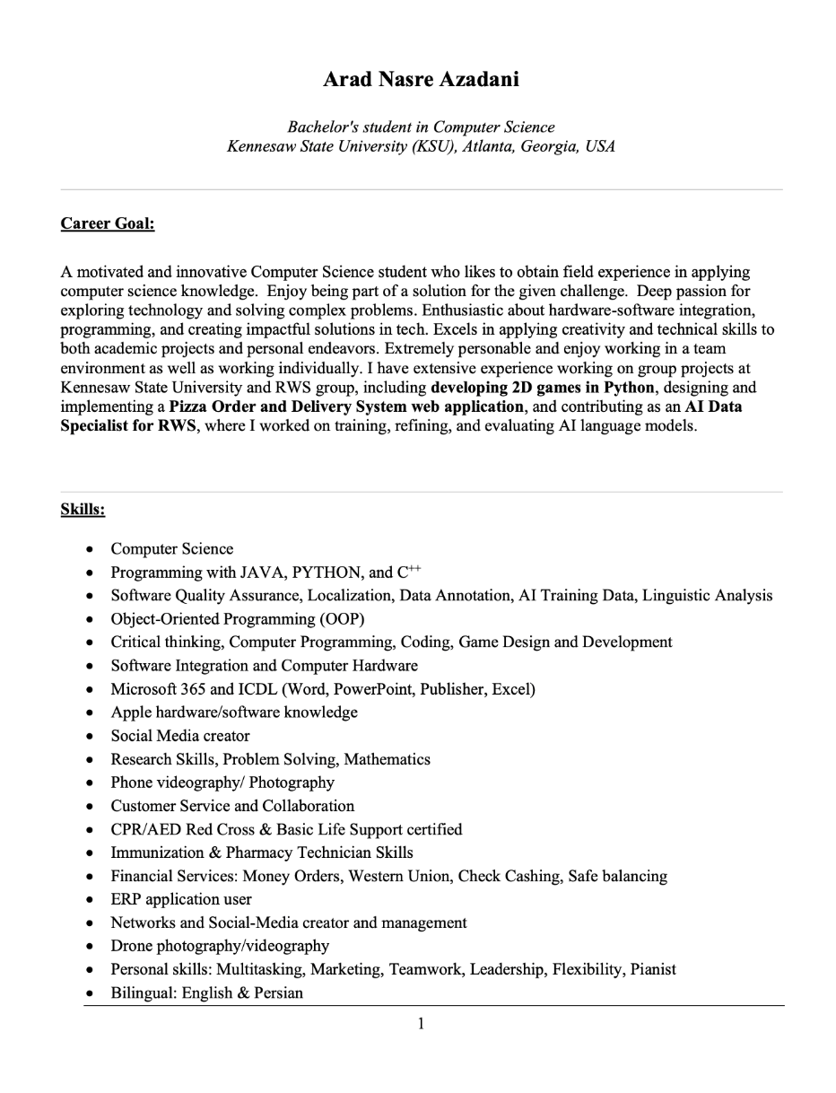
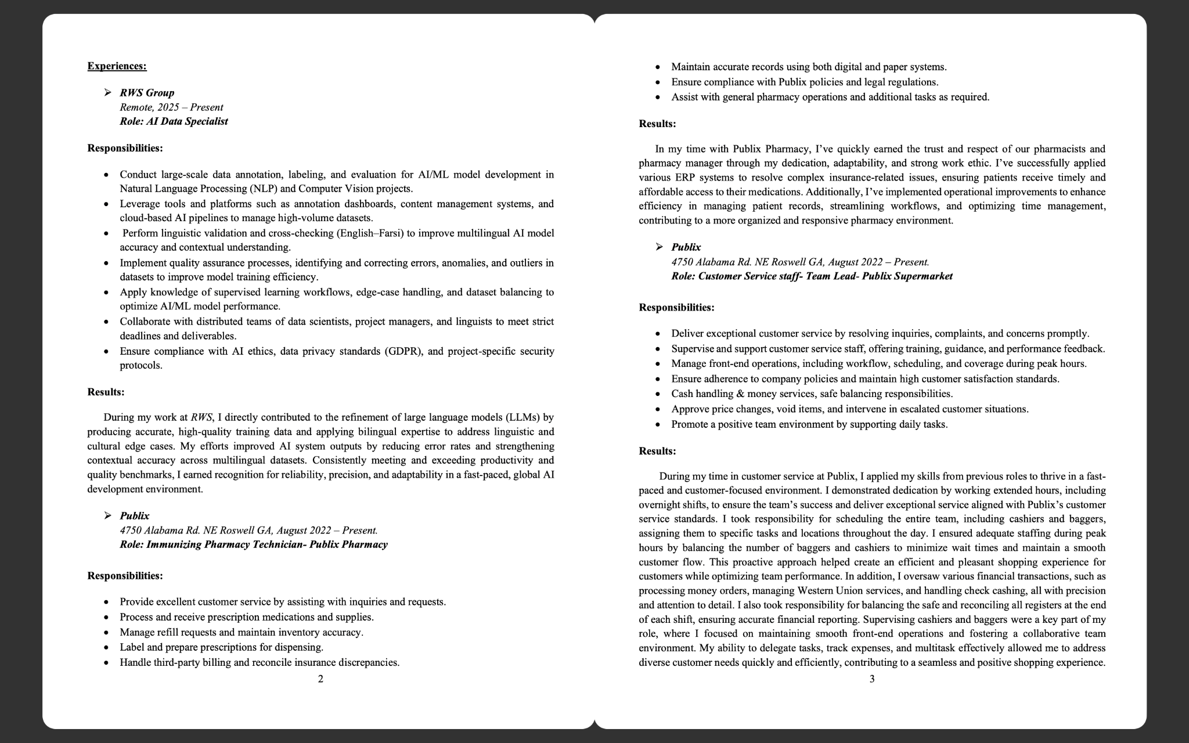
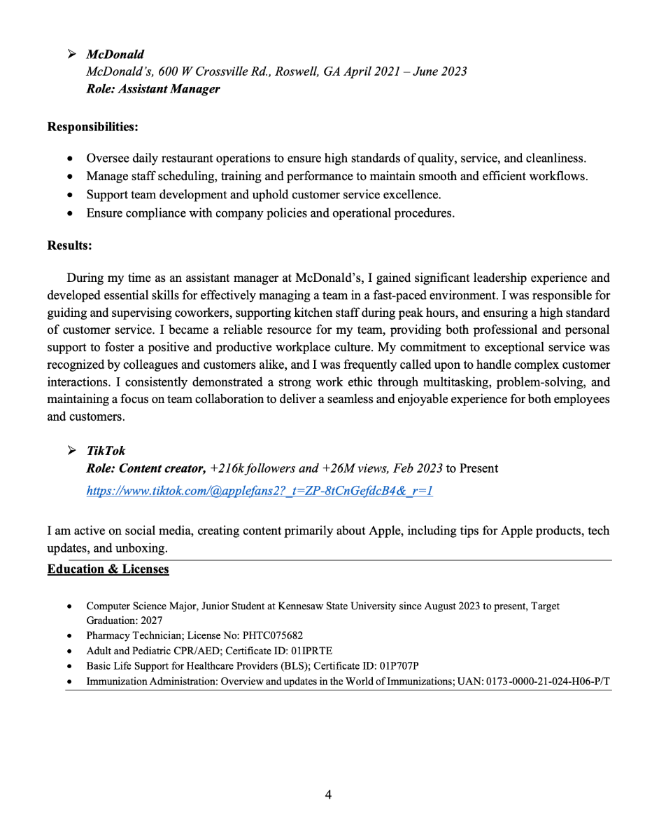

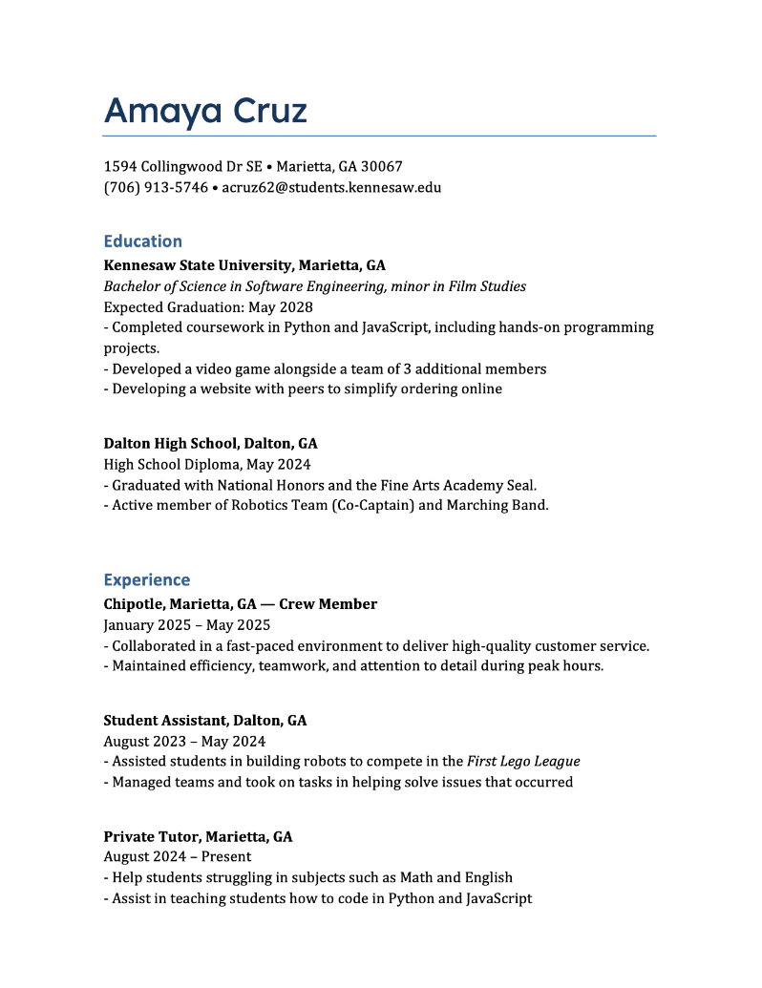
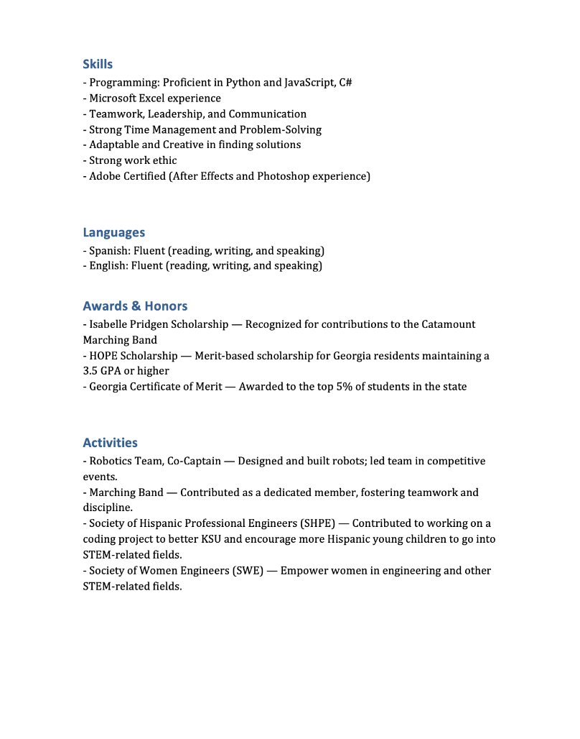
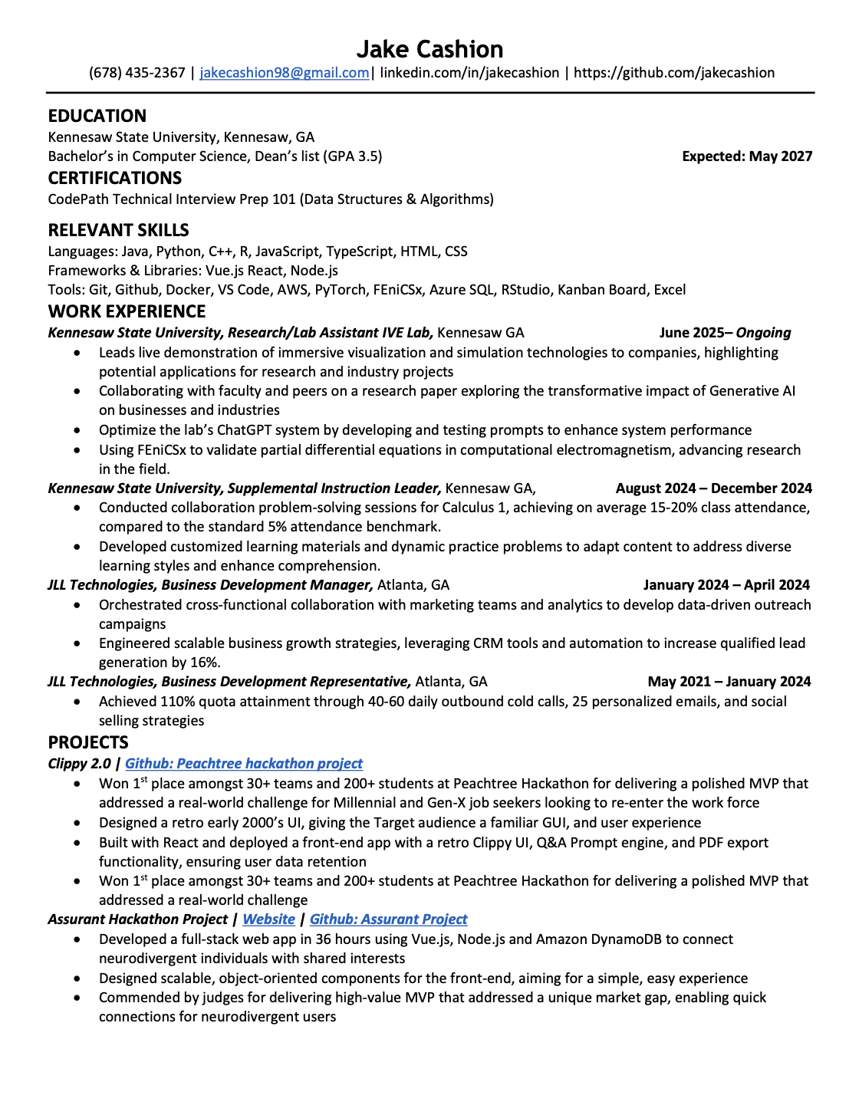

Technical Description
The projected user interface (UI) for this project is designed to balance simplicity, functionality, and scalability. Customers, employees, and managers will each have access to tailored screens based on their roles, but the interface will maintain consistency in style and navigation throughout the website. The overall goal of the UI is to provide a clear, intuitive ordering process for customers while also ensuring that employees and managers have the necessary tools to support operations efficiently.

When a user opens the website, they will be greeted with a homepage that will serve as a navigational tool across the website. There will be six icons that will open separate pages of the website, those being: delivery, pick-up, cart, menu, order history, and sign-in. The icons will be presented visually along with labels. Allowing both first-time users and returning customers to quickly understand the purpose of each icon.

The login page will serve as the entry point for returning users, employees, and managers. Users will have to enter two main areas of input, one for their username and another for their password. The password will be masked to protect users’ information. There will be a clear error message when credentials are used or when there is no information in the database that matches. There will also be a confirmation message when the user is successfully logged in. At the bottom of the two input areas will be an option that will allow new users to sign up and create their username and password. New users will be prompted to create an account before placing an order.

The login page enables users to securely store their information or sign up and place orders through the website. The website will contain a menu page, listing all the different items the restaurant has, along with individual prices. Customers will log in to access ordering features, while employees and managers use the same page but are redirected to their respective dashboards once authenticated.

Additionally, the website will feature an employee page. Employees will be able to log in and edit their personal information. They will also be able to clock in/out, view all orders placed by customers, and view the receipts of every order. Employees will also be able to see if a customer has already paid or will pay when they pick up their order. Employees will also be able to view everything a customer can, which includes the homepage and menu. Employees will not be able to input any information about a customer and will not have access to any passwords or information regarding customers.

Managers will be able to log in, view, and change inventory, see all receipts, total sales, and all the employees' information. This separation of responsibilities ensures that managers can oversee both customer service and employee performance while maintaining security boundaries. However, managers will not be able to see the customer’s payment method.

The menu page is central to the customer experience and contains multiple categories of items with clear customization and ordering options. The menu will display all items available at the restaurant along with the prices of each item. There will be three icons within the menu page, which include a specialty pizza section, a custom pizza section, and a drink section.

Within the specialty pizza section, users will be able to switch to a specialty pizza page where they can customize the crust, toppings, size, and sauce of the pizza they chose. Users will then be prompted to select the quantity of the item. If the item the user orders is out of stock, a clear error message will appear to tell the user the item cannot be ordered. If the item is in stock, a clear message saying the item was added to the user's cart will appear. Before adding an item to the order, if the user is not signed in, they will be prompted to do so.

Similar to the specialty pizza section, the custom pizza section will let the user have complete control over the crust, toppings, sizes, sauces, cheeses, and quantity. There will also be an add to cart feature that requires the user to be signed in.

The drinks section will display all drink types, sizes, and quantities of the items. There will also be an out-of-stock error message that appears if a user tries to order an unavailable item. Users will be prompted to sign in to add items to their cart.

Once a user has filled their cart, the ordering screen guides them through the process. Users will have the option to have items delivered or pick up at the restaurant. If users select delivery, then the system will confirm the address on file, allowing for updates to be made. Non-signed-in users will be prompted to sign in before proceeding. If there are no items in the cart, users will be redirected to the menu page. This structure ensures that customers can efficiently complete orders while minimizing errors.

All customer, employee, and manager interactions are tied to a secure database. Orders, receipts, login information, and inventory are stored in a way that supports role-based permissions. Passwords are encrypted and never viewable by employees or managers.

Some hardware requirements are that the website is compatible with mobile and desktop devices. Therefore, the website requires at least 1280x720 resolution. Servers must provide secure storage for user data and support for any communication needed. Some software requirements are to make sure the website works across all modern browsers, such as Chrome, Firefox, and Safari. Backend will use a secure framework (Node.js or SSMS) and a relational database (SQL). Frontend will use responsive design frameworks.

Some development restrictions are that the website must comply with security standards for storing users' personal information. We must also ensure that every cosmetic feature, such as animations and graphics, is not over budget.

To code and design the website effectively, some methods used are designing the website centered around users, making the website highly accessible. Wireframing and prototyping will ensure that the website has no errors within the code. The website’s design will also be optimized for desktop, tablet, and mobile interfaces. Passwords will be secured by password hashing and role-based controls.

The projected UI ensures that every user can navigate throughout the website easily. Customers will benefit from clear ordering and customization processes. Employees and managers will have access to role-specific tools to provide a great customer experience, allowing the restaurant to operate smoothly. With careful attention to hardware/software requirements, accessibility, and secure coding practices, the system is designed to be reliable, scalable, and user-friendly.

Data Management Plan
There will be three distinct roles in the system. Each with different levels of access and different information. Customer, employee, and manager.
A Customer’s information includes:
- Phone number
- Address
- Subdivision name
- Closest intersection
- Payment history
- Amounts due
- List of items ordered
- Delivery or Pickup
This will be organized into tables for easier visualization. Customers can view all their personal information and change all personal information, but cannot edit amounts due, order items.
An Employee’s information includes:
- Clocking in and Clocking out
An Employee has access to current customer orders, can create, and change customers’ orders.
A manager’s information includes:
- Viewing a complete list of receipts
- Viewing Employee information
  - Including clock-in, clock-out times
- Viewing customer information
  - Cannot access or view payment information
Managers have access to customers and employees, excluding access to customers’ payment information.

Test Plan

Task ID | Deliverable / Task | Start Date | Finish Date | Planned Workload | Assigned To | Progress (%)
1 | Project Plan | 09/16/2025 | 09/18/2025 | 3h | Arad | 100%
2 | Requirements Definition | 09/28/2025 | 10/06/2025 | 15h | Analyst | 0%
2.1 | Functional Requirements | 09/28/2025 | 10/01/2025 | 8h | Analyst | 0%
2.2 | Non-Functional Requirements | 10/02/2025 | 10/06/2025 | 7h | Analyst | 0%
3 | Requirements Specification | 10/07/2025 | 10/17/2025 | 20h | UML Specialist | 0%
3.1 | Use Case Diagram | 10/07/2025 | 10/09/2025 | 5h | UML Specialist | 0%
3.2 | Use Case Flow | 10/10/2025 | 10/13/2025 | 7h | Analyst | 0%
3.3 | Class Diagrams | 10/14/2025 | 10/17/2025 | 8h | Developer | 0%
4 | System Design | 10/18/2025 | 10/28/2025 | 25h | Dev Team | 0%
4.1 | Conceptual Design (reports, screens) | 10/18/2025 | 10/22/2025 | 12h | UI Specialist | 0%
4.2 | Technical Design (database, classes) | 10/23/2025 | 10/28/2025 | 13h | Dev Team | 0%
5 | Implementation Sprint 1 | 10/29/2025 | 11/08/2025 | 40h | Dev Team | 0%
6 | Implementation Sprint 2 | 11/09/2025 | 11/20/2025 | 40h | Dev Team | 0%
7 | Testing & QA | 11/21/2025 | 11/27/2025 | 20h | QA Lead | 0%
8 | Final Notebook & Video Presentation | 11/28/2025 | 12/01/2025 | 15h | Whole Team | 0%

In our project, we intend to utilize multiple forms of testing to ensure we deliver the highest quality program that meets all of our clients’ needs. The tests we intend to use are as follows: Validation test, Verification testing, Unit testing, white box testing, and black box testing.
Before we begin doing any programming, it’s important to be assured we are on the same page as the client. The most effective way to test this is with Validation testing. We want to provide the client with an excellent visual aesthetic. In pursuit of this, we will sketch out the intended layout and design of our website, showing our chosen colors and user interface. Only when we have reached the same page as our client in this aspect can we begin.
To ensure a high quality of the program, we have strict requirements involving unit testing for each developer. We test each function as we write it, and after, we want each piece of the code to work individually before we begin to write functions that are dependent on functions. This practice ensures fewer bugs as we assemble our code base. Our philosophy is that no function should go untested.
Once our system has been well established, we begin the 3rd phase of testing: black and white box testing. These tests are designed to push the internal logic of the system as well as catch any unexpected user inputs. This is an extremely important step in testing as it gives us insight into how users might interact with a system in ways we wouldn’t expect. This is our most exhaustive phase because, in pursuit of quality, we test almost every possible user action to its furthest degree. We can also test the security of our data storage during this. Because we have extremely important customer information, making sure that the databases are secure is a top priority during our testing. Our thorough testing almost eliminates errors in both UI design and internal logic.

