**https://www.geeksforgeeks.org/html-elements/?ref=lbp**

**1.0 What is HTML used for ?**

HTML is used to create the structure of web pages that are displayed on the World Wide Web (www). It contains Tags and Attributes that are used to design the web pages. Also, we can link multiple pages using Hyperlinks.

**HTML Basic Format Page Structure**

The basic structure of an HTML page is laid out below. It contains the essential building-block elements (i.e. doctype declaration, HTML, head, title, and body elements) upon which all web pages are created.

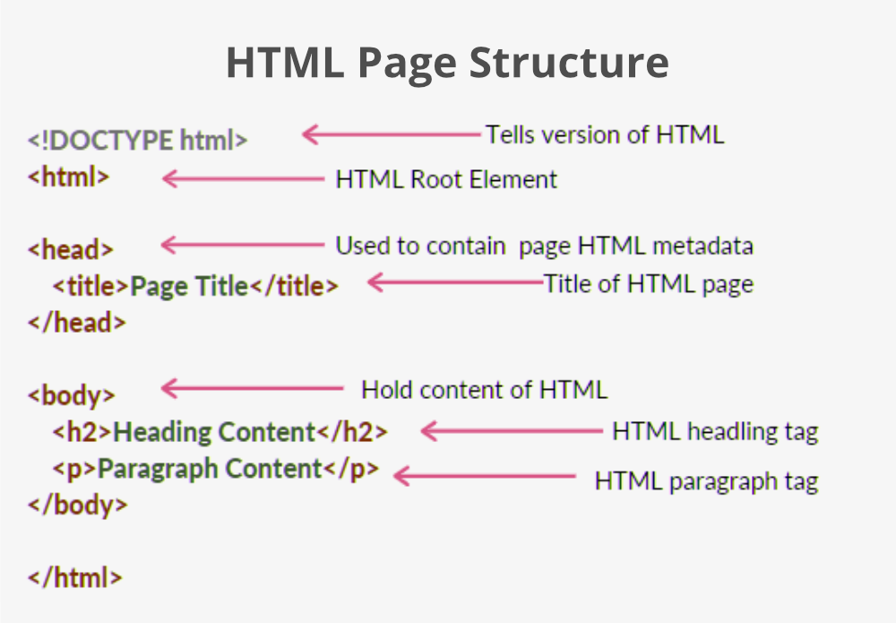

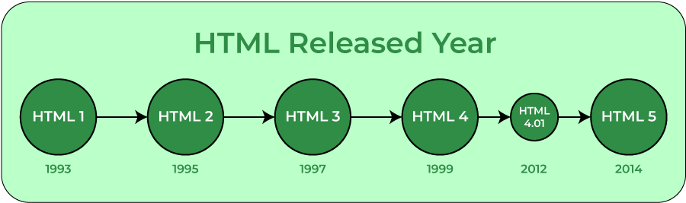

2.**HTML Basics** by understanding all the basic stuff of HTML coding. There are various tags that we must consider and include while starting to code in HTML. These tags help in the organization and basic formatting of elements in our script or web pages. These step-by-step procedures will guide you through the process of writing HTML.

**Basic HTML Document:**Below mentioned are the basic HTML tags that divide the whole document into various parts like head, body, etc.

* Every HTML document begins with a HTML document tag. Although this is not mandatory, it is a good convention to start the document with this below-mentioned tag. Please refer to the [HTML Doctypes](https://www.geeksforgeeks.org/html-doctypes/) article for more information related to Doctypes.

<!DOCTYPE html>

* [**<html>**](https://www.geeksforgeeks.org/html-html-tag/) : Every HTML code must be enclosed between basic HTML tags. It begins with **<html>** and ends with **</html>** tag.
* [**<head>**](https://www.geeksforgeeks.org/html-head-tag/): The head tag comes next which contains all the header information of the web page or documents like the title of the page and other miscellaneous information. This information is enclosed within the head tag which opens with **<head>** and ends with **</head>**. The contents will of this tag will be explained in the later sections of the course.
* [**<title>**](https://www.geeksforgeeks.org/html-title-tag/)**:**We can mention the title of a web page using the **<title>** tag. This is header information and hence is mentioned within the header tags. The tag begins with **<title>** and ends with **</title>.**
* [**<body>**](https://www.geeksforgeeks.org/html-body-tag/)**:**Next step is the most important of all the tags we have learned so far. The body tag contains the actual body of the page which will be visible to all the users. This opens with **<body>** and ends with **</body>**. All content enclosed within this tag will be shown on the web page be it writings or images or audio or videos or even links. We will see later in the section how using various tags we may insert mentioned contents into our web pages.

The whole pattern of the code will look something like the below code example.

**Example:**This example illustrates the **HTML basic** structure.

* HTML

|  |
| --- |
| <**html**>    <**head**>      <!-- Information about the page -->      <!--This is the comment tag-->        <**title**>GeeksforGeeks</**title**>  </**head**>    <**body**>      <!--Contents of the webpage-->  </**body**>    </**html**> |

This code won’t display anything. It just shows the basic pattern of how to write the HTML code and will name the title of the page as *GeeksforGeeks*. <! – – comment here – – > is the comment tag in HTML and it doesn’t read the line present inside this tag.

[**HTML Headings**](https://www.geeksforgeeks.org/html-heading/)**:**These tags help us to give headings to the content of a webpage. These tags are mainly written inside the body tag. HTML provides us with six heading tags from **<h1>** to **<h6>**. Every tag displays the heading in a different style and font size.

Most HTML heading tag that we use :-

* Heading 1
* Heading 2
* Heading 3

**Example**: This example illustrates the use of 6 heading tags from **<h1>** to **<h6>**in HTML.

* HTML

|  |
| --- |
| <**html**>    <**head**>      <**title**>GeeksforGeeks</**title**>  </**head**>    <**body**>      <**h1**>Hello GeeksforGeeks</**h1**>      <**h2**>Hello GeeksforGeeks</**h2**>      <**h3**>Hello GeeksforGeeks</**h3**>      <**h4**>Hello GeeksforGeeks</**h4**>      <**h5**>Hello GeeksforGeeks</**h5**>      <**h6**>Hello GeeksforGeeks</**h6**>  </**body**>    </**html**> |

**Output**:

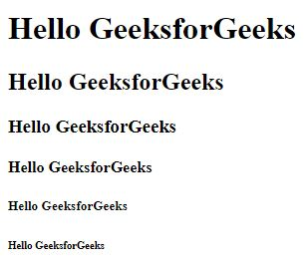

*HTML Headings*

[**HTML Paragraph**](https://www.geeksforgeeks.org/html-paragraph/)**:**These tags help us to write paragraph statements on a webpage. They start with the **<p>** tag and ends with **</p>**.

**HTML Break:** – These tags are used for inserting a single line type break. It does not have any closing tag. In HTML the break tag is written as **<br>.**

**Example**: This example illustrates the use of the <p> tag for writing a paragraph statement in HTML.

* HTML

|  |
| --- |
| <**html**>    <**head**>      <**title**>GeeksforGeeks</**title**>  </**head**>    <**body**>      <**h1**>Hello GeeksforGeeks</**h1**>        <**p**> A Computer Science portal for geeks<**br**>          A Computer Science portal for geeks<**br**>          A Computer Science portal for geeks<**br**>      </**p**>          </**body**>    </**html**> |

**Output**:

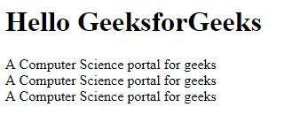

*HTML Paragraph*

**HTML Horizontal Line:**The [<hr> tag](https://www.geeksforgeeks.org/html-hr-tag/) is used to break the page into various parts, creating horizontal margins with help of a horizontal line running from the left to right-hand side of the page. This is also an empty tag and doesn’t take any additional statements.

**Example**: This example illustrates the use of the <hr> tag for the horizontal line in HTML.

* HTML

|  |
| --- |
| <**html**>    <**head**>      <**title**>GeeksforGeeks</**title**>  </**head**>    <**body**>      <**h1**>Hello GeeksforGeeks</**h1**>        <**p**>          A Computer Science portal for geeks<**br**>          A Computer Science portal for geeks<**br**>          A Computer Science portal for geeks<**br**>      </**p**>              <**hr**>        <**p**>          A Computer Science portal for geeks<**br**>          A Computer Science portal for geeks<**br**>          A Computer Science portal for geeks<**br**>      </**p**>              <**hr**>        <**p**>          A Computer Science portal for geeks<**br**>          A Computer Science portal for geeks<**br**>          A Computer Science portal for geeks<**br**>      </**p**>              <**hr**>  </**body**>    </**html**> |

**Output**:

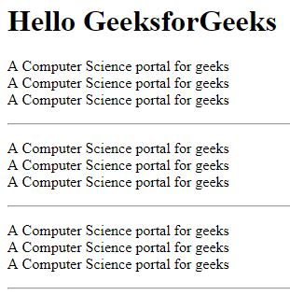

*Adding horizontal line using the <hr> tag*

3.0 [**HTML Images**](https://www.geeksforgeeks.org/html-images/)**:**The image tag is used to insert an image into our web page. The source of the image to be inserted is put inside the **<img src=”*source_of_image*“>** tag.

Image can be inserted in the image tag in two formats: –

* If the image is in the same folder, then we can just write the name of the image and the format as the path.
* If the image is in another folder, then we do need to mention the path of the image and the image name as well as the format of the image.

**Example**: This example illustrates the use of the <img> tag for inserting the images in HTML.

* HTML

|  |
| --- |
| <**html**>    <**head**>      <**title**>GeeksforGeeks</**title**>  </**head**>    <**body**>      <**img** src=  "<https://media.geeksforgeeks.org/wp-content/cdn-uploads/Geek_logi_-low_res.png>">  </**body**>    </**html**> |

**Output**:



*Adding image using <img> tag*

**Supported Browsers:**

* Google Chrome 93.0 & above
* Internet Explorer 11.0
* Microsoft Edge 93.0
* Firefox 92.0 & above
* Opera 79.0
* Safari 14.1

There are also various other tags in HTML to insert links, audios, and various other formatting tags that we will be learning in the later sections.

**4.0 Page layout** is the part of graphic design that deals with the arrangement of visual elements on a page. Page layout is used to make the web pages look better. It establishes the overall appearance, relative importance, and relationships between the graphic elements to achieve a smooth flow of information and eye movement for maximum effectiveness or impact.

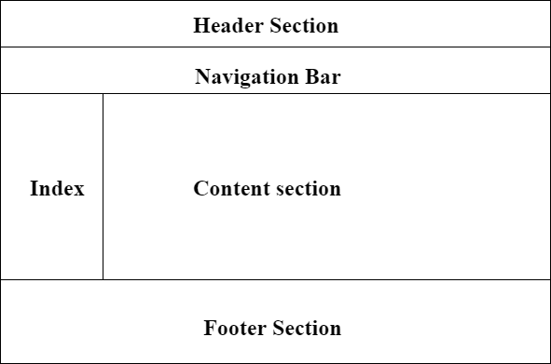

* divs have a special class/id associated with them.

<div class = "header"> ..... </div>

<div class = "section"> ..... </section>

<div class = "footer"> ..... </footer>

**Page Layout Information:**

* **Header:** The part of the front end which is used at the top of the page. <header> tag is used to add a header section on web pages.s

**Syntax:**

<header>

<h1> ----- </h1>

<h2> ----- </h2>

----------------

----------------

</header>

* **Navigation bar:** The navigation bar is the same as the menu list. It is used to display the content information using hyperlinks. <nav> tag is used to add the nav section(nav elements) in web pages.

**Syntax:**

<nav>

<ul>

<li> ..... </li>

<li> ..... </li>

</ul>

</nav>

* **Index / Sidebar:** It holds additional information or advertisements and is not always necessary to be added to the page.
* **Content Section:** The content section is the central part where content is displayed.<main> tag is used to add the main content of the webpages.
* **Footer:** The footer section contains the contact information and other query related to web pages. The footer section is always put on the bottom of the web pages. The <footer> tag sets the footer on web pages.

**Syntax:**

<footer>

.....

</footer>

**Example:** 

* html

|  |
| --- |
| <!DOCTYPE html>  <**html**>  <**head**>      <**title**>Page Layout</**title**>      <**style**>          .head1 {              font-size:40px;              color:#009900;              font-weight:bold;          }          .head2 {              font-size:17px;              margin-left:10px;              margin-bottom:15px;          }          body {              margin: 0 auto;              background-position:center;              background-size: contain;          }            .menu {              position: sticky;              top: 0;              background-color: #009900;              padding:10px 0px 10px 0px;              color:white;              margin: 0 auto;              overflow: hidden;          }          .menu a {              float: left;              color: white;              text-align: center;              padding: 14px 16px;              text-decoration: none;              font-size: 20px;          }          .menu-log {              right: auto;              float: right;          }          footer {              width: 100%;              bottom: 0px;              background-color: #000;              color: #fff;              position: absolute;              padding-top:20px;              padding-bottom:50px;              text-align:center;              font-size:30px;              font-weight:bold;          }          .body_sec {              margin-left:20px;          }      </**style**>  </**head**>    <**body**>        <!-- Header Section -->      <**header**>          <**div** class="head1">GeeksforGeeks</**div**>          <**div** class="head2">A computer science portal for geeks</**div**>      </**header**>        <!-- Menu Navigation Bar -->      <**nav** class="menu">          <**a** href="#home">HOME</**a**>          <**a** href="#news">NEWS</**a**>          <**a** href="#notification">NOTIFICATIONS</**a**>          <**div** class="menu-log">              <**a** href="#login">LOGIN</**a**>          </**div**>        </**nav**>        <!-- Body section -->      <**main** class = "body_sec">          <**section** id="Content">              <**h3**>Content section</**h3**>          </**section**>        </**main**>        <!-- Footer Section -->      <**footer**>Footer Section</**footer**>  </**body**>  </**html**> |

**Output:** 

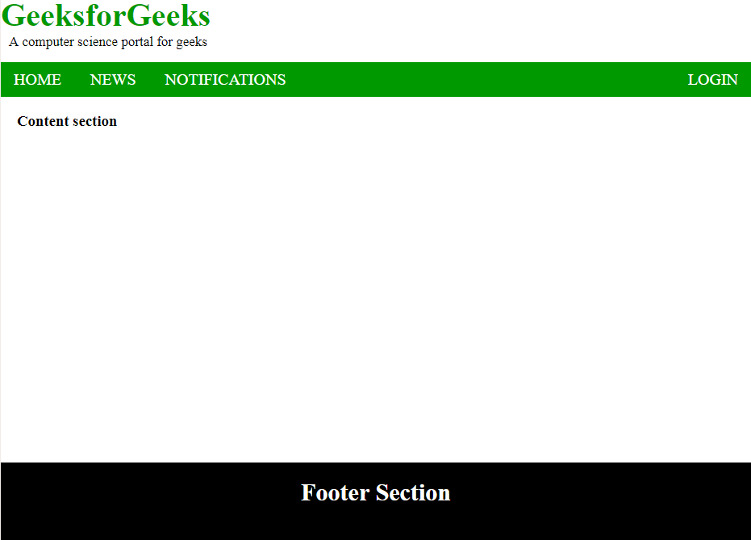

**Supported Browser:**

**5.0** **HTML Elements**, along with understanding the various available elements & their syntax through the examples. An HTML element is the collection of start and end tags with the content inserted in between them.

**Syntax:**

<tagname > Contents... </tagname>

**Supported Tags:**HTML Elements supports almost all [HTML Tags](https://www.geeksforgeeks.org/most-commonly-used-tags-in-html/).

**HTML Element: The HTML element consist of 3 parts.**

i) Opening tag: It is used to tell the browser where the content material starts.

ii)Closing tag: It is used to tell the browser where the content material ends.

iii)Content: It is the actual content material inside the opening and closing tag.

*Combining all these 3 parts results in an overall HTML Element.*

**Example:**

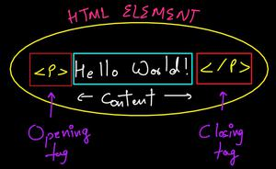

*The entire structure of HTML Element*

**Example 1:**In this example <p> is a starting tag, </p> is an ending tag and it contains some content between the tags, which form an element

* HTML

|  |
| --- |
| <!DOCTYPE html>  <**html**>      <**head**>        <**title**>HTML Elements</**title**>      </**head**>  <**body**>      <**h2**>Welcome To GeeksforGeeks</**h2**>      <**p**>Hi Geeks!</**p**>      </**body**>    </**html**> |

**Output:**



*HTML elements example*

**Example 2:** This example illustrates the use of the HTML paragraph element.

* HTML

|  |
| --- |
| <!-- HTML code to illustrate HTML elements -->  <!DOCTYPE html>  <**html**>  <**head**>      <**title**>HTML Elements</**title**>  </**head**>    <**body**>      <**p**>Welcome to GeeksforGeeks!</**p**>      </**body**>    </**html**> |

**Output:**

Welcome to GeeksforGeeks!

**Nested HTML Elements:** The HTML element is use inside the another HTML Element is called nested HTML elements.

**Example 3:** This example describes the use of the Nested HTML elements. Here, <html> tag contains the [<head>](https://www.geeksforgeeks.org/html-head-tag/#:~:text=The%20tag%20in%20HTML,style%3E%20etc.) and [<body>](https://www.geeksforgeeks.org/html-body-tag/). The <head> and <body> tag contains another elements so it is called nested element.

* HTML

|  |
| --- |
| <!DOCTYPE html>  <**html**>  <**head**>      <**title**>HTML Elements</**title**>  </**head**>    <**body** style="text-align: center">      <**h1**>GeeksforGeeks</**h1**>      <**p**>Computer science portal</**p**>      </**body**>    </**html**> |

**Output:**

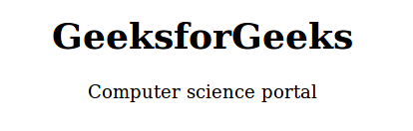

*Nested HTML element*

**Necessary to add end tag:** It is necessary to add the end tag of an element. Otherwise, the displayed content may or may not be displayed correctly. It is a good practice if you add closing tags to the non-void HTML Elements but nowadays browsers are getting more and more advanced and forgiving in nature and that’s why if you somehow forget to apply the closing tag in the non-void Element, the browser will not throw any error but the problem will arise as you insert more and more HTML elements after that.

**Example:**

* HTML

|  |
| --- |
| <!DOCTYPE html>  <**html**>      <**head**>        <**title**>HTML Elements</**title**>      </**head**>  <**body**>      <**h2**>Welcome To GeeksforGeeks</**h2**>      <**p**>Hi Geeks!    </**body**>    </**html**> |

This Image is showing the Browser’s Developer Tools and you can see that the missing closing tag of the paragraph element in the above-written code is automatically added by the browser without showing any error.

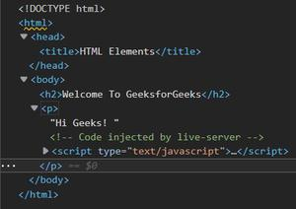

*Developer Tools*

**The Final Output is:**

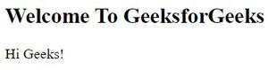

*WebPage*

A web browser is forgiving but it doesn’t mean that you start ignoring the ending/closing tag of the HTML elements. It might show some unexpected behaviour or error in some cases. Like if you have more than one HTML element on your webpage then omitting the closing tag might result in clashing of the boundaries of different HTML elements. The browser won’t know where it ends. It will take the next tag and think it belongs to the previous tag without the closing tag.

*Final Summary of the above text segment: Always put the closing tag to a non-void HTML element.*

**Example 4:** This example describes the HTML element by specifying the end tag.

* HTML

|  |
| --- |
| <!DOCTYPE html>  <**html**>  <**head**>      <**title**>HTML Elements</**title**>  </**head**>    <**body**>      <!-- h1 tag contains the           end tag -->        <**h1**>GeeksforGeeks</**h1**>        <!-- p tag contains the           end tag -->      <**p**>Computer science portal</**p**>      </**body**>  </**html**> |

**Output:**

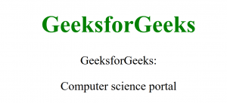

*HTML start & end tag example*

**Empty HTML Elements:**HTML Elements without any content i.e, that do not print anything are called Empty elements. Empty HTML elements do not have an ending tag. For instance. [<br>](https://www.geeksforgeeks.org/html-brgt-tag/), [<hr>](https://www.geeksforgeeks.org/html-hr-tag/), [<link>](https://www.geeksforgeeks.org/html-link-tag/), [<input>](https://www.geeksforgeeks.org/html-input-tag/) etc are HTML elements.

**Example 5:**In this example <br> tag doesn’t print anything. It is used as a line break that breaks the line between <h2> and [<p> tag](https://www.geeksforgeeks.org/html-paragraph/).

* HTML

|  |
| --- |
| <!DOCTYPE html>  <**html**>  <**head**>      <**title**>Empty HTML Elements</**title**>  </**head**>    <**body**>      <**h2**>Welcome To GfG</**h2**>      <**br** />      <**p**>Hello Geeks.</**p**>      </**body**>  </**html**> |

**Output:**

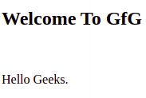

*HTML empty element*

In this article, we will know the **HTML Table**, various ways to implement it, & will also understand its usage through the examples. HTML Table is an arrangement of data in rows and columns, or possibly in a more complex structure. Tables are widely used in communication, research, and data analysis. Tables are useful for various tasks such as presenting text information and numerical data. It can be used to compare two or more items in the tabular form layout. Tables are used to create databases.

**Defining Tables in HTML:**An HTML table is defined with the “table” tag. Each table row is defined with the “tr” tag. A table header is defined with the “th” tag. By default, table headings are bold and centered. A table data/cell is defined with the “td” tag.

**Example 1:**In this example, we are creating a simple table in HTML using a table tag.

* HTML

|  |
| --- |
| <!DOCTYPE html>  <**html**>    <**body**>      <**table**>          <**tr**>              <**th**>Book Name</**th**>              <**th**>Author Name</**th**>              <**th**>Genre</**th**>          </**tr**>          <**tr**>              <**td**>The Book Thief</**td**>              <**td**>Markus Zusak</**td**>              <**td**>Historical Fiction</**td**>          </**tr**>          <**tr**>              <**td**>The Cruel Prince</**td**>              <**td**>Holly Black</**td**>              <**td**>Fantasy</**td**>          </**tr**>          <**tr**>              <**td**>The Silent Patient</**td**>              <**td**> Alex Michaelides</**td**>              <**td**>Psychological Fiction</**td**>          </**tr**>      </**table**>  </**body**>    </**html**> |

**Output:**

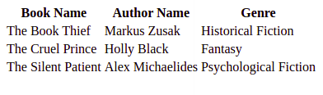

*HTML Table*

**Example 2:**This example explains the use of the HTML Table.

* HTML

|  |
| --- |
| <!DOCTYPE html>  <**html**>    <**body**>      <**table**>          <**tr**>              <**th**>Firstname</**th**>              <**th**>Lastname</**th**>              <**th**>Age</**th**>          </**tr**>          <**tr**>              <**td**>Priya</**td**>              <**td**>Sharma</**td**>              <**td**>24</**td**>          </**tr**>          <**tr**>              <**td**>Arun</**td**>              <**td**>Singh</**td**>              <**td**>32</**td**>          </**tr**>          <**tr**>              <**td**>Sam</**td**>              <**td**>Watson</**td**>              <**td**>41</**td**>          </**tr**>      </**table**>  </**body**>    </**html**> |

**Output:**

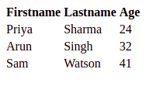

*Simple HTML Table*

**Accepted Attributes:**

* [<table> cellspacing Attribute](https://www.geeksforgeeks.org/html-table-cellspacing-attribute/)
* [<table> rules Attribute](https://www.geeksforgeeks.org/html-table-rules-attribute/)

**Adding a border to an HTML Table:** A border is set using the CSS border property. If you do not specify a border for the table, it will be displayed without borders.

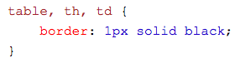

**Example 3**: This example explains the addition of the border to the HTML Table.

* HTML

|  |
| --- |
| <!DOCTYPE html>  <**html**>    <**head**>      <**style**>      table,      th,      td {          border: 1px solid black;      }      </**style**>  </**head**>    <**body**>      <**table** style="width:100%">          <**tr**>              <**th**>Firstname</**th**>              <**th**>Lastname</**th**>              <**th**>Age</**th**>          </**tr**>          <**tr**>              <**td**>Priya</**td**>              <**td**>Sharma</**td**>              <**td**>24</**td**>          </**tr**>          <**tr**>              <**td**>Arun</**td**>              <**td**>Singh</**td**>              <**td**>32</**td**>          </**tr**>          <**tr**>              <**td**>Sam</**td**>              <**td**>Watson</**td**>              <**td**>41</**td**>          </**tr**>      </**table**>  </**body**>    </**html**> |

**Output:**

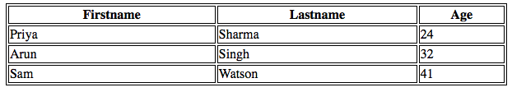

*HTML Table with border*

**Adding Collapsed Borders in an HTML Table:** For borders to collapse into one border, add the CSS border-collapse property.

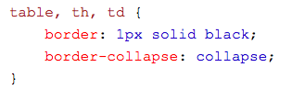

**Example 4:**This example describes the addition of Collapsed Borders in HTML.

* HTML

|  |
| --- |
| <!DOCTYPE html>  <**html**>    <**head**>      <**style**>      table,      th,      td {          border: 1px solid black;          border-collapse: collapse;      }      </**style**>  </**head**>    <**body**>      <**table** style="width:100%">          <**tr**>              <**th**>Firstname</**th**>              <**th**>Lastname</**th**>              <**th**>Age</**th**>          </**tr**>          <**tr**>              <**td**>Priya</**td**>              <**td**>Sharma</**td**>              <**td**>24</**td**>          </**tr**>          <**tr**>              <**td**>Arun</**td**>              <**td**>Singh</**td**>              <**td**>32</**td**>          </**tr**>          <**tr**>              <**td**>Sam</**td**>              <**td**>Watson</**td**>              <**td**>41</**td**>          </**tr**>      </**table**>  </**body**>    </**html**> |

**Output:**

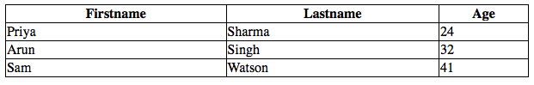

*HTML Table with Collapsed Borders*

**Adding Cell Padding in an HTML Table:** Cell padding specifies the space between the cell content and its borders. If we do not specify a padding, the table cells will be displayed without padding.

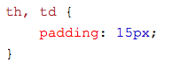

**Example 5:**This example describes the addition of Table cell padding in HTML.

* HTML

|  |
| --- |
| <!DOCTYPE html>  <**html**>    <**head**>      <**style**>      table,      th,      td {          border: 1px solid black;          border-collapse: collapse;      }        th,      td {          padding: 20px;      }      </**style**>  </**head**>    <**body**>      <**table** style="width:100%">          <**tr**>              <**th**>Firstname</**th**>              <**th**>Lastname</**th**>              <**th**>Age</**th**>          </**tr**>          <**tr**>              <**td**>Priya</**td**>              <**td**>Sharma</**td**>              <**td**>24</**td**>          </**tr**>          <**tr**>              <**td**>Arun</**td**>              <**td**>Singh</**td**>              <**td**>32</**td**>          </**tr**>          <**tr**>              <**td**>Sam</**td**>              <**td**>Watson</**td**>              <**td**>41</**td**>          </**tr**>      </**table**>  </**body**>    </**html**> |

**Output:**

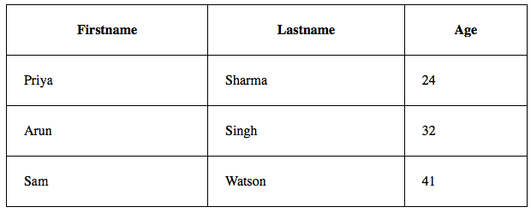

*Adding Table cell padding*

**Adding Left Align Headings in an HTML Table:**By default, the table headings are bold and centered. To left-align the table headings, we must use the CSS text-align property.



**Example 6:**This example explains the [text-align property](https://www.geeksforgeeks.org/css-text-align-property/) where the text is aligned to the left.

* HTML

|  |
| --- |
| <**html**>    <**head**>      <**style**>      table,      th,      td {          border: 1px solid black;          border-collapse: collapse;      }        th,      td {          padding: 20px;      }        th {          text-align: left;      }      </**style**>  </**head**>    <**body**>      <**table** style="width:100%">          <**tr**>              <**th**>Firstname</**th**>              <**th**>Lastname</**th**>              <**th**>Age</**th**>          </**tr**>          <**tr**>              <**td**>Priya</**td**>              <**td**>Sharma</**td**>              <**td**>24</**td**>          </**tr**>          <**tr**>              <**td**>Arun</**td**>              <**td**>Singh</**td**>              <**td**>32</**td**>          </**tr**>          <**tr**>              <**td**>Sam</**td**>              <**td**>Watson</**td**>              <**td**>41</**td**>          </**tr**>      </**table**>  </**body**>    </**html**> |

**Output:**

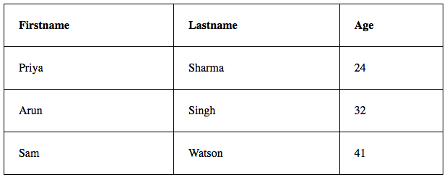

*text-align Property*

**Adding Border Spacing in an HTML Table:**Border spacing specifies the space between the cells. To set the border-spacing for a table, we must use the CSS border-spacing property.

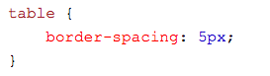

**Example 7:**This example explains the [border space](https://www.geeksforgeeks.org/css-border-spacing-property/) property to make the space between the Table cells.

* HTML

|  |
| --- |
| <**html**>    <**head**>      <**style**>      table,      th,      td {          border: 1px solid black;      }        table {          border-spacing: 5px;      }      </**style**>  </**head**>    <**body**>      <**table** style="width:100%">          <**tr**>              <**th**>Firstname</**th**>              <**th**>Lastname</**th**>              <**th**>Age</**th**>          </**tr**>          <**tr**>              <**td**>Priya</**td**>              <**td**>Sharma</**td**>              <**td**>24</**td**>          </**tr**>          <**tr**>              <**td**>Arun</**td**>              <**td**>Singh</**td**>              <**td**>32</**td**>          </**tr**>          <**tr**>              <**td**>Sam</**td**>              <**td**>Watson</**td**>              <**td**>41</**td**>          </**tr**>      </**table**>  </**body**>    </**html**> |

**Output:**

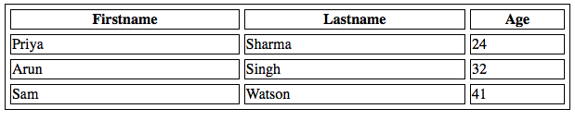

*Border Spacing Property*

**Adding Cells that Span Many Columns in HTML Tables:** To make a cell span more than one column, we must use the colspan attribute.

**Example 8:** This example describes the use of the [colspan attribute](https://www.geeksforgeeks.org/html-colspan-attribute/) in HTML.

* HTML

|  |
| --- |
| <!DOCTYPE html>  <**html**>    <**head**>      <**style**>      table,      th,      td {          border: 1px solid black;          border-collapse: collapse;      }        th,      td {          padding: 5px;          text-align: left;      }      </**style**>  </**head**>    <**body**>      <**h2**>Cell that spans two columns:</**h2**>      <**table** style="width:100%">          <**tr**>              <**th**>Name</**th**>              <**th** colspan="2">Telephone</**th**>          </**tr**>          <**tr**>              <**td**>Vikas Rawat</**td**>              <**td**>9125577854</**td**>              <**td**>8565557785</**td**>          </**tr**>      </**table**>  </**body**>    </**html**> |

**Output:**

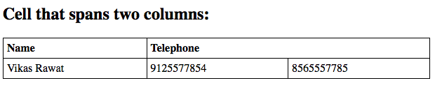

*colspan attribute*

**Adding Cells that span many rows in HTML Tables:**To make a cell span more than one row, we must use the rowspan attribute.

**Example 9:**This example describes the use of the [rowspan attribute](https://www.geeksforgeeks.org/html-rowspan-attribute/) in HTML.

* HTML

|  |
| --- |
| <!DOCTYPE html>  <**html**>    <**head**>      <**style**>      table,      th,      td {          border: 1px solid black;          border-collapse: collapse;      }        th,      td {          padding: 5px;          text-align: left;      }      </**style**>  </**head**>    <**body**>      <**h2**>Cell that spans two rows:</**h2**>      <**table** style="width:100%">          <**tr**>              <**th**>Name:</**th**>              <**td**>Vikas Rawat</**td**>          </**tr**>          <**tr**>              <**th** rowspan="2">Telephone:</**th**>              <**td**>9125577854</**td**>          </**tr**>          <**tr**>              <**td**>8565557785</**td**>          </**tr**>      </**table**>  </**body**>    </**html**> |

**Output:**

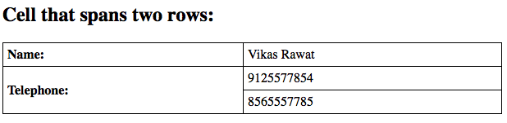

*Use of rowspan attribute*

**Adding a**[**Caption**](https://www.geeksforgeeks.org/html-caption-tag/)**in an HTML Table:**To add a caption to a table, we must use the “caption” tag.



**Example 10:** This example describes the HTML Table caption by specifying the CSS properties for setting its width.

* HTML

|  |
| --- |
| <**html**>    <**head**>      <**style**>      table,      th,      td {          border: 1px solid black;          border-collapse: collapse;      }        th,      td {          padding: 20px;      }        th {          text-align: left;      }      </**style**>  </**head**>    <**body**>      <**table** style="width:100%">          <**caption**>DETAILS</**caption**>          <**tr**>              <**th**>Firstname</**th**>              <**th**>Lastname</**th**>              <**th**>Age</**th**>          </**tr**>          <**tr**>              <**td**>Priya</**td**>              <**td**>Sharma</**td**>              <**td**>24</**td**>          </**tr**>          <**tr**>              <**td**>Arun</**td**>              <**td**>Singh</**td**>              <**td**>32</**td**>          </**tr**>          <**tr**>              <**td**>Sam</**td**>              <**td**>Watson</**td**>              <**td**>41</**td**>          </**tr**>      </**table**>  </**body**>    </**html**> |

**Output:**

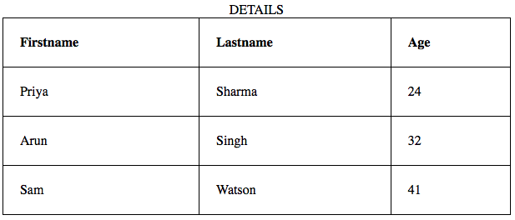

*Adding the caption using the <caption> tag*

**Adding a Background Colour to the Table:**A color can be added as a background in an HTML table using the “*background-color*” option.

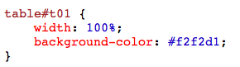

**Example 11:** This example describes the addition of the Table background color in HTML.

* HTML

|  |
| --- |
| <!DOCTYPE html>  <**html**>    <**head**>      <**style**>      table,      th,      td {          border: 1px solid black;          border-collapse: collapse;      }        th,      td {          padding: 5px;          text-align: left;      }        table#t01 {          width: 100%;          background-color: #f2f2d1;      }      </**style**>  </**head**>    <**body**>      <**table** style="width:100%">          <**tr**>              <**th**>Firstname</**th**>              <**th**>Lastname</**th**>              <**th**>Age</**th**>          </**tr**>          <**tr**>              <**td**>Priya</**td**>              <**td**>Sharma</**td**>              <**td**>24</**td**>          </**tr**>          <**tr**>              <**td**>Arun</**td**>              <**td**>Singh</**td**>              <**td**>32</**td**>          </**tr**>          <**tr**>              <**td**>Sam</**td**>              <**td**>Watson</**td**>              <**td**>41</**td**>          </**tr**>      </**table**>      <**br** />      <**br** />      <**table** id="t01">          <**tr**>              <**th**>Firstname</**th**>              <**th**>Lastname</**th**>              <**th**>Age</**th**>          </**tr**>          <**tr**>              <**td**>Priya</**td**>              <**td**>Sharma</**td**>              <**td**>24</**td**>          </**tr**>          <**tr**>              <**td**>Arun</**td**>              <**td**>Singh</**td**>              <**td**>32</**td**>          </**tr**>          <**tr**>              <**td**>Sam</**td**>              <**td**>Watson</**td**>              <**td**>41</**td**>          </**tr**>      </**table**>  </**body**>    </**html**> |

**Output:**

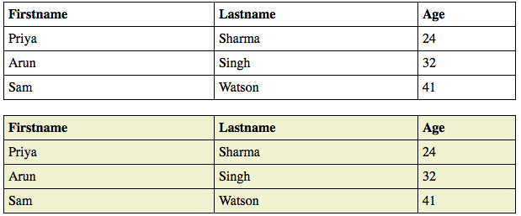

*Adding Table Background color using CSS properties*

**Creating Nested Tables:**Nesting tables simply means making a Table inside another Table. Nesting tables can lead to complex tables layouts, which are visually interesting and have the potential of introducing errors.

**Example 12:**This example describes the Nested of HTML Table.

* HTML

|  |
| --- |
| <!DOCTYPE html>  <**html**>    <**body**>      <**table** border=5 bordercolor=black>          <**tr**>              <**td**> First Column of Outer Table </**td**>              <**td**>                  <**table** border=5 bordercolor=grey>                      <**tr**>                          <**td**> First row of Inner Table </**td**>                      </**tr**>                      <**tr**>                          <**td**> Second row of Inner Table </**td**>                      </**tr**>                  </**table**>              </**td**>          </**tr**>      </**table**>  </**body**>    </**html**> |

**Output:**

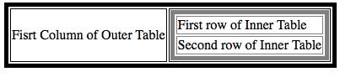

*Nested HTML Table*

**Supported Browsers:**

* Google Chrome 1 and above
* Edge 12 and above
* Firefox 1 and above
* Internet Explorer
* Safari
* Opera

HTML is the foundation of webpages, is used for webpage development by structuring websites and web apps. You can learn HTML from the ground up by following this [HTML Tutorial](https://www.geeksforgeeks.org/html-tutorials/) and [HTML Examples.](https://www.geeksforgeeks.org/html-examples/)

In this article, we will know the **HTML List**, along with understanding its types, and various ways to implement them, through the example.

A list is a record of short pieces of related information or used to display the data or any information on web pages in the ordered or unordered form. For instance, to purchase the items, we need to prepare a list that can either be ordered or unordered list which helps us to organize the data & easy to find the item. Please refer to the [HTML <li> type Attribute](https://www.geeksforgeeks.org/html-li-type-attribute/) article for the various types of attributes that can be used with the ordered & unordered list.

**Example:**The below example illustrates the use of the unordered & ordered list in HTML.

* HTML

|  |
| --- |
| <!DOCTYPE html>  <**html**>    <**head**>      <**title**>GeeksforGeeks</**title**>  </**head**>    <**body**>      <**h2**>Welcome To GeeksforGeeks Learning</**h2**>      <**h5**>List of available courses</**h5**>      <**ul**>          <**li**>Data Structures & Algorithm</**li**>          <**li**>Web Technology</**li**>          <**li**>Aptitude & Logical Reasoning</**li**>          <**li**>Programming Languages</**li**>      </**ul**>      <**h5**>Data Structures topics</**h5**>      <**ol**>          <**li**>Array</**li**>          <**li**>Linked List</**li**>          <**li**>Stacks</**li**>          <**li**>Queues</**li**>          <**li**>Trees</**li**>          <**li**>Graphs</**li**>      </**ol**>  </**body**>    </**html**> |

**Output:**

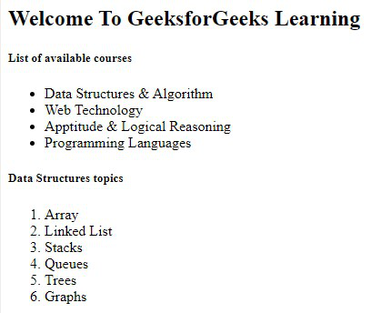

*HTML List*

**Supported Tags:**These tags are used in HTML listing.

* [HTML <ul> Tag](https://www.geeksforgeeks.org/html-ul-tag/)
* [HTML <ol> Tag](https://www.geeksforgeeks.org/html-ol-tag/)
* [HTML <dl> Tag](https://www.geeksforgeeks.org/html-dl-tag/)

**The HTML Unordered List:**An unordered list starts with the “ul” tag. Each list item starts with the “[li](https://www.geeksforgeeks.org/html-li-tag/)” tag. The list items are marked with bullets i.e small black circles by default.

**Syntax:**

<ul> list of items </ul>

**Attribute:** This tag contains two attributes which are listed below:

* [**compact**](https://www.geeksforgeeks.org/html-ul-compact-attribute/#:~:text=The%20HTML%20%7C%20compact,It%20is%20a%20Boolean%20attribute.)**:** It will render the list smaller.
* [**type**](https://www.geeksforgeeks.org/html-ul-type-attribute/)**:** It specifies which kind of marker is used in the list.

**Note:** The <ul> attributes are not supported by HTML5.

**Example:**This example describes the unordered list.

* HTML

|  |
| --- |
| <!DOCTYPE html>  <**html**>    <**body**>      <**h2**>Grocery list</**h2**>      <**ul**>          <**li**>Bread</**li**>          <**li**>Eggs</**li**>          <**li**>Milk</**li**>          <**li**>Coffee</**li**>      </**ul**>  </**body**>    </**html**> |

**Output:**

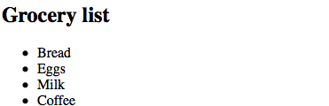

*Unordered List*

**HTML unordered list has various list item markers:**

**Example 1:**The Disc can be used to set the list item marker to a bullet i.e default.

* HTML

|  |
| --- |
| <!DOCTYPE html>  <**html**>    <**head**>      <**title**>HTML ul tag</**title**>  </**head**>    <**body**>      <**h1**>GeeksforGeeks</**h1**>      <**h2**>Unordered List with Disc Bullets</**h2**>    <**p**>GeeksforGeeks courses List:</**p**>          <**ul** style="list-style-type:disc">          <**li**>Geeks</**li**>          <**li**>Sudo</**li**>          <**li**>Gfg</**li**>          <**li**>Gate</**li**>          <**li**>Placement</**li**>      </**ul**>  </**body**>    </**html**> |

**Output:**



*Unordered List with disc item maker*

**Example 2:**The Circle can be used to set the list item marker to a circle.

* HTML

|  |
| --- |
| <!DOCTYPE html>  <**html**>    <**body**>      <**h1**>GeeksforGeeks</**h1**>      <**h2**>Unordered List with Circle Bullets</**h2**>    <**p**>GeeksforGeeks courses List:</**p**>          <**ul** style="list-style-type: circle">          <**li**>Geeks</**li**>          <**li**>Sudo</**li**>          <**li**>Gfg</**li**>          <**li**>Gate</**li**>          <**li**>Placement</**li**>      </**ul**>  </**body**>    </**html**> |

**Output:**



*Unordered List with circle item maker*

**Example 3:**The Square can be used to set the list item marker to a square.

* HTML

|  |
| --- |
| <!DOCTYPE html>  <**html**>    <**body**>      <**h1**>GeeksforGeeks</**h1**>      <**h2**>Unordered List with Square Bullets</**h2**>    <**p**>GeeksforGeeks courses List:</**p**>          <**ul** style="list-style-type: square">          <**li**>Geeks</**li**>          <**li**>Sudo</**li**>          <**li**>Gfg</**li**>          <**li**>Gate</**li**>          <**li**>Placement</**li**>      </**ul**>  </**body**>    </**html**> |

**Output:**

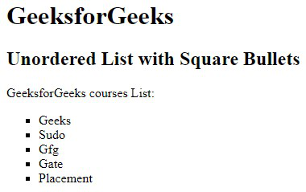

*Unordered List with square item maker*

**Example 4:**It’s none that can be used to set the list item marker with no mark.

* HTML

|  |
| --- |
| <!DOCTYPE html>  <**html**>    <**body**>      <**h1**>GeeksforGeeks</**h1**>      <**h2**>Unordered List with No Bullets</**h2**>    <**p**>GeeksforGeeks courses List:</**p**>          <**ul** style="list-style-type: none">          <**li**>Geeks</**li**>          <**li**>Sudo</**li**>          <**li**>Gfg</**li**>          <**li**>Gate</**li**>          <**li**>Placement</**li**>      </**ul**>  </**body**>    </**html**> |

**Output:**



*Unordered List with none item maker*

**Example:**Nested Unordered List, It is used to nest the list items ie., a list inside another list.

* HTML

|  |
| --- |
| <!DOCTYPE html>  <**html**>    <**body**>      <**h1**>GeeksforGeeks</**h1**>      <**h2**>Nested Unordered List</**h2**>    <**p**>GeeksforGeeks courses List:</**p**>          <**ul**>          <**li**>DSA</**li**>          <**ul**>              <**li**>Array</**li**>              <**li**>Linked List</**li**>              <**li**>stack</**li**>              <**li**>Queue</**li**>          </**ul**>          <**li**>Web Technologies</**li**>          <**ul**>              <**li**>HTML</**li**>              <**li**>CSS</**li**>              <**li**>JavaScript</**li**>          </**ul**>          <**li**>Aptitude</**li**>          <**li**>Gate</**li**>          <**li**>Placement</**li**>      </**ul**>  </**body**>    </**html**> |

**Output:**

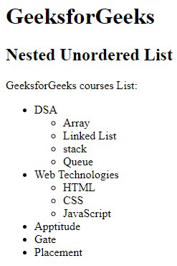

*Nested Unordered List*

**HTML Ordered List:**An ordered list starts with the “ol” tag. Each list item starts with the “li” tag. The list items are marked with numbers by default.

**Syntax:**

<ol>

<li>Item1</li>

<li>Item2</li>

<li>Item3</li>

</ol>

**Attributes:**

* [**compact**](https://www.geeksforgeeks.org/html-ol-compact-attribute/)**:** It defines the list should be compacted (compact attribute is not supported in HTML5. Use CSS instead.).
* [**reversed**](https://www.geeksforgeeks.org/html-ol-reversed-attribute/)**:** It defines that the order will be descending.
* [**start**](https://www.geeksforgeeks.org/html-ol-start-attribute/)**:** It defines from which number or alphabet the order will start.
* [**type**](https://www.geeksforgeeks.org/html-ol-type-attribute/)**:** It defines which type(1, A, a, I, and i) of the order you want in your list of numeric, alphabetic, or roman numbers.

**Example**: This example illustrates the use of the reverse attribute, control list counting & type attribute.

* HTML

|  |
| --- |
| <!DOCTYPE html>  <**html**>    <**head**>      <**title**>HTML ol tag</**title**>  </**head**>    <**body**>      <**h1** style="color: green">GeeksforGeeks</**h1**>      <**h3**>HTML ol tag</**h3**>    <**p**>reversed attribute</**p**>            <**ol** reversed>          <**li**>HTML</**li**>          <**li**>CSS</**li**>          <**li**>JS</**li**>      </**ol**>    <**p**>start attribute</**p**>          <**ol** start="5">          <**li**>HTML</**li**>          <**li**>CSS</**li**>          <**li**>JS</**li**>      </**ol**>    <**p**>type attribute</**p**>          <**ol** type="i">          <**li**>HTML</**li**>          <**li**>CSS</**li**>          <**li**>JS</**li**>      </**ol**>  </**body**>    </**html**> |

**Output:**

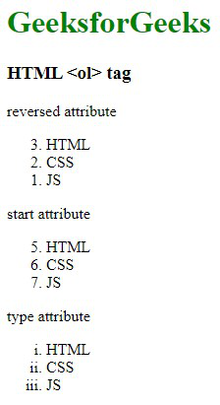

*Ordered List with different list style*

**HTML ordered list has various list item markers**: The type attribute of the <ol> tag defines the type of the list item marker.

**Example 1**: The list items will be numbered with numbers i.e default.

* HTML

|  |
| --- |
| <!DOCTYPE html>  <**html**>    <**body**>      <**h2**>Ordered List with Numbers</**h2**>      <**ol** type="1">          <**li**>Bread</**li**>          <**li**>Eggs</**li**>          <**li**>Milk</**li**>          <**li**>Coffee</**li**>      </**ol**>  </**body**>    </**html**> |

**Output:**

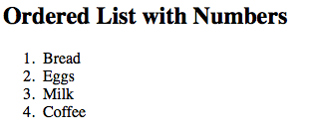

*Ordered List with numeric item maker*

**Example 2**: Type=”A”, this list of items will be numbered with uppercase letters.

* HTML

|  |
| --- |
| <!DOCTYPE html>  <**html**>    <**body**>      <**h2**>Ordered List with Letters</**h2**>      <**ol** type="A">          <**li**>Bread</**li**>          <**li**>Eggs</**li**>          <**li**>Milk</**li**>          <**li**>Coffee</**li**>      </**ol**>  </**body**>    </**html**> |

**Output:**

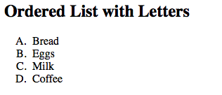

*Ordered List with capital alphabetic item maker*

**Example 3**: Type=”a”, this list of items will be numbered with lowercase letters.

* HTML

|  |
| --- |
| <!DOCTYPE html>  <**html**>    <**body**>      <**h2**>Ordered List with Lowercase Letters</**h2**>      <**ol** type="a">          <**li**>Bread</**li**>          <**li**>Eggs</**li**>          <**li**>Milk</**li**>          <**li**>Coffee</**li**>      </**ol**>  </**body**>    </**html**> |

**Output:**

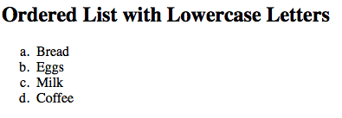

*Ordered List with small alphabetic item maker*

**Example 4**: Type=”I”, this list of items will be numbered with uppercase roman numbers.

* HTML

|  |
| --- |
| <!DOCTYPE html>  <**html**>    <**body**>      <**h2**>Ordered List with Roman Numbers</**h2**>      <**ol** type="I">          <**li**>Bread</**li**>          <**li**>Eggs</**li**>          <**li**>Milk</**li**>          <**li**>Coffee</**li**>      </**ol**>  </**body**>    </**html**> |

**Output:**

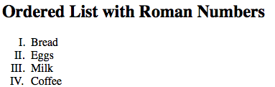

*Ordered List with uppercase roman numbers*

**Example 5**: Type=”i”, this list of items will be numbered with lowercase roman numbers.

* HTML

|  |
| --- |
| <!DOCTYPE html>  <**html**>    <**body**>      <**h2**>Ordered List with Lowercase Roman Numbers</**h2**>      <**ol** type="i">          <**li**>Bread</**li**>          <**li**>Eggs</**li**>          <**li**>Milk</**li**>          <**li**>Coffee</**li**>      </**ol**>  </**body**>    </**html**> |

**Output:**

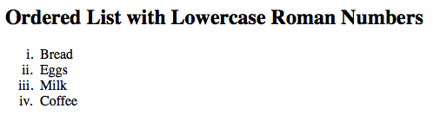

*Ordered List with lowercase roman numbers*

**Example 6:**Nested ordered list, a nested ordered list is a list that has a list inside another list.

* HTML

|  |
| --- |
| <!DOCTYPE html>  <**html**>    <**body**>      <**h1**>GeeksforGeeks</**h1**>      <**h2**>Nested Ordered List</**h2**>      <**ol**>          <**li**>Coffee</**li**>          <**li**> Tea              <**ol**>                  <**li**>Black tea</**li**>                  <**li**>Green tea</**li**>              </**ol**>          </**li**>          <**li**>Milk</**li**>      </**ol**>  </**body**>    </**html**> |

**Output:**

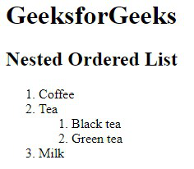

*Nested Ordered List*

*There is another attribute that is specifically defined for a list item, which is used in with the “li” tag and that is the*[*value attribute*](https://www.geeksforgeeks.org/html-value-attribute/)*. Below is a little description of the value attribute specifically used with the “li” tag. Though it is used with various other HTML elements.*

**Value attribute:**

The value attribute may be used on an individual <li> element within an ordered list to change its value within the list. You define the value of a list item and the number of any list item appearing after it will be recalculated accordingly.

**Example:** This example illustrates the use of the “value attribute” used on the <li> element.

* HTML

|  |
| --- |
| <!DOCTYPE html>  <**html**>  <**head**>  <**title**>Page Title</**title**>  </**head**>  <**body**>  <**h2**>Welcome To GFG</**h2**>   <**ol**>     <**li**>Item One</**li**>     <**li** value="10">Item Two</**li**>     <**li**>Item Three</**li**>     <**li**>Item Four</**li**>   </**ol**>  </**body**>  </**html**> |

**Output:**

<img src="https://media.geeksforgeeks.org/wp-content/uploads/20220522105327/GFG20220522105224.jpg" alt="Use of "value attribute" on

• ” srcset=”https://media.geeksforgeeks.org/wp-content/uploads/20220522105327/GFG20220522105224.jpg, ” sizes=”100vw” width=”237″>Value attribute

**HTML Description List:**A description list is a list of terms, with a description of each term. The [<dl>](https://www.geeksforgeeks.org/html-dl-tag/) tag defines the description list, the <dt> tag defines the term name, and the <dd> tag describes each term. Please refer to the [How to add description list of an element using HTML?](https://www.geeksforgeeks.org/how-to-add-description-list-of-an-element-using-html/) article for further details.

**Syntax:**

<dl> Contents... </dl>

**Example:**This example describes the HTML Description List.

* HTML

|  |
| --- |
| <!DOCTYPE html>  <**html**>    <**body**>      <**h2**>A Description List</**h2**>      <**dl**>          <**dt**>Coffee</**dt**>          <**dd**>- 500 gms</**dd**>          <**dt**>Milk</**dt**>          <**dd**>- 1 ltr Tetra Pack</**dd**>      </**dl**>  </**body**>    </**html**> |

**Output:**

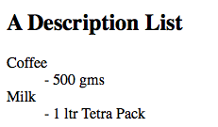

*Description List*

**Supported Browser:**

* Google Chrome 94.0 & above
* Microsoft Edge 93.0
* Firefox 92.0 & above
* Opera 78.0

**HTML Forms**

* Difficulty Level : [Hard](https://www.geeksforgeeks.org/hard/)
* Last Updated : 22 Jun, 2022

• Read

• Discuss

HTML stands for HyperText Markup Language. It is used to design web pages using a markup language. It is a combination of Hypertext and Markup language. HTML uses predefined tags and elements that tell the browser how to properly display the content on the screen, and form is one of them. So, in this article, we will learn what is exactly HTML form, what are the elements of forms and how can we use HTML form in our webpage.

**What is HTML <form>?**

<form> is a HTML element to collect input data with containing interactive controls. It provides facilities to input text, number, values, email, password, and control fields such as checkboxes, radio buttons, submit buttons, etc., or in other words, form is a container that contains input elements like text, email, number, radio buttons, checkboxes, submit buttons, etc. Forms are generally used when you want to collect data from the user. For example, a user wants to buy a bag online, so he/she has to first enter their shipping address in the address form and then add their payment details in the payment form to place an order.

Forms are created by placing input fields within paragraphs, preformatted text, lists and tables. This gives considerable flexibility in designing the layout of forms.

**Syntax:**

<form>

<!--form elements-->

</form>

**Form elements**

These are the following HTML <form> elements:

* **<label>:**It defines label for <form> elements.
* **<input>:**It is used to get input data from the form in various types such as text, password, email, etc by changing its type.
* **<button>:**It defines a clickable button to control other elements or execute a functionality.
* **<select>:**It is used to create a drop-down list.
* **<textarea>:**It is used to get input long text content.
* **<fieldset>:**It is used to draw a box around other form elements and group the related data.
* **<legend>:**It defines caption for fieldset elements.
* **<datalist>:**It is used to specify pre-defined list options for input controls.
* **<output>:**It displays the output of performed calculations.
* **<option>:**It is used to define options in a drop-down list.
* **<optgroup>:**It is used to define group-related options in a drop-down list.

**Textbox in HTML Form**

In an HTML form,we use the <input> tag by assigning type attribute value to text to input single line input. To define type attribute see the below syntax.

Tip: The default value of the type attribute is “text”.

**Syntax:**

<input type="text" />

Or shorthand for “text” type:

<input />

**Password in an HTML Form**

We can change type value text to password to get the input password

**Example:**

* HTML

|  |
| --- |
| <!DOCTYPE html>  <**html**>  <**head**>    <**title**>Page Title</**title**>  </**head**>  <**body**>    <**h2**>Welcome To GFG</**h2**>    <**form**>      <**p**>        <**label**>Username : <**input** type="text" /></**label**>      </**p**>          <**p**>        <**label**>Password : <**input** type="password" /></**label**>      </**p**>          <**p**>         <**button** type="submit">Submit</**button**>      </**p**>        </**form**>  </**body**>  </**html**> |

**Output:**

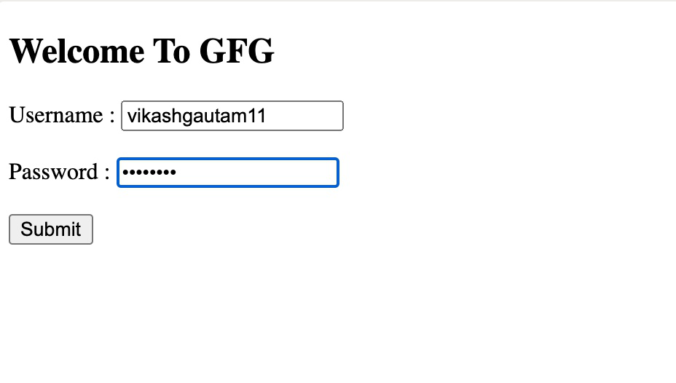

In the above example, we can see the difference between type text and type password. The username will be visible but the password will not be visible.

**Radio Button in an HTML Form**

To create a radio button, we use the <input> tag following by radio type to provide users to choose a limited number of choices.

**Syntax:**

<input type="radio" name="radio_button_name" value="radio_button_value" />

**Note:**The radio button must have shared the same name to be treated as a group.

**Note:** The value attribute defines the unique value associated with each radio button. The value is not shown to the user, but is the value that is sent to the server on “submit” to identify which radio button that was selected.

**Example:**

In this example, we will create a radio button to choose your gender.

* HTML

|  |
| --- |
| <!DOCTYPE html>  <**html**>  <**head**>    <**title**>Page Title</**title**>  </**head**>  <**body**>    <**h2**>Select your gender</**h2**>    <**form**>      <**label**>Male<**input** type="radio" name="gender" value="male" /></**label**>      <**label**>Female<**input** type="radio" name="gender" value="female" /></**label**>    </**form**>  </**body**>  </**html**> |

**Output:**

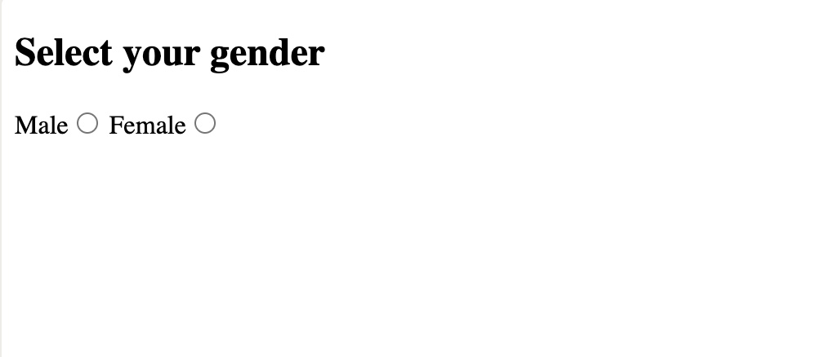

**Checkbox in an HTML Form**

To create a checkbox in an HTML form, we use the <input> tag followed by the input type checkbox. It is a square box to tick to activate this. It used to choose more options at a time.

**Syntax:**

<input type="checkbox" name="select_box_name" value="select_box_value" />

**Note:** the “name” and “value” attributes are used to send the checkbox data to the server.

**Example:**

In this example, we use checkboxes to select language.

* HTML

|  |
| --- |
| <!DOCTYPE html>  <**html**>  <**head**>    <**title**>Page Title</**title**>  </**head**>  <**body**>    <**h2**>Choose Language</**h2**>    <**form**>      <**ul** style="list-style-type:none;">        <**li**><**input** type="checkbox" name="language" value="hindi" />Hindi</**li**>        <**li**><**input** type="checkbox" name="language" value="english" />English</**li**>        <**li**><**input** type="checkbox" name="language" value="sanskrite" />Sanskrit</**li**>      </**ul**>     </**form**>  </**body**>  </**html**> |

**Output:**

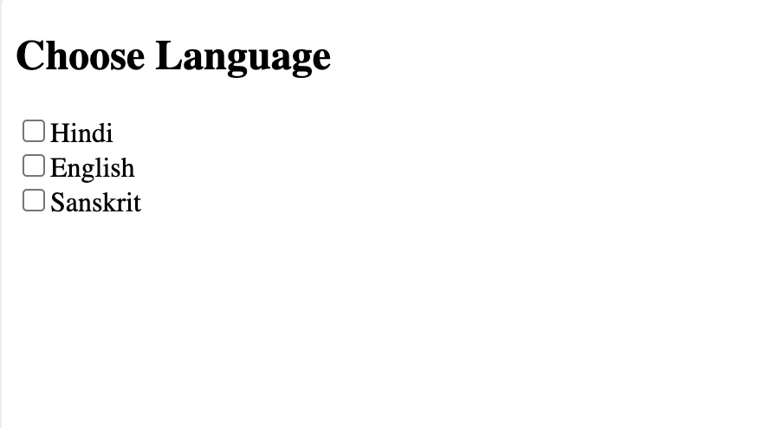

**Combobox in an HTML Form**

Combobox is used to create a drop-down menu in your form which contains multiple options. So, to create an Combobox in an HTML form, we use the <select> tag with <option> tag. It is also known as a drop-down menu.

**Syntax:**

<select name="select_box_name">

<option value="value1">option1</option>

<option value="value2">option2</option>

<option value="value3">option3</option>

</select>

**Note:** the “name” and “value” attributes are used to send the Combobox data to the server.

**Example:**

In this example, we will create a dropdown menu to select Nationality.

* HTML

|  |
| --- |
| <!DOCTYPE html>  <**html**>  <**head**>    <**title**>Page Title</**title**>  </**head**>  <**body**>    <**h2**>Select Your Nationality</**h2**>    <**form**>     <**select** name="language">       <**option** value="indian">Indian</**option**>       <**option** value="nepali">Nepali</**option**>       <**option** value="others">Others</**option**>     </**select**>    </**form**>  </**body**>  </**html**> |

**Output:**



**Submit button in an HTML Form**

In the HTML form, submit button is used to submit the details of the form to the form handler. A form handler is a file on the server with a script that is used to process input data.

**Syntax:**

<button type="submit">submit</button>

**Example:**

* HTML

|  |
| --- |
| <!DOCTYPE html>  <**html**>  <**head**>    <**title**>Page Title</**title**>  </**head**>  <**body**>    <**h2**>Welcome To GeeksforGeeks</**h2**>    <**form**>      <**p**>        <**label**>Username: <**input** type="text" /></**label**>      <**p**>        <**label**>Password: <**input** type="password" /></**label**>      </**p**>          <**p**>        <**button** type="submit">submit</**button**>      </**p**>        </**form**>  </**body**>  </**html**> |

**Output:**

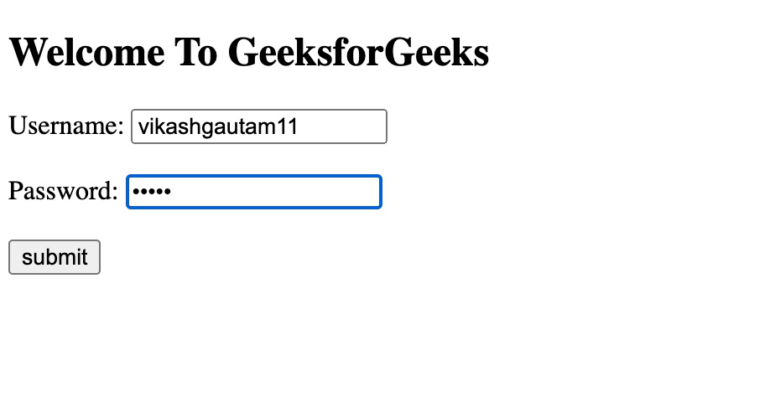

**TextArea in an HTML Form**

In the HTML form, a text area is used to add comments or reviews, or addresses to the form, in other words, the text area is a multi-line text input control. It contains an unlimited number of characters, the text renders in a fixed-width font, and the size of the text area is given by the <rows> and <cols> attributes. To create a text area in the form use the <textarea> tag.

**Syntax:**

<textarea name="textarea_name">content</textarea>

**Note:** the name attribute is used to reference the textarea data after it is send to a server.

**Example:**

* HTML

|  |
| --- |
| <!DOCTYPE html>  <**html**>  <**head**>    <**title**>Page Title</**title**>  </**head**>  <**body**>    <**h2**>Welcome To GeeksforGeeks</**h2**>    <**form**>      <**textarea** name="welcomeMessage" rows="3" cols="40">GeeksforGeeks is a online portal</**textarea**>    </**form**>  </**body**>  </**html**> |

**Output:**

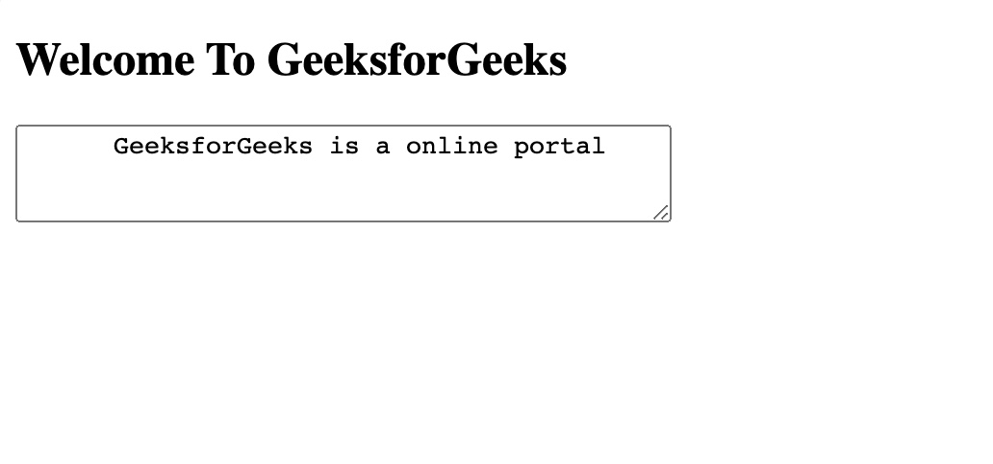

**Create an HTML form to input the basic details of a student**

In this example, we will take input such as Salutation, First Name, Last Name, Email, Phone, Gender, Date of Birth, and Address.

To create this form, we need to use the <legend> tag to defined caption, <select> tag for Salutation, <option> tag to define elements of Salutation, <input> tag for First Name, Last Name, Email, Phone, Date of Birth by changing <input> tag type attribute, <textarea> to input address, radio button for gender. After defining all these stuffs, we will use a <button> to submit this form data.

* HTML

|  |
| --- |
| <!DOCTYPE html>  <**html** lang="en">  <**head**>    <**meta** charset="UTF-8">    <**meta** http-equiv="X-UA-Compatible" content="IE=edge">    <**meta** name="viewport" content="width=device-width, initial-scale=1.0">    <**title**>GfG</**title**>  </**head**>  <**body**>    <**form**>      <**fieldset**>        <**legend**>Personal Details</**legend**>      <**p**>          <**label**>            Salutation            <**br** />            <**select** name="salutation">              <**option**>--None--</**option**>              <**option**>Mr.</**option**>              <**option**>Ms.</**option**>              <**option**>Mrs.</**option**>              <**option**>Dr.</**option**>              <**option**>Prof.</**option**>            </**select**>          </**label**>        </**p**>          <**p**>          <**label**>First name: <**input** name="firstName" /></**label**>        </**p**>          <**p**>          <**label**>Last name: <**input** name="lastName" /></**label**>        </**p**>          <**p**>          Gender :          <**label**><**input** type="radio" name="gender" value="male" /> Male</**label**>          <**label**><**input** type="radio" name="gender" value="female" /> Female</**label**>        </**p**>          <**p**>          <**label**>Email:<**input** type="email" name="email" /></**label**>        </**p**>          <**p**>          <**label**>Date of Birth:<**input** type="date" name="birthDate"></**label**>        </**p**>          <**p**>          <**label**>            Address :            <**br** />            <**textarea** name="address" cols="30" rows="3"></**textarea**>          </**label**>        </**p**>          <**p**>          <**button** type="submit">Submit</**button**>        </**p**>           </**fieldset**>    </**form**>  </**body**>  </**html**> |