THE MAHARAJA SAYAJIRAO UNIVERSITY OF BARODA
FACULTY OF TECHNOLOGY AND ENGINEERING
DEPARTMENT OF COMPUTER SCIENCE & ENGINEERING
―――――――――――――――――――――――――――――――――――――――――――――
LABORATORY WORK SUBMISSION
BASIC WEB PROGRAMMING (BWP)
Academic Year: 2025 – 2026
Student Name: | Om Kumar Khatri
PRN: | 8024056707
Roll No: | 36
Class: | BE-III (GIA)
Branch: | Computer Science & Engineering
Subject: | Basic Web Programming (BWP)

INDEX / LIST OF EXPERIMENTS
Sr No. | Aim / Experiment Title | Technology
Exp 1.1 | Design side menu using list like following (Computers & Accessories, Price) | HTML/CSS
Exp 1.2 | Design first page of Faculty of Technology and Engineering using table | HTML/CSS
Exp 2.1 | Design a simple static website using HTML with Header, Left sidebar, and Content area Home.html | HTML/CSS
Exp 2.2 | Create a student registration form using <form>, <input>, <textarea>, <button>, <select>, <option> | HTML/CSS
Exp 2.3 | Design MSU Home page using HTML5 and also include collage video in it | JavaScript
Exp 3.1 | Design vertical navigation bar like following | HTML/CSS
Exp 3.2 | Design horizontal navigation bar like following | HTML/CSS
Exp 3.3 | Create art and craft photo album using bootstrap | Bootstrap 5
Exp 3.4 | Create student marksheet using bootstrap | Bootstrap 5
Exp 3.5 | Create employment application form like below | HTML/CSS
Exp 3.6 | Design home of flipKart in which Navigation bar with dropdown is available using bootstrap | Bootstrap 5
Exp 4.1 | Play video in your web page and play/pause, change the dimension of it using javascript using button(small,normal,large) | JavaScript
Exp 4.2 | Implement Type Writer using DHTML and Javascript | JavaScript
Exp 4.3 | Write down java script code to validate user name and password | HTML/CSS
Exp 4.4 | Write an HTML file with Javascript that finds position of first occurrence of vowel 'a', last occurrence of vowel 'a' in a given word and returns the string between them | JavaScript
Exp 4.5 | Write a JavaScript that handles key events: key code, vowel announcement, and background change to blue on release | JavaScript
Exp 4.6 | Design a webpage which demonstrate snow fall using javascript | JavaScript
Exp 5.1 | Use a jQuery method to toggle between sliding up and down a <div> element, when clicking on a button | jQuery
Exp 5.2 | Use the animate() method to move a <div> element 250 pixels to the right | HTML/CSS
Exp 5.3 | Use the animate() method to set CSS properties for <div>: opacity:0.4, height:500px, width:500px | HTML/CSS
Exp 5.4 | Use the animate() method to set the font-size of a <div> element to 100 pixels with slow duration | HTML/CSS
Exp 5.5 | Create cartoon animation using jQuery | jQuery
Exp 6.1 | Create Stock market web page using AJAX in which stock price come form .txt file | AJAX
Exp 6.2 | Display cricket live score using AJAX | AJAX
Exp 6.3 | Implement Server clock using AJAX | AJAX
Exp 7.1 | Develop XML document that will hold player collection with fields for player-name, age, batting-average and highest-score, write suitable schema for the XML | XML / XSLT
Exp 7.2 | Write an XML file to store your semester mark sheet. Write an XSL file using XSLT to display it in XHTML table form | XML / XSLT
Exp 7.3 | Develop an XML document that will hold a book collection with fields for book name, author, ISBN number and quantity. Write suitable schema for the XML | XML / XSLT
Exp 7.4 | Write an XSL file to print list of products which has price< 300Rs. For item.xml file in tabular structure | XML / XSLT
Exp 7.5 | Develop XML File for book record and also write XSL for it to display in table format | XML / XSLT
Exp Node.1 | Create a module for area calculation in node.js for circle, rectangle, and square. Use this module in your current file to find area of all shape | Node.js
Exp Node.2 | Write a program to read a file from server and check whether no read from file is armstrong or not using node.js | Node.js
Exp Node.3 | Write a program to read student.json file from a server and display the information of student for given PRN no in tabular format | Node.js

― LAB - 1 ―
Experiment 1.1: Design side menu using list like following (Computers & Accessories, Price)
Code:
<!DOCTYPE html>
<html>
<head>
<meta charset="UTF-8">
<title>Side Menu</title>
<style>
body {
font-family: Arial, sans-serif;
padding: 20px;
background-color: #ffffff;
}
.container-box {
display: flex;
width: 600px;
min-height: 420px;
border: 1px solid #000000;
}
.side-menu {
width: 270px;
border-right: 1px solid #000000;
padding: 15px 20px;
box-sizing: border-box;
}
.side-menu h4 {
margin-top: 5px;
margin-bottom: 8px;
font-size: 15px;
font-weight: bold;
color: #000000;
}
.side-menu ul {
margin-top: 0;
margin-bottom: 20px;
padding-left: 22px;
}
.side-menu li {
margin: 6px 0;
font-size: 13px;
}
.side-menu a {
color: #0044cc;
text-decoration: underline;
}
.side-menu a:hover {
color: #002277;
}
.content-area {
flex: 1;
padding: 20px;
}
</style>
</head>
<body>
<div class="container-box">
<!-- Left Side Menu Column -->
<div class="side-menu">
<h4>Computers & Accessories</h4>
<ul>
<li><a href="#">Accessories &amp; Peripherals</a></li>
<li><a href="#">Components</a></li>
<li><a href="#">Desktops</a></li>
<li><a href="#">External Devices &amp; Data Storage</a></li>
<li><a href="#">Laptops</a></li>
</ul>
<h4>Price</h4>
<ul>
<li><a href="#">Under &#8377;1,000</a></li>
<li><a href="#">&#8377;1,000 - &#8377;5,000</a></li>
<li><a href="#">&#8377;5,000 - &#8377;10,000</a></li>
<li><a href="#">&#8377;10,000 - &#8377;20,000</a></li>
<li><a href="#">Over &#8377;20,000</a></li>
</ul>
</div>
<!-- Right Content Area -->
<div class="content-area">
</div>
</div>
</body>
</html>
Output:
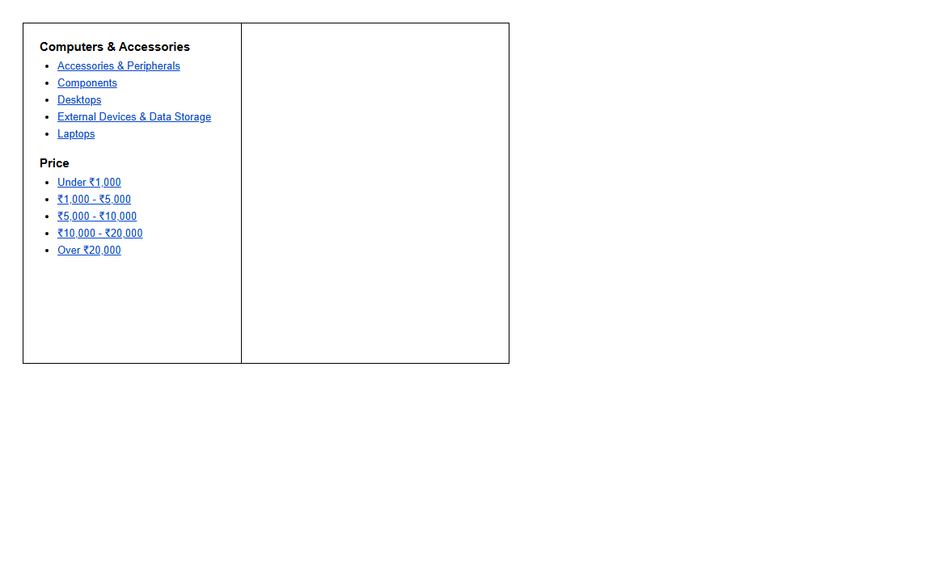
―――――――――――――――――――――――――――――――――――――――――――――――――――――――
Experiment 1.2: Design first page of Faculty of Technology and Engineering using table
Code:
<!DOCTYPE html>
<html lang="en">
<head>
<meta charset="UTF-8">
<meta name="viewport" content="width=device-width, initial-scale=1.0">
<title>Faculty of Technology and Engineering | The Maharaja Sayajirao University of Baroda</title>
<link rel="stylesheet" href="https://cdnjs.cloudflare.com/ajax/libs/font-awesome/6.4.0/css/all.min.css">
<style>
* {
box-sizing: border-box;
margin: 0;
padding: 0;
}
body {
font-family: Arial, Helvetica, sans-serif;
background-color: #f0f2f5;
color: #333333;
}
/* Master Table */
table.main-layout {
width: 100%;
max-width: 1200px;
margin: 20px auto;
background-color: #ffffff;
border-collapse: collapse;
box-shadow: 0 4px 15px rgba(0,0,0,0.15);
border: 1px solid #c0c6cc;
}
/* Top Utilities Bar */
.top-bar-cell {
background-color: #00a8e8;
color: #ffffff;
padding: 8px 20px;
font-size: 13px;
}
.top-bar-cell a {
color: #ffffff;
text-decoration: none;
margin-right: 15px;
}
.top-bar-cell a:hover {
text-decoration: underline;
}
/* Header Row */
.header-cell {
background-color: #ffffff;
padding: 15px 25px;
border-bottom: 3px solid #1a2b4c;
}
.header-table {
width: 100%;
border-collapse: collapse;
}
.logo-cell {
width: 90px;
vertical-align: middle;
text-align: center;
}
.msu-seal {
width: 80px;
height: 80px;
border-radius: 50%;
border: 2px solid #1a2b4c;
display: flex;
align-items: center;
justify-content: center;
background: #fdfdfd;
box-shadow: 0 2px 6px rgba(0,0,0,0.1);
}
.title-cell {
padding-left: 20px;
vertical-align: middle;
}
.title-cell h1 {
font-size: 24px;
color: #1a2b4c;
margin-bottom: 4px;
font-weight: bold;
letter-spacing: 0.5px;
}
.title-cell h2 {
font-size: 17px;
color: #0088cc;
font-weight: 600;
margin-bottom: 4px;
}
.title-cell p {
font-size: 12px;
color: #666666;
}
.badge-cell {
width: 150px;
text-align: right;
vertical-align: middle;
}
.naac-badge {
display: inline-block;
background-color: #ff8800;
color: #ffffff;
font-weight: bold;
padding: 6px 14px;
border-radius: 4px;
font-size: 12px;
}
/* Navigation Menu Row */
.nav-cell {
background-color: #1a2b4c;
padding: 0;
}
.nav-table {
width: 100%;
border-collapse: collapse;
text-align: center;
}
.nav-table td {
padding: 12px 10px;
border-right: 1px solid #2b3a55;
}
.nav-table td:last-child {
border-right: none;
}
.nav-table a {
color: #ffffff;
text-decoration: none;
font-size: 14px;
font-weight: bold;
display: block;
transition: color 0.2s;
}
.nav-table td:hover {
background-color: #0088cc;
}
.nav-table td.active {
background-color: #ff8800;
}
/* Banner Row */
.banner-cell {
padding: 0;
background-color: #000;
position: relative;
}
.banner-img {
width: 100%;
height: 320px;
object-fit: cover;
display: block;
opacity: 0.9;
}
.banner-caption {
background: linear-gradient(to right, rgba(26,43,76,0.95), rgba(26,43,76,0.7));
color: #ffffff;
padding: 12px 25px;
font-size: 15px;
font-weight: 500;
border-left: 5px solid #ff8800;
}
/* Content Table Row */
.content-cell {
padding: 20px;
background-color: #ffffff;
}
.inner-content-table {
width: 100%;
border-collapse: collapse;
}
/* Left Sidebar (Table Cell) */
.sidebar-cell {
width: 28%;
vertical-align: top;
padding-right: 20px;
border-right: 2px solid #e9ecef;
}
.widget-table {
width: 100%;
border-collapse: collapse;
margin-bottom: 25px;
border: 1px solid #dcdcdc;
border-radius: 4px;
overflow: hidden;
}
.widget-header {
background-color: #1a2b4c;
color: #ffffff;
padding: 10px 14px;
font-size: 14px;
font-weight: bold;
text-align: left;
}
.widget-row td {
padding: 10px 14px;
border-bottom: 1px solid #eeeeee;
font-size: 13px;
}
.widget-row:hover td {
background-color: #f8f9fa;
}
.widget-row a {
color: #0066cc;
text-decoration: none;
display: block;
}
.widget-row a:hover {
text-decoration: underline;
}
/* Main Center Area (Table Cell) */
.main-cell {
width: 72%;
vertical-align: top;
padding-left: 20px;
}
.section-box {
margin-
... [Code truncated for print length. Complete source in project files] ...
Output:

―――――――――――――――――――――――――――――――――――――――――――――――――――――――
― LAB - 2 ―
Experiment 2.1: Design a simple static website using HTML with Header, Left sidebar, and Content area Home.html
Code:
<!DOCTYPE html>
<html lang="en">
<head>
<meta charset="UTF-8">
<meta name="viewport" content="width=device-width, initial-scale=1.0">
<title>Static Website Layout - Lab 2.1</title>
<style>
body {
font-family: Arial, sans-serif;
background-color: #f5f5f5;
margin: 0;
padding: 20px;
display: flex;
justify-content: center;
}
.site-container {
width: 850px;
border: 2px solid #000000;
background-color: #ffffff;
box-shadow: 0 4px 12px rgba(0,0,0,0.15);
}
/* Top Header */
.site-header {
background-color: #5b9bd5;
color: #ffffff;
text-align: center;
padding: 22px 10px;
font-size: 24px;
font-weight: bold;
letter-spacing: 2px;
border-bottom: 2px solid #000000;
}
/* Body Split: Sidebar + Content Frame */
.site-body {
display: flex;
min-height: 460px;
}
/* Left Blue Sidebar */
.site-sidebar {
width: 220px;
background-color: #5b9bd5;
padding: 30px 20px;
box-sizing: border-box;
border-right: 2px solid #000000;
}
.site-sidebar a {
display: block;
color: #ffffff;
font-size: 16px;
text-decoration: none;
margin-bottom: 18px;
padding: 8px 12px;
border-radius: 4px;
font-weight: 500;
transition: background-color 0.2s, color 0.2s;
}
.site-sidebar a:hover,
.site-sidebar a.active {
background-color: #3b74aa;
text-decoration: underline;
}
/* Right Content Area */
.site-content {
flex: 1;
background-color: #ffffff;
padding: 0;
}
iframe.content-frame {
width: 100%;
height: 100%;
min-height: 460px;
border: none;
display: block;
}
</style>
</head>
<body>
<div class="site-container">
<!-- HEADER Section -->
<div class="site-header">
HEADER
</div>
<div class="site-body">
<!-- Left Sidebar Navigation -->
<div class="site-sidebar">
<a href="Home.html" target="content-frame" class="active" onclick="setActive(this)">Home</a>
<a href="About.html" target="content-frame" onclick="setActive(this)">About Me</a>
<a href="Contact.html" target="content-frame" onclick="setActive(this)">Contact us</a>
</div>
<!-- Right Content Area (Loads Home.html by default) -->
<div class="site-content">
<iframe name="content-frame" class="content-frame" src="Home.html"></iframe>
</div>
</div>
</div>
<script>
function setActive(element) {
const links = document.querySelectorAll('.site-sidebar a');
links.forEach(link => link.classList.remove('active'));
element.classList.add('active');
}
</script>
</body>
</html>
<!DOCTYPE html>
<html lang="en">
<head>
<meta charset="UTF-8">
<title>Home.html</title>
<style>
body {
font-family: Arial, sans-serif;
margin: 0;
padding: 30px;
color: #333333;
background-color: #ffffff;
line-height: 1.6;
}
h1 {
color: #2b5797;
font-size: 24px;
border-bottom: 2px solid #5b9bd5;
padding-bottom: 8px;
margin-top: 0;
}
.highlight-box {
background-color: #f0f6fc;
border-left: 4px solid #5b9bd5;
padding: 15px;
margin: 20px 0;
border-radius: 2px;
}
ul {
padding-left: 20px;
}
li {
margin-bottom: 8px;
}
</style>
</head>
<body>
<h1>Home.html</h1>
<p>Welcome to the home page of this static website! This page demonstrates the basic structure of a website with a header, left navigation sidebar, and dynamic content pane.</p>
<div class="highlight-box">
<strong>Structure Overview:</strong>
<ul>
<li><strong>HEADER:</strong> Top full-width banner containing the website heading.</li>
<li><strong>Left Sidebar:</strong> Navigation links for <em>Home</em>, <em>About Me</em>, and <em>Contact us</em>.</li>
<li><strong>Content Area:</strong> Dynamically loads target HTML documents like <code>Home.html</code>.</li>
</ul>
</div>
<p>Use the navigation links on the left menu to explore <strong>About Me</strong> and <strong>Contact us</strong> sections.</p>
</body>
</html>
<!DOCTYPE html>
<html lang="en">
<head>
<meta charset="UTF-8">
<title>About Me</title>
<style>
body {
font-family: Arial, sans-serif;
margin: 0;
padding: 30px;
color: #333333;
background-color: #ffffff;
line-height: 1.6;
}
h1 {
color: #2b5797;
font-size: 24px;
border-bottom: 2px solid #5b9bd5;
padding-bottom: 8px;
margin-top: 0;
}
.profile-table {
width: 100%;
border-collapse: collapse;
margin-top: 15px;
}
.profile-table td {
padding: 8px 12px;
border-bottom: 1px solid #e0e0e0;
font-size: 14px;
}
.profile-table td.label {
font-weight: bold;
color: #555555;
width: 130px;
}
</style>
</head>
<body>
<h1>About Me</h1>
<p>Hello! Here is a brief profile overview:</p>
<table class="profile-table">
<tr>
<td class="label">Name:</td>
<td>Om Kumar Khatri</td>
</tr>
<tr>
<td class="label">Course:</td>
<td>B.E. Computer Science and Engineering</td>
</tr>
<tr>
<td class="label">Institute:</td>
<td>Faculty of Technology and Engineering, MSU Baroda</td>
</tr>
<tr>
<td class="label">Subject:</td>
<td>Basic Web Programming (BWP)</td>
</tr>
<tr>
<td class="label">Technical Skills:</td>
<td>HTML5, CSS3, JavaScript, jQuery, Bootstrap, Node.js, XML/XSLT</td>
</tr>
<tr>
<td class="label">Interests:</td>
<td>Full-Stack Web Development, UI/UX Design, Algorithmic Problem Solving</td>
</tr>
</table>
</body>
</html>
<!DOCTYPE html>
<html lang="en">
<head>
<meta charset="UTF-8">
<title>Contact Us</title>
<style>
body {
font-family: Arial, sans-serif;
margin: 0;
padding: 30px;
color: #333333;
background-color: #ffffff;
line-height: 1.6;
}
h1 {
color: #2b5797;
font-size: 24px;
border-bottom: 2px solid #5b9bd5;
padding-bottom: 8px;
margin-top: 0;
}
.contact-info {
margin-top: 15px;
background-color: #f9fbfd;
border: 1px solid #e1e8ed;
padding: 18px;
border-radius: 4px;
}
.contact-info p {
margin: 8px 0;
}
</style>
</head>
<body>
<h1>Contact Us</h1>
<p>Feel free to reach out for queries, academic discussions, or collaborations:</p>
<div class="contact-info">
<p><strong>Email:</strong> contact@msubaroda.ac.in</p>
<p><strong>Telephone:</strong> +91-265-2434188</p>
<p><strong>Campus Address:</strong> Faculty of Technology and Engineering, The Maharaja Sayajirao University of Baroda, Dandia Bazar, Vadodara - 390001, Gujarat, India.</p>
<p><strong>Office Hours:</strong> Monday &ndash; Friday: 10:30 AM &ndash; 5:30 PM</p>
</div>
</body>
</html>
Output:
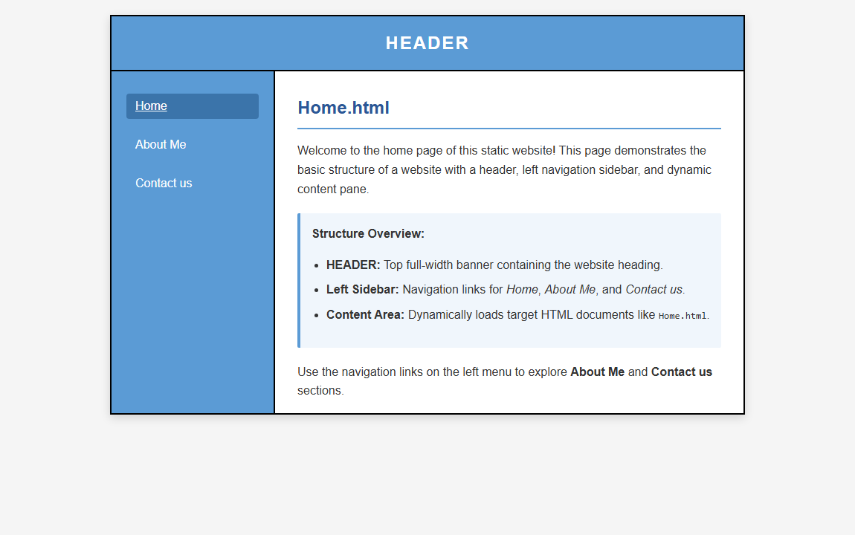
―――――――――――――――――――――――――――――――――――――――――――――――――――――――
Experiment 2.2: Create a student registration form using <form>, <input>, <textarea>, <button>, <select>, <option>
Code:
<!DOCTYPE html>
<html lang="en">
<head>
<meta charset="UTF-8">
<meta name="viewport" content="width=device-width, initial-scale=1.0">
<title>Student Registration Form</title>
<style>
body {
font-family: Arial, sans-serif;
background-color: #f4f6f9;
padding: 30px;
margin: 0;
}
.form-card {
max-width: 650px;
margin: 0 auto;
background-color: #ffffff;
padding: 35px;
border-radius: 8px;
box-shadow: 0 4px 15px rgba(0,0,0,0.1);
}
h2 {
text-align: center;
color: #007bff;
margin-top: 0;
margin-bottom: 25px;
border-bottom: 2px solid #007bff;
padding-bottom: 10px;
}
.form-group {
margin-bottom: 18px;
}
label {
font-weight: bold;
display: block;
margin-bottom: 6px;
color: #333333;
}
input[type="text"],
input[type="tel"],
input[type="email"],
textarea,
select {
width: 100%;
padding: 10px;
border: 1px solid #cccccc;
border-radius: 4px;
font-size: 14px;
box-sizing: border-box;
}
textarea {
height: 80px;
resize: vertical;
}
.radio-group, .checkbox-group {
display: flex;
gap: 15px;
align-items: center;
margin-top: 5px;
}
.radio-group label, .checkbox-group label {
font-weight: normal;
cursor: pointer;
margin-bottom: 0;
}
.btn-container {
text-align: center;
margin-top: 25px;
}
button {
padding: 12px 30px;
font-size: 16px;
font-weight: bold;
border: none;
border-radius: 4px;
cursor: pointer;
margin: 0 5px;
}
button[type="submit"] {
background-color: #28a745;
color: #ffffff;
}
button[type="submit"]:hover {
background-color: #218838;
}
button[type="reset"] {
background-color: #dc3545;
color: #ffffff;
}
button[type="reset"]:hover {
background-color: #c82333;
}
</style>
</head>
<body>
<div class="form-card">
<h2>Student Registration Form</h2>
<!-- FORM TAG -->
<form action="#" method="POST" onsubmit="alert('Registration Form Submitted Successfully!'); return false;">
<!-- First Name, Middle Name, Last Name -->
<div class="form-group">
<label for="firstName">First Name *</label>
<input type="text" id="firstName" name="firstName" placeholder="Enter First Name" required>
</div>
<div class="form-group">
<label for="middleName">Middle Name</label>
<input type="text" id="middleName" name="middleName" placeholder="Enter Middle Name">
</div>
<div class="form-group">
<label for="lastName">Last Name *</label>
<input type="text" id="lastName" name="lastName" placeholder="Enter Last Name" required>
</div>
<!-- Gender (Radio Buttons) -->
<div class="form-group">
<label>Gender *</label>
<div class="radio-group">
<label><input type="radio" name="gender" value="Male" required> Male</label>
<label><input type="radio" name="gender" value="Female"> Female</label>
<label><input type="radio" name="gender" value="Other"> Other</label>
</div>
</div>
<!-- Address (Textarea) -->
<div class="form-group">
<label for="address">Address *</label>
<textarea id="address" name="address" placeholder="Enter Complete Address" required></textarea>
</div>
<!-- Phone No. & Email ID -->
<div class="form-group">
<label for="phone">Phone No. *</label>
<input type="tel" id="phone" name="phone" placeholder="Enter 10-digit Phone Number" required>
</div>
<div class="form-group">
<label for="email">Email ID *</label>
<input type="email" id="email" name="email" placeholder="Enter Email Address" required>
</div>
<!-- Hobbies (Checkboxes) -->
<div class="form-group">
<label>Hobbies</label>
<div class="checkbox-group">
<label><input type="checkbox" name="hobbies" value="Reading"> Reading</label>
<label><input type="checkbox" name="hobbies" value="Coding"> Coding</label>
<label><input type="checkbox" name="hobbies" value="Sports"> Sports</label>
<label><input type="checkbox" name="hobbies" value="Music"> Music</label>
</div>
</div>
<!-- City, State, Country -->
<div class="form-group">
<label for="city">City *</label>
<input type="text" id="city" name="city" placeholder="Enter City" required>
</div>
<div class="form-group">
<label for="state">State *</label>
<input type="text" id="state" name="state" placeholder="Enter State" required>
</div>
<div class="form-group">
<label for="country">Country *</label>
<input type="text" id="country" name="country" value="India" placeholder="Enter Country" required>
</div>
<!-- College Name (Dropdown Menu) -->
<div
... [Code truncated for print length. Complete source in project files] ...
Output:
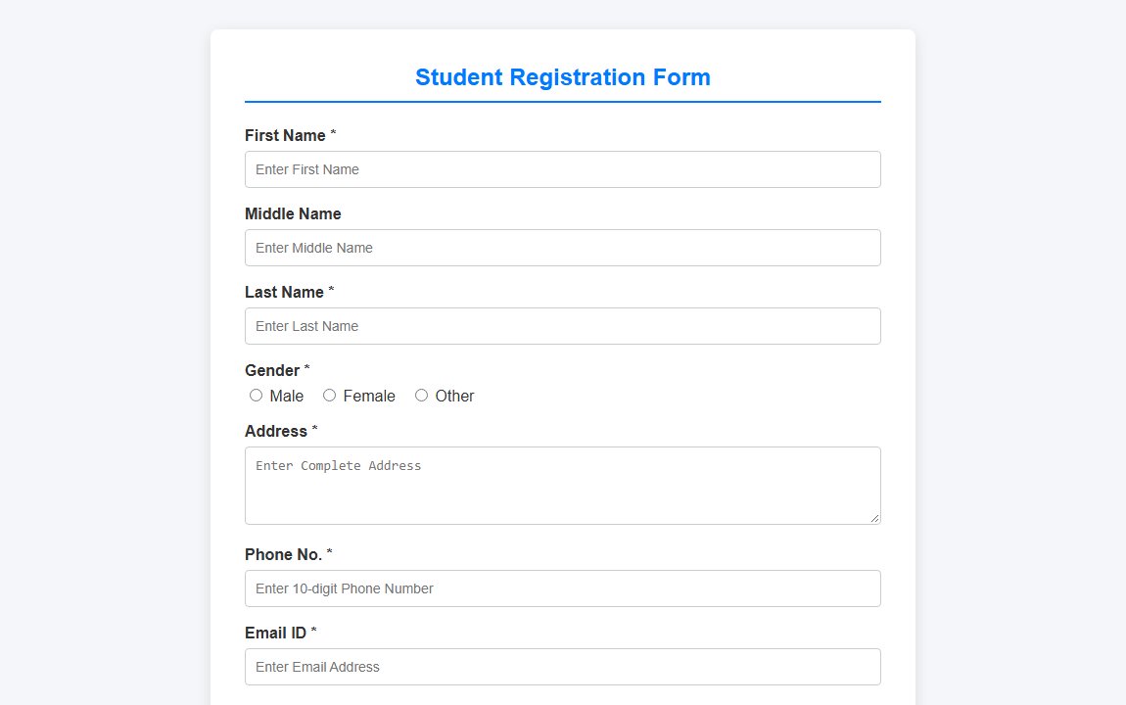
―――――――――――――――――――――――――――――――――――――――――――――――――――――――
Experiment 2.3: Design MSU Home page using HTML5 and also include collage video in it
Code:
<!DOCTYPE html>
<html lang="en">
<head>
<meta charset="UTF-8">
<meta name="viewport" content="width=device-width, initial-scale=1.0">
<title>The Maharaja Sayajirao University of Baroda | MSU Baroda</title>
<!-- FontAwesome Icons -->
<link rel="stylesheet" href="https://cdnjs.cloudflare.com/ajax/libs/font-awesome/6.4.0/css/all.min.css">
<style>
:root {
--msu-blue: #122b4d;
--msu-secondary: #0077b6;
--msu-gold: #e67e22;
--msu-light: #f4f6f9;
--text-dark: #2c3e50;
--text-muted: #6c757d;
}
* {
margin: 0;
padding: 0;
box-sizing: border-box;
}
body {
font-family: 'Segoe UI', Tahoma, Geneva, Verdana, sans-serif;
color: var(--text-dark);
background-color: #ffffff;
line-height: 1.6;
}
/* 1. Top Utility Header */
.top-utility {
background-color: #0d1e36;
color: #ffffff;
font-size: 13px;
padding: 8px 40px;
display: flex;
justify-content: space-between;
align-items: center;
}
.top-utility a {
color: #e0e6ed;
text-decoration: none;
margin: 0 10px;
transition: color 0.2s;
}
.top-utility a:hover {
color: var(--msu-gold);
}
/* 2. Main University Header */
header.university-header {
background-color: #ffffff;
padding: 18px 40px;
display: flex;
align-items: center;
justify-content: space-between;
border-bottom: 3px solid var(--msu-gold);
box-shadow: 0 2px 8px rgba(0,0,0,0.06);
}
.header-brand {
display: flex;
align-items: center;
gap: 20px;
}
.msu-crest {
width: 75px;
height: 75px;
background: linear-gradient(135deg, var(--msu-blue), var(--msu-secondary));
border-radius: 50%;
display: flex;
align-items: center;
justify-content: center;
color: #ffffff;
font-size: 36px;
box-shadow: 0 3px 8px rgba(0,0,0,0.15);
}
.brand-text h1 {
font-size: 24px;
font-weight: 800;
color: var(--msu-blue);
letter-spacing: 0.5px;
text-transform: uppercase;
}
.brand-text h2 {
font-size: 15px;
font-weight: 600;
color: var(--msu-secondary);
}
.brand-text p {
font-size: 12px;
color: var(--text-muted);
}
.header-badges {
text-align: right;
}
.badge-naac {
background-color: var(--msu-gold);
color: #ffffff;
font-weight: bold;
padding: 6px 14px;
border-radius: 4px;
font-size: 13px;
display: inline-block;
}
/* 3. HTML5 Semantic Nav Bar */
nav.main-nav {
background-color: var(--msu-blue);
position: sticky;
top: 0;
z-index: 1000;
box-shadow: 0 4px 10px rgba(0,0,0,0.15);
}
nav.main-nav ul {
list-style: none;
display: flex;
padding: 0 40px;
margin: 0;
}
nav.main-nav li {
position: relative;
}
nav.main-nav a {
display: block;
color: #ffffff;
text-decoration: none;
padding: 14px 18px;
font-size: 14px;
font-weight: 600;
text-transform: uppercase;
letter-spacing: 0.3px;
transition: all 0.2s;
}
nav.main-nav a:hover,
nav.main-nav a.active {
background-color: var(--msu-secondary);
color: #ffffff;
}
/* 4. College Video Showcase Section */
section.video-hero {
background: linear-gradient(rgba(18, 43, 77, 0.92), rgba(18, 43, 77, 0.95));
color: #ffffff;
padding: 50px 40px;
text-align: center;
}
.hero-heading {
margin-bottom: 25px;
}
.hero-heading h2 {
font-size: 32px;
font-weight: 700;
margin-bottom: 8px;
}
.hero-heading h2 span {
color: var(--msu-gold);
}
.hero-heading p {
font-size: 16px;
color: #dbe4ef;
max-width: 750px;
margin: auto;
}
.video-container {
max-width: 900px;
margin: 25px auto 10px auto;
background-color: #000000;
border-radius: 10px;
overflow: hidden;
box-shadow: 0 10px 30px rgba(0,0,0,0.4);
border: 3px solid rgba(255, 255, 255, 0.15);
}
video.college-video {
width: 100%;
height: auto;
max-height: 480px;
display: block;
outline: none;
}
.video-caption {
padding: 12px;
background-color: #0a1728;
font-size: 13px;
color: #a0b2c6;
}
/* 5. Main Content Container */
main.content-wrapper {
max-width: 1200px;
margin: 40px auto;
padding: 0 20px;
}
.section-title {
text-align: center;
margin-bottom: 35px;
position: relative;
}
.section-title h3 {
font-size: 26px;
color: var(--msu-blue);
text-transform: uppercase;
font-weight: 800;
}
.section-title h3 span {
color: var(--msu-gold);
}
.s
... [Code truncated for print length. Complete source in project files] ...
Output:

―――――――――――――――――――――――――――――――――――――――――――――――――――――――
― LAB - 3 ―
Experiment 3.1: Design vertical navigation bar like following
Code:
<!DOCTYPE html>
<html lang="en">
<head>
<meta charset="UTF-8">
<meta name="viewport" content="width=device-width, initial-scale=1.0">
<title>Vertical Navigation Bar</title>
<style>
ul {
list-style-type: none;
margin: 0;
padding: 10px 0;
width: 200px;
background-color: #89c440;
}
li a {
display: block;
color: #ffffff;
font-family: 'Times New Roman', Times, serif;
font-weight: bold;
font-size: 18px;
text-transform: uppercase;
text-align: center;
padding: 10px 15px;
text-decoration: none;
}
li a:hover {
background-color: #7ab332;
}
</style>
</head>
<body>
<ul>
<li><a href="#">HOME</a></li>
<li><a href="#">NEWS</a></li>
<li><a href="#">CONTACT</a></li>
<li><a href="#">ABOUT</a></li>
</ul>
</body>
</html>
Output:
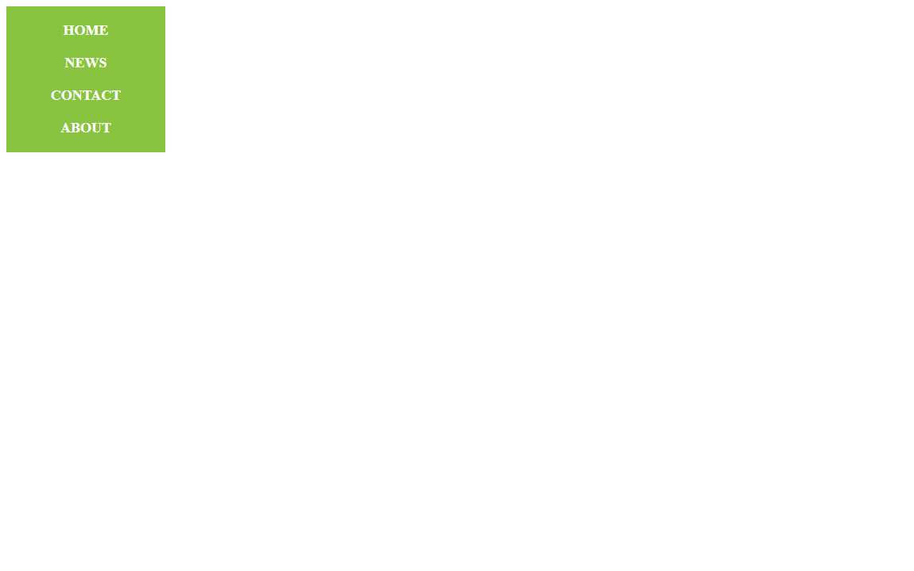
―――――――――――――――――――――――――――――――――――――――――――――――――――――――
Experiment 3.2: Design horizontal navigation bar like following
Code:
<!DOCTYPE html>
<html lang="en">
<head>
<meta charset="UTF-8">
<meta name="viewport" content="width=device-width, initial-scale=1.0">
<title>Horizontal Navigation Bar</title>
<style>
ul {
list-style-type: none;
margin: 0;
padding: 0;
overflow: hidden;
background-color: #89c440;
width: 800px;
}
li {
float: left;
width: 200px;
}
li a {
display: block;
color: #ffffff;
font-family: 'Times New Roman', Times, serif;
font-weight: bold;
font-size: 18px;
text-transform: uppercase;
text-align: center;
padding: 10px 0;
text-decoration: none;
}
li a:hover {
background-color: #7ab332;
}
</style>
</head>
<body>
<ul>
<li><a href="#">HOME</a></li>
<li><a href="#">NEWS</a></li>
<li><a href="#">CONTACT</a></li>
<li><a href="#">ABOUT</a></li>
</ul>
</body>
</html>
Output:
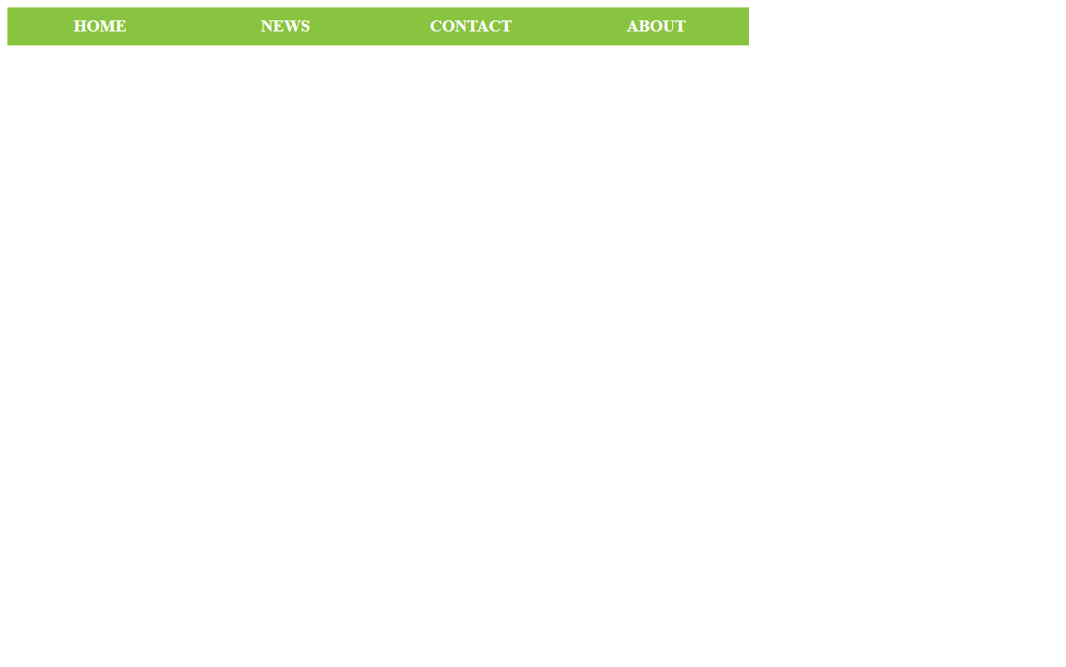
―――――――――――――――――――――――――――――――――――――――――――――――――――――――
Experiment 3.3: Create art and craft photo album using bootstrap
Code:
<!DOCTYPE html>
<html lang="en">
<head>
<meta charset="UTF-8">
<meta name="viewport" content="width=device-width, initial-scale=1.0">
<title>Art and Craft Photo Album</title>
<!-- Bootstrap 5 CSS -->
<link href="https://cdn.jsdelivr.net/npm/bootstrap@5.3.2/dist/css/bootstrap.min.css" rel="stylesheet">
<style>
body {
background-color: #f8f9fa;
}
.hero-section {
background-color: #343a40;
color: #ffffff;
padding: 60px 0;
text-align: center;
}
.card-img-top {
height: 220px;
object-fit: cover;
}
.card {
box-shadow: 0 4px 8px rgba(0, 0, 0, 0.1);
transition: transform 0.2s;
}
.card:hover {
transform: translateY(-5px);
}
footer {
background-color: #212529;
color: #ffffff;
padding: 20px 0;
margin-top: 50px;
text-align: center;
}
</style>
</head>
<body>
<!-- Header / Hero Section -->
<div class="hero-section mb-5">
<div class="container">
<h1 class="fw-bold">Art & Craft Photo Album</h1>
<p class="lead">A showcase of handmade pottery, paintings, paper crafts, and creative designs.</p>
</div>
</div>
<!-- Album Photo Gallery -->
<div class="container mb-5">
<div class="row row-cols-1 row-cols-sm-2 row-cols-md-3 g-4">
<!-- Card 1 -->
<div class="col">
<div class="card h-100">
<img src="https://images.unsplash.com/photo-1565193566173-7a0ee3dbe261?auto=format&fit=crop&w=500&q=80" class="card-img-top" alt="Pottery & Clay Art">
<div class="card-body">
<h5 class="card-title fw-bold">Pottery & Clay Art</h5>
<p class="card-text text-muted">Handcrafted ceramic vases and pottery made using traditional spinning wheels.</p>
<div class="d-flex justify-content-between align-items-center">
<button type="button" class="btn btn-sm btn-outline-primary">View</button>
<small class="text-muted">9 mins ago</small>
</div>
</div>
</div>
</div>
<!-- Card 2 -->
<div class="col">
<div class="card h-100">
<img src="https://images.unsplash.com/photo-1579783902614-a3fb3927b675?auto=format&fit=crop&w=500&q=80" class="card-img-top" alt="Canvas Oil Painting">
<div class="card-body">
<h5 class="card-title fw-bold">Canvas Oil Painting</h5>
<p class="card-text text-muted">Vibrant abstract canvas paintings created with acrylics and oil colors.</p>
<div class="d-flex justify-content-between align-items-center">
<button type="button" class="btn btn-sm btn-outline-primary">View</button>
<small class="text-muted">15 mins ago</small>
</div>
</div>
</div>
</div>
<!-- Card 3 -->
<div class="col">
<div class="card h-100">
<img src="https://images.unsplash.com/photo-1513519245088-0e12902e5a38?auto=format&fit=crop&w=500&q=80" class="card-img-top" alt="Paper & Origami Crafts">
<div class="card-body">
<h5 class="card-title fw-bold">Paper & Origami Crafts</h5>
<p class="card-text text-muted">Creative paper quilling, origami sculptures, and handmade greeting cards.</p>
<div class="d-flex justify-content-between align-items-center">
<button type="button" class="btn btn-sm btn-outline-primary">View</button>
<small class="text-muted">30 mins ago</small>
</div>
</div>
</div>
</div>
<!-- Card 4 -->
<div class="col">
<div class="card h-100">
<img src="https://images.unsplash.com/photo-1520412099551-62b6bafeb5bb?auto=format&fit=crop&w=500&q=80" class="card-img-top" alt="Handmade Wooden Crafts">
<div class="card-body">
<h5 class="card-title fw-bold">Wooden Handcrafts</h5>
<p class="card-text text-muted">Custom carved wooden home decor items, toys, and aesthetic wall art.</p>
<div class="d-flex justify-content-between align-items-center">
<button type="button" class="btn btn-sm btn-outline-primary">View</button>
<small class="text-muted">1 hour ago</small>
</div>
</div>
</div>
</div>
<!-- Card 5 -->
<div class="col">
<div class="card h-100">
<img src="https://images.unsplash.com/photo-1606760227091-3dd850d97f1d?auto=format&fit=crop&w=500&q=80" class="card-img-top" alt="Knitting & Thread Art">
<div class="card-body">
<h5 class="card-title fw-bold">Knitting & Thread Art</h5>
<p class="card-text text-muted">Hand-knit wool products, macrame wall hangings, and embroidery patterns.</p>
<div class="d-flex justify-content-between align-items-center">
<button type="button" class="btn btn-sm btn-outline-primary">View</button>
<small class="text-muted">2 hours ago</small>
</div>
</div>
</div>
</div>
... [Code truncated for print length. Complete source in project files] ...
Output:
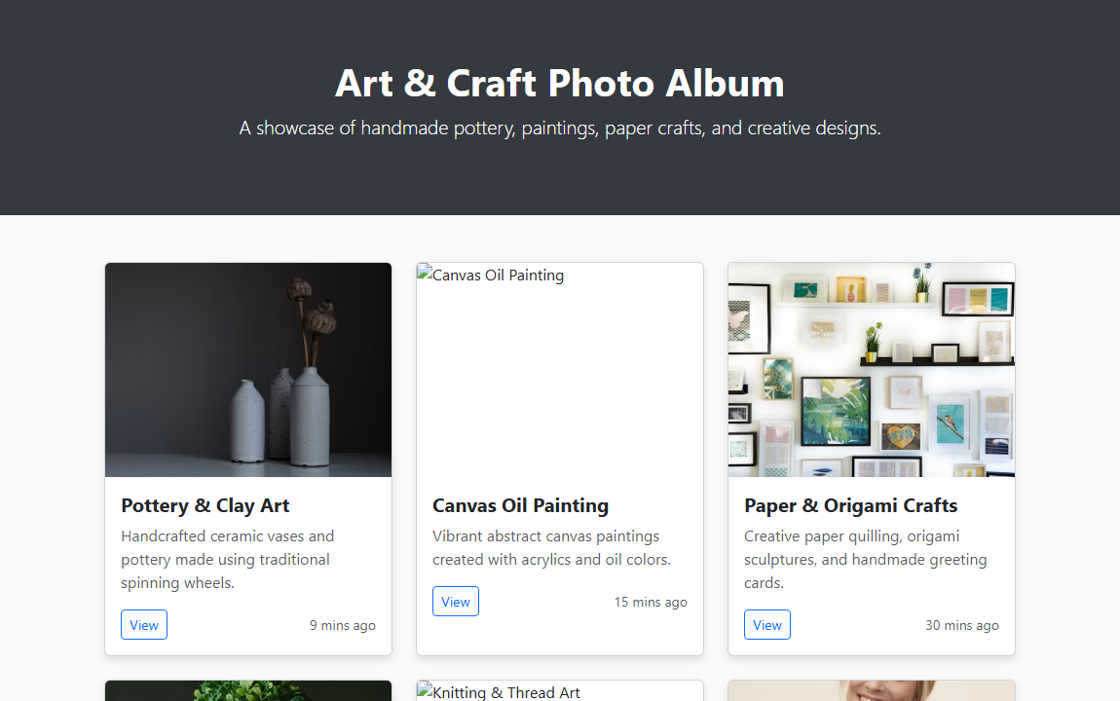
―――――――――――――――――――――――――――――――――――――――――――――――――――――――
Experiment 3.4: Create student marksheet using bootstrap
Code:
<!DOCTYPE html>
<html lang="en">
<head>
<meta charset="UTF-8">
<meta name="viewport" content="width=device-width, initial-scale=1.0">
<title>Student Marksheet</title>
<!-- Bootstrap 5 CSS -->
<link href="https://cdn.jsdelivr.net/npm/bootstrap@5.3.2/dist/css/bootstrap.min.css" rel="stylesheet">
<style>
body {
background-color: #f4f6f9;
font-family: Arial, sans-serif;
padding: 30px 0;
}
.marksheet-card {
background-color: #ffffff;
border-radius: 8px;
box-shadow: 0 4px 12px rgba(0, 0, 0, 0.1);
padding: 30px;
max-width: 850px;
margin: auto;
}
.university-header {
text-align: center;
border-bottom: 2px solid #0d6efd;
padding-bottom: 15px;
margin-bottom: 25px;
}
.info-table td {
padding: 6px 12px;
font-size: 0.95rem;
}
.summary-box {
background-color: #e9ecef;
border-radius: 6px;
padding: 15px;
margin-top: 20px;
}
</style>
</head>
<body>
<div class="container">
<div class="marksheet-card">
<!-- Header Section -->
<div class="university-header">
<h3 class="fw-bold text-primary mb-1">FACULTY OF TECHNOLOGY & ENGINEERING</h3>
<h5 class="text-secondary mb-0">STUDENT ACADEMIC MARKSHEET</h5>
</div>
<!-- Student Info Section -->
<div class="row mb-4">
<div class="col-md-6">
<table class="table-borderless info-table">
<tr><td><strong>Student Name:</strong> OM KUMAR KHATRI</td></tr>
<tr><td><strong>Enrollment No:</strong> 2026001234</td></tr>
<tr><td><strong>Roll No:</strong> 105</td></tr>
</table>
</div>
<div class="col-md-6">
<table class="table-borderless info-table">
<tr><td><strong>Course:</strong> B.E. Computer Science &amp; Engineering</td></tr>
<tr><td><strong>Semester:</strong> IV (4th Semester)</td></tr>
<tr><td><strong>Academic Year:</strong> 2025 - 2026</td></tr>
</table>
</div>
</div>
<!-- Marksheet Table -->
<div class="table-responsive">
<table class="table table-bordered table-striped table-hover align-middle">
<thead class="table-primary text-center">
<tr>
<th>Sub Code</th>
<th>Subject Name</th>
<th>Max Marks</th>
<th>Min Marks</th>
<th>Obtained Marks</th>
<th>Grade</th>
<th>Result</th>
</tr>
</thead>
<tbody>
<tr>
<td class="text-center">CSE401</td>
<td>Basic Web Programming (BWP)</td>
<td class="text-center">100</td>
<td class="text-center">40</td>
<td class="text-center fw-bold">88</td>
<td class="text-center text-primary fw-bold">A+</td>
<td class="text-center"><span class="badge bg-success">PASS</span></td>
</tr>
<tr>
<td class="text-center">CSE402</td>
<td>Data Structures & Algorithms</td>
<td class="text-center">100</td>
<td class="text-center">40</td>
<td class="text-center fw-bold">82</td>
<td class="text-center text-primary fw-bold">A</td>
<td class="text-center"><span class="badge bg-success">PASS</span></td>
</tr>
<tr>
<td class="text-center">CSE403</td>
<td>Database Management Systems</td>
<td class="text-center">100</td>
<td class="text-center">40</td>
<td class="text-center fw-bold">79</td>
<td class="text-center text-primary fw-bold">B+</td>
<td class="text-center"><span class="badge bg-success">PASS</span></td>
</tr>
<tr>
<td class="text-center">CSE404</td>
<td>Operating Systems</td>
<td class="text-center">100</td>
<td class="text-center">40</td>
<td class="text-center fw-bold">85</td>
<td class="text-center text-primary fw-bold">A</td>
<td class="text-center"><span class="badge bg-success">PASS</span></td>
</tr>
<tr>
<td class="text-center">CSE405</td>
<td>Computer Networks</td>
<td class="text-center">100</td>
<td class="text-center">40</td>
<td class="text-center fw-bold">91</td>
<td class="text-center text-primary fw-bold">O</td>
<td class="text-center"><span class="badge bg-success">PASS</span></td>
</tr>
</tbody>
</table>
</div>
... [Code truncated for print length. Complete source in project files] ...
Output:

―――――――――――――――――――――――――――――――――――――――――――――――――――――――
Experiment 3.5: Create employment application form like below
Code:
<!DOCTYPE html>
<html lang="en">
<head>
<meta charset="UTF-8">
<meta name="viewport" content="width=device-width, initial-scale=1.0">
<title>Employment Application Form</title>
<style>
body {
font-family: Arial, sans-serif;
background-color: #f4f4f4;
padding: 20px;
}
.form-container {
width: 780px;
margin: 0 auto;
background-color: #ffffff;
border: 2px solid #000000;
padding: 10px;
}
h2.title {
text-align: center;
font-weight: bold;
font-size: 22px;
margin-top: 5px;
margin-bottom: 15px;
letter-spacing: 1px;
}
.blue-header {
background-color: #0073cb;
color: #ffffff;
text-align: center;
font-weight: bold;
padding: 8px;
font-size: 13px;
}
.grey-header {
background-color: #e6e6e6;
text-align: center;
font-weight: bold;
padding: 6px;
font-size: 13px;
border-top: 1px solid #000;
border-bottom: 1px solid #000;
}
table.form-table {
width: 100%;
border-collapse: collapse;
}
table.form-table td, table.form-table th {
border: 1px solid #000000;
padding: 6px;
font-size: 13px;
vertical-align: top;
}
.sub-label {
display: flex;
justify-content: space-around;
font-size: 11px;
color: #333333;
margin-top: 4px;
}
input[type="text"], input[type="date"], input[type="number"] {
width: 95%;
border: none;
border-bottom: 1px solid #999;
outline: none;
font-size: 13px;
background: transparent;
}
.days-grid {
display: grid;
grid-template-columns: 1fr 1fr;
gap: 5px;
font-size: 12px;
}
.section-title-bg {
background-color: #dcdcdc;
font-weight: bold;
}
</style>
</head>
<body>
<div class="form-container">
<h2 class="title">EMPLOYMENT APPLICATION FORM</h2>
<div class="blue-header">
PLEASE PRINT ALL INFORMATION REQUESTED EXCEPT SIGNATURE
</div>
<table class="form-table">
<tr>
<td colspan="2" class="text-center fw-bold" style="text-align: center;">
<strong>APPLICANTS MAY BE TESTED FOR ILLEGAL DRUGS</strong>
</td>
</tr>
<tr>
<td style="width: 70%;">
<strong>PLEASE COMPLETE PAGES 1-5.</strong>
</td>
<td style="width: 30%;">
<strong>Date:</strong> <input type="date">
</td>
</tr>
<tr>
<td colspan="2">
<strong>Name:</strong> <input type="text" placeholder="Enter Full Name">
<div class="sub-label">
<span>Last</span>
<span>First</span>
<span>Middle</span>
<span>Maiden</span>
</div>
</td>
</tr>
<tr>
<td colspan="2">
<strong>Present Address:</strong> <input type="text">
<div class="sub-label">
<span>Number</span>
<span>Street</span>
<span>City</span>
<span>State</span>
<span>Zip</span>
</div>
</td>
</tr>
<tr>
<td>
<strong>How Long:</strong> <input type="text">
</td>
<td>
<strong>Social Security No.:</strong> <input type="text">
</td>
</tr>
<tr>
<td colspan="2">
<strong>Telephone:</strong> <input type="text">
</td>
</tr>
<tr>
<td colspan="2">
<strong>If under 18, please list age:</strong> <input type="number" style="width: 100px;">
</td>
</tr>
<tr>
<td>
<strong>Position Applied For:</strong> <input type="text"><br><br>
<strong>Salary Desired:</strong> <input type="text">
</td>
<td>
<strong>Days/Hours Available to Work:</strong>
<div class="days-grid" style="margin-top: 5px;">
<div>No Pref <input type="text" style="width: 60px;"></div>
<div>Thur <input type="text" style="width: 60px;"></div>
<div>Mon <input type="text" style="width: 60px;"></div>
<div>Fri <input type="text" style="width: 60px;"></div>
<div>Tue <input type="text" style="width: 60px;"></div>
<div>Sat <input type="text" style="width: 60px;"></div>
<div>Wed <input type="text" style="width: 60px;"></div>
<div>Sun <input type="text" style="width: 60px;"></div>
</div>
</td>
</tr>
<tr>
<td>
<strong>How many hours can you work weekly?</strong> <input type="text">
</td>
<td>
<strong>Can you work nights?</strong> <input type="text">
</td>
</tr>
<tr>
<td colspan="2">
... [Code truncated for print length. Complete source in project files] ...
Output:
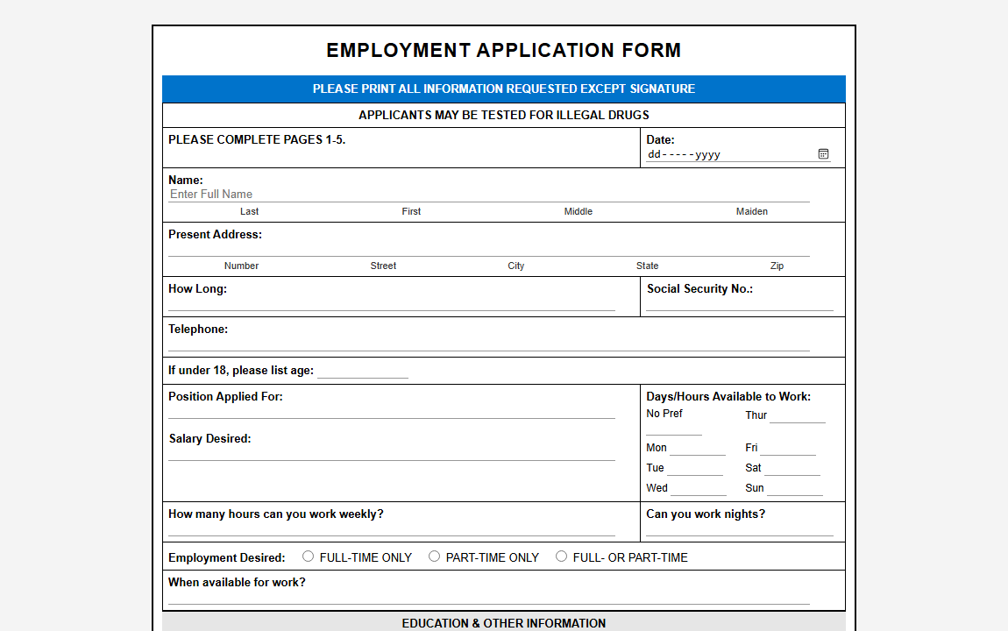
―――――――――――――――――――――――――――――――――――――――――――――――――――――――
Experiment 3.6: Design home of flipKart in which Navigation bar with dropdown is available using bootstrap
Code:
<!DOCTYPE html>
<html lang="en">
<head>
<meta charset="UTF-8">
<meta name="viewport" content="width=device-width, initial-scale=1.0">
<title>Flipkart - Online Shopping Site</title>
<!-- Bootstrap 5 CSS -->
<link href="https://cdn.jsdelivr.net/npm/bootstrap@5.3.2/dist/css/bootstrap.min.css" rel="stylesheet">
<!-- FontAwesome Icons -->
<link rel="stylesheet" href="https://cdnjs.cloudflare.com/ajax/libs/font-awesome/6.4.0/css/all.min.css">
<style>
body {
background-color: #f1f3f6;
font-family: Arial, sans-serif;
}
/* Top Blue Header */
.fk-navbar {
background-color: #2874f0;
padding: 10px 0;
}
.fk-logo {
font-weight: 700;
font-style: italic;
font-size: 1.3rem;
color: #ffffff;
text-decoration: none;
line-height: 1;
}
.fk-logo span {
color: #ffe500;
}
.fk-sub-logo {
font-size: 0.7rem;
color: #ffffff;
font-style: italic;
}
.fk-search-input {
border-radius: 2px 0 0 2px;
border: none;
font-size: 0.9rem;
padding: 8px 16px;
}
.fk-search-btn {
border-radius: 0 2px 2px 0;
background: #ffffff;
border: none;
color: #2874f0;
}
.btn-fk-login {
background-color: #ffffff;
color: #2874f0;
font-weight: 600;
border-radius: 2px;
padding: 5px 25px;
text-decoration: none;
}
.btn-fk-login:hover {
background-color: #f0f0f0;
color: #2874f0;
}
.header-link {
color: #ffffff;
font-weight: 600;
text-decoration: none;
font-size: 0.95rem;
}
.header-link:hover {
color: #ffffff;
}
/* Category Navigation Ribbon */
.category-ribbon {
background-color: #ffffff;
box-shadow: 0 1px 1px 0 rgba(0,0,0,0.16);
padding: 10px 0;
}
.category-ribbon .nav-link {
color: #212121;
font-weight: 600;
font-size: 0.88rem;
padding: 8px 12px !important;
}
.category-ribbon .nav-link:hover {
color: #2874f0;
}
/* Product Cards */
.product-card {
background-color: #ffffff;
border-radius: 4px;
padding: 15px;
text-align: center;
transition: transform 0.2s;
border: 1px solid #e0e0e0;
}
.product-card:hover {
transform: translateY(-4px);
box-shadow: 0 4px 12px rgba(0,0,0,0.1);
}
.product-card img {
height: 150px;
object-fit: contain;
margin-bottom: 10px;
}
.product-title {
font-size: 0.9rem;
font-weight: 600;
color: #212121;
margin-bottom: 4px;
}
.product-offer {
font-size: 0.85rem;
color: #388e3c;
font-weight: bold;
}
.product-sub {
font-size: 0.8rem;
color: #878787;
}
/* Footer */
footer {
background-color: #172337;
color: #878787;
font-size: 0.8rem;
padding: 40px 0 20px;
margin-top: 40px;
}
footer h6 {
color: #878787;
font-size: 0.75rem;
text-transform: uppercase;
margin-bottom: 12px;
font-weight: bold;
}
footer ul {
list-style: none;
padding: 0;
}
footer ul li {
margin-bottom: 6px;
}
footer ul li a {
color: #ffffff;
text-decoration: none;
}
footer ul li a:hover {
text-decoration: underline;
}
</style>
</head>
<body>
<!-- 1. Top Blue Header Navbar -->
<header class="fk-navbar sticky-top">
<div class="container d-flex align-items-center justify-content-between">
<!-- Logo -->
<a href="#" class="d-flex flex-column text-white text-decoration-none me-3">
<span class="fk-logo">Flipkart <span>Plus</span></span>
<span class="fk-sub-logo">Explore <span style="color: #ffe500;">Plus <i class="fa-solid fa-plus"></i></span></span>
</a>
<!-- Search Bar -->
<div class="input-group flex-grow-1 mx-3" style="max-width: 500px;">
<input type="text" class="form-control fk-search-input" placeholder="Search for products, brands and more">
<button class="btn fk-search-btn" type="button"><i class="fa-solid fa-magnifying-glass"></i></button>
</div>
<!-- Login Dropdown & Header Options -->
<div class="d-flex align-items-center gap-4">
<!-- Login Dropdown -->
<div class="dropdown">
<a href="#" class="btn-fk-login dropdown-toggle" role="button" data-bs-toggle="dropdown">Login</a>
<ul class="dropdown-menu shadow">
<li><a class="dropdown-item" href="#"><i class="fa-regular fa-circle-user me-2 text-primary"></i> My Profile</a></li>
<li><a class="dropdown-item" href="#"><i class="fa-solid fa-box me-2 text-primary"></i> Orders</a></li>
<li><a class="dropdown-item" href="#"><i class="fa-regular fa-heart me-2 text-primary"></i> Wishlist</a></li>
<li><a class="dropdown-item" href="#"><i class="fa-solid fa-gift me-2 text-primary"></i> Rewards</a></li>
</ul>
... [Code truncated for print length. Complete source in project files] ...
Output:
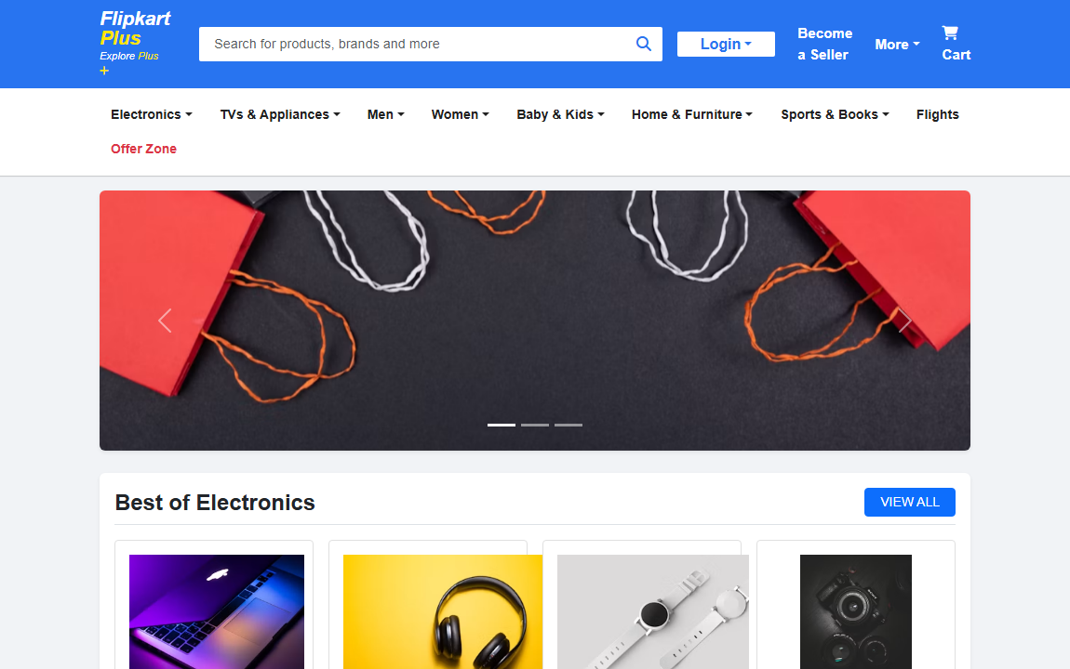
―――――――――――――――――――――――――――――――――――――――――――――――――――――――
― LAB - 4 ―
Experiment 4.1: Play video in your web page and play/pause, change the dimension of it using javascript using button(small,normal,large)
Code:
<!DOCTYPE html>
<html lang="en">
<head>
<meta charset="UTF-8">
<meta name="viewport" content="width=device-width, initial-scale=1.0">
<title>Lab 4.1 - Video Player Controls</title>
<style>
body {
font-family: Arial, sans-serif;
background-color: #f4f4f4;
padding: 30px;
text-align: center;
}
.container {
background-color: #ffffff;
border-radius: 8px;
padding: 25px;
max-width: 900px;
margin: auto;
box-shadow: 0 4px 10px rgba(0,0,0,0.1);
}
video {
border: 2px solid #333333;
border-radius: 6px;
margin-bottom: 20px;
transition: width 0.3s ease;
}
.btn-group button {
background-color: #007bff;
color: #ffffff;
border: none;
padding: 10px 18px;
margin: 5px;
font-size: 15px;
font-weight: bold;
border-radius: 4px;
cursor: pointer;
transition: background 0.2s;
}
.btn-group button:hover {
background-color: #0056b3;
}
.btn-group button.btn-danger {
background-color: #dc3545;
}
.btn-group button.btn-danger:hover {
background-color: #a71d2a;
}
</style>
</head>
<body>
<div class="container">
<h2>Video Player with JavaScript Controls</h2>
<p>Use the buttons below to Play/Pause and change video dimensions.</p>
<!-- Video Element -->
<video id="myVideo" width="560" controls>
<source src="https://www.w3schools.com/html/mov_bbb.mp4" type="video/mp4">
Your browser does not support the video tag.
</video>
<!-- Control Buttons -->
<div class="btn-group">
<button onclick="playPause()" id="playBtn">Play / Pause</button>
<button onclick="makeSmall()">Small (320px)</button>
<button onclick="makeNormal()">Normal (560px)</button>
<button onclick="makeLarge()">Large (800px)</button>
</div>
</div>
<script>
var video = document.getElementById("myVideo");
function playPause() {
if (video.paused) {
video.play();
} else {
video.pause();
}
}
function makeSmall() {
video.width = 320;
}
function makeNormal() {
video.width = 560;
}
function makeLarge() {
video.width = 800;
}
</script>
</body>
</html>
Output:
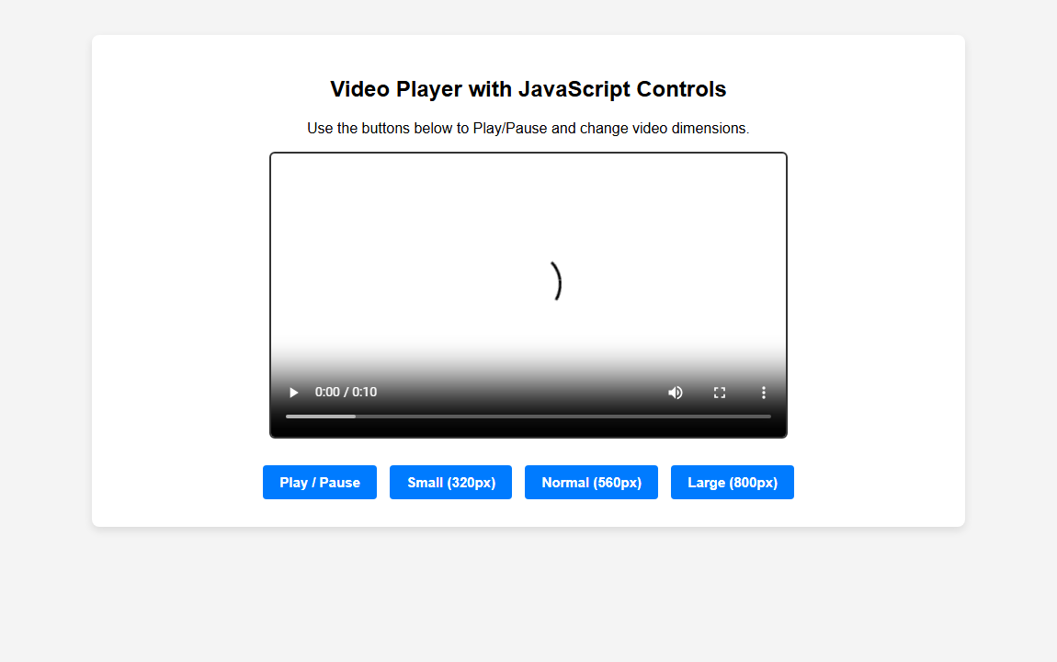
―――――――――――――――――――――――――――――――――――――――――――――――――――――――
Experiment 4.2: Implement Type Writer using DHTML and Javascript
Code:
<!DOCTYPE html>
<html lang="en">
<head>
<meta charset="UTF-8">
<meta name="viewport" content="width=device-width, initial-scale=1.0">
<title>Lab 4.2 - Typewriter Effect</title>
<style>
body {
font-family: 'Courier New', Courier, monospace;
background-color: #1e1e1e;
color: #00ff66;
display: flex;
justify-content: center;
align-items: center;
min-height: 100vh;
margin: 0;
}
.typewriter-box {
background-color: #2b2b2b;
border: 2px solid #00ff66;
border-radius: 8px;
padding: 30px;
width: 600px;
box-shadow: 0 0 15px rgba(0, 255, 102, 0.3);
}
h2 {
color: #ffffff;
font-family: Arial, sans-serif;
text-align: center;
margin-top: 0;
}
#typewriter {
font-size: 20px;
min-height: 80px;
line-height: 1.5;
white-space: pre-wrap;
border-right: 3px solid #00ff66;
animation: blink 0.75s step-end infinite;
}
@keyframes blink {
from, to { border-color: transparent }
50% { border-color: #00ff66; }
}
.controls {
text-align: center;
margin-top: 25px;
}
button {
background-color: #00ff66;
color: #1e1e1e;
border: none;
padding: 10px 20px;
font-size: 15px;
font-weight: bold;
border-radius: 4px;
cursor: pointer;
margin: 0 5px;
}
button:hover {
background-color: #00cc52;
}
</style>
</head>
<body>
<div class="typewriter-box">
<h2>Type Writer Effect</h2>
<hr style="border-color: #444;">
<div id="typewriter"></div>
<div class="controls">
<button onclick="startTypewriter()">Start Typing</button>
<button onclick="resetTypewriter()">Reset</button>
</div>
</div>
<script>
var text = "Hello! Welcome to the DHTML & JavaScript Typewriter Demonstration. This text is typed out character by character dynamically.";
var index = 0;
var speed = 70;
var timer;
function typeWriter() {
if (index < text.length) {
document.getElementById("typewriter").innerHTML += text.charAt(index);
index++;
timer = setTimeout(typeWriter, speed);
}
}
function startTypewriter() {
resetTypewriter();
typeWriter();
}
function resetTypewriter() {
clearTimeout(timer);
index = 0;
document.getElementById("typewriter").innerHTML = "";
}
// Auto start on page load
window.onload = startTypewriter;
</script>
</body>
</html>
Output:
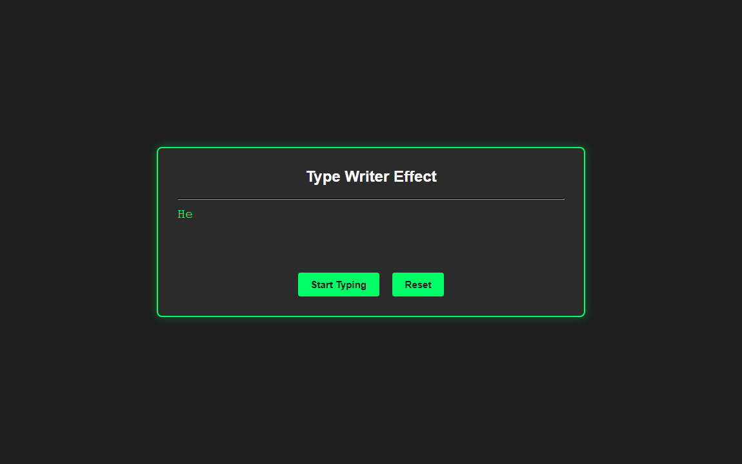
―――――――――――――――――――――――――――――――――――――――――――――――――――――――
Experiment 4.3: Write down java script code to validate user name and password
Code:
<!DOCTYPE html>
<html lang="en">
<head>
<meta charset="UTF-8">
<meta name="viewport" content="width=device-width, initial-scale=1.0">
<title>Lab 4.3 - Form Validation</title>
<style>
body {
font-family: Arial, sans-serif;
background-color: #f4f6f9;
display: flex;
justify-content: center;
align-items: center;
min-height: 100vh;
margin: 0;
}
.form-box {
background-color: #ffffff;
padding: 30px;
border-radius: 8px;
box-shadow: 0 4px 12px rgba(0, 0, 0, 0.1);
width: 380px;
}
h2 {
text-align: center;
color: #333;
margin-bottom: 20px;
}
.form-group {
margin-bottom: 18px;
}
label {
display: block;
margin-bottom: 6px;
font-weight: bold;
color: #555;
}
input[type="text"], input[type="password"] {
width: 100%;
padding: 10px;
border: 1px solid #ccc;
border-radius: 4px;
box-sizing: border-box;
font-size: 14px;
}
button {
width: 100%;
background-color: #28a745;
color: white;
padding: 12px;
border: none;
border-radius: 4px;
font-size: 16px;
font-weight: bold;
cursor: pointer;
}
button:hover {
background-color: #218838;
}
.error-msg {
color: #dc3545;
font-size: 13px;
margin-top: 5px;
display: none;
}
.success-msg {
color: #28a745;
font-size: 14px;
text-align: center;
margin-top: 15px;
display: none;
font-weight: bold;
}
</style>
</head>
<body>
<div class="form-box">
<h2>User Login Validation</h2>
<form id="loginForm" onsubmit="return validateForm(event)">
<div class="form-group">
<label for="username">Username:</label>
<input type="text" id="username" placeholder="Enter username">
<div id="usernameError" class="error-msg"></div>
</div>
<div class="form-group">
<label for="password">Password:</label>
<input type="password" id="password" placeholder="Enter password">
<div id="passwordError" class="error-msg"></div>
</div>
<button type="submit">Submit</button>
<div id="successMsg" class="success-msg">Validation Successful!</div>
</form>
</div>
<script>
function validateForm(event) {
event.preventDefault();
var username = document.getElementById("username").value.trim();
var password = document.getElementById("password").value;
var usernameError = document.getElementById("usernameError");
var passwordError = document.getElementById("passwordError");
var successMsg = document.getElementById("successMsg");
// Reset errors
usernameError.style.display = "none";
passwordError.style.display = "none";
successMsg.style.display = "none";
var isValid = true;
// 1. Username validation: not blank, should not start with _, @, or number
if (username === "") {
usernameError.innerText = "Username cannot be blank.";
usernameError.style.display = "block";
isValid = false;
} else {
var firstChar = username.charAt(0);
if (firstChar === '_' || firstChar === '@' || (firstChar >= '0' && firstChar <= '9')) {
usernameError.innerText = "Username cannot start with '_', '@', or any number.";
usernameError.style.display = "block";
isValid = false;
}
}
// 2. Password validation: not blank, length between 6 and 12 characters
if (password === "") {
passwordError.innerText = "Password cannot be blank.";
passwordError.style.display = "block";
isValid = false;
} else if (password.length < 6 || password.length > 12) {
passwordError.innerText = "Password length must be between 6 to 12 characters.";
passwordError.style.display = "block";
isValid = false;
}
if (isValid) {
successMsg.style.display = "block";
alert("Validation Passed Successfully!");
}
return isValid;
}
</script>
</body>
</html>
Output:
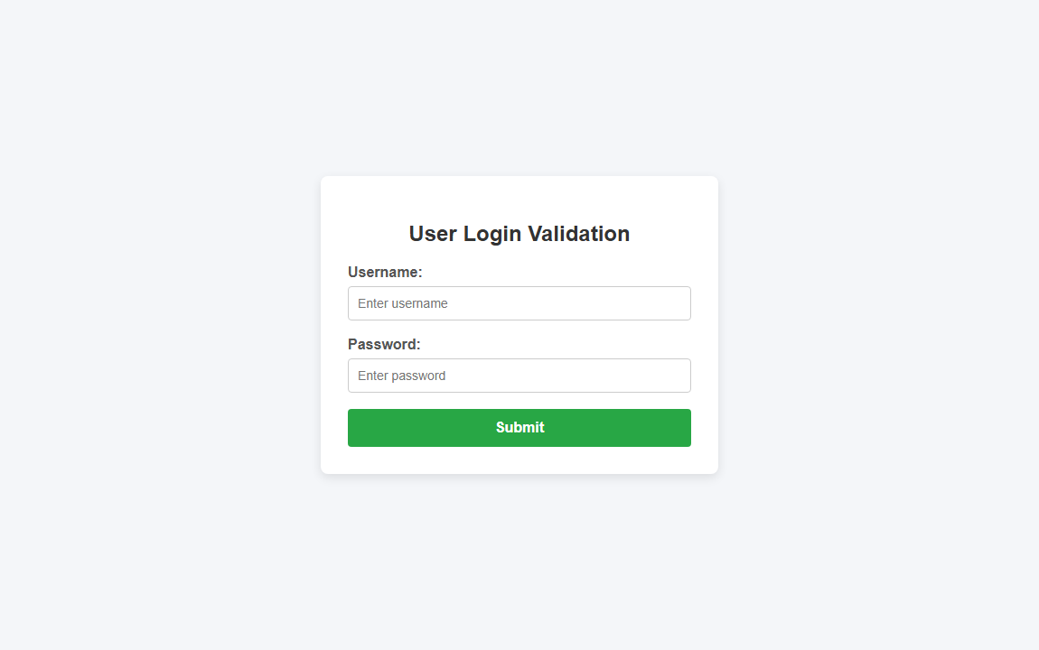
―――――――――――――――――――――――――――――――――――――――――――――――――――――――
Experiment 4.4: Write an HTML file with Javascript that finds position of first occurrence of vowel 'a', last occurrence of vowel 'a' in a given word and returns the string between them
Code:
<!DOCTYPE html>
<html lang="en">
<head>
<meta charset="UTF-8">
<meta name="viewport" content="width=device-width, initial-scale=1.0">
<title>Lab 4.4 - Vowel 'a' Occurrence Finder</title>
<style>
body {
font-family: Arial, sans-serif;
background-color: #f8f9fa;
padding: 40px;
display: flex;
justify-content: center;
}
.box {
background-color: #ffffff;
padding: 30px;
border-radius: 8px;
box-shadow: 0 4px 10px rgba(0,0,0,0.1);
width: 480px;
}
h2 {
text-align: center;
color: #333;
margin-top: 0;
}
label {
font-weight: bold;
display: block;
margin-bottom: 8px;
}
input[type="text"] {
width: 100%;
padding: 10px;
border: 1px solid #ccc;
border-radius: 4px;
font-size: 15px;
box-sizing: border-box;
margin-bottom: 15px;
}
button {
width: 100%;
background-color: #007bff;
color: white;
padding: 10px;
border: none;
border-radius: 4px;
font-size: 16px;
font-weight: bold;
cursor: pointer;
}
button:hover {
background-color: #0056b3;
}
.result-box {
margin-top: 20px;
background-color: #e9ecef;
padding: 15px;
border-radius: 4px;
display: none;
}
.result-box p {
margin: 6px 0;
font-size: 15px;
}
.highlight {
font-weight: bold;
color: #d9534f;
}
</style>
</head>
<body>
<div class="box">
<h2>Vowel 'a' Finder & Substring</h2>
<p class="text-muted" style="font-size: 13px; color: #666;">Enter a word (e.g., <strong>ajanta</strong>) to find first/last position of 'a' and extract the string between them.</p>
<label for="wordInput">Enter Word:</label>
<input type="text" id="wordInput" value="ajanta" placeholder="Type a word...">
<button onclick="findVowels()">Find Positions & Substring</button>
<div id="resultBox" class="result-box">
<p><strong>Input Word:</strong> <span id="resWord"></span></p>
<p><strong>First Occurrence of 'a':</strong> Position <span id="firstPos" class="highlight"></span></p>
<p><strong>Last Occurrence of 'a':</strong> Position <span id="lastPos" class="highlight"></span></p>
<p><strong>String Between Them:</strong> "<span id="betweenStr" class="highlight"></span>"</p>
</div>
</div>
<script>
function findVowels() {
var word = document.getElementById("wordInput").value.trim();
var lowerWord = word.toLowerCase();
var firstIndex = lowerWord.indexOf('a');
var lastIndex = lowerWord.lastIndexOf('a');
var resultBox = document.getElementById("resultBox");
if (firstIndex === -1) {
alert("Vowel 'a' was not found in the given word.");
resultBox.style.display = "none";
return;
}
if (firstIndex === lastIndex) {
alert("Only one occurrence of 'a' was found at position " + (firstIndex + 1) + ". Need at least 2 occurrences of 'a'.");
resultBox.style.display = "none";
return;
}
// Positions (1-indexed for human readability)
var firstPos = firstIndex + 1;
var lastPos = lastIndex + 1;
// Extract string between first 'a' and last 'a'
var substringBetween = word.substring(firstIndex + 1, lastIndex);
document.getElementById("resWord").innerText = word;
document.getElementById("firstPos").innerText = firstPos;
document.getElementById("lastPos").innerText = lastPos;
document.getElementById("betweenStr").innerText = substringBetween;
resultBox.style.display = "block";
}
</script>
</body>
</html>
Output:
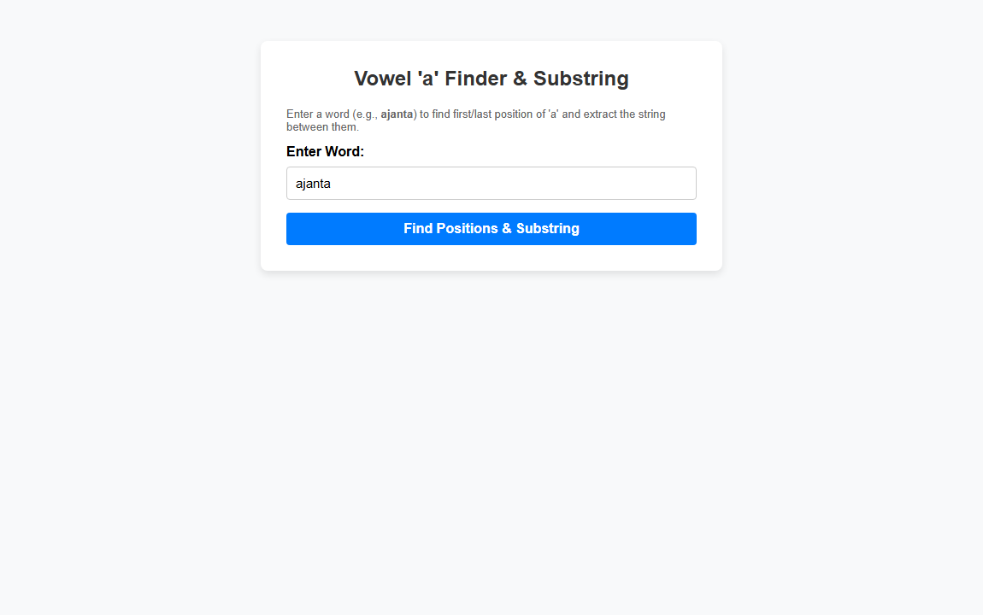
―――――――――――――――――――――――――――――――――――――――――――――――――――――――
Experiment 4.5: Write a JavaScript that handles key events: key code, vowel announcement, and background change to blue on release
Code:
<!DOCTYPE html>
<html lang="en">
<head>
<meta charset="UTF-8">
<meta name="viewport" content="width=device-width, initial-scale=1.0">
<title>Lab 4.5 - Keyboard Event Handler</title>
<style>
body {
font-family: Arial, sans-serif;
background-color: #f0f0f0;
margin: 0;
padding: 0;
min-height: 100vh;
display: flex;
justify-content: center;
align-items: center;
transition: background-color 0.4s ease;
}
.card-box {
background-color: #ffffff;
padding: 35px;
border-radius: 10px;
box-shadow: 0 4px 15px rgba(0, 0, 0, 0.15);
text-align: center;
width: 450px;
}
h2 {
margin-top: 0;
color: #333;
}
.display-key {
font-size: 50px;
font-weight: bold;
color: #007bff;
margin: 15px 0;
min-height: 60px;
}
.info-text {
font-size: 16px;
color: #555;
margin: 10px 0;
}
.vowel-alert {
background-color: #ffc107;
color: #856404;
padding: 10px;
border-radius: 4px;
font-weight: bold;
margin-top: 15px;
display: none;
}
</style>
</head>
<body id="pageBody">
<div class="card-box">
<h2>Keyboard Event Handler</h2>
<p class="info-text">Press any key on your keyboard to test event handling.</p>
<div class="display-key" id="keyDisplay">-</div>
<p class="info-text"><strong>Key Code:</strong> <span id="keyCodeDisplay" style="font-size: 20px; color: #d9534f; font-weight: bold;">-</span></p>
<div id="vowelAlert" class="vowel-alert">
🎉 Vowel is Pressed! (<span id="vowelChar"></span>)
</div>
<p style="font-size: 12px; color: #777; margin-top: 25px;">
<em>Note: When key is released, background will change to blue.</em>
</p>
</div>
<script>
var pageBody = document.getElementById("pageBody");
var keyDisplay = document.getElementById("keyDisplay");
var keyCodeDisplay = document.getElementById("keyCodeDisplay");
var vowelAlert = document.getElementById("vowelAlert");
var vowelChar = document.getElementById("vowelChar");
// Key Down Event Handler
document.addEventListener("keydown", function(event) {
var key = event.key;
var keyCode = event.keyCode || event.which;
// (i) Show Key Code
keyDisplay.innerText = key === " " ? "Space" : key;
keyCodeDisplay.innerText = keyCode;
// (ii) Check if Key is Vowel (a, e, i, o, u)
var lowerKey = key.toLowerCase();
if (lowerKey === 'a' || lowerKey === 'e' || lowerKey === 'i' || lowerKey === 'o' || lowerKey === 'u') {
vowelChar.innerText = key.toUpperCase();
vowelAlert.style.display = "block";
} else {
vowelAlert.style.display = "none";
}
});
// (iii) Key Up Event Handler: Change background to blue
document.addEventListener("keyup", function(event) {
pageBody.style.backgroundColor = "#007bff"; // Blue background on release
});
</script>
</body>
</html>
Output:
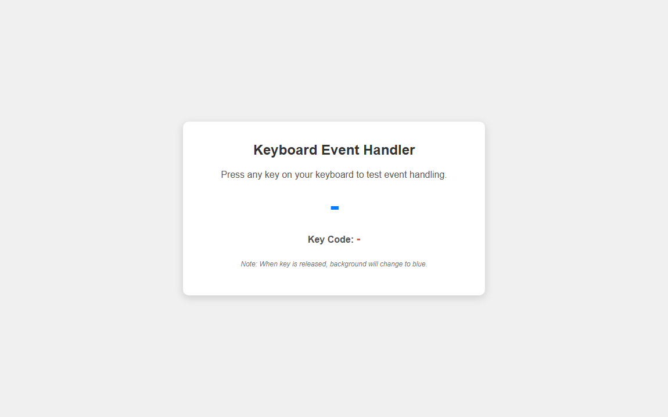
―――――――――――――――――――――――――――――――――――――――――――――――――――――――
Experiment 4.6: Design a webpage which demonstrate snow fall using javascript
Code:
<!DOCTYPE html>
<html lang="en">
<head>
<meta charset="UTF-8">
<meta name="viewport" content="width=device-width, initial-scale=1.0">
<title>Lab 4.6 - Snowfall Animation</title>
<style>
body {
margin: 0;
padding: 0;
overflow: hidden;
background: linear-gradient(to bottom, #020b18 0%, #0a2342 100%);
font-family: Arial, sans-serif;
color: #ffffff;
}
canvas {
display: block;
position: absolute;
top: 0;
left: 0;
z-index: 1;
}
.content-overlay {
position: relative;
z-index: 10;
text-align: center;
margin-top: 50px;
pointer-events: none;
}
h1 {
font-size: 3rem;
text-shadow: 0 0 10px rgba(255, 255, 255, 0.8);
margin-bottom: 10px;
}
p {
font-size: 1.2rem;
color: #d0e8ff;
}
.controls {
pointer-events: auto;
margin-top: 20px;
}
button {
background-color: rgba(255, 255, 255, 0.2);
color: #ffffff;
border: 1px solid #ffffff;
padding: 10px 20px;
font-size: 15px;
border-radius: 20px;
cursor: pointer;
margin: 0 8px;
backdrop-filter: blur(5px);
transition: all 0.3s;
}
button:hover {
background-color: #ffffff;
color: #020b18;
}
</style>
</head>
<body>
<!-- HTML5 Canvas for Snowfall -->
<canvas id="snowCanvas"></canvas>
<!-- Overlay Text & Controls -->
<div class="content-overlay">
<h1>❄ Snowfall Demonstration ❄</h1>
<p>Interactive Snowfall Effect Created using JavaScript & Canvas</p>
<div class="controls">
<button onclick="toggleSnow()">Pause / Resume</button>
<button onclick="addFlakes()">Add More Snow</button>
</div>
</div>
<script>
var canvas = document.getElementById("snowCanvas");
var ctx = canvas.getContext("2d");
// Resize Canvas to Window
function resizeCanvas() {
canvas.width = window.innerWidth;
canvas.height = window.innerHeight;
}
resizeCanvas();
window.addEventListener("resize", resizeCanvas);
// Snowflake Array
var snowflakes = [];
var maxSnowflakes = 150;
var isPaused = false;
// Initialize Snowflakes
function createSnowflake() {
return {
x: Math.random() * canvas.width,
y: Math.random() * canvas.height,
radius: Math.random() * 4 + 1,
density: Math.random() * maxSnowflakes,
speed: Math.random() * 2 + 0.5,
opacity: Math.random() * 0.8 + 0.2,
swing: Math.random() * 0.05
};
}
for (var i = 0; i < maxSnowflakes; i++) {
snowflakes.push(createSnowflake());
}
var angle = 0;
// Draw Snowflakes
function drawSnowflakes() {
ctx.clearRect(0, 0, canvas.width, canvas.height);
for (var i = 0; i < snowflakes.length; i++) {
var flake = snowflakes[i];
ctx.beginPath();
ctx.arc(flake.x, flake.y, flake.radius, 0, Math.PI * 2, false);
ctx.fillStyle = "rgba(255, 255, 255, " + flake.opacity + ")";
ctx.shadowBlur = 5;
ctx.shadowColor = "#ffffff";
ctx.fill();
}
}
// Update Snowflakes Position
function updateSnowflakes() {
angle += 0.01;
for (var i = 0; i < snowflakes.length; i++) {
var flake = snowflakes[i];
// Vertical falling & horizontal gentle sway
flake.y += flake.speed;
flake.x += Math.sin(angle + flake.density) * 0.8;
// Reset snowflake to top when it reaches bottom
if (flake.y > canvas.height) {
snowflakes[i] = {
x: Math.random() * canvas.width,
y: 0,
radius: flake.radius,
density: flake.density,
speed: flake.speed,
opacity: flake.opacity,
swing: flake.swing
};
}
}
}
// Animation Loop
function animate() {
if (!isPaused) {
drawSnowflakes();
updateSnowflakes();
}
requestAnimationFrame(animate);
}
animate();
// Control Functions
function toggleSnow() {
isPaused = !isPaused;
}
function addFlakes() {
for (var i = 0; i < 50; i++) {
snowflakes.push(createSnowflake());
}
}
</script>
</body>
</html>
Output:
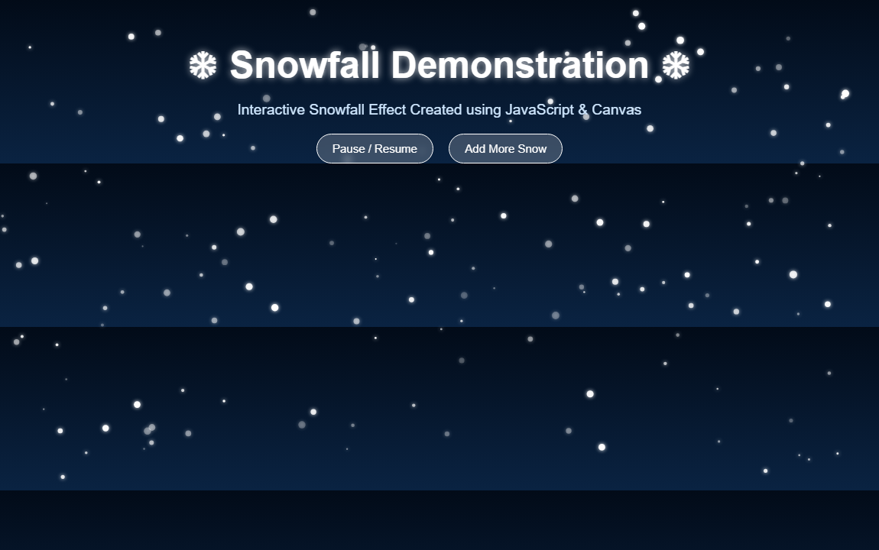
―――――――――――――――――――――――――――――――――――――――――――――――――――――――
― LAB - 5 ―
Experiment 5.1: Use a jQuery method to toggle between sliding up and down a <div> element, when clicking on a button
Code:
<!DOCTYPE html>
<html lang="en">
<head>
<meta charset="UTF-8">
<meta name="viewport" content="width=device-width, initial-scale=1.0">
<title>Lab 5.1 - jQuery Slide Toggle</title>
<!-- Include jQuery -->
<script src="https://code.jquery.com/jquery-3.7.1.min.js"></script>
<style>
body {
font-family: Arial, sans-serif;
background-color: #f4f6f9;
padding: 40px;
text-align: center;
}
.container {
max-width: 500px;
margin: 0 auto;
background: #ffffff;
padding: 25px;
border-radius: 8px;
box-shadow: 0 4px 10px rgba(0,0,0,0.1);
}
#flip {
padding: 12px;
text-align: center;
background-color: #007bff;
color: #ffffff;
border: none;
border-radius: 4px;
font-size: 16px;
font-weight: bold;
cursor: pointer;
width: 100%;
margin-bottom: 15px;
}
#flip:hover {
background-color: #0056b3;
}
#panel {
padding: 40px 20px;
text-align: center;
background-color: #e9ecef;
border: 2px solid #007bff;
border-radius: 6px;
font-size: 18px;
color: #333;
font-weight: bold;
}
</style>
</head>
<body>
<div class="container">
<h2>jQuery slideToggle() Demo</h2>
<p>Click the button below to slide up and down the panel.</p>
<!-- Toggle Button -->
<button id="flip">Click to Slide Toggle Panel</button>
<!-- Target Div -->
<div id="panel">
👋 Hello! I am a sliding div panel.
</div>
</div>
<script>
$(document).ready(function(){
// Use jQuery slideToggle method to slide up and down
$("#flip").click(function(){
$("#panel").slideToggle("slow");
});
});
</script>
</body>
</html>
Output:
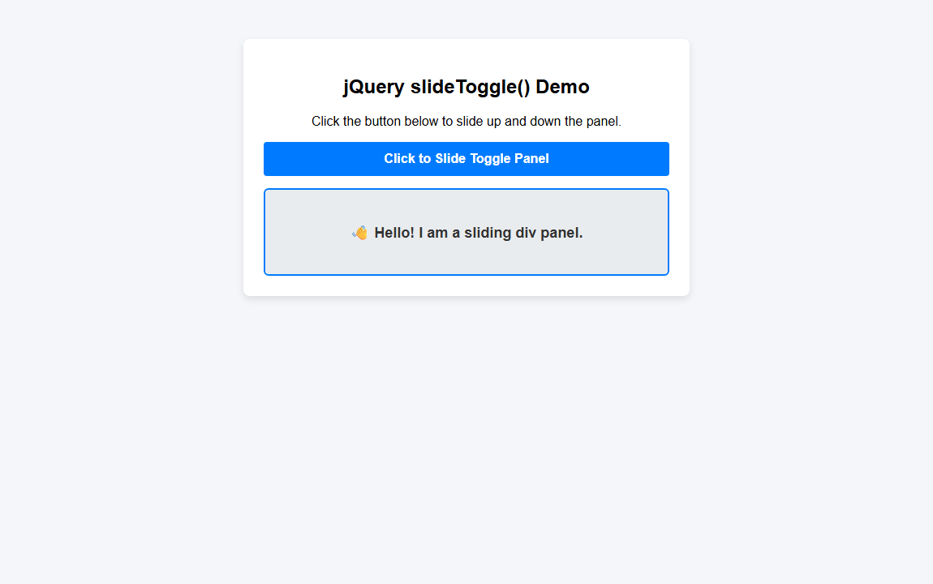
―――――――――――――――――――――――――――――――――――――――――――――――――――――――
Experiment 5.2: Use the animate() method to move a <div> element 250 pixels to the right
Code:
<!DOCTYPE html>
<html lang="en">
<head>
<meta charset="UTF-8">
<meta name="viewport" content="width=device-width, initial-scale=1.0">
<title>Lab 5.2 - jQuery Animate Move Right</title>
<!-- Include jQuery -->
<script src="https://code.jquery.com/jquery-3.7.1.min.js"></script>
<style>
body {
font-family: Arial, sans-serif;
background-color: #f4f6f9;
padding: 40px;
}
.container {
max-width: 600px;
margin: 0 auto;
background: #ffffff;
padding: 25px;
border-radius: 8px;
box-shadow: 0 4px 10px rgba(0,0,0,0.1);
}
button {
background-color: #28a745;
color: #ffffff;
border: none;
padding: 12px 20px;
border-radius: 4px;
font-size: 16px;
font-weight: bold;
cursor: pointer;
margin-bottom: 30px;
}
button:hover {
background-color: #218838;
}
.box-container {
position: relative;
height: 120px;
background-color: #e9ecef;
border-radius: 6px;
padding: 10px;
}
#box {
background-color: #007bff;
color: #ffffff;
width: 100px;
height: 100px;
position: absolute;
left: 10px;
top: 10px;
border-radius: 6px;
display: flex;
align-items: center;
justify-content: center;
font-weight: bold;
}
</style>
</head>
<body>
<div class="container">
<h2>jQuery animate() Move Right</h2>
<p>Click the button to move the box 250 pixels to the right.</p>
<button id="moveBtn">Move 250px Right</button>
<button id="resetBtn" style="background-color: #dc3545;">Reset</button>
<div class="box-container">
<div id="box">MOVE ME</div>
</div>
</div>
<script>
$(document).ready(function(){
// Animate 250px to the right
$("#moveBtn").click(function(){
$("#box").animate({
left: '250px'
});
});
// Reset box position
$("#resetBtn").click(function(){
$("#box").animate({
left: '10px'
});
});
});
</script>
</body>
</html>
Output:
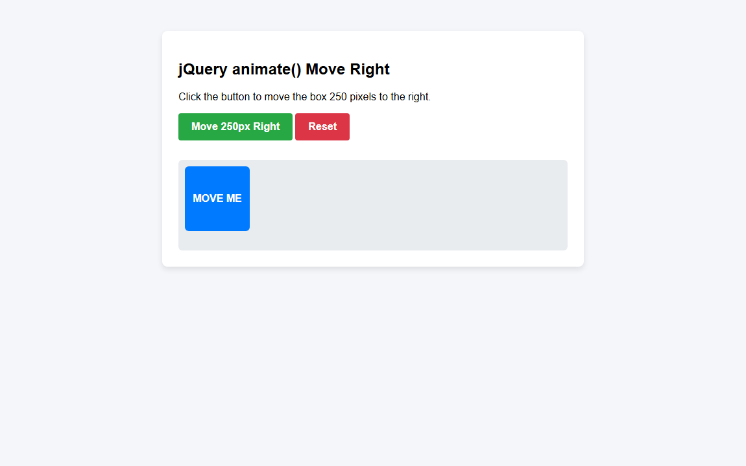
―――――――――――――――――――――――――――――――――――――――――――――――――――――――
Experiment 5.3: Use the animate() method to set CSS properties for <div>: opacity:0.4, height:500px, width:500px
Code:
<!DOCTYPE html>
<html lang="en">
<head>
<meta charset="UTF-8">
<meta name="viewport" content="width=device-width, initial-scale=1.0">
<title>Lab 5.3 - jQuery Animate Multiple Properties</title>
<!-- Include jQuery -->
<script src="https://code.jquery.com/jquery-3.7.1.min.js"></script>
<style>
body {
font-family: Arial, sans-serif;
background-color: #f4f6f9;
padding: 40px;
}
.container {
max-width: 700px;
margin: 0 auto;
background: #ffffff;
padding: 25px;
border-radius: 8px;
box-shadow: 0 4px 10px rgba(0,0,0,0.1);
text-align: center;
}
button {
background-color: #6f42c1;
color: #ffffff;
border: none;
padding: 12px 20px;
border-radius: 4px;
font-size: 16px;
font-weight: bold;
cursor: pointer;
margin-bottom: 25px;
}
button:hover {
background-color: #593196;
}
#box {
background-color: #fd7e14;
color: #ffffff;
width: 150px;
height: 150px;
opacity: 1;
margin: 0 auto;
border-radius: 8px;
display: flex;
align-items: center;
justify-content: center;
font-weight: bold;
font-size: 18px;
}
</style>
</head>
<body>
<div class="container">
<h2>jQuery animate() CSS Properties</h2>
<p>Click the button to animate <code>opacity: 0.4</code>, <code>height: 500px</code>, and <code>width: 500px</code>.</p>
<button id="animateBtn">Start Animation</button>
<button id="resetBtn" style="background-color: #dc3545;">Reset Box</button>
<div id="box">Target Div</div>
</div>
<script>
$(document).ready(function(){
// Set opacity: 0.4, height: 500px, width: 500px
$("#animateBtn").click(function(){
$("#box").animate({
opacity: 0.4,
height: '500px',
width: '500px'
});
});
// Reset box to original size
$("#resetBtn").click(function(){
$("#box").animate({
opacity: 1,
height: '150px',
width: '150px'
});
});
});
</script>
</body>
</html>
Output:
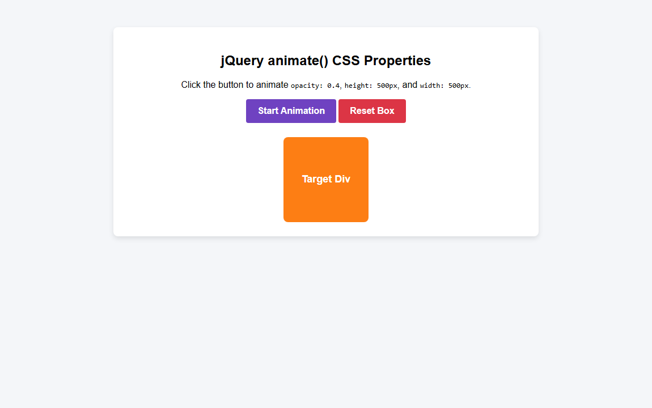
―――――――――――――――――――――――――――――――――――――――――――――――――――――――
Experiment 5.4: Use the animate() method to set the font-size of a <div> element to 100 pixels with slow duration
Code:
<!DOCTYPE html>
<html lang="en">
<head>
<meta charset="UTF-8">
<meta name="viewport" content="width=device-width, initial-scale=1.0">
<title>Lab 5.4 - jQuery Animate Font Size Slow</title>
<!-- Include jQuery -->
<script src="https://code.jquery.com/jquery-3.7.1.min.js"></script>
<style>
body {
font-family: Arial, sans-serif;
background-color: #f4f6f9;
padding: 40px;
text-align: center;
}
.container {
max-width: 800px;
margin: 0 auto;
background: #ffffff;
padding: 30px;
border-radius: 8px;
box-shadow: 0 4px 10px rgba(0,0,0,0.1);
}
button {
background-color: #e83e8c;
color: #ffffff;
border: none;
padding: 12px 24px;
border-radius: 4px;
font-size: 16px;
font-weight: bold;
cursor: pointer;
margin: 10px;
}
button:hover {
background-color: #d63384;
}
#textDiv {
font-size: 20px;
color: #20c997;
font-weight: bold;
margin-top: 30px;
padding: 20px;
background-color: #f8f9fa;
border-radius: 6px;
border: 2px dashed #20c997;
}
</style>
</head>
<body>
<div class="container">
<h2>jQuery animate() Font Size (Slow)</h2>
<p>Click the button to set the font-size of the div to 100px with a <strong>slow</strong> duration.</p>
<button id="growBtn">Increase Font Size (100px Slow)</button>
<button id="resetBtn" style="background-color: #6c757d;">Reset Font Size</button>
<!-- Target Div -->
<div id="textDiv">
jQuery Animation
</div>
</div>
<script>
$(document).ready(function(){
// Set font-size to 100px with duration 'slow'
$("#growBtn").click(function(){
$("#textDiv").animate({
fontSize: '100px'
}, 'slow');
});
// Reset font-size to 20px
$("#resetBtn").click(function(){
$("#textDiv").animate({
fontSize: '20px'
}, 'slow');
});
});
</script>
</body>
</html>
Output:
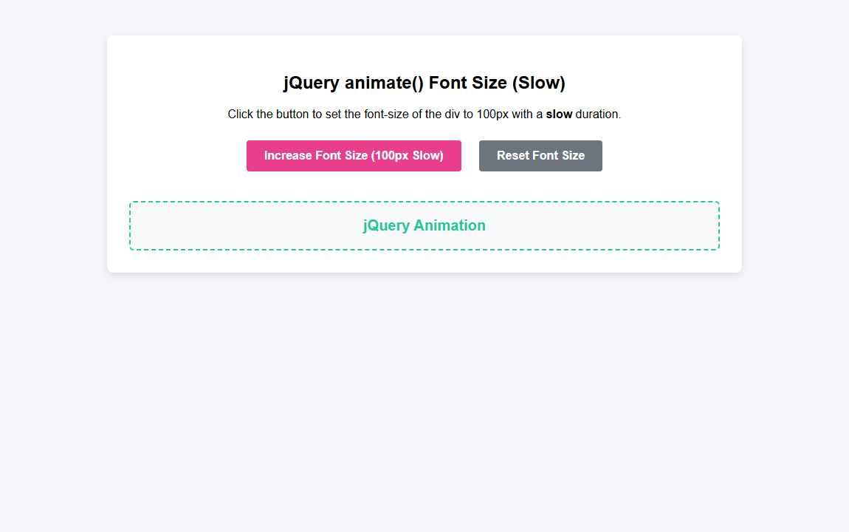
―――――――――――――――――――――――――――――――――――――――――――――――――――――――
Experiment 5.5: Create cartoon animation using jQuery
Code:
<!DOCTYPE html>
<html lang="en">
<head>
<meta charset="UTF-8">
<meta name="viewport" content="width=device-width, initial-scale=1.0">
<title>Lab 5.5 - Cartoon Animation using jQuery</title>
<!-- Include jQuery -->
<script src="https://code.jquery.com/jquery-3.7.1.min.js"></script>
<style>
body {
font-family: Arial, sans-serif;
background-color: #f0f4f8;
padding: 40px;
text-align: center;
}
.container {
max-width: 750px;
margin: 0 auto;
background: #ffffff;
padding: 30px;
border-radius: 12px;
box-shadow: 0 4px 15px rgba(0,0,0,0.1);
}
.stage {
position: relative;
height: 300px;
background: linear-gradient(to bottom, #87ceeb 0%, #e0f6ff 70%, #90ee90 70%, #76c776 100%);
border-radius: 8px;
overflow: hidden;
margin-top: 20px;
border: 2px solid #555;
}
/* Cartoon Character */
#cartoon {
position: absolute;
bottom: 30px;
left: 30px;
width: 100px;
height: 100px;
background-color: #ffcc00;
border: 3px solid #333;
border-radius: 50%;
box-shadow: 0 4px 8px rgba(0,0,0,0.2);
}
/* Cartoon Face Elements */
.eye {
position: absolute;
top: 28px;
width: 14px;
height: 20px;
background-color: #333;
border-radius: 50%;
}
.eye.left { left: 25px; }
.eye.right { right: 25px; }
.pupil {
position: absolute;
top: 3px;
left: 3px;
width: 6px;
height: 6px;
background-color: #fff;
border-radius: 50%;
}
.mouth {
position: absolute;
bottom: 22px;
left: 30px;
width: 40px;
height: 20px;
border-bottom: 4px solid #333;
border-radius: 0 0 20px 20px;
}
/* Buttons */
.btn-group {
margin-top: 20px;
}
button {
background-color: #ff5722;
color: #ffffff;
border: none;
padding: 12px 24px;
border-radius: 25px;
font-size: 15px;
font-weight: bold;
cursor: pointer;
margin: 0 6px;
transition: transform 0.2s;
}
button:hover {
transform: scale(1.05);
background-color: #e64a19;
}
.btn-green { background-color: #4caf50; }
.btn-green:hover { background-color: #388e3c; }
.btn-blue { background-color: #2196f3; }
.btn-blue:hover { background-color: #1976d2; }
</style>
</head>
<body>
<div class="container">
<h2>Cartoon Animation using jQuery</h2>
<p>Click the buttons below to trigger jQuery sequential animations on the cartoon character!</p>
<div class="btn-group">
<button id="startAnim" class="btn-green">▶ Play Full Cartoon Walk & Jump</button>
<button id="jumpAnim" class="btn-blue">🦘 High Jump</button>
<button id="resetAnim" style="background-color: #9e9e9e;">🔄 Reset Position</button>
</div>
<!-- Animation Stage -->
<div class="stage">
<div id="cartoon">
<div class="eye left"><div class="pupil"></div></div>
<div class="eye right"><div class="pupil"></div></div>
<div class="mouth"></div>
</div>
</div>
</div>
<script>
$(document).ready(function(){
// 1. Full Cartoon Walk, Jump & Scale Animation Sequence
$("#startAnim").click(function(){
var char = $("#cartoon");
// Reset first
char.stop(true, true).css({ left: '30px', bottom: '30px', width: '100px', height: '100px' });
// Chained jQuery Animations
char.animate({ left: '250px' }, 1000) // Walk right to middle
.animate({ bottom: '150px' }, 400) // Jump up
.animate({ bottom: '30px' }, 400) // Land down
.animate({ left: '550px' }, 1000) // Walk to right side
.animate({ width: '130px', height: '130px' }, 300) // Grow big
.animate({ width: '100px', height: '100px' }, 300) // Shrink back
.animate({ left: '30px' }, 1200); // Walk back home
});
// 2. High Jump Animation
$("#jumpAnim").click(function(){
var char = $("#cartoon");
char.animate({ bottom: '170px' }, 400)
.animate({ bottom: '30px' }, 400);
});
// 3. Reset Animation
$("#resetAnim").click(function(){
$("#cartoon").stop(true, true).animate({
left: '30px',
bottom: '30px',
width: '100px',
height: '100px'
}, 500);
});
});
</script>
</body>
</html>
Output:
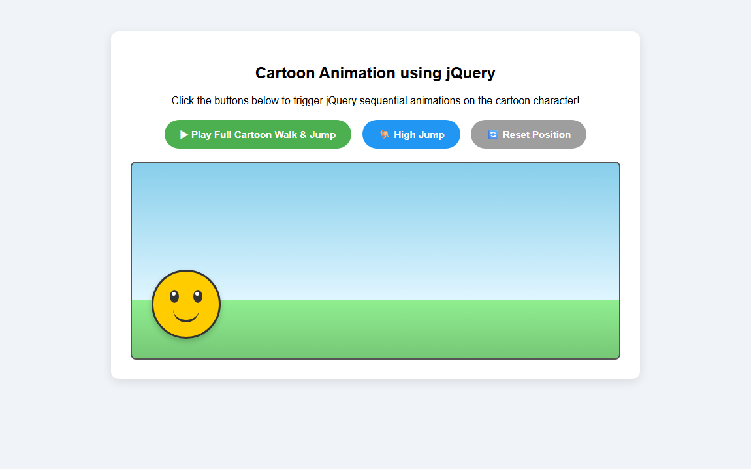
―――――――――――――――――――――――――――――――――――――――――――――――――――――――
― LAB - 6 ―
Experiment 6.1: Create Stock market web page using AJAX in which stock price come form .txt file
Code:
<!DOCTYPE html>
<html lang="en">
<head>
<meta charset="UTF-8">
<meta name="viewport" content="width=device-width, initial-scale=1.0">
<title>Lab 6.1 - Stock Market AJAX</title>
<style>
body {
font-family: Arial, sans-serif;
background-color: #121824;
color: #ffffff;
padding: 40px;
margin: 0;
}
.container {
max-width: 700px;
margin: 0 auto;
background-color: #1e2638;
padding: 30px;
border-radius: 10px;
box-shadow: 0 4px 20px rgba(0, 0, 0, 0.4);
}
h2 {
text-align: center;
color: #00d2ff;
margin-top: 0;
}
.btn-box {
text-align: center;
margin-bottom: 25px;
}
button {
background-color: #00d2ff;
color: #121824;
border: none;
padding: 12px 24px;
font-size: 15px;
font-weight: bold;
border-radius: 4px;
cursor: pointer;
transition: background 0.2s;
}
button:hover {
background-color: #0099cc;
color: #ffffff;
}
table {
width: 100%;
border-collapse: collapse;
margin-top: 15px;
}
th, td {
padding: 12px 15px;
text-align: left;
border-bottom: 1px solid #2d3850;
}
th {
background-color: #161d2d;
color: #8f9bba;
font-size: 13px;
text-transform: uppercase;
}
.up {
color: #00e676;
font-weight: bold;
}
.down {
color: #ff5252;
font-weight: bold;
}
.status-badge {
font-size: 12px;
padding: 3px 8px;
border-radius: 3px;
}
.bg-up { background-color: rgba(0, 230, 118, 0.2); }
.bg-down { background-color: rgba(255, 82, 82, 0.2); }
</style>
</head>
<body>
<div class="container">
<h2>📈 Live Stock Market (AJAX)</h2>
<p style="text-align: center; color: #8f9bba; font-size: 14px;">Stock prices loaded dynamically from <code>stocks.txt</code> using AJAX (XMLHttpRequest).</p>
<div class="btn-box">
<button onclick="loadStockPrices()">🔄 Fetch Stock Prices via AJAX</button>
</div>
<table>
<thead>
<tr>
<th>Stock Symbol</th>
<th>Price</th>
<th>Change (%)</th>
<th>Status</th>
</tr>
</thead>
<tbody id="stockTableBody">
<tr>
<td colspan="4" style="text-align: center; color: #8f9bba;">Click button to load stock data via AJAX...</td>
</tr>
</tbody>
</table>
</div>
<script>
function loadStockPrices() {
// Create AJAX XMLHttpRequest Object
var xhr = new XMLHttpRequest();
// Open request to fetch stocks.txt
xhr.open("GET", "stocks.txt", true);
xhr.onreadystatechange = function () {
if (xhr.readyState === 4 && xhr.status === 200) {
var textData = xhr.responseText;
var lines = textData.trim().split("\n");
var html = "";
for (var i = 0; i < lines.length; i++) {
var parts = lines[i].split("|");
if (parts.length >= 4) {
var symbol = parts[0].trim();
var price = parts[1].trim();
var change = parts[2].trim();
var status = parts[3].trim();
var isUp = change.includes("+");
var colorClass = isUp ? "up" : "down";
var bgClass = isUp ? "bg-up" : "bg-down";
html += "<tr>";
html += "<td><strong>" + symbol + "</strong></td>";
html += "<td>" + price + "</td>";
html += "<td class='" + colorClass + "'>" + change + "</td>";
html += "<td><span class='status-badge " + colorClass + " " + bgClass + "'>" + status + "</span></td>";
html += "</tr>";
}
}
document.getElementById("stockTableBody").innerHTML = html;
}
};
// Send AJAX request
xhr.send();
}
// Auto load on page visit
window.onload = loadStockPrices;
</script>
</body>
</html>
TATA MOTORS | ₹985.50 | +2.4% | UP
RELIANCE | ₹2,940.00 | +1.1% | UP
INFOSYS | ₹1,820.75 | -0.5% | DOWN
TCS | ₹4,250.30 | +1.8% | UP
HDFC BANK | ₹1,650.00 | +0.8% | UP
WIPRO | ₹520.40 | -1.2% | DOWN
Output:
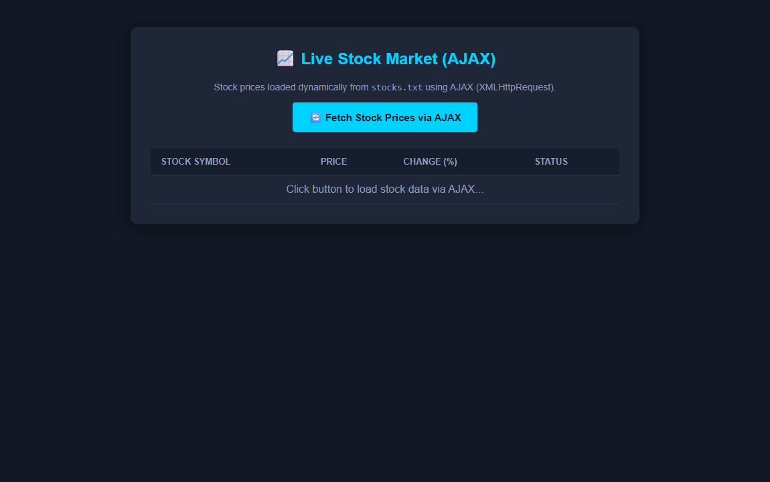
―――――――――――――――――――――――――――――――――――――――――――――――――――――――
Experiment 6.2: Display cricket live score using AJAX
Code:
<!DOCTYPE html>
<html lang="en">
<head>
<meta charset="UTF-8">
<meta name="viewport" content="width=device-width, initial-scale=1.0">
<title>Lab 6.2 - Live Cricket Score AJAX</title>
<style>
body {
font-family: Arial, sans-serif;
background-color: #0f1923;
color: #ffffff;
padding: 40px;
margin: 0;
}
.scoreboard-card {
max-width: 600px;
margin: 0 auto;
background: linear-gradient(135deg, #1b2838 0%, #101c2c 100%);
border: 1px solid #00d2ff;
border-radius: 12px;
padding: 30px;
box-shadow: 0 4px 25px rgba(0, 210, 255, 0.2);
}
.match-header {
text-align: center;
border-bottom: 1px solid #2a3a4e;
padding-bottom: 15px;
margin-bottom: 20px;
}
.match-header h3 {
color: #ffcc00;
margin: 0 0 5px 0;
font-size: 20px;
}
.match-header p {
color: #8f9bba;
margin: 0;
font-size: 13px;
}
.score-display {
text-align: center;
background-color: rgba(0, 210, 255, 0.08);
border-radius: 8px;
padding: 20px;
margin-bottom: 20px;
}
.team-score {
font-size: 26px;
font-weight: bold;
color: #00e676;
margin-bottom: 8px;
}
.match-status {
font-size: 14px;
color: #ff5252;
font-weight: bold;
}
.player-info {
font-size: 14px;
line-height: 1.8;
margin-bottom: 20px;
background: #142132;
padding: 15px;
border-radius: 6px;
}
.player-info div {
display: flex;
justify-content: space-between;
}
.recent-over {
text-align: center;
font-size: 14px;
color: #ffcc00;
}
.btn-box {
text-align: center;
margin-top: 25px;
}
button {
background-color: #00d2ff;
color: #0f1923;
border: none;
padding: 12px 24px;
font-size: 15px;
font-weight: bold;
border-radius: 4px;
cursor: pointer;
}
button:hover {
background-color: #0099cc;
color: #ffffff;
}
</style>
</head>
<body>
<div class="scoreboard-card">
<div class="match-header">
<h3 id="matchName">Live Cricket Scoreboard</h3>
<p id="matchVenue">Fetching details...</p>
</div>
<div class="score-display">
<div class="team-score" id="teamScore">-- / --</div>
<div class="match-status" id="matchStatus">Loading Live Score via AJAX...</div>
</div>
<div class="player-info">
<div><span><strong>Striker:</strong></span> <span id="batsman1" style="color: #00d2ff;">--</span></div>
<div><span><strong>Non-Striker:</strong></span> <span id="batsman2" style="color: #00d2ff;">--</span></div>
<div><span><strong>Bowler:</strong></span> <span id="bowler" style="color: #ffcc00;">--</span></div>
</div>
<div class="recent-over">
<strong>Recent Over:</strong> <span id="recent">--</span>
</div>
<div class="btn-box">
<button onclick="fetchLiveScore()">🏏 Refresh Live Score (AJAX)</button>
</div>
</div>
<script>
function fetchLiveScore() {
var xhr = new XMLHttpRequest();
xhr.open("GET", "score.json", true);
xhr.onreadystatechange = function () {
if (xhr.readyState === 4 && xhr.status === 200) {
var data = JSON.parse(xhr.responseText);
document.getElementById("matchName").innerText = data.match;
document.getElementById("matchVenue").innerText = data.venue;
document.getElementById("teamScore").innerText = data.team2;
document.getElementById("matchStatus").innerText = data.status;
document.getElementById("batsman1").innerText = data.batsman1;
document.getElementById("batsman2").innerText = data.batsman2;
document.getElementById("bowler").innerText = data.bowler;
document.getElementById("recent").innerText = data.recent;
}
};
xhr.send();
}
// Auto load live score via AJAX
window.onload = function() {
fetchLiveScore();
// Polling every 3 seconds
setInterval(fetchLiveScore, 3000);
};
</script>
</body>
</html>
{
"match": "India vs Australia - 3rd ODI",
"venue": "M. Chinnaswamy Stadium, Bengaluru",
"status": "India won by 4 wickets",
"team1": "AUS 282/8 (50.0)",
"team2": "IND 285/6 (48.2)",
"batsman1": "Rohit Sharma - 89* (72 balls)",
"batsman2": "KL Rahul - 45* (38 balls)",
"bowler": "Mitchell Starc - 2/54 (9.2 overs)",
"recent": "4 1 6 2 1 4"
}
Output:
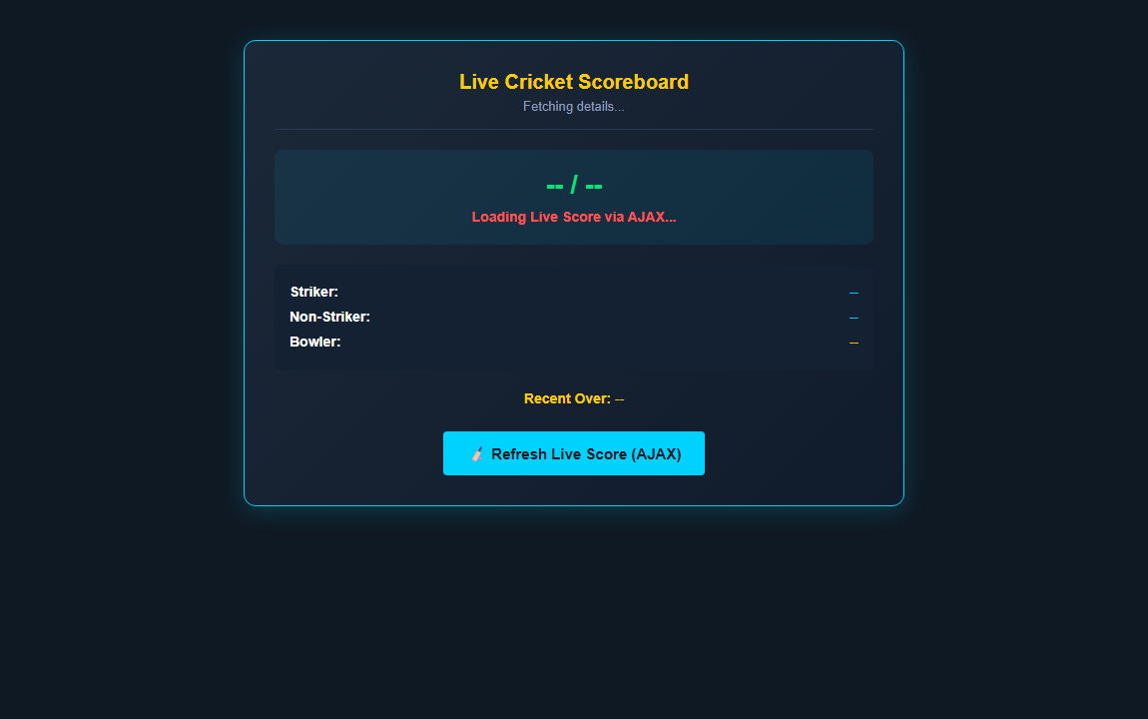
―――――――――――――――――――――――――――――――――――――――――――――――――――――――
Experiment 6.3: Implement Server clock using AJAX
Code:
<!DOCTYPE html>
<html lang="en">
<head>
<meta charset="UTF-8">
<meta name="viewport" content="width=device-width, initial-scale=1.0">
<title>Lab 6.3 - Server Clock AJAX</title>
<style>
body {
font-family: Arial, sans-serif;
background-color: #18191a;
color: #ffffff;
display: flex;
justify-content: center;
align-items: center;
min-height: 100vh;
margin: 0;
}
.clock-card {
background-color: #242526;
border: 2px solid #00e676;
border-radius: 12px;
padding: 40px;
text-align: center;
width: 450px;
box-shadow: 0 0 20px rgba(0, 230, 118, 0.2);
}
h2 {
margin-top: 0;
color: #ffffff;
}
.clock-display {
font-family: 'Courier New', Courier, monospace;
font-size: 42px;
font-weight: bold;
color: #00e676;
background-color: #18191a;
padding: 15px;
border-radius: 8px;
margin: 20px 0;
letter-spacing: 2px;
box-shadow: inset 0 0 10px rgba(0,0,0,0.5);
}
.date-display {
font-size: 16px;
color: #b0b3b8;
}
.badge {
display: inline-block;
background-color: rgba(0, 230, 118, 0.2);
color: #00e676;
font-size: 12px;
font-weight: bold;
padding: 4px 10px;
border-radius: 12px;
margin-top: 15px;
}
</style>
</head>
<body>
<div class="clock-card">
<h2>⏰ AJAX Server Clock</h2>
<p style="font-size: 13px; color: #b0b3b8;">Fetching live server time using XMLHttpRequest (AJAX)</p>
<!-- Digital Clock Display -->
<div class="clock-display" id="clock">00:00:00 AM</div>
<!-- Date Display -->
<div class="date-display" id="date">Loading Server Date...</div>
<div class="badge">● LIVE AJAX Sync Every 1 sec</div>
</div>
<script>
function fetchServerClock() {
var xhr = new XMLHttpRequest();
// Fetch server response headers / time.txt with cache busting
xhr.open("GET", "time.txt?t=" + new Date().getTime(), true);
xhr.onreadystatechange = function () {
if (xhr.readyState === 4) {
// Extract Date header from Server or fallback to system time
var serverDateStr = xhr.getResponseHeader("Date");
var now = serverDateStr ? new Date(serverDateStr) : new Date();
var hours = now.getHours();
var minutes = now.getMinutes();
var seconds = now.getSeconds();
var ampm = hours >= 12 ? 'PM' : 'AM';
hours = hours % 12;
hours = hours ? hours : 12; // 0 becomes 12
hours = hours < 10 ? '0' + hours : hours;
minutes = minutes < 10 ? '0' + minutes : minutes;
seconds = seconds < 10 ? '0' + seconds : seconds;
var timeString = hours + ":" + minutes + ":" + seconds + " " + ampm;
var options = { weekday: 'long', year: 'numeric', month: 'long', day: 'numeric' };
var dateString = now.toLocaleDateString("en-US", options);
document.getElementById("clock").innerText = timeString;
document.getElementById("date").innerText = dateString;
}
};
xhr.send();
}
// Start Server Clock polling via AJAX every 1 second
fetchServerClock();
setInterval(fetchServerClock, 1000);
</script>
</body>
</html>
SERVER_TIME_ENDPOINT
Output:
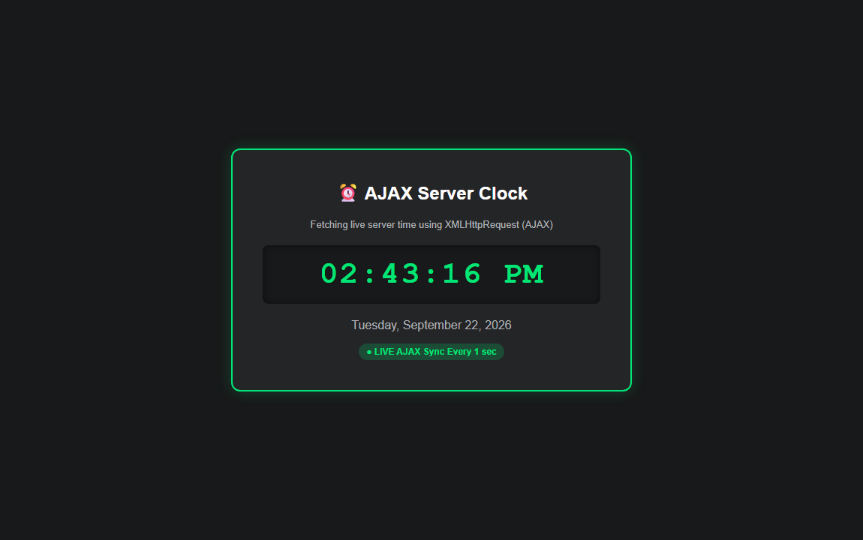
―――――――――――――――――――――――――――――――――――――――――――――――――――――――
― LAB - 7 ―
Experiment 7.1: Develop XML document that will hold player collection with fields for player-name, age, batting-average and highest-score, write suitable schema for the XML
Code:
<?xml version="1.0" encoding="UTF-8"?>
<players xmlns:xsi="http://www.w3.org/2001/XMLSchema-instance" xsi:noNamespaceSchemaLocation="players.xsd">
<player>
<player-name>Virat Kohli</player-name>
<age>35</age>
<batting-average>58.67</batting-average>
<highest-score>183</highest-score>
</player>
<player>
<player-name>Rohit Sharma</player-name>
<age>37</age>
<batting-average>49.12</batting-average>
<highest-score>264</highest-score>
</player>
<player>
<player-name>MS Dhoni</player-name>
<age>42</age>
<batting-average>50.57</batting-average>
<highest-score>183</highest-score>
</player>
<player>
<player-name>Shubman Gill</player-name>
<age>24</age>
<batting-average>55.20</batting-average>
<highest-score>208</highest-score>
</player>
</players>
<?xml version="1.0" encoding="UTF-8"?>
<xs:schema xmlns:xs="http://www.w3.org/2001/XMLSchema">
<xs:element name="players">
<xs:complexType>
<xs:sequence>
<xs:element name="player" maxOccurs="unbounded">
<xs:complexType>
<xs:sequence>
<xs:element name="player-name" type="xs:string"/>
<xs:element name="age" type="xs:integer"/>
<xs:element name="batting-average" type="xs:decimal"/>
<xs:element name="highest-score" type="xs:integer"/>
</xs:sequence>
</xs:complexType>
</xs:element>
</xs:sequence>
</xs:complexType>
</xs:element>
</xs:schema>
<!DOCTYPE html>
<html lang="en">
<head>
<meta charset="UTF-8">
<meta name="viewport" content="width=device-width, initial-scale=1.0">
<title>Lab 7.1 - Cricket Players XML & XSD Schema</title>
<style>
body {
font-family: Arial, sans-serif;
background-color: #f4f6f9;
padding: 30px;
}
.container {
max-width: 750px;
margin: 0 auto;
background-color: #ffffff;
padding: 25px;
border-radius: 8px;
box-shadow: 0 4px 10px rgba(0,0,0,0.1);
}
h2 {
color: #007bff;
text-align: center;
}
table {
width: 100%;
border-collapse: collapse;
margin-top: 20px;
}
th, td {
border: 1px solid #dddddd;
padding: 12px;
text-align: center;
}
th {
background-color: #007bff;
color: #ffffff;
}
tr:nth-child(even) {
background-color: #f9f9f9;
}
</style>
</head>
<body>
<div class="container">
<h2>🏏 Cricket Players Collection (XML & XSD)</h2>
<p style="text-align: center; color: #666;">Data loaded from <code>players.xml</code> validated against <code>players.xsd</code> schema.</p>
<table>
<thead>
<tr>
<th>Player Name</th>
<th>Age</th>
<th>Batting Average</th>
<th>Highest Score</th>
</tr>
</thead>
<tbody id="playerTableBody">
<tr>
<td colspan="4">Loading XML data...</td>
</tr>
</tbody>
</table>
</div>
<script>
function loadXML() {
var xhr = new XMLHttpRequest();
xhr.open("GET", "players.xml", true);
xhr.onreadystatechange = function () {
if (xhr.readyState === 4 && xhr.status === 200) {
var xmlDoc = xhr.responseXML;
var players = xmlDoc.getElementsByTagName("player");
var html = "";
for (var i = 0; i < players.length; i++) {
var name = players[i].getElementsByTagName("player-name")[0].childNodes[0].nodeValue;
var age = players[i].getElementsByTagName("age")[0].childNodes[0].nodeValue;
var avg = players[i].getElementsByTagName("batting-average")[0].childNodes[0].nodeValue;
var hs = players[i].getElementsByTagName("highest-score")[0].childNodes[0].nodeValue;
html += "<tr>";
html += "<td><strong>" + name + "</strong></td>";
html += "<td>" + age + "</td>";
html += "<td>" + avg + "</td>";
html += "<td>" + hs + "</td>";
html += "</tr>";
}
document.getElementById("playerTableBody").innerHTML = html;
}
};
xhr.send();
}
window.onload = loadXML;
</script>
</body>
</html>
Output:
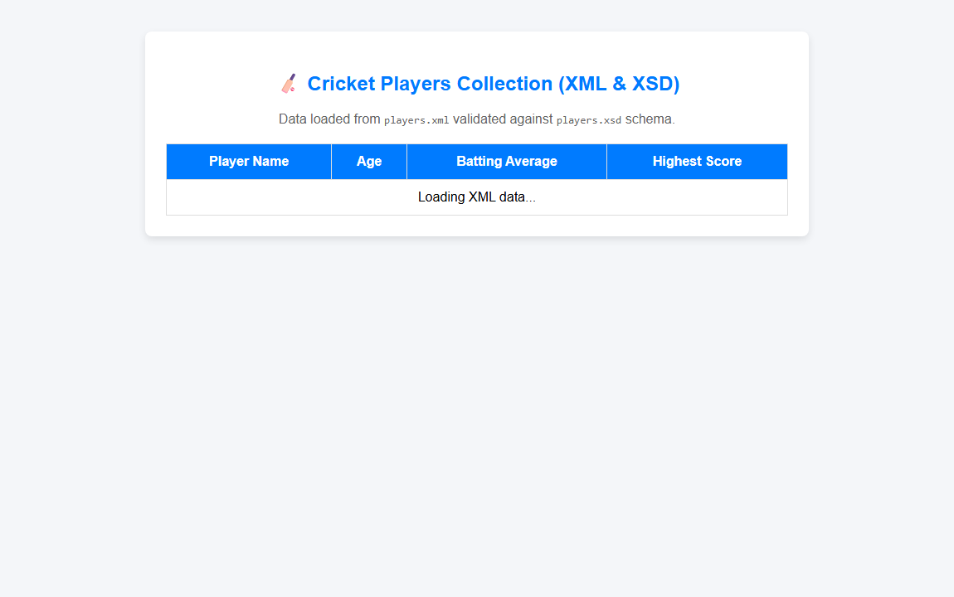
―――――――――――――――――――――――――――――――――――――――――――――――――――――――
Experiment 7.2: Write an XML file to store your semester mark sheet. Write an XSL file using XSLT to display it in XHTML table form
Code:
<?xml version="1.0" encoding="UTF-8"?>
<?xml-stylesheet type="text/xsl" href="marksheet.xsl"?>
<marksheet>
<student>
<name>Deep Jaiswal</name>
<rollno>105</rollno>
<semester>IV</semester>
<course>B.E. Computer Science &amp; Engineering</course>
</student>
<subject>
<code>CSE401</code>
<title>Basic Web Programming</title>
<max-marks>100</max-marks>
<obtained>88</obtained>
<grade>A+</grade>
</subject>
<subject>
<code>CSE402</code>
<title>Data Structures &amp; Algorithms</title>
<max-marks>100</max-marks>
<obtained>82</obtained>
<grade>A</grade>
</subject>
<subject>
<code>CSE403</code>
<title>Database Management Systems</title>
<max-marks>100</max-marks>
<obtained>79</obtained>
<grade>B+</grade>
</subject>
<subject>
<code>CSE404</code>
<title>Operating Systems</title>
<max-marks>100</max-marks>
<obtained>85</obtained>
<grade>A</grade>
</subject>
<subject>
<code>CSE405</code>
<title>Computer Networks</title>
<max-marks>100</max-marks>
<obtained>91</obtained>
<grade>O</grade>
</subject>
</marksheet>
<?xml version="1.0" encoding="UTF-8"?>
<xsl:stylesheet version="1.0" xmlns:xsl="http://www.w3.org/1999/XSL/Transform">
<xsl:template match="/">
<html xmlns="http://www.w3.org/1999/xhtml">
<head>
<title>Semester Marksheet (XSLT)</title>
<style>
body {
font-family: Arial, sans-serif;
background-color: #f4f6f9;
padding: 30px;
}
.marksheet-box {
max-width: 750px;
margin: 0 auto;
background: #ffffff;
padding: 25px;
border-radius: 8px;
box-shadow: 0 4px 10px rgba(0,0,0,0.1);
}
h2 {
text-align: center;
color: #007bff;
margin-top: 0;
}
.student-info {
margin-bottom: 20px;
background-color: #e9ecef;
padding: 12px;
border-radius: 4px;
}
table {
width: 100%;
border-collapse: collapse;
margin-top: 15px;
}
th, td {
border: 1px solid #dddddd;
padding: 10px;
text-align: center;
}
th {
background-color: #007bff;
color: #ffffff;
}
tr:nth-child(even) {
background-color: #f9f9f9;
}
</style>
</head>
<body>
<div class="marksheet-box">
<h2>Semester Academic Marksheet</h2>
<div class="student-info">
<p><strong>Student Name:</strong> <xsl:value-of select="marksheet/student/name"/></p>
<p><strong>Roll No:</strong> <xsl:value-of select="marksheet/student/rollno"/></p>
<p><strong>Semester:</strong> <xsl:value-of select="marksheet/student/semester"/></p>
<p><strong>Course:</strong> <xsl:value-of select="marksheet/student/course"/></p>
</div>
<table>
<thead>
<tr>
<th>Subject Code</th>
<th>Subject Title</th>
<th>Max Marks</th>
<th>Marks Obtained</th>
<th>Grade</th>
</tr>
</thead>
<tbody>
<xsl:for-each select="marksheet/subject">
<tr>
<td><xsl:value-of select="code"/></td>
<td style="text-align: left;"><strong><xsl:value-of select="title"/></strong></td>
<td><xsl:value-of select="max-marks"/></td>
<td><xsl:value-of select="obtained"/></td>
<td><strong><xsl:value-of select="grade"/></strong></td>
</tr>
</xsl:for-each>
</tbody>
</table>
</div>
</body>
</html>
</xsl:template>
</xsl:stylesheet>
<!DOCTYPE html>
<html lang="en">
<head>
<meta charset="UTF-8">
<meta name="viewport" content="width=device-width, initial-scale=1.0">
<title>Lab 7.2 - Semester Marksheet XML & XSLT</title>
</head>
<body>
<div id="output">Loading Marksheet XSLT Transformation...</div>
<script>
function loadXSLT() {
var reqXml = new XMLHttpRequest();
reqXml.open("GET", "marksheet.xml", true);
reqXml.onreadystatechange = function () {
if (reqXml.readyState === 4 && reqXml.status === 200) {
var xml = reqXml.responseXML;
var reqXsl = new XMLHttpRequest();
reqXsl.open("GET", "marksheet.xsl", true);
reqXsl.onreadystatechange = function () {
if (reqXsl.readyState === 4 && reqXsl.status === 200) {
var xsl = reqXsl.responseXML;
if (window.XSLTProcessor) {
var xsltProcessor = new XSLTProcessor();
xsltProcessor.importStylesheet(xsl);
var resultDocument = xsltProcessor.transformToFragment(xml, document);
document.getElementById("output").innerHTML = "";
document.getElementById("output").appendChild(resultDocument);
} else {
alert("XSLTProcessor is not supported in this browser.");
}
}
};
reqXsl.send();
}
};
reqXml.send();
}
window.onload = loadXSLT;
</script>
</body>
</html>
Output:

―――――――――――――――――――――――――――――――――――――――――――――――――――――――
Experiment 7.3: Develop an XML document that will hold a book collection with fields for book name, author, ISBN number and quantity. Write suitable schema for the XML
Code:
<?xml version="1.0" encoding="UTF-8"?>
<books xmlns:xsi="http://www.w3.org/2001/XMLSchema-instance" xsi:noNamespaceSchemaLocation="books.xsd">
<book>
<book-name>Operating System Concepts</book-name>
<author>Abraham Silberschatz</author>
<isbn>978-1118063330</isbn>
<quantity>15</quantity>
</book>
<book>
<book-name>Introduction to Algorithms</book-name>
<author>Thomas H. Cormen</author>
<isbn>978-0262033848</isbn>
<quantity>22</quantity>
</book>
<book>
<book-name>Computer Networking: A Top-Down Approach</book-name>
<author>James Kurose</author>
<isbn>978-0133594140</isbn>
<quantity>18</quantity>
</book>
<book>
<book-name>Database System Concepts</book-name>
<author>Henry F. Korth</author>
<isbn>978-0073523323</isbn>
<quantity>30</quantity>
</book>
</books>
<?xml version="1.0" encoding="UTF-8"?>
<xs:schema xmlns:xs="http://www.w3.org/2001/XMLSchema">
<xs:element name="books">
<xs:complexType>
<xs:sequence>
<xs:element name="book" maxOccurs="unbounded">
<xs:complexType>
<xs:sequence>
<xs:element name="book-name" type="xs:string"/>
<xs:element name="author" type="xs:string"/>
<xs:element name="isbn" type="xs:string"/>
<xs:element name="quantity" type="xs:integer"/>
</xs:sequence>
</xs:complexType>
</xs:element>
</xs:sequence>
</xs:complexType>
</xs:element>
</xs:schema>
<!DOCTYPE html>
<html lang="en">
<head>
<meta charset="UTF-8">
<meta name="viewport" content="width=device-width, initial-scale=1.0">
<title>Lab 7.3 - Book Collection XML & XSD Schema</title>
<style>
body {
font-family: Arial, sans-serif;
background-color: #f4f6f9;
padding: 30px;
}
.container {
max-width: 800px;
margin: 0 auto;
background-color: #ffffff;
padding: 25px;
border-radius: 8px;
box-shadow: 0 4px 10px rgba(0,0,0,0.1);
}
h2 {
color: #28a745;
text-align: center;
}
table {
width: 100%;
border-collapse: collapse;
margin-top: 20px;
}
th, td {
border: 1px solid #dddddd;
padding: 12px;
text-align: center;
}
th {
background-color: #28a745;
color: #ffffff;
}
tr:nth-child(even) {
background-color: #f9f9f9;
}
</style>
</head>
<body>
<div class="container">
<h2>📚 Book Collection (XML & XSD Schema)</h2>
<p style="text-align: center; color: #666;">Data loaded from <code>books.xml</code> validated against <code>books.xsd</code> schema.</p>
<table>
<thead>
<tr>
<th>Book Name</th>
<th>Author</th>
<th>ISBN Number</th>
<th>Quantity</th>
</tr>
</thead>
<tbody id="bookTableBody">
<tr>
<td colspan="4">Loading XML data...</td>
</tr>
</tbody>
</table>
</div>
<script>
function loadXML() {
var xhr = new XMLHttpRequest();
xhr.open("GET", "books.xml", true);
xhr.onreadystatechange = function () {
if (xhr.readyState === 4 && xhr.status === 200) {
var xmlDoc = xhr.responseXML;
var books = xmlDoc.getElementsByTagName("book");
var html = "";
for (var i = 0; i < books.length; i++) {
var name = books[i].getElementsByTagName("book-name")[0].childNodes[0].nodeValue;
var author = books[i].getElementsByTagName("author")[0].childNodes[0].nodeValue;
var isbn = books[i].getElementsByTagName("isbn")[0].childNodes[0].nodeValue;
var qty = books[i].getElementsByTagName("quantity")[0].childNodes[0].nodeValue;
html += "<tr>";
html += "<td style='text-align: left;'><strong>" + name + "</strong></td>";
html += "<td>" + author + "</td>";
html += "<td><code>" + isbn + "</code></td>";
html += "<td><strong>" + qty + "</strong></td>";
html += "</tr>";
}
document.getElementById("bookTableBody").innerHTML = html;
}
};
xhr.send();
}
window.onload = loadXML;
</script>
</body>
</html>
Output:
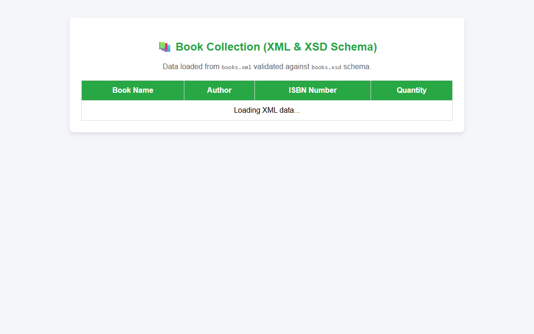
―――――――――――――――――――――――――――――――――――――――――――――――――――――――
Experiment 7.4: Write an XSL file to print list of products which has price< 300Rs. For item.xml file in tabular structure
Code:
<?xml version="1.0" encoding="UTF-8"?>
<?xml-stylesheet type="text/xsl" href="item.xsl"?>
<items>
<product>
<id>P101</id>
<name>Wireless Mouse</name>
<price>250</price>
<category>Electronics</category>
</product>
<product>
<id>P102</id>
<name>Mechanical Keyboard</name>
<price>1200</price>
<category>Electronics</category>
</product>
<product>
<id>P103</id>
<name>USB Pendrive 32GB</name>
<price>280</price>
<category>Storage</category>
</product>
<product>
<id>P104</id>
<name>Gaming Headset</name>
<price>850</price>
<category>Audio</category>
</product>
<product>
<id>P105</id>
<name>Mouse Pad Mat</name>
<price>150</price>
<category>Accessories</category>
</product>
<product>
<id>P106</id>
<name>HDMI Cable 1.5m</name>
<price>199</price>
<category>Accessories</category>
</product>
</items>
<?xml version="1.0" encoding="UTF-8"?>
<xsl:stylesheet version="1.0" xmlns:xsl="http://www.w3.org/1999/XSL/Transform">
<xsl:template match="/">
<html xmlns="http://www.w3.org/1999/xhtml">
<head>
<title>Products Price Under 300Rs (XSLT Filter)</title>
<style>
body {
font-family: Arial, sans-serif;
background-color: #f4f6f9;
padding: 30px;
}
.container {
max-width: 650px;
margin: 0 auto;
background: #ffffff;
padding: 25px;
border-radius: 8px;
box-shadow: 0 4px 10px rgba(0,0,0,0.1);
}
h2 {
text-align: center;
color: #d9534f;
margin-top: 0;
}
table {
width: 100%;
border-collapse: collapse;
margin-top: 20px;
}
th, td {
border: 1px solid #dddddd;
padding: 10px;
text-align: center;
}
th {
background-color: #d9534f;
color: #ffffff;
}
tr:nth-child(even) {
background-color: #f9f9f9;
}
.price-tag {
color: #5cb85c;
font-weight: bold;
}
</style>
</head>
<body>
<div class="container">
<h2>Products List (Price &lt; 300 Rs)</h2>
<p style="text-align: center; color: #666; font-size: 14px;">Filtered using XSLT <code>&lt;xsl:if test="price &amp;lt; 300"&gt;</code></p>
<table>
<thead>
<tr>
<th>Item ID</th>
<th>Product Name</th>
<th>Category</th>
<th>Price (Rs)</th>
</tr>
</thead>
<tbody>
<!-- Filter products with price < 300 -->
<xsl:for-each select="items/product">
<xsl:if test="price &lt; 300">
<tr>
<td><code><xsl:value-of select="id"/></code></td>
<td style="text-align: left;"><strong><xsl:value-of select="name"/></strong></td>
<td><xsl:value-of select="category"/></td>
<td class="price-tag">₹<xsl:value-of select="price"/></td>
</tr>
</xsl:if>
</xsl:for-each>
</tbody>
</table>
</div>
</body>
</html>
</xsl:template>
</xsl:stylesheet>
<!DOCTYPE html>
<html lang="en">
<head>
<meta charset="UTF-8">
<meta name="viewport" content="width=device-width, initial-scale=1.0">
<title>Lab 7.4 - Products Price Under 300Rs (XSLT)</title>
</head>
<body>
<div id="output">Loading Filtered Products via XSLT...</div>
<script>
function loadXSLT() {
var reqXml = new XMLHttpRequest();
reqXml.open("GET", "item.xml", true);
reqXml.onreadystatechange = function () {
if (reqXml.readyState === 4 && reqXml.status === 200) {
var xml = reqXml.responseXML;
var reqXsl = new XMLHttpRequest();
reqXsl.open("GET", "item.xsl", true);
reqXsl.onreadystatechange = function () {
if (reqXsl.readyState === 4 && reqXsl.status === 200) {
var xsl = reqXsl.responseXML;
if (window.XSLTProcessor) {
var xsltProcessor = new XSLTProcessor();
xsltProcessor.importStylesheet(xsl);
var resultDocument = xsltProcessor.transformToFragment(xml, document);
document.getElementById("output").innerHTML = "";
document.getElementById("output").appendChild(resultDocument);
} else {
alert("XSLTProcessor is not supported in this browser.");
}
}
};
reqXsl.send();
}
};
reqXml.send();
}
window.onload = loadXSLT;
</script>
</body>
</html>
Output:

―――――――――――――――――――――――――――――――――――――――――――――――――――――――
Experiment 7.5: Develop XML File for book record and also write XSL for it to display in table format
Code:
<?xml version="1.0" encoding="UTF-8"?>
<?xml-stylesheet type="text/xsl" href="bookrecord.xsl"?>
<bookstore>
<book category="Programming">
<title lang="en">Java: The Complete Reference</title>
<author>Herbert Schildt</author>
<year>2021</year>
<price>650</price>
<publisher>McGraw-Hill</publisher>
</book>
<book category="Web Development">
<title lang="en">HTML &amp; CSS: Design and Build Websites</title>
<author>Jon Duckett</author>
<year>2018</year>
<price>480</price>
<publisher>Wiley</publisher>
</book>
<book category="Database">
<title lang="en">Learning SQL</title>
<author>Alan Beaulieu</author>
<year>2020</year>
<price>390</price>
<publisher>O'Reilly</publisher>
</book>
<book category="Algorithms">
<title lang="en">Data Structures &amp; Algorithms in Python</title>
<author>Michael T. Goodrich</author>
<year>2019</year>
<price>540</price>
<publisher>Wiley</publisher>
</book>
</bookstore>
<?xml version="1.0" encoding="UTF-8"?>
<xsl:stylesheet version="1.0" xmlns:xsl="http://www.w3.org/1999/XSL/Transform">
<xsl:template match="/">
<html xmlns="http://www.w3.org/1999/xhtml">
<head>
<title>Book Record (XSLT Table Format)</title>
<style>
body {
font-family: Arial, sans-serif;
background-color: #f4f6f9;
padding: 30px;
}
.container {
max-width: 800px;
margin: 0 auto;
background: #ffffff;
padding: 25px;
border-radius: 8px;
box-shadow: 0 4px 10px rgba(0,0,0,0.1);
}
h2 {
text-align: center;
color: #17a2b8;
margin-top: 0;
}
table {
width: 100%;
border-collapse: collapse;
margin-top: 20px;
}
th, td {
border: 1px solid #dddddd;
padding: 12px;
text-align: center;
}
th {
background-color: #17a2b8;
color: #ffffff;
}
tr:nth-child(even) {
background-color: #f9f9f9;
}
.price {
font-weight: bold;
color: #28a745;
}
</style>
</head>
<body>
<div class="container">
<h2>📖 Bookstore Records Table</h2>
<p style="text-align: center; color: #666; font-size: 14px;">Formatted from <code>bookrecord.xml</code> using XSLT stylesheet.</p>
<table>
<thead>
<tr>
<th>Book Title</th>
<th>Category</th>
<th>Author</th>
<th>Year</th>
<th>Publisher</th>
<th>Price (₹)</th>
</tr>
</thead>
<tbody>
<xsl:for-each select="bookstore/book">
<tr>
<td style="text-align: left;"><strong><xsl:value-of select="title"/></strong></td>
<td><xsl:value-of select="@category"/></td>
<td><xsl:value-of select="author"/></td>
<td><xsl:value-of select="year"/></td>
<td><xsl:value-of select="publisher"/></td>
<td class="price">₹<xsl:value-of select="price"/></td>
</tr>
</xsl:for-each>
</tbody>
</table>
</div>
</body>
</html>
</xsl:template>
</xsl:stylesheet>
<!DOCTYPE html>
<html lang="en">
<head>
<meta charset="UTF-8">
<meta name="viewport" content="width=device-width, initial-scale=1.0">
<title>Lab 7.5 - Book Record XML & XSLT Table</title>
</head>
<body>
<div id="output">Loading Book Record Table via XSLT...</div>
<script>
function loadXSLT() {
var reqXml = new XMLHttpRequest();
reqXml.open("GET", "bookrecord.xml", true);
reqXml.onreadystatechange = function () {
if (reqXml.readyState === 4 && reqXml.status === 200) {
var xml = reqXml.responseXML;
var reqXsl = new XMLHttpRequest();
reqXsl.open("GET", "bookrecord.xsl", true);
reqXsl.onreadystatechange = function () {
if (reqXsl.readyState === 4 && reqXsl.status === 200) {
var xsl = reqXsl.responseXML;
if (window.XSLTProcessor) {
var xsltProcessor = new XSLTProcessor();
xsltProcessor.importStylesheet(xsl);
var resultDocument = xsltProcessor.transformToFragment(xml, document);
document.getElementById("output").innerHTML = "";
document.getElementById("output").appendChild(resultDocument);
} else {
alert("XSLTProcessor is not supported in this browser.");
}
}
};
reqXsl.send();
}
};
reqXml.send();
}
window.onload = loadXSLT;
</script>
</body>
</html>
Output:

―――――――――――――――――――――――――――――――――――――――――――――――――――――――
― NODE.JS LAB ―
Experiment Node.1: Create a module for area calculation in node.js for circle, rectangle, and square. Use this module in your current file to find area of all shape
Code:
// Node.js Module for Area Calculation
// Area of Circle: A = pi * r * r
function areaOfCircle(radius) {
return (Math.PI * radius * radius).toFixed(2);
}
// Area of Rectangle: A = length * width
function areaOfRectangle(length, width) {
return (length * width).toFixed(2);
}
// Area of Square: A = side * side
function areaOfSquare(side) {
return (side * side).toFixed(2);
}
// Export module functions
module.exports = {
areaOfCircle,
areaOfRectangle,
areaOfSquare
};
// Main Application File using areaModule.js
const http = require('http');
const areaModule = require('./areaModule');
// Sample dimensions
const radius = 7;
const rectLength = 10;
const rectWidth = 5;
const squareSide = 4;
// Calculate areas using imported module
const circleArea = areaModule.areaOfCircle(radius);
const rectArea = areaModule.areaOfRectangle(rectLength, rectWidth);
const squareArea = areaModule.areaOfSquare(squareSide);
// Print results to Console
console.log("=== Node.js Area Calculation Module Results ===");
console.log(`Area of Circle (radius ${radius}): ${circleArea}`);
console.log(`Area of Rectangle (${rectLength} x ${rectWidth}): ${rectArea}`);
console.log(`Area of Square (side ${squareSide}): ${squareArea}`);
// Create HTTP Server to display results in web browser
const server = http.createServer((req, res) => {
res.writeHead(200, { 'Content-Type': 'text/html' });
res.write(`
<!DOCTYPE html>
<html>
<head>
<title>Node.js Area Calculation Module</title>
<style>
body { font-family: Arial, sans-serif; background: #f4f6f9; padding: 40px; }
.box { max-width: 600px; margin: auto; background: white; padding: 30px; border-radius: 8px; box-shadow: 0 4px 10px rgba(0,0,0,0.1); }
h2 { color: #007bff; text-align: center; }
ul { font-size: 18px; line-height: 2; }
</style>
</head>
<body>
<div class="box">
<h2>📐 Node.js Area Calculation Module</h2>
<hr>
<ul>
<li><strong>Area of Circle</strong> (r = ${radius}): <code>${circleArea} sq units</code></li>
<li><strong>Area of Rectangle</strong> (${rectLength} x ${rectWidth}): <code>${rectArea} sq units</code></li>
<li><strong>Area of Square</strong> (side = ${squareSide}): <code>${squareArea} sq units</code></li>
</ul>
</div>
</body>
</html>
`);
res.end();
});
const PORT = 3001;
server.listen(PORT, () => {
console.log(`Server running at http://localhost:${PORT}/`);
});
<!DOCTYPE html>
<html lang="en">
<head>
<meta charset="UTF-8">
<meta name="viewport" content="width=device-width, initial-scale=1.0">
<title>Lab Node-1 - Area Calculation Module</title>
<style>
body {
font-family: Arial, sans-serif;
background-color: #f4f6f9;
padding: 40px;
}
.container {
max-width: 600px;
margin: 0 auto;
background-color: #ffffff;
padding: 30px;
border-radius: 8px;
box-shadow: 0 4px 10px rgba(0,0,0,0.1);
}
h2 {
color: #007bff;
text-align: center;
}
.form-section {
margin-bottom: 20px;
background: #f8f9fa;
padding: 15px;
border-radius: 6px;
border-left: 4px solid #007bff;
}
label {
font-weight: bold;
display: block;
margin-bottom: 5px;
}
input {
width: 100px;
padding: 6px;
margin-bottom: 10px;
}
button {
background-color: #007bff;
color: white;
border: none;
padding: 8px 16px;
border-radius: 4px;
cursor: pointer;
font-weight: bold;
}
.result {
margin-top: 10px;
font-weight: bold;
color: #28a745;
}
</style>
</head>
<body>
<div class="container">
<h2>📐 Area Calculation Module Demo</h2>
<p style="text-align: center; color: #666; font-size: 14px;">Demonstrating Node.js module functions for Circle, Rectangle, and Square.</p>
<!-- Circle Section -->
<div class="form-section">
<label>Circle Area</label>
Radius (r): <input type="number" id="radius" value="7">
<button onclick="calcCircle()">Calculate</button>
<div id="circleRes" class="result">Result: 153.94 sq units</div>
</div>
<!-- Rectangle Section -->
<div class="form-section">
<label>Rectangle Area</label>
Length: <input type="number" id="length" value="10"> &nbsp;
Width: <input type="number" id="width" value="5">
<button onclick="calcRectangle()">Calculate</button>
<div id="rectRes" class="result">Result: 50.00 sq units</div>
</div>
<!-- Square Section -->
<div class="form-section">
<label>Square Area</label>
Side (s): <input type="number" id="side" value="4">
<button onclick="calcSquare()">Calculate</button>
<div id="squareRes" class="result">Result: 16.00 sq units</div>
</div>
</div>
<script>
function calcCircle() {
var r = parseFloat(document.getElementById("radius").value);
var area = (Math.PI * r * r).toFixed(2);
document.getElementById("circleRes").innerText = "Result: " + area + " sq units";
}
function calcRectangle() {
var l = parseFloat(document.getElementById("length").value);
var w = parseFloat(document.getElementById("width").value);
var area = (l * w).toFixed(2);
document.getElementById("rectRes").innerText = "Result: " + area + " sq units";
}
function calcSquare() {
var s = parseFloat(document.getElementById("side").value);
var area = (s * s).toFixed(2);
document.getElementById("squareRes").innerText = "Result: " + area + " sq units";
}
</script>
</body>
</html>
Output:
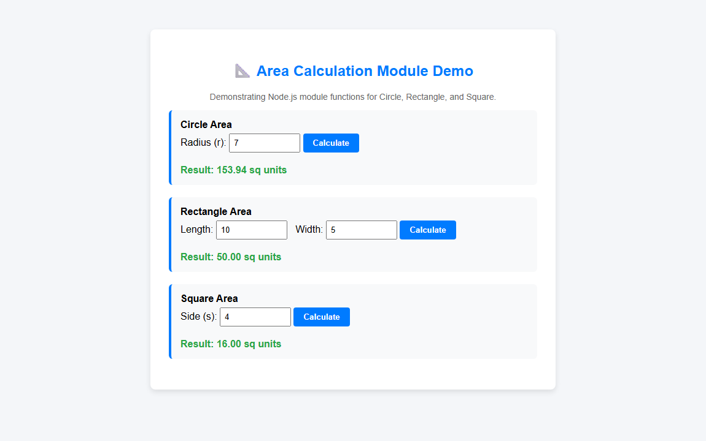
―――――――――――――――――――――――――――――――――――――――――――――――――――――――
Experiment Node.2: Write a program to read a file from server and check whether no read from file is armstrong or not using node.js
Code:
// Node.js Program to read number from file and check Armstrong
const fs = require('fs');
const http = require('http');
// Function to check Armstrong Number
function isArmstrong(num) {
const numStr = num.toString().trim();
const len = numStr.length;
let sum = 0;
for (let i = 0; i < len; i++) {
const digit = parseInt(numStr[i]);
sum += Math.pow(digit, len);
}
return sum === parseInt(num);
}
// Read file 'number.txt' asynchronously
fs.readFile('number.txt', 'utf8', (err, data) => {
if (err) {
console.error("Error reading file:", err);
return;
}
const number = parseInt(data.trim());
const result = isArmstrong(number);
console.log("=== Node.js Armstrong Number Checker ===");
console.log(`Number read from file 'number.txt': ${number}`);
if (result) {
console.log(`RESULT: ${number} IS an Armstrong number.`);
} else {
console.log(`RESULT: ${number} is NOT an Armstrong number.`);
}
// Start HTTP Server to present output on Browser
const server = http.createServer((req, res) => {
res.writeHead(200, { 'Content-Type': 'text/html' });
res.write(`
<!DOCTYPE html>
<html>
<head>
<title>Armstrong Number Checker - Node.js</title>
<style>
body { font-family: Arial, sans-serif; background-color: #f4f6f9; padding: 40px; }
.card { max-width: 500px; margin: auto; background: white; padding: 30px; border-radius: 8px; box-shadow: 0 4px 10px rgba(0,0,0,0.1); text-align: center; }
.badge-yes { background-color: #28a745; color: white; padding: 10px 20px; font-size: 18px; border-radius: 4px; display: inline-block; margin-top: 15px; }
.badge-no { background-color: #dc3545; color: white; padding: 10px 20px; font-size: 18px; border-radius: 4px; display: inline-block; margin-top: 15px; }
</style>
</head>
<body>
<div class="card">
<h2>🔢 Armstrong Number Check</h2>
<p>Number read from <code>number.txt</code>: <strong>${number}</strong></p>
<div class="${result ? 'badge-yes' : 'badge-no'}">
${result ? `✅ ${number} is an Armstrong Number` : `❌ ${number} is NOT an Armstrong Number`}
</div>
</div>
</body>
</html>
`);
res.end();
});
const PORT = 3002;
server.listen(PORT, () => {
console.log(`Server running at http://localhost:${PORT}/`);
});
});
153
<!DOCTYPE html>
<html lang="en">
<head>
<meta charset="UTF-8">
<meta name="viewport" content="width=device-width, initial-scale=1.0">
<title>Lab Node-2 - Armstrong Number Checker</title>
<style>
body {
font-family: Arial, sans-serif;
background-color: #f4f6f9;
padding: 40px;
}
.container {
max-width: 500px;
margin: 0 auto;
background-color: #ffffff;
padding: 30px;
border-radius: 8px;
box-shadow: 0 4px 10px rgba(0,0,0,0.1);
text-align: center;
}
h2 {
color: #007bff;
}
input {
width: 150px;
padding: 8px;
font-size: 16px;
text-align: center;
margin-bottom: 15px;
}
button {
background-color: #28a745;
color: white;
border: none;
padding: 10px 20px;
border-radius: 4px;
font-size: 16px;
cursor: pointer;
font-weight: bold;
}
.result-box {
margin-top: 20px;
font-size: 18px;
font-weight: bold;
padding: 15px;
border-radius: 6px;
}
.is-armstrong {
background-color: #d4edda;
color: #155724;
border: 1px solid #c3e6cb;
}
.not-armstrong {
background-color: #f8d7da;
color: #721c24;
border: 1px solid #f5c6cb;
}
</style>
</head>
<body>
<div class="container">
<h2>🔢 Armstrong Number Checker</h2>
<p style="color: #666; font-size: 14px;">Checks whether the number read from <code>number.txt</code> is an Armstrong number.</p>
<label for="numInput"><strong>Number from File:</strong></label><br>
<input type="number" id="numInput" value="153"><br>
<button onclick="checkArmstrong()">Check Armstrong</button>
<div id="resultBox" class="result-box is-armstrong">
153 IS an Armstrong Number! (1³ + 5³ + 3³ = 153)
</div>
</div>
<script>
function checkArmstrong() {
var numStr = document.getElementById("numInput").value.trim();
var num = parseInt(numStr);
var len = numStr.length;
var sum = 0;
for (var i = 0; i < len; i++) {
var digit = parseInt(numStr.charAt(i));
sum += Math.pow(digit, len);
}
var resultBox = document.getElementById("resultBox");
if (sum === num) {
resultBox.className = "result-box is-armstrong";
resultBox.innerText = num + " IS an Armstrong Number!";
} else {
resultBox.className = "result-box not-armstrong";
resultBox.innerText = num + " is NOT an Armstrong Number.";
}
}
</script>
</body>
</html>
Output:
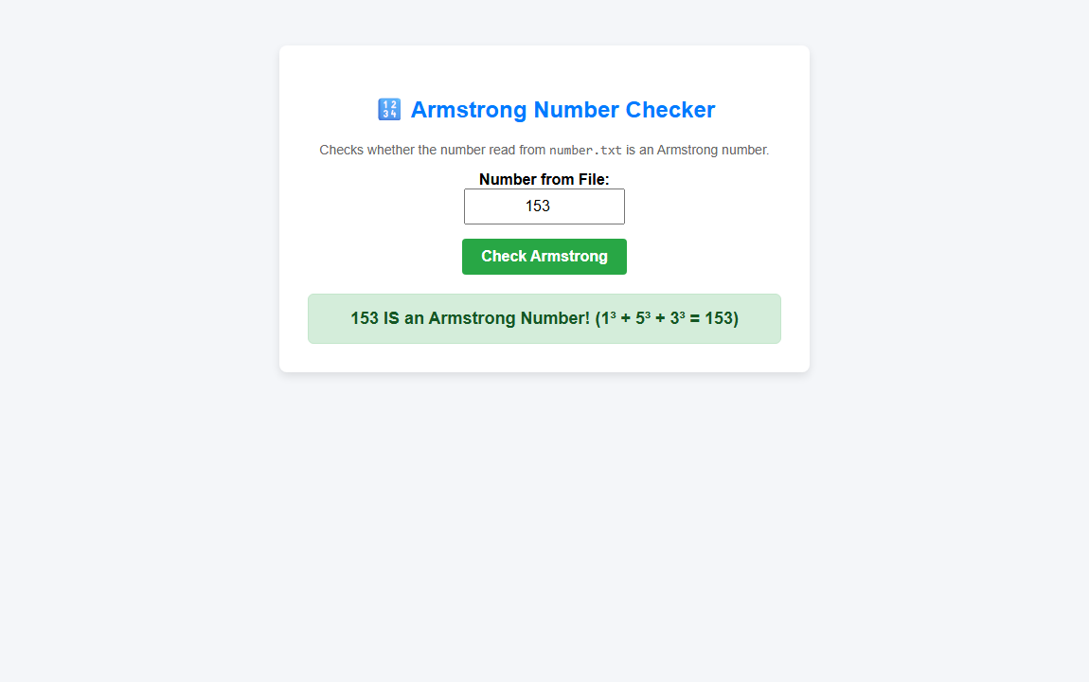
―――――――――――――――――――――――――――――――――――――――――――――――――――――――
Experiment Node.3: Write a program to read student.json file from a server and display the information of student for given PRN no in tabular format
Code:
// Node.js Server to read student.json and display information for given PRN in tabular format
const http = require('http');
const fs = require('fs');
const url = require('url');
const PORT = 3003;
const server = http.createServer((req, res) => {
const parsedUrl = url.parse(req.url, true);
const queryPRN = parsedUrl.query.prn || "202600101"; // Default PRN if not specified
// Read student.json from server
fs.readFile('student.json', 'utf8', (err, data) => {
res.writeHead(200, { 'Content-Type': 'text/html' });
if (err) {
res.write("<h3>Error reading student.json file from server.</h3>");
return res.end();
}
const students = JSON.parse(data);
const student = students.find(s => s.PRN === queryPRN);
let html = `
<!DOCTYPE html>
<html>
<head>
<title>Student Information - PRN ${queryPRN}</title>
<style>
body { font-family: Arial, sans-serif; background-color: #f4f6f9; padding: 40px; }
.card { max-width: 700px; margin: auto; background: white; padding: 30px; border-radius: 8px; box-shadow: 0 4px 12px rgba(0,0,0,0.1); }
h2 { color: #007bff; text-align: center; }
.search-box { text-align: center; margin-bottom: 25px; }
input[type="text"] { padding: 8px; font-size: 15px; width: 200px; border: 1px solid #ccc; border-radius: 4px; }
button { padding: 8px 16px; background-color: #007bff; color: white; border: none; border-radius: 4px; font-weight: bold; cursor: pointer; }
table { width: 100%; border-collapse: collapse; margin-top: 20px; }
td, th { padding: 12px; border: 1px solid #ddd; font-size: 15px; }
th { background-color: #007bff; color: white; text-align: left; width: 30%; }
.no-found { text-align: center; color: #dc3545; font-weight: bold; font-size: 16px; margin-top: 20px; }
</style>
</head>
<body>
<div class="card">
<h2>🎓 Student Information Lookup (Node.js Server)</h2>
<div class="search-box">
<form action="/" method="GET">
<label><strong>Enter PRN No:</strong></label>
<input type="text" name="prn" value="${queryPRN}" placeholder="Enter PRN">
<button type="submit">Search PRN</button>
</form>
</div>
`;
if (student) {
html += `
<table>
<tr><th>Student Name</th><td><strong>${student.name}</strong></td></tr>
<tr><th>PRN No</th><td><code>${student.PRN}</code></td></tr>
<tr><th>Branch</th><td>${student.Branch}</td></tr>
<tr><th>Semester</th><td>${student.Semester}</td></tr>
<tr><th>Address</th><td>${student.address}</td></tr>
<tr><th>Subject Name</th><td>${student.subjectName}</td></tr>
</table>
`;
} else {
html += `<div class="no-found">❌ No Student record found for PRN: ${queryPRN}</div>`;
}
html += `
</div>
</body>
</html>
`;
res.end(html);
});
});
server.listen(PORT, () => {
console.log(`Node.js Student PRN Server running at http://localhost:${PORT}/`);
});
[
{
"name": "Deep Jaiswal",
"PRN": "202600101",
"Branch": "Computer Science & Engineering",
"Semester": "4th Semester",
"address": "Vadodara, Gujarat - 390002",
"subjectName": "Basic Web Programming, Data Structures, Operating Systems"
},
{
"name": "Aarav Patel",
"PRN": "202600102",
"Branch": "Electrical Engineering",
"Semester": "4th Semester",
"address": "Ahmedabad, Gujarat - 380001",
"subjectName": "Power Systems, Electrical Machines, Control Systems"
},
{
"name": "Riya Sharma",
"PRN": "202600103",
"Branch": "Mechanical Engineering",
"Semester": "6th Semester",
"address": "Surat, Gujarat - 395007",
"subjectName": "Thermodynamics, Fluid Mechanics, CAD/CAM"
},
{
"name": "Ananya Mehta",
"PRN": "202600104",
"Branch": "Civil Engineering",
"Semester": "4th Semester",
"address": "Rajkot, Gujarat - 360001",
"subjectName": "Structural Analysis, Concrete Technology, Surveying"
}
]
<!DOCTYPE html>
<html lang="en">
<head>
<meta charset="UTF-8">
<meta name="viewport" content="width=device-width, initial-scale=1.0">
<title>Lab Node-3 - Student Info by PRN</title>
<style>
body {
font-family: Arial, sans-serif;
background-color: #f4f6f9;
padding: 40px;
}
.container {
max-width: 700px;
margin: 0 auto;
background-color: #ffffff;
padding: 30px;
border-radius: 8px;
box-shadow: 0 4px 10px rgba(0,0,0,0.1);
}
h2 {
color: #007bff;
text-align: center;
}
.search-box {
text-align: center;
margin-bottom: 25px;
}
input[type="text"] {
padding: 8px 12px;
font-size: 15px;
width: 220px;
border: 1px solid #ccc;
border-radius: 4px;
}
button {
padding: 8px 16px;
background-color: #007bff;
color: white;
border: none;
border-radius: 4px;
font-weight: bold;
cursor: pointer;
}
button:hover {
background-color: #0056b3;
}
table {
width: 100%;
border-collapse: collapse;
margin-top: 20px;
}
td, th {
padding: 12px;
border: 1px solid #ddd;
font-size: 15px;
}
th {
background-color: #007bff;
color: white;
text-align: left;
width: 30%;
}
.no-result {
color: #dc3545;
text-align: center;
font-weight: bold;
margin-top: 20px;
}
</style>
</head>
<body>
<div class="container">
<h2>🎓 Student Information Lookup by PRN</h2>
<p style="text-align: center; color: #666; font-size: 14px;">Reads <code>student.json</code> file from server and displays student information in tabular format.</p>
<div class="search-box">
<label for="prnInput"><strong>Select or Enter PRN:</strong></label>&nbsp;
<input type="text" id="prnInput" value="202600101" placeholder="Enter PRN No">
<button onclick="searchStudent()">Search Info</button>
</div>
<div id="studentTableContainer">
<!-- Dynamic Tabular Output -->
</div>
</div>
<script>
var studentsData = [];
function loadStudentJSON() {
var xhr = new XMLHttpRequest();
xhr.open("GET", "student.json", true);
xhr.onreadystatechange = function () {
if (xhr.readyState === 4 && xhr.status === 200) {
studentsData = JSON.parse(xhr.responseText);
searchStudent();
}
};
xhr.send();
}
function searchStudent() {
var prn = document.getElementById("prnInput").value.trim();
var student = studentsData.find(function(s) { return s.PRN === prn; });
var container = document.getElementById("studentTableContainer");
if (student) {
var html = '<table>';
html += '<tr><th>Student Name</th><td><strong>' + student.name + '</strong></td></tr>';
html += '<tr><th>PRN Number</th><td><code>' + student.PRN + '</code></td></tr>';
html += '<tr><th>Branch</th><td>' + student.Branch + '</td></tr>';
html += '<tr><th>Semester</th><td>' + student.Semester + '</td></tr>';
html += '<tr><th>Address</th><td>' + student.address + '</td></tr>';
html += '<tr><th>Subject Name</th><td>' + student.subjectName + '</td></tr>';
html += '</table>';
container.innerHTML = html;
} else {
container.innerHTML = '<div class="no-result">❌ No student record found for PRN: ' + prn + '</div>';
}
}
window.onload = loadStudentJSON;
</script>
</body>
</html>
Output:



