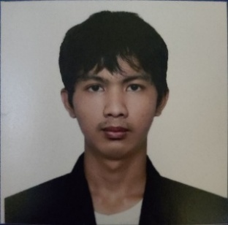

**Name: Magno, Ian S.**

**Section: CE12S8  
Program: BSCE**

**R E F L E C T I O N**

1. **How would you describe your experience during the community outreach project?**

Describing my experience with our outreach program is fascinating. Our activity was a Zumba recreational program, and I had the opportunity to meet amazing people who were very dedicated to their tasks, which helped improve the overall success of the program. Since Zumba is a recreational activity, it gave us a lot of exposure to the local community. The interaction with the local people was truly heartwarming they welcomed us with open arms and were very friendly. Moreover, during the program, I had the experience of being a multitasker. Although I was assigned to take pictures for our documentation, I still joined the Zumba session. Doing Zumba while taking photos was enjoyable for me because I was able to use both my mind and body at the same time. It helped refresh my mental and physical health, especially after the stress of school activities.

1. **How did your outreach project address the specific needs or challenges in the community? Explain how the community benefited from it.**

Our outreach project addresses the needs of the community by encouraging everyone to join the Zumba session, providing an opportunity to exercise their bodies and refresh their minds. It promotes both physical and mental well-being, especially for adults.

1. **What specific skills did you develop throughout the outreach, and how did these contribute to your personal growth? How did your understanding of social issues deepen as a result of participating in the outreach?**

The skill I developed throughout the outreach is my social skill and analytical skill. This outreach program contributed to my personal growth as a student and as a person because it developed my analytical skill to think about what the best decision should be for our program and for the participants. Since this outreach program was a recreational activity, Zumba is a very practical activity that is good for our health. And because this was Zumba, which involved a lot of exposure, it also developed my social skill, where interaction and communication were very important. I am very grateful for this because I am an introverted person who doesn’t like socializing with many people. That’s why this outreach program was very helpful in enhancing my skills.

1. **What was the most impactful lesson you learned from this outreach experience? How does this outreach experience relate to your chosen program or course of study?**

The impactful lesson I learned from this outreach was that being physically and mentally healthy is very important in life, especially for my course, which is Civil Engineering, where both body and mind are needed. This realization was helpful, and starting today, we will join the Zumba program in our barangay to exercise our bodies and refresh our minds. I will also start working out to be physically and mentally healthy while being a student and for my future, where I need a healthy body and mind as a Civil Engineer.