**Project Overview:**

The project aims to use the 20 variables over the course of 30 days to predict the return of shares over the course of 30 days. This will allow us to create a tool to facilitate users in getting better entry points for trades. The 20 variables are as follows:

1. 'Book_Value_Per_Share_*_USD',
2. 'Cap_Spending_USD_Mil',
3. 'Earnings_Per_Share_USD',
4. 'Free_Cash_Flow_Per_Share_*_USD',
5. 'Free_Cash_Flow_USD_Mil',
6. 'Gross_Margin_%',
7. 'Net_Income_USD_Mil',
8. 'Operating_Cash_Flow_USD_Mil',
9. 'Operating_Income_USD_Mil',
10. 'Operating_Margin_%',
11. 'Payout_Ratio_%_*',
12. 'Revenue_USD_Mil',
13. 'Shares_Mil',
14. 'Working_Capital_USD_Mil',
15. 'close',
16. 'dividend_amount',
17. 'high', ‘
18. ‘low',
19. 'open',
20. 'volume'

Given that we have chosen 131 tickers which made up the Dow Jones U.S. Technology Index, we expect them to be helpful in explaining the moves of one another. For example, an increase in Apple’s earnings per share will have a predictive impact on Google’s returns.

For our input data, I used 2 data source specifically and spliced it together to come up with the complete data set. The first data set is from AlphaVantage that provides me with the data on the equity prices such as high, low, open, share splits, volume and dividend amount. The second set of data is picked up from Morningstar. The data consist of the key ratios such as earnings per share, operating income, payout ratios, revenue and working capital. The companies report these data on a quarterly basis but Morningstar complies them on annual basis which is useful as it removes the seasonality factor of the data. Furthermore, some of the data by the companies have yet been reported and thus, I decided to forward fill the information i.e. filling forward the information such that the most recent readings will be used for the yet-reported data.

Initially, there was a plan to utilise Twitter data but I failed to properly classify the sentiment used and hence decided that it will be much more useful to utilise clean data rather than having a data point that is flawed. Furthermore, I am fortunate enough to obtain a lot more information from Morningstar and thus decided on removing the Twitter dependency but introduce more variables that I have sourced from Morningstar.

**Problem Statement:**

I will look to build a stock price predictor that takes daily trading data over a certain date range as input and output buy or sell signals for the given query date.

The best proxy for the future is the recent past is the basis of the strategy to solve this problem. I believe that all shares exhibit similar behaviours which allows us to utilise what we have learned from the share price movements in Apple to predict the future movements of Facebook or Google. On this basis it will be incredibly useful for each factor to learn from one another and thus help us to maximise the dataset we have. Furthermore, a rise in Apple revenue also could drive other related companies like Micron or Intel and thus, we can utilise such cross company information to help refine the expected return of the shares.

One has to note that a 30 day return model is used as well and this is fundamental because it helps us avoid volatility which is intrinsic in the market. The expected solution will be one where we provide a complete set of information of all the related data and will be able to confidently tell us if the share price of our target company will rise or fall. This expected solution will be a dense neural network comprising of 3 layers. Between each of these layers, I look to drop out 20% of the point so as to ensure that we do not overfit the model to the data we have. It is extremely important to do that given that a lot of the information we have are correlated and thus resulting in us failing to see the wood for the trees.

**Metrics:**

Originally the proposed metric to use the area under the Receiver Operating Characteristic Curve where the curve is plotted by using the True Positive Rate (True Positive divided by the sum of False Negative and True Positive) and False Positive Rate (False Positive divided by the sum of False Positive and True Negative) with different thresholds for the logistic regression. However, this was scrapped after I ran the model once as I realised that 30 days return is often highly skewed. For example, the last 30 values of the 30 days return for AMD is all positive and there is only one class present in the y true value making it impossible for us to calculate True Positive and False Positive Rates and thus unable to utilise the ROC AUC score. Thus I decided to change to utilise accuracy score which is a simple singular metrics to use which make the model output and that of the benchmark model easily comparable.

**Data Exploration:**

Looking at the data, I first spliced the various data sets into a single HDF. Thereafter, I took a first look at the first 5 rows of the dataframe. The first thing that jumped out was that there are various measures that has data that are empty. For example, the volume information of WP, Z and VSM is coming in as NaN.

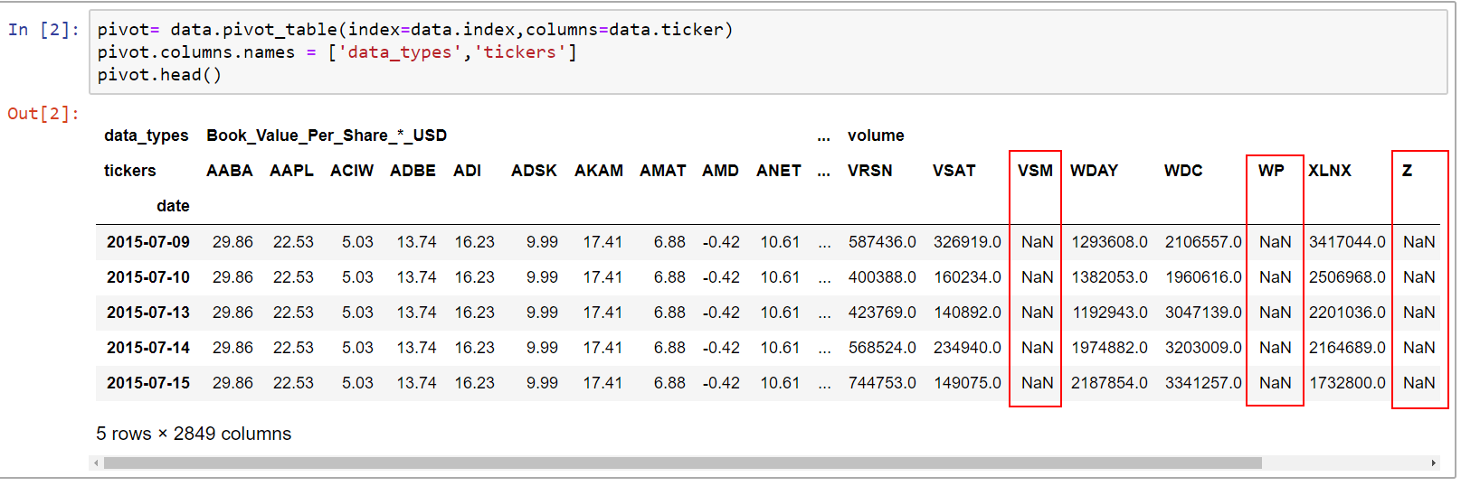

The data frame has 750 rows and 2849 columns where the rows are dates starting from 9th July 2015 to 28th June 2018. The columns have 2 layers namely data_types and tickers. Thus there are 23 different data types for each of the 131 unique tickers.

I created a new “missing_data” dataframe using a summary of “total” and “percent” dataframes. I then sorted it and noticed that out of the 2849 columns, there are 393 columns that have some sort of data that is missing in the columns. Each ticker is supposed to have 23 * 750 = 17,250 data points. Given that I will need to split the data into training and testing dataset, I decided to remove the tickers which has more than 15% of 17,250 data points missing. Thus, out of the 131 tickers, 4 of the tickers have more than 15% of their data missing as below:

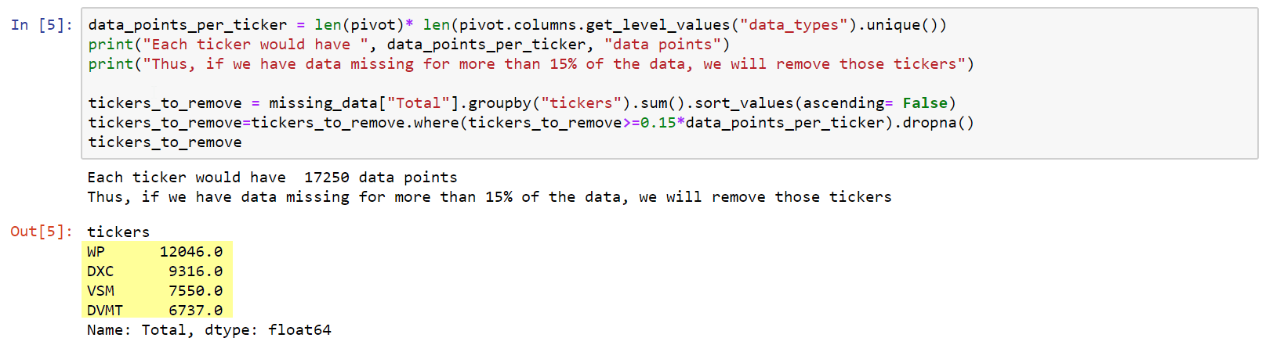

Thus we are left with 393-(4*23) = 301 columns that has some sort of missing data. Looking at the top 20 names that drive the highest percentage of missing data, I noticed that all the data that are missing are data from my Morningstar source

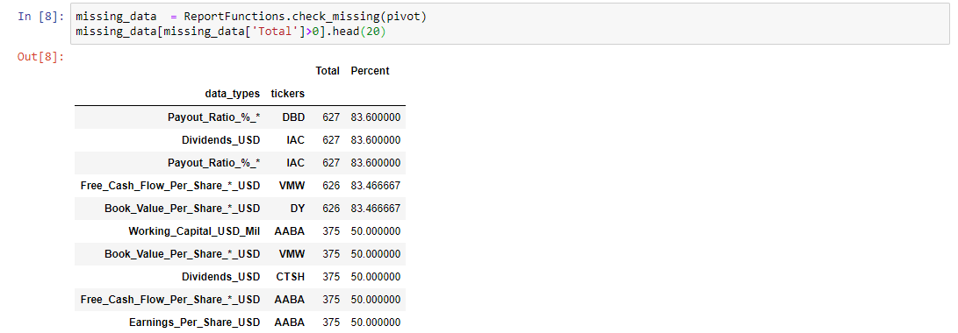

Looking at the column with the highest ratio of missing data, I noticed that DBD has missing payout ratio due to the fact that Payout Ratio is computed as Dividends divided by Earnings. However, given that the company made a loss in 2016, 2017 and 2018. It resulted in a negative Payout Ratio which the data omits. Thus, decide that I will replace all the Payout Ratio by dividing the Dividends by the Earnings and accept that there will be negative Payout Ratios.

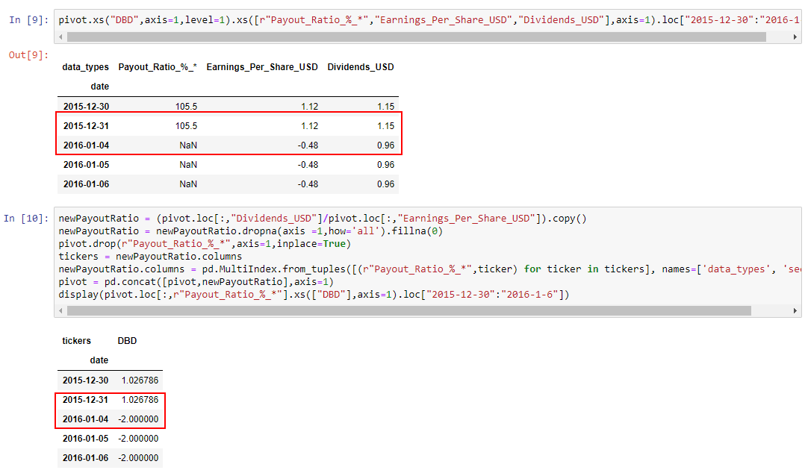After this cleaning, we note that we have significantly less dirty data and we note that they are generally concentrated in the following 5 fields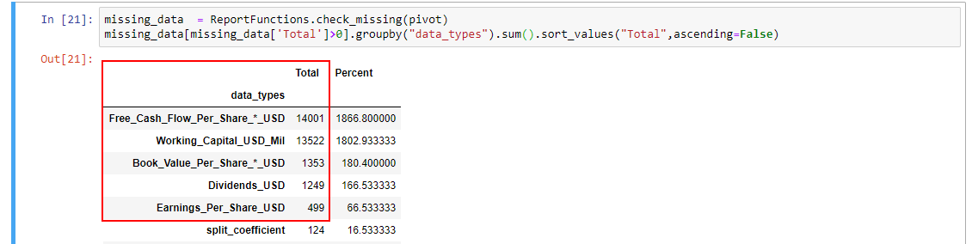

Given that we have 2 measures that are identical to each other namely

1. Free_Cash_Flow_Per_Share_*_USD
2. 'Free_Cash_Flow_Per_Share_*_USD'.

Thus, we can safely ignore the issues with the measure Free_Cash_Flow_Per_Share_*_USD

Also, I note that there are shares that do not distribute dividends like IAC in recent years hence, it is fair to fill the NaN values in as zero. The same applies to that of Book_Value_Per_Share_*_USD and Working_Capital_USD_Mil.

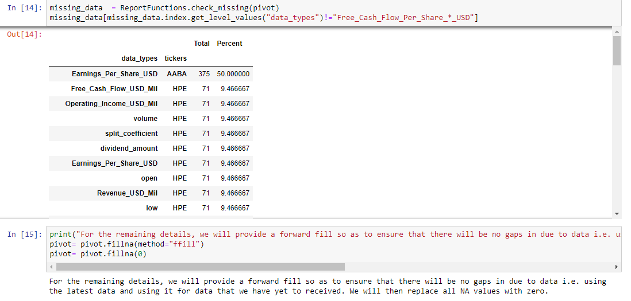Hence we are left with just some odd data points that are empty. AABA has incomplete information but given that we are in a situation where we are unable to get the completeness of the Earnings per share of AABA, I decide that I will forward fill so as to ensure that there will be no gaps in due to data i.e. using the latest data and using it for data that we have yet to received and replace all the remaining NA values with zero for simiplicity sake given that they are minimal.

Next, I sorted and printed all the tickers that has their stock split and when they were split.

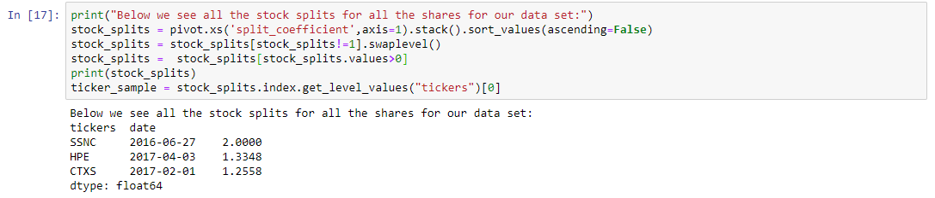

We note that 3 tickers namely SSNC, HPE and CTXS has had stock splits over the years and hence their data would be skewed and we can see the impact of a share split on the closing price of stock prices as seen below.

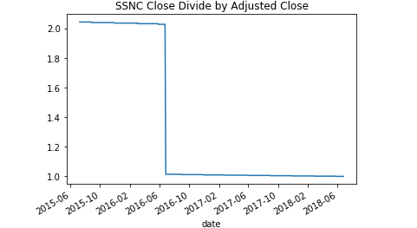

This is particularly evident in the data we have downloaded from Alpha Vantage. Thus, I decided to divide all the values before the stock split by the stock split ratio and hence making it consistent. We can easily see that upon the adjustment, the 4 variables namely ['high', 'low', 'open', 'volume'] are much smoother as seen in Appendix 1.

**Appendix 1**

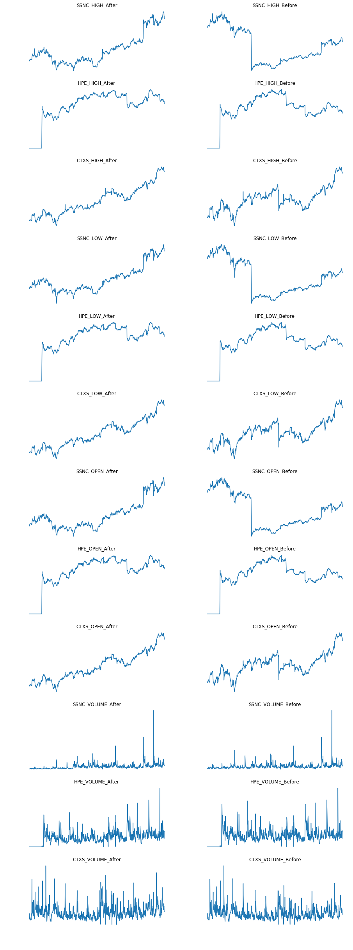

<https://stackoverflow.com/questions/332289/how-do-you-change-the-size-of-figures-drawn-with-matplotlib>

<https://stackoverflow.com/questions/18770504/resize-ipython-notebook-output-window>

<https://www.somebits.com/~nelson/pandas-multiindex-slice-demo.html>

<https://www.shanelynn.ie/select-pandas-dataframe-rows-and-columns-using-iloc-loc-and-ix/>