

THE UNIVERSITY OF AZAD JAMMU & KASHMIR
Department of Software Engineering
LAB 04 — STUDENT CASE STUDY
UML Sequence Diagram: ATM Cash Withdrawal System
Course | Software Design and Architecture | Program | B.Sc. Software Engineering
Student name | Khawaja Tahreem Rasheed | Roll no. | 2025-SE-18

1. Completed UML Sequence Diagram
The diagram shows the four required participants, chronological messages, return messages, and alternative outcomes.
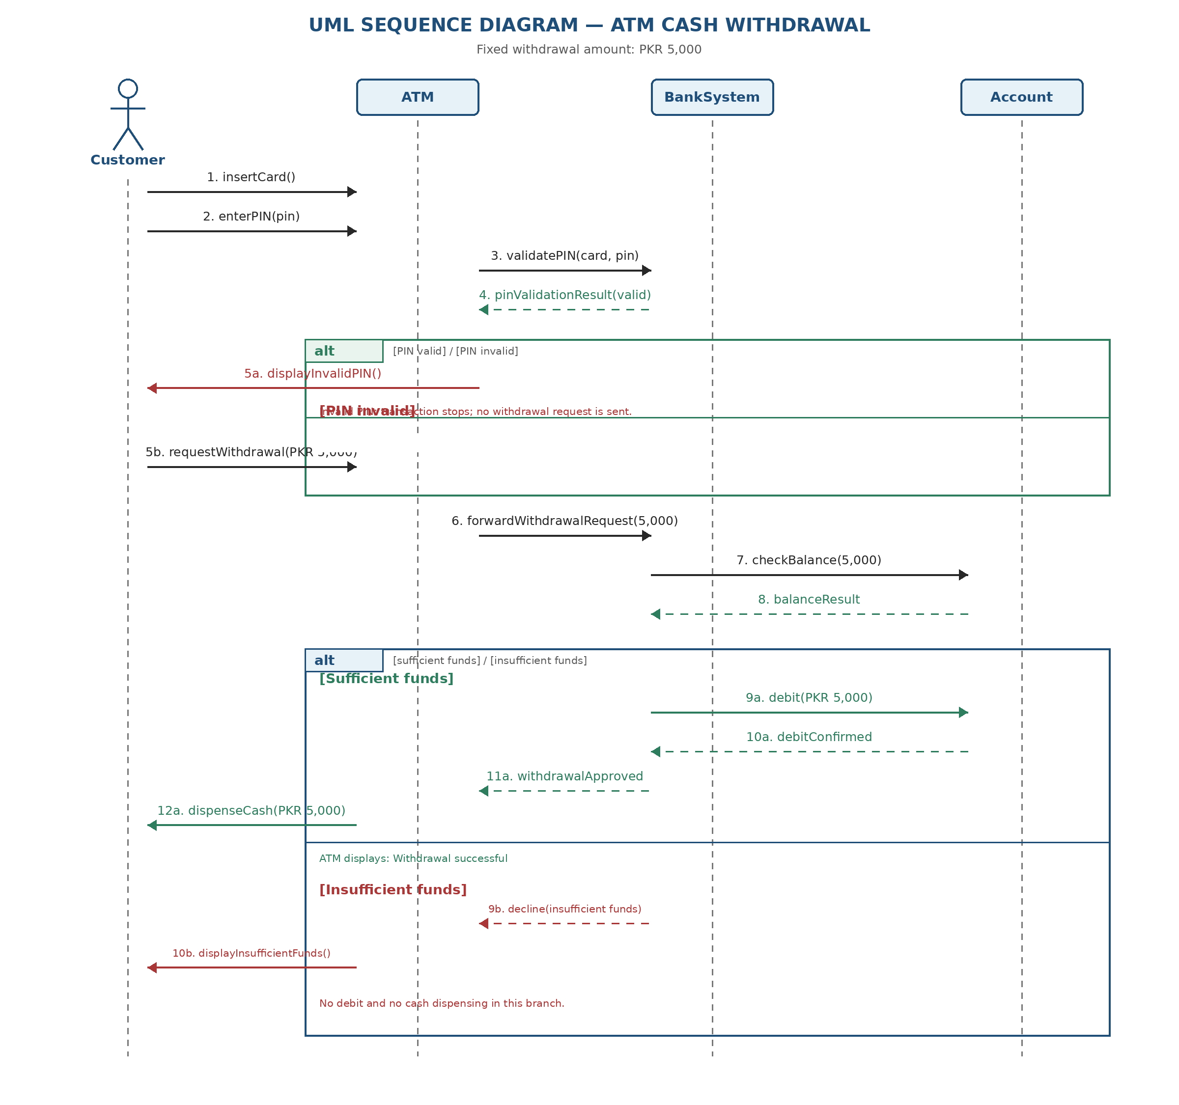

2. Message Sequence:
- Customer inserts the ATM card and enters the PIN.
- ATM sends the card information and PIN to BankSystem for validation.
- BankSystem validates the PIN and returns the validation result to the ATM.
- If the PIN is invalid, the ATM displays an invalid-PIN message and stops the transaction.
- If the PIN is valid, the customer requests withdrawal of PKR 5,000.
- ATM forwards the withdrawal request to BankSystem.
- BankSystem asks Account to check whether at least PKR 5,000 is available.
- Account returns the balance-check result to BankSystem.
- If sufficient funds are available, BankSystem requests Account to debit PKR 5,000 and waits for confirmation.
- After debit confirmation and bank approval, ATM dispenses PKR 5,000 and displays a success message.
- If funds are insufficient, BankSystem refuses the transaction and ATM displays an insufficient-funds message. No debit or cash dispensing occurs.

3. Short Design Note :
The Customer starts the withdrawal by inserting an ATM card and entering a PIN. The ATM sends the card details and PIN to BankSystem, which validates them before any withdrawal request is processed. If the PIN is invalid, the ATM displays an error and the transaction stops. If the PIN is valid, the customer requests PKR 5,000 and the ATM forwards the request to BankSystem. BankSystem asks Account to check the available balance. In the [sufficient funds] branch, Account debits PKR 5,000 and confirms the debit; only then does BankSystem approve the withdrawal and the ATM dispense cash. In the [insufficient funds] branch, the ATM displays a refusal message, and no debit or cash dispensing occurs. The model assumes network availability and sufficient physical cash in the ATM.

4. Answers to the Design Questions:

- Who initiates the first message?
The Customer initiates the interaction by inserting the ATM card.
- Which participant is responsible for validating the PIN?
BankSystem validates the PIN after receiving the card information and PIN from the ATM.
- Which participant knows whether enough money is available?
The Account provides the balance-related information and returns whether the requested amount is available.
- Which message must occur before the ATM can dispense cash?
The ATM can dispense cash only after BankSystem approves the withdrawal. Approval follows a successful balance check and debit confirmation.
- What should the ATM do if the Account returns an insufficient-funds result?
The ATM should display an insufficient-funds message. The transaction must not debit the account or dispense cash.
- Which part of the diagram would change if the customer entered the wrong PIN?
The PIN-validation alternative would take the [PIN invalid] branch. The ATM displays an invalid-PIN message, and the withdrawal request and balance-check messages do not occur.

5. Assumptions:
- The withdrawal amount is fixed at PKR 5,000.
- The ATM has sufficient physical cash and the network is available.
- Cash is dispensed only after bank approval.
- Activation bars and low-level implementation details are omitted because the lab makes them optional.

6. Final Submission Checklist:
☐ All four participants and lifelines are shown.
☐ Messages are labelled and arranged in chronological order.
☐ PIN validation occurs before withdrawal processing.
☐ Account balance is checked before debit.
☐ Cash is dispensed only after approval.
☐ The insufficient-funds branch has no debit and no cash dispensing.
☐ The editable .drawio source file is retained.
☐ The final sequence diagram is exported as PDF or PNG.

