Change to: **Projects where roles are assigned to me**

|  |  |
| --- | --- |
|  | |
|  | 222,943 Click Hand Icon Royalty-Free Photos and Stock Images ... |

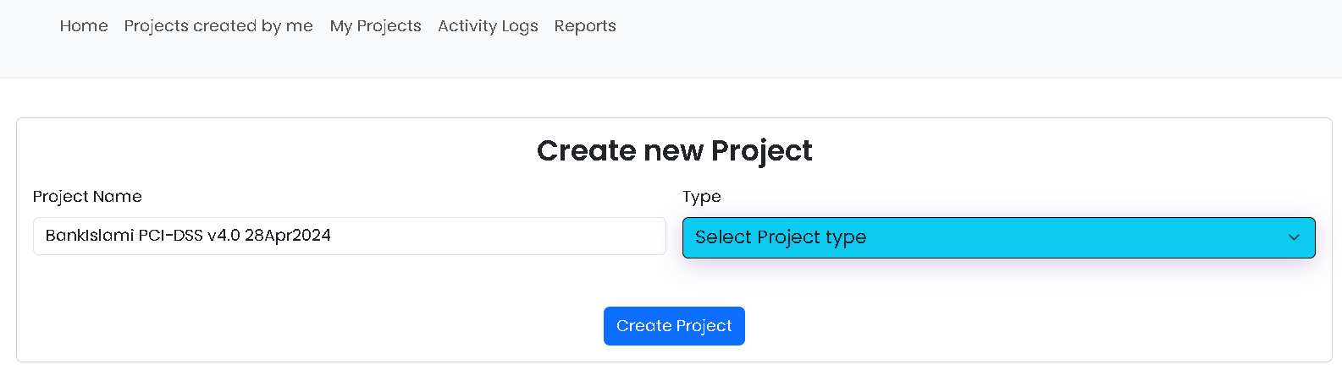

**PCI-DSS v4-Merchant**

**PCI-DSS v4-Multi-Tenant Service Provider (mtSP)**

**PCI-DSS v4-Single-Tenant Service Provider (stSP)**

**ISO 27001:2022**

Change ISO to ISO 27001:2022



Add 3 more options for PCI (there are 3 different xls sheets)

Create hyperlinks same as in the table on the page: “My Assigned Projects”

Change to: Edit Project Name, Type, Status, End Users

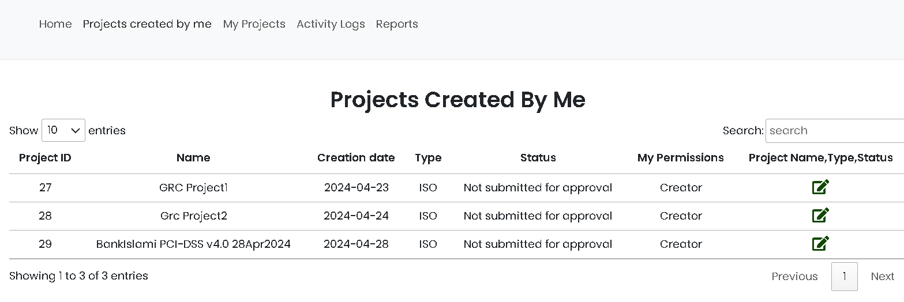

**PCI-DSS v4 mtSP**



Add this table to this page for both ISO & PCI projects

Remove this column

Change to: **Projects where roles are assigned to me**

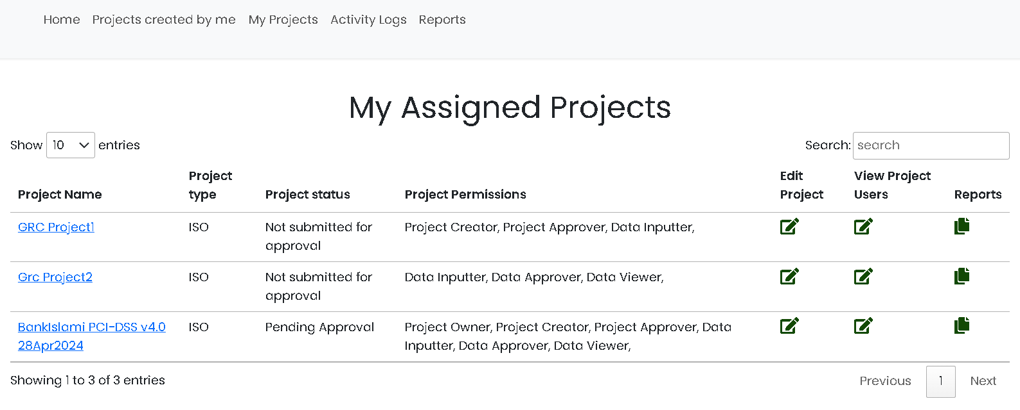

**PCI-DSS v4**



Remove the words “of ISO 27001:2022” for both PCI and ISO projects

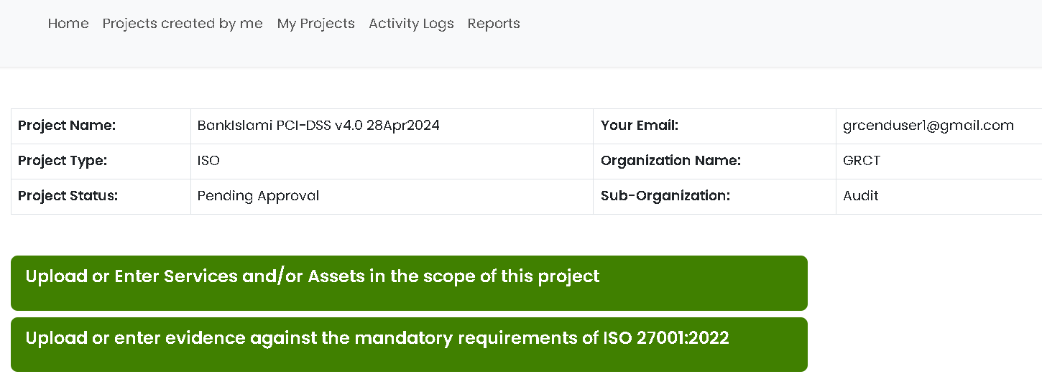

**PCI-DSS v4 mtSP**

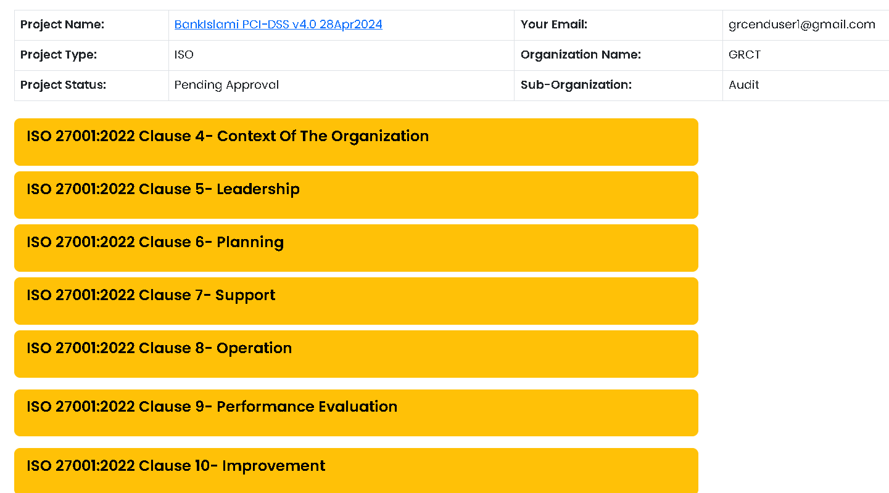

**PCI-DSS v4**

Replace the 7 buttons above with the 13 buttons as below (add 14th only – shaded green below - if user selected PCI-DSS v4-mtSP)

PCI-DSS v4.0 Requirement 1: Install and Maintain Network Security Controls

PCI-DSS v4.0 Requirement 2: Apply Secure Configurations to All System Components

PCI-DSS v4.0 Requirement 3: Protect Stored Account Data

PCI-DSS v4.0 Requirement 4: Protect Cardholder Data with Strong Cryptography During Transmission Over Open, Public Networks

PCI-DSS v4.0 Requirement 5: Protect All Systems and Networks from Malicious Software

PCI-DSS v4.0 Requirement 6: Develop and Maintain Secure Systems and Software

PCI-DSS v4.0 Requirement 7: Restrict Access to System Components and Cardholder Data by Business Need to Know

PCI-DSS v4.0 Requirement 8: Identify Users and Authenticate Access to System Components

PCI-DSS v4.0 Requirement 9: Restrict Physical Access to Cardholder Data

PCI-DSS v4.0 Requirement 10: Log and Monitor All Access to System Components and Cardholder Data

PCI-DSS v4.0 Requirement 11: Test Security of Systems and Networks Regularly

PCI-DSS v4.0 Requirement 12: Support Information Security with Organizational Policies and Programs

Appendix A1: Additional PCI DSS Requirements for Multi-Tenant Service Providers

Appendix A2: Additional PCI DSS Requirements for Entities Using SSL/Early TLS for Card-Present POS POI Terminal Connections

Pressing any of the 14 buttons above will take you to the respective pages as below:



**PCI-DSS v4**

**PCI-DSS v4.0 Requirement 1: Install and Maintain Network Security Controls**

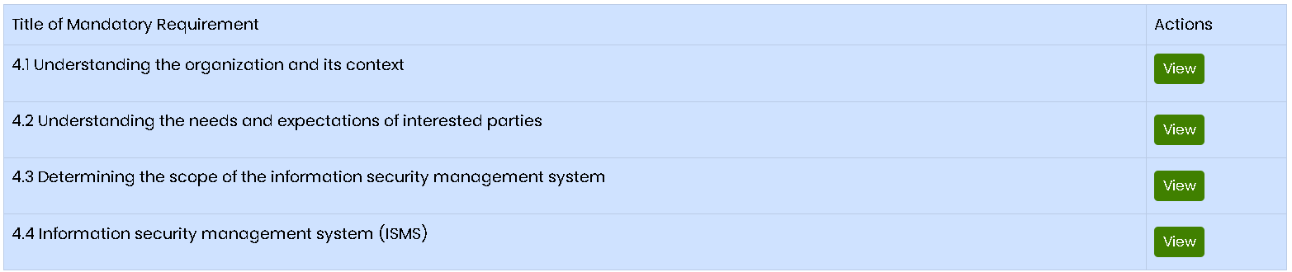

Replace with content as per PCI DSS spreadsheet columns B and C for each of the 14 requirements numbers labeled in Column A



**1.5 Risks to the CDE from computing devices that are able to connect to both untrusted networks and the CDE are mitigated.**

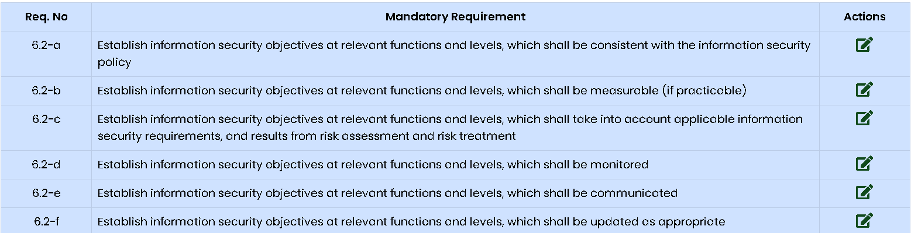

Replace with content as per PCI DSS spreadsheet columns D and E for each of the requirements numbers labeled in Column B and add a column titled “Mandatory From” as per spreadsheet Column F