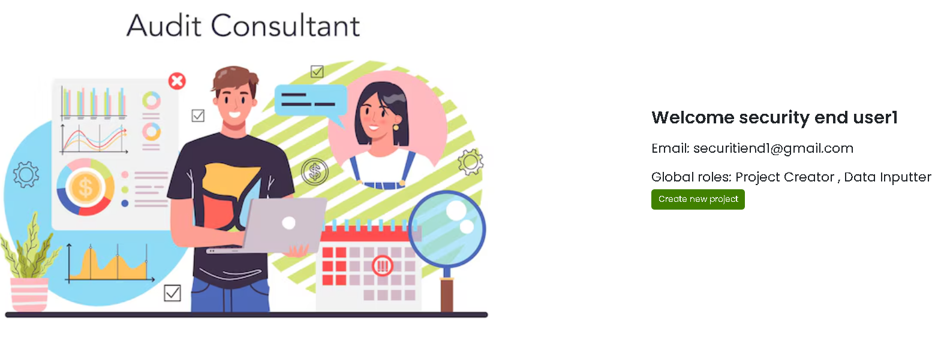

**Create New Project**

**Visual and AI Dashboard**

AI-enabled Infosec Program



|  |  |
| --- | --- |
| **Projects created by me**  **(by Type)** | **Projects where roles are assigned to me**  **(by Type)** |
| **Pie-chart of number of projects created by me by type:**   * ISO 27001:2022 * PCI DSS stSP * PCI DSS 4.0 mtSP * PCI DSS 4.0 Merchant | **Pie-chart of number of projects where roles are assigned to me by type:**   * ISO 27001:2022 * PCI DSS stSP * PCI DSS 4.0 mtSP * PCI DSS 4.0 Merchant |
| **Projects created by me**  **(by Project Status)** | **Projects where roles are assigned to me**  **(by Project Status)** |
| **Pie-chart of number of projects created by me by Project Status:**   * Not submitted for approval * Pending approval * Approved | **Pie-chart of number of projects where roles are assigned to me by Project Status:**   * Not submitted for approval * Pending approval * Approved |



Add 3 new columns

|  |  |  |
| --- | --- | --- |
|  |  | **Delete** |

Correct this page heading



|  |  |
| --- | --- |
|  | **Delete** |

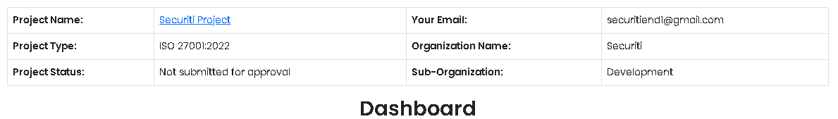

Remove this page heading

“Dashboard”

**Go to AI Wizard for this project (see other doc)**

**Services and assets in the scope of this project**

|  |  |  |  |  |  |  |  |
| --- | --- | --- | --- | --- | --- | --- | --- |
| 7 |  |  |  |  |  |  |  |
| 6 |  |  |  |  |  |  |
| 5 |  |  |  |  |  |  |
| 4 |  |  |  |  |  |
| 3 |  |  |  |  |  |
| 2 |  |  |  |  |
| 1 |  |  |  |
|  | **Services** |  | **Asset Groups** |  | **Assets** |  | **Asset Components** |

**Compliance status against mandatory controls**

**Pie-chart of % of Mandatory Requirements that have Compliance Status as:**

* Yes
* No
* Partial

**Y**

**P**

**N**

Note: Pull and aggregate data from this table

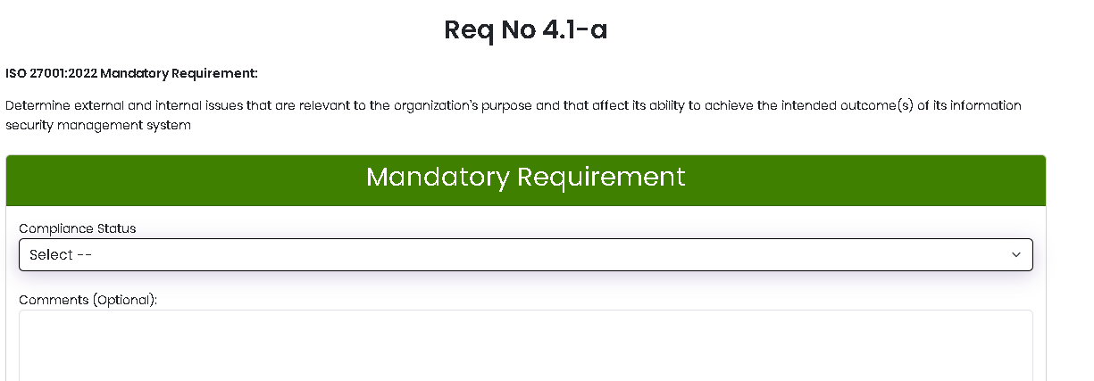

**Statement of Applicability of Controls**

**Pie-chart of % of ISO 27001:2022 Annex A controls where the value of “Control is Applicable” is:**

* Yes
* No

**Outcome of Risk Treatment**

**Pie-chart of % of ISO 27001:2022 Annex A controls where the value of “Control is Applicable” is:**

* Retain and Accept Risk
* Share Risk
* Avoid Risk
* Modify Risk

**S**

**A**

**M**

**R**