Project-Phase 2
  - Deadline: Day 09/08/2026 @ 23:59
[Total Mark is 15]

Computer Networks
IT351

Instructions:
- You must submit two separate copies (one Word file and one PDF file) using the Assignment Template on Blackboard via the allocated folder. These files must not be in compressed format.
- It is your responsibility to check and make sure that you have uploaded both the correct files.
- Zero mark will be given if you try to bypass the SafeAssign (e.g., misspell words, remove spaces between words, hide characters, use different character sets, convert text into image or languages other than English or any kind of manipulation).
- Email submission will not be accepted.
- You are advised to make your work clear and well-presented. This includes filling your information on the cover page.
- You must use this template, failing which will result in zero mark.
- You MUST show all your work, and text must not be converted into an image, unless specified otherwise by the question.
- Late submission will result in ZERO mark.
- The work should be your own, copying from students or other resources will result in ZERO mark.
- Use Times New Roman font for all your answers.
Student Details: CRN:
Name:  Name:  Name: |  | ID:  ID:  ID:

Project Instruction
Project Objective:
Design, configure, and test a network setup in Packet Tracer to successfully transmit data packets between devices in different LANs across two separate WANs (WAN 1 and WAN 2).
Group Details
- Group Size = Maximum of 3 Members.
- One group member (group leader/coordinator) must submit the project report on blackboard. Marks will be given based on your submission and quality of the contents.
Project Report
- The project is divided into two phases:
  - Phase 1 (Mid project Progress Report)
  - Phase 2 (Final project Report)
- This report is for Phase 2. In this report, you should complete all the requirements for Phase 2.
- Each Report will be evaluated according to the marking criteria

Project Description (Common to Phase 1 and Phase 2)
Learning Outcome(s):
Demonstrate protocol configuration, network-addressing schemes and analyze packet transmission for the Local and Wide Area Networks.

A university operates two campuses: a Main Campus and a Branch Campus. Each campus network is treated as a separate WAN site. Your task is to design and configure, in Cisco Packet Tracer, a network that successfully transmits data packets from a device in any LAN of WAN 1 (Main Campus) to a device in any LAN of WAN 2 (Branch Campus). Each WAN contains 2 LANs, and each LAN has 3 end devices.

Network Design Requirements:
- WAN 1 (Main Campus):
  - Contains LAN 1 (Computer Lab) and LAN 2 (Admin Office).
  - Each LAN has 3 devices (PCs or laptops) connected through a switch.
  - Assign private IP addresses to the devices in each LAN (e.g., use 172.16.10.0/24 for LAN 1 and 172.16.20.0/24 for LAN 2).
  - Connect each LAN to a router (Router 1).
- WAN 2 (Branch Campus):
  - Contains LAN 3 (Library) and LAN 4 (Faculty Office).
  - Each LAN has 3 devices (PCs or laptops) connected through a switch.
  - Assign private IP addresses to the devices in each LAN (e.g., use 172.16.30.0/24 for LAN 3 and 172.16.40.0/24 for LAN 4).
  - Connect each LAN to a router (Router 2).
- WAN Connection:
  - Connect Router 1 and Router 2 using a serial link to simulate a WAN connection.
  - Assign IP addresses to the serial interfaces (e.g., 10.10.10.1/30 for Router 1 and 10.10.10.2/30 for Router 2).

Configuration Details:
- Assign IP Addresses:
  - Configure IP addresses, subnet masks, and default gateways for all devices in each LAN. Example:
    - LAN 1: 172.16.10.0/24, Default Gateway: 172.16.10.1 (Router 1's interface).
    - LAN 2: 172.16.20.0/24, Default Gateway: 172.16.20.1 (Router 1's interface).
    - LAN 3: 172.16.30.0/24, Default Gateway: 172.16.30.1 (Router 2's interface).
    - LAN 4: 172.16.40.0/24, Default Gateway: 172.16.40.1 (Router 2's interface).
- Router Configuration:
  - Configure IP addresses on the LAN and WAN interfaces of both routers. Example:
    - Router 1:
      - LAN 1 Interface: 172.16.10.1/24
      - LAN 2 Interface: 172.16.20.1/24
      - WAN Interface (Serial): 10.10.10.1/30
    - Router 2:
      - LAN 3 Interface: 172.16.30.1/24
      - LAN 4 Interface: 172.16.40.1/24
      - WAN Interface (Serial): 10.10.10.2/30
- Enable Routing:
  - Configure static routes or a dynamic routing protocol (e.g., RIP) on both routers to ensure communication between WAN 1 and WAN 2.

Phase 2 Requirements
15 Marks
Testing and Verification
- Use the ping command to test connectivity between a device in any LAN of WAN 1 and a device in any LAN of WAN 2.
- Verify that data packets are successfully transmitted (0% packet loss).

Questions to Answer (10 Marks — 2 marks each)
Answer all five questions. For each question, you must include (a) a clear screenshot from your Packet Tracer project and (b) the commands used at that instance (e.g., IOS CLI commands or the configuration steps applied). Screenshots without the corresponding commands/steps will receive ZERO marks for that question.
- Creating nodes: Show a screenshot of the complete topology with all nodes created (12 end devices, 4 switches, 2 routers). List the device types selected and any steps/commands used to name the devices (e.g., hostname configuration). (2 marks)
- Giving connections in the LAN: Show a screenshot of the LAN connections between end devices, switches, and routers. State the cable types used for each connection and why. (2 marks)
- Assigning IP addresses: Show screenshots of IP address, subnet mask, and default gateway assignment on at least one end device in each LAN, and the commands used to configure the router LAN interfaces (e.g., interface, ip address, no shutdown). (2 marks)
- Creating the WAN connection: Show a screenshot of the serial link between Router 1 and Router 2, and the commands used to configure the serial interfaces and enable routing (static routes or a dynamic routing protocol such as RIP), including clock rate if applicable. (2 marks)
- Successful data transmission using the ping command: Show screenshots of successful ping tests between a device in WAN 1 and a device in WAN 2 (both directions), with the exact ping commands used and the results (replies received, 0% loss). (2 marks)

Written Reflection — End of Project Report (5 Marks)
The project report must include a Reflection section (300–500 words) as the last section before the Project Artifacts section. This section must be written in the students' own words and should address some of the following:
- Describe one specific challenge or obstacle you encountered during this project and explain in detail how you identified and resolved it.
- Explain why you chose your specific approach/method (e.g., static routing vs. RIP, your IP addressing scheme) over at least one alternative you considered, and what tradeoffs informed that decision.
- If you used any AI tools during this project (e.g., ChatGPT, Claude, Copilot), disclose which tool(s), for what specific purpose (e.g., debugging, grammar checking, brainstorming), and how you verified or modified the output.
- What would you do differently if you were to redo this project with more time or resources?

Version History / Commit Log Requirements (Common to Both Reports)
Students must document and submit their project history/timestamps using a live, editable link:
- Written report: Submit a shared Google Doc or Word Online link (sharing set to "Anyone with the link can view") along with your final PDF report. The link must show the progress of the students' work with timestamps/screenshots.
- Code/data/configuration files: Submit Packet Tracer files (.pkt) and any configuration scripts via a GitHub or GitLab repository link (the coordinator may choose a repository suitable for the course). The repository must show a commit history reflecting incremental progress. Commit regularly (at minimum once per week), with clear, descriptive commit messages.
A separate section in the report must be added and named "Project Artifacts" to include all links, for example:
  - Live report document (with edit history): [link]
  - GitHub/GitLab repository (with commit history): [link]
  - Packet Tracer project file (.pkt): [link or attached]
What NOT to do: Students must not write their report elsewhere and paste the final version in at the last minute. They also must not make a single commit containing the entire project. Both are treated as red flags regardless of the quality of the final work.

Important Notes
- AI use: Students may use AI tools (ChatGPT, Claude, Copilot, Gemini, etc.) only for brainstorming approaches, debugging small errors, or proofreading text. AI must not be used to generate analysis, write configuration logic, or produce substantial portions of the report or project files. Any permitted AI use must be disclosed in the Reflection section. Undisclosed AI use, or AI use beyond this scope (disclosed or not), will result in a zero grade for the entire project.
- Any submission lacking a valid, inspectable version/commit history, or showing evidence of AI generation or plagiarism, will receive a zero grade for the entire project.
- Failure to submit the mid progress report as required, or submission of reports found to be fabricated, copied, or AI-generated, will result in a zero grade for the entire project.
- The final report must be submitted as a PDF, together with the live document link, the repository link, and the Packet Tracer (.pkt) file.
- The edit history of the live document and the commit history of the repository must show incremental progress across both phases (Phase 1 and Phase 2).

Samar's Section: WAN Routing and Connectivity Testing
This section documents the work completed for Question 4 and Question 5. It includes the serial WAN connection, interface addressing, clock-rate configuration, static routing, route verification, router-to-router testing, and successful end-to-end ping tests in both directions.
Question 4: Creating the WAN Connection
Router1 and Router2 were connected through a Serial DCE/DTE link using interface Serial0/3/0 on both routers. The /30 WAN subnet 10.10.10.0/30 was selected because it provides exactly two usable host addresses for a point-to-point connection. Router1 was the DCE side, so a clock rate of 64000 was configured on that interface.
Device | Serial Interface | WAN Address | Role / Clock Rate
Router1 | Serial0/3/0 | 10.10.10.1/30 | DCE / 64000
Router2 | Serial0/3/0 | 10.10.10.2/30 | DTE / Not required
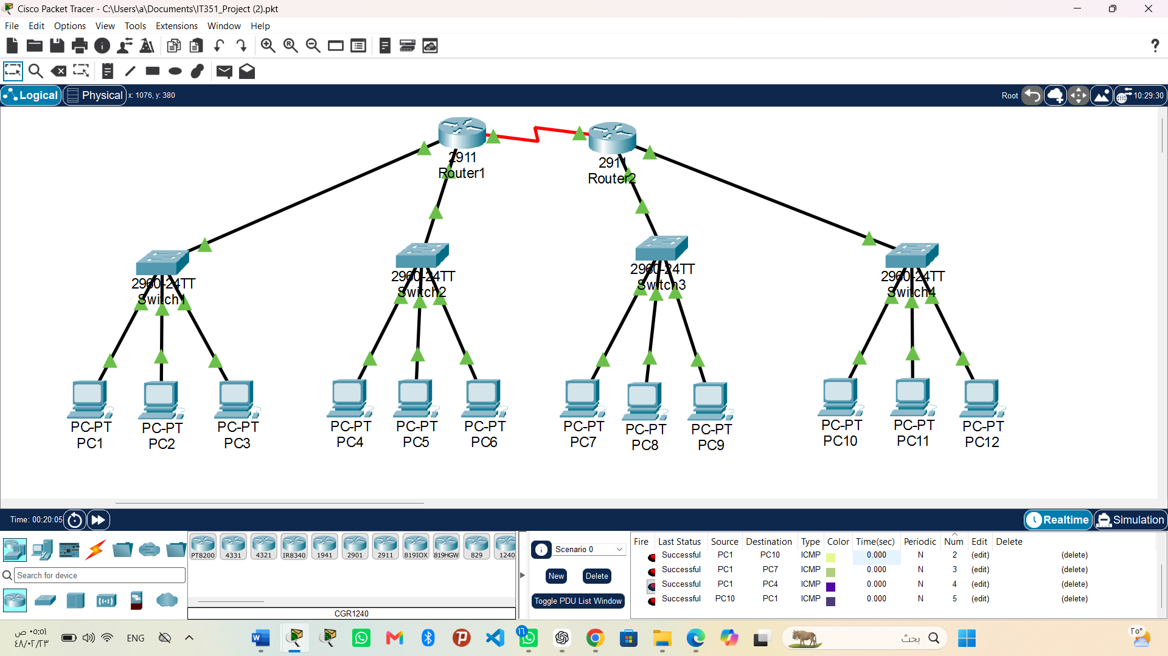
Figure 1. Complete network topology after the WAN configuration and connectivity tests.
The topology contains two routers, four switches, and twelve PCs. The successful PDU entries shown in the simulation panel provide additional evidence that packets can traverse the configured network.
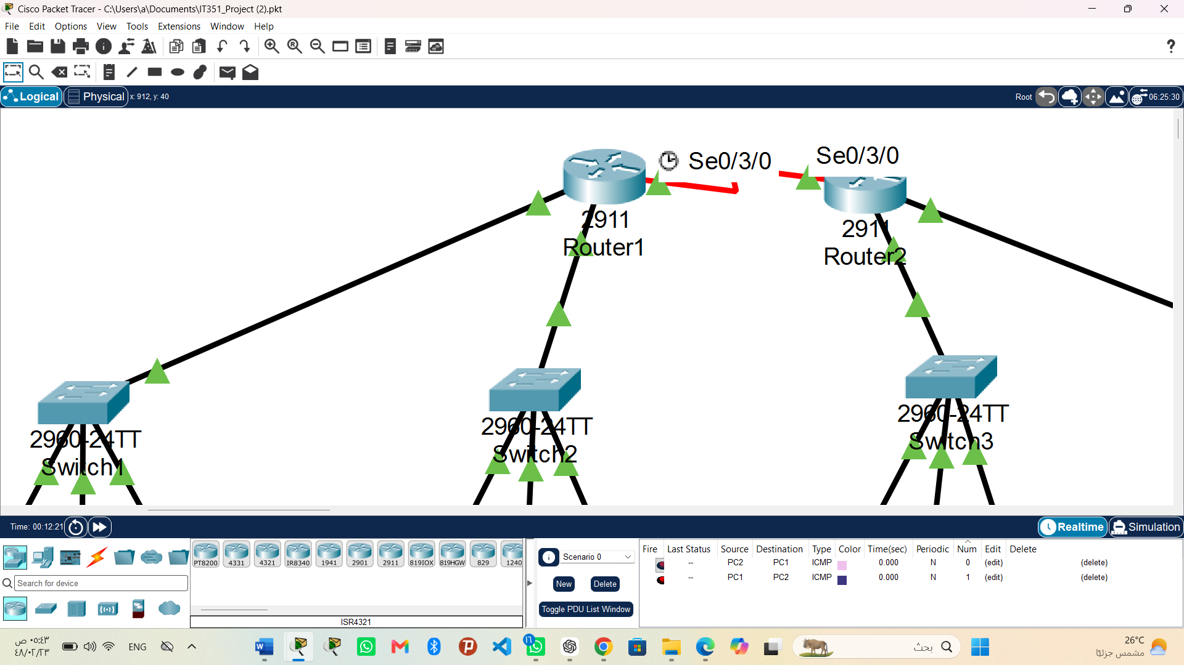
Figure 2. Serial0/3/0 WAN link between Router1 and Router2.
Both routers use Serial0/3/0. The clock symbol beside Router1 identifies it as the DCE endpoint, where the clock rate was applied. The green interface indicators show that the connected interfaces are operational.

Router1 Serial Interface Configuration
Commands used on Router1:
enable
configure terminal
interface serial0/3/0
ip address 10.10.10.1 255.255.255.252
clock rate 64000
no shutdown
end
show ip interface brief
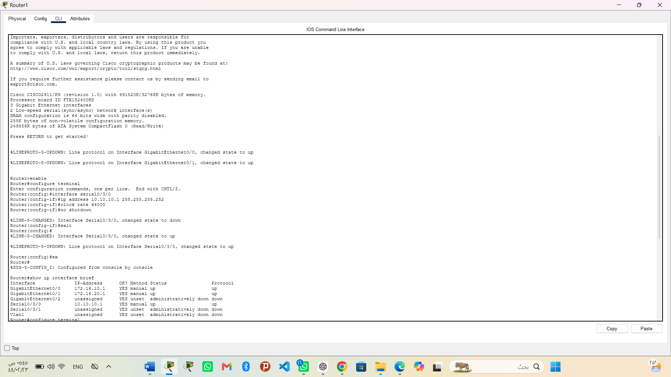
Figure 3. Router1 serial configuration and interface-status verification.
The screenshot shows the WAN address 10.10.10.1/30, the DCE clock rate of 64000, and the no shutdown command. The show ip interface brief output confirms that Serial0/3/0 is in the up/up state.

Router2 Serial Interface Configuration
Commands used on Router2:
enable
configure terminal
interface serial0/3/0
ip address 10.10.10.2 255.255.255.252
no shutdown
end
show ip interface brief
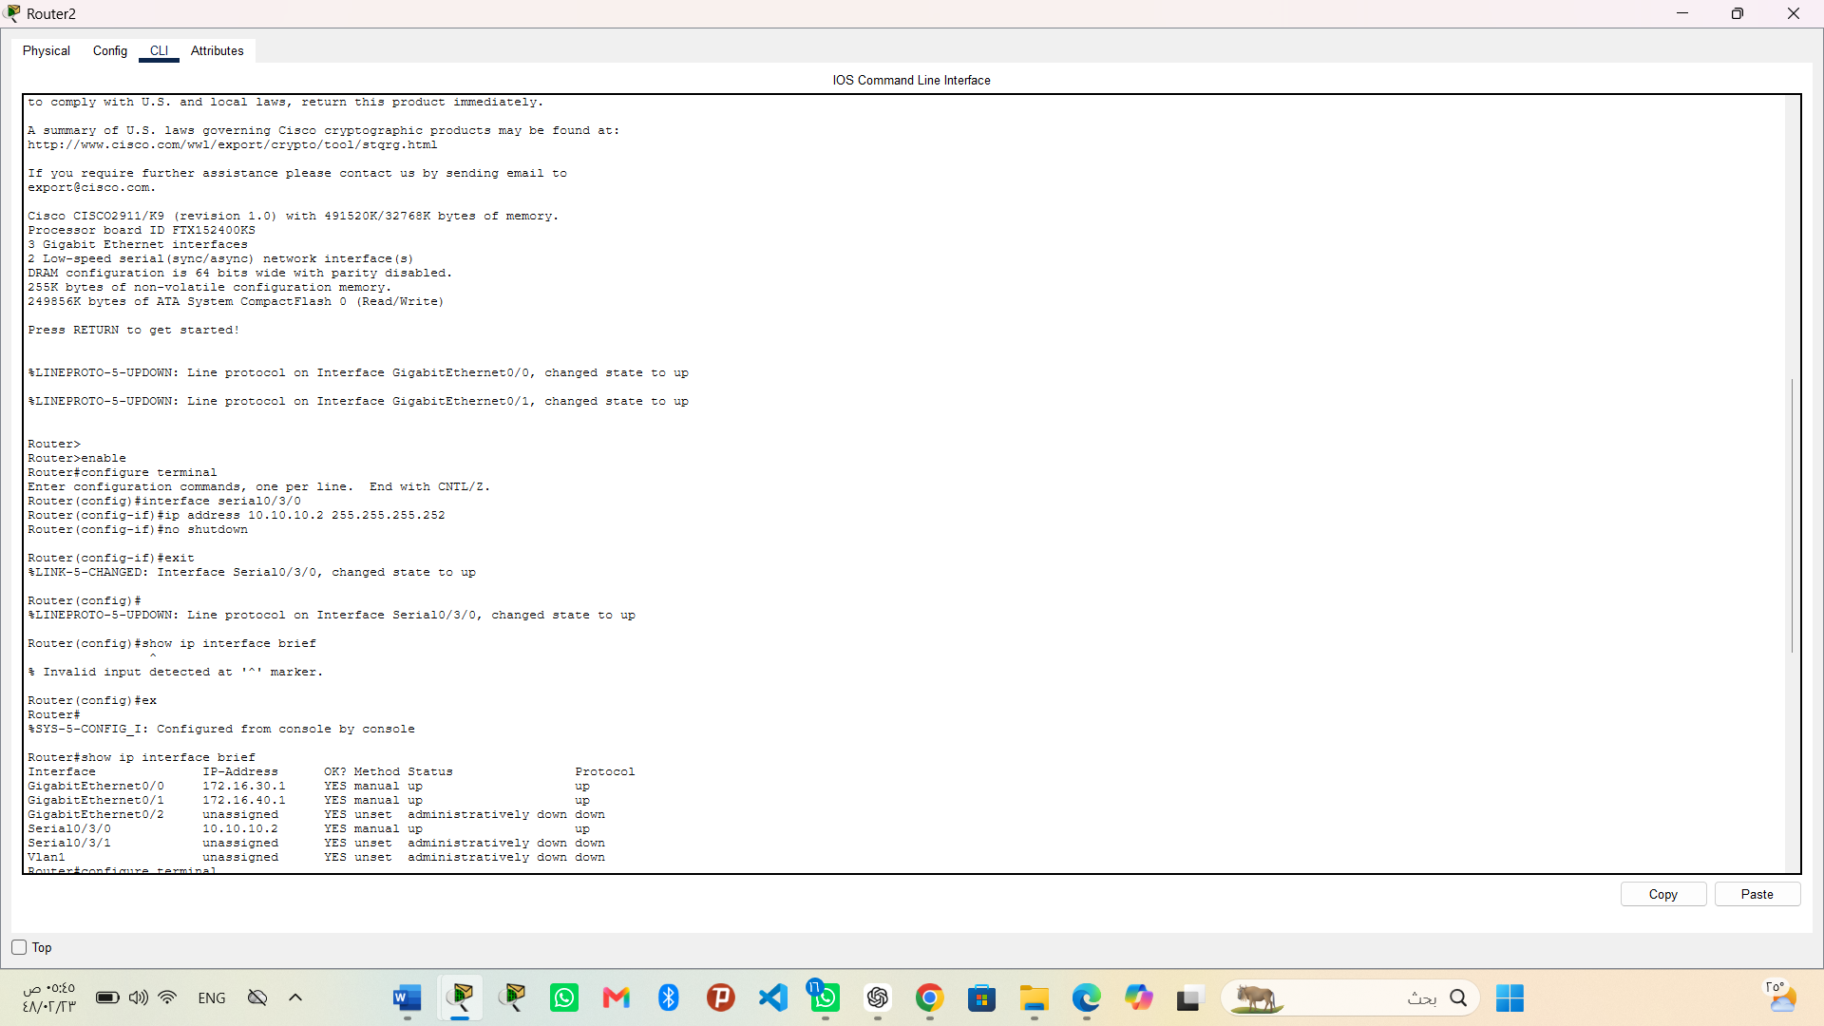
Figure 4. Router2 serial configuration and interface-status verification.
The WAN interface was assigned 10.10.10.2/30 and enabled. A show command was initially entered while still in configuration mode, producing a syntax message; after returning to privileged EXEC mode, show ip interface brief was executed successfully and Serial0/3/0 was confirmed as up/up.

Static Routing Configuration
Static routing was selected because the topology contains only two routers and four known LAN networks. It provides a direct and transparent route configuration without the additional routing updates generated by a dynamic protocol.
Static routes configured on Router1:
configure terminal
ip route 172.16.30.0 255.255.255.0 10.10.10.2
ip route 172.16.40.0 255.255.255.0 10.10.10.2
end
show ip route
Static routes configured on Router2:
configure terminal
ip route 172.16.10.0 255.255.255.0 10.10.10.1
ip route 172.16.20.0 255.255.255.0 10.10.10.1
end
show ip route
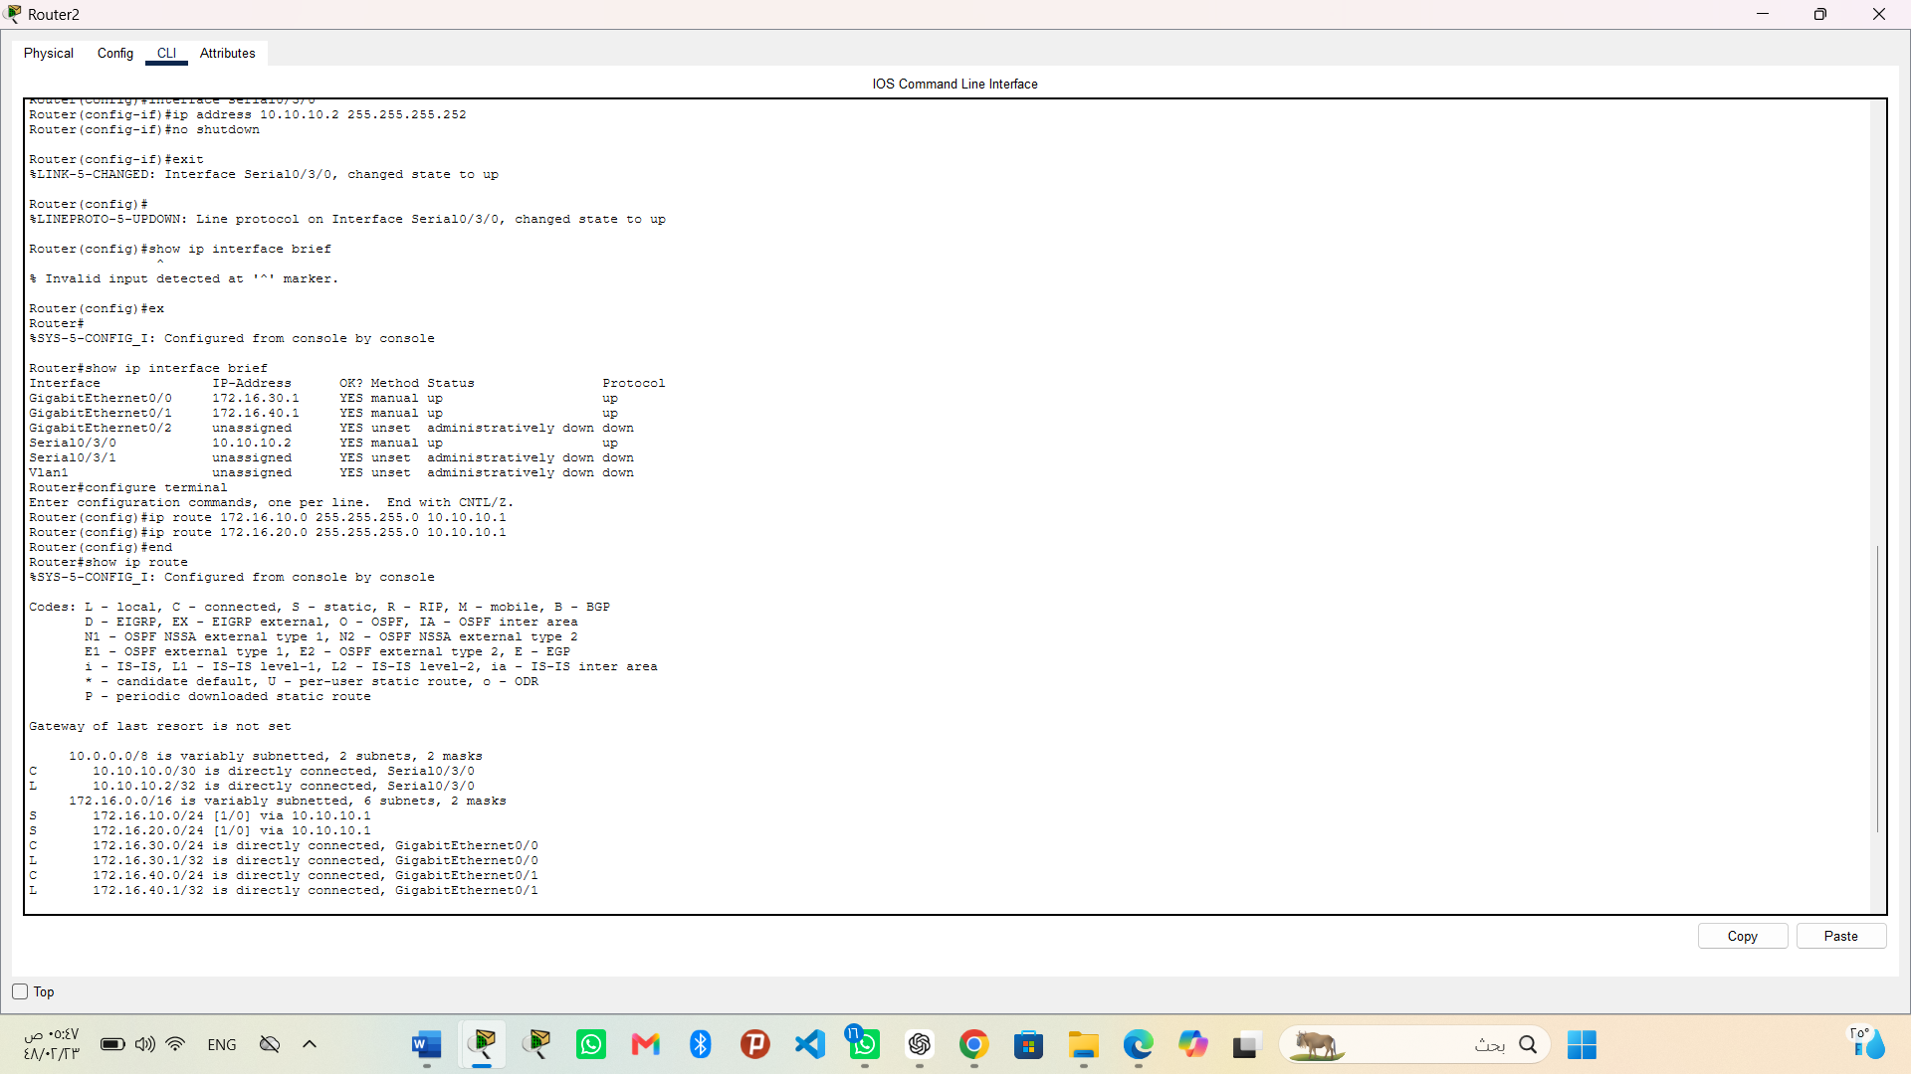
Figure 5. Router2 static routes and routing-table verification.
The entries marked with S show that Router2 can reach LAN 1 (172.16.10.0/24) and LAN 2 (172.16.20.0/24) through the next-hop address 10.10.10.1.

WAN Verification and Configuration Saving
Verification and save commands on Router2:
ping 10.10.10.1
copy running-config startup-config
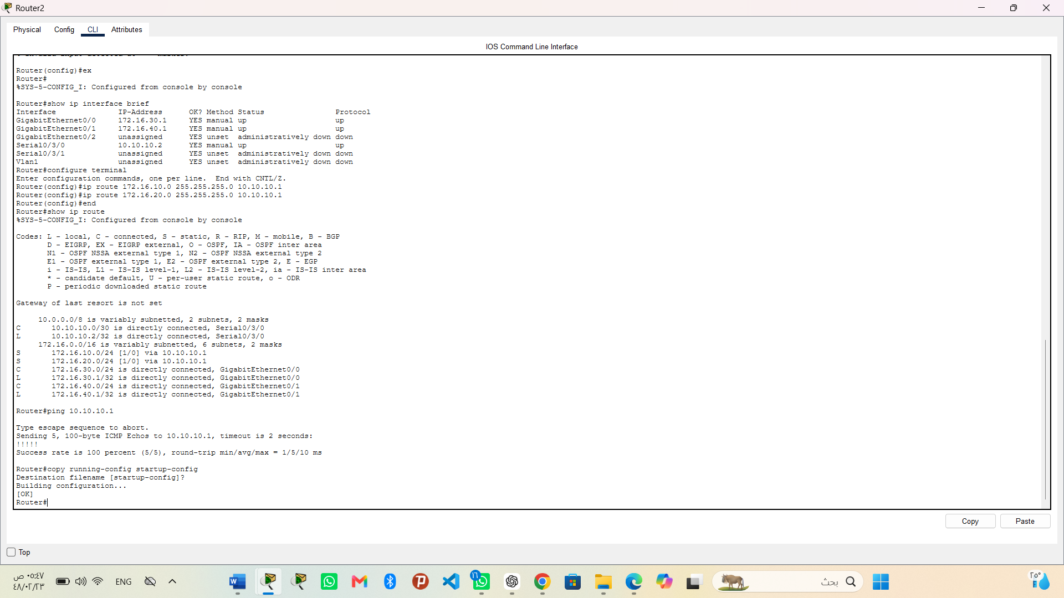
Figure 6. Router2 route verification, WAN ping, and saved configuration.
Router2 successfully reached Router1 at 10.10.10.1 with a 100 percent success rate (5/5). The running configuration was then copied to startup-config and Packet Tracer returned [OK].
Verification and save commands on Router1:
ping 10.10.10.2
copy running-config startup-config
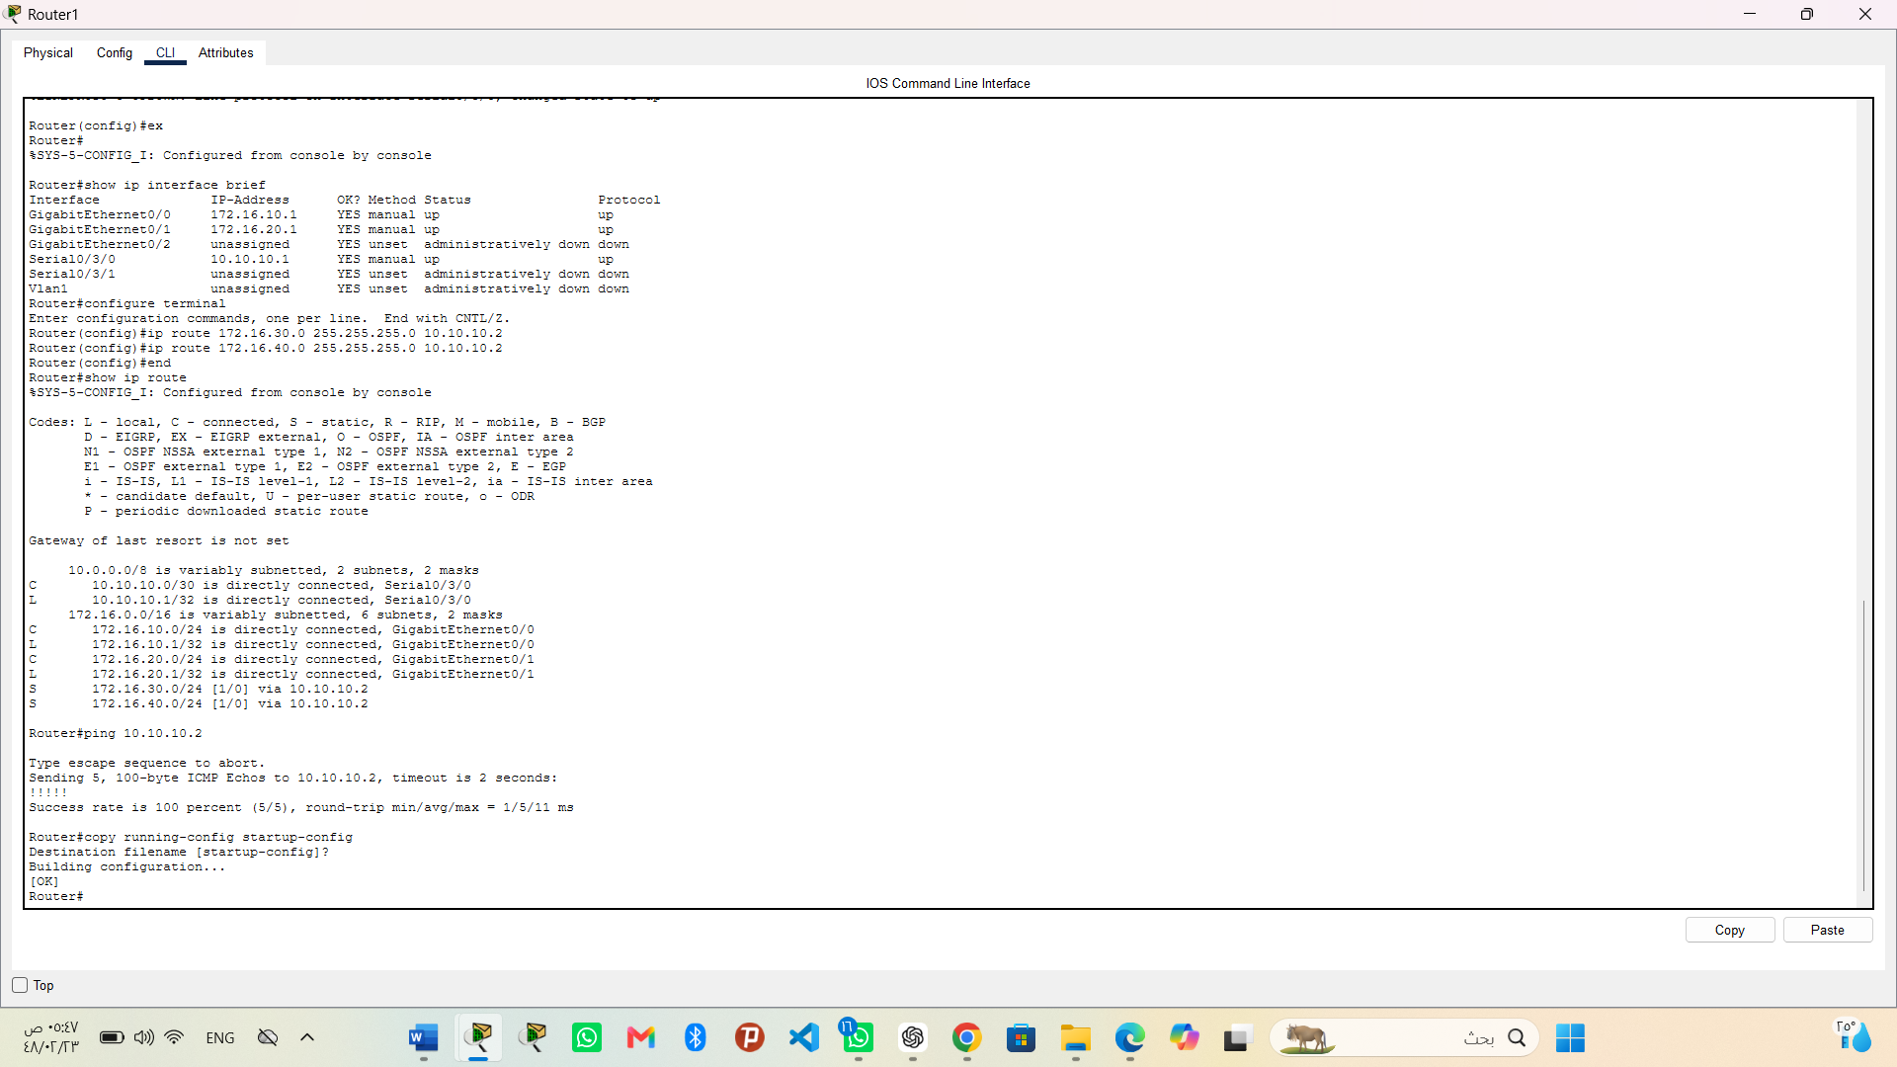
Figure 7. Router1 route verification, WAN ping, and saved configuration.
Router1 contains static routes to LAN 3 and LAN 4 through 10.10.10.2. The ping to Router2 achieved a 100 percent success rate (5/5), and the configuration was saved successfully.

Question 5: Successful Data Transmission Using Ping
End-to-end connectivity was tested between PC1 in WAN 1 and PC10 in WAN 2. The tests were performed in both directions, as required. PC1 uses address 172.16.10.11, while PC10 uses address 172.16.40.41.
Ping command from PC1 in WAN 1 to PC10 in WAN 2:
ping 172.16.40.41
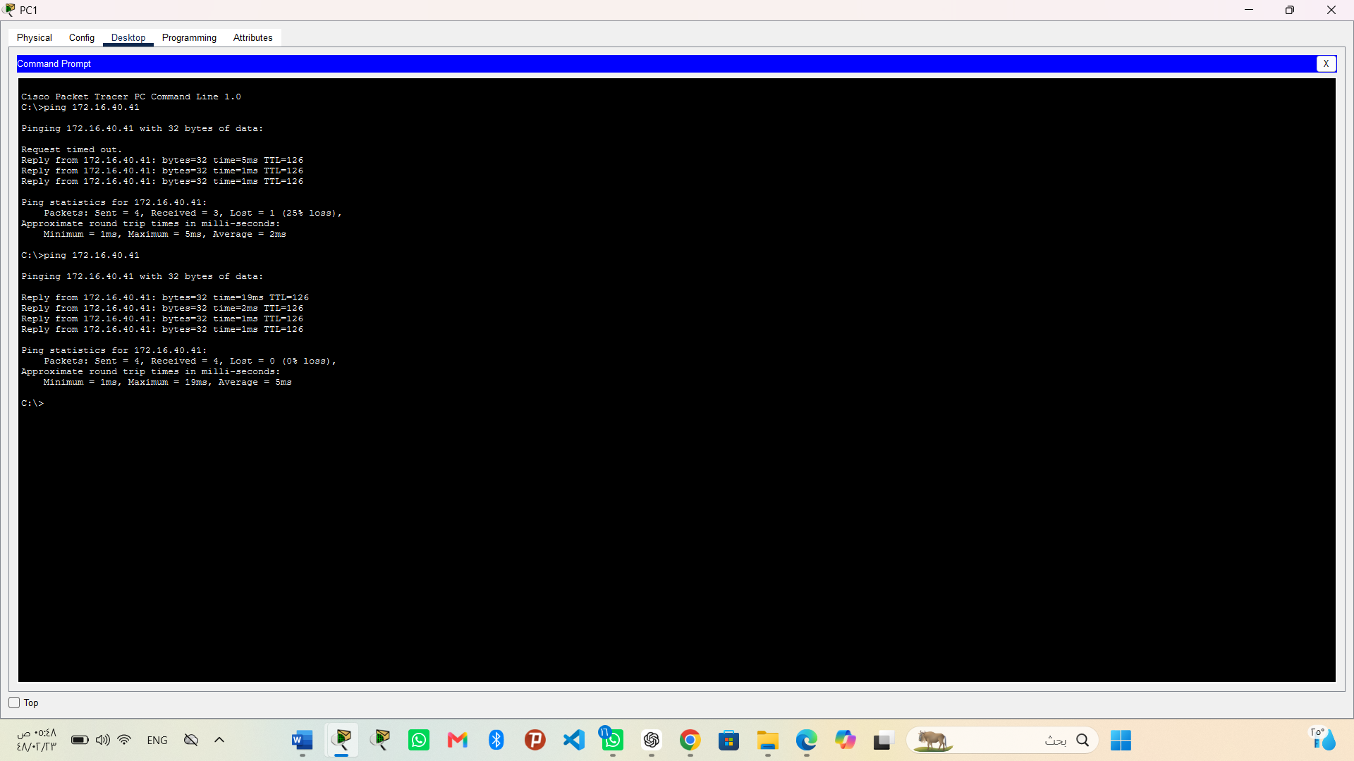
Figure 8. Ping test from PC1 (172.16.10.11) to PC10 (172.16.40.41).
The first attempt contained one initial timeout while address-resolution information was being learned. The command was repeated, and the second test received four replies with Lost = 0 (0% loss), confirming successful transmission from WAN 1 to WAN 2.
Ping command from PC10 in WAN 2 to PC1 in WAN 1:
ping 172.16.10.11
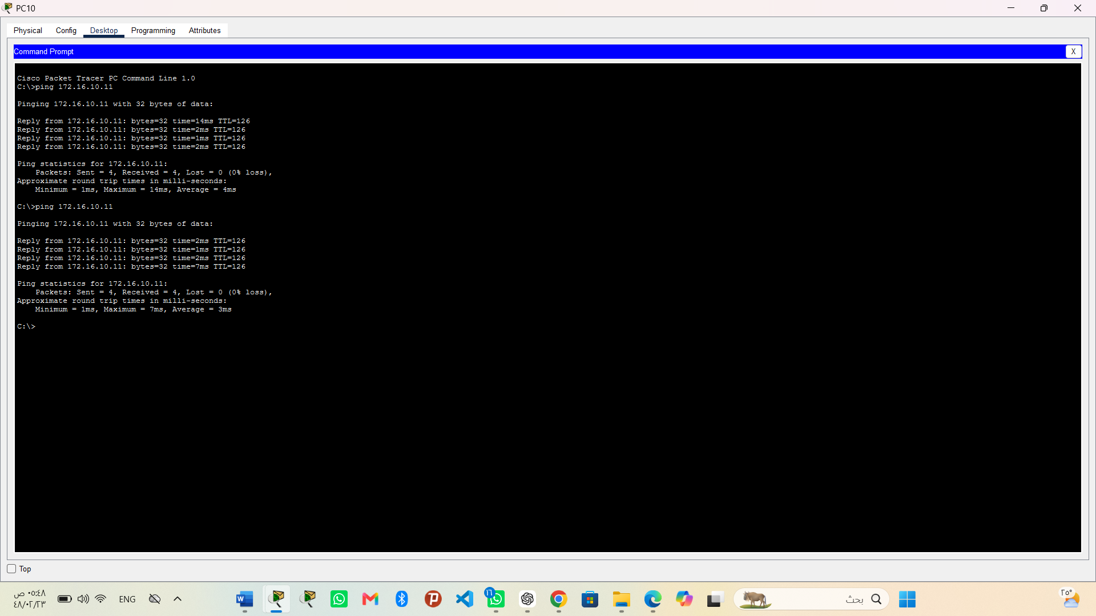
Figure 9. Ping test from PC10 (172.16.40.41) to PC1 (172.16.10.11).
The return-direction test received four replies with Lost = 0 (0% loss). This confirms that the serial WAN link and the static routes support bidirectional communication between the two campus networks.
Result
The WAN serial connection was configured successfully, both serial interfaces reached the up/up state, the static routes appeared in the routing tables, the routers communicated with a 100 percent success rate, and the final end-device tests achieved 0% packet loss in both directions. Therefore, the requirements of Question 4 and Question 5 were satisfied.

