PROJECT REPORT
WeatherBot
An AI-Style Conversational Weather Chatbot

Technical Documentation & System Design
Project Type | Single-page web application (front-end only)
Core Technology | HTML5 · CSS3 · Vanilla JavaScript · Leaflet.js
Document Version | 1.0
Date | 01 June 2026

Table of Contents
1. Executive Summary
2. Project Overview
3. Key Features
4. Technology Stack
5. System Architecture
6. How Everything Is Linked Together
7. Component & Module Map
8. End-to-End Request Flow
9. User Interface Design
10. Input Modes
11. External Services & Data Sources
12. Natural-Language Understanding
13. Error Handling & Resilience
14. Security & Privacy
15. Limitations & Future Enhancements
16. Conclusion

1. Executive Summary
WeatherBot is a lightweight, conversational weather assistant that runs entirely inside a web browser. Presented as a modern chat interface, it lets a user ask about the weather for any location on Earth using plain English, their voice, their device's GPS location, or by tapping a point on an interactive world map. The application interprets the request, looks up the location, retrieves live meteorological data, and replies with a friendly, formatted message that can also be read aloud.
The entire product is delivered as a single self-contained HTML file. There is no back-end server, no database, no build step, and no API keys to manage. All intelligence and orchestration happen on the client side in vanilla JavaScript, while live data is fetched directly from free, public, key-less web APIs. This makes WeatherBot exceptionally portable: it can be opened by double-clicking the file or hosted on any static web host.
2. Project Overview
The goal of the project is to demonstrate how a polished, multi-modal, “AI-style” assistant experience can be achieved using only standard browser technologies. Rather than relying on a large language model, WeatherBot uses a compact, rule-based natural-language parser to extract the user's intent (which place, and which time window) and then chains together a series of public web services to fulfil the request.
The application is named WeatherBot and is themed around a frosted-glass (“glassmorphism”) visual design with an animated, colourful background. It is intentionally simple to deploy and reason about, while still offering four distinct ways to interact with it.
Attribute | Detail
File | index.html (single file, ~620 lines)
Type | Client-side single-page application (SPA)
Back-end | None — all logic runs in the browser
Dependencies | Leaflet.js (maps) via CDN; everything else is native
Data sources | Open-Meteo, BigDataCloud, OpenStreetMap
Deployment | Open the file directly, or host as a static asset

3. Key Features
- Natural-language chat — interprets free-text questions such as “Will it rain in Paris tomorrow?” and replies conversationally.
- Voice interaction — ask by speaking (speech-to-text) and have replies read back aloud (text-to-speech).
- Geolocation — one tap uses the device's GPS to report the local weather.
- Map selection — an interactive world map lets the user pick any point to get its weather.
- Three time horizons — current conditions, a “tomorrow” outlook, and a full 7-day forecast.
- Rich formatting — weather codes are mapped to friendly descriptions and emoji icons.
- Responsive design — animated glassmorphism interface that adapts to phones and desktops.
- Guided prompts — quick-reply suggestion chips guide the user toward common questions.
4. Technology Stack
WeatherBot deliberately uses a minimal, dependency-light stack. The table below lists each technology and the role it plays.
Layer | Technology | Role in the Project
Structure | HTML5 | Defines the chat panel, tool buttons, map overlay and input form.
Styling | CSS3 | Glassmorphism look, animated background blobs, responsive layout, animations.
Logic | Vanilla JavaScript | NLU parsing, API calls, rendering, and all event handling.
Mapping | Leaflet.js 1.9.4 | Renders the interactive, tappable world map.
Geolocation | Browser Geolocation API | Reads the device's GPS coordinates.
Speech in | Web Speech API | Converts spoken questions into text.
Speech out | SpeechSynthesis API | Reads bot replies aloud.
Weather data | Open-Meteo REST API | Geocoding and live + forecast weather.
Place names | BigDataCloud API | Reverse-geocodes coordinates into city names.
Map tiles | OpenStreetMap | Supplies the map's tile imagery.

5. System Architecture
Architecturally, WeatherBot is a thin client that orchestrates several independent public services. Everything inside the browser is organised into a presentation layer (HTML/CSS), an application-logic layer (JavaScript), and a set of native browser capabilities. Outside the browser sit four external services, each reached over HTTPS. Because there is no back-end of our own, the browser itself is the application server, client, and orchestrator all at once.
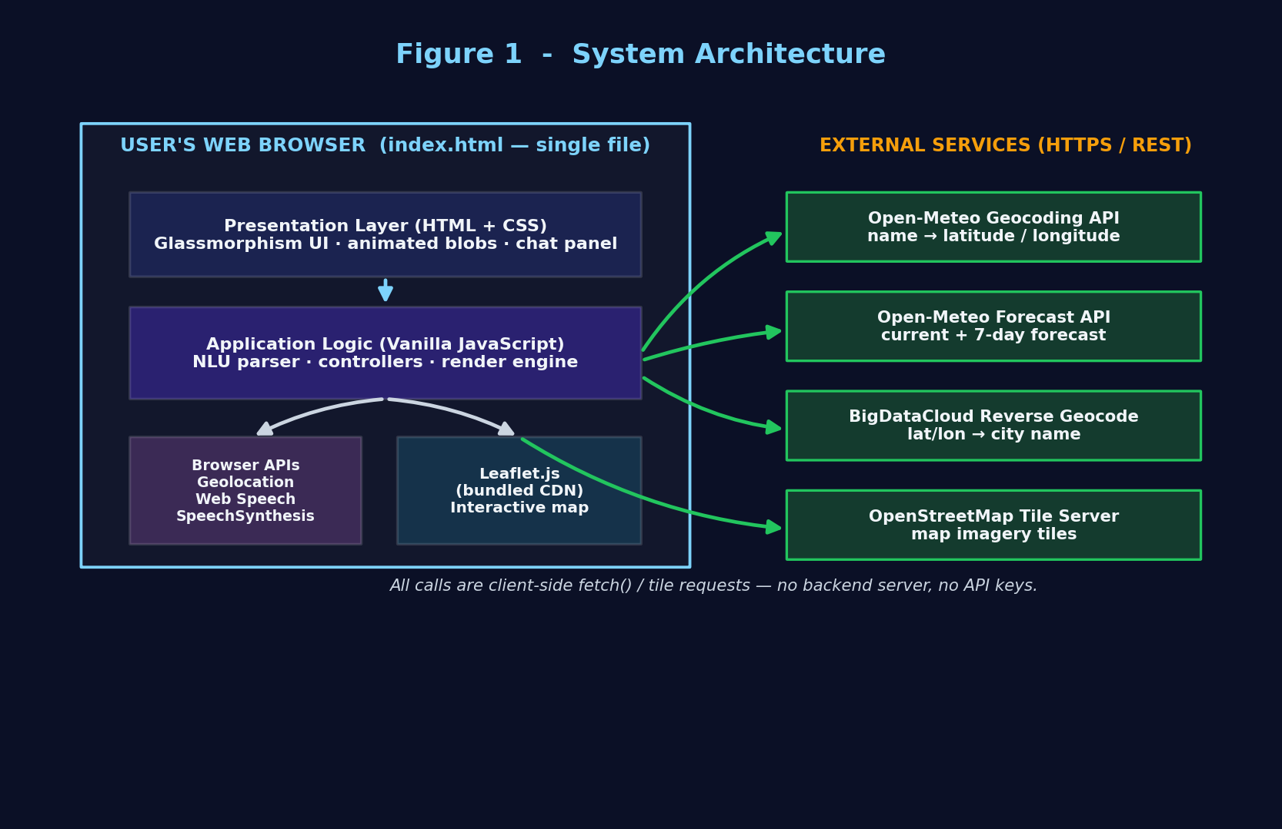
Figure 1 — High-level system architecture. The single HTML file orchestrates four external services directly from the browser.
This design has three important consequences. First, the application is stateless and serverless — there is nothing to deploy beyond a static file. Second, all data is fetched on demand and nothing is stored. Third, the user's browser is the trust boundary: location and microphone access are requested directly by the browser and never pass through a server we control.
6. How Everything Is Linked Together
The pieces of WeatherBot are connected through a single, shared idea: every interaction is ultimately reduced to a location object — a latitude, a longitude, and a place name — plus a time intent (today, tomorrow, or the week). No matter how the user starts (typing, speaking, GPS, or the map), the application funnels that input into the same core weather-reporting routine.
6.1 The Linking Chain
- The event handlers — captures the raw input (text, transcript, GPS fix, or map tap).
- The parser, parse() — turns a free-text question into a city name and a time intent.
- The geocoders — convert a place name or coordinates into a concrete location object.
- report() — the single hub that takes a location + time intent, fetches the forecast, and renders the answer.
- The renderers, addMsg()/addChips() — display every message and the suggestion chips in the chat.
- speak() — optionally reads the reply aloud through the speech layer.
Because all four input modes converge on report(), the system is easy to extend: adding a new way to choose a location requires nothing more than producing a location object and calling report(). The data contract between components is deliberately small and uniform.
// The shared 'contract' that links every component
location = { lat: Number, lon: Number, name, admin, country }
when = 'today' | 'tomorrow' | 'week'

report(location, when) // <- every path ends here

7. Component & Module Map
Although the code lives in one file, it is logically divided into cohesive groups of functions. The map below shows these groups and how they revolve around the central event handlers and the shared report() routine.
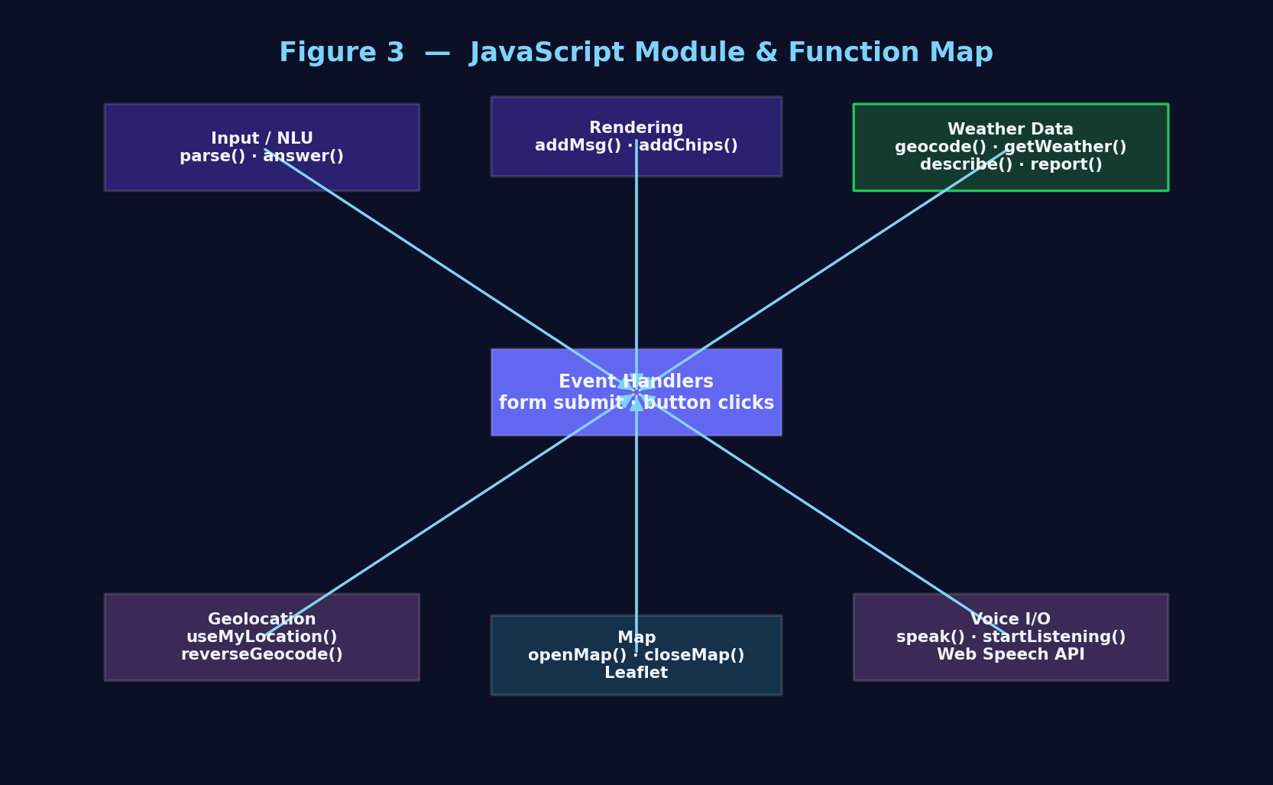
Figure 3 — Logical grouping of JavaScript functions and how they interconnect.
Module | Key Functions | Responsibility
Input / NLU | parse(), answer() | Extract city + time intent and drive the response.
Weather data | geocode(), getWeather(), describe(), report() | Fetch and format meteorological data.
Rendering | addMsg(), addChips() | Create chat bubbles and quick-reply chips.
Geolocation | useMyLocation(), reverseGeocode() | Resolve the device's GPS into a place.
Map | openMap(), closeMap() | Manage the Leaflet map overlay and clicks.
Voice I/O | speak(), startListening() | Speech output and speech input.

8. End-to-End Request Flow
To make the linkage concrete, consider the question “Will it rain in Paris tomorrow?”. The diagram traces the request from the moment the user presses Send to the moment a reply appears (and is optionally spoken).
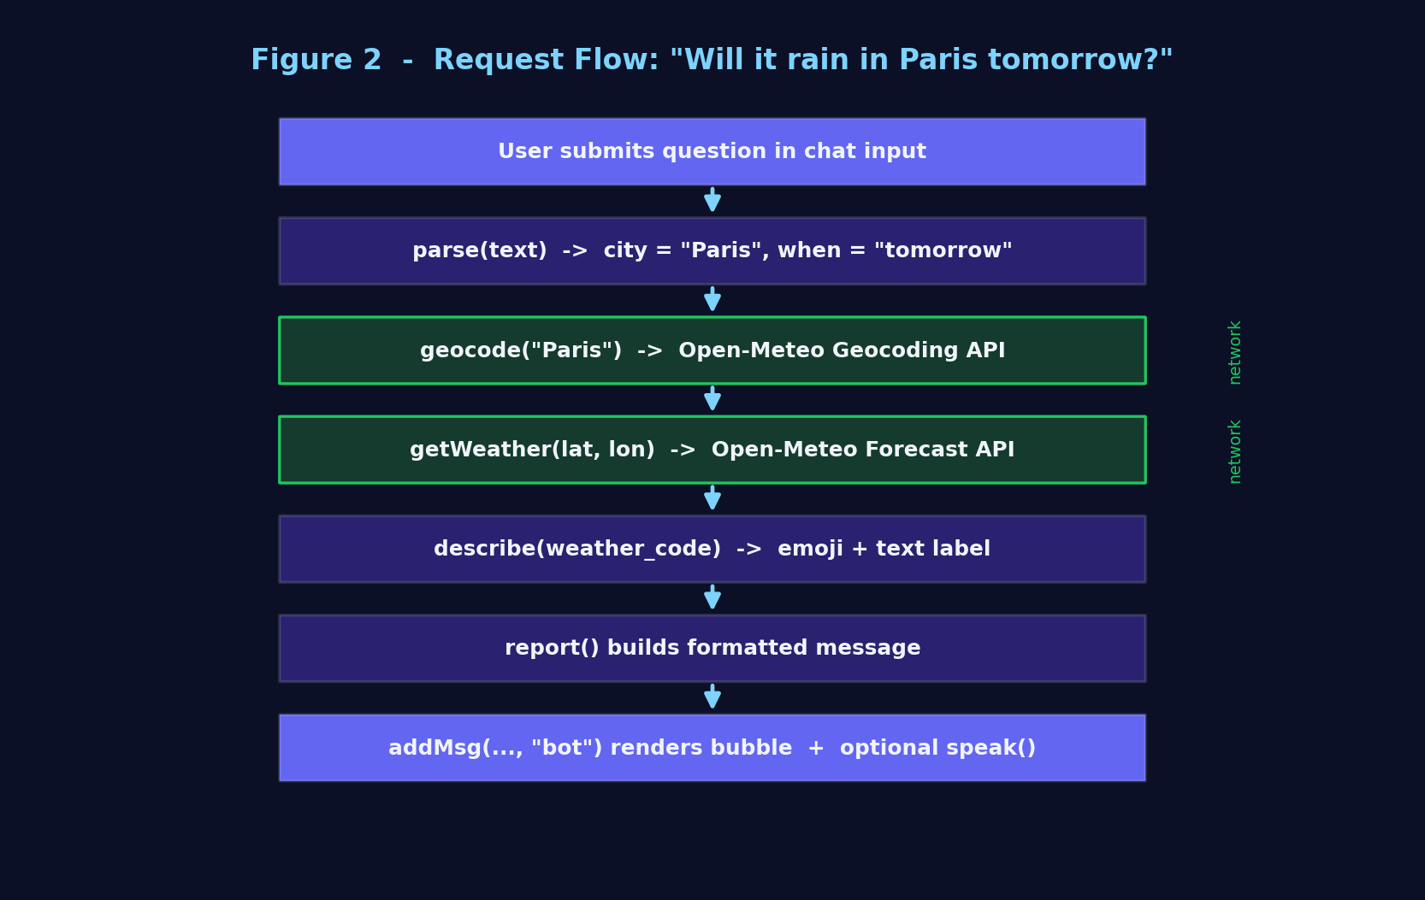
Figure 2 — Step-by-step request flow for a typed weather question.
Each numbered stage corresponds directly to a function in the source code. Two of the stages — geocoding and the forecast lookup — are asynchronous network calls; the rest are local computation and DOM updates. A temporary “typing” bubble is shown while the network requests are in flight, then replaced with the final answer.
9. User Interface Design
The interface is a single frosted-glass chat panel centred over an animated, multi-colour background. Four animated “blobs” drift behind the panel and are blurred through it via a CSS backdrop filter, producing the signature glassmorphism effect. The layout is a vertical stack: a header, a scrollable message area, an optional map overlay, and a fixed input area with a row of tool buttons.
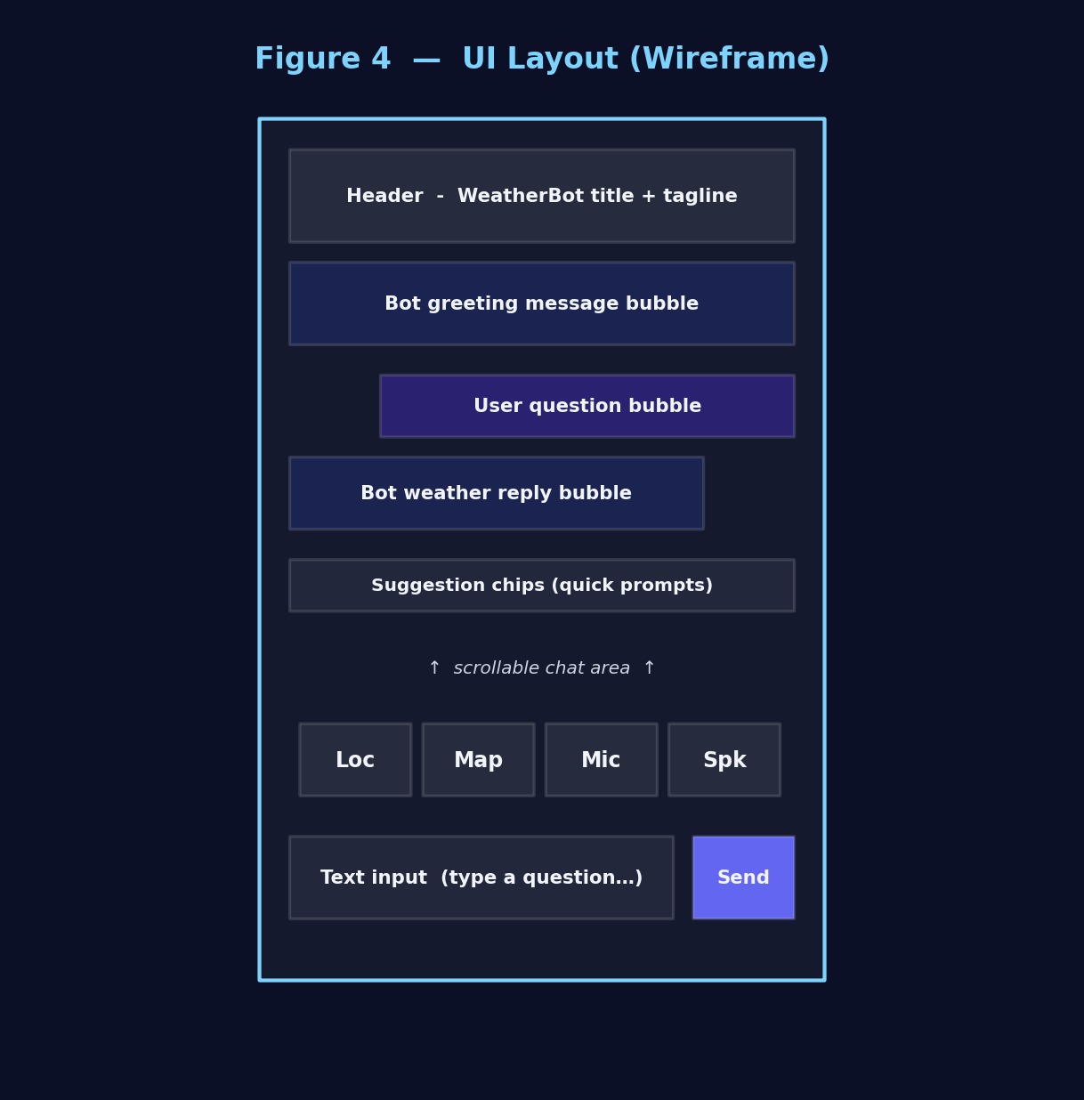
Figure 4 — Wireframe of the WeatherBot interface.
9.1 Notable UI Behaviours
- New messages animate in with a subtle pop, and the chat auto-scrolls to the newest bubble.
- User and bot bubbles are visually distinct (gradient vs. frosted glass) and aligned to opposite sides.
- The microphone button pulses red while listening; the speaker button toggles between muted and active states.
- Suggestion chips can either submit a pre-written question or run a custom action (e.g. “My location”).
10. Input Modes
A defining characteristic of WeatherBot is that four very different input methods all feed into the same weather pipeline. Typed and voice inputs are free text and therefore pass through geocoding; the GPS and map inputs already carry coordinates, so they skip straight to reverse-geocoding and reporting.
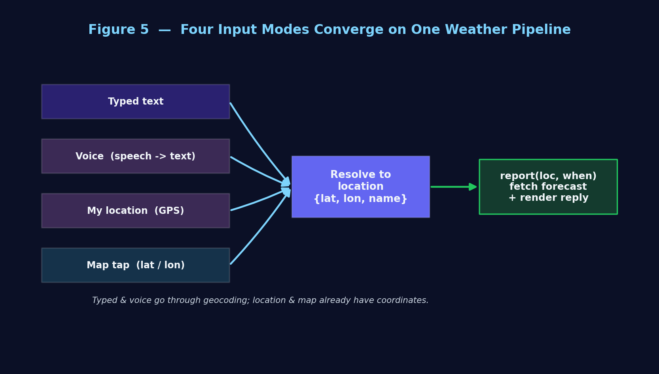
Figure 5 — All four input modes converge on a single weather-reporting pipeline.
Input Mode | Trigger | How the Location Is Resolved
Typed text | Send button / Enter | parse() → geocode() by name
Voice | Microphone button | Speech-to-text → parse() → geocode()
My location | Pin button | Geolocation API → reverseGeocode()
Map tap | Map button + click | Map coordinates → reverseGeocode()

11. External Services & Data Sources
WeatherBot relies on four free, public services. None require an API key, an account, or a payment method, which is central to the project's zero-configuration philosophy.
Service | Purpose | Endpoint (summarised)
Open-Meteo Geocoding | City name → coordinates | geocoding-api.open-meteo.com/v1/search
Open-Meteo Forecast | Live + 7-day weather | api.open-meteo.com/v1/forecast
BigDataCloud | Coordinates → city name | api.bigdatacloud.net/.../reverse-geocode-client
OpenStreetMap | Map tile imagery | tile.openstreetmap.org/{z}/{x}/{y}.png

The forecast request asks Open-Meteo for current conditions (temperature, apparent temperature, humidity, wind speed and a weather code) plus seven days of daily highs, lows, weather codes and precipitation probabilities. The numeric weather code returned by Open-Meteo is then translated locally into a human description and emoji via a lookup table.
12. Natural-Language Understanding
WeatherBot does not use a machine-learning language model. Instead, parse() applies a set of pragmatic text rules. It first detects the time intent by looking for keywords such as “tomorrow” or “week/forecast”, defaulting to “today”. It then strips away common filler words — question words, weather vocabulary, prepositions and punctuation — so that what remains is, in most cases, the place name.
function parse(text) {
let when = 'today';
if (/\btomorrow\b/.test(lower)) when = 'tomorrow';
else if (/week|forecast|next few days/.test(lower)) when = 'week';
// remove filler words -> what's left is the city
let city = text.replace(/\b(what's|weather|in|for|...)\b/gi, ' ').trim();
return { city, when };
}

This approach is intentionally lightweight and transparent. It handles the vast majority of everyday phrasings (“weather in Tokyo”, “forecast for New York”, “will it rain in Paris tomorrow”) while remaining fully offline and instantaneous, with no model to download and no inference cost.
13. Error Handling & Resilience
Because the app depends on the network and on browser permissions, it handles failure gracefully at each step and always responds with a helpful chat message rather than failing silently.
- If parse() cannot find a city, the bot asks the user to name one.
- If geocoding returns no match, the bot suggests checking the spelling.
- If the forecast request throws, a friendly network-error message is shown and the error is logged to the console.
- If the user denies location or microphone access, the bot explains and invites typing a city instead.
- If a browser lacks speech or geolocation support, the relevant feature degrades with a clear notice.
14. Security & Privacy
- No back-end — there is no server of our own, so there is no central place where user data could be collected or breached.
- No persistence — the app stores nothing; closing the tab discards the entire conversation.
- Explicit consent — GPS and microphone access are requested by the browser and used only in-page.
- Key-less APIs — all external calls use HTTPS, and no credentials or keys are embedded in the code.
Voice input relies on the browser's Web Speech API, which in some browsers may process audio via the browser vendor's servers; this is a property of the browser, not of WeatherBot.
15. Limitations & Future Enhancements
15.1 Current Limitations
- The rule-based parser can misread very unusual phrasings or multi-word edge cases.
- Only one place is matched per question (the top geocoding result).
- English-only vocabulary and voice locale.
- Requires an internet connection for all live data.
15.2 Possible Future Enhancements
- Add multi-language support for both parsing and speech.
- Offer hourly forecasts and severe-weather alerts.
- Cache recent results for brief offline availability.
- Introduce unit selection (°C/°F, km/h vs mph).
- Optionally integrate a true language model for richer conversation.
16. Conclusion
WeatherBot shows that a refined, multi-modal assistant can be built with nothing more than standard browser technologies and a handful of free public APIs. Its strength lies in a simple, uniform internal contract: every interaction — typed, spoken, located or tapped — is reduced to a location and a time intent, then handed to a single reporting routine that fetches live data and renders a friendly reply. This clean separation of concerns makes the project easy to understand, easy to extend, and effortless to deploy, while still delivering a polished, modern user experience.

