seeps

Jiayi Sun

2020/11/9

seep<-read.csv("Seeps.csv")  
head(seep,3)

## 锘縊BJECTID Shape SeepID Date Seep_Name Latitude Longitude  
## 1 15 Point NACE16 3/26/2015 T6-2 Site 2 38.81862 -77.00645  
## 2 18 Point NACE94 12/15/2015 T4-2 Site 5 38.82095 -77.01170  
## 3 23 Point NACE90 12/8/2015 T4-2 Site 1 38.82361 -77.01364  
## Clay_Layer_Presence Clay_Layer_Depth__cm Temperature Conductivity_mScm  
## 1 Y 5 9.4 0.184  
## 2 N <Null> 12.8 0.659  
## 3 Y 18 11.33 0.283  
## Salinity DO DOmgL pH Water_Presence Flowing_Water Blackened_Leaves  
## 1 0.13 15.5 1.77 7.1 Y N Y  
## 2 0.43 15.6 1.64 6.08 Y N Y  
## 3 0.18 50.1 5.38 5.58 Y Y Y  
## Visible_Exit Phosphates_ppm Nitrates_ppm Radon__Bq_m3 Stygobromus Crangonyx  
## 1 Y 11.587 0.691 <Null> 1 1  
## 2 Y <Null> 3.023 9490.518481 0 1  
## 3 Y 15.223 1.912 7099.140455 1 1  
## Caecidotea_kenki Caecidotea_jeffersoni Caecidotea_sp__Unknown Fontigens  
## 1 1 0 0 0  
## 2 1 0 0 0  
## 3 0 0 0 0  
## Inhabitants  
## 1 3  
## 2 2  
## 3 2  
## Species_identified  
## 1 Crangonyx shoemaker, terrestrial isopod, tabanidae, terrestrial beetle, Stygobromus, Caecidotea  
## 2 crangonyx, caecidotea  
## 3 7 Crangonyx shoemakeri  
## PARKNAME Notes ORIG_LABEL  
## 1 BALD EAGLE HILL clay was gray Ql  
## 2 SHEPERD PARKWAY species not identified yet, no clay up to 30 cm QTu  
## 3 SHEPERD PARKWAY <Null> QTu  
## SGMC_LABEL UNIT_LINK UNIT_AGE ROCKTYPE1 ROCKTYPE2 AWC CLAY KFFACT OM  
## 1 Ql;5 Lowland Deps Quaternary gravel sand 0.13 26.7 0.26 0.4  
## 2 QTu;5 Upland Deps WS Quaternary gravel sand 0.13 26.7 0.26 0.4  
## 3 QTu;5 Upland Deps WS Quaternary gravel sand 0.13 26.7 0.26 0.4  
## PERM THICK HYGRP DRAIN LL IFHYDRIC AFLDFREQ Precipmm Snowfallmm Snowdepthmm  
## 1 2.33 59.8 2.7 3.5 34.1 0.1 3.8 0 0 0  
## 2 2.33 59.8 2.7 3.5 34.1 0.1 3.8 0 0 0  
## 3 2.33 59.8 2.7 3.5 34.1 0.1 3.8 0 0 0  
## MaxtempC MintempC ElevationM SlopeDegree TWetnessI SEEP_DIST INHAB_DIST  
## 1 7.2 -2.2 8.282 27.37952 3.511528 47.42823 0  
## 2 22.8 11.1 41.086 15.87029 <Null> 21.00605 0  
## 3 11.1 -1.1 42.256 10.01969 6.412803 10.60047 0  
## ROAD_FID ROAD_DIST TRAIL_FID TRAIL_DIST OUTFALL_FID OUTFALL_DIST IMPERV_DIST  
## 1 1126 142.50881 19 757.9361 200 357.4940 125.45123  
## 2 1166 57.38739 19 883.0809 155 100.2865 57.38739  
## 3 168 35.03696 19 1203.3713 155 322.1816 35.03699  
## BORDER_FID BORDER_DIST BORDER_FEAT radius area_circ compactness  
## 1 8 31.084042 NatParkBorders 1428.159 6407703 0.066310  
## 2 17 7.675773 NatParkBorders 1428.159 6407703 0.066310  
## 3 17 25.240904 NatParkBorders 1320.133 5475007 0.040093  
## core_area core_per neighbor_d Seeps_per_m2 Proportion_Inhab  
## 1 354893.2 6046.973 2.048477 4.0e-05 0.411765  
## 2 354893.2 6046.973 2.048477 4.0e-05 0.411765  
## 3 156352.0 4549.269 8.014161 2.7e-05 0.333333  
## Count_Species_inpatch Seepsperpatch Count_Inhab_inpatch Is_Calvert Is_Upland  
## 1 3 17 7 0 0  
## 2 3 17 7 0 1  
## 3 2 6 2 0 1  
## Is_Water Is_Potomac Is_Lowland SoilC_FAC1 SoilC_FAC2 SoilC_FAC3 SoilC_FAC4  
## 1 0 0 1 -0.8277801 0.9328452 -0.1024195 0.04777038  
## 2 0 0 0 -0.8277801 0.9328452 -0.1024195 0.04777038  
## 3 0 0 0 -0.8277801 0.9328452 -0.1024195 0.04777038  
## SoilC_FAC5 SoilC_FAC6 Rock1_gravel Rock1_sand Rock1_water Rock2_none  
## 1 0.2103188 -2.199085e-07 1 0 0 0  
## 2 0.2103188 -2.199085e-07 1 0 0 0  
## 3 0.2103188 -2.199085e-07 1 0 0 0  
## Rock2_clayormud Rock2_sand Bin_hotspot Bin_inhabited  
## 1 0 1 1 1  
## 2 0 1 1 1  
## 3 0 1 1 1

sreg <- glm(Stygobromus~Precipmm+ElevationM+SlopeDegree+SEEP_DIST+INHAB_DIST+ROAD_DIST+TRAIL_DIST+OUTFALL_DIST+IMPERV_DIST+BORDER_DIST+Seeps_per_m2+Seepsperpatch+Count_Inhab_inpatch, data= seep, family = "binomial")

## Warning: glm.fit: algorithm did not converge

## Warning: glm.fit: fitted probabilities numerically 0 or 1 occurred

sreg

##   
## Call: glm(formula = Stygobromus ~ Precipmm + ElevationM + SlopeDegree +   
## SEEP_DIST + INHAB_DIST + ROAD_DIST + TRAIL_DIST + OUTFALL_DIST +   
## IMPERV_DIST + BORDER_DIST + Seeps_per_m2 + Seepsperpatch +   
## Count_Inhab_inpatch, family = "binomial", data = seep)  
##   
## Coefficients:  
## (Intercept) Precipmm ElevationM   
## 4.438e+00 -4.664e-02 -7.129e-02   
## SlopeDegree SEEP_DIST INHAB_DIST   
## 1.020e-02 2.348e-02 -2.903e+00   
## ROAD_DIST TRAIL_DIST OUTFALL_DIST   
## 1.224e-02 3.494e-04 -1.827e-03   
## IMPERV_DIST BORDER_DIST Seeps_per_m2   
## -2.381e-02 4.566e-03 2.316e+04   
## Seepsperpatch Count_Inhab_inpatch   
## 2.030e-01 -1.044e+00   
##   
## Degrees of Freedom: 203 Total (i.e. Null); 190 Residual  
## (3 observations deleted due to missingness)  
## Null Deviance: 190.1   
## Residual Deviance: 69.72 AIC: 97.72

summary(sreg)

##   
## Call:  
## glm(formula = Stygobromus ~ Precipmm + ElevationM + SlopeDegree +   
## SEEP_DIST + INHAB_DIST + ROAD_DIST + TRAIL_DIST + OUTFALL_DIST +   
## IMPERV_DIST + BORDER_DIST + Seeps_per_m2 + Seepsperpatch +   
## Count_Inhab_inpatch, family = "binomial", data = seep)  
##   
## Deviance Residuals:   
## Min 1Q Median 3Q Max   
## -1.849 0.000 0.000 0.000 2.478   
##   
## Coefficients:  
## Estimate Std. Error z value Pr(>|z|)   
## (Intercept) 4.438e+00 2.436e+00 1.822 0.06851 .   
## Precipmm -4.664e-02 6.182e-02 -0.755 0.45052   
## ElevationM -7.129e-02 3.630e-02 -1.964 0.04957 *   
## SlopeDegree 1.020e-02 3.706e-02 0.275 0.78315   
## SEEP_DIST 2.348e-02 1.760e-02 1.334 0.18222   
## INHAB_DIST -2.903e+00 1.016e+02 -0.029 0.97720   
## ROAD_DIST 1.224e-02 2.539e-02 0.482 0.62982   
## TRAIL_DIST 3.494e-04 6.901e-04 0.506 0.61262   
## OUTFALL_DIST -1.827e-03 1.453e-03 -1.257 0.20864   
## IMPERV_DIST -2.381e-02 2.592e-02 -0.918 0.35839   
## BORDER_DIST 4.566e-03 3.237e-03 1.411 0.15837   
## Seeps_per_m2 2.316e+04 1.213e+04 1.910 0.05610 .   
## Seepsperpatch 2.030e-01 9.341e-02 2.173 0.02979 *   
## Count_Inhab_inpatch -1.044e+00 4.022e-01 -2.595 0.00945 **  
## ---  
## Signif. codes: 0 '***' 0.001 '**' 0.01 '*' 0.05 '.' 0.1 ' ' 1  
##   
## (Dispersion parameter for binomial family taken to be 1)  
##   
## Null deviance: 190.128 on 203 degrees of freedom  
## Residual deviance: 69.723 on 190 degrees of freedom  
## (3 observations deleted due to missingness)  
## AIC: 97.723  
##   
## Number of Fisher Scoring iterations: 25

plot(sreg)

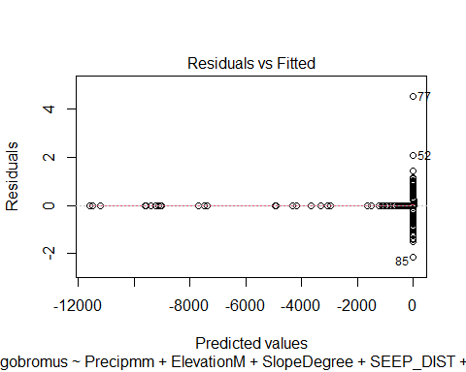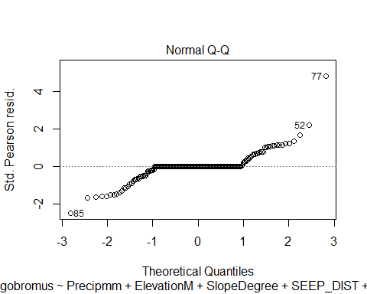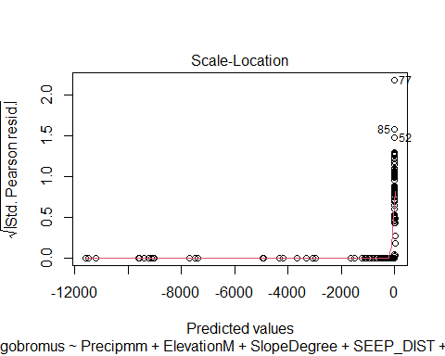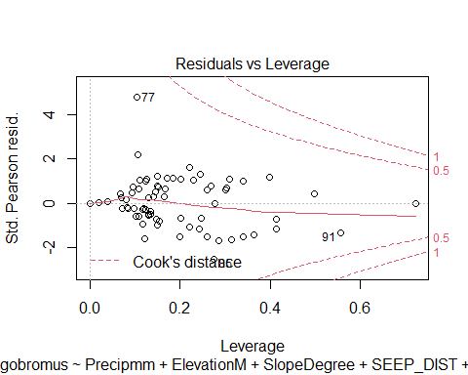

creg <- glm(Crangonyx~Precipmm+ElevationM+SlopeDegree+SEEP_DIST+INHAB_DIST+ROAD_DIST+TRAIL_DIST+OUTFALL_DIST+IMPERV_DIST+BORDER_DIST+Seeps_per_m2+Seepsperpatch+Count_Inhab_inpatch, data= seep, family = "binomial")

## Warning: glm.fit: algorithm did not converge

## Warning: glm.fit: fitted probabilities numerically 0 or 1 occurred

creg

##   
## Call: glm(formula = Crangonyx ~ Precipmm + ElevationM + SlopeDegree +   
## SEEP_DIST + INHAB_DIST + ROAD_DIST + TRAIL_DIST + OUTFALL_DIST +   
## IMPERV_DIST + BORDER_DIST + Seeps_per_m2 + Seepsperpatch +   
## Count_Inhab_inpatch, family = "binomial", data = seep)  
##   
## Coefficients:  
## (Intercept) Precipmm ElevationM   
## -1.807e+15 -5.129e+12 2.205e+13   
## SlopeDegree SEEP_DIST INHAB_DIST   
## 2.942e+13 -3.922e+12 -8.001e+11   
## ROAD_DIST TRAIL_DIST OUTFALL_DIST   
## 6.532e+12 6.451e+11 -1.266e+12   
## IMPERV_DIST BORDER_DIST Seeps_per_m2   
## -9.249e+10 -5.092e+12 -5.008e+18   
## Seepsperpatch Count_Inhab_inpatch   
## 2.550e+13 -8.713e+13   
##   
## Degrees of Freedom: 203 Total (i.e. Null); 190 Residual  
## (3 observations deleted due to missingness)  
## Null Deviance: 159.5   
## Residual Deviance: 1946 AIC: 1974

summary(creg)

##   
## Call:  
## glm(formula = Crangonyx ~ Precipmm + ElevationM + SlopeDegree +   
## SEEP_DIST + INHAB_DIST + ROAD_DIST + TRAIL_DIST + OUTFALL_DIST +   
## IMPERV_DIST + BORDER_DIST + Seeps_per_m2 + Seepsperpatch +   
## Count_Inhab_inpatch, family = "binomial", data = seep)  
##   
## Deviance Residuals:   
## Min 1Q Median 3Q Max   
## -8.49 0.00 0.00 0.00 8.49   
##   
## Coefficients:  
## Estimate Std. Error z value Pr(>|z|)   
## (Intercept) -1.807e+15 2.454e+07 -73637055 <2e-16 ***  
## Precipmm -5.129e+12 8.707e+05 -5891044 <2e-16 ***  
## ElevationM 2.205e+13 4.071e+05 54169500 <2e-16 ***  
## SlopeDegree 2.942e+13 5.605e+05 52492302 <2e-16 ***  
## SEEP_DIST -3.922e+12 6.128e+04 -64010854 <2e-16 ***  
## INHAB_DIST -8.001e+11 9.312e+03 -85918692 <2e-16 ***  
## ROAD_DIST 6.532e+12 1.635e+05 39941672 <2e-16 ***  
## TRAIL_DIST 6.451e+11 8.864e+03 72776021 <2e-16 ***  
## OUTFALL_DIST -1.266e+12 1.752e+04 -72272136 <2e-16 ***  
## IMPERV_DIST -9.249e+10 1.777e+05 -520610 <2e-16 ***  
## BORDER_DIST -5.092e+12 6.265e+04 -81265415 <2e-16 ***  
## Seeps_per_m2 -5.008e+18 1.329e+11 -37673393 <2e-16 ***  
## Seepsperpatch 2.550e+13 1.006e+06 25343949 <2e-16 ***  
## Count_Inhab_inpatch -8.713e+13 3.703e+06 -23529219 <2e-16 ***  
## ---  
## Signif. codes: 0 '***' 0.001 '**' 0.01 '*' 0.05 '.' 0.1 ' ' 1  
##   
## (Dispersion parameter for binomial family taken to be 1)  
##   
## Null deviance: 159.46 on 203 degrees of freedom  
## Residual deviance: 1946.36 on 190 degrees of freedom  
## (3 observations deleted due to missingness)  
## AIC: 1974.4  
##   
## Number of Fisher Scoring iterations: 25

plot(creg)

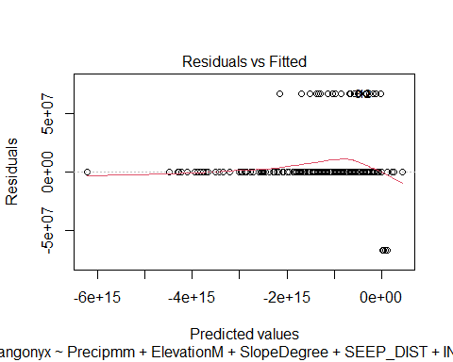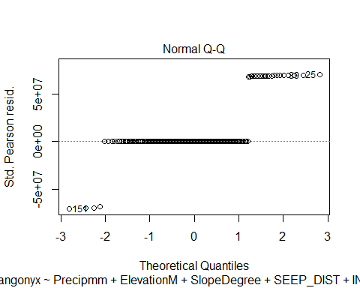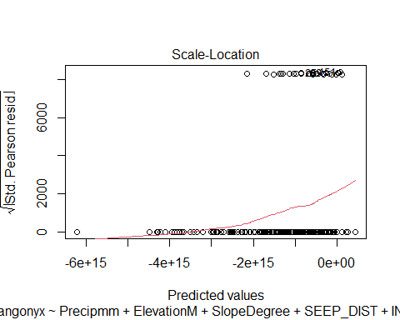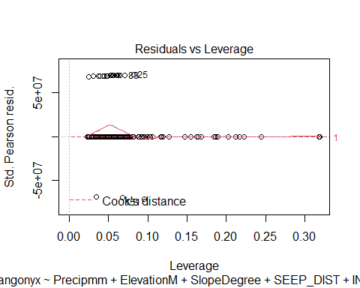

bhreg <- glm(Bin_hotspot~Precipmm+ElevationM+SlopeDegree+SEEP_DIST+INHAB_DIST+ROAD_DIST+TRAIL_DIST+OUTFALL_DIST+IMPERV_DIST+BORDER_DIST+Seeps_per_m2+Seepsperpatch+Count_Inhab_inpatch, data= seep, family = "binomial")

## Warning: glm.fit: algorithm did not converge

## Warning: glm.fit: fitted probabilities numerically 0 or 1 occurred

bhreg

##   
## Call: glm(formula = Bin_hotspot ~ Precipmm + ElevationM + SlopeDegree +   
## SEEP_DIST + INHAB_DIST + ROAD_DIST + TRAIL_DIST + OUTFALL_DIST +   
## IMPERV_DIST + BORDER_DIST + Seeps_per_m2 + Seepsperpatch +   
## Count_Inhab_inpatch, family = "binomial", data = seep)  
##   
## Coefficients:  
## (Intercept) Precipmm ElevationM   
## 7.662e-01 -3.053e-02 -4.903e-02   
## SlopeDegree SEEP_DIST INHAB_DIST   
## 1.244e-02 -2.250e-02 -2.513e+00   
## ROAD_DIST TRAIL_DIST OUTFALL_DIST   
## 1.968e-02 5.803e-04 -9.082e-04   
## IMPERV_DIST BORDER_DIST Seeps_per_m2   
## -3.663e-02 4.459e-04 -3.750e+03   
## Seepsperpatch Count_Inhab_inpatch   
## -1.232e-02 2.113e-01   
##   
## Degrees of Freedom: 203 Total (i.e. Null); 190 Residual  
## (3 observations deleted due to missingness)  
## Null Deviance: 96.74   
## Residual Deviance: 57.73 AIC: 85.73

summary(bhreg)

##   
## Call:  
## glm(formula = Bin_hotspot ~ Precipmm + ElevationM + SlopeDegree +   
## SEEP_DIST + INHAB_DIST + ROAD_DIST + TRAIL_DIST + OUTFALL_DIST +   
## IMPERV_DIST + BORDER_DIST + Seeps_per_m2 + Seepsperpatch +   
## Count_Inhab_inpatch, family = "binomial", data = seep)  
##   
## Deviance Residuals:   
## Min 1Q Median 3Q Max   
## -1.3520 -0.1774 0.0000 0.0000 1.9815   
##   
## Coefficients:  
## Estimate Std. Error z value Pr(>|z|)  
## (Intercept) 7.662e-01 2.558e+00 0.300 0.765  
## Precipmm -3.053e-02 6.618e-02 -0.461 0.645  
## ElevationM -4.903e-02 5.198e-02 -0.943 0.346  
## SlopeDegree 1.244e-02 4.467e-02 0.278 0.781  
## SEEP_DIST -2.250e-02 1.967e-02 -1.144 0.253  
## INHAB_DIST -2.513e+00 1.233e+02 -0.020 0.984  
## ROAD_DIST 1.968e-02 2.286e-02 0.861 0.389  
## TRAIL_DIST 5.803e-04 7.427e-04 0.781 0.435  
## OUTFALL_DIST -9.082e-04 9.979e-04 -0.910 0.363  
## IMPERV_DIST -3.663e-02 2.740e-02 -1.337 0.181  
## BORDER_DIST 4.459e-04 3.852e-03 0.116 0.908  
## Seeps_per_m2 -3.750e+03 1.627e+04 -0.231 0.818  
## Seepsperpatch -1.232e-02 9.788e-02 -0.126 0.900  
## Count_Inhab_inpatch 2.113e-01 3.835e-01 0.551 0.582  
##   
## (Dispersion parameter for binomial family taken to be 1)  
##   
## Null deviance: 96.736 on 203 degrees of freedom  
## Residual deviance: 57.730 on 190 degrees of freedom  
## (3 observations deleted due to missingness)  
## AIC: 85.73  
##   
## Number of Fisher Scoring iterations: 25

plot(bhreg)

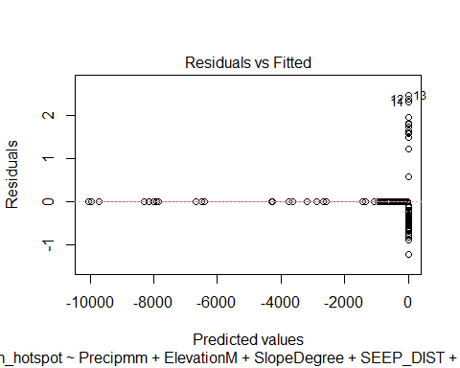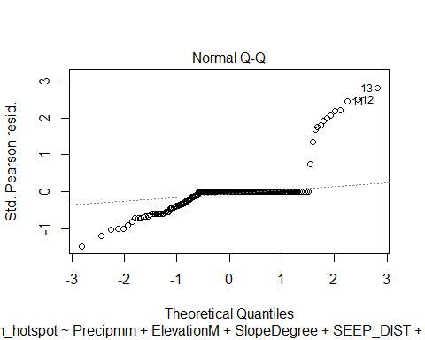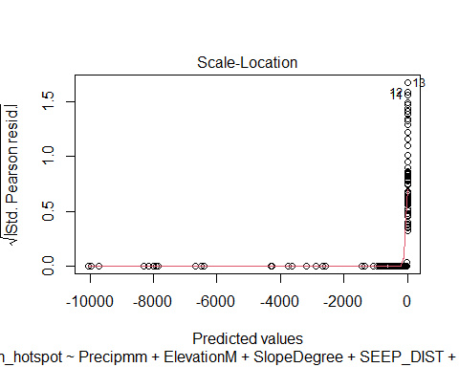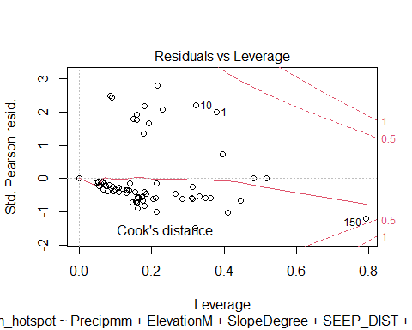

bireg <- glm(Bin_inhabited~Precipmm+ElevationM+SlopeDegree+SEEP_DIST+INHAB_DIST+ROAD_DIST+TRAIL_DIST+OUTFALL_DIST+IMPERV_DIST+BORDER_DIST+Seeps_per_m2+Seepsperpatch+Count_Inhab_inpatch, data= seep, family = "binomial")

## Warning: glm.fit: algorithm did not converge

## Warning: glm.fit: fitted probabilities numerically 0 or 1 occurred

bireg

##   
## Call: glm(formula = Bin_inhabited ~ Precipmm + ElevationM + SlopeDegree +   
## SEEP_DIST + INHAB_DIST + ROAD_DIST + TRAIL_DIST + OUTFALL_DIST +   
## IMPERV_DIST + BORDER_DIST + Seeps_per_m2 + Seepsperpatch +   
## Count_Inhab_inpatch, family = "binomial", data = seep)  
##   
## Coefficients:  
## (Intercept) Precipmm ElevationM   
## -1.317e+15 1.500e+13 -5.985e+12   
## SlopeDegree SEEP_DIST INHAB_DIST   
## 2.729e+13 2.104e+12 -1.396e+12   
## ROAD_DIST TRAIL_DIST OUTFALL_DIST   
## 3.735e+11 -6.854e+11 1.926e+12   
## IMPERV_DIST BORDER_DIST Seeps_per_m2   
## -1.597e+12 1.408e+12 -1.703e+18   
## Seepsperpatch Count_Inhab_inpatch   
## -1.803e+13 1.880e+14   
##   
## Degrees of Freedom: 203 Total (i.e. Null); 190 Residual  
## (3 observations deleted due to missingness)  
## Null Deviance: 256.8   
## Residual Deviance: 5334 AIC: 5362

summary(bireg)

##   
## Call:  
## glm(formula = Bin_inhabited ~ Precipmm + ElevationM + SlopeDegree +   
## SEEP_DIST + INHAB_DIST + ROAD_DIST + TRAIL_DIST + OUTFALL_DIST +   
## IMPERV_DIST + BORDER_DIST + Seeps_per_m2 + Seepsperpatch +   
## Count_Inhab_inpatch, family = "binomial", data = seep)  
##   
## Deviance Residuals:   
## Min 1Q Median 3Q Max   
## -8.49 0.00 0.00 0.00 8.49   
##   
## Coefficients:  
## Estimate Std. Error z value Pr(>|z|)   
## (Intercept) -1.317e+15 2.454e+07 -53656363 <2e-16 ***  
## Precipmm 1.500e+13 8.707e+05 17230778 <2e-16 ***  
## ElevationM -5.985e+12 4.071e+05 -14702351 <2e-16 ***  
## SlopeDegree 2.729e+13 5.605e+05 48685730 <2e-16 ***  
## SEEP_DIST 2.104e+12 6.128e+04 34342818 <2e-16 ***  
## INHAB_DIST -1.396e+12 9.312e+03 -149867975 <2e-16 ***  
## ROAD_DIST 3.735e+11 1.635e+05 2284225 <2e-16 ***  
## TRAIL_DIST -6.854e+11 8.864e+03 -77319304 <2e-16 ***  
## OUTFALL_DIST 1.926e+12 1.752e+04 109958813 <2e-16 ***  
## IMPERV_DIST -1.597e+12 1.777e+05 -8988406 <2e-16 ***  
## BORDER_DIST 1.408e+12 6.265e+04 22473549 <2e-16 ***  
## Seeps_per_m2 -1.703e+18 1.329e+11 -12813463 <2e-16 ***  
## Seepsperpatch -1.803e+13 1.006e+06 -17915232 <2e-16 ***  
## Count_Inhab_inpatch 1.880e+14 3.703e+06 50773811 <2e-16 ***  
## ---  
## Signif. codes: 0 '***' 0.001 '**' 0.01 '*' 0.05 '.' 0.1 ' ' 1  
##   
## (Dispersion parameter for binomial family taken to be 1)  
##   
## Null deviance: 256.84 on 203 degrees of freedom  
## Residual deviance: 5334.46 on 190 degrees of freedom  
## (3 observations deleted due to missingness)  
## AIC: 5362.5  
##   
## Number of Fisher Scoring iterations: 25

plot(bireg)

