**Lab 3**

1. In the code folder for this lab there is a package lesson3.labs.prob1 containing two classes, Person and PersonWithJob. In each class, the equals method has been overridden. Run the main method in the PersonWithJob class. In the main method, two instances of Person have been compared to determine if they are equal. The comparison is done in two different ways. One way leads to a “false”, the other to a “true.” Explain why this has happened. Then provide a solution by replacing inheritance with composition.

Answer:

* False because:
  + p1.equals is using the Override equals method of class PersonWithJob
  + p2 is not the instance of PersonWithJob, Person which mean p2 does hold to information of salary
* True because
  + p2.equals is using the Override equals method of class Person
  + p1 is an instance of Person because PersonWithJob inherited from Person Class

1. Design a solution to the problem given below and then implement in code. Write a Main to test your code.

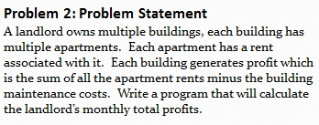

1. In Lab 1 a properties management system was introduced. In that lab, you specified classes and some attributes for those classes. In this exercise, think of a way to design further using inheritance and include associations (with multiplicities) and some operations for your classes. Then translate your diagram into Java code. Both an Admin and Driver class have been provided in your code folder. The Driver class creates some instances of the different properties and passes these into the Admin method computeTotalRent; this method performs a correct computation, but the implementation proceeds by checking the types of the different rental properties. Refactor the implementation of computeTotalRent so that the inheritance you have introduced is used, together with polymorphism. Below is provided the problem statement and a solution for the Lab 1 exercise.

