Karl Parks cssc0548

CS 320 Fall 2018: Extra Credit Scheme Program

29.99 Points

12/15/2018

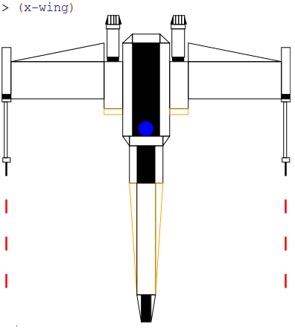

Above is the isometric top view of a Star Wars X-Wing Starfighter.