Consider the provided files: **Generator.html, theStyle.css** and **theScript.js** representing the following Web page.

**Complete** the HTML document [**Generator.html**] and apply the appropriate changes using the style rules from **[theStyle.css]** file so it looks like the following screenshots.

**Note:** **[theStyle.css]** file has all the style rules and you **DON’T need to edit it**.

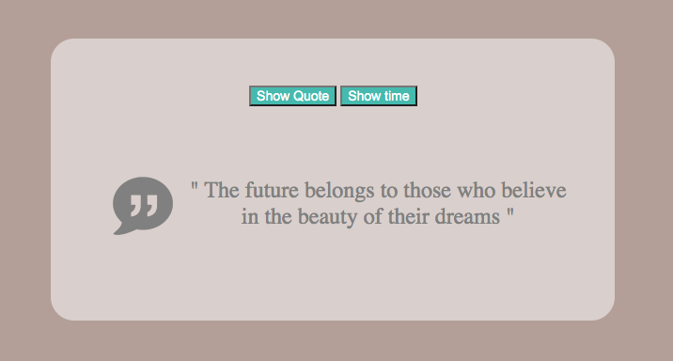

**Generator.html** file instructions:

* Create a form that contains two buttons, “New Quote” and "Show time”.

After you complete the HTML document [**Generator.html**], write a JavaScript code in [**theScript.js**] file that performs one of the following actions depending on user’s choice

1. When the user clicks on “New Quote” button:
   * Generates and displays a random quote.
   * And displays the **quote icon** on the left of the generated quote.
2. When the user clicks on "Show time” button:

* Displays the current time.
* And displays the **time icon** on the left of the time as shown in the next page.

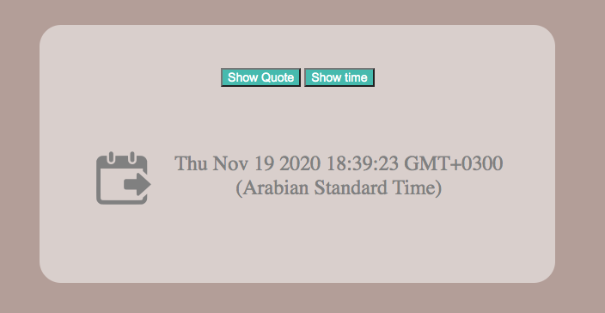

* **Note:**
* The quotes are provided as an array in [**theScript.js**] file.
* The initial page (when the user opens the web page for the first time) shows a quote of your choice along with the quote icon.