**SETUP AND EXECUTION**

* **Hardware Used**

The system has following specifications:

* 4GB RAM
* 1 TB
* i5 8th generation.
* **Software Used**
* OS Used - Windows 10 64-bit version
* IntelliJ IDEA community Edition 2020.2
* MySQL workbench 8.0 CE
* Ganache 2.5.4
* Firefox 85.0 (64-bit) web browser

**To run application**

1. Start MySQL workbench. It must contain database with name auth2. If not present create it.
2. Inside Source Code open ‘Land_Digitization version 1.0’ as maven application in IntelliJ IDEA.
3. Wait until IntelliJ IDEA download all dependency and build the project.
4. Initialize Ganache as explain below.
5. After updating application.properties file we are ready to run the application.
6. Open the Source Code\UI\land digtization using blockchain\Homepage.html in web browser.
7. The application is running now.

**Step to** **initialize Ganache**

1. Install Ganache on the system.
2. You will see the screen below. IF you are new user Click on ‘NEW WORKSPACE ETHEREUM’ to create. If already created the you can see it in workspace area. Open it by clicking.

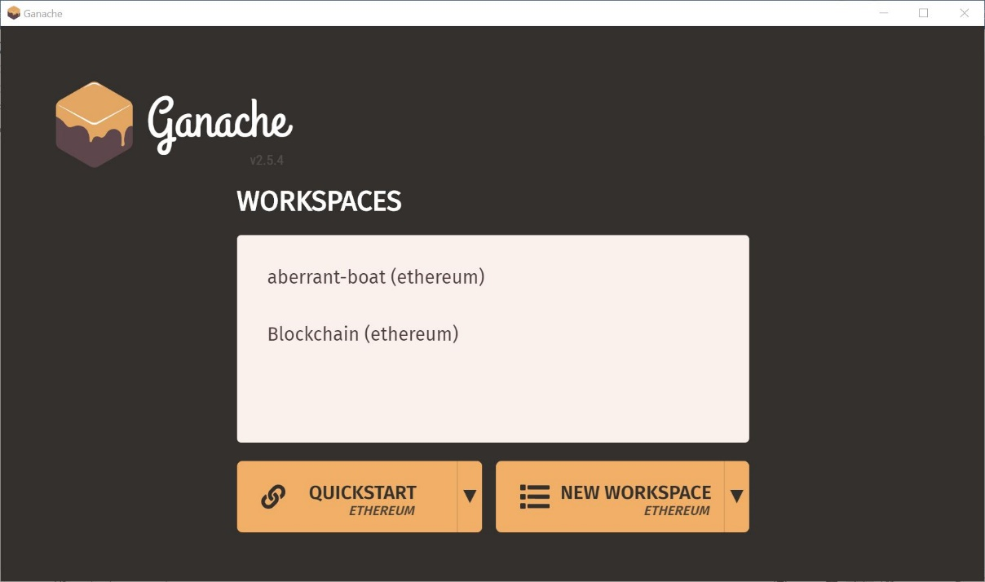

**Figure 1: Ganache Application Homepage**

1. Click on settings, under server change port to 8545.
2. Copy the ‘GAS PRICE’ and ‘GAS LIMIT’ with first ‘Address’ as owner address and put in application.properties file in SpringBoot application.

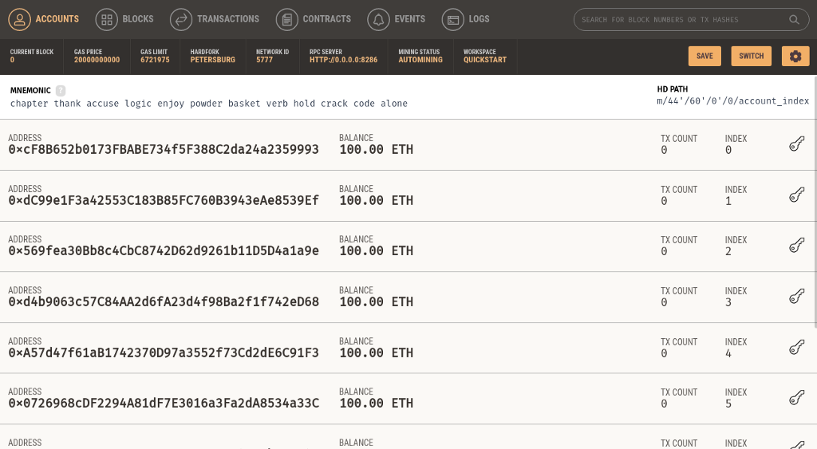

**Figure 2: Ganache Application Workspace**