

UNIVERSITY OF TECHNOLOGY, MAURITIUS
SCHOOL OF INNOVATIVE TECHNOLOGIES AND ENGINEERING
DEPARTMENT OF INDUSTRIAL SYSTEM ENGINEERING

PERSONALISED FITNESS RECOMMENDATION SYSTEM
FINAL REPORT

BY
KURMALLY Mohammad Housein
Student ID: 2403_27576
Module Code: BCNS3006C

This Capstone Project is submitted in partial fulfilment of the requirements for the Bachelor's Degree in Computer Science with Network Security.
SUPERVISOR: Mr Doorgesh Sookarah
September 2026

ABSTRACT
Gym members differ in experience, goals, available equipment and physical restrictions, yet trainers cannot realistically hand-craft and continually adjust a validated weekly plan for every member. This project designed, implemented and evaluated FitWise, a personalised fitness recommendation system comprising a Next.js web application for trainers and gym administrators, a Flutter member mobile application, a FastAPI machine-learning service and a Supabase PostgreSQL backend protected by Row-Level Security. A scikit-learn classifier trained on the Gym Members Exercise Dataset predicts a workout category from information available before a member’s first session. A Gemini-assisted generator and a deterministic rule-based generator then draft weekly plans from the same approved exercise catalogue, and one shared validator checks every plan before a trainer can approve it.
The system was evaluated with executed evidence. The selected Logistic Regression model achieved a macro F1 of 0.222 and did not exceed the majority-class baseline’s accuracy; a leakage diagnostic showed that this reflects the dataset’s target variable rather than the method. Across 20 fixed member profiles with identical inputs, the rule-based generator produced 20 valid plans in under one millisecond on average, while Gemini produced 4 valid plans at about 29 seconds per plan, failing mainly on out-of-range numeric values and plan structure but never on exercise suitability. Functional and security tests, including 27 database policy checks, confirmed authentication gating and database-level access control.
The results support the central design decision that neither the classifier nor the language model is trusted on its own: every output is validated deterministically and approved by a trainer. Usability testing with real users and authenticated cross-member security tests remain the main items of future work.

ACKNOWLEDGEMENTS
I wish to express sincere appreciation to the project supervisor, Mr Doorgesh Sookarah, for his guidance and feedback throughout this capstone project. Appreciation is also extended to the University of Technology, Mauritius, and the staff of the School of Innovative Technologies and Engineering for providing the academic framework within which the project was undertaken.

TABLE OF CONTENTS
Contents
ABSTRACT ii
ACKNOWLEDGEMENTS iii
TABLE OF CONTENTS iv
LIST OF TABLES x
LIST OF FIGURES xii
LIST OF ACRONYMS xiv
CHAPTER 1: INTRODUCTION 1
1.1 Background and Context 1
1.2 Problem Statement 2
1.3 Project Aim 3
1.4 Project Objectives 3
1.5 Research and Development Questions 4
1.6 Proposed Solution Overview 4
1.7 Scope and System Boundary 5
1.8 Expected Contributions 5
CHAPTER 2: LITERATURE REVIEW 7
2.1 Literature Review Strategy 7
2.2 Physical Activity, Exercise Prescription and Fitness Monitoring 7
2.3 Digital Health and Mobile Fitness Applications 8
2.4 Recommender Systems and Personalisation 9
2.5 Machine Learning for Fitness Prediction 10
2.6 Generative AI and Controlled Workout-Plan Generation 12
2.7 Progress Estimation and Feedback 13
2.8 Security, Privacy and Ethical Considerations 13
2.9 Existing Systems and Comparative Analysis 14
2.10 Research and Development Gap 16
2.11 Conceptual Framework 16
CHAPTER 3: METHODOLOGY AND PROJECT MANAGEMENT 18
3.1 Methodology Overview 18
3.2 Requirements-Gathering Approach 18
3.3 Software Development Lifecycle 19
3.4 Dataset Selection and Data Preparation Method 19
3.5 Machine-Learning Experimental Method 20
3.6 Hybrid Workout-Plan Generation and Validation Method 20
3.7 Progress-Estimation Method 21
3.8 Testing and Evaluation Method 21
3.9 Ethics, Privacy and Safety 22
3.10 Quality Assurance 22
3.11 Project Plan and Progress Control 22
CHAPTER 4: REQUIREMENTS ANALYSIS 24
4.1 User Roles 24
4.2 Current and Proposed Process 24
4.3 Functional Requirements 26
4.4 Non-Functional Requirements 27
4.5 Use-Case Model 27
4.6 Detailed Core Use Cases 28
4.7 User Stories and Acceptance Criteria 29
4.8 Requirements Traceability 30
CHAPTER 5: SYSTEM DESIGN AND ARCHITECTURE 32
5.1 Architectural Overview 32
5.2 Technology Stack and Design Rationale 33
5.3 Component Design 34
5.4 Key Interaction and Sequence Design 34
5.5 Data Model and Database Design 35
5.6 API Design 37
5.7 Machine-Learning Model Design 38
5.8 Gemini-Assisted Plan Generation and Deterministic Validation 39
5.9 Security and Privacy Design 40
5.10 UI/UX and Navigation Design 41
5.11 Deployment Architecture 44
CHAPTER 6: IMPLEMENTATION 45
6.1 Development Environment and Repository Structure 45
6.2 Dataset Exploration and Preprocessing 45
6.3 Machine-Learning Model Development 46
6.4 Model Selection, Explainability and Export 47
6.5 Backend API and Integration Services 48
6.6 Authentication, Authorisation and Supabase 48
6.7 Gemini-Assisted and Rule-Based Plan Generation 49
6.8 Progress Estimation Implementation 50
6.9 Public Website, Trainer and Administration Web Application 50
6.10 Gym-Member Mobile Application 52
6.11 End-to-End System Integration and Security 52
6.12 Technical Challenges and Solutions 53
CHAPTER 7: TESTING AND EVALUATION 54
7.1 Test Strategy and Environment 54
7.2 Functional and System Test Cases 55
7.3 API and Integration Testing 55
7.4 Machine-Learning Evaluation 55
7.5 Plan-Generation Validation and Comparison 56
7.6 Usability and User Acceptance Testing 57
7.7 Security and Privacy Testing 58
7.8 Performance, Reliability and Defects 58
7.9 Evaluation Against Objectives 59
7.10 Discussion of Results 60
CHAPTER 8: DEPLOYMENT, OPERATION AND DOCUMENTATION 61
8.1 Deployment Approach 61
8.2 Configuration and Secret Management 61
8.3 Backup, Recovery and Monitoring 61
8.4 Documentation, Maintenance and Extensibility 61
CHAPTER 9: CONCLUSION AND RECOMMENDATIONS 63
9.1 Project Summary 63
9.2 Achievement of Aim and Objectives 63
9.3 Main Contributions 63
9.4 Limitations 63
9.5 Critical Appraisal and Lessons Learned 64
9.6 Recommendations and Future Work 64
9.7 Final Conclusion 65
REFERENCES 66
GLOSSARY 69
APPENDIX A: GYM-MEMBER USER MANUAL 70
A.1 Signing In 70
A.2 Home and Recommendation 70
A.3 Following Your Weekly Plan 71
A.4 Progress and Projection 72
A.5 Achievements, Messages and Settings 73
APPENDIX B: TRAINER AND ADMINISTRATOR USER MANUAL 74
B.1 Applying for a Trainer Account 74
B.2 Signing In and Dashboard 74
B.3 Registering and Assessing a Member 75
B.4 Requesting a Prediction 75
B.5 Generating and Reviewing a Plan 76
B.6 Monitoring Progress, Analytics and Alerts 76
B.7 Settings 77
B.8 Gym Administrator Tasks 78
APPENDIX C: TECHNICAL AND DEPLOYMENT MANUAL 79
C.1 Prerequisites 79
C.2 Repository Structure 79
C.3 Environment Variables 79
C.4 Database Setup 80
C.5 ML Service Setup 80
C.6 Web and Mobile Setup 80
C.7 API Routes 80
C.8 Verifying the Installation 81
APPENDIX D: REQUIREMENTS TRACEABILITY 82
D.1 Functional Requirements Traceability 82
D.2 Non-Functional Requirements Traceability 83
APPENDIX E: DATASET AND MACHINE-LEARNING EVIDENCE 84
E.1 Dataset Summary 84
E.2 Hyperparameter Search 84
E.3 Effect of Tuning 85
E.4 Leakage Diagnostic 85
E.5 Exported Artefacts 85
APPENDIX F: RULE-ENGINE SPECIFICATION 86
APPENDIX G: TEST PLAN AND TEST EVIDENCE 88
G.1 Per-Profile Plan-Generation Results 88
G.2 Sample Validator Output 89
G.3 Usability and UAT Task Script 89
APPENDIX H: SECURITY, PRIVACY AND ETHICS EVIDENCE 91
H.1 Implemented Access-Control Matrix 91
H.2 Row-Level Security Policy Example 91
H.3 Privacy and Data Minimisation 92
H.4 Ethical Considerations 92
APPENDIX I: POC SCREEN GALLERY 93
APPENDIX J: PROJECT MANAGEMENT EVIDENCE 97
J.1 Milestone Record 97
J.2 Change Log 97
J.3 Gantt Chart and Supervision Record 98

LIST OF TABLES
Table 1.1: Project scope and system boundary 5
Table 2.1: Comparison of representative fitness systems and research prototypes 15
Table 2.2: Research and development gap analysis 16
Table 3.1: Project methodology outputs 23
Table 4.1: Role and access analysis 24
Table 4.2: Functional requirements 26
Table 4.3: Non-functional requirements 27
Table 4.4: Prioritised user stories 29
Table 4.5: Requirements traceability matrix 30
Table 5.1: Technology stack and design rationale 33
Table 5.2: Core database entities 36
Table 5.3: Proposed API endpoints 37
Table 5.4: Deterministic plan-validation rules 39
Table 5.5: Access-control matrix 41
Table 6.1: Implemented components and versions 45
Table 6.2: Feature-availability audit 46
Table 6.3: Candidate model comparison 47
Table 6.4: Technical challenges and solutions 53
Table 7.1: Test levels, methods and results 54
Table 7.2: Functional and system test cases 55
Table 7.3: Class-level test performance of the selected model (Logistic Regression) 56
Table 7.4: Confusion matrix on the held-out test set (rows actual, columns predicted) 56
Table 7.5: Rule-based and Gemini generator comparison across 20 profiles 57
Table 7.6: Distribution of Gemini validation violations (69 in total) 57
Table 7.7: Security and privacy checks 58
Table 7.8: Defect log 59
Table 7.9: Achievement of project objectives 59
Table C.1: Repository structure 79
Table C.2: Web application environment variables 79
Table C.3: Implemented API routes 80
Table D.1: Functional requirements traceability 82
Table D.2: Non-functional requirements traceability 83
Table E.1: Hyperparameter grids searched with five-fold GridSearchCV 84
Table E.2: Cross-validated macro F1 with default and tuned hyperparameters 85
Table E.3: Leakage diagnostic (untuned Random Forest, five-fold CV macro F1 on the training set) 85
Table F.1: Rule catalogue and implementation 86
Table F.2: Prescription templates 86
Table G.1: Per-profile results (rule-based and Gemini) 88
Table G.2: UAT task script 90
Table H.1: Implemented access-control matrix 91
Table J.1: Milestone record from project artefacts 97
Table J.2: Material changes from the original plan 97

LIST OF FIGURES
Figure 1.1: High-level overview of the proposed FitWise solution 5
Figure 2.1: Conceptual framework for the FitWise recommendation and feedback loop 17
Figure 3.1: Iterative development and evaluation methodology 18
Figure 4.1: Proposed end-to-end FitWise process 25
Figure 4.2: FitWise use-case model 28
Figure 5.1: FitWise system architecture 33
Figure 5.2: Sequence for prediction and plan generation 35
Figure 5.3: Logical relational data model 36
Figure 5.4: Machine-learning training and inference pipeline 38
Figure 5.5: Security boundaries and access-control design 40
Figure 5.6: Trainer web-application POC screen gallery 42
Figure 5.7: Gym-member mobile-application POC screen gallery 43
Figure 5.8: FitWise deployment architecture 44
Figure 6.1: Cross-validated macro F1 of the candidate models 47
Figure 6.2: Trainer dashboard 51
Figure 6.3: Rule-based and Gemini-assisted plans with validation status 51
Figure 6.4: Member application home, weekly plan and progress screens 52
Figure A.1: Sign-in screen and recommendation detail 71
Figure A.2: Weekly plan and session details 72
Figure A.3: Progress tab and profile tab 73
Figure B.1: Trainer application form 74
Figure B.2: Recording a member assessment (Fitness Data tab) 75
Figure B.3: ML prediction with class probabilities and disclaimer 76
Figure B.4: Roster-wide progress and analytics 77
Figure B.5: Trainer settings and notification preferences 77
Figure I.1: FitWise proof-of-concept screen gallery 93
Figure I.2: Trainer member list 94
Figure I.3: Member workout history 95
Figure I.4: Public website home page 96

LIST OF ACRONYMS
Acronym | Meaning
API | Application Programming Interface
APK | Android Package
BMI | Body Mass Index
BPM | Beats Per Minute
CRUD | Create, Read, Update and Delete
CV | Cross-Validation
F1-score | Harmonic mean of precision and recall
FITT | Frequency, Intensity, Time and Type
GDPR | General Data Protection Regulation
HIIT | High-Intensity Interval Training
JSON | JavaScript Object Notation
JWT | JSON Web Token
LLM | Large Language Model
ML | Machine Learning
MVVM | Model–View–ViewModel
NFR | Non-Functional Requirement
POC | Proof of Concept
RBAC | Role-Based Access Control
REST | Representational State Transfer
RLS | Row-Level Security
SDK | Software Development Kit
SUS | System Usability Scale
UAT | User Acceptance Testing
UI/UX | User Interface / User Experience
WBS | Work Breakdown Structure

CHAPTER 1: INTRODUCTION

1.1 Background and Context
Regular physical activity is associated with substantial physical and mental health benefits, including improved cardiovascular and musculoskeletal health and reduced risk of several non-communicable diseases. Nevertheless, the World Health Organization reported that approximately 31% of adults did not achieve recommended levels of physical activity in 2022, illustrating that access to general information does not automatically translate into sustained behaviour (World Health Organization, 2024). The WHO guidelines emphasise frequency, intensity and duration while recognising that recommendations must be adapted to the individual, particularly where chronic conditions or physical limitations are present (World Health Organization, 2020).
Digital fitness technologies attempt to bridge the gap between broad recommendations and day-to-day action. Mobile applications can deliver reminders, self-monitoring, feedback, instructional media and progress visualisation at relatively low cost. Systematic reviews suggest that app- and tracker-based interventions can produce small-to-moderate improvements in physical activity, with personalisation and continuous feedback associated with stronger outcomes in some studies (Laranjo et al., 2021; Tong et al., 2021). However, the evidence remains heterogeneous, and many applications focus on recording completed activity rather than assisting a user and trainer to create, approve and adapt a coherent workout programme.
Personalisation is important because gym members differ in age, body measurements, training experience, objectives, available time, available equipment, previous performance and reported restrictions. A beginner seeking general fitness should not automatically receive the same exercise volume or intensity as an experienced member pursuing strength. Similarly, a plan that assumes access to a fully equipped gym is unsuitable for a member training at home. When trainers manage many members, collecting these factors, reviewing progress and repeatedly adjusting weekly plans can become administratively demanding. The challenge is therefore not simply to display exercises, but to transform structured member information into an explainable recommendation that remains reviewable by a trainer.
FitWise was developed as a multi-client software system that supports this process. It provides a trainer workspace and public entry point through Next.js and TypeScript, a member mobile application through Flutter, a PostgreSQL database and authentication services through Supabase, and a Python machine-learning service through FastAPI. A trained classification pipeline predicts a suitable workout category such as Cardio, Strength, HIIT or Yoga. Gemini then assists in composing a structured weekly plan from an approved exercise catalogue, while the Next.js backend validates exercise identifiers, session duration, equipment availability, difficulty, reported restrictions and other deterministic constraints. The plan remains subject to trainer review before assignment.

1.2 Problem Statement
Gym members are exposed to a large quantity of workout advice through websites, social media and general-purpose applications. Although this material may be useful, it is frequently presented as a fixed routine and may not correspond to the member’s goal, experience, schedule, equipment or physical limitations. As a result, members may select inappropriate routines, change programmes without a clear basis, or lose motivation when progress is difficult to interpret. The problem is particularly important for beginners, who may not possess sufficient knowledge to distinguish between a popular routine and a suitable one.
Trainers face a related management problem. Member registration, assessment, plan creation, workout monitoring and progress review are often carried out through separate forms, messaging tools or spreadsheets. This fragmentation makes it difficult to maintain a consistent record of the data used for a recommendation, the model or rule version that produced it, the plan approved by the trainer and the member’s subsequent completion data. A trainer managing multiple members may therefore spend significant time on repetitive administrative work while still lacking an integrated view of adherence and progress.
Existing commercial systems demonstrate that algorithmic personalisation is feasible, but their internal reasoning, data handling and trainer workflows are generally proprietary. Academic research also shows promise in personalised mobile interventions and LLM-assisted exercise planning, yet concerns remain regarding reliability, safety, privacy, hallucinated content and insufficient expert oversight (Wang et al., 2024; Choi et al., 2026). There is therefore a need for an academically transparent system that combines data-driven prediction, controlled generative assistance, deterministic validation, trainer review, progress tracking and role-based access within one coherent architecture.

1.3 Project Aim
The aim of this project is to design, develop and evaluate an intelligent personalised fitness recommendation and progress tracking system that combines machine-learning-based workout-category prediction with Gemini-assisted workout-plan generation, deterministic validation and trainer review through a Next.js web application and a Flutter gym-member mobile application.

1.4 Project Objectives
- Analyse and prepare the Gym Members Exercise Dataset for reproducible machine-learning experimentation, including a data-quality and leakage audit.
- Develop and evaluate classification models for predicting a suitable workout category, such as Cardio, Strength, HIIT or Yoga.
- Develop a controlled hybrid plan-generation process in which Gemini constructs a structured draft from approved exercises and the Next.js backend enforces deterministic constraints.
- Develop a transparent progress-estimation method that presents one-, two- and three-month projections with explicit assumptions and limitations.
- Develop a secure public website and trainer web application using Next.js and TypeScript for member management, assessment, prediction, plan review and progress monitoring.
- Develop a Flutter mobile application through which gym members can view recommendations, follow assigned plans, record workout completion and review progress.
- Implement Supabase PostgreSQL, Authentication, Storage and Row-Level Security for persistent data and role/ownership-based access.
- Integrate the Next.js application, Supabase services, FastAPI inference service, Gemini API and Flutter application into one end-to-end system.
- Evaluate the machine-learning model, generated-plan validation, software functionality, usability, security, performance and integration, and document the deployed system.

1.5 Research and Development Questions
- Which classification approach provides the most reliable and practically defensible workout-category prediction on the selected dataset?
- How can Gemini-assisted generation, an approved exercise catalogue and deterministic validation be combined to produce structured, explainable and reviewable workout plans?
- To what extent does the completed Next.js, Flutter, Supabase and FastAPI system satisfy its functional, usability, security and integration requirements?

1.6 Proposed Solution Overview
The proposed workflow begins when a trainer creates or activates a member account and records an initial fitness assessment. The Next.js backend validates the assessment, stores the authorised data in Supabase and prepares the features required by the Python model. The FastAPI service loads a saved scikit-learn pipeline once at application start-up and returns the predicted workout category, confidence values and model version. Next.js retrieves approved candidate exercises from Supabase and submits only the necessary profile, prediction and exercise metadata to Gemini using a structured-output schema. The generated draft is treated as untrusted input: server-side validation checks identifiers, durations, repetitions, equipment, difficulty, duplication and exclusion rules before the trainer can approve and assign the plan. The Flutter application then retrieves the approved plan and records workout completion and progress data, which become available to the member and trainer dashboards.
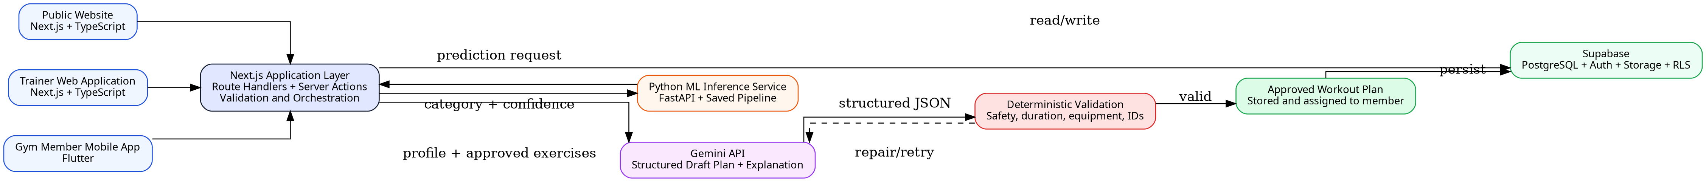
Figure 1.1: High-level overview of the proposed FitWise solution
Source: Housein’s design

1.7 Scope and System Boundary
Table 1.1: Project scope and system boundary
In Scope | Out of Scope / Constraint
Public FitWise website, trainer web workspace and gym-member mobile application | Medical diagnosis, rehabilitation prescription or emergency monitoring
Supabase email/password authentication with trainer/member access boundaries | Replacement of a qualified doctor, physiotherapist or trainer
ML classification of workout category using a documented dataset and pipeline | Guaranteed body-composition or health outcomes
Gemini-assisted draft plan creation from approved exercises | Unrestricted generation of arbitrary exercises without validation
Deterministic checks for exercise IDs, equipment, duration, difficulty and reported restrictions | Clinical validation for complex health conditions
Trainer review, approval and override with an audit reason | Fully autonomous high-risk decision-making
Workout completion, adherence and progress visualisation | Automatic wearable-device integration unless time permits
POC deployment, technical documentation and controlled user evaluation | Commercial-scale operation or regulatory certification

1.8 Expected Contributions
The principal computing contribution is a transparent hybrid architecture rather than a standalone fitness interface. The project integrates supervised machine learning, a generative model, deterministic business and safety controls, relational data design, role-based security and two user-facing clients. The use of an approved exercise catalogue limits inconsistent naming and permits every generated plan item to be linked to instructions, equipment and tracking data. The server-side validation layer addresses the fact that structured LLM output may be syntactically correct without being semantically suitable (Google AI for Developers, 2026).
A second contribution is the end-to-end trainer–member workflow. The trainer is not removed from the process; instead, FitWise uses automation to support registration, prediction, plan drafting and monitoring while preserving trainer approval. The member receives a clear weekly plan and records actual completion rather than viewing a one-off recommendation. The resulting data model provides traceability across assessments, predictions, model versions, generated plans, approvals, sessions and progress records.
Finally, the dissertation contributes an honest evaluation of the selected public dataset and the limitations of progress projection. Post-workout variables were examined for leakage and unrealistic inference-time availability. Progress estimates are presented as scenario-based guidance rather than scientifically validated forecasts because the selected dataset does not contain longitudinal observations of the same member over several months.

CHAPTER 2: LITERATURE REVIEW

2.1 Literature Review Strategy
A structured narrative review was undertaken to connect the fitness domain with the computing decisions required by FitWise. Sources were identified through PubMed, IEEE Xplore, ACM publications, Google Scholar, SpringerLink, ScienceDirect and official standards or product documentation. Searches combined terms including personalised fitness, physical activity application, mHealth intervention, exercise recommendation, hybrid recommender, machine-learning classification, large language model exercise planning, health-data privacy, API security, Next.js, Supabase, Flutter and FastAPI. Priority was given to peer-reviewed systematic reviews, meta-analyses, recognised exercise guidance and primary technical documentation. Recent work from 2021–2026 was emphasised, while foundational recommender-system and behaviour-change studies were retained where they define concepts still used in current research.
The review was not designed as a clinical systematic review and does not claim exhaustive coverage. Sources were selected for their relevance to the proposed system and assessed according to publication type, methodological transparency, sample size or evidence base, direct relevance, and the authority of the issuing organisation. Commercial application documentation was used only to compare publicly described features, not to make unverified claims about proprietary algorithms.

2.2 Physical Activity, Exercise Prescription and Fitness Monitoring
The WHO guidelines describe physical activity recommendations in terms of frequency, intensity and duration and advise adults to undertake regular aerobic and muscle-strengthening activity (World Health Organization, 2020). Exercise planning is therefore not limited to selecting a label such as Cardio or Strength. A useful system must eventually translate a broad category into sessions that balance type, duration, intensity and recovery. Garber et al. (2011) similarly describe exercise programmes as combinations of cardiorespiratory, resistance, flexibility and neuromotor activity, reinforcing the need to consider different fitness components rather than maximising one metric.
Fitness monitoring commonly uses body measurements, session completion, heart rate, duration and estimated energy expenditure. Ainsworth et al. (2011) demonstrated that activities have different energy costs, but values such as calories burned are estimates influenced by body mass, duration, intensity and measurement method. Consequently, FitWise should not treat any single value as a definitive indicator of health or progress. Measurements must also be interpreted according to when they are available. Resting heart rate and stated workout frequency may be collected during onboarding, whereas average exercise heart rate, session duration and calories burned are normally known after a workout. Mixing these variables in a new-member prediction creates a methodological risk that must be addressed in the ML design.
The project therefore uses exercise guidance as a framework and keeps a human reviewer in the loop. Reported restrictions can influence exclusion or substitution, but the application will not diagnose a condition. A trainer must review plans where a member declares pain, injury or another limitation, and the interface must provide an explicit statement that the recommendation is general fitness guidance.

2.3 Digital Health and Mobile Fitness Applications
Mobile fitness applications can deliver self-monitoring, feedback and reminders in the context in which behaviour occurs. Emberson et al. (2021) found that smartphone interventions produced positive outcomes in a proportion of reviewed studies across physical, weight-related and psychological measures. Laranjo et al. (2021) reported a small-to-moderate positive effect from apps and activity trackers and identified personalisation and text messaging as potentially important features. These results support the inclusion of progress feedback and notifications, but they also indicate that technology alone does not guarantee long-term adherence.
Personalisation appears to improve relevance. Tong et al. (2021) synthesised personalised mobile interventions and found preliminary evidence of a moderate positive effect on lifestyle behaviours. Interventions using system-captured data were associated with stronger effects than those relying only on self-report. FitWise initially depends on trainer-entered and member-entered information, so the limitation of self-reported data should be acknowledged. The design partially mitigates this through structured validation, recorded workout completion and the possibility of comparing initial assessments with later measurements.
Application quality is uneven. Paganini et al. (2021) found substantial variation in physical-activity apps and assessed both quality and privacy/security measures. Davergne et al. (2023) found that personalised exercise-video applications may improve physical function and exercise confidence, but the quality of evidence was low. These findings suggest that a convincing final-year project should evaluate task completion, clarity and trust rather than using attractive mockups as proof of usability. FitWise’s evaluation therefore planned task-based user acceptance testing rather than relying on interface screenshots.
Behaviour-change theory also supports goal setting, self-monitoring and feedback. The Behaviour Change Wheel describes behaviour through capability, opportunity and motivation (Michie, van Stralen and West, 2011), while the Behaviour Change Technique Taxonomy identifies goal setting, feedback and self-monitoring among commonly used techniques (Michie et al., 2013). FitWise incorporates these principles through visible goals, weekly completion, progress trends, trainer feedback and reassessment triggers. Gamification features such as badges may support engagement (Yang, Hu and Koenigstorfer, 2022), but they are secondary because the core research contribution lies in recommendation, integration and evaluation.

2.4 Recommender Systems and Personalisation
Recommender systems reduce information overload by selecting or ranking items according to user data, item characteristics and interaction history. Collaborative filtering learns from similarities between users or behaviours, while content-based methods match item properties to a user profile. Knowledge-based and rule-based methods apply explicit domain relationships or constraints, and hybrid systems combine approaches to compensate for individual weaknesses (Adomavicius and Tuzhilin, 2005; Burke, 2002; Ricci, Rokach and Shapira, 2011).
Collaborative filtering is not appropriate as the primary method for the present dataset because it does not contain user ratings, repeated preference histories or interactions between many identifiable members and many workout plans. A content- or knowledge-based approach is more defensible: member characteristics and a predicted workout category can be matched to exercises described by category, difficulty, equipment and constraints. The classification model provides a data-driven signal, while the catalogue and validation logic preserve explicit control.
The selected design is therefore hybrid at three levels. First, supervised ML predicts the broad workout category. Second, Gemini synthesises the member context and candidate exercises into a structured weekly draft. Third, deterministic checks and trainer review decide whether the draft is acceptable. Research on hybrid clinical decision systems shows that machine learning and rule-based reasoning can be combined in multiple architectures to achieve both pattern recognition and explicit control (Kierner, Kucharski and Kierner, 2023). Although FitWise is not a clinical system, the same design principle is useful because exercise-plan constraints should remain inspectable.
Evaluation must consider more than overall accuracy. Herlocker et al. (2004) argued that recommender evaluation should reflect the task and user experience rather than a single generic metric. For FitWise, model performance, plan validity, trainer acceptance, task completion and perceived clarity are separate outcomes. A high classification score does not prove that a generated weekly plan respects equipment or duration, and a valid plan does not prove that users can understand the mobile workflow.

2.5 Machine Learning for Fitness Prediction
The selected Gym Members Exercise Dataset contains 973 records and 15 variables, including demographic characteristics, body measurements, heart-rate metrics, workout frequency, session duration, calories burned, experience level and the target Workout_Type (Khorasani, 2024). Its four target categories make the problem suitable for multi-class classification. Candidate algorithms include logistic regression, decision trees, random forests, support vector machines and gradient boosting. Logistic regression provides an interpretable baseline; decision trees expose explicit splits but may overfit; random forests can capture non-linear interactions and reduce individual-tree variance; support vector machines can perform well in medium-sized feature spaces but may require scaling and provide less direct interpretability.
The project had to avoid data leakage and unrealistic input assumptions. Workout_Type must never appear among the predictors. Duplicate records should be removed before splitting so that equivalent rows do not appear in both training and test sets. More importantly, variables recorded during or after a workout, such as Avg_BPM, Max_BPM, Session_Duration and Calories_Burned may reveal the workout that was already performed rather than help select a workout before it occurs. A model trained on those fields could achieve a strong score while failing the real application scenario. FitWise therefore conducted a feature-availability audit (Section 3.4), and a separate returning-member feature set is left for future work.
The preprocessing and classifier should be saved as one pipeline so that categorical encoding, scaling and feature order remain identical during training and inference. Scikit-learn provides tools for pipelines and evaluation (Pedregosa et al., 2011; Buitinck et al., 2013), but persisted joblib or pickle-based artefacts should only be loaded from trusted sources and require compatible Python and dependency versions (Scikit-learn Developers, 2026). FastAPI lifespan events can load the model once before requests are accepted, avoiding model reload for each prediction (FastAPI, 2026a).
Model selection should use a stratified held-out test set, cross-validation and class-level metrics, since accuracy alone can hide poor performance on one category; macro precision, macro recall and macro F1 give equal weight to each class regardless of its size, while the confusion matrix reveals systematic category errors that a single aggregate score conceals (Sokolova and Lapalme, 2009). Confidence values must be described as model scores rather than probabilities of safety or guaranteed success. Following the model-reporting framework proposed by Mitchell et al. (2019), this report records the intended use, training data, features, performance, limitations and version of the deployed model (Sections 6.3, 6.4 and 7.4 and Appendix E).

2.6 Generative AI and Controlled Workout-Plan Generation
A traditional rule engine could map every combination of goal, level, days, equipment and restriction to a fixed template, but the number of combinations grows quickly and results can become repetitive. Large language models offer a more flexible mechanism for combining natural-language constraints and producing explanations. PlanFitting demonstrated that an LLM-driven conversational system could help users articulate constraints and create actionable weekly exercise plans; the design grounded generation in an external exercise dataset to reduce irrelevant or hallucinated exercises (Shin, Hsieh and Kim, 2025).
However, generative output cannot be treated as authoritative. Wang et al. (2024) found that reliability and bias were dominant concerns in research on conversational LLMs in health care, consistent with the confabulation, harmful-bias and dangerous-content risks identified in the NIST generative-AI risk-management profile (Autio et al., 2024). Recent expert evaluation of Gemini-generated exercise prescriptions found that structured prompting improved some aspects of safety and guideline alignment but still assumed expert involvement (Choi et al., 2026). A 2026 systematic review concluded that LLMs should be treated as assistive tools rather than replacements for professional exercise decision-making (He et al., 2026). These findings strongly support FitWise’s human-in-the-loop and validation design.
Gemini structured outputs can enforce a JSON schema, enabling the application to request fixed fields such as plan name, days, exercise identifiers, sets, repetitions, duration and rest. Google’s documentation nevertheless states that schema compliance does not guarantee semantically correct values and recommends application-level validation (Google AI for Developers, 2026). FitWise therefore permits Gemini to choose only from exercise IDs supplied by the backend. Unknown IDs, duplicate exercises, incompatible equipment, out-of-range values and restricted movements are rejected, and a draft that fails validation is returned with its errors for trainer review.
This approach is more defensible than replacing the catalogue entirely with generated text. A controlled catalogue gives each exercise a stable identifier and links it to instructions, difficulty, equipment, muscle group and media. It also makes workout history and analytics reliable because the same exercise is not recorded under several names. Generative AI is used for composition and explanation, while the application remains the source of truth.

2.7 Progress Estimation and Feedback
Progress tracking supports reflection and may improve motivation, but progress estimation must be framed carefully. The selected dataset is cross-sectional and does not track the same people at one-, two- and three-month intervals. It cannot therefore train a scientifically validated longitudinal forecasting model. A projection based on current weight, stated goal, workout frequency and expected adherence is an assumption-based estimate rather than evidence that a specific result will occur.
FitWise separates actual records, namely dated assessments and completed sessions, from projected values. The projection applies a transparent, conservative change rate and displays the assumptions used, including the adherence factor and the absence of nutrition, sleep and measurement-error modelling. As new assessments and completions are recorded, the projection is recalculated. The system avoids language such as “guaranteed result” or “accurate prediction”.
Feedback must also remain actionable. The trainer dashboard should highlight missed sessions, low adherence and milestone achievement, while the member dashboard should answer what to do today, how the current week is progressing and how recent values compare with the starting point. This aligns the progress module with self-monitoring and feedback techniques identified in behaviour-change research (Michie et al., 2013).

2.8 Security, Privacy and Ethical Considerations
FitWise processes data that may include body measurements, heart-rate values, fitness goals and restrictions. Such data can be sensitive even when the project is not providing health care. The European Commission identifies data concerning health as a special category under the GDPR, and the European Data Protection Board emphasises purpose limitation, data minimisation, storage limitation, integrity and confidentiality (European Commission, n.d.; European Data Protection Board, n.d.). The project should therefore collect only fields required for recommendation and progress features, explain their purpose and avoid using real personal data in demonstrations without consent.
Security concerns can reduce adoption of mHealth applications. Aljedaani and Babar (2021) identified developer knowledge and organisational practices as important challenges in secure mHealth development, while a later systematic review found that users repeatedly express concern about confidentiality, privacy and security (Alhuwail et al., 2024). FitWise uses Supabase Authentication, server-side session verification and PostgreSQL Row-Level Security. Members should access only their own records; trainers should access only assigned members; service-role credentials and the Gemini key must remain on trusted servers.
API design must also address broken object-level authorisation, broken authentication, unrestricted resource consumption and unsafe consumption of third-party APIs, all of which appear in the OWASP API Security Top 10 (OWASP, 2023). Every endpoint that accepts a member or plan identifier must verify the caller’s role and relationship to that record. Requests to Gemini and FastAPI must be server-to-server, time-limited and validated. Rate limiting and bounded schema sizes are required for generation endpoints because they can consume external quota and compute resources.
Ethically, the system should be positioned as decision support. Explanations should disclose that recommendations are generated from a limited public dataset and approved catalogue. Trainers must be able to reject or edit a draft, and the audit record should capture who approved a plan. Users should have a way to correct their data, and test participants should receive a clear explanation of the study, data use and voluntary nature of participation.

2.9 Existing Systems and Comparative Analysis
Representative systems illustrate the current fitness-technology landscape. Fitbod publicly describes workouts tailored to goals, experience, equipment, duration, workout history and recovery, with exercise demonstrations and adaptive progression (Fitbod, 2026). Freeletics describes an AI Coach that adjusts plans according to onboarding information, performance and post-session feedback (Freeletics, 2026). Strava emphasises activity recording, goals, training plans and longitudinal performance tracking, particularly for endurance activities (Strava, 2026). These systems demonstrate strong consumer functionality, but their internal models and validation rules are proprietary and they are not designed as transparent academic trainer–member platforms.
Academic prototypes provide complementary insights. P3FitRec explores privacy-preserving recommendations from wearable fitness data (Liu et al., 2022), Mahyari and Pirolli (2021) modelled exercise recommendation and outcome prediction using interconnected recurrent neural networks, and PlanFitting uses an LLM and external exercise knowledge to support iterative plan creation (Shin, Hsieh and Kim, 2025). FitWise does not attempt to reproduce the scale, sensor integration or model complexity of these systems. Its contribution is the transparent integration of a public classification experiment, approved catalogue, structured LLM generation, deterministic validation, trainer approval and separate trainer/member clients.
Table 2.1: Comparison of representative fitness systems and research prototypes
System / Study | Personalisation | Trainer Support | Progress / Feedback | Transparency / Limitation
Fitbod | Algorithmic workouts based on goals, history, recovery, time and equipment | Primarily self-service | Workout reports, recovery and performance metrics | Strong adaptive features; proprietary logic and consumer focus
Freeletics | AI Coach adapts journeys from onboarding, performance and feedback | Digital coach rather than gym-trainer workspace | Feedback-driven plan adaptation | Proprietary system; subscription-based consumer product
Strava | Goals, plans and analytics informed by recorded activities | Coaches/clubs possible but not central to plan generation | Extensive activity history and performance trends | Strong tracking; less focused on multi-type gym plan generation
P3FitRec (Liu et al., 2022) | Deep-learning recommendation from wearable data with privacy focus | No integrated gym-trainer approval workflow described | Predicts distance, speed and heart-rate sequences | Research prototype requiring large sensor histories
PlanFitting (Shin et al., 2025) | LLM conversation plus external exercise knowledge | Expert evaluation, but not a full trainer management platform | Iterative plan refinement | Promising planning support; generation requires grounding and oversight
Proposed FitWise | ML category prediction + Gemini plan draft + deterministic validation | Dedicated trainer web app with approval and override | Member completion, adherence and progress dashboards | Academic POC; transparent architecture, limited dataset and no medical claims

2.10 Research and Development Gap
The literature indicates that mobile interventions can support activity and that personalisation can improve relevance, but four gaps remain directly relevant to this project. First, many applications either provide broad content libraries or use proprietary recommendation logic that cannot be examined in an academic evaluation. Second, exercise planning research often focuses on a single user-facing tool and does not integrate trainer approval, member completion and traceable model evidence. Third, generative systems can produce flexible plans but require grounding, validation and expert oversight. Fourth, progress projections are often presented persuasively despite limited longitudinal evidence.
Table 2.2: Research and development gap analysis
Observed Gap | Evidence | FitWise Response | Evaluation
Generic or opaque workout recommendations | Mobile and commercial systems frequently hide the basis of selection | Documented ML features, model version, confidence and plan rationale | Model metrics, explanation review and trainer acceptance
Weak integration between trainer management and member execution | Most studies focus on one client or one intervention component | Next.js trainer application and Flutter member application share the same Supabase data | End-to-end integration tests and UAT tasks
LLM flexibility without dependable semantic safety | LLM literature reports reliability, hallucination and oversight concerns | Approved exercise IDs, JSON schema, deterministic validator and trainer approval | Normal, boundary, conflict and restricted-profile tests
Unclear treatment of sensitive fitness data | mHealth studies report privacy and security concerns | Supabase Auth, RLS, least privilege, data minimisation and audit logs | Negative authorisation tests and privacy review
Progress forecasts unsupported by longitudinal data | Selected dataset contains sessions, not repeated monthly outcomes | Transparent scenario projection separated from actual progress | Sensitivity checks, disclaimer and actual-versus-estimated comparison

2.11 Conceptual Framework
The conceptual framework links personalisation inputs to a controlled feedback loop. A member profile and contextual constraints enter the classification stage. The category prediction and approved exercise catalogue inform Gemini-assisted drafting. Deterministic validation and trainer review transform the draft into an assigned plan. Completion and progress records then inform dashboards and later reassessment. This separation makes it possible to test each component independently while preserving an end-to-end user journey.
Figure 2.1: Conceptual framework for the FitWise recommendation and feedback loop
Source: Housein’s design

CHAPTER 3: METHODOLOGY AND PROJECT MANAGEMENT

3.1 Methodology Overview
The project used a combined methodology because it contained both software-development and machine-learning research activities. The software was developed iteratively through vertical slices, while the ML component followed a reproducible experimental sequence of data understanding, preparation, modelling, evaluation and deployment. The two workstreams were planned to converge early, with a simple prediction endpoint and a minimal member workflow integrated before the remaining screens, to reduce the risk of producing attractive but disconnected interfaces.
The methodology has eight stages: requirements and literature review; POC and UX prototyping; data preparation and ML experiments; architecture and database design; vertical-slice implementation; integration and security hardening; testing and user evaluation; and deployment and documentation. Feedback can move the project back to earlier stages. For example, a failed RLS test may require a database-policy redesign, and an unrealistic model feature may require repeating preprocessing and experiments.
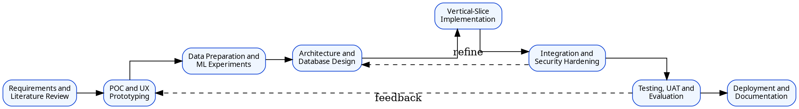
Figure 3.1: Iterative development and evaluation methodology
Source: Housein’s design

3.2 Requirements-Gathering Approach
The initial requirements were derived from the literature review on fitness applications and recommendation systems, supervisor discussions and iterative mockup review. The POC screens were used as elicitation artefacts to expose missing actions, duplicate registration flows and excessive scope. Requirements were refined through supervisor review; walkthroughs with trainers or gym members were planned but had not taken place by submission (Section 7.6). This report distinguishes clearly between methods actually performed and methods that were only considered.

3.3 Software Development Lifecycle
An iterative Agile-style lifecycle was used without claiming full organisational Scrum. Work was prioritised and implemented in increments, each producing a reviewable artefact such as a database migration, authenticated page, API endpoint, model experiment or Flutter feature. Git provided version control for the repository. Core requirements were prioritised over optional features such as badges, messaging or advanced social login.
Implementation followed a thin end-to-end slice: trainer authentication; member creation; assessment persistence; FastAPI prediction; result storage; approved exercise retrieval; Gemini draft; deterministic validation; trainer approval; Flutter plan display; completion write-back; and dashboard update. Once this chain worked, additional screens and analytics were added with lower integration risk.

3.4 Dataset Selection and Data Preparation Method
The Gym Members Exercise Dataset was selected because it contains 973 observations and four workout categories with demographic, body and workout variables under an Apache 2.0 licence (Khorasani, 2024). The data-preparation process checked variable names and types, missing values, duplicates and the target distribution. Categorical predictors were encoded within a scikit-learn ColumnTransformer, and numeric features were imputed and scaled within the same pipeline.
A dedicated leakage and feature-availability audit was completed before modelling. It classified each variable as available before the first recommendation, available only after workout history exists, derived from another variable or unsuitable. Age, gender, height, weight, BMI, body-fat percentage, resting BPM, workout frequency and experience level were identified as available at onboarding, and post-workout metrics were excluded from the primary model (Section 6.2).
After duplicate removal, the dataset was divided using a stratified train/test split with a fixed random seed. All preprocessing was fitted only on training folds, and the held-out test set remained untouched until model selection was complete. Class distributions were reported, and synthetic oversampling was not introduced because the classes were close to balanced.

3.5 Machine-Learning Experimental Method
The experimental comparison included a majority-class baseline and logistic regression, decision tree, random forest, support vector machine and gradient boosting classifiers. Five-fold stratified cross-validation estimated validation performance, and hyperparameters were tuned through a bounded grid search. Candidate models were compared using accuracy, macro precision, macro recall, macro F1, tuning time and interpretability.
The final model was selected on cross-validated macro F1 rather than on test accuracy, with per-class errors, confidence availability, complexity and deployment requirements also considered. The complete preprocessing and classifier pipeline was exported with joblib and accompanied by the feature schema, model version and training metadata. The FastAPI service rejects missing or out-of-range fields before inference.

3.6 Hybrid Workout-Plan Generation and Validation Method
The plan-generation module used a controlled hybrid procedure rather than allowing Gemini to generate an unrestricted plan. First, Next.js retrieves the active exercises from Supabase, each with a stable identifier and only the metadata required for generation. Second, a server-side prompt states the member context, number of days, session duration, predicted category and restrictions and requires output matching a JSON schema. Third, the response is parsed and subjected to deterministic validation. A deterministic rule-based generator was also built so that both strategies could be compared fairly on identical inputs.
Validation rules include unknown exercise rejection, equipment compatibility, difficulty compatibility, duration limits, bounds for sets, repetitions and rest, duplicate control, weekly session count and exclusion mappings for reported restrictions. A trainer reviews the validated draft and approves or rejects it, and approvals and overrides are stored with a reason to preserve auditability. The evaluation tested beginner, intermediate and advanced profiles with different equipment and restrictions across 20 fixed profiles (Section 7.5).

3.7 Progress-Estimation Method
Because the dataset lacks longitudinal targets, the progress module used transparent scenario projection rather than a fitted forecasting model. A conservative expected monthly change is combined with the current value and an adherence factor: projected change = base monthly change × adherence factor × elapsed months. The rates are documented in Section 6.8 and are not represented as a clinical prescription.
The projection is displayed for one, two and three months together with the assumptions used, and it is recalculated as new assessments and completions are recorded. Every output includes a statement that results vary with nutrition, sleep, individual physiology and measurement error.

3.8 Testing and Evaluation Method
Evaluation was planned to cover the ML model, Next.js and FastAPI APIs, database security, Flutter and web workflows, Gemini output validation, usability and performance. In practice, testing combined static analysis, a structural run of the generators and validator across 20 fixed profiles, live functional and integration tests, and the ML and plan-generation evaluations reported in Chapter 7. An automated unit-test suite was not built and is noted as a limitation.
User acceptance testing was designed around task scripts rather than a general satisfaction question: registering a member, generating and interpreting a prediction, approving a plan, locating the day’s workout, recording completion and interpreting progress, measured by completion, errors, time and a short usability rating. These sessions had not taken place by submission (Section 7.6). ML evaluation used the held-out metrics and confusion matrix described in Section 3.5, and the security tests executed are reported in Section 7.7.

3.9 Ethics, Privacy and Safety
Only data required by the implemented features was collected, and demonstration accounts used synthetic identities. Any future user-testing participants will receive an information statement and provide consent, and results will be reported using anonymous participant codes. The project did not collect medical records or claim to treat injury, and members who report pain or a serious condition are advised to stop and seek qualified professional advice.
Authentication and authorisation are separate concerns: Supabase Auth establishes identity, while application role checks and RLS restrict access. The Gemini prompt avoids direct identifiers and sends only the profile context required for plan construction. API keys and service-role credentials are stored in server environment variables and excluded from source control and client bundles.

3.10 Quality Assurance
Quality assurance used TypeScript strict mode with tsc --noEmit, Dart static analysis, modular services and reproducible dependency files. Database changes were captured as numbered migrations, and shared TypeScript types kept the generators, validator and API routes consistent. Errors returned to users are controlled and do not reveal stack traces or secrets.
Evidence was retained in the repository, including dataset checks, model artefacts and metrics, evaluation results, database migrations and the test records in Chapter 7. This ensures that the final report and demonstration faithfully represent completed work. Every claim of security, performance or usability is tied to a test rather than asserted without evidence.

3.11 Project Plan and Progress Control
The original plan was Firebase and a web frontend separated from the backend. The architecture has since changed to Next.js and TypeScript for the public website, trainer interface and main backend; Supabase for PostgreSQL, authentication, storage and RLS; Flutter for mobile; FastAPI for Python inference; and Gemini for controlled plan drafting. This change reduces duplicated web/backend code and provides a relational data model that is suitable for plans, exercises, sessions and progress records. The change must be recorded in the project diary and updated Gantt chart rather than silently replacing the original plan.
Progress was tracked against milestones rather than screen count. The critical milestones were the database and authentication baseline, model experiment completion, prediction integration, generated-plan validation, Flutter plan completion, security testing and deployment, with time reserved for report revision, model reruns and demonstration preparation.
Table 3.1: Project methodology outputs
Phase | Key Output | Completion Evidence
Research and requirements | Critical literature synthesis, scope and traceable requirements | Chapter drafts, requirements catalogue and supervisor feedback
Data and ML | Leakage audit, reproducible experiments and saved pipeline | Notebook/script, metrics, confusion matrix and model card
Data and security design | Supabase schema, RLS policies and access matrix | Migrations and positive/negative policy tests
Vertical slice | Member assessment to prediction to approved plan | API logs, database records and UI evidence
Mobile integration | Assigned plan, completion and progress update | Device/emulator test and shared data evidence
Evaluation and deployment | System, UAT, security and deployment results | Test report, defect log, URLs/APK and manuals

CHAPTER 4: REQUIREMENTS ANALYSIS

4.1 User Roles
The core operational roles are the trainer and gym member. The trainer creates or activates a member account, confirms assessment information, requests and interprets predictions, reviews generated plans and monitors progress. The member uses the Flutter application to view the assigned recommendation and weekly plan, record completion and inspect personal progress. A system administrator role should be implemented only if operational configuration genuinely requires it; otherwise, administrative functions remain deployment responsibilities rather than a third business role.
Table 4.1: Role and access analysis
Role | Primary Needs | Responsibilities | Access Boundary
Trainer | Manage assigned members, assessments, predictions, plans and progress | Verify input, review AI output, approve/override plans and respond to alerts | Trainer-only functions and records of assigned members
Gym Member | View own recommendation and plan, record workouts and progress | Provide accurate information and report pain or limitations | Own profile, plans, sessions and progress only
System Maintainer | Configure deployment, exercise catalogue and model version | Protect secrets, migrations, logs, backups and releases | Trusted server/admin environment; not a normal member role
Supervisor / Examiner | Evidence of substantial, tested and ethically scoped computing work | Assess report, code and demonstration | Documentation and controlled demonstration access

4.2 Current and Proposed Process
In the current general process, a member may receive advice from internet sources or a trainer, record progress inconsistently and communicate changes through separate channels. The trainer may maintain member details, plans and progress in unrelated documents. There is limited traceability between the data used for a recommendation and later outcomes, and repeated plan creation can be time-consuming.
The proposed process creates a single controlled record. The trainer signs in, creates the member and assessment, and requests a prediction. Approved exercises are supplied to Gemini, the draft is validated and the trainer approves the plan. The member views and completes the plan in Flutter, and the shared database updates adherence and progress for both roles. Failed prediction, generation or validation steps return a controlled error without assigning a partial plan.
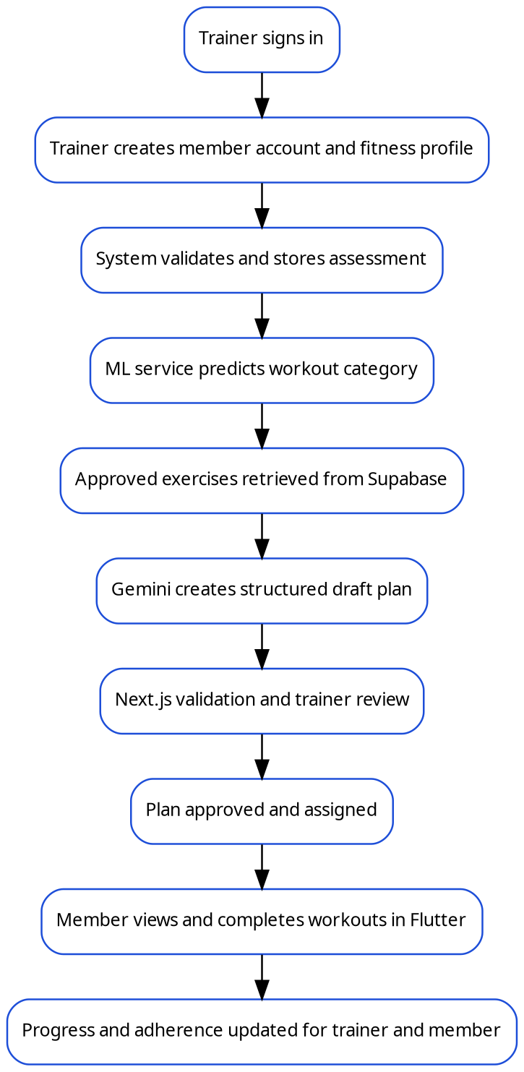
Figure 4.1: Proposed end-to-end FitWise process
Source: Housein’s design

4.3 Functional Requirements
Table 4.2: Functional requirements
ID | Requirement | Priority | Acceptance Criterion
FR-01 | The public website shall present the FitWise purpose, features, disclaimer and access links. | Must | Pages are accessible and navigation reaches login/download information.
FR-02 | The trainer and member shall authenticate using Supabase Auth. | Must | Valid credentials create a session; invalid, expired or disabled access is rejected.
FR-03 | The trainer shall create a unique member account/profile. | Must | Required fields are stored and duplicate email/account creation is rejected.
FR-04 | The trainer shall record and update a member fitness assessment. | Must | Validated measurements, goals, availability, equipment and restrictions are persisted.
FR-05 | The system shall request and store a workout-category prediction. | Must | Prediction, confidence, model version, assessment and timestamp are saved.
FR-06 | The system shall retrieve only active approved exercises compatible with the plan context. | Must | Candidate list excludes inactive and clearly incompatible catalogue items.
FR-07 | The system shall generate a structured draft plan using Gemini. | Must | Response matches the required schema or returns a controlled generation error.
FR-08 | The Next.js backend shall validate every generated plan before it is shown for approval. | Must | Unknown IDs, invalid bounds, unavailable equipment and excluded exercises are rejected.
FR-09 | The trainer shall review, edit, approve, reject or regenerate a draft plan. | Must | Only an approved plan can be assigned; override reason is recorded.
FR-10 | The member shall view the current recommendation and approved weekly plan. | Must | Member sees only own assigned plan with exercise details.
FR-11 | The member shall start and complete a workout session. | Must | Session, exercises, actual repetitions/duration and completion status are stored.
FR-12 | The trainer and member shall view authorised progress and adherence information. | Must | Dashboards refresh from stored assessments, sessions and progress records.
FR-13 | The trainer shall record new measurements and compare actual with projected progress. | Should | New record updates charts and recalculates the projection.
FR-14 | The system shall notify users of important plan, reminder or adherence events. | Should | Relevant notification is stored and displayed to the correct user.
FR-15 | The system shall maintain audit records for sensitive actions. | Must | Creation, approval, override and role-sensitive changes record actor and timestamp.
FR-16 | The member and trainer shall manage profile and notification preferences. | Should | Permitted fields update without bypassing ownership/role rules.
FR-17 | The system maintainer shall manage approved exercises and media. | Should | Only trusted administrative operation can activate/deactivate catalogue items.
FR-18 | The system shall provide controlled loading, empty and error states. | Must | Client displays understandable feedback without exposing secrets or stack traces.

4.4 Non-Functional Requirements
Table 4.3: Non-functional requirements
ID | Category | Requirement | Measure / Target
NFR-01 | Security | Users shall access only functions and records permitted by role and ownership. | All negative role/ownership tests pass; no cross-member disclosure.
NFR-02 | Privacy | Only necessary fitness data shall be collected and purpose/disclaimer text displayed. | Data inventory completed; unnecessary identifiers excluded from Gemini prompts.
NFR-03 | Performance | Core non-generation API requests shall respond promptly under POC load. | Median server response target <2 s locally/hosted; generation separately measured.
NFR-04 | Reliability | Failed external calls shall not create partial or approved records. | Transactions/statuses preserve consistent state and retries are bounded.
NFR-05 | Usability | Core trainer/member tasks shall be understandable without developer assistance. | Target task completion ≥80% in small POC UAT; issues documented.
NFR-06 | Maintainability | The system shall use modular services, typed schemas and migrations. | Repository structure, linting and setup documentation reviewed.
NFR-07 | Compatibility | Trainer web app shall support modern desktop browsers; mobile POC shall run on target Android device/emulator. | Defined browser/device matrix passes core scenarios.
NFR-08 | Auditability | Predictions and plan approvals shall be traceable. | Model version, prompt/plan version, actor and timestamps recorded.
NFR-09 | AI robustness | Gemini output shall never be accepted solely because it is valid JSON. | All plans pass server validator and trainer approval.
NFR-10 | Accessibility | Interfaces shall use readable contrast, labels and touch targets. | Manual accessibility checklist and keyboard/mobile review completed.
NFR-11 | Scalability | POC design shall avoid hard-coded member-specific logic and support indexed queries. | Relational schema and filtered RLS queries documented.
NFR-12 | Recoverability | Development and deployment configuration shall support reconstruction. | Migrations, environment template, model metadata and README available.

4.5 Use-Case Model
The use-case model separates the trainer’s supervisory functions from the member’s execution and self-monitoring functions. Both roles authenticate and manage permitted profile settings, but only the trainer manages assessments, predictions and approvals. The member cannot call trainer-only generation endpoints or retrieve another member’s records.
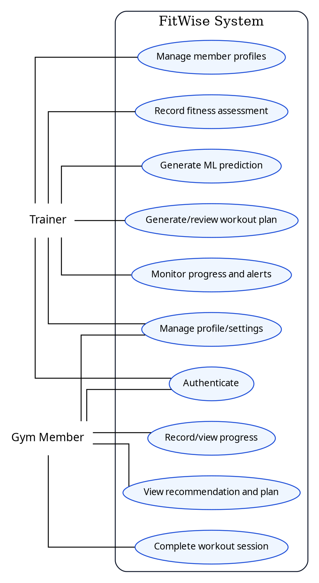
Figure 4.2: FitWise use-case model
Source: Housein’s design

4.6 Detailed Core Use Cases
UC-01 – Create Member and Assessment. The primary actor is the trainer. Preconditions are an authenticated active trainer and no existing account with the same email. The trainer enters account and assessment information. The server validates types and ranges, creates or invites the Supabase user, stores the profile and creates the trainer–member assignment. If validation fails or a duplicate exists, no partial profile is committed. The postcondition is a member with a complete draft assessment ready for prediction.
UC-02 – Generate Prediction and Draft Plan. The trainer selects a complete assessment and requests a prediction. Next.js verifies assignment and sends the allowed feature schema to FastAPI. The returned category and confidence are stored. Next.js fetches approved exercises, calls Gemini with a structured schema and validates the result. Alternative flows include unavailable ML service, Gemini timeout, schema failure or semantic validation errors. The postcondition is a stored draft plan with validation status, not an automatically assigned plan.
UC-03 – Review and Assign Plan. The trainer opens the draft, examines the prediction explanation and plan content, edits permitted values or rejects/regenerates the plan, and records any override reason. Approval changes the plan status and makes it visible to the member. A plan that has not passed validation cannot be approved.
UC-04 – Complete Workout. The member opens the assigned plan, starts a scheduled workout, records actual sets, repetitions or duration and completes the session. The system verifies ownership and plan status, saves completion records and recalculates adherence. If the network request fails, the client must display an error and avoid falsely marking the workout as synchronised.
UC-05 – Record and Review Progress. An authorised trainer or member records a permitted measurement. The system stores the dated value, updates actual trend charts and recalculates the transparent projection. Both roles see only data permitted by policy. The system displays the projection assumptions and does not present the result as guaranteed.

4.7 User Stories and Acceptance Criteria
Table 4.4: Prioritised user stories
Priority | User Story | Acceptance Summary
Must | As a trainer, I want to create a complete member assessment so that recommendations use consistent information. | Invalid ranges and duplicates are rejected; valid assessment is persisted.
Must | As a trainer, I want to see the category, confidence and contributing information so that I can judge the model output. | Prediction record displays category, scores, model version and timestamp.
Must | As a trainer, I want Gemini to use only approved exercises so that generated plans remain trackable. | Every returned exercise ID exists, is active and was supplied as a candidate.
Must | As a trainer, I want to approve or override a plan so that human supervision is preserved. | Member sees only approved plan; override reason is audited.
Must | As a member, I want to see today’s workout and instructions so that I know what to perform. | Current plan day and exercise details load for the authenticated owner.
Must | As a member, I want to record what I completed so that progress reflects actual activity. | Session details persist and adherence updates.
Should | As a trainer, I want low-adherence alerts so that I can follow up with members. | Defined threshold creates a role-appropriate alert.
Should | As a member, I want understandable progress charts so that I can compare actual performance with my target. | Chart labels and assumptions are clear during UAT.
Could | As a member, I want badges and streaks so that regular completion feels rewarding. | Feature added only after core integration and testing are stable.

4.8 Requirements Traceability
Traceability connects each requirement to the project objectives, design components and test evidence. The status values in Table 4.5 record design-stage coverage; the implemented and tested status of every requirement is given in Appendix D.
Table 4.5: Requirements traceability matrix
Requirement | Objective | Design Component | Planned Test | Draft Status
FR-02 Authentication | OBJ-05/06/07 | Supabase Auth, session middleware and RLS | TC-AUTH-01 to 05 | Designed
FR-03/04 Member and assessment | OBJ-05/07 | Profile service, relational schema and trainer assignment | TC-MEM-01 to 08 | Designed
FR-05 Prediction | OBJ-02/08 | FastAPI model service and prediction table | TC-ML-01 to 10 | Designed
FR-07/08 Plan draft and validation | OBJ-03/08 | Gemini service, Zod schema and deterministic validator | TC-AI-01 to 15 | Designed
FR-09 Trainer approval | OBJ-03/05 | Plan workflow and audit log | TC-PLAN-01 to 08 | Designed
FR-10/11 Mobile plan and completion | OBJ-06/07 | Flutter repositories/view models and session endpoints | TC-MOB-01 to 12 | Designed
FR-12/13 Progress | OBJ-04/05/06 | Progress service and dashboards | TC-PROG-01 to 08 | Designed
NFR-01 Security | OBJ-08 | JWT verification, RLS and ownership checks | TC-SEC-01 to 12 | Designed
NFR-09 AI robustness | OBJ-03/08 | Candidate restriction, validation and approval | TC-AI-BND/CONFLICT | Designed

CHAPTER 5: SYSTEM DESIGN AND ARCHITECTURE

5.1 Architectural Overview
FitWise uses a layered client–server architecture with Next.js as the main application and orchestration layer. The public website and trainer web application are implemented in one Next.js App Router project. Route Handlers expose REST endpoints required by Flutter, while Server Actions or server-side services support web mutations and shared business logic. Next.js documentation describes Route Handlers as custom request handlers within the app directory and supports standard HTTP methods, making them suitable for the mobile API surface (Next.js, 2026a).
Supabase provides authentication, PostgreSQL storage, file storage and Row-Level Security. Supabase Auth issues JWTs and integrates with database policies; RLS acts as a database-level authorisation layer and should be enabled on every exposed table (Supabase, 2026a; Supabase, 2026b). The Python model remains a separate runtime because a joblib scikit-learn pipeline cannot be imported directly by TypeScript. A small FastAPI service in the same repository loads the trusted model and exposes prediction and health endpoints. Gemini is called only by the trusted Next.js backend.
This separation gives each component one principal responsibility. Clients render user experiences; Next.js validates and orchestrates; Supabase is the persistent source of truth; FastAPI performs model inference; Gemini composes a draft; and the validator plus trainer determines whether a plan is assigned. A failure in Gemini must not prevent members from accessing already approved plans, and a FastAPI outage must not corrupt stored assessments.
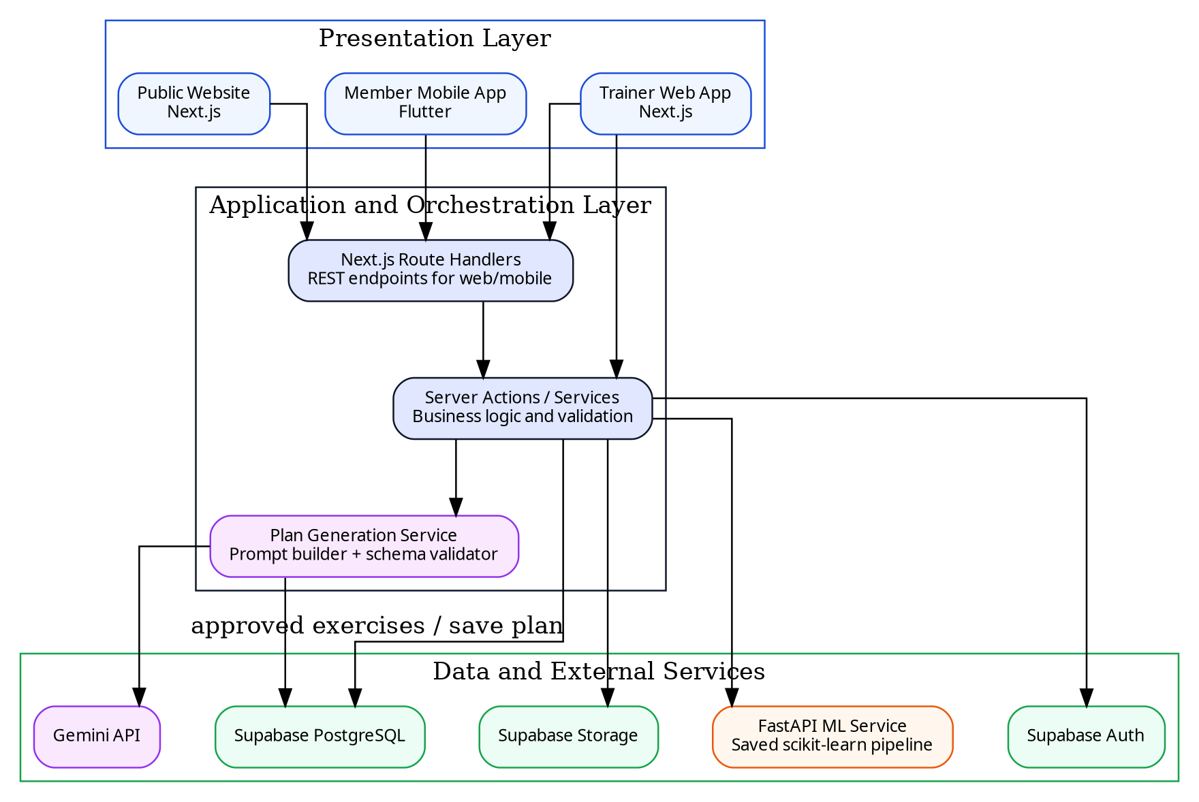
Figure 5.1: FitWise system architecture
Source: Housein’s design

5.2 Technology Stack and Design Rationale
Table 5.1: Technology stack and design rationale
Layer | Selected Technology | Purpose | Rationale / Alternative
Public and trainer web | Next.js App Router + TypeScript | Website, trainer UI, server rendering and web mutations | Combines frontend and backend concerns in one typed project; selected over separate static frontend plus general API.
Mobile client | Flutter + Dart | Gym-member mobile experience | Cross-platform UI with one codebase; recommended layered architecture improves testability (Flutter, 2026).
Application API | Next.js Route Handlers / server services | REST for Flutter, validation, business logic and orchestration | Avoids duplicating business logic in clients; supports standard HTTP methods (Next.js, 2026a).
Relational data | Supabase PostgreSQL | Profiles, assessments, exercises, predictions, plans, sessions and progress | Relational constraints and joins suit the domain better than the previous Firestore proposal.
Identity and authorisation | Supabase Auth + RLS | JWT identity and row-level access | Auth integrates with PostgreSQL policies; adds defence in depth (Supabase, 2026a; 2026b).
Media storage | Supabase Storage | Profile and exercise media | Storage policies can use RLS; avoids storing binaries in database rows (Supabase, 2026c).
ML development | Python, pandas and scikit-learn | EDA, preprocessing, model training and export | Mature classification and pipeline ecosystem; consistent with selected dataset and student skills.
ML inference | FastAPI | Load saved pipeline and serve prediction | Lightweight typed Python API; lifespan can load shared model once (FastAPI, 2026a).
Plan drafting | Gemini API structured output | Create weekly draft and explanation from approved exercises | Flexible composition with JSON schema; values remain subject to semantic validation (Google AI for Developers, 2026).
Deployment | Vercel/equivalent + Python container + Supabase Cloud | Host web/API, ML service and data | Separates runtime requirements while preserving a single Git repository and repeatable CI/CD.

5.3 Component Design
Within Next.js, the system should be divided into domain services rather than embedding database and AI calls in page components. The Authentication Service resolves the session and role. The Member Service manages profiles, assignments and assessments. The Prediction Service maps a validated assessment to the FastAPI schema and stores the result. The Exercise Catalogue Service retrieves candidates. The Plan Generation Service constructs prompts, calls Gemini, parses output and invokes the Plan Validator. The Progress Service aggregates sessions and measurements, and the Audit Service records sensitive actions.
The Flutter design followed the separation recommended by the Flutter architecture guide: views in the UI layer, with data access and HTTP/authentication services kept apart from widgets (Flutter, 2026). The Flutter client contains no Gemini or Supabase service-role credentials and works only with the signed-in user’s session. The design proposed calling the Next.js API for all data; the implemented data access is described in Section 6.10.

5.4 Key Interaction and Sequence Design
The prediction and plan sequence begins with an authenticated trainer request. Next.js verifies the trainer–member relationship before storing or reading member data. It sends only the model schema to FastAPI and stores the result with the model version. Candidate exercises are selected from Supabase before Gemini is called. The validator then checks semantic constraints. A plan can remain in generated, validation_failed, draft, approved, assigned, archived or rejected status, preventing an incomplete response from appearing as active.
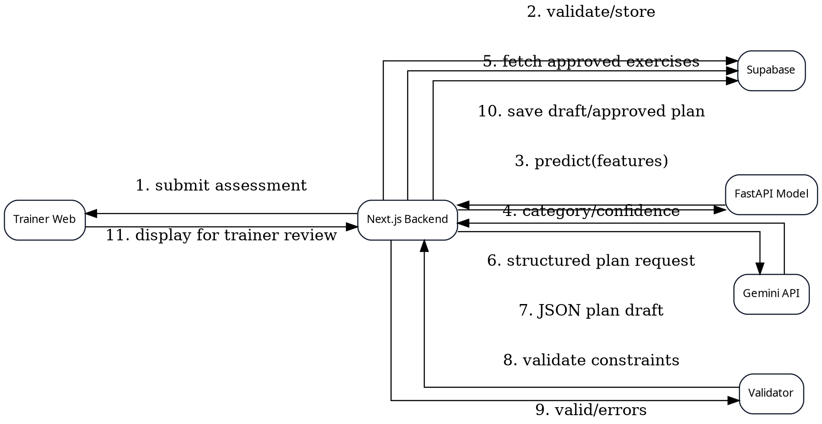
Figure 5.2: Sequence for prediction and plan generation
Source: Housein’s design
For workout completion, Flutter requests the active plan through Next.js. When the member starts a session, the API creates a workout_sessions record. Exercise completion writes are linked to the session and approved plan-day item. On final completion, the server calculates summary values and adherence in one controlled operation. Repeated submissions should be idempotent through a unique session/action identifier or a state check, preventing duplicate completion records when a mobile request is retried.

5.5 Data Model and Database Design
A relational model was selected because FitWise contains clear one-to-many and many-to-many relationships. Supabase Auth owns the authentication identity, while public.profiles stores application attributes and references auth.users by the stable UUID. A trainer_member_assignments table defines which trainer may manage which member. Fitness profiles store relatively stable attributes; assessments and progress records preserve dated changes. Predictions reference the assessment and model version used. Workout plans contain plan days and plan exercises that reference catalogue exercises.
The schema separates a generated plan from actual workout sessions. This allows a member to perform the same assigned plan on multiple dates while preserving the originally approved prescription. Audit logs record actor, action, entity and timestamp for sensitive transitions. Foreign keys, not-null constraints, checks and unique indexes should enforce integrity before RLS is considered.
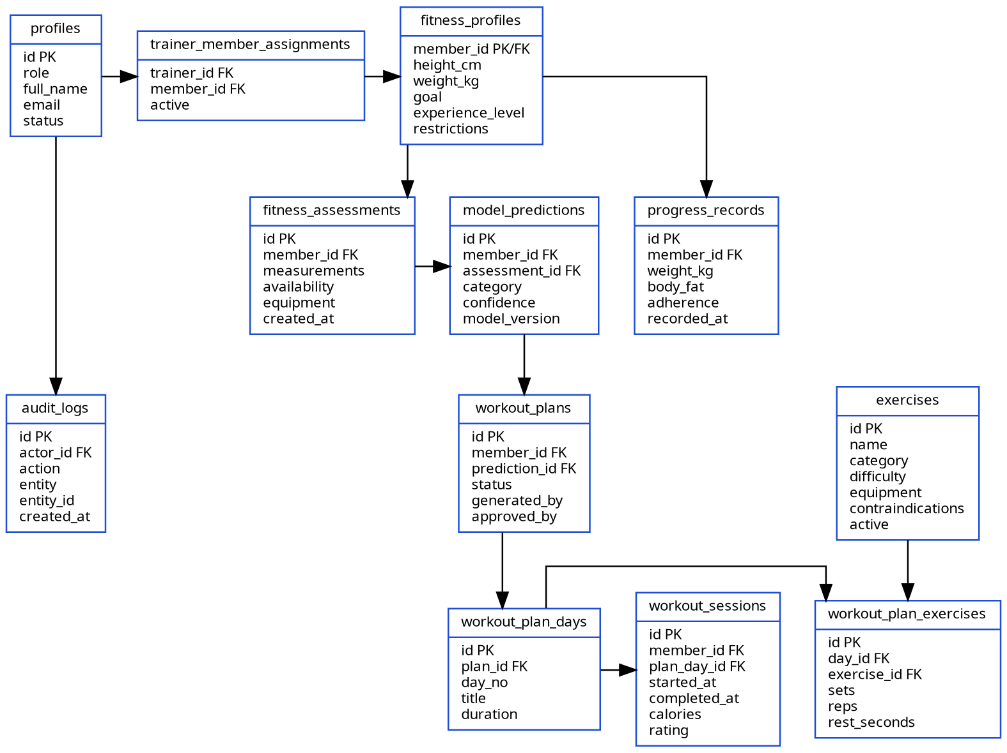
Figure 5.3: Logical relational data model
Source: Housein’s design
Table 5.2: Core database entities
Entity | Purpose | Selected Fields | Security / Relationship
profiles | Application identity and role | id, full_name, role, status | References auth.users; own profile or authorised trainer view.
trainer_member_assignments | Trainer ownership boundary | trainer_id, member_id, active | Used by RLS and server role checks.
fitness_profiles | Current member context | goal, level, measurements, restrictions | Member read-own; assigned trainer manage.
fitness_assessments | Dated recommendation input | availability, equipment, measurements, created_at | Immutable or versioned after prediction.
model_predictions | ML evidence | category, scores, model_version, assessment_id | Linked to member and requesting trainer.
exercises | Approved exercise catalogue | category, difficulty, equipment, contraindications, active | Read candidates server-side; admin-maintained.
workout_plans / days / exercises | Generated and approved prescription | status, generated_by, approved_by, sets, reps, rest | Member reads assigned approved plan only.
workout_sessions | Actual performed workout | start/end, completion, calories, rating | Member writes own active session; trainer reads assigned.
progress_records | Dated actual measurements | weight, body_fat, adherence, recorded_at | Member/assigned trainer according to policy.
audit_logs | Traceable sensitive actions | actor, action, entity, entity_id, created_at | Insert server-side; restricted read.

5.6 API Design
The public website and trainer pages use Server Components, while Flutter requires stable HTTP endpoints. Route Handlers return JSON with consistent success and error structures. Protected endpoints resolve the Supabase session and then perform explicit role checks, with RLS enforcing ownership. The service-role key is used only where a trusted server operation genuinely requires it; normal user operations preserve the signed-in user context so RLS remains effective.
Table 5.3: Proposed API endpoints
Method | Endpoint | Role | Purpose | Key Validation
POST | /api/members | Trainer | Create/invite member and profile | Trainer role, unique email, required fields and transaction/cleanup.
POST | /api/members/{id}/assessments | Trainer | Create assessment | Assignment, numeric ranges, allowed enums and complete context.
POST | /api/predictions | Trainer | Run ML inference | Assignment, assessment completeness, exact model schema and service timeout.
POST | /api/plans/generate | Trainer | Generate and validate draft | Prediction exists, candidate exercises, rate limit, schema and semantic validator.
PATCH | /api/plans/{id} | Trainer | Edit/approve/reject draft | Assignment, allowed status transition and override reason.
GET | /api/me/plan | Member | Retrieve own approved active plan | Authenticated owner; approved/assigned status only.
POST | /api/workouts/{dayId}/start | Member | Create workout session | Ownership, active plan and no conflicting active session.
POST | /api/workout-sessions/{id}/complete | Member | Store completion and summary | Session owner, value bounds and idempotency.
GET | /api/progress/{memberId} | Member/Trainer | Retrieve authorised progress | Owner or assigned trainer; filtered fields.
POST | /api/progress/{memberId} | Member/Trainer | Record measurement | Owner/assignment, allowed fields and range validation.
GET | /api/health/ml | Maintainer | Check inference service | Server/internal access; no sensitive details.

5.7 Machine-Learning Model Design
The ML design has separate training and inference paths. Training begins with an immutable dataset snapshot and data-quality report. The leakage audit produces the final feature list. A ColumnTransformer applies categorical encoding and numeric transformations within each cross-validation fold. Candidate estimators are evaluated, and the selected complete pipeline is exported with its model card and dependency metadata. The FastAPI input schema mirrors the feature list exactly.
At service start-up, the FastAPI lifespan handler loads the trusted model once. The /predict endpoint validates the request, creates the expected tabular structure and returns the predicted class, confidence/probability map and model version. The model file is not exposed for download, and user-supplied model paths are never accepted. Joblib files are trusted build artefacts because pickle-based loading can execute code (Scikit-learn Developers, 2026).
Figure 5.4: Machine-learning training and inference pipeline
Source: Housein’s design

5.8 Gemini-Assisted Plan Generation and Deterministic Validation
The plan generator receives the saved prediction and member context but does not expose the complete database. The server queries a bounded candidate set and sends exercise IDs, names, category, difficulty, equipment and short constraints. The prompt asks Gemini to produce a weekly plan matching a strict schema. Temperature should be low, token/output size bounded and the request timed out. The response is parsed through a Zod schema before semantic validation.
The semantic validator is deterministic and versioned. It checks that every exercise was offered as a candidate, that the member has the required equipment, that beginner members do not receive advanced items, and that reported restriction mappings are respected. It calculates estimated duration from warm-up, exercise prescriptions and rest rather than trusting the model’s stated total. A valid plan is still a draft until the trainer approves it.
Table 5.4: Deterministic plan-validation rules
Rule ID | Condition | Action | Priority
VAL-01 | Exercise ID was not supplied or is inactive | Reject item and plan | Critical
VAL-02 | Required equipment is unavailable | Reject or substitute from approved candidate set | Critical
VAL-03 | Exercise matches a configured restriction/exclusion | Reject and require trainer review/substitution | Critical
VAL-04 | Difficulty exceeds member level | Reject item unless trainer explicitly overrides | High
VAL-05 | Session count exceeds available days | Reject plan | High
VAL-06 | Calculated duration exceeds allowed duration plus tolerance | Return validation error/repair request | High
VAL-07 | Sets, repetitions, timed duration or rest outside configured bounds | Clamp only if rule is explicit; otherwise reject | High
VAL-08 | Duplicate exercise appears inappropriately within a session | Reject duplicate or require explanation | Medium
VAL-09 | Weekly plan lacks balance for selected category/template | Flag for trainer review | Medium
VAL-10 | Trainer override provided | Apply permitted change and store reason/actor | Highest human decision

5.9 Security and Privacy Design
Supabase Auth establishes user identity through JWT sessions. Application roles should be stored in trusted app metadata or a protected profile/role table, not editable user metadata. Next.js verifies the session for every protected request and performs function-level checks before accessing business services. RLS is enabled on all exposed public tables. A member policy uses auth.uid() to match the member profile or owner foreign key; a trainer policy additionally checks an active trainer_member_assignments relationship. Supabase recommends explicit RLS on exposed tables and notes that service keys bypass policies and must never be placed in the browser (Supabase, 2026b).
The architecture applies defence in depth. A bug in a page query should still encounter RLS, while the backend independently prevents broken object-level authorisation. The browser and Flutter receive only publishable configuration and user sessions. Gemini and service-role keys remain in server environments. Supabase Storage policies restrict profile or exercise uploads to approved buckets and paths. Audit logging records plan approval, override and sensitive record changes.
Input validation uses bounded numeric schemas, allowed enums and UUID validation. External API responses are treated as untrusted. Generation endpoints are rate-limited per trainer and member, and request content is minimised. Logs omit passwords, tokens, API keys and unnecessary fitness details. HTTPS is required for deployed web, mobile API and FastAPI communication. Development CORS settings should list explicit origins rather than allow unrestricted production access.
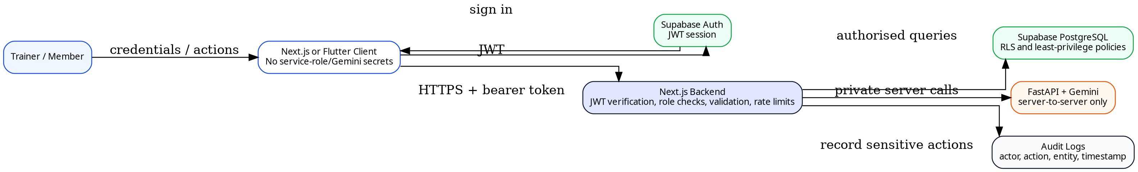
Figure 5.5: Security boundaries and access-control design
Source: Housein’s design

Table 5.5: Access-control matrix
Resource / Action | Member | Assigned Trainer | Other Trainer | Anonymous
View member profile | Own only | Assigned member | Denied | Denied
Edit fitness assessment | Limited own fields if enabled | Allowed for assigned member | Denied | Denied
Request ML prediction | Denied | Allowed for assigned member | Denied | Denied
Generate/approve plan | Denied | Allowed for assigned member | Denied | Denied
View approved plan | Own only | Assigned member | Denied | Denied
Record workout session | Own only | Read assigned member | Denied | Denied
View progress | Own only | Assigned member | Denied | Denied
Manage exercise catalogue | Denied | Denied unless explicit maintainer role | Denied | Denied

5.10 UI/UX and Navigation Design
The public website introduces the problem, explains the workflow and provides authentication/download entry points. The trainer web application uses a persistent sidebar because trainers frequently move between dashboard, members, prediction, plan and progress views. The member mobile application uses bottom navigation for Home, Plan, Workouts, Progress and Profile. The POC includes additional screens, but implementation priority remains the core end-to-end scenario.
Interface design uses a consistent FitWise blue, teal and green palette, readable cards and clear status labels. Prediction confidence is accompanied by a plain-language explanation and disclaimer. Generated plans distinguish draft, invalid, approved and rejected states. Empty, loading and failure states are included so that external-service errors are not mistaken for a valid zero result, and mobile controls use touch-friendly sizes and scrolling for forms and long workout details.
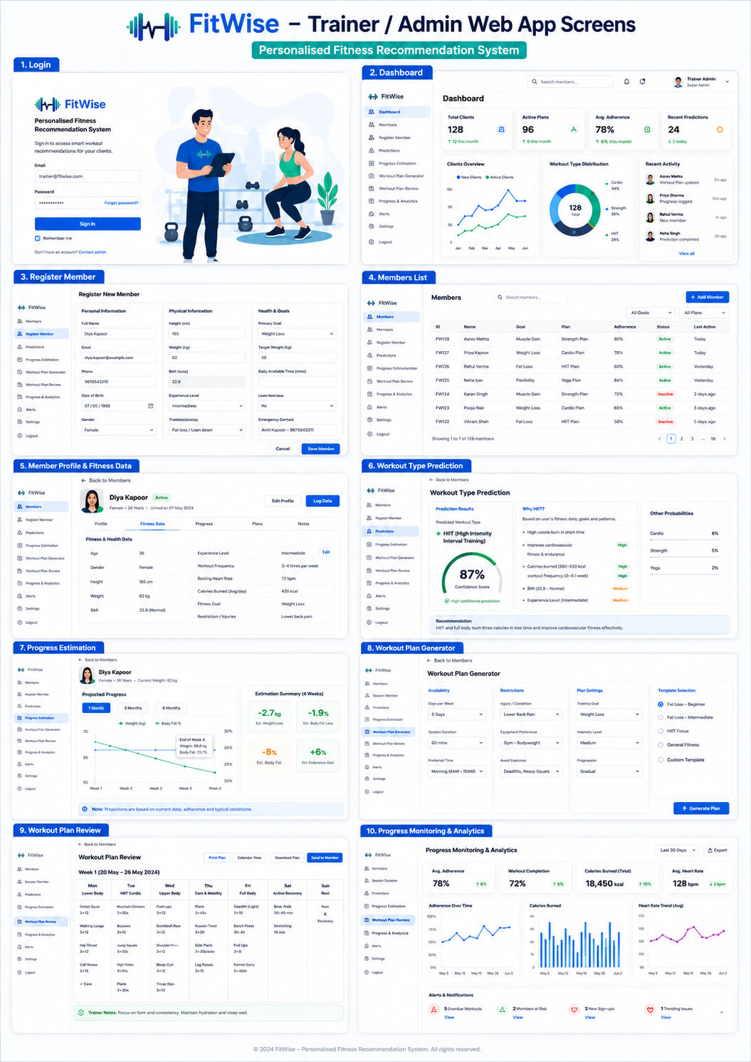
Figure 5.6: Trainer web-application POC screen gallery
Source: Housein’s FitWise POC
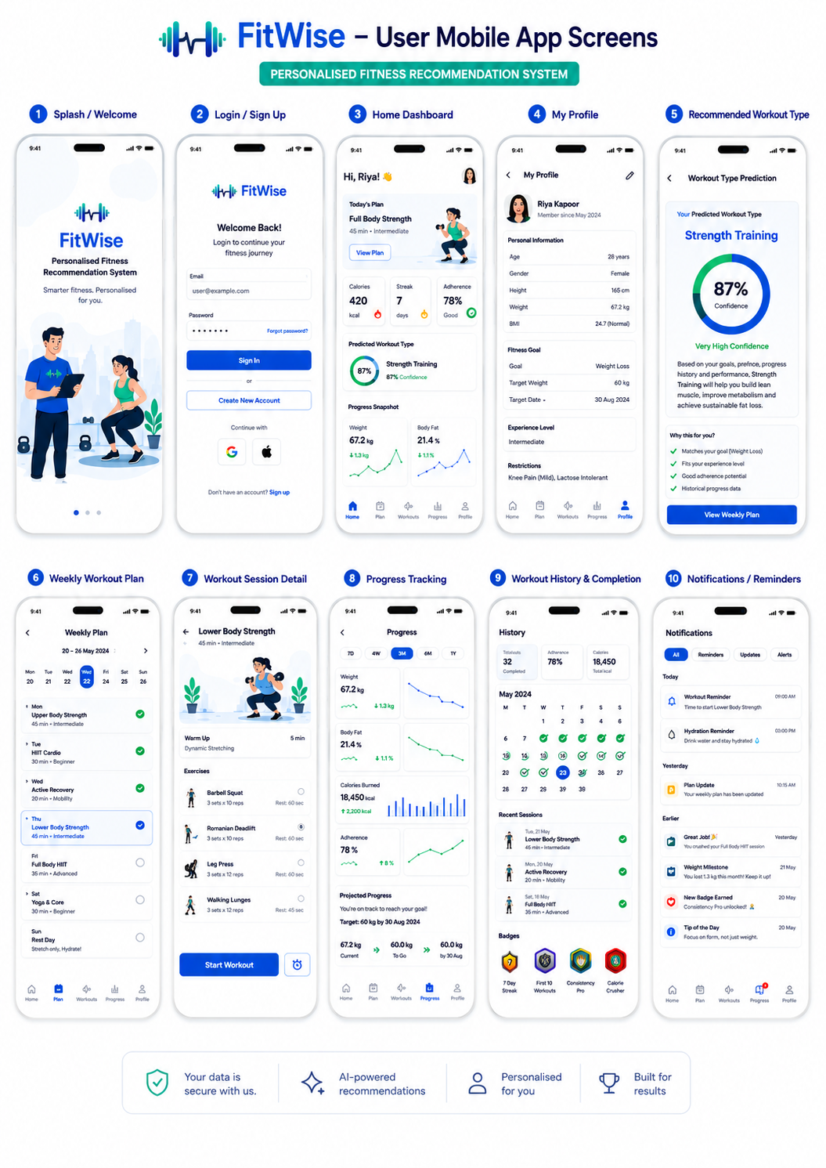
Figure 5.7: Gym-member mobile-application POC screen gallery
Source: Housein’s FitWise POC

5.11 Deployment Architecture
The project is kept in one Git repository with separate web, mobile and ML workspaces while using separate runtime deployments. The Next.js application can be hosted on Vercel or an equivalent Node-compatible platform, and the FastAPI service can be deployed as a Python container with a health endpoint and the model artefact packaged from the trusted repository. Supabase hosts PostgreSQL and Auth. Flutter can produce an Android APK or web build for demonstration.
Environment variables include the Supabase URL and publishable key for clients, the server-side Supabase secret key, the ML service URL and the Gemini API key, and values are not committed. A CI/CD pipeline running type checks and tests before deployment is recommended. The ML deployment must pin Python, scikit-learn, numpy and pandas versions because persisted models require compatible environments. FastAPI deployment should account for HTTPS, restarts, process memory and start-up loading (FastAPI, 2026b).
Operational resilience for the POC includes database export or migration backup, retained model artefacts, seed/demo data, a local development mode and a recorded fallback demonstration. Already approved plans remain stored in Supabase and can be displayed even if Gemini is temporarily unavailable. Generation and inference failures are visible as service errors and never converted silently into default plans.
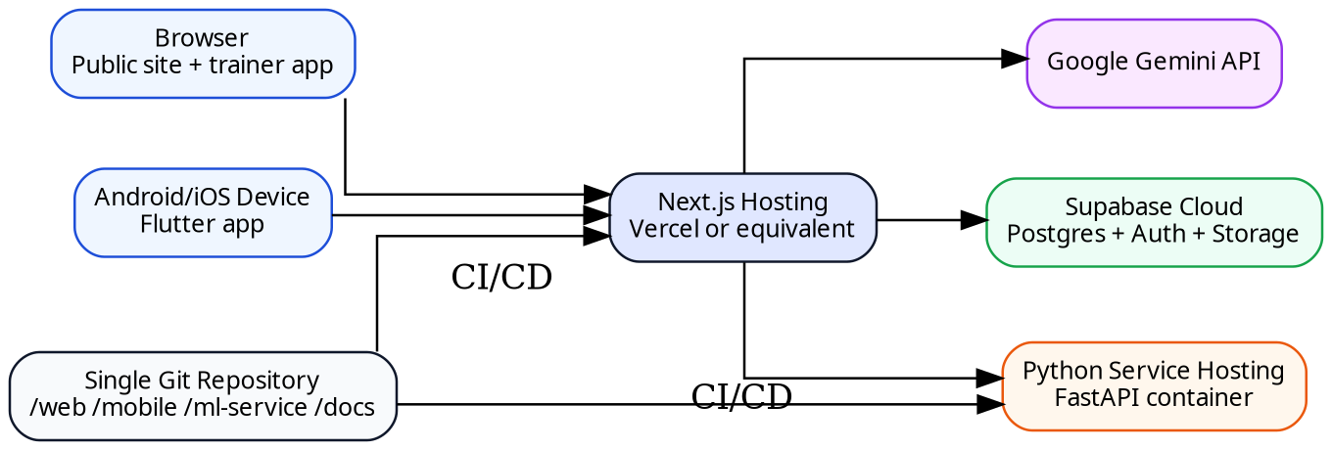
Figure 5.8: FitWise deployment architecture
Source: Housein’s design

CHAPTER 6: IMPLEMENTATION

6.1 Development Environment and Repository Structure
The implementation was organised as two workspaces in one Git repository. FitWise_Prototype_Lab is a controlled comparison harness containing the training script, the FastAPI inference service and a small Next.js application that runs both plan generators against identical inputs; it produced the evidence in Chapter 7. FitWise_App contains the production web and mobile applications and ten numbered Supabase migrations. The generators, validator and shared types were ported from the lab without modification, so the evaluated logic is the logic the application uses. The web application is built on the Next.js App Router (Next.js, 2026b), and its code base passed tsc --noEmit with zero errors. Table 6.1 summarises the components.
Table 6.1: Implemented components and versions
Component | Technology and Version | Location
ML training and inference | Python 3.12, scikit-learn, FastAPI, Uvicorn | FitWise_Prototype_Lab/ml
Web application and API | Next.js 16.3 (App Router), React 19.2, TypeScript | FitWise_App/web
Plan drafting | Google Gen AI SDK 2.19 (Gemini API) | FitWise_App/web/lib/geminiGenerator.ts
Mobile client | Flutter (Dart 3.11), supabase_flutter 2.17 | FitWise_App/mobile
Data and identity | Supabase PostgreSQL, Auth and RLS | FitWise_App/web/supabase/migrations

6.2 Dataset Exploration and Preprocessing
The Gym Members Exercise Dataset (Khorasani, 2024) contained 973 records with no duplicates or missing values, and its classes were close to balanced (Strength 258, Cardio 255, Yoga 239, HIIT 221), so a weak result could not be blamed on imbalance. The feature-availability audit planned in Section 3.4 retained only variables a trainer can record before a member’s first workout (Table 6.2). Resting_BPM, although available at assessment, was not included in this model version and is noted in Section 9.6.
Table 6.2: Feature-availability audit
Variable(s) | Available Before First Workout? | Decision
Age, Gender, Weight, Height, BMI, Fat_Percentage, Workout_Frequency, Experience_Level | Yes | Retained
Resting_BPM | Yes | Not used in version prototype-0.1.0
Avg_BPM, Max_BPM, Session_Duration, Calories_Burned, Water_Intake | No, recorded during or after a session | Excluded; leakage diagnostic only
Workout_Type | Target | Never a predictor

Preprocessing (median imputation and scaling for numeric fields, one-hot encoding for Gender) was placed in a ColumnTransformer inside the same Pipeline as the classifier, so the FastAPI service applies exactly the transformation learned in training.

6.3 Machine-Learning Model Development
The data were split 80/20 with stratification and a fixed seed (778 training and 195 test rows). A majority-class baseline was compared with Logistic Regression, Decision Tree, Random Forest, Support Vector Machine and Gradient Boosting, with class weighting where supported. Each candidate was tuned with GridSearchCV over a bounded grid (46 combinations in total) using five-fold stratified cross-validation and macro F1 (Pedregosa et al., 2011). The test set was used once, after selection (Table 6.3, Figure 6.1).
Table 6.3: Candidate model comparison
Model | Best Hyperparameters | CV Macro F1 (Mean ± SD) | Test Accuracy | Test Macro F1
Baseline (majority class) | n/a | n/a | 0.267 | 0.105
Logistic Regression | C = 0.1 | 0.284 ± 0.034 | 0.236 | 0.222
Support Vector Machine | C = 10, gamma = auto | 0.278 ± 0.037 | 0.221 | 0.222
Decision Tree | max_depth = None, min_samples_leaf = 1 | 0.258 ± 0.038 | 0.195 | 0.193
Gradient Boosting | learning_rate = 0.05, max_depth = 2, n_estimators = 100 | 0.258 ± 0.042 | 0.190 | 0.164
Random Forest | max_depth = 10, min_samples_leaf = 1, n_estimators = 200 | 0.258 ± 0.031 | 0.215 | 0.216

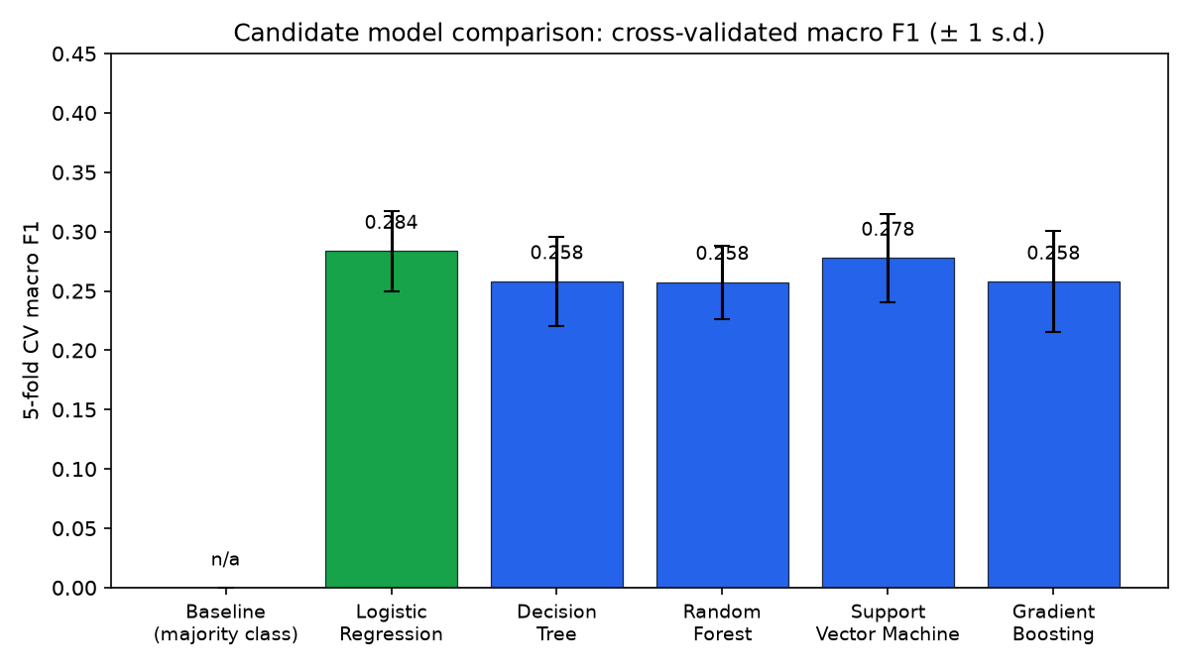
Figure 6.1: Cross-validated macro F1 of the candidate models
Source: Housein’s training run (model_results.json)

6.4 Model Selection, Explainability and Export
Logistic Regression was selected for the highest cross-validated macro F1 (0.284), following the rule in Section 3.5. No candidate exceeded the baseline’s accuracy, and the differences between candidates are similar to each model’s cross-validation standard deviation, so no algorithm is meaningfully better (Section 7.4). Logistic Regression also gives interpretable class probabilities, so the endpoint returns the full distribution; for profile P01 it returned Cardio 34.5%, HIIT 24.6%, Strength 24.1% and Yoga 16.8%, which the trainer sees with a disclaimer. The pipeline is exported as workout_pipeline.joblib with model_metadata.json (version prototype-0.1.0, features, classes, seed and hyperparameters), loaded once at FastAPI start-up (FastAPI, 2026a), and every stored prediction records the model version (NFR-08).

6.5 Backend API and Integration Services
Application logic is exposed through Next.js Route Handlers under app/api (Next.js, 2026a), listed in Appendix C. Each handler authenticates the caller, reads or writes through the Supabase server client and returns JSON with an explicit HTTP status on failure. The plan-generation route mirrors the lab’s comparison route, so both generators receive an identical profile, prediction and catalogue; the only difference is that production reads active exercises from the database, so catalogue changes need no redeployment.

6.6 Authentication, Authorisation and Supabase
Supabase Auth provides email and password sign-in, and each account has a profiles row with a role (admin, trainer or member) and a status (pending, active or disabled). The admin role implements the system maintainer of Table 4.1 as a gym administrator. Following the Data Access Layer pattern (Next.js, 2026c), verifySession(), requireTrainer(), requireAdmin() and their API equivalents are the only functions pages and routes use to establish identity, role and status. Row-Level Security is enabled on all nine tables, including admin_audit_log, with trainer policies scoped by members.trainer_id = auth.uid() (Supabase, 2026b). A security-definer function, current_app_role(), returns a role only for active accounts, so pending and disabled accounts match no policy.
Testing found that the original self-update policy let any user change their own role, so a member could promote themselves to trainer (D-06). Migration 0011 added a trigger that allows role, status and email changes only from the server, and restricted creation of trainer-member links to active trainers (D-07).
The implemented schema is simpler than Figure 5.3: members carry the trainer relationship instead of an assignment table, plans store days and validation results as JSONB, completions replace workout sessions, and progress is derived from assessments and completions. This reduced integration effort while keeping ownership enforceable by policy.

6.7 Gemini-Assisted and Rule-Based Plan Generation
Section 5.8 was implemented as three modules: a Gemini generator, a deterministic rule-based generator and one shared validator, all using an approved catalogue of 28 exercises (12 Strength, 6 Yoga, 5 Cardio, 5 HIIT) tagged with difficulty, equipment, duration and contraindications such as knee_high_load and lower_back_bending. Using one catalogue means any quality difference reflects the generation strategy, not the source material.
The Gemini prompt states nine explicit constraints, including approved IDs only, an exact day count, the duration limit and equipment and restriction compliance. Structured output enforces required fields and integer types (Google AI for Developers, 2026) but does not bound numeric ranges, which proved significant (Section 7.5). The prompt contains no name, email or account identifier.
The rule-based generator applies six ordered rules: prioritise the predicted category, exclude unavailable equipment, exclude restricted exercises, match experience level, fill each day within the session duration and rotate the pool across days (Appendix F). It returns the same plan for the same profile in under one millisecond, serving as both a fallback and an evaluation baseline.
Every plan passes through the validator before a trainer sees it. It checks category preservation, day count, duration, at least two exercises per day, duplicates, catalogue IDs, difficulty, equipment and restrictions, and bounds sets (1 to 10), repetitions (1 to 50) and rest (0 to 300 seconds). The bounds were added after Gemini returned a sets value of the order of 10^18 during development.

6.8 Progress Estimation Implementation
Because the dataset has no repeated measurements, progress is a transparent scenario projection (Section 3.7). A conservative monthly rate of −2 kg for weight loss and +0.25 kg for muscle gain (zero for other goals) is scaled by an adherence factor, completed over expected plan days limited to 0 to 1, and projected over one to three months. Each response returns its assumptions and a disclaimer.

6.9 Public Website, Trainer and Administration Web Application
The trainer workspace consists of session-gated pages providing a dashboard (Figure 6.2), member registration and a member page with Overview, Fitness Data, Predictions, Workout Plans, Progress and Notes tabs, plus analytics, alerts and settings. The Workout Plans tab shows both generated plans with their validation results (Figure 6.3); an invalid plan is flagged with its Approve button disabled, the approve route rejects it on the server unless an override reason is recorded, and each decision is written to plan_audit_log.
The public website explains the workflow and links to sign-in and to a trainer application form (Appendix I). Applicants become pending trainers who see only a status page until a gym administrator approves them. The administration area lets an administrator approve or reject applications, add trainers directly with a one-time password, deactivate or reactivate trainers, reassign members, manage the exercise catalogue and review an activity log. Deactivation first moves the trainer’s members to another trainer and then bans the account in Supabase Auth. Administrators see member names and assignments but, by policy, no fitness data.
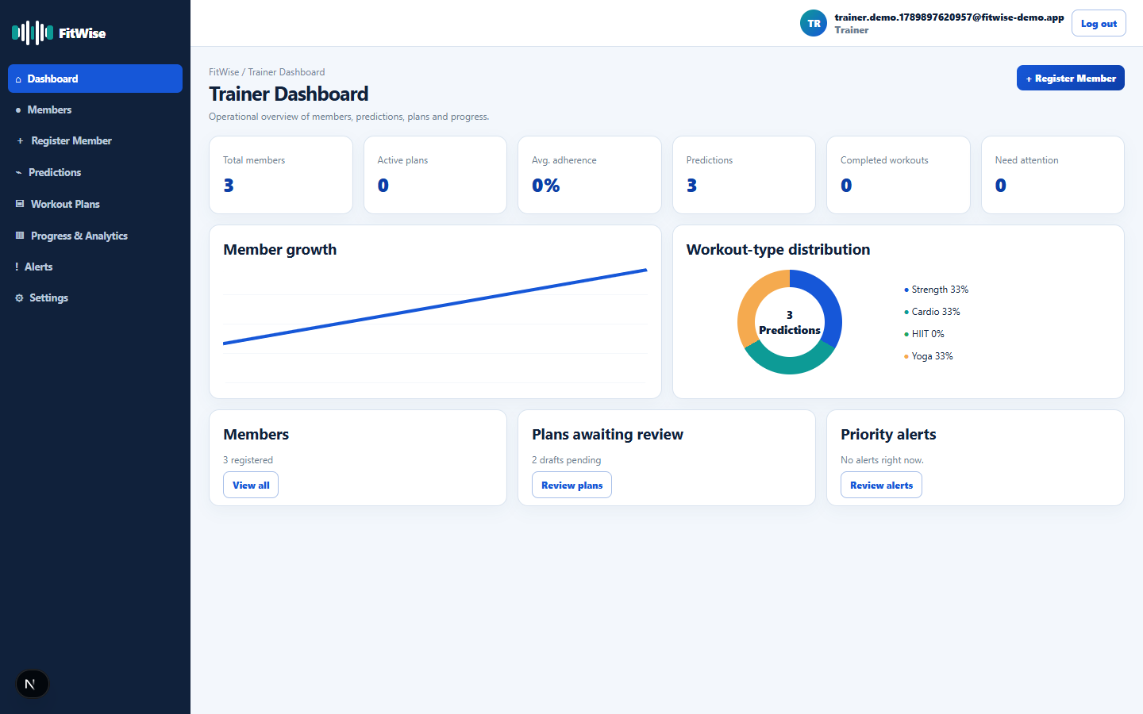
Figure 6.2: Trainer dashboard
Source: Housein’s FitWise application
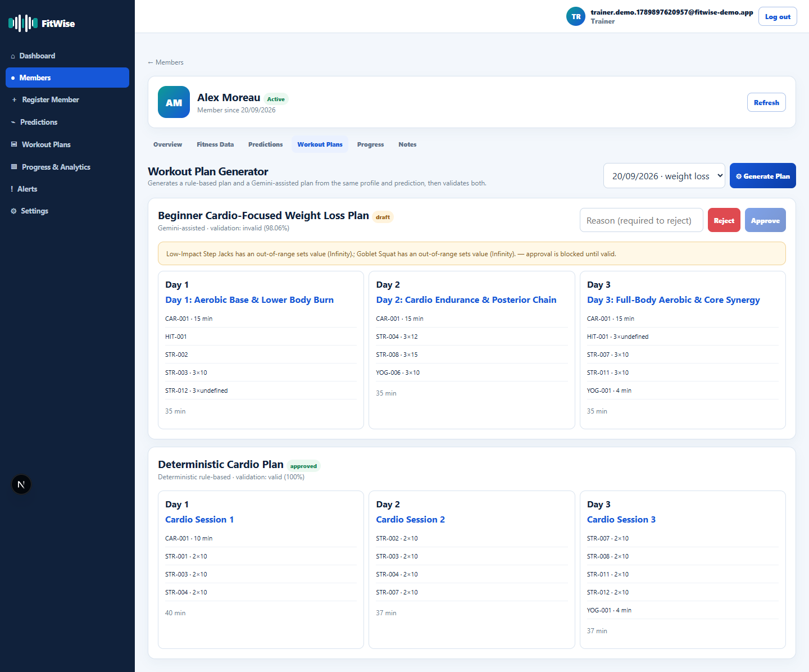
Figure 6.3: Rule-based and Gemini-assisted plans with validation status
Source: Housein’s FitWise application

6.10 Gym-Member Mobile Application
The Flutter application has 18 screens, including onboarding and login, a five-tab home shell (Home, Workouts, Plan, Progress, Profile), recommendation, session, active-workout and completion screens, projected progress, achievements, messages and settings (Figure 6.4). Unlike the design in Section 5.3, it reads and writes the member’s own records directly through supabase_flutter, with RLS as the enforcing boundary, and calls the Next.js API only for the progress projection. This removed a duplicate API layer but makes the database policies the sole ownership check (Section 7.7).
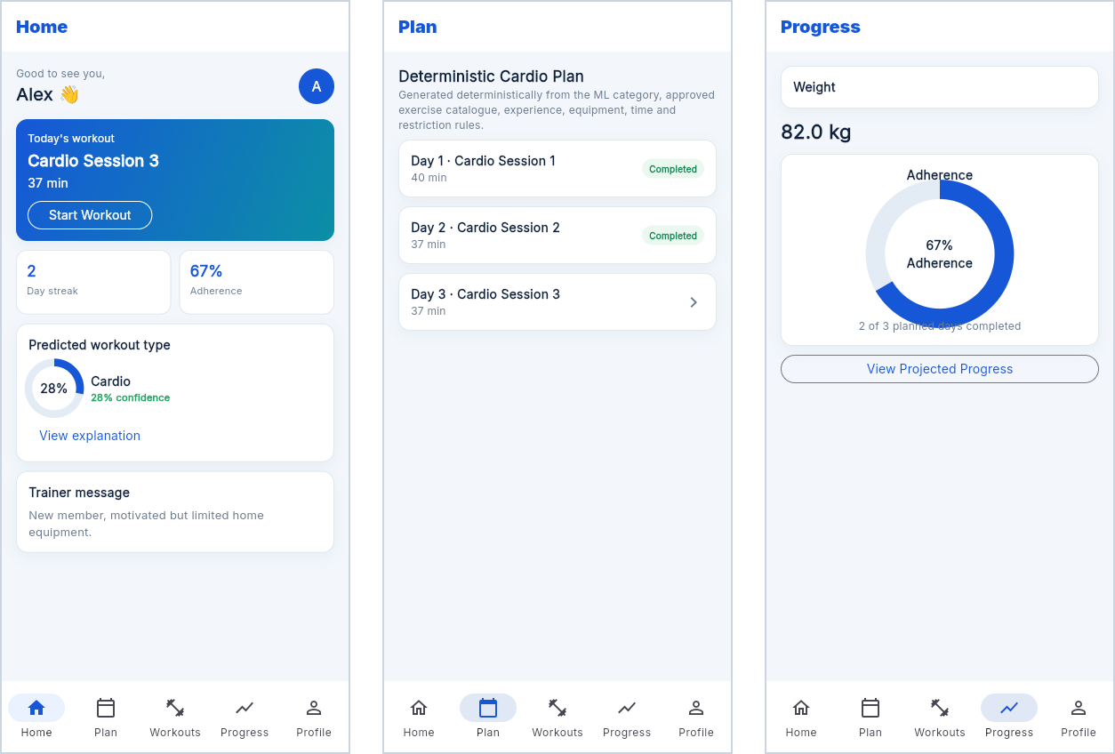
Figure 6.4: Member application home, weekly plan and progress screens
Source: Housein’s FitWise application

6.11 End-to-End System Integration and Security
All clients share one Supabase instance; the only direct service calls are from the Next.js server to the ML endpoint and to Gemini. A trainer records an assessment, obtains a prediction, generates two validated drafts and approves one; the member completes sessions on mobile, and completions drive adherence, the projection and the trainer’s alerts. The Supabase secret key is used only in the server module lib/supabase/admin.ts, errors are returned as JSON status codes rather than stack traces, and a failed prediction or generation leaves approved plans unchanged.

6.12 Technical Challenges and Solutions
Table 6.4: Technical challenges and solutions
Challenge | Solution
Gemini returned valid JSON with implausible numbers (sets of the order of 10^18) | Numeric bounds in the shared validator for sets, repetitions and rest
Free-tier Gemini quota of 20 requests per day interrupted evaluation | Sequential batch harness with retry, back-off and saving after every profile
Next.js development server blocked scripts under 127.0.0.1 | Fixed port 3001 with 127.0.0.1 in allowedDevOrigins
Classifier performed near chance level | Baseline, leakage diagnostic and confidence display; classifier treated as advisory

CHAPTER 7: TESTING AND EVALUATION

7.1 Test Strategy and Environment
Testing was layered by defect type (Table 7.1) and ran against the live environment: Next.js 16, Python 3.12 with FastAPI, the Flutter application, a cloud-hosted Supabase project and the Gemini API. No component was stubbed.
Table 7.1: Test levels, methods and results
Level | Method | Result
Static analysis | tsc --noEmit; flutter analyze | No errors
Deterministic logic | Generator and validator on 20 profiles | 20 of 20 plans valid
Functional and system | Live HTTP requests | 9 of 9 passed (Table 7.2)
Integration | /api/health and batch harness | All three boundaries confirmed
ML and plan generation | Held-out test set; 20-profile comparison | Sections 7.4 and 7.5
Security | Negative tests, code inspection and 27 database policy checks | Section 7.7
Usability / UAT | Task script with SUS | Not yet conducted (Section 7.6)

7.2 Functional and System Test Cases
Table 7.2: Functional and system test cases
ID | Test Case | Expected | Actual | Status
TC-01 | GET /api/health with services running | Both services ok | supabase ok; ml ok | Pass
TC-02 | Unauthenticated GET /trainer | Redirected | HTTP 307 | Pass
TC-03 | Unauthenticated GET /member | Redirected | HTTP 307 | Pass
TC-04 | Unauthenticated GET /api/trainer/members | Rejected, no data | HTTP 401, empty body | Pass
TC-05 | GET /login while signed out | Page available | HTTP 200 | Pass
TC-06 | Prediction for a valid profile | Four probabilities summing to 1 | Sum 1.0 | Pass
TC-07 | Rule-based plans for 20 profiles | All valid | 20 of 20 valid | Pass
TC-08 | Gemini plan with out-of-range sets | Violation reported | Flagged, not approvable | Pass
TC-09 | Malformed Gemini JSON (profile P05) | Batch recovers | Retried successfully | Pass

7.3 API and Integration Testing
Three boundaries were tested live. Web to ML: all 20 batch predictions returned a four-class distribution summing to 1.0 with model version prototype-0.1.0. Web to Supabase: TC-01 and the policy-enforced rejection in TC-04. Web to Gemini: 20 sequential requests under real latency and quota; the first run stopped after 19 profiles when the daily quota ran out, and one malformed response (P05) was recovered by retry. The batch harness saves after every profile and can be rerun as a regression test after any change to the generators or validator.

7.4 Machine-Learning Evaluation
On the untouched 195-row test set, accuracy was 23.6%, below the majority baseline’s 26.7%, while macro F1 (0.222) exceeded the baseline’s 0.105 (Tables 7.3 and 7.4; Sokolova and Lapalme, 2009).
Table 7.3: Class-level test performance of the selected model (Logistic Regression)
Class | Precision | Recall | F1-score | Support
Cardio | 0.257 | 0.353 | 0.298 | 51
HIIT | 0.143 | 0.091 | 0.111 | 44
Strength | 0.333 | 0.327 | 0.330 | 52
Yoga | 0.152 | 0.146 | 0.149 | 48
Macro average | 0.221 | 0.229 | 0.222 | 195

Table 7.4: Confusion matrix on the held-out test set (rows actual, columns predicted)
Actual / Predicted | Cardio | HIIT | Strength | Yoga
Cardio | 18 | 5 | 10 | 18
HIIT | 17 | 4 | 11 | 12
Strength | 18 | 8 | 17 | 9
Yoga | 17 | 11 | 13 | 7

HIIT was recognised in only 4 of 44 cases and most often predicted as Cardio (17), so the features cannot separate these categories. Two checks tested whether the method caused the weak result. Tuning changed cross-validated macro F1 by at most 0.014 compared with default settings. A leakage diagnostic gave 0.259 with the leakage-safe features, 0.267 with all 14 variables including post-workout measurements and 0.239 with post-workout variables alone (Appendix E), so even leaking data did not make Workout_Type predictable.
The result is therefore a property of the dataset: as anticipated in Section 2.5, Workout_Type records the workout a member performed, not an expert-assigned recommendation. This supports the decision in Section 5.1 to treat the classifier as low-confidence advisory input, always shown with its confidence.

7.5 Plan-Generation Validation and Comparison
Following Section 3.6, 20 fixed profiles covering three experience levels, five goals, three equipment tiers and knee, lower-back and high-impact restrictions were each passed once through the ML endpoint and then through both generators with identical inputs, and the shared validator scored both plans (Appendix G).
Table 7.5: Rule-based and Gemini generator comparison across 20 profiles
Metric | Rule-Based | Gemini
Plans fully valid | 20 / 20 (100%) | 4 / 20 (20%)
Mean validator score | 100.0 | 92.81
Mean latency (range) | 0.66 ms (0.10 to 3.59 ms) | 29.2 s (12.2 to 115.6 s)

Table 7.6: Distribution of Gemini validation violations (69 in total)
Violation Type | Count | Share
Out-of-range sets value | 57 | 82.6%
Incorrect number of workout days | 6 | 8.7%
Duplicate exercise within a day | 4 | 5.8%
Too few exercises on a day | 2 | 2.9%

Gemini produced fully valid plans only for P01, P02, P06 and P16. Its mean score stays high because each invalid plan failed only a few of several dozen checks, showing that an aggregate score can describe an output still unfit for a member (Section 2.4). Out-of-range sets values ranged from 30 to over 3 × 10^12 and included the literal value Infinity (P05, P07, P14); structural errors included one-day plans for five-day requests (P08, P11). No equipment, restriction, difficulty or unknown-ID violation occurred: Gemini chose suitable exercises but was unreliable at numbers and plan shape, errors a busy reviewer could easily miss.
The classifier predicted Yoga for eight profiles, including an intermediate muscle-gain member with a full gym (P02), confirming that trainer review of the category remains necessary. Gemini was called once per profile rather than the three repetitions planned, so stability is a limitation (Section 9.4).

7.6 Usability and User Acceptance Testing
Formal usability testing with real trainers and members had not been carried out at submission, so NFR-05 is not yet measured. The prepared protocol (Appendix G) asks a trainer and a member to complete six core tasks against the 80% completion target, followed by the System Usability Scale (Brooke, 1996).

7.7 Security and Privacy Testing
Table 7.7: Security and privacy checks
Check | Method | Result
Unauthenticated API and page access | Requests without a session | HTTP 401 and 307 (TC-02 to TC-04)
RLS coverage | Review of migrations 0001 to 0010 | Enabled on all eight tables
Secret-key exposure | Code search | Only in lib/supabase/admin.ts
Secrets in source control | git check-ignore | Ignored in all workspaces
Data sent to Gemini | Prompt inspection | No name, email or account ID
Untrusted AI output | Validator on all Gemini plans | 69 violations detected
Server-side approval of invalid plan | Review of approve route | Found unblocked (D-05); fixed
Role self-promotion and member-link claims | Policy tests on embedded PostgreSQL | Found possible (D-06, D-07); fixed; 27 of 27 checks pass
Admin access to fitness data | Policy tests as the admin role | No rows returned

Review found that the approve route re-validated only edited plans, so a direct API call could approve an invalid plan that the interface blocked (D-05). The route now rejects any plan whose validation failed unless an override reason is recorded. Migrations 0001 to 0011 were also applied to an embedded PostgreSQL database with a simulated Supabase auth layer, and 27 checks confirmed what members, pending and active trainers, administrators and the server can and cannot read or change. Authenticated cross-member tests, expired-token tests and penetration testing were not executed; because the mobile client relies directly on RLS, cross-member tests are the priority addition (OWASP, 2023).

7.8 Performance, Reliability and Defects
Generation averaged 0.66 ms for the rule-based generator and 29.2 s for Gemini (Table 7.5), a real operational cost that the interface must present as a waiting state; other routes were responsive but not load-tested (NFR-03). Quota exhaustion and a live malformed response (TC-09) were both recovered without losing results or storing partial plans (NFR-04). Table 7.8 lists the defects found.
Table 7.8: Defect log
ID | Defect | Severity | Corrective Action | Status
D-01 | Implausible Gemini numeric values | High | Numeric bounds in validator | Fixed
D-02 | Evaluation interrupted by quota | Medium | Sequential harness with retry and saving | Fixed
D-03 | Malformed Gemini JSON | Medium | Retry with back-off | Fixed
D-04 | Dev server blocked 127.0.0.1 | Low | allowedDevOrigins entry | Fixed
D-05 | Approve route skipped the validation check when no edits were sent | High | Server rejects invalid plans unless an override reason is given | Fixed
D-06 | Any user could change their own role | Critical | Trigger restricts role and status changes to the server | Fixed
D-07 | Any user could create a trainer-member link | Medium | Link creation limited to active trainers | Fixed

7.9 Evaluation Against Objectives
Table 7.9: Achievement of project objectives
No. | Objective | Evidence | Status
1 | Dataset preparation and leakage audit | 6.2, 7.4 | Achieved
2 | Classification models | 6.3, 6.4, 7.4 | Achieved (weak dataset result reported)
3 | Controlled hybrid plan generation | 6.7, 7.5 | Achieved
4 | Transparent progress estimation | 6.8 | Achieved
5 | Public website and trainer application | 6.9, 7.7 | Achieved
6 | Flutter member application | 6.10 | Substantially (not yet user-tested)
7 | Supabase PostgreSQL, Auth, Storage and RLS | 6.6, 7.7 | Achieved (Storage not required)
8 | End-to-end integration | 6.11, 7.3 | Achieved
9 | Evaluation and documentation | Ch. 7, 8; App. A to C | Substantially (usability not measured)

7.10 Discussion of Results
Taken together, the results argue for treating both the classifier and Gemini as advisory inputs to a deterministic, auditable system with trainer approval, rather than removing either. The classifier’s weak result was established through a baseline, bounded search and diagnostic, not a shortfall in effort. The generators showed a consistent trade-off: the rule-based generator was fully compliant and effectively free, while Gemini was slower and failed on numbers and structure rather than on exercise safety. This directly supports the decision, taken before any results existed, to validate every plan regardless of its source.

CHAPTER 8: DEPLOYMENT, OPERATION AND DOCUMENTATION

8.1 Deployment Approach
At submission, the Supabase project is cloud-hosted while the Next.js application and FastAPI service run locally and the member application runs as a Flutter web release build, so all Chapter 7 results use the real database and authentication service. The target deployment (Figure 5.8) places the web application on Vercel or another Node host, the ML service in a small container with pinned requirements (FastAPI, 2026b), and the mobile client in an Android APK; these steps are documented in Appendix C but were not carried out within the timeline.

8.2 Configuration and Secret Management
Environment values are supplied through git-ignored .env.local and .env files, and a committed .env.example lists every variable name without values (Appendix C). Only publishable Supabase values reach client code; the secret key, ML address and Gemini key are server-only, and no secret appears in this report. The first administrator is created once with a bootstrap script; all later trainer accounts are managed in the application.

8.3 Backup, Recovery and Monitoring
Supabase offers automated backups depending on the project plan (Supabase, 2026d). Independently, the schema can be rebuilt from the ordered migrations and the model regenerated with a fixed seed (NFR-12), while plan_audit_log records every approval decision. /api/health provides a live signal for both dependencies; production use would add scheduled checks with alerting.

8.4 Documentation, Maintenance and Extensibility
Appendices A and B are user manuals based on real screens, and Appendix C is the technical manual; each workspace also has a README. Maintenance is supported by the database-backed catalogue, generators and validator shared between the lab and production, versioned model metadata, numbered migrations and shared TypeScript types, so a new validation rule applies to both generators and to any rerun of the evaluation.

CHAPTER 9: CONCLUSION AND RECOMMENDATIONS

9.1 Project Summary
FitWise was built to help trainers produce suitable weekly plans for many members. A classifier proposes a workout category, Gemini-assisted and rule-based generators draft plans from an approved catalogue, one shared validator enforces every constraint, and a trainer approves the result before a member follows it on mobile.

9.2 Achievement of Aim and Objectives
Seven objectives were fully and two substantially achieved (Section 7.9). On the research questions in Section 1.5: first, Logistic Regression gave the best cross-validated result, but no approach beat the baseline’s accuracy on this dataset, so the classifier can only serve as advisory input. Second, restricting Gemini to catalogue IDs gave suitable exercise selection in every profile, while the validator caught 69 numeric and structural violations; with trainer approval this yields structured, explainable and reviewable plans. Third, 17 of 18 functional and 9 of 12 non-functional requirements were met, with the remainder partially met or not yet measured (Appendix D).

9.3 Main Contributions
The main contribution is the hybrid architecture and its fair evaluation: two generators compared under identical inputs and one validator isolated the effect of generation strategy, showing that a language model under explicit instructions and a typed schema remained unreliable at bounded numbers and plan structure while reliable at categorical constraints. A second contribution is treating a weak dataset result, reached rigorously, as evidence for an architectural decision.

9.4 Limitations
The classifier performs near chance on the available data. The generator evaluation used one Gemini call per profile with default temperature. Usability testing, authenticated cross-member tests, penetration testing and an automated unit-test suite were not completed. The administration features were verified by type checking and database policy tests rather than a recorded end-to-end walkthrough, trainer applications have no email verification or rate limiting, plan editing exists in the API but not the interface, the system was not deployed to hosted infrastructure, and the progress projection is an unvalidated scenario based on entered data.

9.5 Critical Appraisal and Lessons Learned
Designing the fairness controls before running the comparison made its findings defensible, and interrogating the weak classifier turned a disappointing number into a justified design decision. External AI dependencies introduced quota, format and latency failures that had to be engineered for explicitly. In hindsight, usability testing and server-side control checks should have been part of each increment rather than left to the end, while the separate prototype lab proved valuable for producing controlled evidence.

9.6 Recommendations and Future Work
- Add automated tests, including authenticated cross-member, expired-token and server-side approval regression tests.
- Conduct usability testing with trainers and members using the Appendix G script and the System Usability Scale.
- Bound sets, repetitions and rest in the Gemini schema, set a low temperature and repeat the evaluation with three calls per profile.
- Obtain expert-labelled data and evaluate Resting_BPM and workout-history features for returning members.
- Add email verification and rate limiting to trainer applications, and an in-place plan-editing interface using the existing edit-and-revalidate API.
- Deploy the web application, ML container and Android build with scheduled health monitoring.

9.7 Final Conclusion
FitWise shows that a hybrid architecture, combining a modest classifier, a generative drafter and a deterministic validator that neither can bypass, can be built, integrated across web, mobile and a managed database, and evaluated with executed evidence. Its central finding is that a system designed to trust neither component on its own, and to check both before a trainer signs off, produced a working and transparently evaluated result.

REFERENCES
Adomavicius, G. and Tuzhilin, A. (2005) ‘Toward the next generation of recommender systems: a survey of the state-of-the-art and possible extensions’, IEEE Transactions on Knowledge and Data Engineering, 17(6), pp. 734–749. https://doi.org/10.1109/TKDE.2005.99.
Ainsworth, B.E. et al. (2011) ‘2011 Compendium of Physical Activities: A second update of codes and MET values’, Medicine & Science in Sports & Exercise, 43(8), pp. 1575–1581. https://doi.org/10.1249/MSS.0b013e31821ece12.
Alhuwail, D. et al. (2024) ‘Patients’ perspectives on the data confidentiality, privacy, and security of mHealth apps: systematic review’, Journal of Medical Internet Research, 26, e50715. https://doi.org/10.2196/50715.
Aljedaani, B. and Babar, M.A. (2021) ‘Challenges with developing secure mobile health applications: systematic review’, JMIR mHealth and uHealth, 9(6), e15654. https://doi.org/10.2196/15654.
Autio, C. et al. (2024) Artificial Intelligence Risk Management Framework: Generative Artificial Intelligence Profile. NIST AI 600-1. Gaithersburg, MD: National Institute of Standards and Technology. https://doi.org/10.6028/NIST.AI.600-1.
Brooke, J. (1996) ‘SUS: a “quick and dirty” usability scale’, in Jordan, P.W., Thomas, B., Weerdmeester, B.A. and McClelland, I.L. (eds.) Usability Evaluation in Industry. London: Taylor & Francis, pp. 189–194.
Buitinck, L. et al. (2013) ‘API design for machine learning software: experiences from the scikit-learn project’, ECML PKDD Workshop: Languages for Data Mining and Machine Learning, pp. 108–122. Available at: https://arxiv.org/abs/1309.0238 (Accessed: 30 July 2026).
Burke, R. (2002) ‘Hybrid recommender systems: survey and experiments’, User Modeling and User-Adapted Interaction, 12(4), pp. 331–370. https://doi.org/10.1023/A:1021240730564.
Choi, M., Park, J., Lee, M., Beom, J., Jung, S.Y. and Lee, K. (2026) ‘AI-generated exercise prescriptions for at-risk populations: safety and feasibility of a large language model assessed by expert evaluation’, Journal of Clinical Medicine, 15(6), 2457. https://doi.org/10.3390/jcm15062457.
Davergne, T., Meidinger, P., Dechartres, A. and Gossec, L. (2023) ‘The effectiveness of digital apps providing personalized exercise videos: systematic review with meta-analysis’, Journal of Medical Internet Research, 25, e45207. https://doi.org/10.2196/45207.
Emberson, M.A. et al. (2021) ‘Effectiveness of smartphone-based physical activity interventions on individuals’ health outcomes: a systematic review’, BioMed Research International, 2021, 6296896. https://doi.org/10.1155/2021/6296896.
European Commission (n.d.) Information for individuals: special categories of personal data. Available at: https://commission.europa.eu/law/law-topic/data-protection/information-individuals_en (Accessed: 30 July 2026).
European Data Protection Board (n.d.) Basic principles. Available at: https://www.edpb.europa.eu/topics/key-gdpr-concepts/basic-principles_en (Accessed: 30 July 2026).
FastAPI (2026a) Lifespan events. Available at: https://fastapi.tiangolo.com/advanced/events/ (Accessed: 30 July 2026).
FastAPI (2026b) Deployment concepts. Available at: https://fastapi.tiangolo.com/deployment/concepts/ (Accessed: 30 July 2026).
Fitbod (2026) Understanding Fitbod and how it works. Available at: https://help.fitbod.me/hc/en-us/sections/360001078993-Understanding-Fitbod-How-It-Works (Accessed: 30 July 2026).
Flutter (2026) Guide to app architecture. Available at: https://docs.flutter.dev/app-architecture/guide (Accessed: 30 July 2026).
Freeletics (2026) Get started with Freeletics Training. Available at: https://help.freeletics.com/hc/en-us/articles/115004675229-Get-started-with-Freeletics-Training (Accessed: 30 July 2026).
Garber, C.E. et al. (2011) ‘Quantity and quality of exercise for developing and maintaining cardiorespiratory, musculoskeletal, and neuromotor fitness in apparently healthy adults’, Medicine & Science in Sports & Exercise, 43(7), pp. 1334–1359. https://doi.org/10.1249/MSS.0b013e318213fefb.
Google AI for Developers (2026) Structured outputs: Gemini API. Available at: https://ai.google.dev/gemini-api/docs/structured-output (Accessed: 30 July 2026).
He, T., Lu, D., Ma, Y., He, J., Li, D., Li, G. and Sun, J. (2026) ‘The AI recommendation paradox: a systematic review evaluating the promise, peril, and path forward for large language models in exercise recommendation’, Biology of Sport, 43, pp. 949–961. https://doi.org/10.5114/biolsport.2026.158676.
Herlocker, J.L., Konstan, J.A., Terveen, L.G. and Riedl, J.T. (2004) ‘Evaluating collaborative filtering recommender systems’, ACM Transactions on Information Systems, 22(1), pp. 5–53. https://doi.org/10.1145/963770.963772.
Khorasani, V. (2024) Gym Members Exercise Dataset. Kaggle. Available at: https://www.kaggle.com/datasets/valakhorasani/gym-members-exercise-dataset (Accessed: 30 July 2026).
Kierner, S., Kucharski, J. and Kierner, Z. (2023) ‘Taxonomy of hybrid architectures involving rule-based reasoning and machine learning in clinical decision systems: a scoping review’, Journal of Biomedical Informatics, 144, 104428. https://doi.org/10.1016/j.jbi.2023.104428.
Laranjo, L. et al. (2021) ‘Do smartphone applications and activity trackers increase physical activity in adults? Systematic review, meta-analysis and metaregression’, British Journal of Sports Medicine, 55(8), pp. 422–432. https://doi.org/10.1136/bjsports-2020-102892.
Liu, X. et al. (2022) ‘Privacy-preserving personalized fitness recommender system (P3FitRec): a multi-level deep learning approach’. Available at: https://arxiv.org/abs/2203.12200 (Accessed: 30 July 2026).
Mahyari, A. and Pirolli, P. (2021) ‘Physical exercise recommendation and success prediction using interconnected recurrent neural networks’. Available at: https://arxiv.org/abs/2010.00482 (Accessed: 30 July 2026).
Michie, S., van Stralen, M.M. and West, R. (2011) ‘The behaviour change wheel: a new method for characterising and designing behaviour change interventions’, Implementation Science, 6, 42. https://doi.org/10.1186/1748-5908-6-42.
Michie, S. et al. (2013) ‘The Behavior Change Technique Taxonomy (v1) of 93 hierarchically clustered techniques’, Annals of Behavioral Medicine, 46(1), pp. 81–95. https://doi.org/10.1007/s12160-013-9486-6.
Mitchell, M., Wu, S., Zaldivar, A., Barnes, P., Vasserman, L., Hutchinson, B., Spitzer, E., Raji, I.D. and Gebru, T. (2019) ‘Model cards for model reporting’, in Proceedings of the Conference on Fairness, Accountability, and Transparency (FAT* ’19). New York: ACM, pp. 220–229. https://doi.org/10.1145/3287560.3287596.
Next.js (2026a) Route Handlers. Available at: https://nextjs.org/docs/app/getting-started/route-handlers (Accessed: 30 July 2026).
Next.js (2026b) App Router. Available at: https://nextjs.org/docs/app (Accessed: 30 July 2026).
Next.js (2026c) Authentication. Available at: https://nextjs.org/docs/app/guides/authentication (Accessed: 28 September 2026).
OWASP (2023) OWASP API Security Top 10 – 2023. Available at: https://owasp.org/API-Security/editions/2023/en/0x11-t10/ (Accessed: 30 July 2026).
Paganini, S. et al. (2021) ‘Quality of physical activity apps: systematic search in app stores and content analysis’, JMIR mHealth and uHealth, 9(6), e22587. https://doi.org/10.2196/22587.
Pedregosa, F. et al. (2011) ‘Scikit-learn: machine learning in Python’, Journal of Machine Learning Research, 12, pp. 2825–2830.
Ricci, F., Rokach, L. and Shapira, B. (2011) ‘Introduction to recommender systems handbook’, in Ricci, F. et al. (eds.) Recommender Systems Handbook. Boston, MA: Springer, pp. 1–35. https://doi.org/10.1007/978-0-387-85820-3_1.
Scikit-learn Developers (2026) Model persistence. Available at: https://scikit-learn.org/stable/model_persistence.html (Accessed: 30 July 2026).
Shin, D., Hsieh, G. and Kim, Y.-H. (2025) ‘PlanFitting: personalized exercise planning with large language model-driven conversational agent’, Proceedings of the 7th ACM Conference on Conversational User Interfaces. https://doi.org/10.1145/3719160.3736607.
Sokolova, M. and Lapalme, G. (2009) ‘A systematic analysis of performance measures for classification tasks’, Information Processing & Management, 45(4), pp. 427–437. https://doi.org/10.1016/j.ipm.2009.03.002.
Strava (2026) Goals and training plans. Available at: https://support.strava.com/en-us/collections/19668882-goals-and-training-plans (Accessed: 30 July 2026).
Supabase (2026a) Auth. Available at: https://supabase.com/docs/guides/auth (Accessed: 30 July 2026).
Supabase (2026b) Row Level Security. Available at: https://supabase.com/docs/guides/database/postgres/row-level-security (Accessed: 30 July 2026).
Supabase (2026c) Storage access control. Available at: https://supabase.com/docs/guides/storage/security/access-control (Accessed: 30 July 2026).
Supabase (2026d) Database backups. Available at: https://supabase.com/docs/guides/platform/backups (Accessed: 28 September 2026).
Tong, H.L. et al. (2021) ‘Personalized mobile technologies for lifestyle behavior change: a systematic review, meta-analysis, and meta-regression’, Preventive Medicine, 148, 106532. https://doi.org/10.1016/j.ypmed.2021.106532.
Wang, L. et al. (2024) ‘Applications and concerns of ChatGPT and other conversational large language models in health care: systematic review’, Journal of Medical Internet Research, 26, e22769. https://doi.org/10.2196/22769.
World Health Organization (2020) WHO guidelines on physical activity and sedentary behaviour. Geneva: World Health Organization.
World Health Organization (2024) Physical activity. Available at: https://www.who.int/news-room/fact-sheets/detail/physical-activity (Accessed: 30 July 2026).
Yang, Y., Hu, H. and Koenigstorfer, J. (2022) ‘Effects of gamified smartphone applications on physical activity: a systematic review and meta-analysis’, American Journal of Preventive Medicine, 62(4), pp. 602–613. https://doi.org/10.1016/j.amepre.2021.10.005.

GLOSSARY
Term | Definition
Adherence factor | The proportion of expected plan days a member has completed, limited to the range 0 to 1 and used to scale the progress projection.
Account status | Whether an account is pending approval, active or disabled; only active accounts receive any role-based access.
Approved exercise catalogue | The database-backed list of exercises, with stable IDs and tags, from which both generators must choose.
Data leakage | Use of information during training that would not be available when the model is used, producing misleadingly optimistic results.
Deterministic validator | The shared rule-based component that checks every generated plan against fixed constraints before a trainer can approve it.
Hybrid recommendation | An approach combining several techniques; in FitWise, ML category prediction, generative drafting, rule-based generation and trainer review.
Macro F1 | The unweighted mean of per-class F1-scores, giving each workout category equal importance regardless of its size.
Model inference | The use of a trained model to generate a prediction for new input data.
Row-Level Security | A PostgreSQL feature that filters the rows a user may read or change according to policies evaluated in the database.
Rule-based generator | The deterministic generator that builds a plan from explicit rules and always returns the same plan for the same inputs.
Scenario projection | An assumption-based estimate of future progress that is labelled as such and is not a fitted forecast.
Structured output | A Gemini API feature that constrains the response to a supplied JSON schema.

APPENDIX A: GYM-MEMBER USER MANUAL
This manual describes the FitWise member application. The screens shown were captured from the running application (Flutter web release build) signed in as a seeded demonstration member.

A.1 Signing In
- Open the FitWise application. On first launch, read the onboarding screens.
- Enter the email address and password created by your trainer and select Sign In.
- If sign-in fails, check the credentials or ask your trainer to confirm that your account is active.

A.2 Home and Recommendation
- The Home tab shows today’s session, your streak and adherence, your recommended workout category and any note from your trainer (Figure 6.4).
- Select the recommendation to see the full confidence breakdown across Cardio, HIIT, Strength and Yoga.
- Read the disclaimer: the recommendation is general fitness guidance, not medical advice, and your trainer has reviewed your plan.
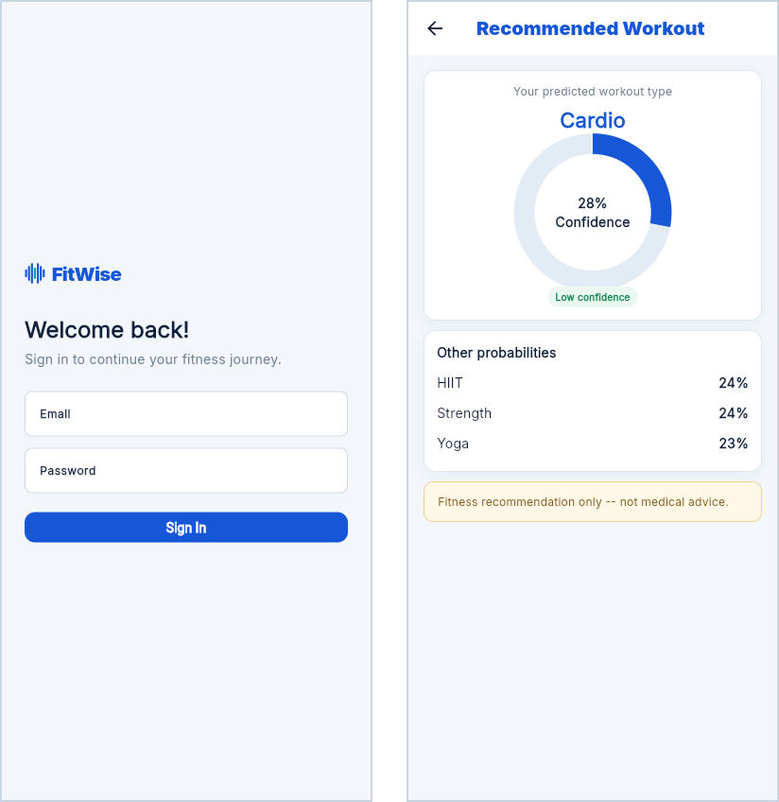
Figure A.1: Sign-in screen and recommendation detail
Source: Housein’s FitWise application

A.3 Following Your Weekly Plan
- Open the Plan tab to see the weekly plan approved by your trainer. Draft or rejected plans are never shown.
- Select a day to view its exercises, sets and repetitions or duration, and rest periods.
- Start the workout and move through each exercise; on the final screen, mark the workout as complete.
- Completed workouts update your adherence, which is visible to your trainer.
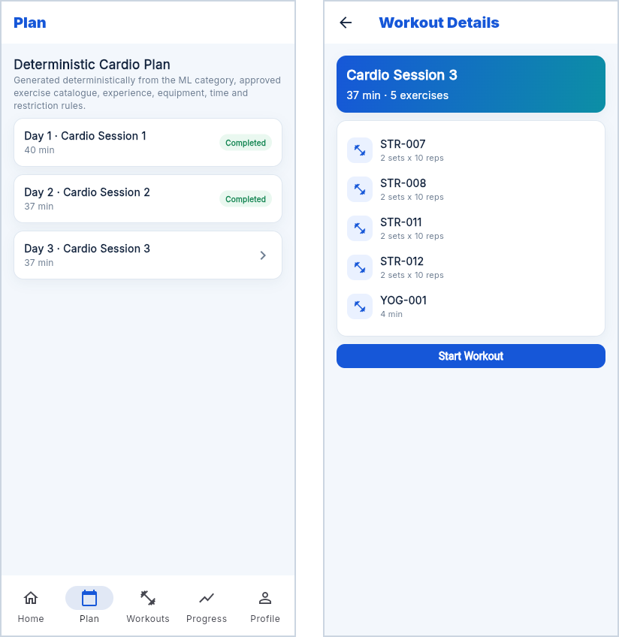
Figure A.2: Weekly plan and session details
Source: Housein’s FitWise application

A.4 Progress and Projection
- Open the Progress tab to see your current weight and adherence against the assigned plan.
- Select View Projected Progress to see a one-, two- and three-month scenario.
- Read the listed assumptions: the projection depends on adherence, nutrition, sleep and individual response and is not a guarantee.
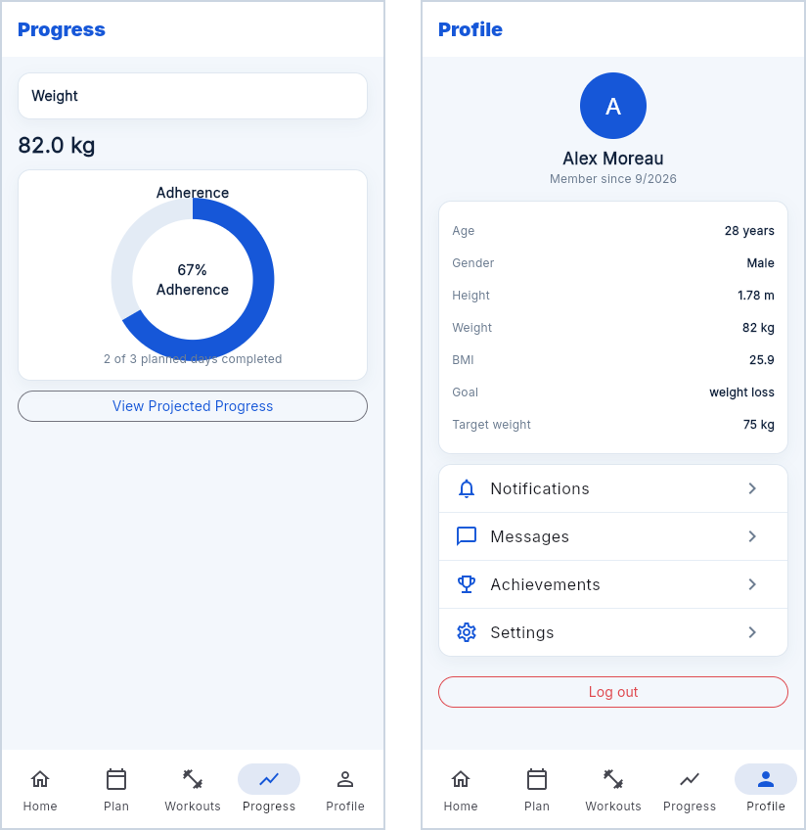
Figure A.3: Progress tab and profile tab
Source: Housein’s FitWise application

A.5 Achievements, Messages and Settings
The Profile tab links to Achievements, Messages from your trainer, Notifications and Settings, where notification preferences can be changed. If you experience pain or a new health condition, stop the workout and inform your trainer before continuing.

APPENDIX B: TRAINER AND ADMINISTRATOR USER MANUAL
This manual describes the trainer workspace and the gym administration area. The trainer screens were captured from the running application signed in as a seeded demonstration trainer managing three demonstration members.

B.1 Applying for a Trainer Account
- Open the FitWise website and select Apply as a trainer (Figure B.1).
- Enter your name, email, phone, specialisation and a password of at least eight characters, then submit the application.
- You are signed in to an Application received page. Once a gym administrator approves you, sign in again to open the trainer workspace.
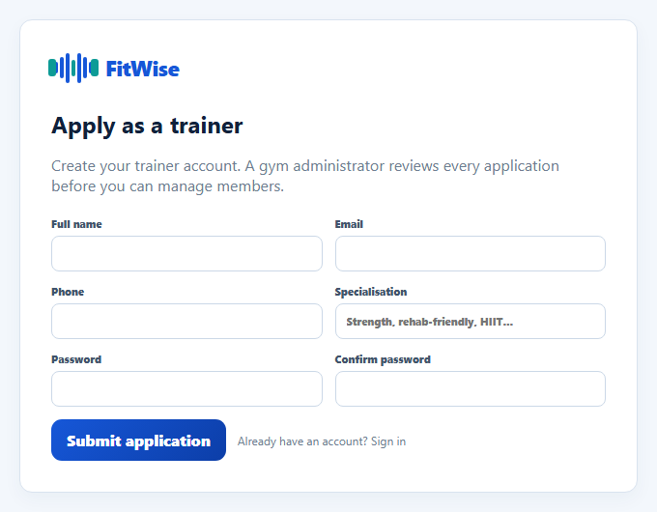
Figure B.1: Trainer application form
Source: Housein’s FitWise application

B.2 Signing In and Dashboard
- Go to /login and sign in with an approved trainer account. Other accounts are sent to their own area, and pending applicants to the status page.
- The dashboard (Figure 6.2) shows total members, active plans, average adherence, predictions, completed workouts and members needing attention.

B.3 Registering and Assessing a Member
- Select Register Member, enter the member’s details and save. Duplicate email addresses are rejected.
- Open the member and use the Fitness Data tab to record weight, height, body-fat percentage, workout frequency, experience level, goal, available equipment and any restrictions.
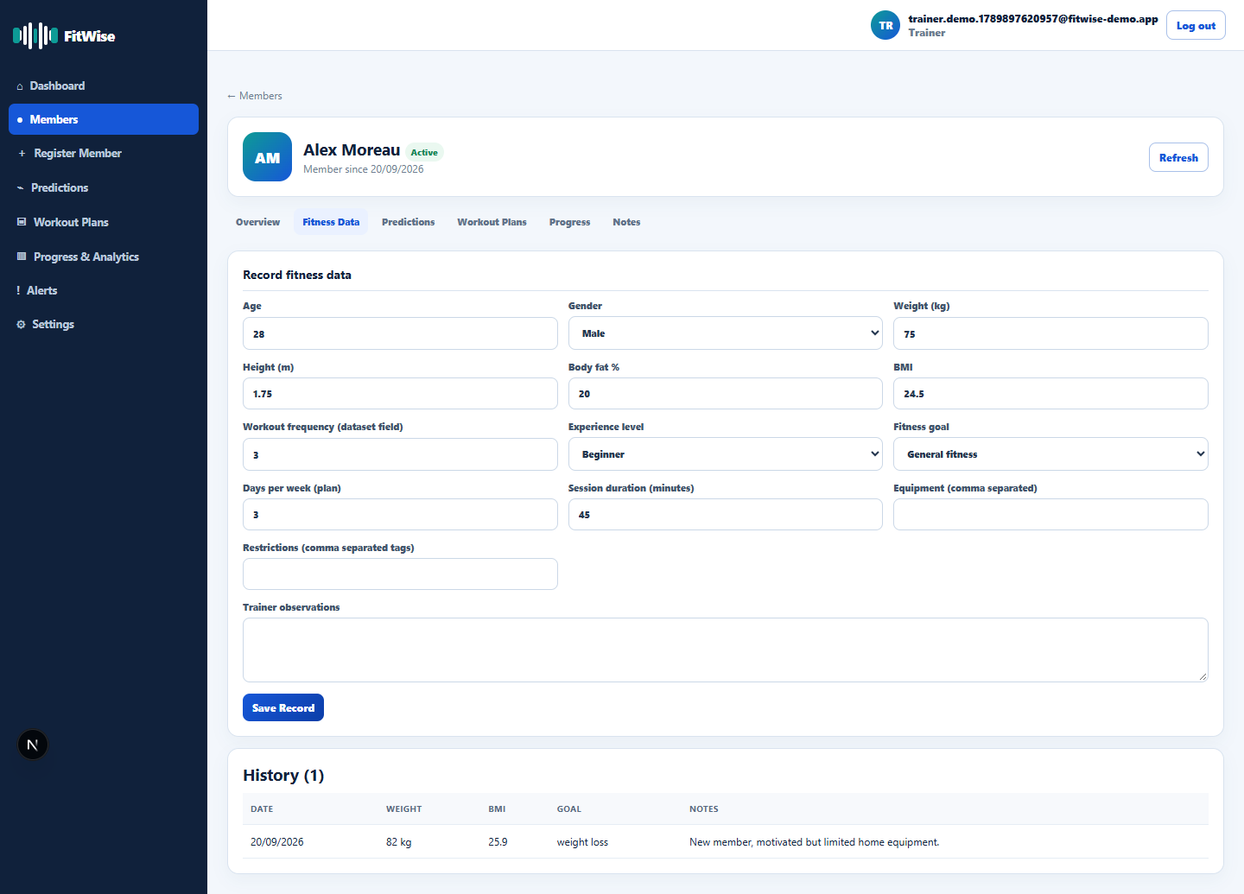
Figure B.2: Recording a member assessment (Fitness Data tab)
Source: Housein’s FitWise application

B.4 Requesting a Prediction
- On the Predictions tab, request a prediction for the latest assessment.
- Review the predicted category together with the full probability breakdown and disclaimer. Treat low-confidence predictions as a starting point only.
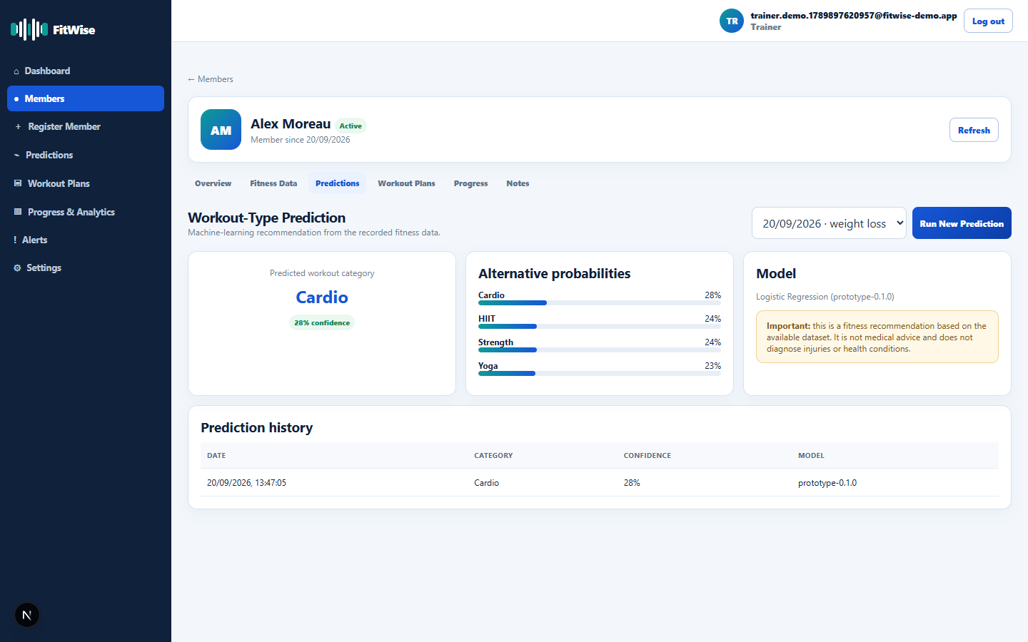
Figure B.3: ML prediction with class probabilities and disclaimer
Source: Housein’s FitWise application

B.5 Generating and Reviewing a Plan
- On the Workout Plans tab, select Generate Plan. The rule-based and Gemini-assisted generators run against the same prediction and catalogue (Figure 6.3).
- Review both plans. Any validation violation is listed above the plan, and approval is blocked until the plan is valid.
- Approve one plan to assign it to the member, or reject it with a reason. Both actions are recorded in the audit log.

B.6 Monitoring Progress, Analytics and Alerts
- Use a member’s Progress tab to review completions against the assigned plan and the projected scenario.
- Use Progress and Analytics for roster-wide adherence and workout-type distribution.
- Use Alerts to find members with low adherence and follow up with them.
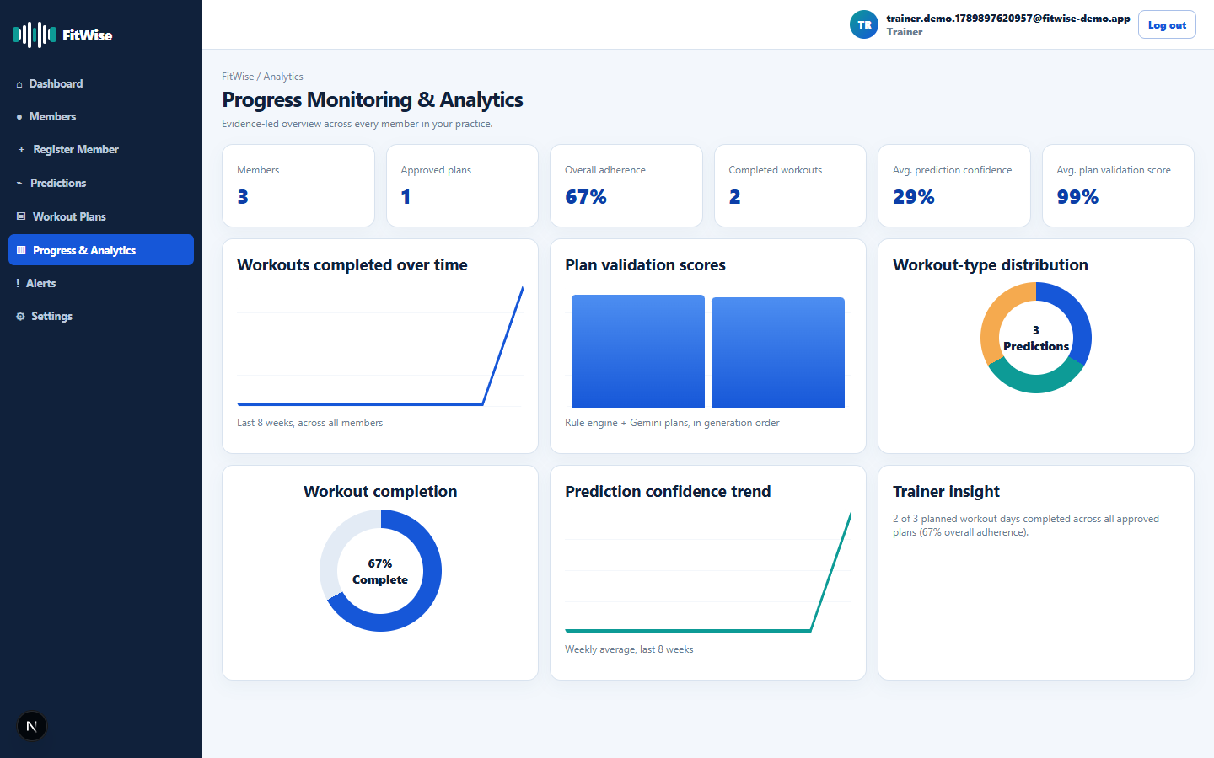
Figure B.4: Roster-wide progress and analytics
Source: Housein’s FitWise application

B.7 Settings
The Settings page manages your name, password and notification preferences. The exercise catalogue is managed by the gym administrator.
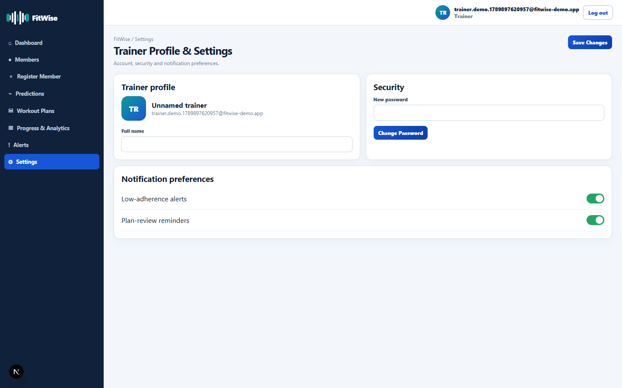
Figure B.5: Trainer settings and notification preferences
Source: Housein’s FitWise application

B.8 Gym Administrator Tasks
Administrators sign in at /login and are taken to the administration area. The first administrator is created once with scripts/bootstrap-admin.mjs (Appendix C).
- Dashboard: review totals, pending trainer applications and recent activity.
- Trainers: approve or reject applications, or select Add Trainer to create an active account and hand over its one-time password.
- To deactivate a trainer, choose another active trainer to take over their members, then confirm. The account can no longer sign in; Reactivate restores it.
- Members: see each member’s assigned trainer and reassign them. Fitness records are not visible to administrators.
- Exercise Catalogue: activate or deactivate exercises; the change applies to the next plan any trainer generates.
- Activity Log: review every administrative action with its time and author.

APPENDIX C: TECHNICAL AND DEPLOYMENT MANUAL

C.1 Prerequisites
Node.js 22 or later with npm; Python 3.12 with venv; the Flutter SDK (Dart 3.11); a Supabase project with the email and password provider enabled; and a Google Gemini API key.

C.2 Repository Structure
Table C.1: Repository structure
Folder | Contents
FitWise_App/web | Next.js application: app/ (pages and API routes), lib/ (generators, validator, auth, progress), supabase/migrations/
FitWise_App/mobile | Flutter member application: lib/screens/, lib/theme.dart, pubspec.yaml
FitWise_Prototype_Lab/ml | train.py, app.py (FastAPI), requirements.txt, data/, artifacts/
FitWise_Prototype_Lab/web | Comparison harness, scripts/run-batch-comparison.mjs and results/

C.3 Environment Variables
Table C.2: Web application environment variables
Variable | Used By | Exposure
NEXT_PUBLIC_SUPABASE_URL | Browser and server | Public
NEXT_PUBLIC_SUPABASE_PUBLISHABLE_KEY | Browser and server | Public, restricted by RLS
SUPABASE_URL, SUPABASE_PUBLISHABLE_KEY | Server | Server only
SUPABASE_SECRET_KEY | Server (lib/supabase/admin.ts) | Secret; bypasses RLS
ML_API_URL | Server | Internal service address
GEMINI_API_KEY, GEMINI_MODEL | Server | Secret key and model name

Copy .env.example to .env.local in FitWise_App/web and fill in the variables in Table C.2. For Flutter, create FitWise_App/mobile/.env with SUPABASE_URL, SUPABASE_ANON_KEY, WEB_API_URL (Android emulator address of the web application) and WEB_API_URL_WEB (browser address). Never commit these files.

C.4 Database Setup
Apply the eleven migrations in FitWise_App/web/supabase/migrations in numeric order (0001_profiles.sql to 0011_admin_and_trainer_signup.sql) using the Supabase SQL editor or CLI. They create the nine application tables, enable Row-Level Security on each and add the admin role. Then create the first administrator:
cd FitWise_App/web
node scripts/bootstrap-admin.mjs admin@yourgym.com "StrongPassword" "Full Name"

C.5 ML Service Setup
cd FitWise_Prototype_Lab/ml
python -m venv .venv
.venv\Scripts\activate
pip install -r requirements.txt
python train.py # writes artifacts/workout_pipeline.joblib and metadata
uvicorn app:app --host 127.0.0.1 --port 8000

C.6 Web and Mobile Setup
cd FitWise_App/web
npm install
npm run dev # or: npm run build && npm run start
cd ../mobile
flutter pub get
flutter run # or: flutter build apk / flutter build web

C.7 API Routes
Table C.3: Implemented API routes
Method | Route | Purpose
GET | /api/health | Report Supabase and ML-service connectivity
GET, POST | /api/trainer/members | List or register the trainer’s members
GET, POST | /api/trainer/members/{id}/assessments | Read or record a member assessment
POST | /api/assessments/{id}/predict | Call the ML prediction endpoint and store the result
POST | /api/plans/generate | Run both generators and the validator; store draft plans
POST | /api/plans/{id}/approve and /reject | Change plan status and write plan_audit_log
GET, PATCH | /api/exercises and /api/exercises/{id} | Read the catalogue; administrator activates or deactivates an exercise
POST | /api/member/completions | Record a completed workout day
GET | /api/members/{id}/progress | Return adherence and the progress scenario
POST | /api/auth/trainer-signup | Create a pending trainer application (public)
POST | /api/admin/trainers | Administrator adds an active trainer
POST | /api/admin/trainers/{id}/status | Approve, reject, deactivate or reactivate a trainer
POST | /api/admin/members/{id}/reassign | Move a member to another active trainer

C.8 Verifying the Installation
Open /api/health on the web application. A response reporting ok for both Supabase and the ML service confirms that the database and inference service are reachable; this is test TC-01 and the recommended first check after any redeployment. Then sign in as the administrator, add or approve a trainer, and as that trainer register a member, record an assessment, request a prediction and generate a plan.

APPENDIX D: REQUIREMENTS TRACEABILITY
This appendix maps each requirement in Tables 4.2 and 4.3 to its implementation and test evidence, replacing the design-stage status in Table 4.5.

D.1 Functional Requirements Traceability
Table D.1: Functional requirements traceability
ID | Requirement (Summary) | Evidence | Status
FR-01 | Public website | app/page.tsx; trainer application at /signup (Appendix I) | Met
FR-02 | Supabase Auth sign-in | Section 6.6; TC-02 to TC-05 | Met
FR-03 | Create member account and profile | Section 6.9; migration 0002 | Met
FR-04 | Record and update assessment | Fitness Data tab; migrations 0002, 0008 | Met
FR-05 | Request and store prediction | Section 6.4; TC-06; migration 0003 | Met
FR-06 | Retrieve active approved exercises | Section 6.5; is_active filter | Met
FR-07 | Generate structured draft with Gemini | Sections 6.7, 7.5 | Met (reliability limits in Table 7.6)
FR-08 | Validate every generated plan | Section 6.7; TC-08 | Met (interface and server; D-05 fixed)
FR-09 | Review, edit, approve, reject or regenerate | Approve and reject in interface; edit supported by API only | Partially met
FR-10 | Member views recommendation and plan | Section 6.10; Appendix A | Met
FR-11 | Member completes workout | Active-workout screens; migration 0006 | Met
FR-12 | View authorised progress and adherence | Sections 6.8, 6.9 | Met
FR-13 | Compare actual with projected progress | Section 6.8; progress endpoint | Met
FR-14 | Notify users of important events | Alerts page; migration 0010 | Met
FR-15 | Audit sensitive actions | plan_audit_log; migration 0005 | Met
FR-16 | Manage profile and notification preferences | Settings pages; migration 0010 | Met
FR-17 | Manage approved exercises | Admin Exercise Catalogue; migration 0011 | Met
FR-18 | Controlled loading, empty and error states | Section 6.11 | Met

D.2 Non-Functional Requirements Traceability
Table D.2: Non-functional requirements traceability
ID | Requirement (Summary) | Evidence | Status
NFR-01 | Role and ownership access | RLS on all tables; TC-04; 27 policy checks | Met
NFR-02 | Privacy and minimal data | No identifiers sent to Gemini (Table 7.7) | Met
NFR-03 | Performance | Section 7.8 | Met for observed use; not load-tested
NFR-04 | Reliability | Sections 7.3, 7.8; TC-09 | Met
NFR-05 | Usability | Section 7.6 | Not yet measured
NFR-06 | Maintainability | Section 8.4; typed modules and migrations | Met
NFR-07 | Compatibility | Not formally tested | Not yet measured
NFR-08 | Auditability | Model version on predictions; plan_audit_log | Met
NFR-09 | AI robustness | Sections 6.7, 7.5; 69 violations caught | Met
NFR-10 | Accessibility | Not formally audited | Not yet measured
NFR-11 | Scalability | Normalised schema with policy-scoped queries | Met by design
NFR-12 | Recoverability | Section 8.3 | Met

Of 18 functional requirements, 17 are met and 1 (FR-09) partially met. Of 12 non-functional requirements, 9 are met and 3 (usability, compatibility and accessibility) are not yet measured.

APPENDIX E: DATASET AND MACHINE-LEARNING EVIDENCE
This appendix expands the evidence in Sections 6.3, 6.4 and 7.4 using the saved training artefacts (model_results.json and model_metadata.json).

E.1 Dataset Summary
Source: Gym Members Exercise Dataset (Khorasani, 2024); 973 rows, no duplicates and no missing values. Split: 778 training and 195 test rows (80/20, stratified, random_state = 42). Features: Age, Gender, Weight (kg), Height (m), Fat_Percentage, Workout_Frequency (days/week), Experience_Level and BMI. Target: Workout_Type (Cardio, HIIT, Strength, Yoga).

E.2 Hyperparameter Search
Table E.1: Hyperparameter grids searched with five-fold GridSearchCV
Model | Grid | Combinations | Tuning Time (s)
Logistic Regression | C: 0.01, 0.1, 1, 10 | 4 | 8.7
Decision Tree | max_depth: 3, 5, 7, None; min_samples_leaf: 1, 2, 5 | 12 | 0.5
Random Forest | n_estimators: 200, 400; max_depth: None, 10, 20; min_samples_leaf: 1, 2 | 12 | 21.2
Support Vector Machine | C: 0.1, 1, 10; gamma: scale, auto | 6 | 2.7
Gradient Boosting | n_estimators: 100, 200; learning_rate: 0.05, 0.1, 0.2; max_depth: 2, 3 | 12 | 21.3

E.3 Effect of Tuning
Table E.2: Cross-validated macro F1 with default and tuned hyperparameters
Model | Default | Tuned | Difference
Logistic Regression | 0.277 | 0.284 | +0.006
Decision Tree | 0.258 | 0.258 | 0.000
Random Forest | 0.258 | 0.258 | −0.001
Support Vector Machine | 0.273 | 0.278 | +0.005
Gradient Boosting | 0.244 | 0.258 | +0.014

E.4 Leakage Diagnostic
Table E.3: Leakage diagnostic (untuned Random Forest, five-fold CV macro F1 on the training set)
Feature Set | Variables | CV Macro F1
Leakage-safe (primary) | 8 pre-workout variables | 0.259
All variables | 14 variables including post-workout measurements | 0.267
Post-workout only | Avg_BPM, Max_BPM, Session_Duration, Calories_Burned, Water_Intake | 0.239

All three feature sets remain close to the chance level of 0.25, which shows that Workout_Type is weakly related to every recorded variable, not only to those available before a first workout.

E.5 Exported Artefacts
workout_pipeline.joblib contains the fitted ColumnTransformer and LogisticRegression as one scikit-learn Pipeline. model_metadata.json records the model name, version prototype-0.1.0, feature list, class labels, random seed and selected hyperparameters. model_results.json records all candidate metrics, the classification report and the confusion matrix. Joblib files are loaded only from the trusted repository (Scikit-learn Developers, 2026).

APPENDIX F: RULE-ENGINE SPECIFICATION
The rule-based generator (lib/ruleBased.ts) is a pure function of the member profile, the predicted category and the approved catalogue. Given the same inputs it always returns the same plan.
Table F.1: Rule catalogue and implementation
Rule ID | Rule | Implementation
RULE-01 | Prioritise the predicted category | Fixed fallback order per category, for example Strength: Strength, HIIT, Yoga, Cardio; Yoga: Yoga, Strength, Cardio, HIIT
RULE-02 | Exclude unavailable equipment | Every item in an exercise’s equipment list must be in the member’s equipment list
RULE-03 | Exclude restricted exercises | No contraindication tag may appear in the member’s restrictions
RULE-04 | Match experience level | The member’s level must appear in the exercise’s difficulty list
RULE-05 | Respect session duration | Starting from an 8-minute warm-up allowance, exercises are added while the estimate stays within the session length less a 5-minute buffer; 3 to 6 exercises per day, avoiding repeated primary muscles for the first four
RULE-06 | Rotate across days | Day i uses the eligible pool rotated by (i × 3) mod pool size

Precedence: RULE-01 to RULE-04 are applied as sequential hard filters, so an exercise removed by one rule cannot be reintroduced by a later rule. RULE-05 then bounds each day by time and RULE-06 determines day-to-day order. If fewer than three exercises remain eligible, generation stops with an explicit error rather than producing an unsafe plan.
Table F.2: Prescription templates
Category | Beginner | Intermediate | Advanced
Strength | 2 sets × 10 reps, 75 s rest | 3 sets × 10 reps, 60 s rest | 4 sets × 8 reps, 60 s rest
HIIT | Exercise duration, 45 s rest | Exercise duration, 45 s rest | Exercise duration, 45 s rest
Cardio and Yoga | Exercise duration, 30 s rest | Exercise duration, 30 s rest | Exercise duration, 30 s rest

Validation: all 20 rule-based plans in the Section 7.5 evaluation passed every check of the shared validator with zero violations.

APPENDIX G: TEST PLAN AND TEST EVIDENCE

G.1 Per-Profile Plan-Generation Results
Table G.1 lists the result for every evaluation profile, taken from batch_comparison_results.json. Scores are validator percentages; latency is for plan generation only.
Table G.1: Per-profile results (rule-based and Gemini)
ID | Profile | Prediction | Rule Score | Gemini Score | Gemini Violations | Gemini Time (s)
P01 | Beginner weight loss, home/no equipment | Cardio (35%) | 100 | 100.0 | 0 | 15.8
P02 | Intermediate muscle gain, full gym | Yoga (27%) | 100 | 100.0 | 0 | 18.1
P03 | Beginner with knee/high-impact restrictions | Cardio (34%) | 100 | 93.3 | 6 | 18.1
P04 | Intermediate endurance, home | Yoga (28%) | 100 | 97.0 | 4 | 17.3
P05 | Advanced strength with lower-back restriction | Yoga (30%) | 100 | 97.0 | 5 | 115.6
P06 | Beginner flexibility, minimal time, no equipment | Cardio (30%) | 100 | 100.0 | 0 | 17.1
P07 | Beginner muscle gain, dumbbells only | HIIT (27%) | 100 | 72.7 | 3 | 25.0
P08 | Intermediate weight loss, high frequency | Strength (33%) | 100 | 76.5 | 4 | 13.6
P09 | Intermediate flexibility with lower-back restriction | Cardio (27%) | 100 | 98.1 | 2 | 23.5
P10 | Advanced endurance, cardio equipment | Yoga (31%) | 100 | 97.5 | 5 | 20.8
P11 | Advanced muscle gain, full gym, long session | Yoga (29%) | 100 | 82.6 | 4 | 19.0
P12 | Beginner general fitness with knee restriction | Strength (27%) | 100 | 83.3 | 4 | 18.2
P13 | Intermediate muscle gain with high-impact restriction | Yoga (27%) | 100 | 84.0 | 4 | 18.6
P14 | Advanced weight loss, full gym, high frequency | Strength (28%) | 100 | 93.8 | 3 | 115.3
P15 | Beginner endurance, minimal time, no equipment | Cardio (33%) | 100 | 97.8 | 1 | 12.2
P16 | Intermediate general fitness with knee restriction | Strength (28%) | 100 | 100.0 | 0 | 22.9
P17 | Advanced flexibility with multiple restrictions | Yoga (29%) | 100 | 98.3 | 2 | 24.6
P18 | Beginner muscle gain, dumbbells only, short session | Cardio (31%) | 100 | 90.7 | 10 | 20.4
P19 | Intermediate endurance with high-impact restriction | Strength (33%) | 100 | 94.1 | 11 | 25.5
P20 | Advanced general fitness, full gym plus cardio | Yoga (33%) | 100 | 99.4 | 1 | 21.7

G.2 Sample Validator Output
The following violations were recorded verbatim for Gemini’s plan for profile P03 (beginner with knee and high-impact restrictions):
Dumbbell Chest Press has an out-of-range sets value (3012).
Standing Dumbbell Row has an out-of-range sets value (3012).
Glute Bridge has an out-of-range sets value (3015).
Bird Dog has an out-of-range sets value (3010).
Seated Dumbbell Shoulder Press has an out-of-range sets value (3010).
Incline Push-Up has an out-of-range sets value (3010).

G.3 Usability and UAT Task Script
Formal usability testing had not been conducted at submission (Section 7.6). The following script is prepared for the sessions recommended in Section 9.6; participants will give informed consent and results will be reported with anonymous codes.
Table G.2: UAT task script
Task | User | Success Criterion
Register a member and record an assessment | Trainer | Member saved with a complete assessment without assistance
Request and interpret a prediction | Trainer | Trainer explains the category and its confidence
Generate, review and approve a plan | Trainer | Valid plan approved; invalid plan recognised as blocked
Find and complete today’s workout | Member | Workout marked complete and adherence updated
Interpret the progress projection | Member | Member states that the projection is a scenario, not a guarantee

After the tasks, each participant completes the ten-item System Usability Scale (Brooke, 1996). Task completion of at least 80% is the target from NFR-05.

APPENDIX H: SECURITY, PRIVACY AND ETHICS EVIDENCE

H.1 Implemented Access-Control Matrix
Table H.1: Implemented access-control matrix
Resource | Admin | Trainer | Member | Signed Out
Own profile (name, preferences) | Edit | Edit | Edit | No access
Role and account status | Via server routes only | No | No | No
Trainer accounts and applications | Approve, add, deactivate | No | No | Apply only
Member list and trainer assignment | Read; reassign | Own members | Own record | No access
Assessments, predictions, plans, completions | No access | Own members (RLS) | Own records | No access
Exercise catalogue | Read; activate or deactivate | Read | Read | No access
plan_audit_log / admin_audit_log | Admin log only | Own members’ plans | No access | No access

H.2 Row-Level Security Policy Example
The following policy from migration 0002 restricts assessments to the member’s own trainer; equivalent policies protect predictions and plans:
create policy ... on public.assessments for all using (
exists (select 1 from public.members m
where m.profile_id = assessments.member_id
and m.trainer_id = auth.uid()));

Role and status changes are protected by a trigger added in migration 0011, which rejects them unless the request comes from the server:
if (new.role is distinct from old.role or new.status is distinct from old.status)
and coalesce(auth.role(), ’service_role’) <> ’service_role’ then
raise exception ’role, status and email can only be changed by the server’;

H.3 Privacy and Data Minimisation
Only fields required by a stated functional requirement are collected (FR-04). The Gemini prompt contains the training-relevant profile fields (age, gender, body measurements, experience, goal, days, duration, equipment and restrictions) and the predicted category, but no name, email address or account identifier. Demonstration accounts use synthetic identities, and all secrets are kept out of source control and out of this report.

H.4 Ethical Considerations
Two ethical commitments are implemented in code rather than only stated. The prediction is always shown with its full probability breakdown and a disclaimer that it is not medical advice, and the progress projection is labelled as a scenario with its assumptions because the dataset cannot support a genuine forecast. Trainer approval remains mandatory before any plan reaches a member, and members are advised to stop and inform their trainer if they experience pain.

APPENDIX I: POC SCREEN GALLERY
Figure I.1 shows the proof-of-concept gallery produced during the prototype phase and referred to in Section 5.10. Figures I.2 to I.4 show additional screens from the final application, including the public website, that are not included in Appendices A and B.
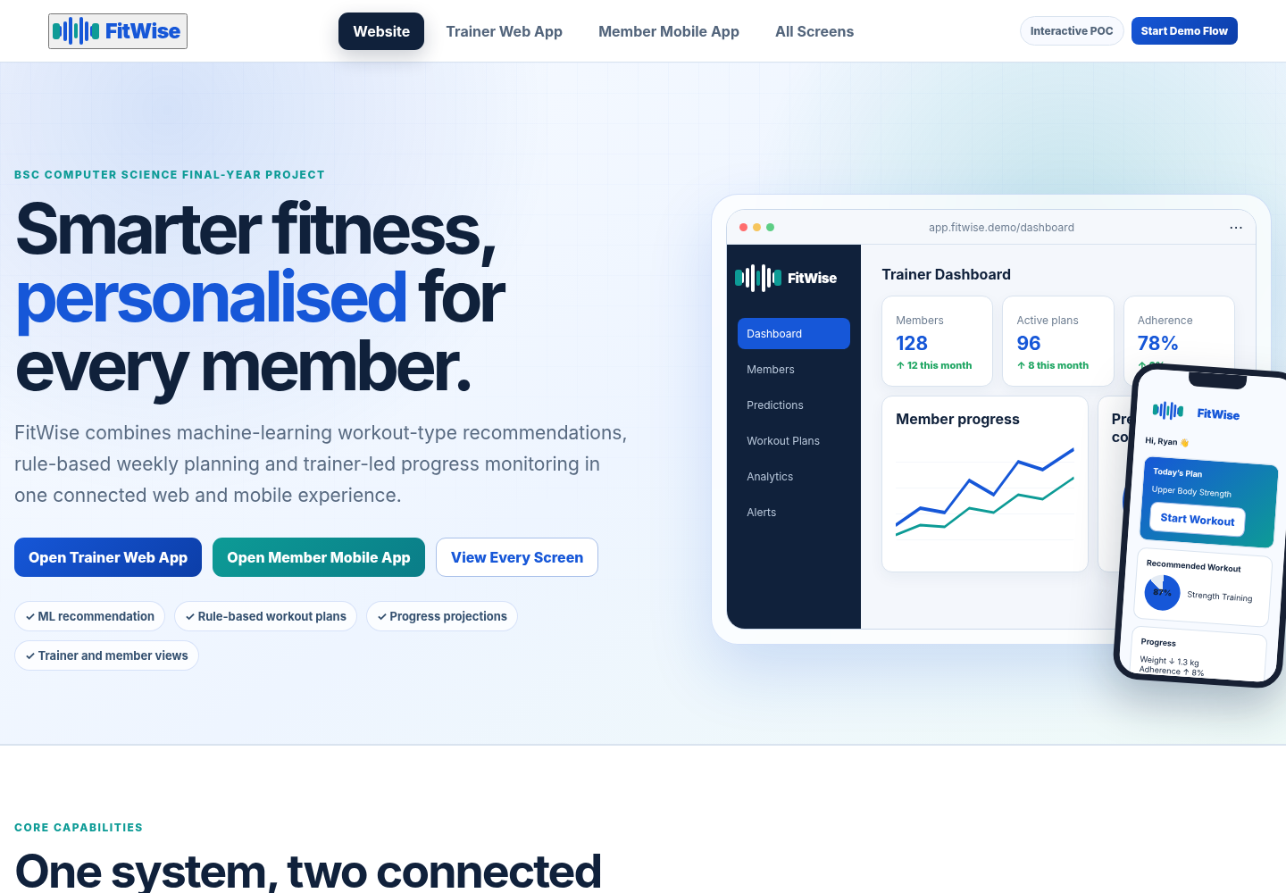
Figure I.1: FitWise proof-of-concept screen gallery
Source: Housein’s FitWise POC
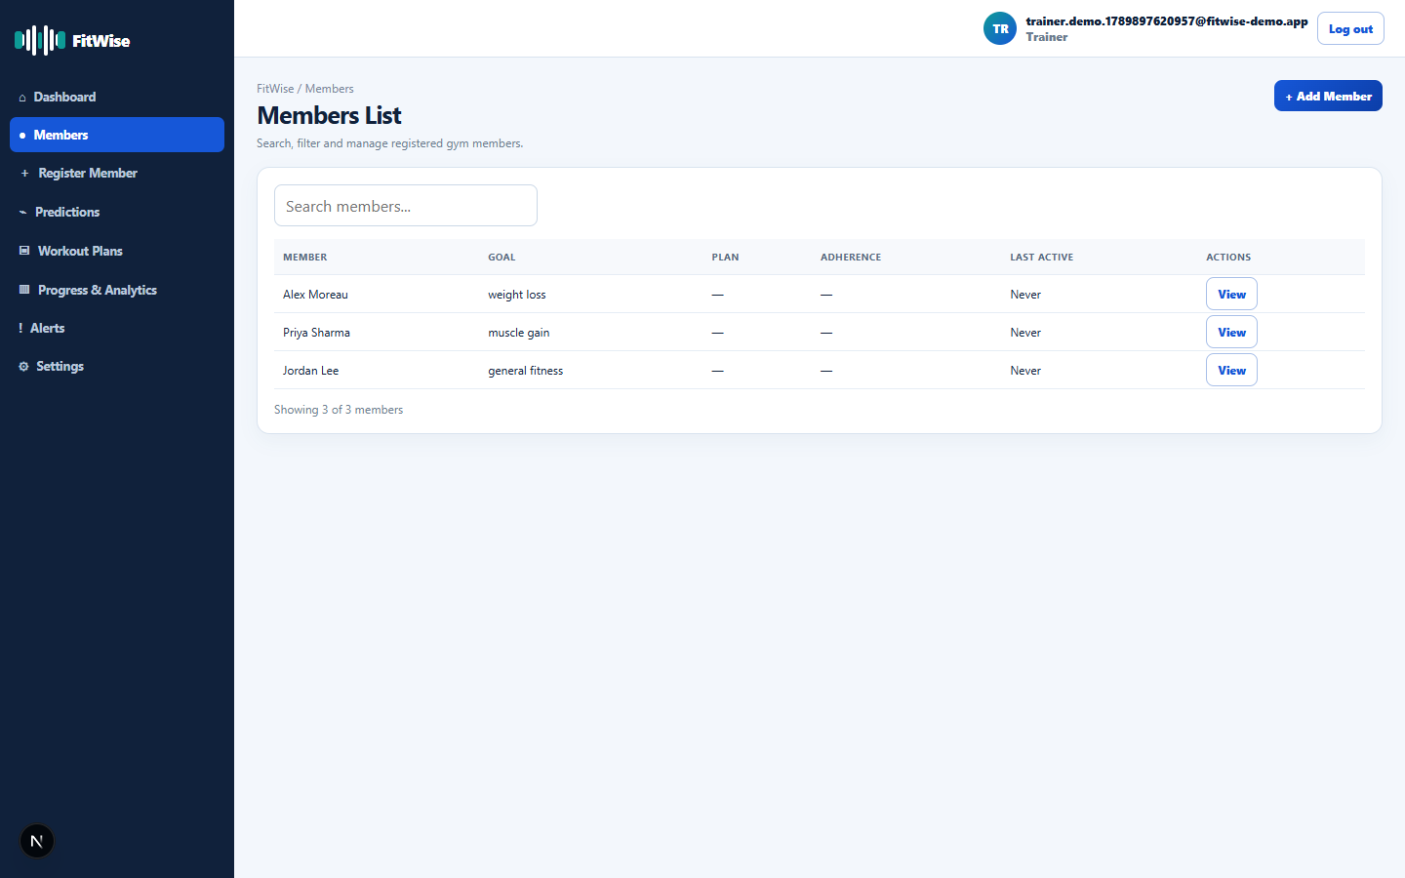
Figure I.2: Trainer member list
Source: Housein’s FitWise application
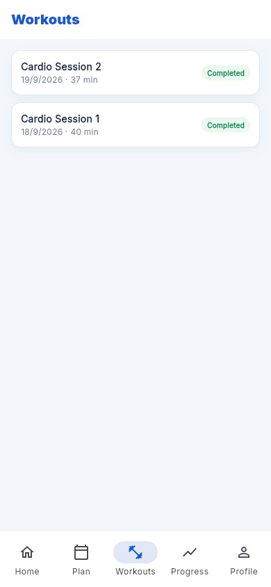
Figure I.3: Member workout history
Source: Housein’s FitWise application
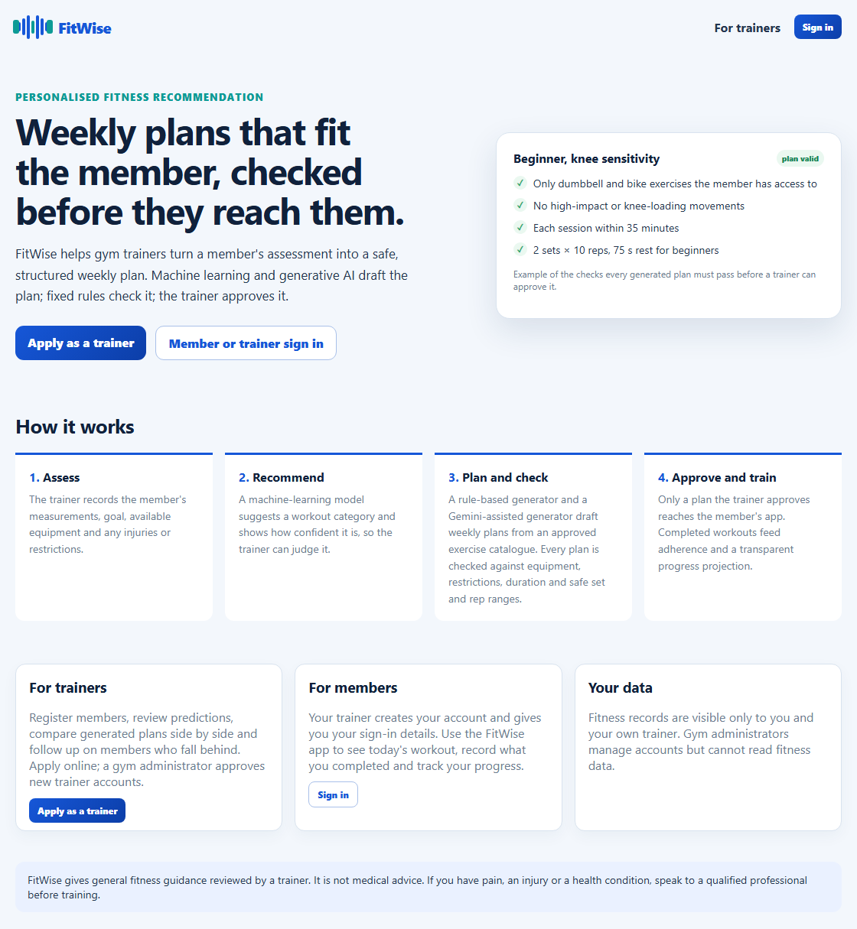
Figure I.4: Public website home page
Source: Housein’s FitWise application

APPENDIX J: PROJECT MANAGEMENT EVIDENCE

J.1 Milestone Record
Table J.1: Milestone record from project artefacts
Milestone | Evidence | Date
Interim report (Chapters 1 to 5) | Interim report submission | July 2026
Prototype lab and first trained pipeline | Initial repository commit and model artefacts | August 2026
Model retrained with class weighting | model_results.json and workout_pipeline.joblib | 14 September 2026
Final 20-profile generator evaluation | batch_comparison_results.json | 20 September 2026
Administration area, trainer applications and public website | Migration 0011 and 27 database policy checks | 28 September 2026
Final report | This document | September 2026

J.2 Change Log
Table J.2: Material changes from the original plan
Change | Reason | Reference
Firebase replaced by Next.js, Supabase, FastAPI and Flutter | Relational data, RLS and one typed web and API project | Section 3.11
Deterministic rule-based generator added alongside Gemini | Fair baseline for evaluation and a dependable fallback | Sections 6.7, 7.5
Separate prototype lab created | Controlled evidence without destabilising the application | Section 6.1
Schema simplified (JSONB plan days, completions table) | Reduced integration effort with policies preserved | Section 6.6
Mobile client reads Supabase directly under RLS | Removed a duplicate API layer | Section 6.10
Admin role and trainer self-application added | Gyms must onboard trainers without database access | Section 6.9
Usability testing moved to future work | Not completed within the timeline | Sections 7.6, 9.6

J.3 Gantt Chart and Supervision Record
[Insert the original and updated Gantt charts and the signed Student Diary / supervision meeting sheets here before submission.]

