COMPUTER STATISTIC
PROBABILITY DISTRIBUTION



KHEN MUHAMMAD CAHYO
244107023002
TI-2I
STATE POLYTECHNIC OF MALANG
INFORMATION TECHNOLOGY DEPARTMENT

ASSIGNMENT PART 1
- Age and Fare Missing Value
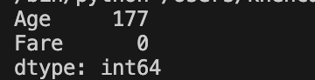
From image above, Age has 177 missing values and Fare not have missing values.
- Age and Fare Data Distribution
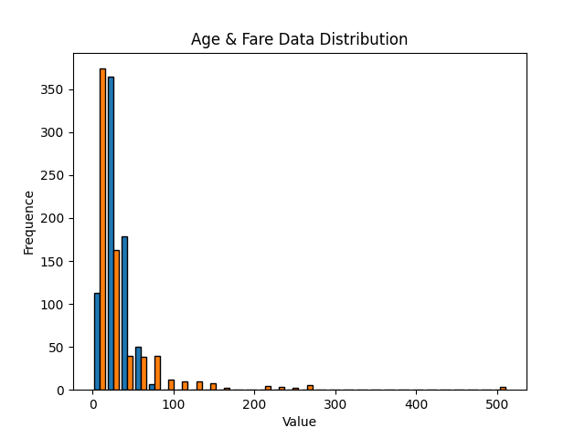
From the Histogram diagram above, it can be seen that most of the data is concentrated in low values, especially in the range of 0 to 100, with the highest frequency being in the smaller value intervals. The distribution is right-skewed, indicating that there are some values that are much larger than the majority of the data.
- Simple Data Imputation
Since the Histogram diagram shows that the data has outliers, I used the median to assign values to the missing values in the Age and Fare variables.
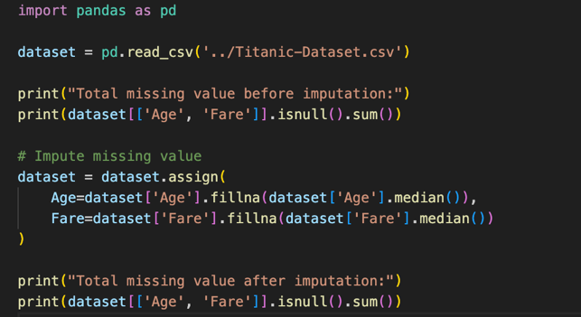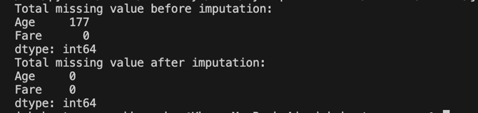

ASSIGNMENT PART 2
- Data Imputation with Mean Method
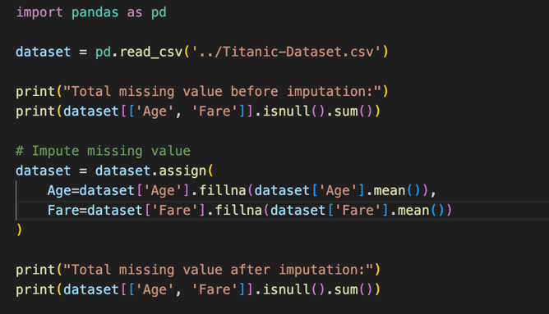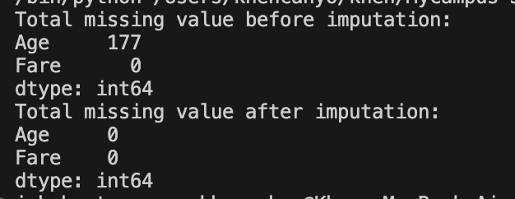
- Age Z-Score
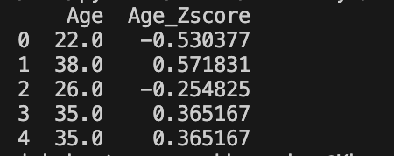
- Total Outlier from Age with |Z| > 3
- Age in Normal Distribution
