COMPUTER NETWORK PRACTICUM
PING AND ROUTE



KHEN MUHAMMAD CAHYO
244107023002
TI-2I
STATE POLYTECHNIC OF MALANG
INFORMATION TECHNOLOGY DEPARTMENT

PING PRACTICUM
- 10.10.10.1 PING
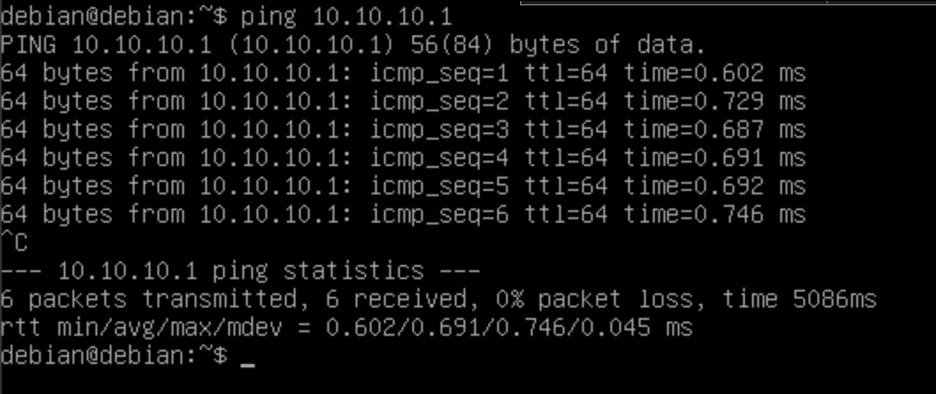
- 10x PING DETIK.COM
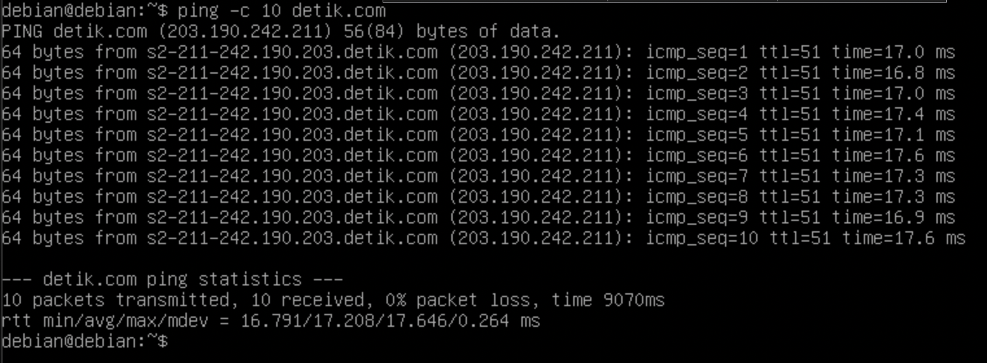
- 5x PING KOMPAS.COM WITH 3s PAUSE
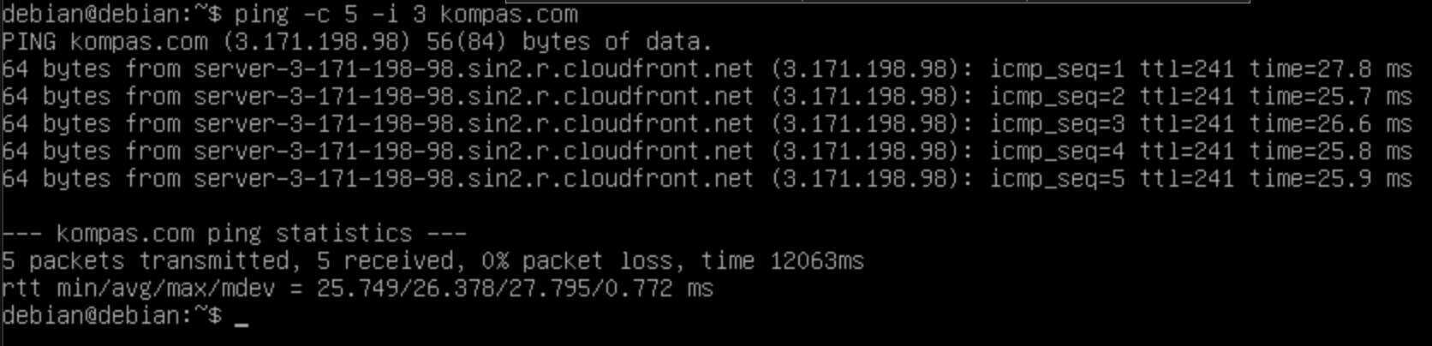
- 5x PING MICROTIC.COM WITH 0.3s TIMEOUT
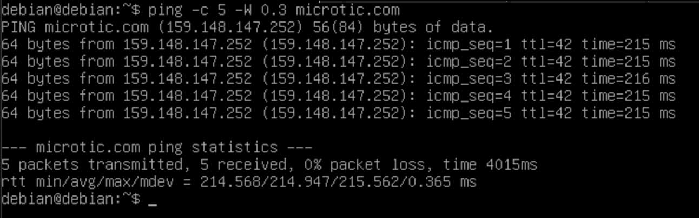

ROUTE PRACTICUM
- Route List
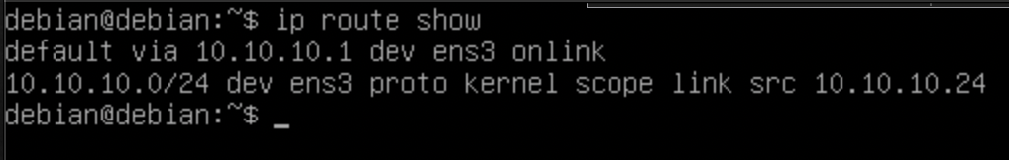
- Delete Default IP Gateway
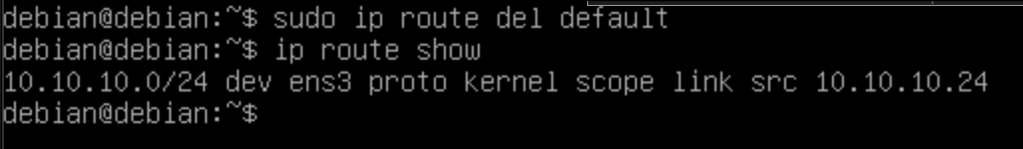
- Test PING After Delete Default IP Gateway
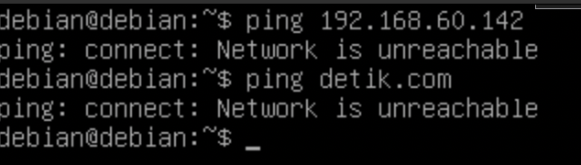
The above result occurs because the computer loses the main route to access the outside network (including the internet) so the system does not know where to send packets.
- Add Default IP Gateway
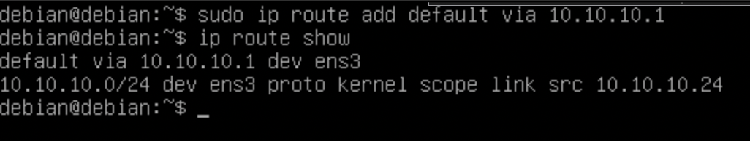

- Test PING After Add Default IP Gateway
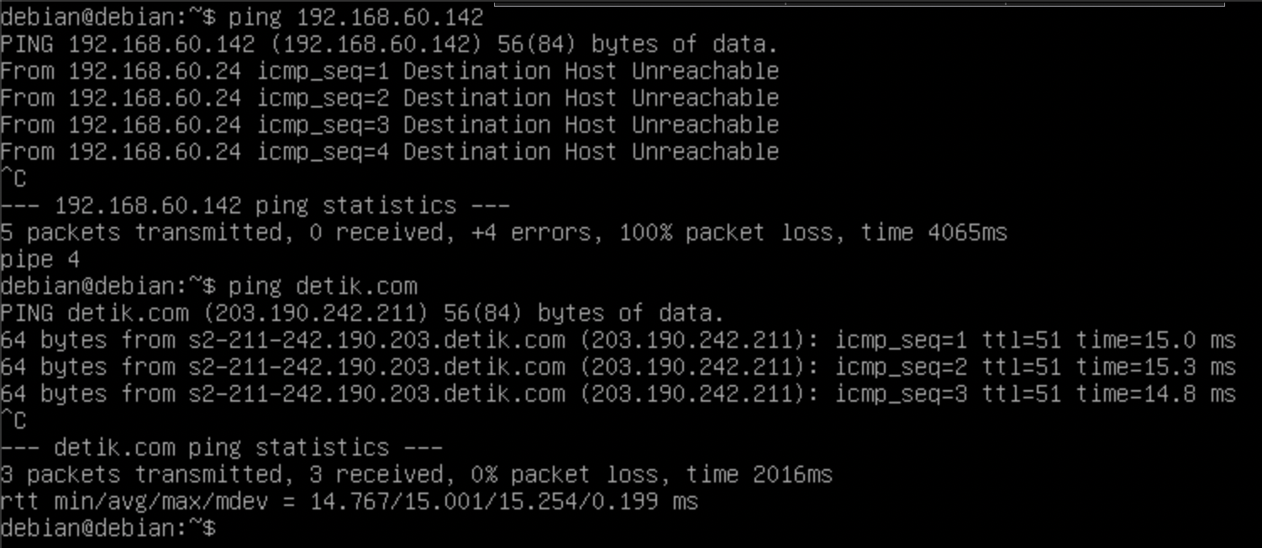
- Block Access From Range IP 10.10.10.0/24
