ADVANCED WEB PROGRAMMING
ELOQUENT ORM



KHEN MUHAMMAD CAHYO
244107023002
TI-2I
STATE POLYTECHNIC OF MALANG
INFORMATION TECHNOLOGY DEPARTMENT

PRACTICUM 1 (FILLABLE & GUARD)
- Practicum 1-3
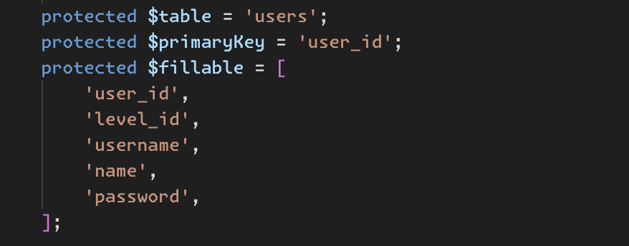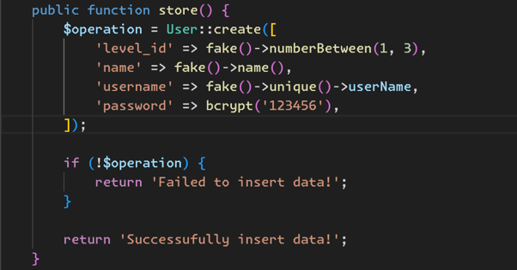
The $fillable property in the model specifies which attributes can be mass-assigned. In the store() method, a new User record is created using Laravel's User::create() method (ORM), with level_id, name, username, and password populated using Faker for random values. The password is encrypted using bcrypt().
- Practicum 4-6
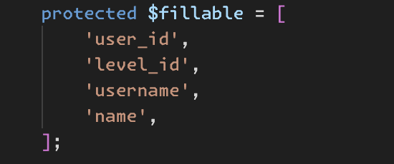
If we remove password from the $fillable array, Laravel will prevent mass assignment of the password field when using User::create() ORM. This means the store() method will fail to insert the password, causing an error or ignoring the field.

PRACTICUM 2.1 (RETRIEVING SINGLE MODELS)
- Practicum 1-3
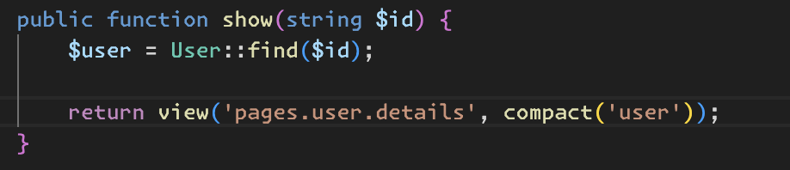
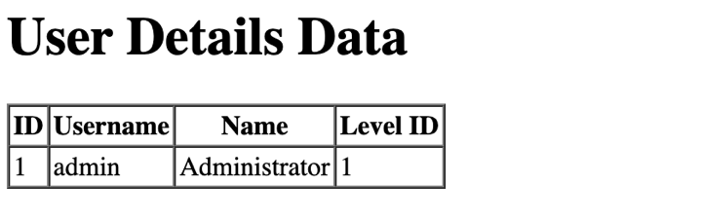
The show() method retrieves a User record by its $id using User::find($id) and passes it to the pages.user.details view using the compact('user') function. In the Blade template, the <tbody> section dynamically displays the user_id, username, name, and level_id of the retrieved user. However, if User::find($id) returns null (e.g., if the user does not exist), this code may cause an error when trying to access properties on a null object.
- Practicum 4-5
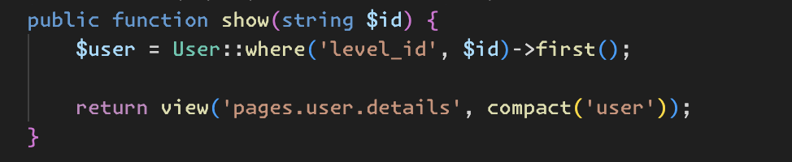
The show() method retrieves the first User record where the level_id matches the provided $id using User::where('level_id', $id)->first(). The retrieved user is then passed to the pages.user.details view using compact('user'). However, this approach assumes $id represents a level_id rather than a unique user_id, which might lead to unintended results if multiple users share the same level_id. Additionally, if no matching user is found, $user will be null.

- Practicum 6-7
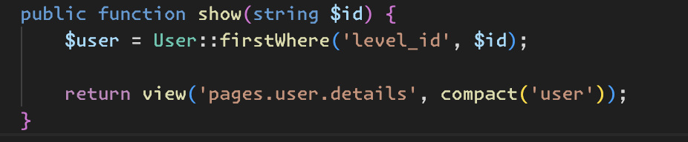
The show() method retrieves the first User record where level_id matches the provided $id using User::firstWhere('level_id', $id), which is a shorthand for where()->first(). The retrieved user is then passed to the pages.user.details view using compact('user'). However, this approach assumes $id corresponds to a level_id rather than a unique user_id, which may lead to unexpected results if multiple users share the same level_id. Additionally, if no matching user is found, $user will be null
- Practicum 8-11

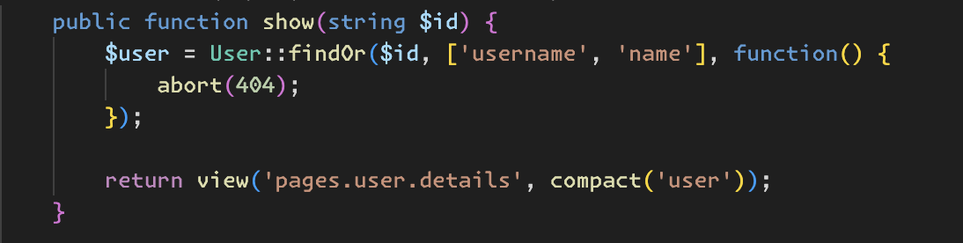
The show() method attempts to retrieve a User record with an id of $id while selecting only the username and name columns using User::findOr(1, ['username', 'name'], function() { abort(404);, ensuring that if no record is found, a 404 error is automatically returned.

PRACTICUM 2.2 (NOT FOUND EXCEPTIONS)
- Practicum 1-2
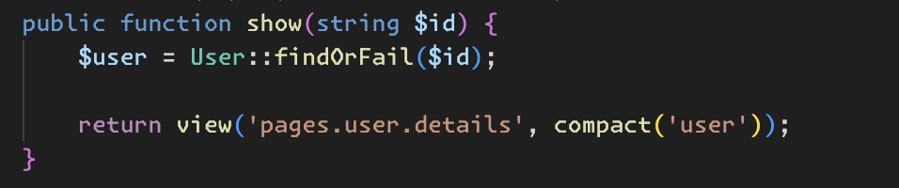
The show() method retrieves a User record by its $id using User::findOrFail($id). If a user with the given id exists, it is passed to the pages.user.details view using compact('user'). However, if no user is found, Laravel automatically throws a 404 Not Found error instead of returning null, preventing potential errors in the view when accessing user properties. This approach ensures that only valid users are displayed and provides a proper error response if the requested user does not exist.
- Practicum 3-4
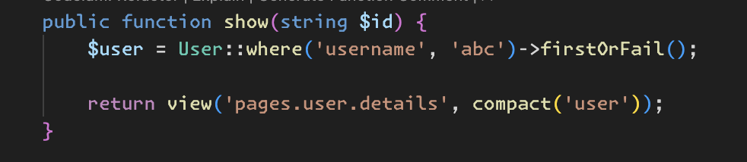
The show() method retrieves the first User record where the username is 'abc' using firstOrFail(), which throws a 404 Not Found error if no match is found. This differs from findOrFail($id), which searches by id, whereas this method always looks for the hardcoded username 'abc', making the $id parameter ineffective. To dynamically fetch a user by username, the query should use where('username', $id).

PRACTICUM 2.3 (RETREIVING AGGREGATES)
- Practicum 1-2
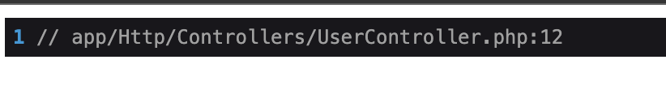
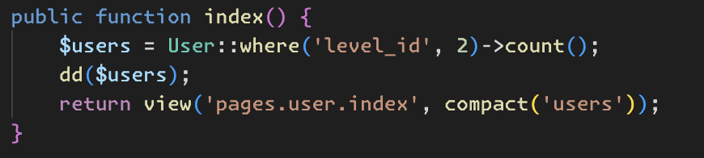
The index() method retrieves the count of User records where level_id is 2 using User::where('level_id', 2)->count(). The result, which is an integer representing the number of matching users, is stored in $users. The dd($users); (dump and die) statement then stops execution and outputs the count for debugging purposes. Because of this, the return view('pages.user.index', compact('users')); statement will never execute. To properly display the count in the view, the dd() statement should be removed.
- Practicum 3-4
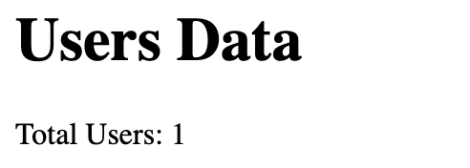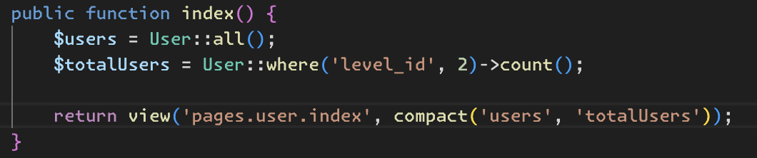
The index() method retrieves all users and counts those with level_id of 2, passing both to the view. The Blade template then displays the total count using <p>Total Users: {{ $totalUsers }}</p>.

PRACTICUM 2.4 (RETREIVING OR CREATING MODELS)
- Practicum 1-3
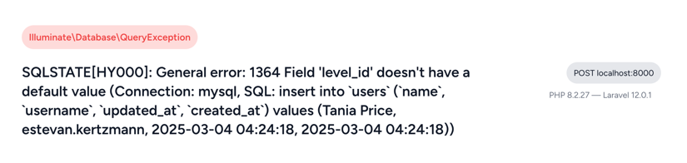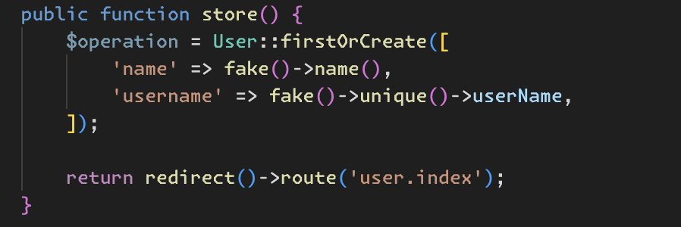
The store() method will give us errors because level_id and password don’t have default value in database and it’s not nullable columns. So we must create value for level_id and password also.
- Practicum 4-5
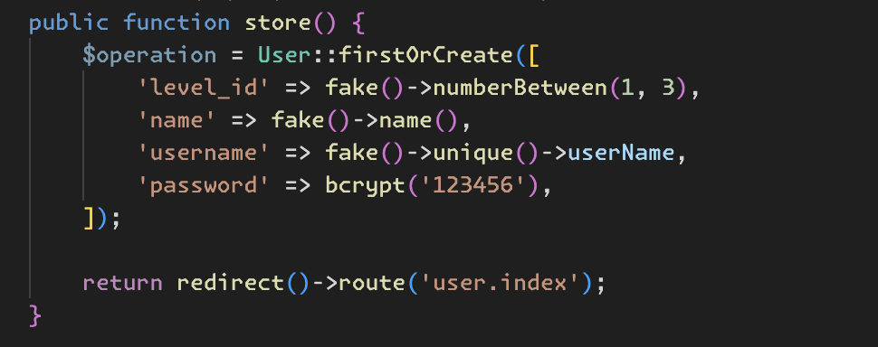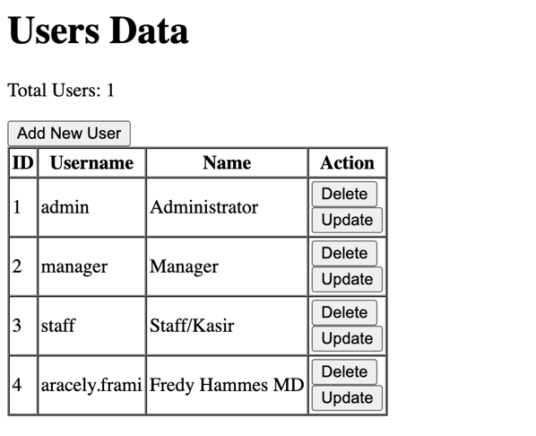
The store() method attempts to create a new User record using firstOrCreate(), which checks if a user with the given attributes already exists; if not, it creates a new one. It generates random level_id, name, and username using Faker, while the password is encrypted with bcrypt('123456').

- Practicum 6-7
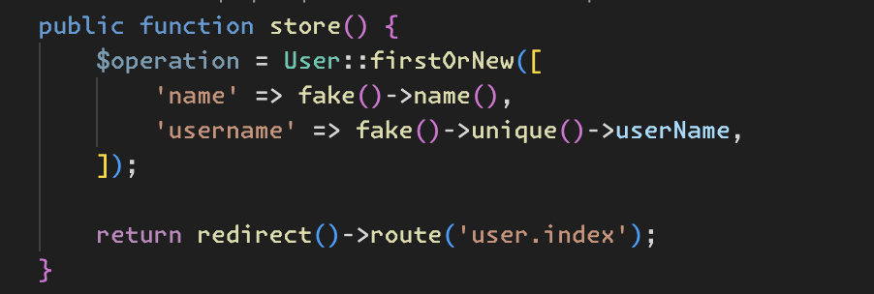
The store() method attempts to find a User with the given name and username using firstOrNew(), which returns an existing user if found or creates a new instance without saving it to the database. However, since firstOrNew() does not automatically persist the record, the new user will not be saved unless save() is explicitly called.
- Practicum 8-9
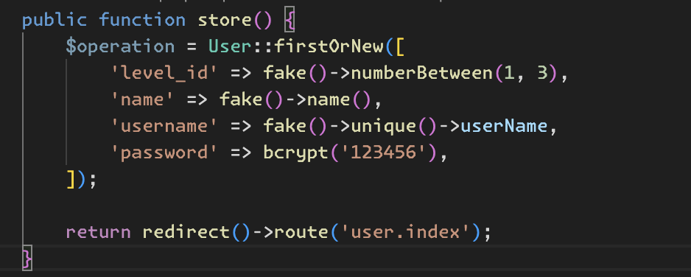
The store() method attempts to find a User with the given level_id, name, username, and password using firstOrNew(). If a matching record exists, it returns that instance; otherwise, it creates a new one but does not save it to the database unless save() is explicitly called.
- Practicum 10-11
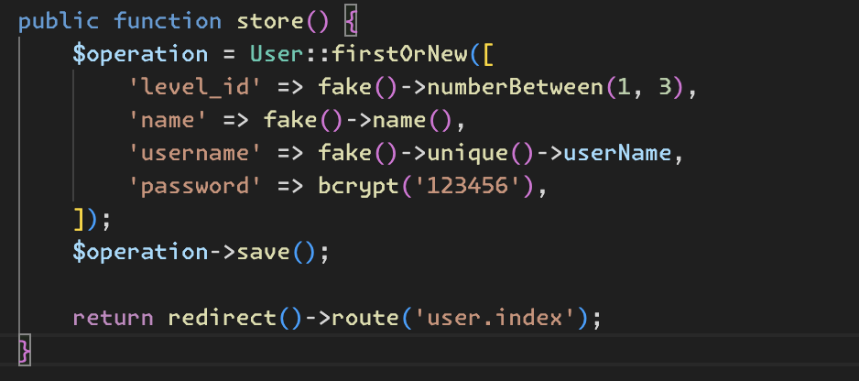
The store() method finds or creates a User without saving it immediately, then calls save() to persist it in the database before redirecting to user.index.
PRACTICUM 2.5 (ATTRIBUTE CHANGES)
- Practicum 1-2
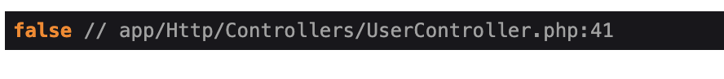
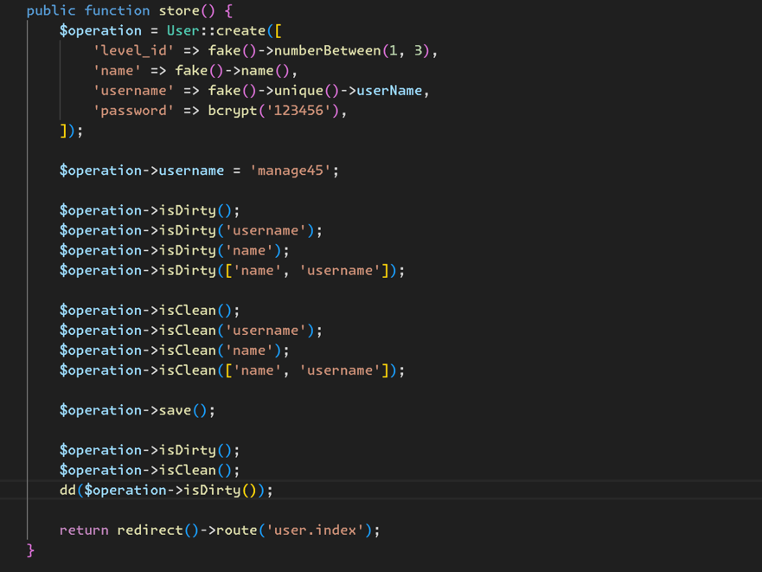
The store() method creates a new User record and assigns it to $operation. The username is then updated to 'manage45', making the model "dirty" (modified but not saved). Several isDirty() and isClean() checks are performed to determine if specific attributes (username, name) or the entire model have unsaved changes. After calling save(), the model becomes "clean" (no pending changes). Another set of isDirty() and isClean() checks is performed before dd($operation->isDirty()) dumps the final state, preventing further execution.

- Practicum 3-4
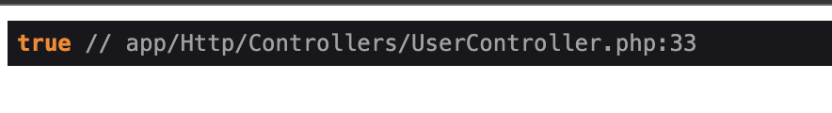
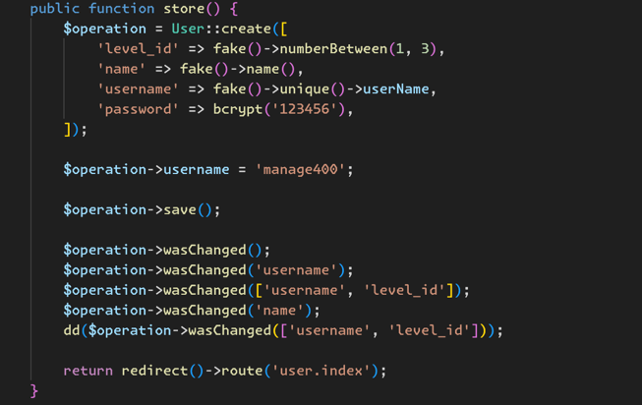
The store() method creates a new User record and assigns it to $operation. The username is then updated to 'manage400', and save() is called to persist the change. Several wasChanged() checks are performed to determine if specific attributes (username, level_id, name) were modified after saving.

PRACTICUM 2.6 (CRUD)
- Practicum 1-3
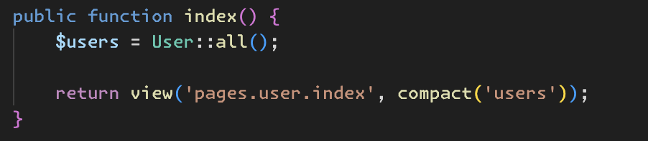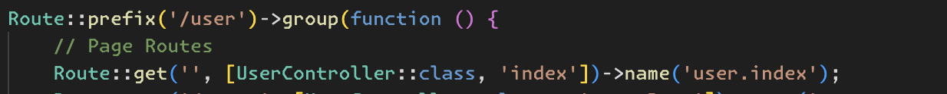
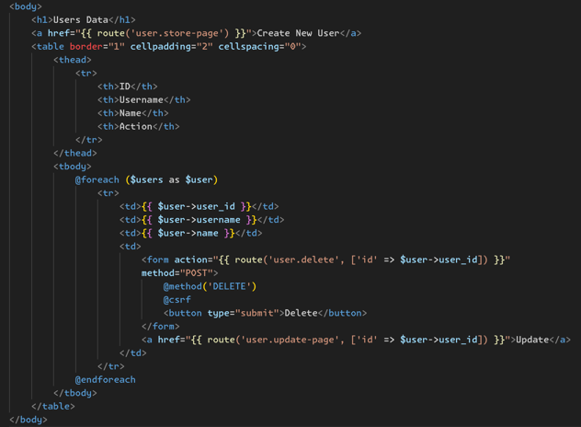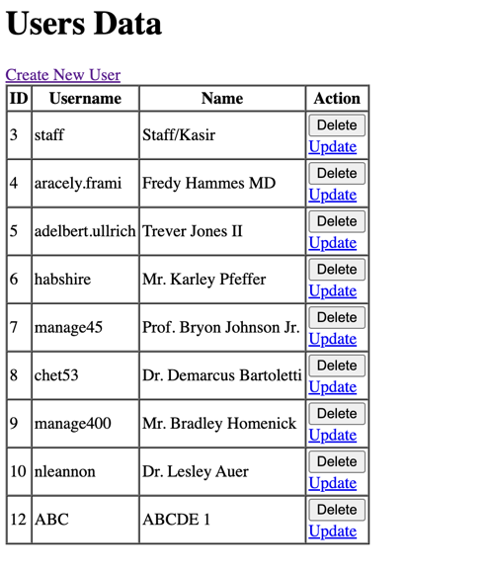
The index() method retrieves all users and passes them to the pages.user.index view. The view displays a table listing user data with options to update or delete each user. A link is provided to create a new user. The DELETE method is used for deletions, protected by CSRF. The route group prefixes /user and includes the index route for displaying users.

- Practicum 4-10
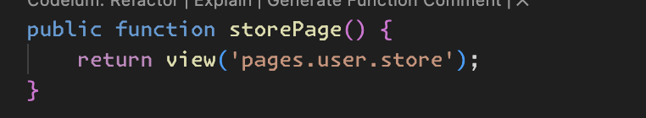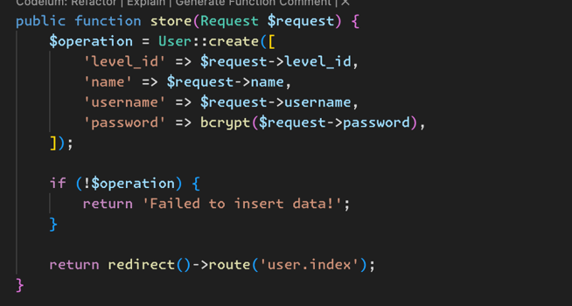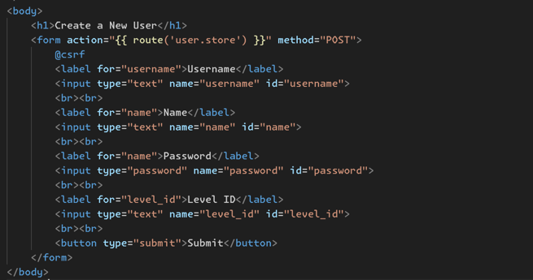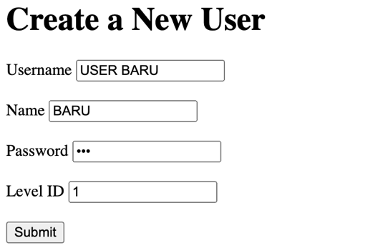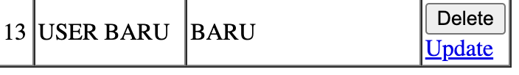
The storePage() method returns the user creation form, which submits data via POST to the store() method. This method creates a new user with the provided level_id, name, username, and hashed password. If creation fails, an error message is returned; otherwise, it redirects to the user list. The form includes CSRF protection and input fields for user details. The routes define paths for displaying and processing the form.

- Practicum 11-17
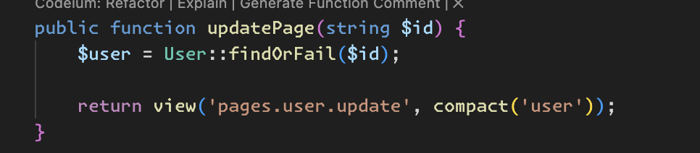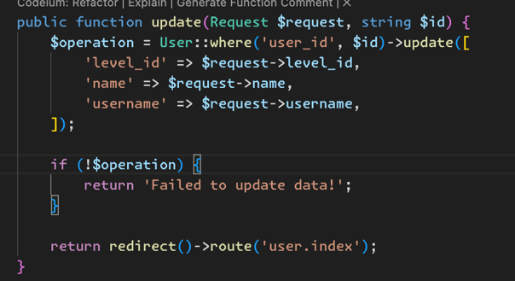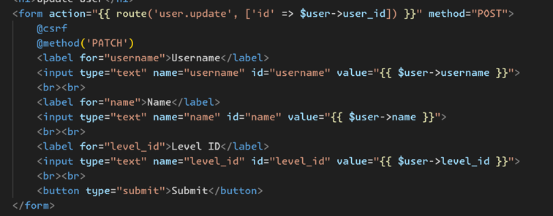
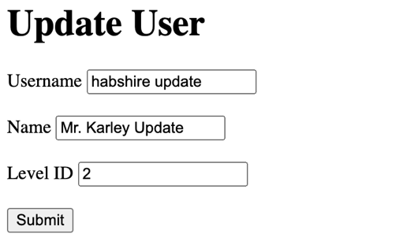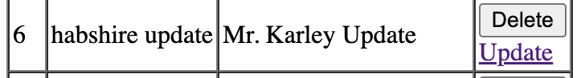
The updatePage() method retrieves a user by ID and displays the update form pre-filled with their data. The form submits a PATCH request to the update() method, which updates the user's level_id, name, and username. If the update fails, an error message is returned; otherwise, it redirects to the user list. Routes define the paths for displaying and processing updates.

- Practicum 18-20
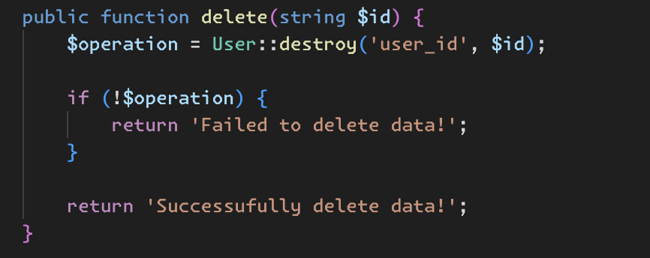

The delete() method attempts to delete a user by their user_id using User::destroy('user_id', $id), but this is incorrect because destroy() expects an ID directly, not a column name. If the deletion fails, it returns a failure message; otherwise, it confirms success. The corresponding DELETE route maps to this method, allowing users to be deleted via an HTTP DELETE request.
PRACTICUM 2.7 (RELATIONSHIP)
- Practicum 1-3
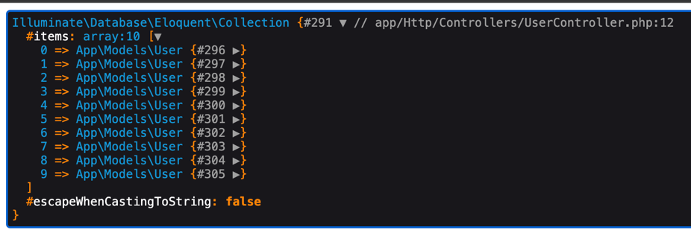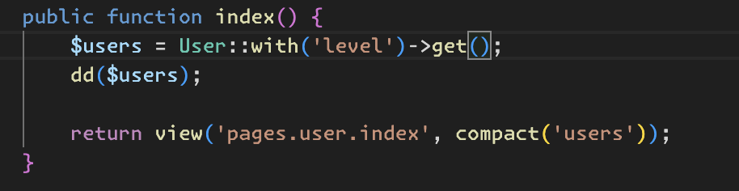
The index() method retrieves all users along with their associated level data using Eloquent's with() to eager load the relationship, then dumps the result with dd($users). The level() method defines a belongsTo relationship, linking each user to a Level model based on level_id.

- Practicum 4-6
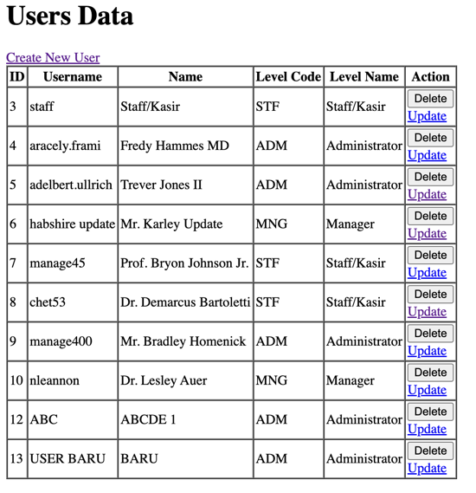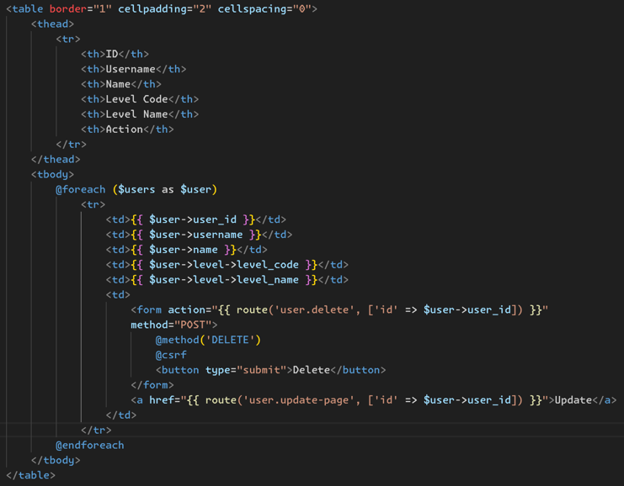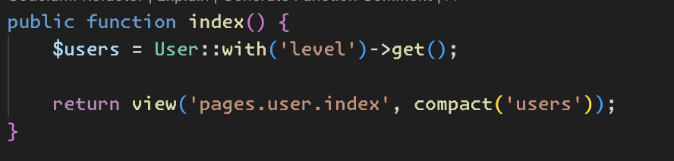
The index() method retrieves all users along with their associated level data using Eloquent's with('level') for eager loading, then passes the data to the pages.user.index view. In the view, a table displays user details, including their ID, username, name, and related level_code and level_name from the level relationship. Each row includes options to delete or update the user using a form with a DELETE request and a link to the update page.

