ADVANCED WEB PROGRAMMING
EXPORT & IMPORT



KHEN MUHAMMAD CAHYO
244107023002
TI-2I
STATE POLYTECHNIC OF MALANG
INFORMATION TECHNOLOGY DEPARTMENT

TASK 1 – IMPORT DATA
- User Level
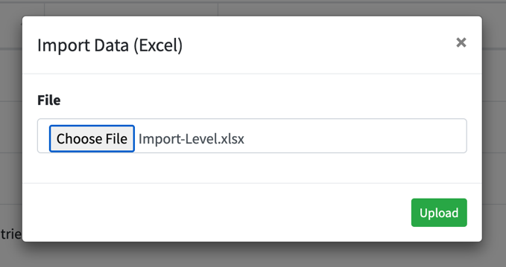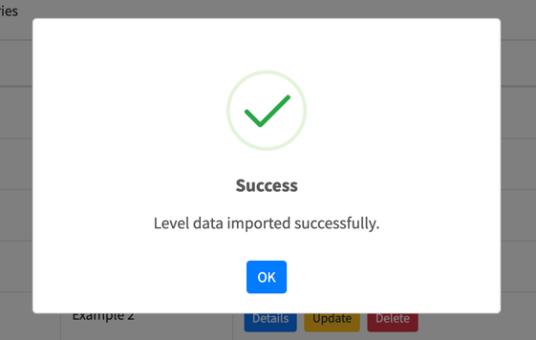
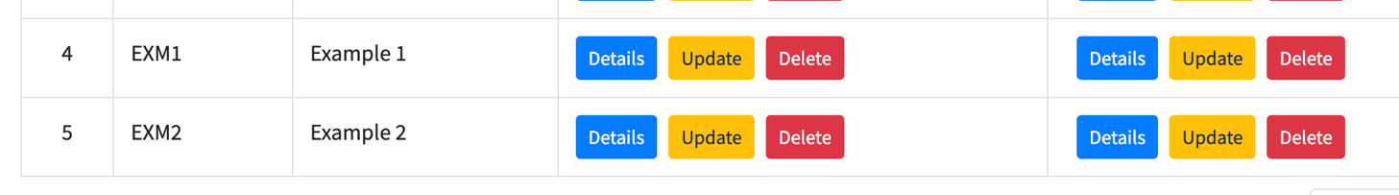
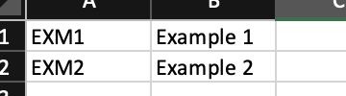
- User
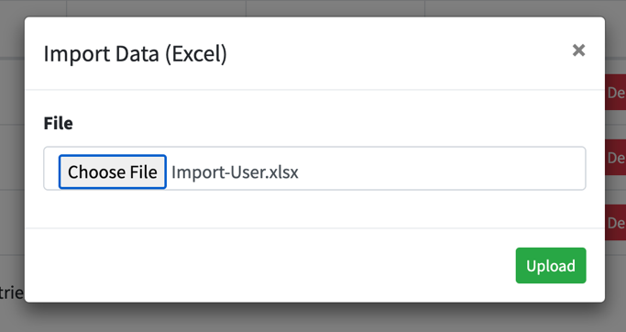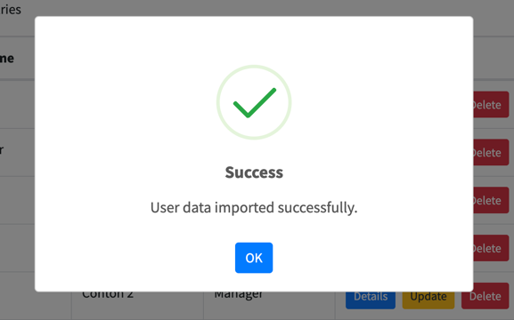
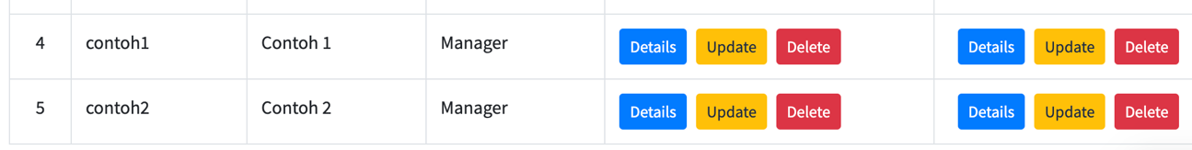
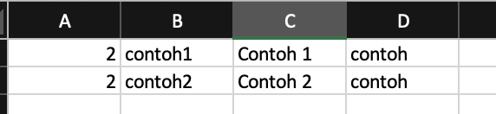

- Category
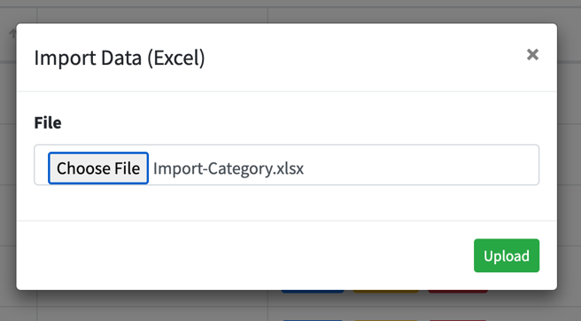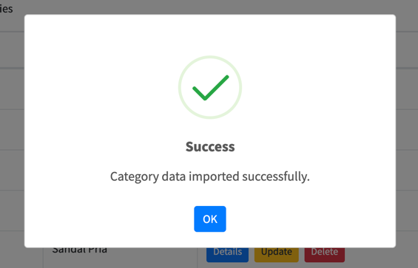
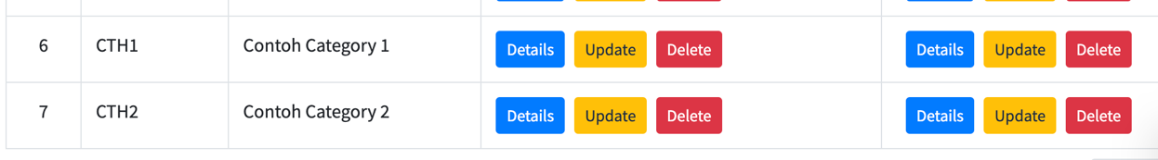
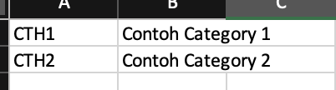
- Item
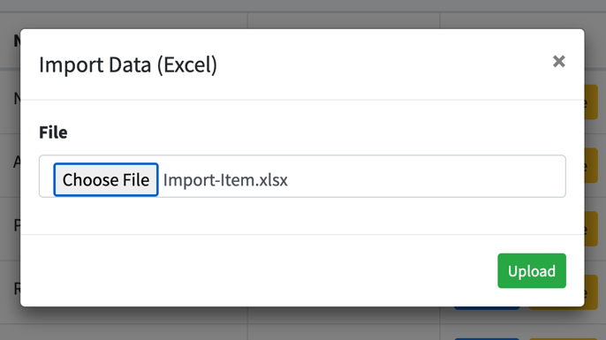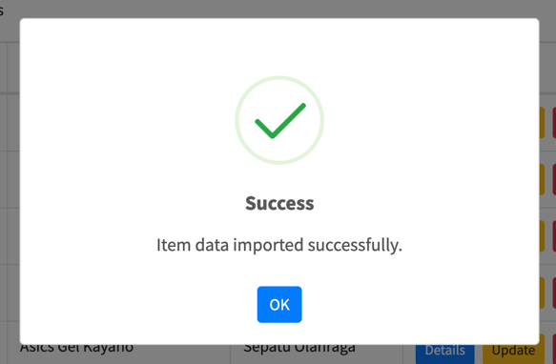
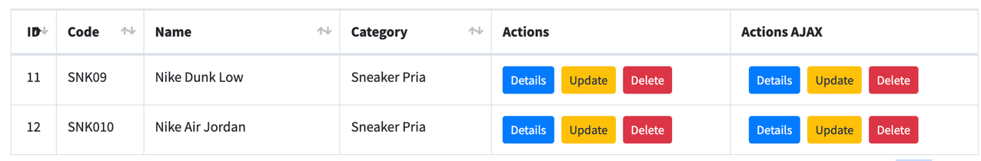
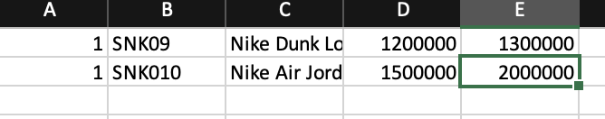

- Stock
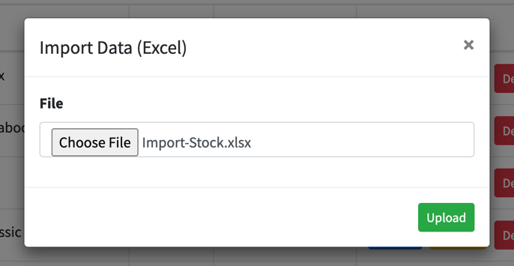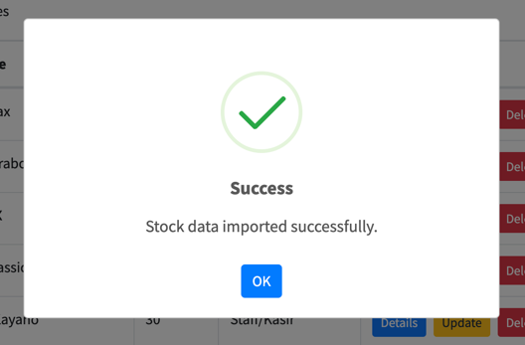
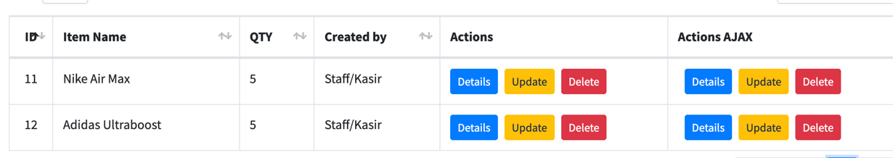
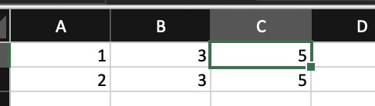
- Explanation
Because all of this feature has same code, I will explain it from one entity (User Level). For this import data from excel feature, I used Laravel Excel library from maatwebsite, and here is explanation from each steps I did.
  - Creating Import class
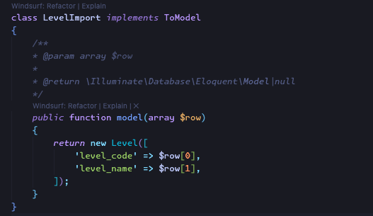
A required class used for mapping data into the database in the form of a model. This is a feature of Laravel Excel and is created with the command php artisan make:import LevelImport –model=Level.

  - Creating Controller
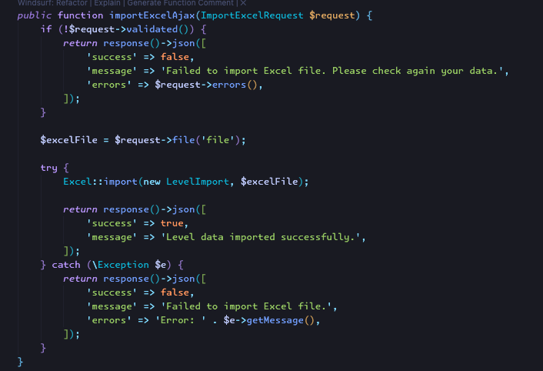
A method that used to import data from an Excel file asynchronously via AJAX. This method first validates the request using ImportExcelRequest. If the validation fails, it returns a JSON response with the failed status and error details. If validation is successful, the Excel file is retrieved from the input file, then processed using Laravel Excel from maatwebsite by running the LevelImport class to handle the import process.

  - AJAX Request
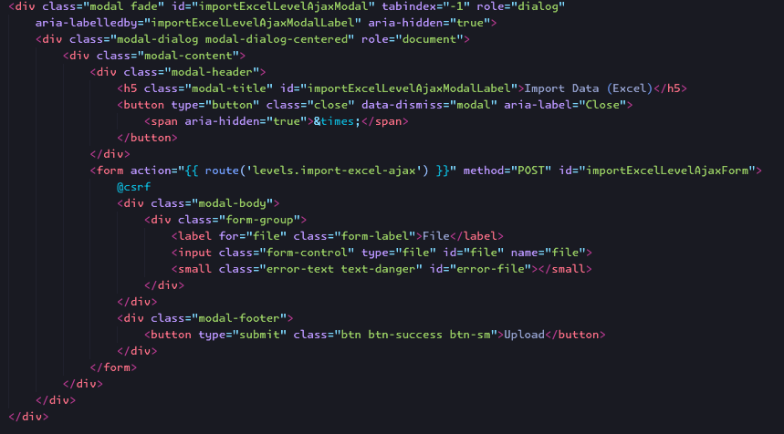
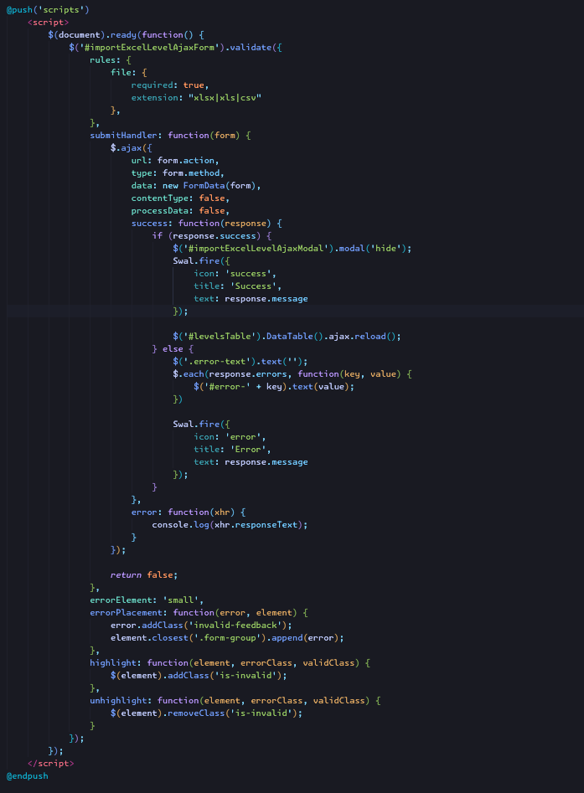

TASK 2 – EXPORT DATA (EXCEL)
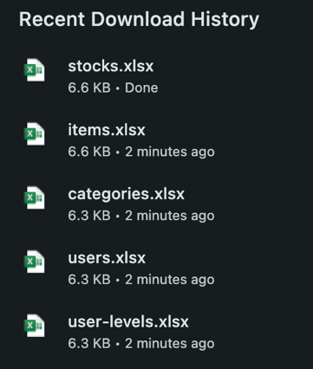
- User Level
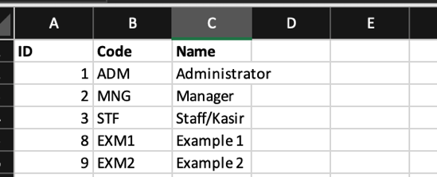
- User
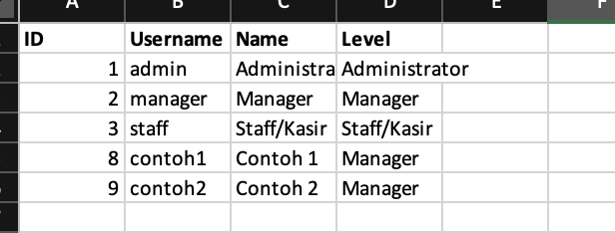
- Category
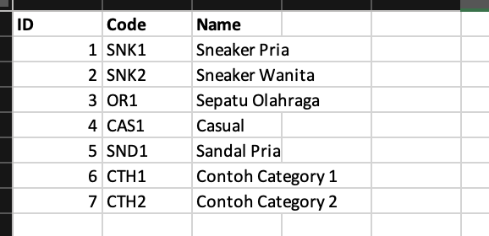

- Item
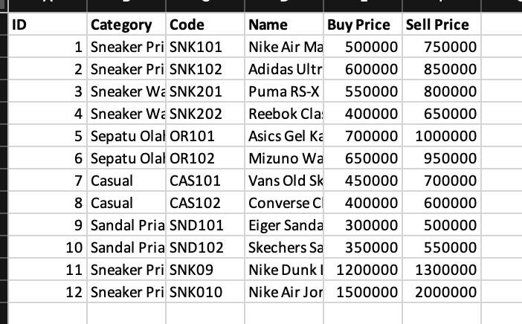
- Stock
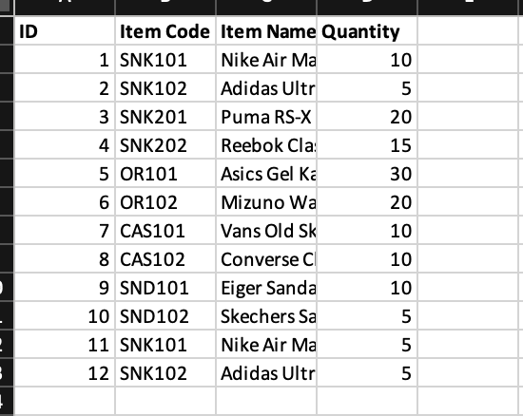

- Explanation
Because all of this feature has same code, I will explain it from one entity (User Level). For this export data from excel feature, I used Laravel Excel library from maatwebsite, and here is explanation from each steps I did.
  - Creating Export Class
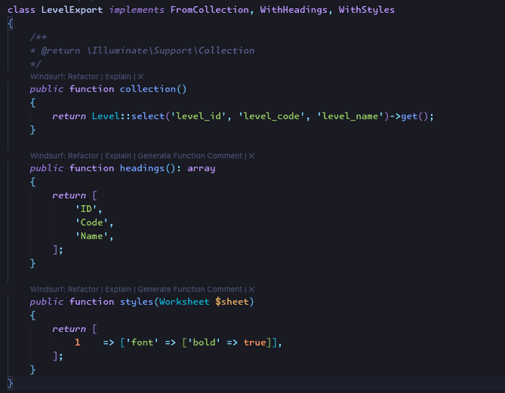
This class implements three interfaces: FromCollection to export data from the Eloquent collection (Level::select(...)->get()), WithHeadings to specify column headings on the first row of Excel (i.e. ‘ID’, ‘Code’, and ‘Name’), and WithStyles to add styles to the worksheet, where in this example, the first row is styled with bold text to highlight the headings.
  - Creating Controller
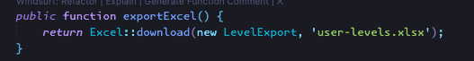
The exportExcel() function is responsible for exporting data into an Excel file and downloading it directly when called. This function utilizes the Excel facade of Laravel Excel to process the export, using an instance of the LevelExport class as the data source and export configuration. The exported file will be named user-levels.xlsx.
  - Routing & Download Action

TASK 3 – EXPORT DATA (PDF)
- User Level
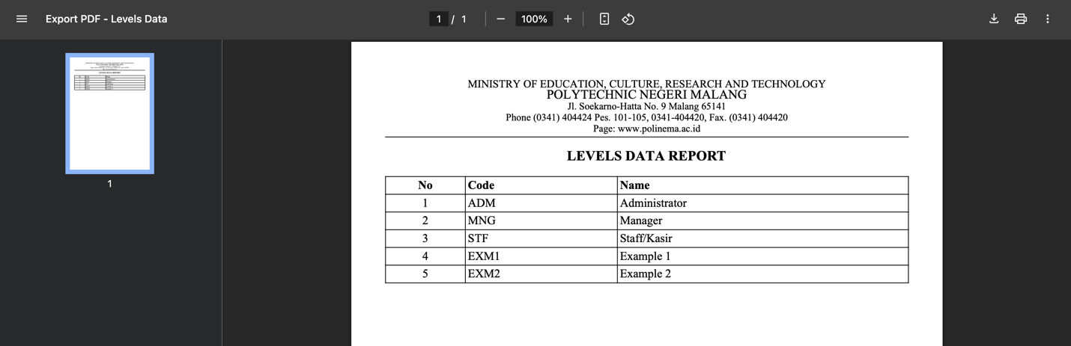
- User
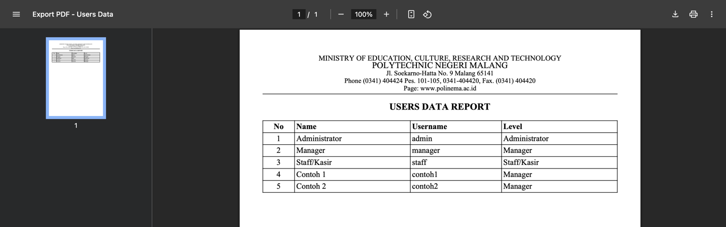
- Category
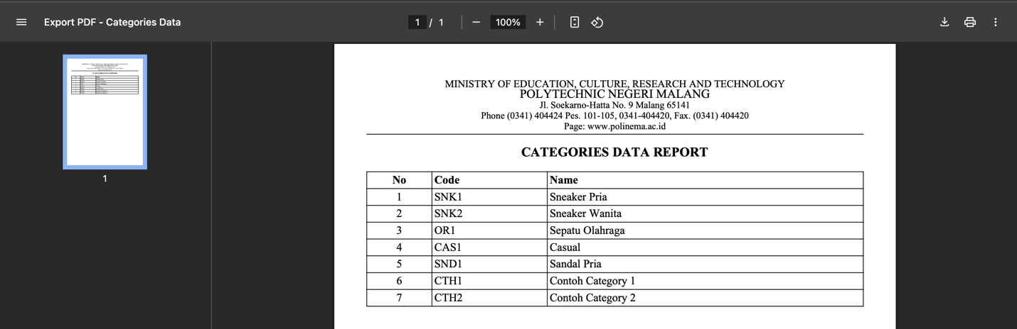

- Item
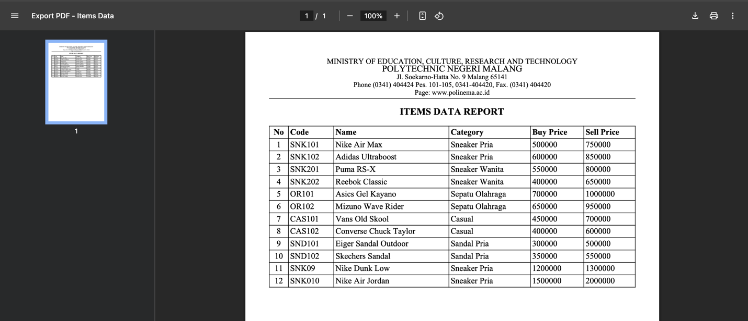
- Stock
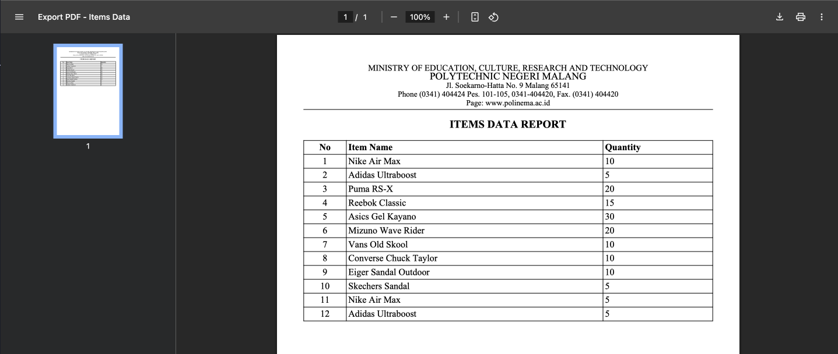

- Explanation
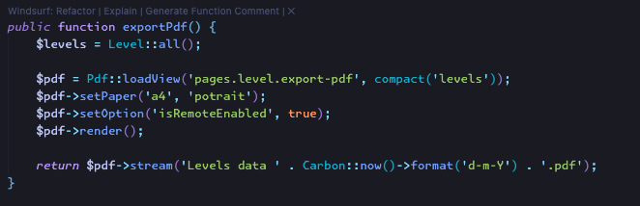
Because all of this feature has same code, I will explain it from one entity (User Level). exportPdf itself is a function used to export level data into PDF format. This function first retrieves all the data from the Level model using Level::all(), then uses the PDF library (likely barryvdh/laravel-dompdf) to load view pages.level.export-pdf with the retrieved data. After that, the PDF is set to use A4 paper size and portrait orientation, as well as enabling the isRemoteEnabled option so that it can retrieve external resources if needed. Next, the render() function is executed to process the contents of the PDF, and finally the PDF file is displayed directly in the browser using the stream() method with a filename that includes the current date.

TASK 4 – UPLOAD PROFILE PICTURE
- Results
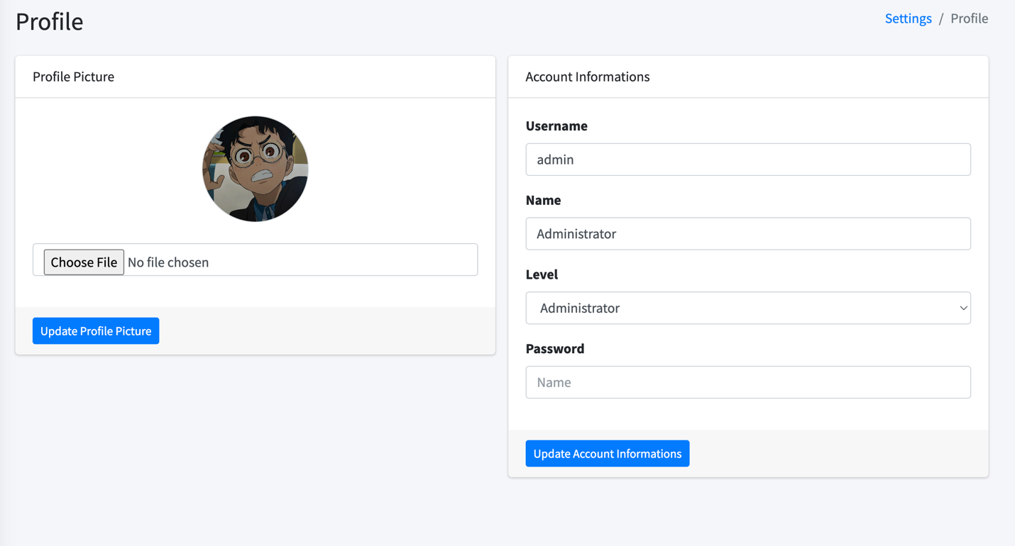

- Codes
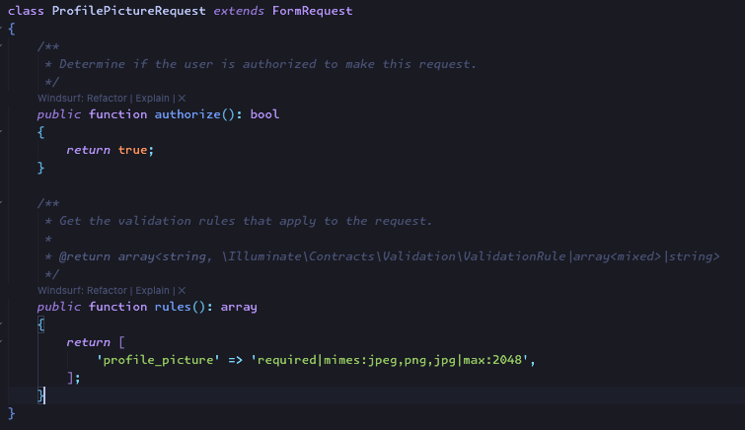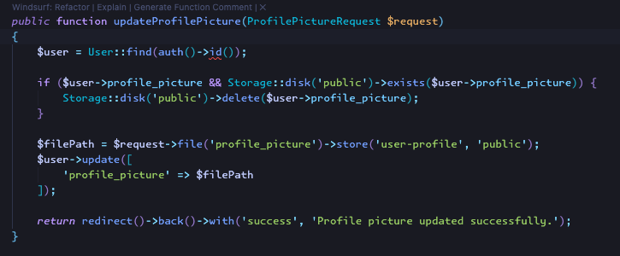
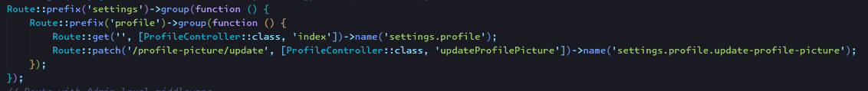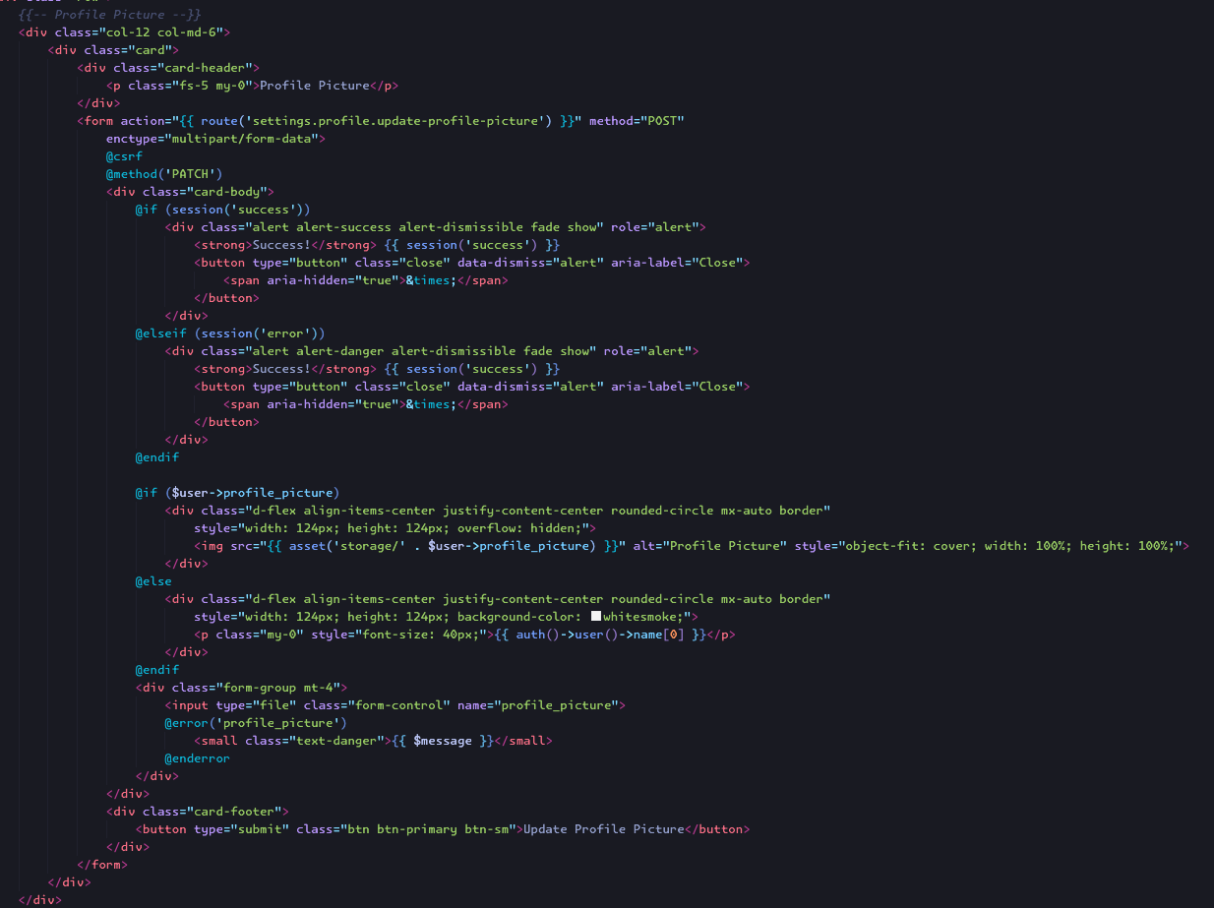

- Explanation
In the ProfilePictureRequest section, there is validation to ensure that the uploaded file is of jpeg, png, or jpg type and its size does not exceed 2MB. Inside the ProfileController, the updateProfilePicture function receives the validated request, then checks if the current user already has a previous profile picture and removes it from storage if it exists. After that, the new file is saved to the user-profile folder in the public disk, and its path is stored in the user's profile_picture field. The view displays file-type input with validation error handling, and the route uses the PATCH method to process the profile photo update request via the URL /profile-picture/update.

