COMPUTER NETWORKING PRACTICUM
APPLICATION LAYER PROTOCOL



KHEN MUHAMMAD CAHYO
244107023002
TI-2I
STATE POLYTECHNIC OF MALANG
INFORMATION TECHNOLOGY DEPARTMENT

- DIG Command
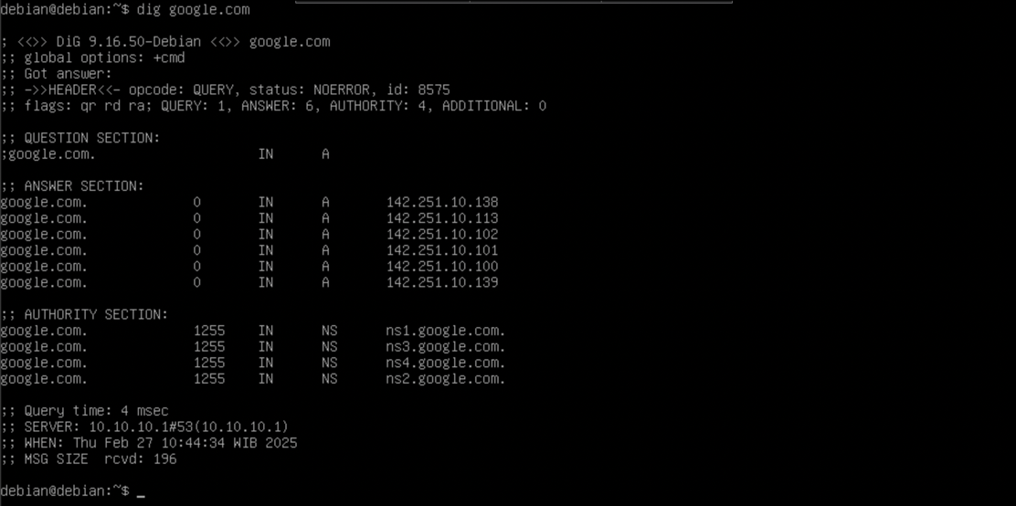
- NSLOOKUP Command
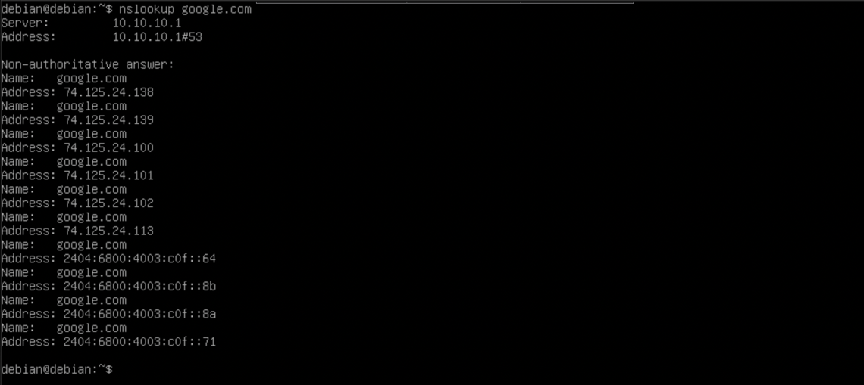

PRACTICUM PREPARATION
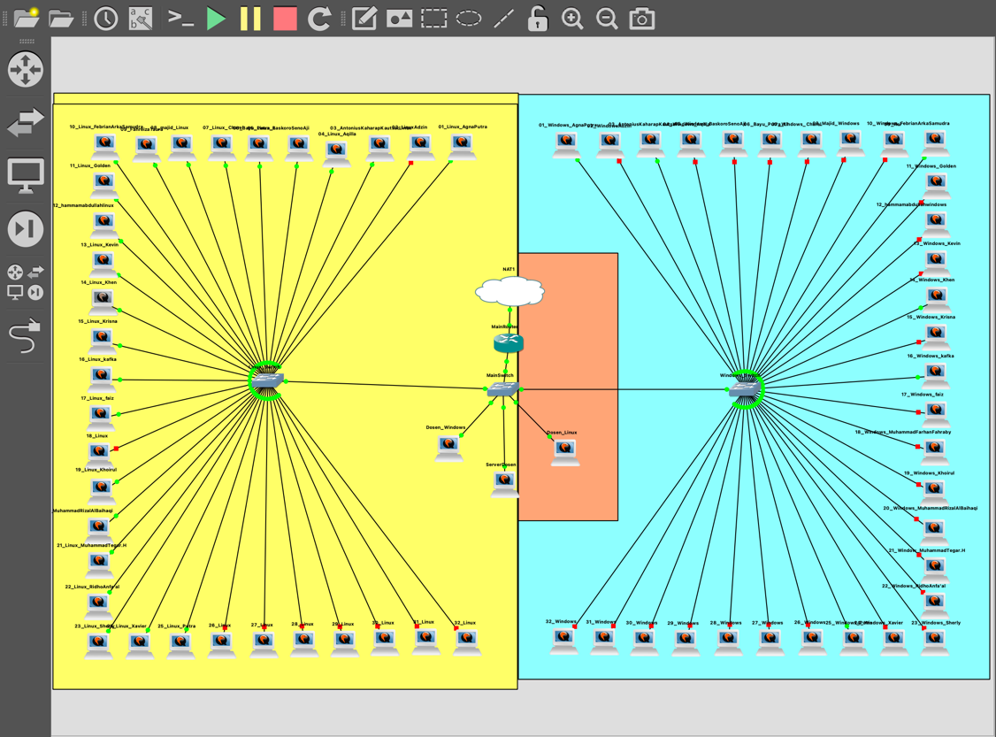

PRACTICUM 1 (LINUX DIG & NSLOOKUP)
- Check Internet Connection
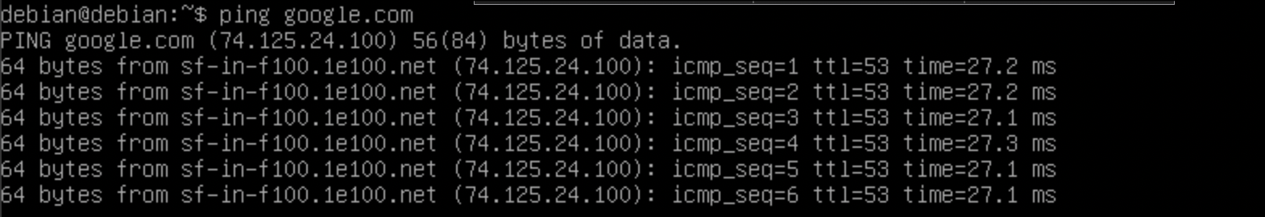
- DIG Polinema
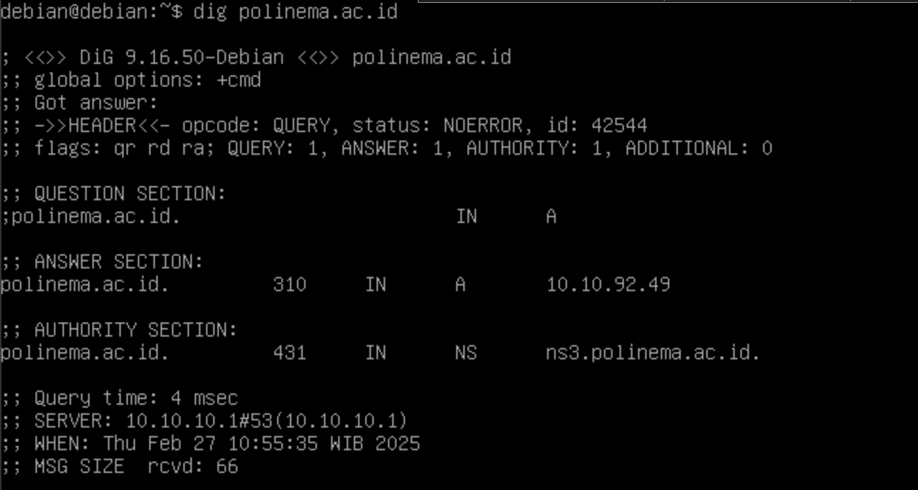
- NSLLOOKUP Polinema
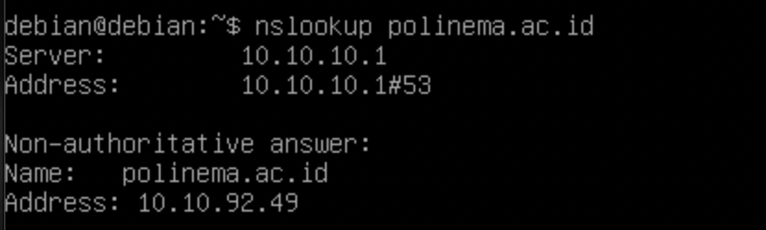

- Find Ip Address and Server Name using DIG (Google)
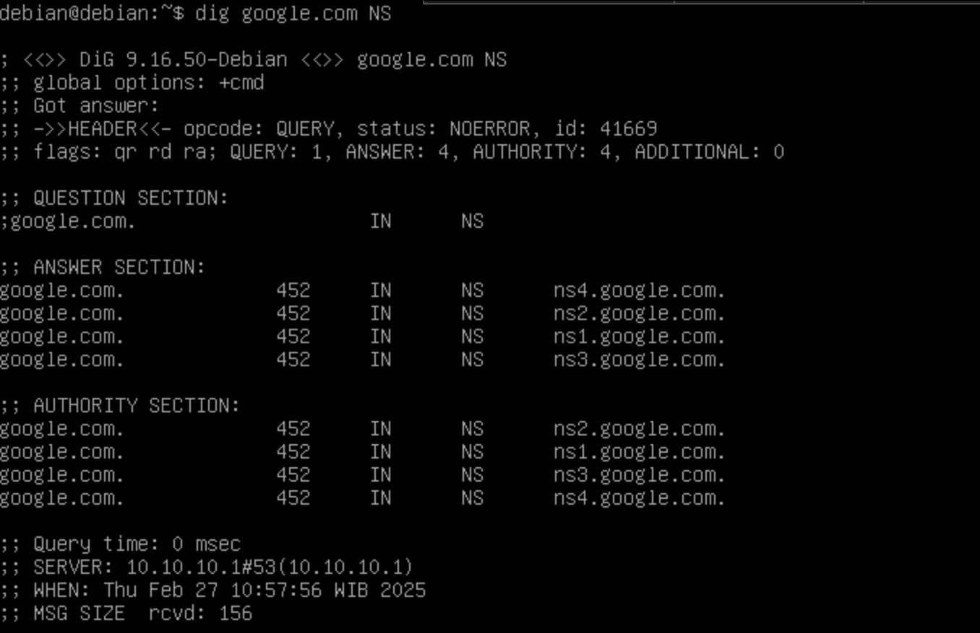
- Find Ip Address and Server Name using NSLOOKUP (Google)
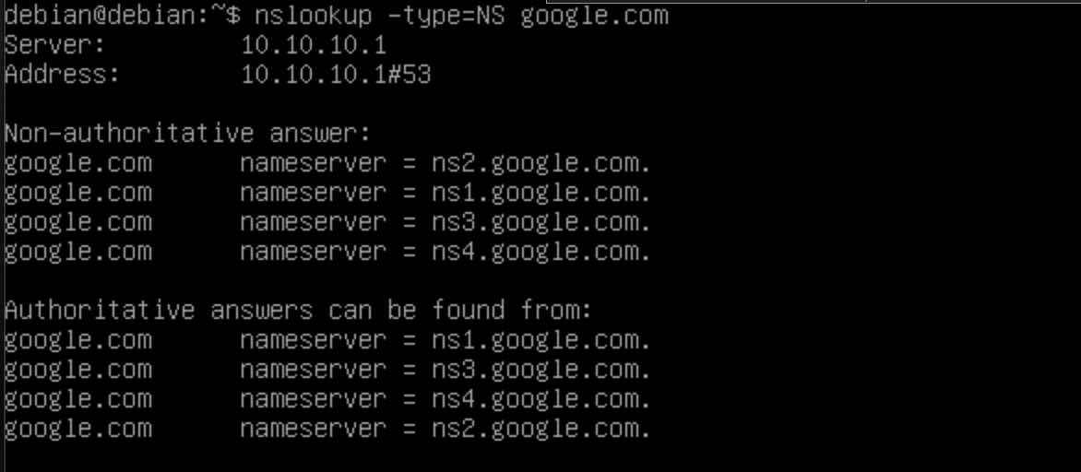
- Find Ip Address and Server Name using DIG (Polinema)
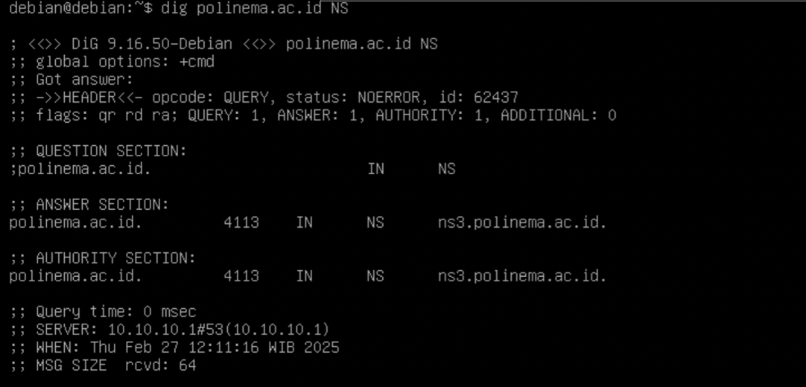

- Find Ip Address and Mail Server Name using DIG (Google)
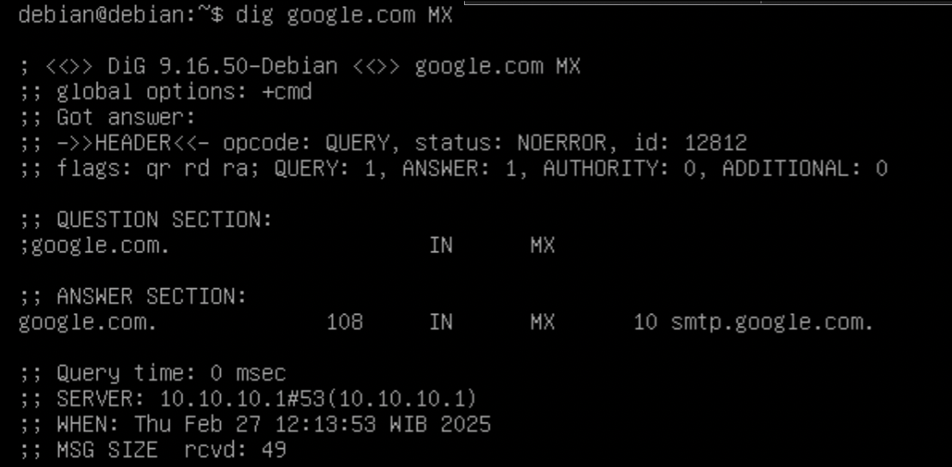
- Find Ip Address and Mail Server Name using NSLOOKUP (Google)
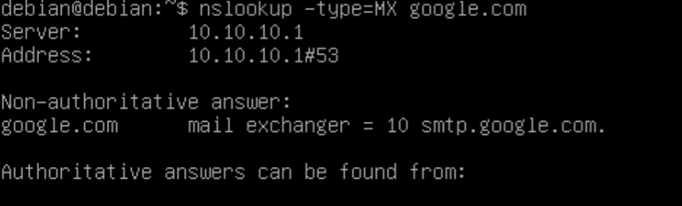
- Find Ip Address and Mail Server Name using DIG (Polinema)
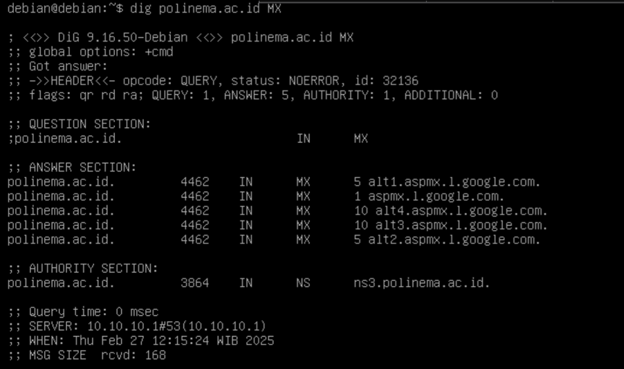
- Find Ip Address and Mail Server Name using NSLOOKUP (Polinema)
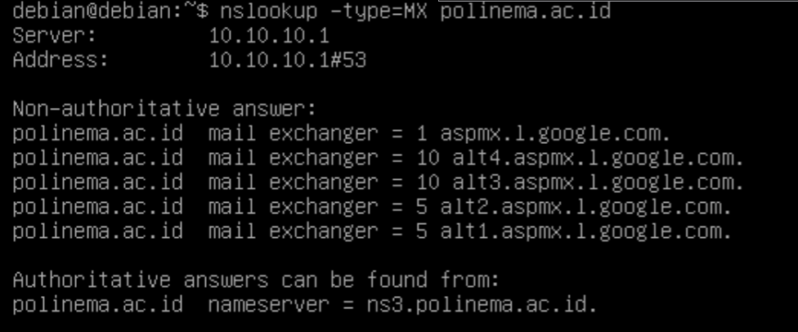

PRACTICUM 2 (LINUX SSH)
- Connect to Class SSH
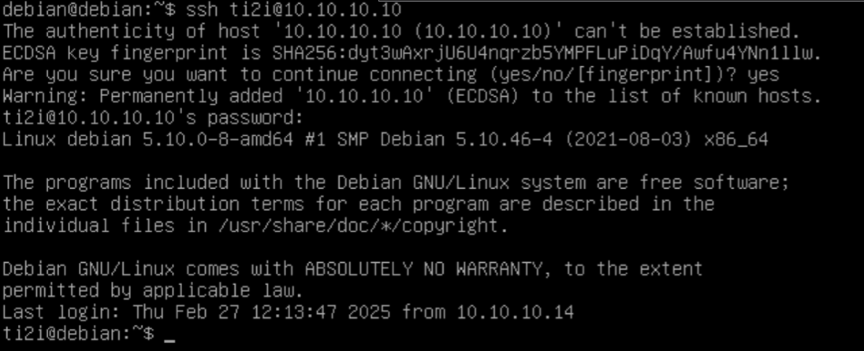
- Creating Directory
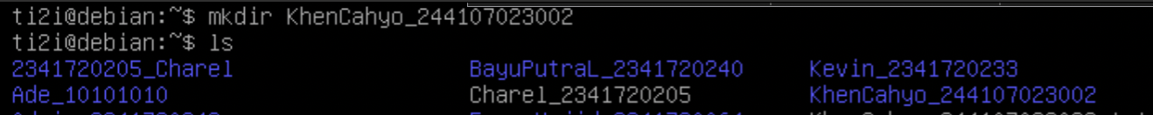
- Moving .txt File
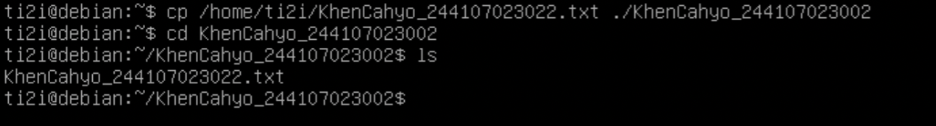
- Edit File Content
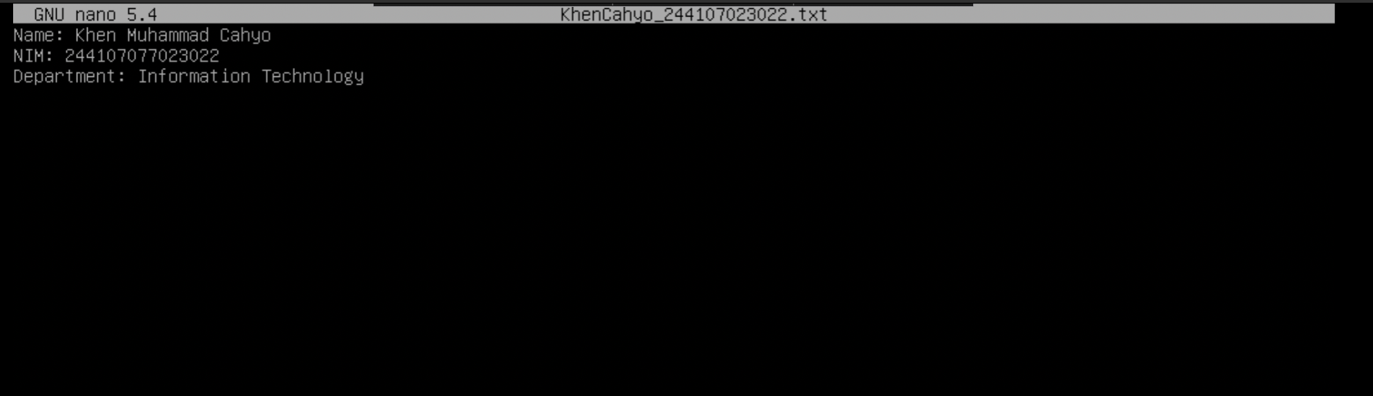
- Logout From SSH
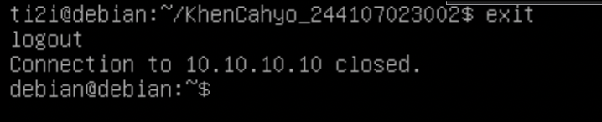

PRACTICUM 2 (LINUX FTP)
- Creating New File
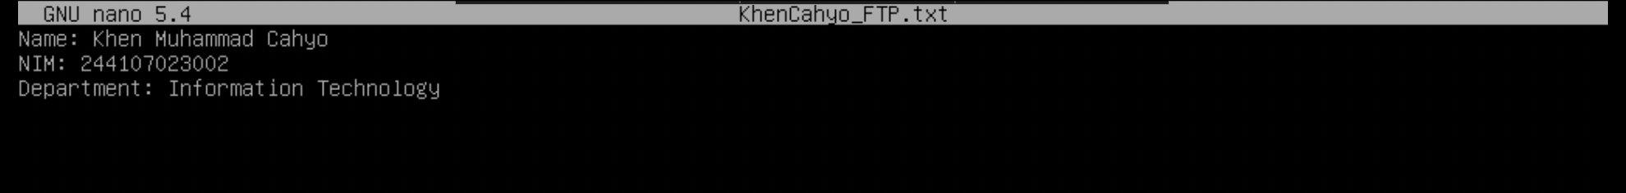
- Installing FTP
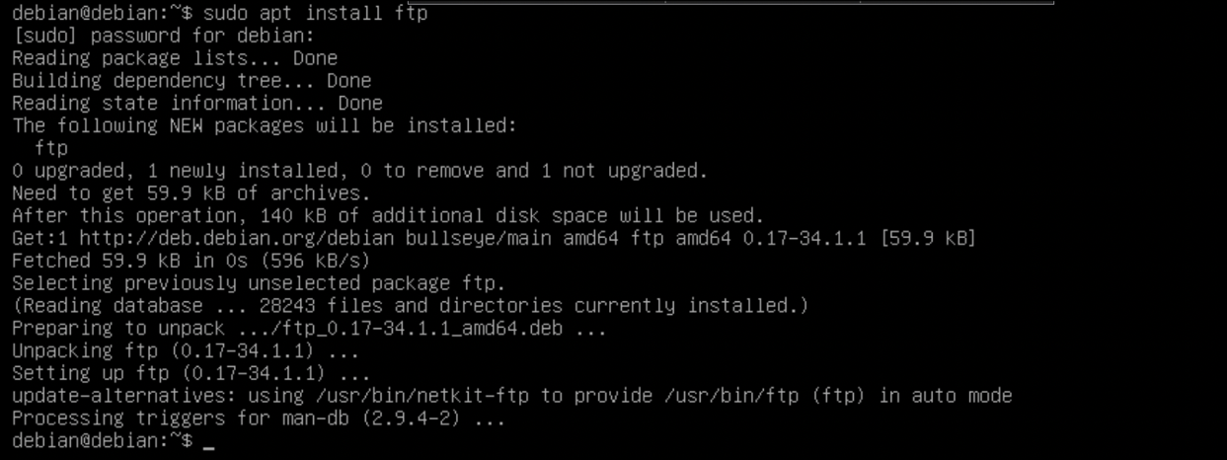
- Getting File From FTP
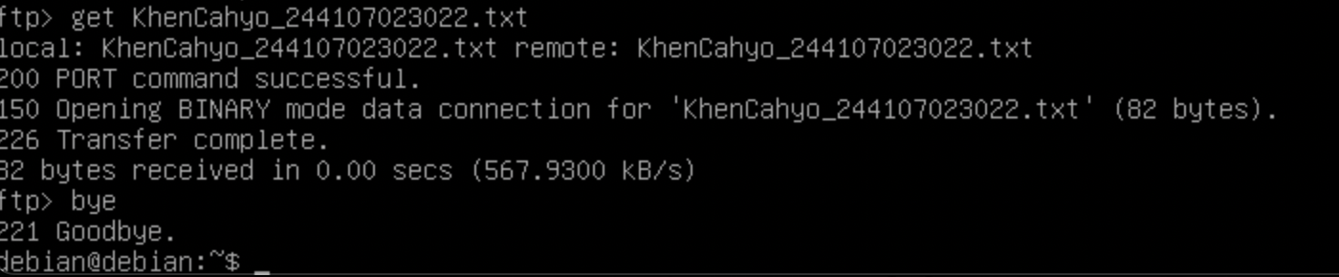
- Putting File From FTP
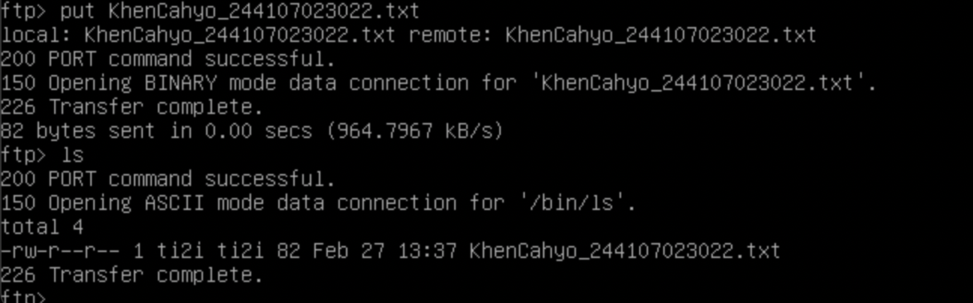

PRACTICUM 1 (WINDOWS NSLOOKUP)
- Check Connection
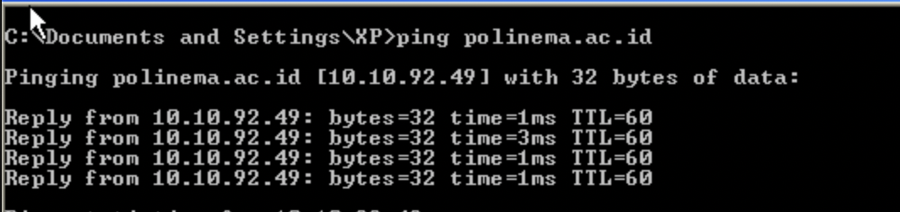
- NSLOOKUP Polinema
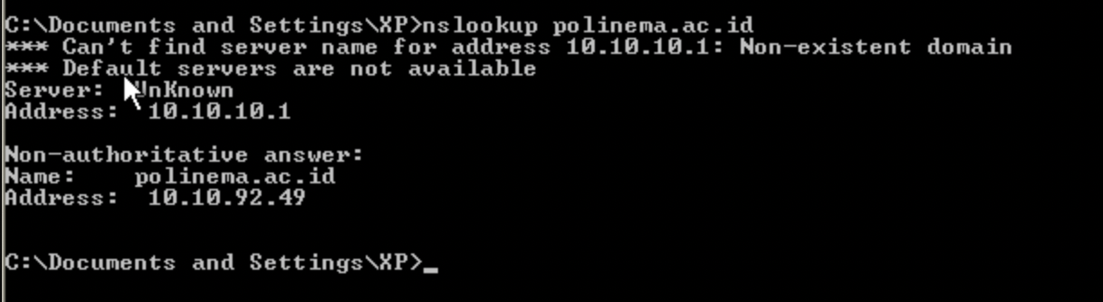
- Find Ip Address and Server Name using Polinema
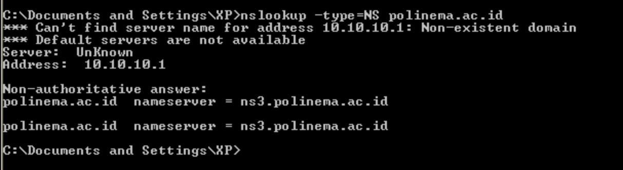
- Find Ip Address and Mail Server Name Polinema
