DECISION MAKING SYSTEM
ANALYTICAL HIERARCHY PROCESS (AHP)



KHEN MUHAMMAD CAHYO - 244107023002
XAVIER ZAIDANE ATHAYA – 2341720189
MIKAILA KAFKA AKMALSYAH - 2341720223

STATE POLYTECHNIC OF MALANG
INFORMATION TECHNOLOGY DEPARTMENT

- Background
A manufacturing company is looking for the best supplier to procure its main raw materials. This decision is very important because it will affect production costs, product quality, and operational efficiency. For this reason, the company uses the Analytical Hierarchy Process (AHP) method as a Decision Support System (SPK) in determining the best supplier.
- Goals
Determine the best supplier that provides maximum benefits at minimal cost.
- Breakdown Process
In this assignment, we analyze and break down the criteria into 2, namely benefits and costs. The following are the criteria based on these categories:
- Benefits (The higher the score, the better)
- Raw Material Quality: Standard raw materials that meet company specifications.
- Delivery Speed: The time it takes for suppliers to deliver orders.
- Supplier Reputation: The supplier's credibility and track record in the industry.
- After-Sales Service: Technical support, warranty, or replacement of problematic products.
- Costs (The lower the value, the better)
  - Price per Unit: The cost per unit of raw materials offered by the supplier.
  - Shipping Cost: Logistics and transportation costs that must be incurred by the company.
  - Minimum Order Quantity: The minimum amount that must be purchased in one transaction.
  - Risk of Delay: Possible delays that could affect production.
For alternatives, we have 4 alternatives:
- Supplier A
- Supplier B
- Supplier C
- Supplier D

- Hierarchy of Problems
After we find the criterias and alternatives, we then draw a hierarchy diagram as follows:
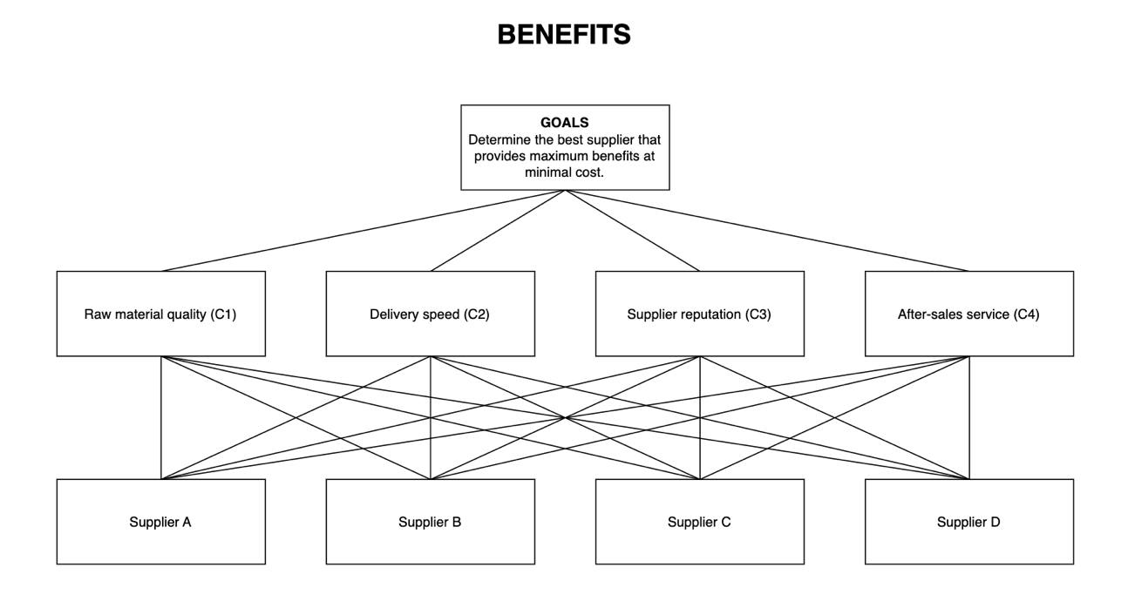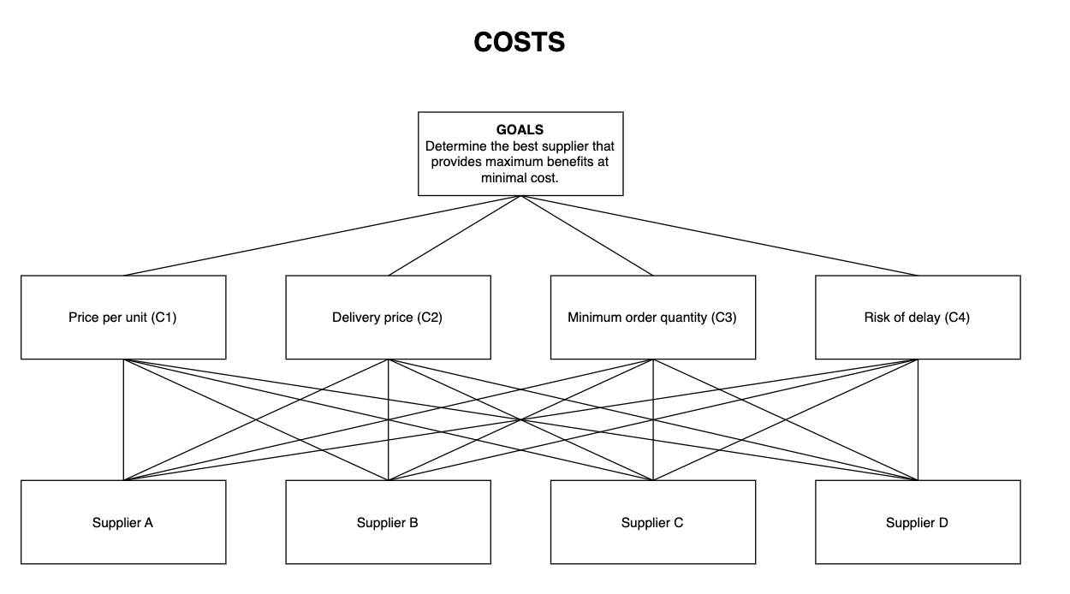

- Benefits Calculation
- Intensity of Interest
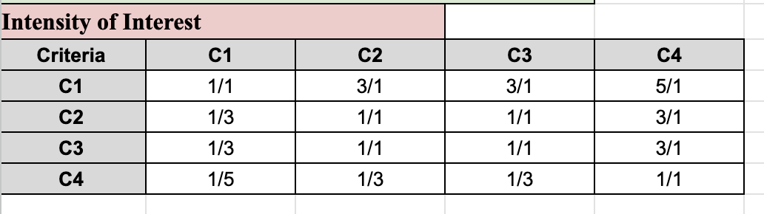
- Normalization
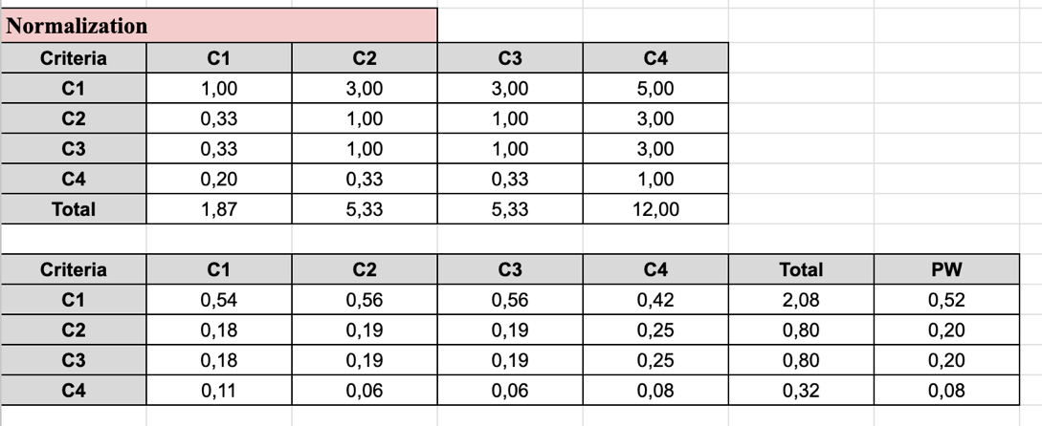
- Calculating Ratio
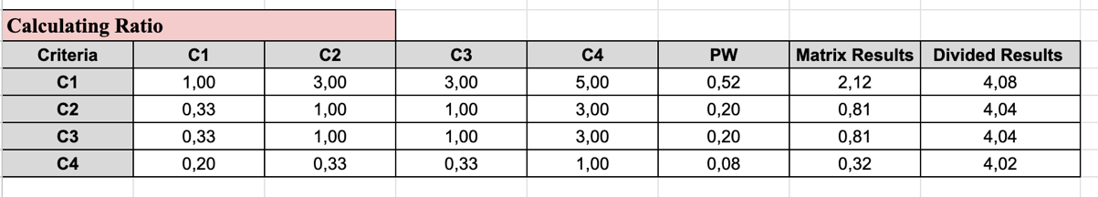
- Count Maks
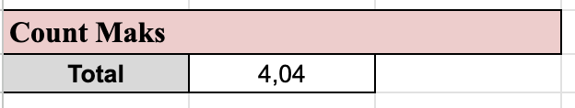
- Count Consistency Index
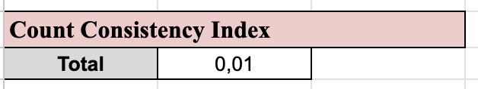
- Consistency Ratio
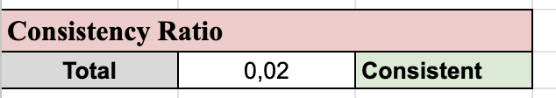
- Consistency Ratio for C1
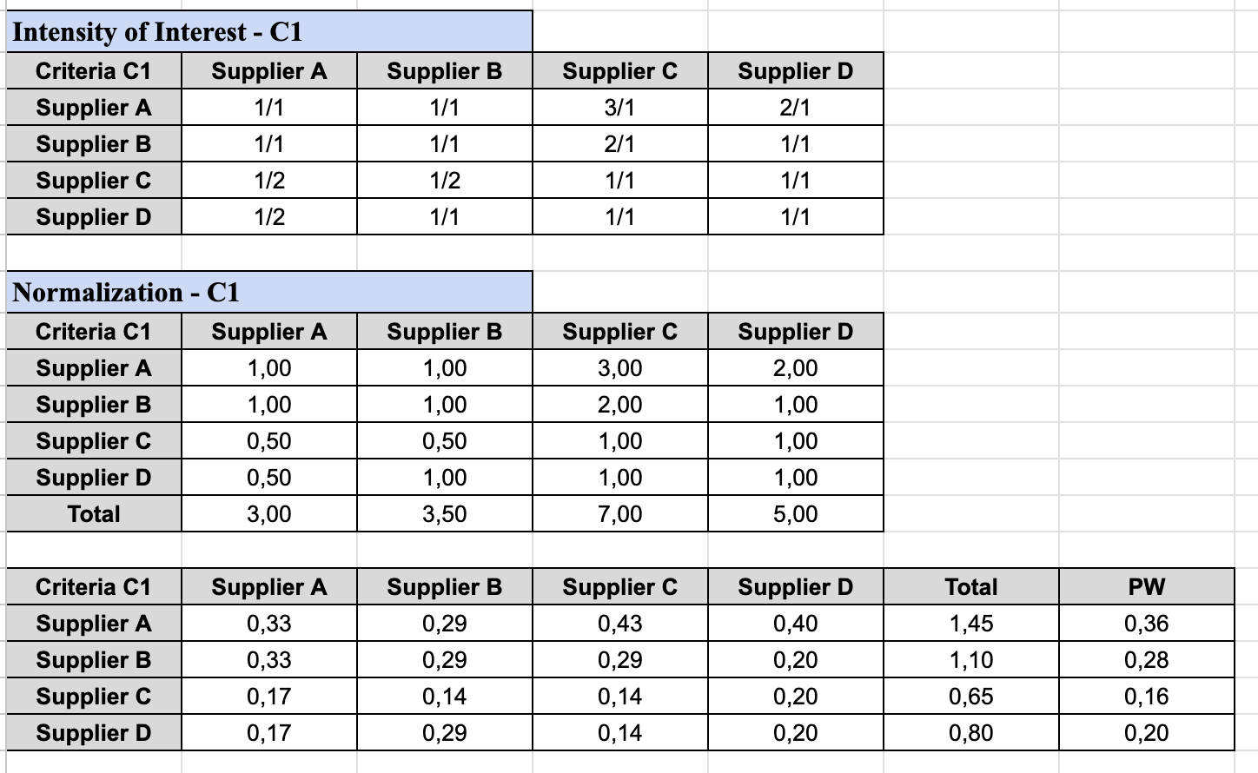
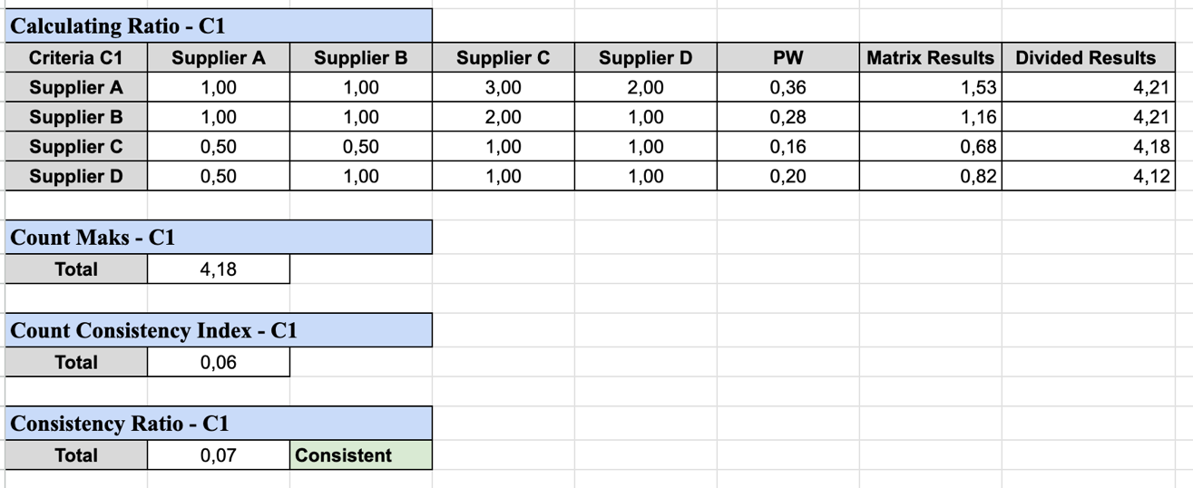

- Consistency Ratio for C2
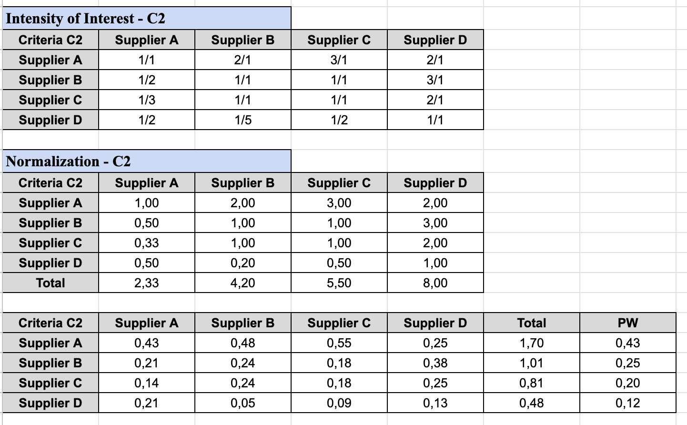
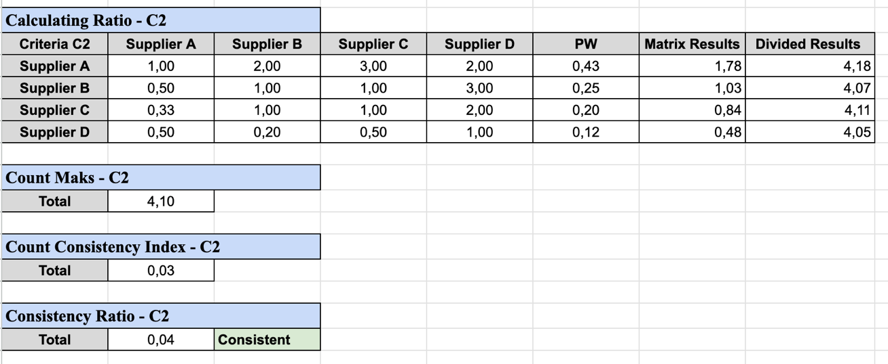

- Consistency Ratio for C3
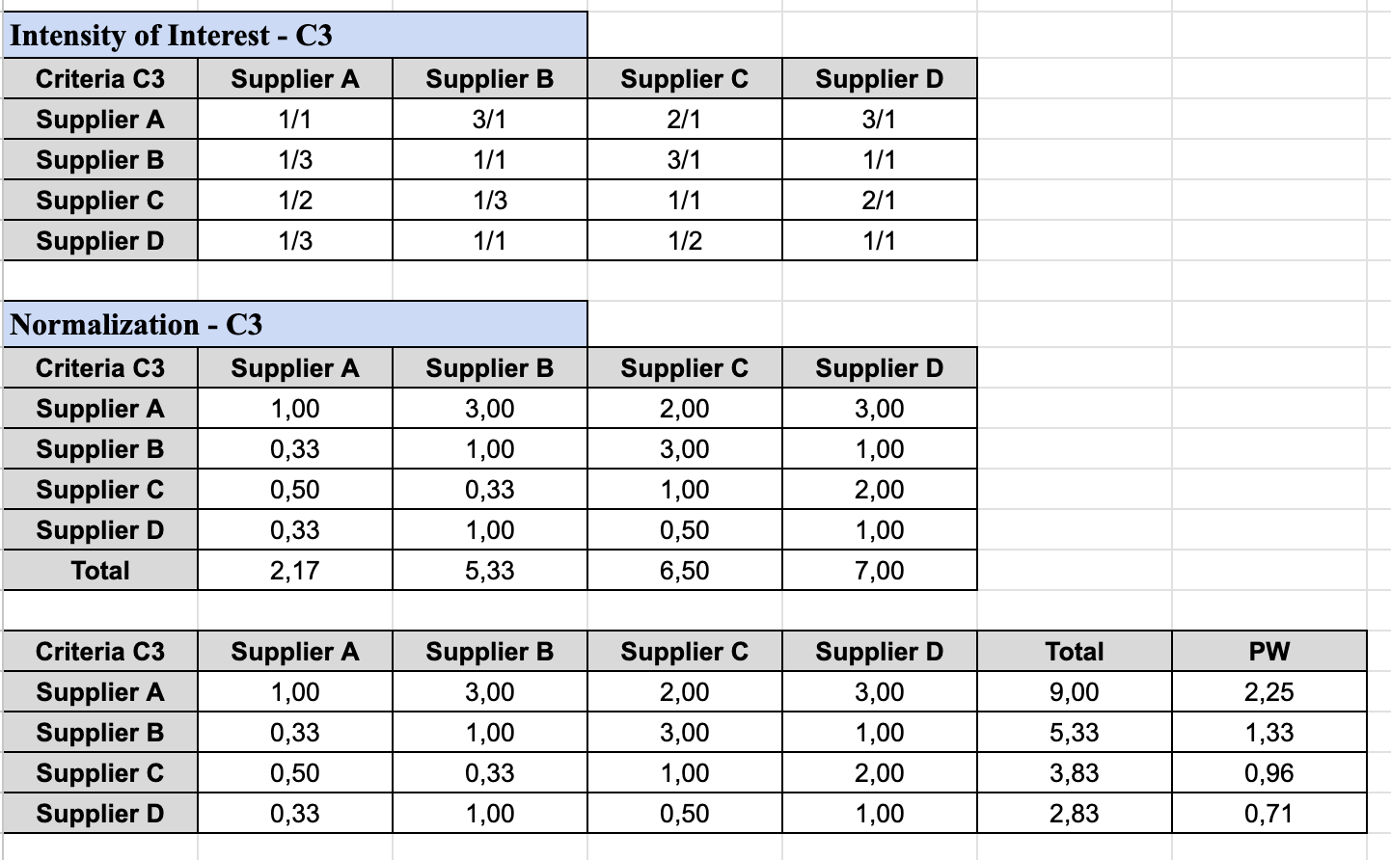
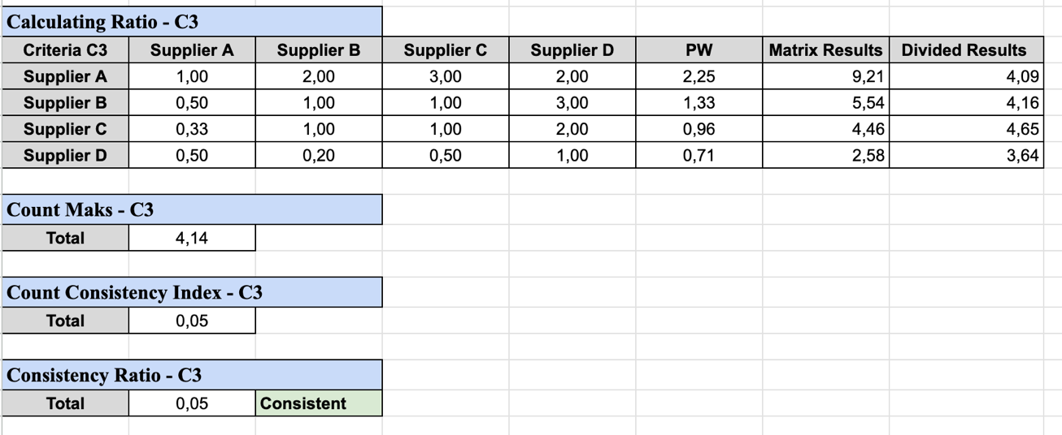

- Consistency Ratio for C4
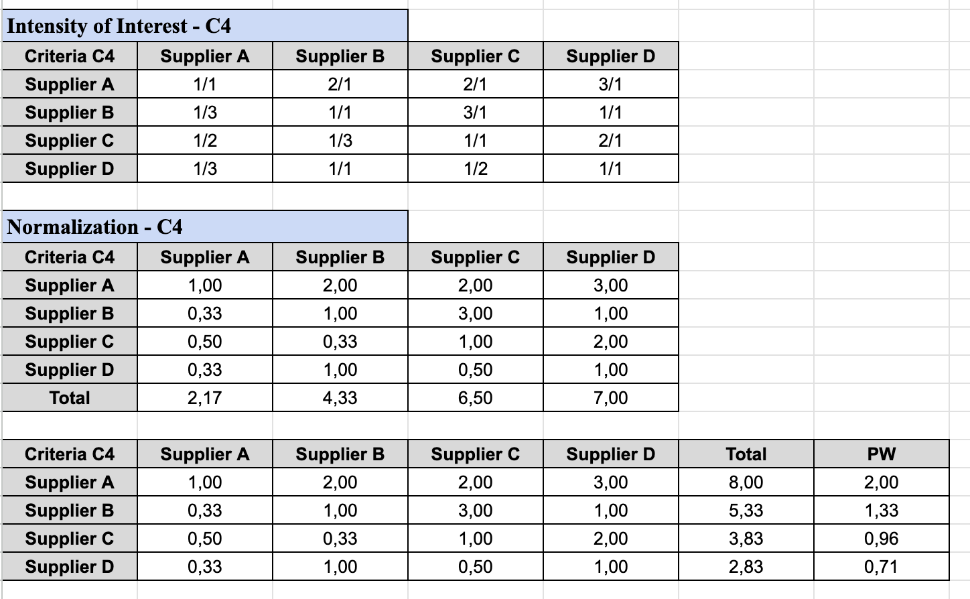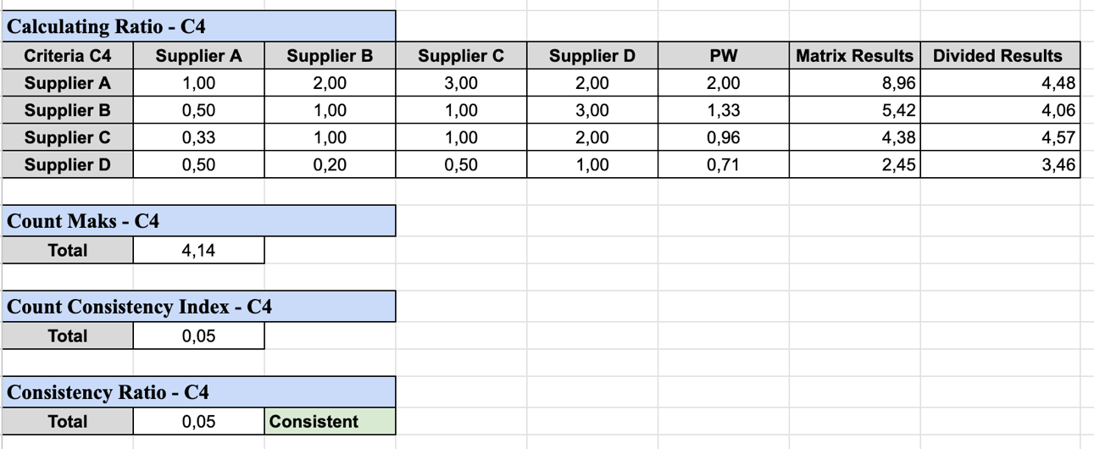

- Costs Calculation
- Intensity of Interest
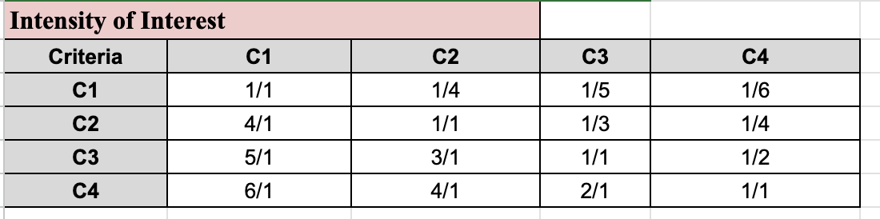
- Normalization
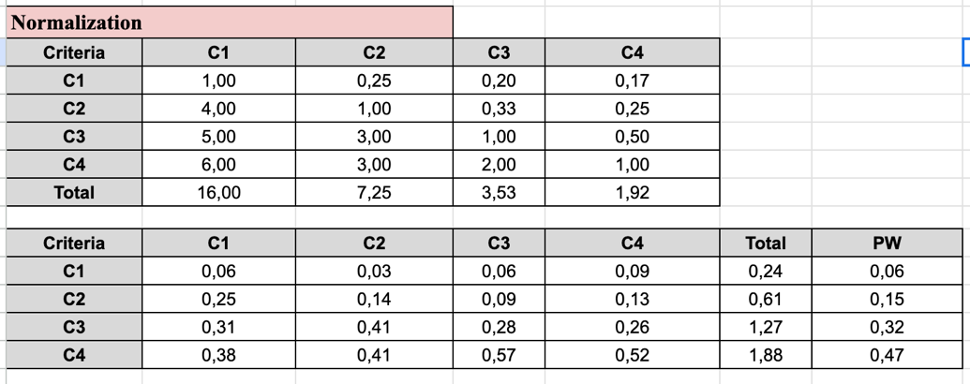
- Calculating Ratio
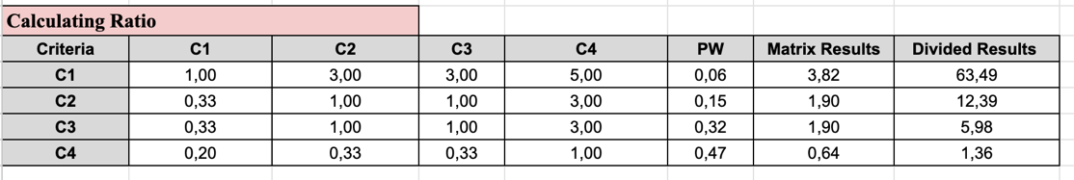
- Count Maks
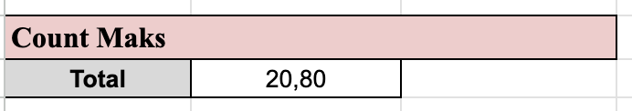
- Count Consistency Index
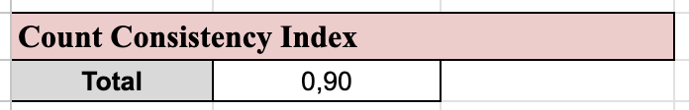
- Consistency Ratio
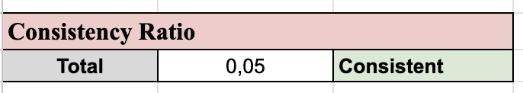

- Consistency Ratio for C1
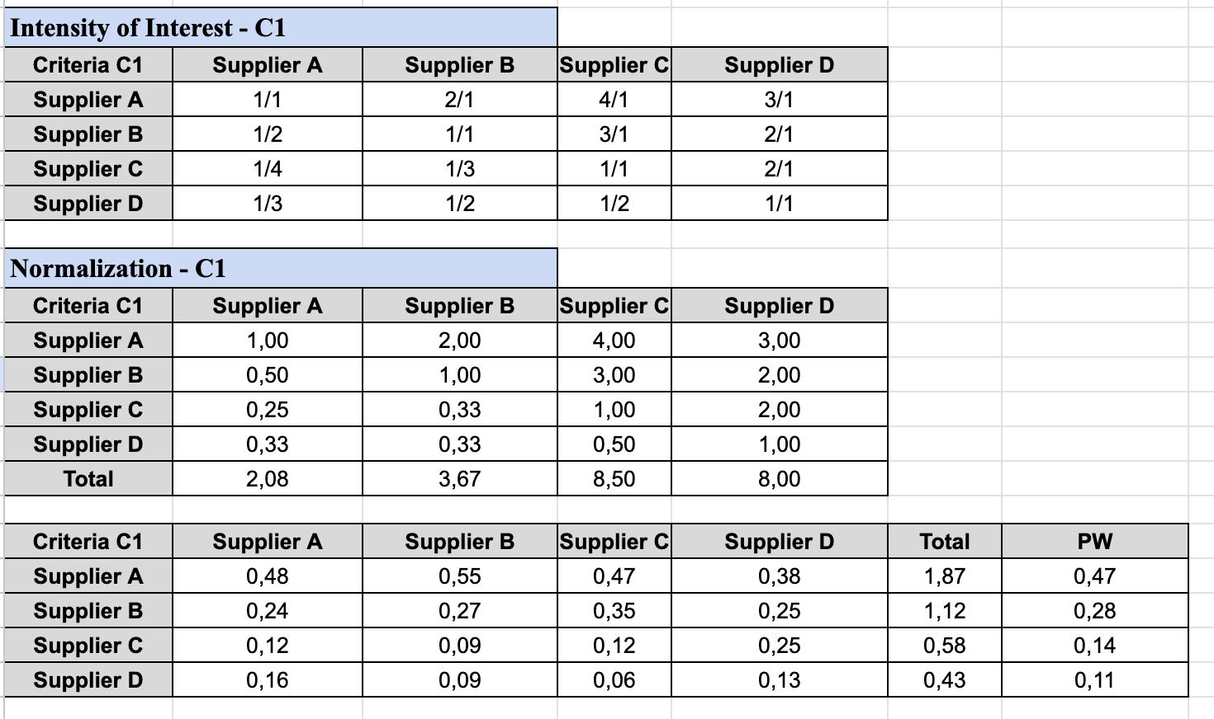
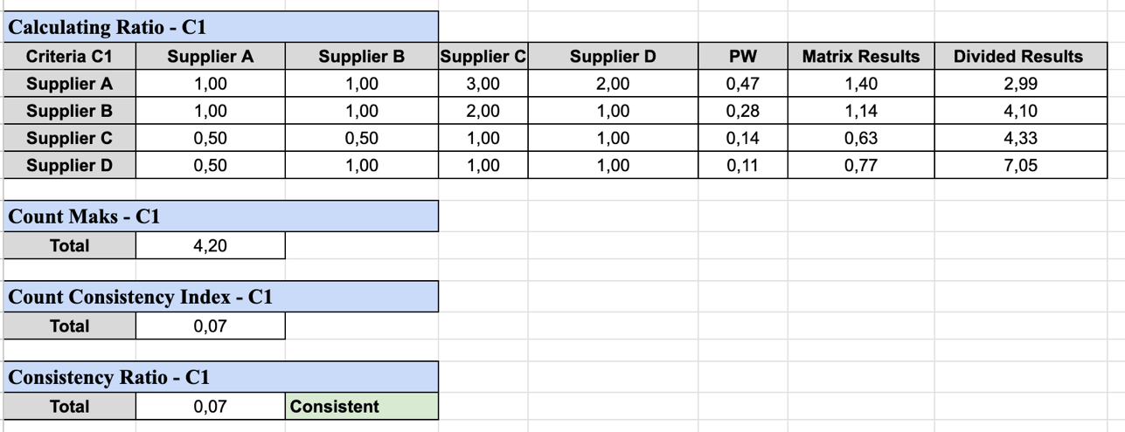

- Consistency Ratio for C2
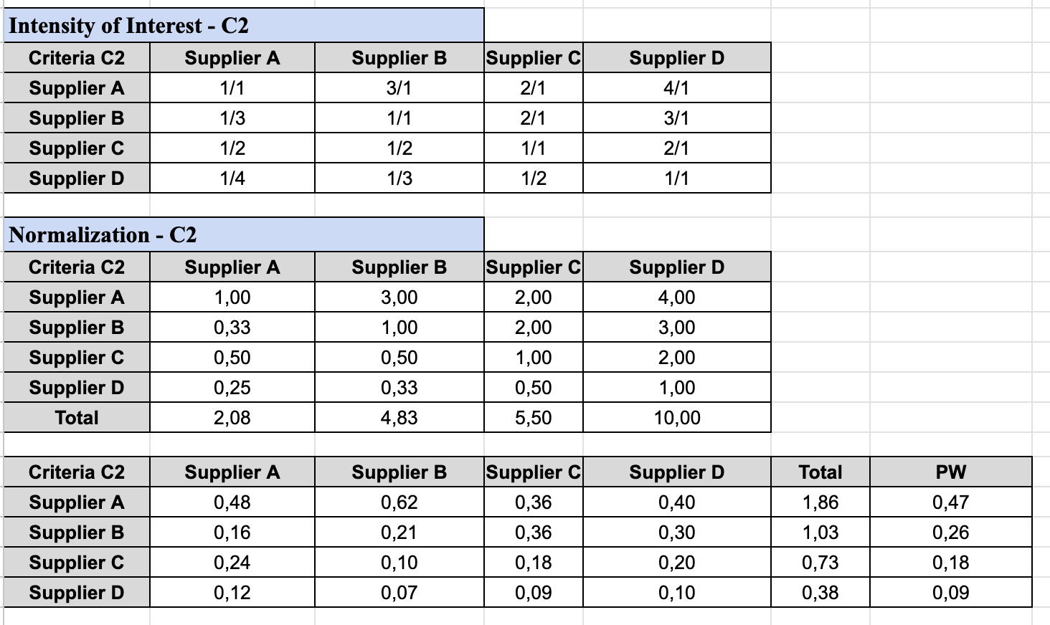
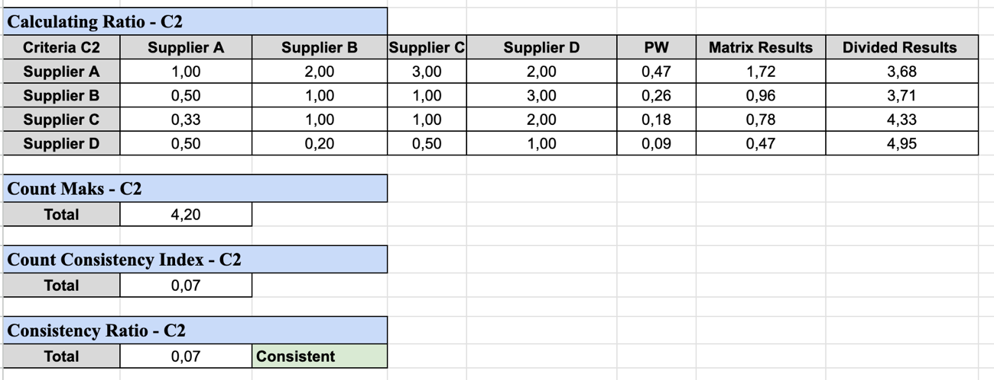

- Consistency Ratio for C3
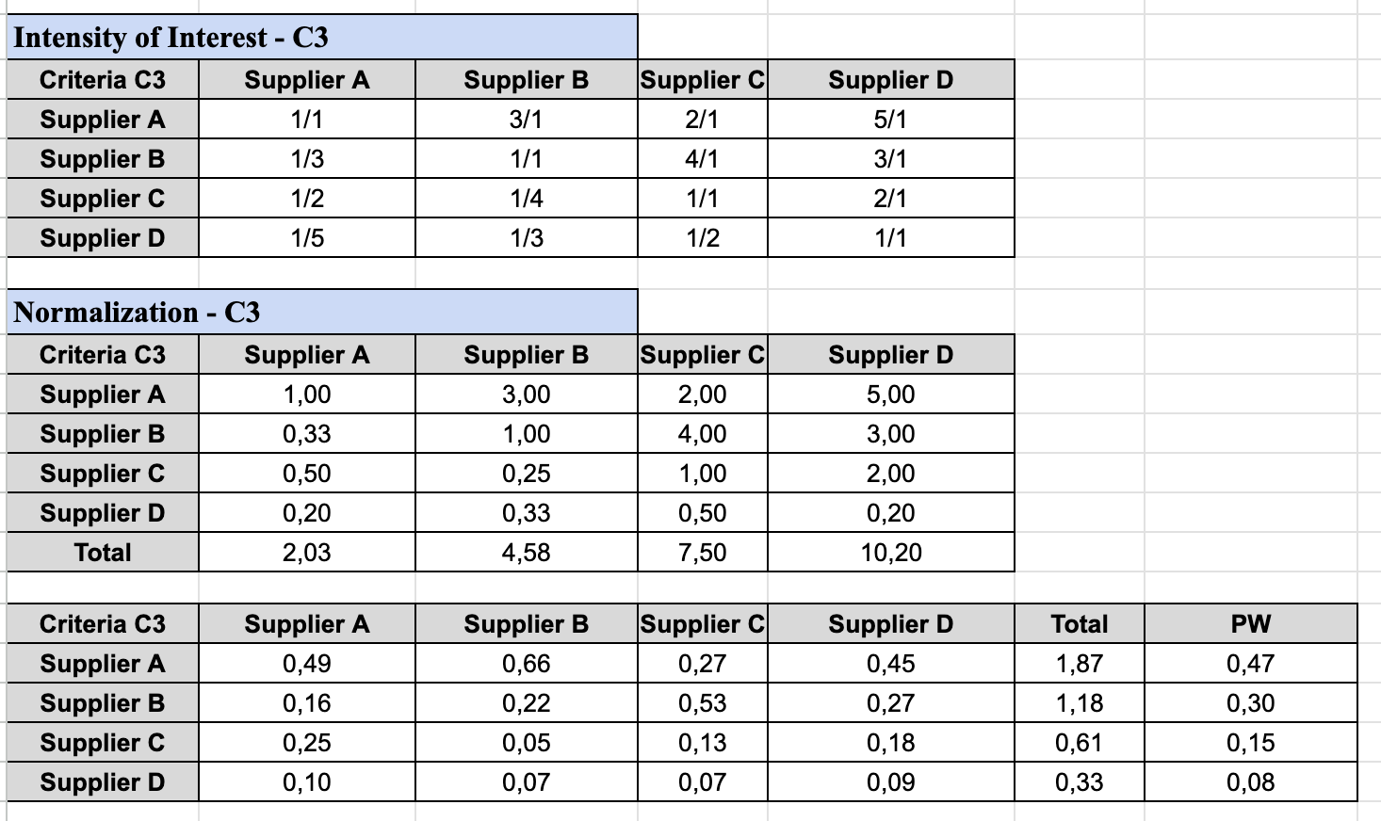
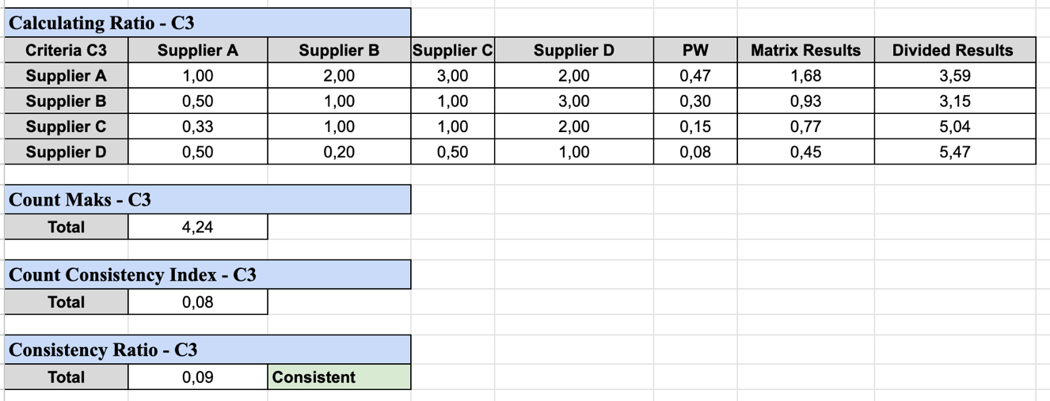

- Consistency Ratio for C4
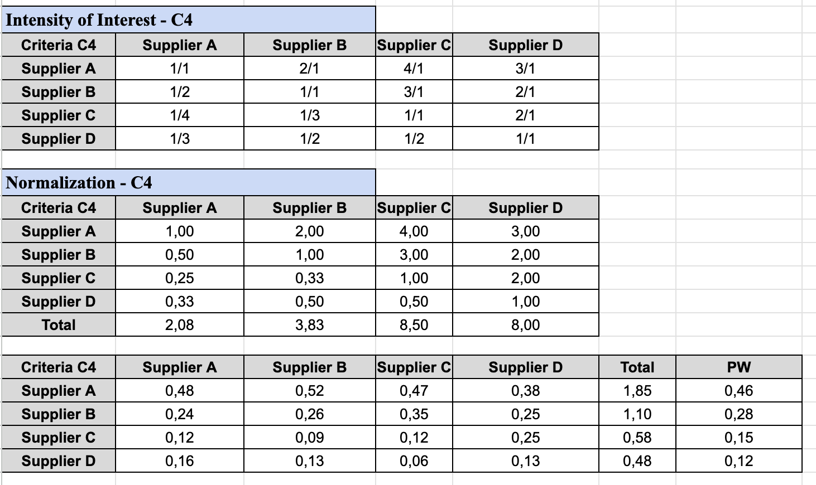
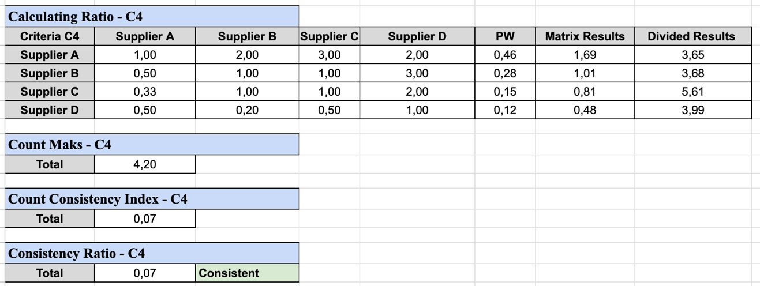

- Final Results
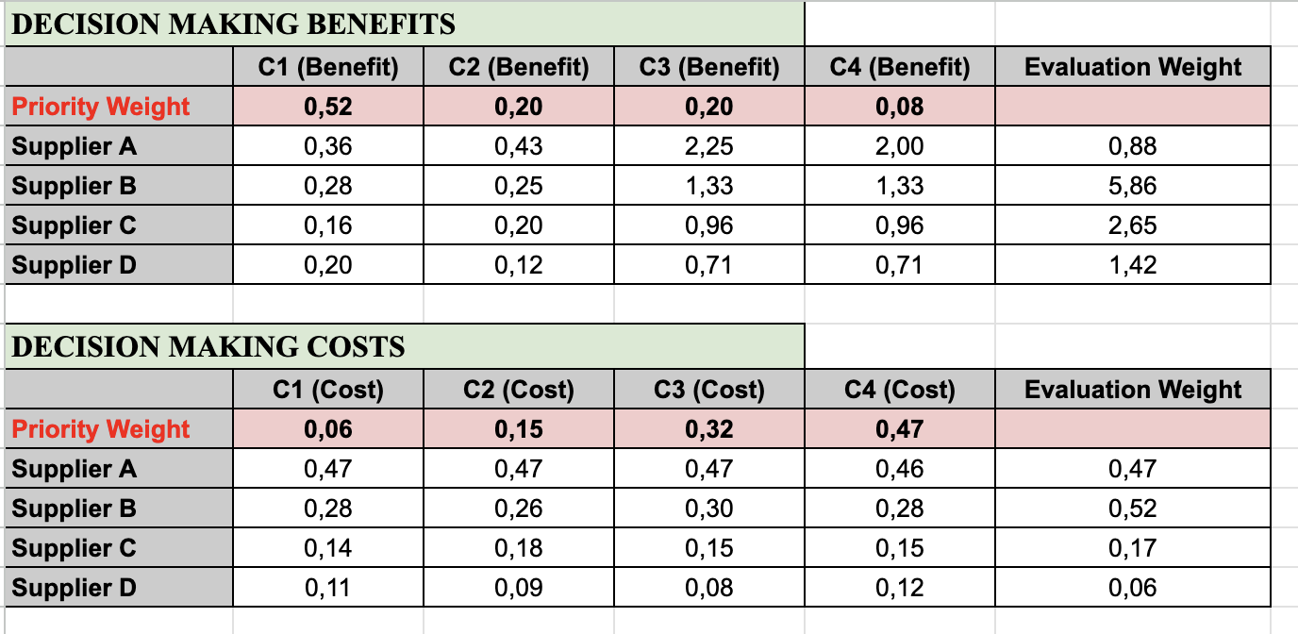
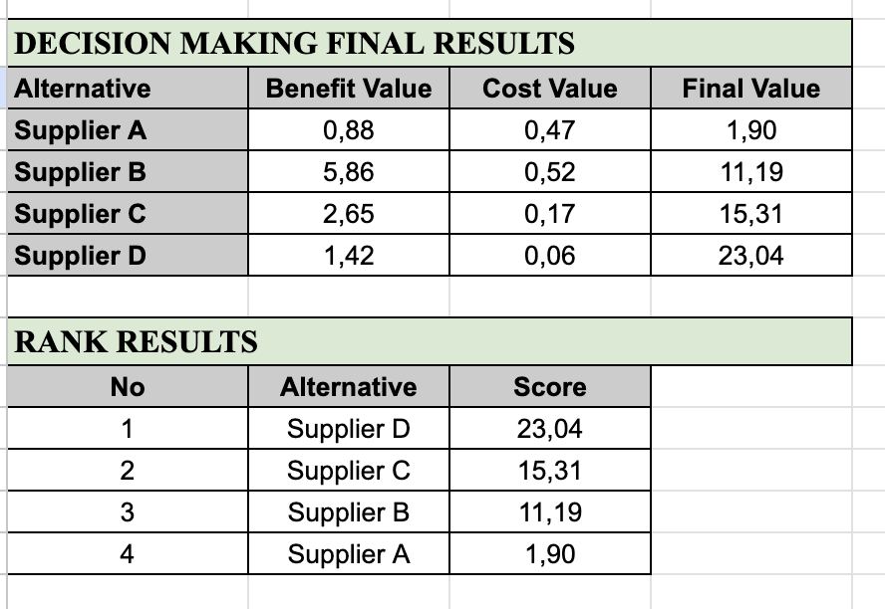

- Conclusions
Based on the analysis using the Analytical Hierarchy Process (AHP) method, the calculation results show that Supplier D has the highest score, which is 23.04, so it is the best choice as the main supplier. The ranking order of suppliers based on the final score is as follows:
- Supplier D – 23,04 (Rank 1)
- Supplier C – 15,31 (Rank 2)
- Supplier B – 11,19 (Rank 3)
- Supplier A – 1,90 (Rank 4)
From these results, it can be concluded that Supplier D is superior in meeting benefit criteria such as raw material quality, delivery speed, reputation, and after-sales service compared to other suppliers. In addition, Supplier D is also more optimal in cost aspects, such as price per unit, shipping costs, minimum order quantity, and risk of delays.
In contrast, Supplier A has the lowest score (1.90), indicating that it falls short of meeting the criteria, both in terms of service quality and cost efficiency.
By considering all the factors that have been calculated using the AHP method, Supplier D is recommended as the main choice to ensure the supply of quality, efficient raw materials, and in accordance with the company's needs.

Here the link for excel results:
https://docs.google.com/spreadsheets/d/1PkLvrmt3uA1oxMLe0_ANVGh2ppPmHAAtfkQKhuStDGs/edit?usp=sharing

